Name | Maida Mohamed Abdikarim | Date | 29/10/2026
ID | C6240415 | Subject | Linux
Class | CNS242

Chapter 1:

1. Introduction
Linux is an open-source operating system (OS). Ubuntu is a popular, easy-to-use distribution (version) of Linux.
Linux commands are instructions typed into the terminal to manage files, view information about the computer, copy and move files, and install programs.

2. Linux Commands

Command 1: whoami
Meaning: The whoami command shows the name of the user currently logged in to the system.
Example: Type whoami and press Enter. The username you are logged in as is displayed.
Practice
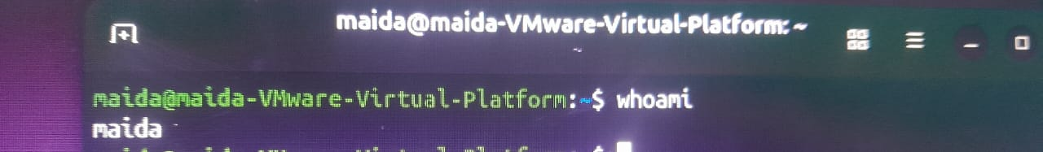

Command 2: pwd
Meaning: The pwd command (print working directory) shows the folder you are currently in.
Syntax: pwd
Practice
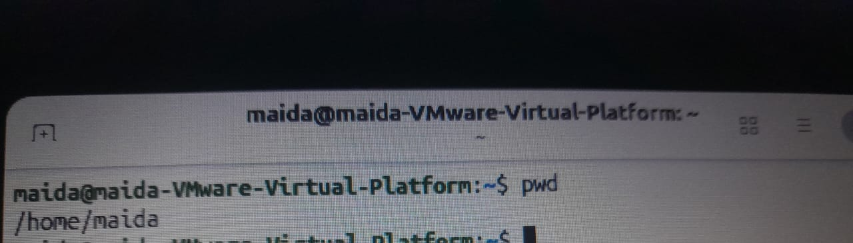

Command 3: uname
Meaning: The uname command displays information about the Linux system. It has four common forms:

Form 1: uname -r
Shows the kernel version (release).
Practice

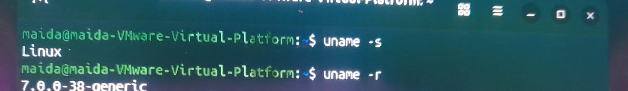

Form 2: uname -s
Shows the kernel name.
Practice

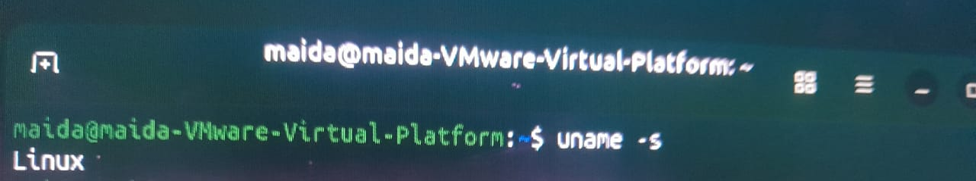

Form 3: uname -a
Shows all available information about the system.
Practice
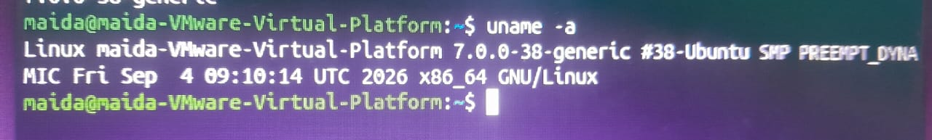
Form 4: uname -m
Shows the machine hardware type (processor architecture) of the computer.
Practice


Command 4: cat
Meaning: The cat command displays the contents of a text file.
General syntax: cat filename (where filename is the name of the file you want to read)
Example: cat /etc/os-release
This command displays information about the installed Ubuntu system, such as its version.
Practice
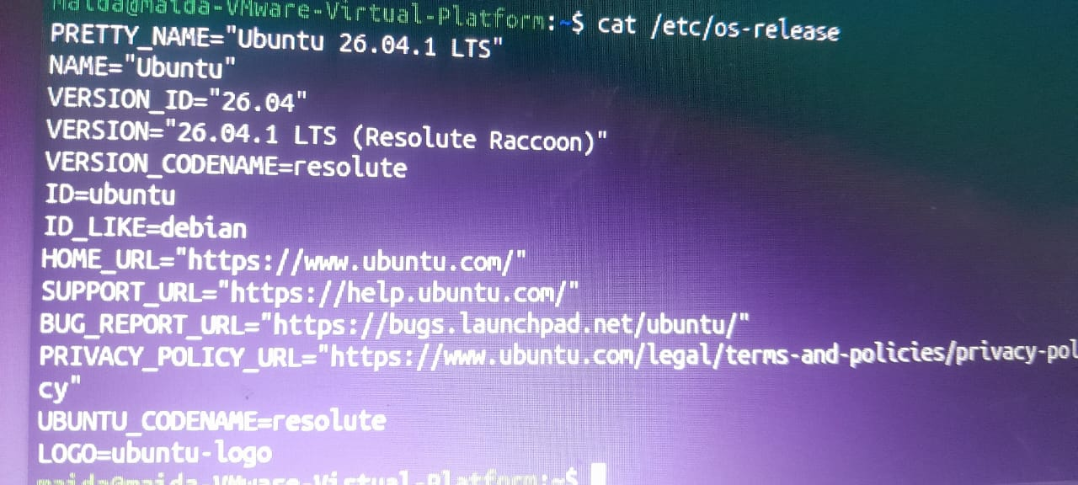

Command 5: ls
Meaning: The ls command lists the files and folders in your current location. It has five common forms:

Form 1: ls
Lists the normal (visible) files and folders.
Practice
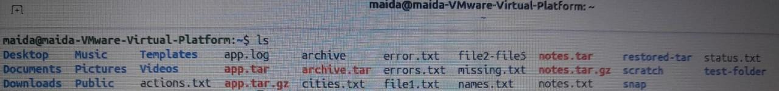
Form 2: ls -l
Shows a detailed list including permissions, owner, size, and last modification time.
Practice
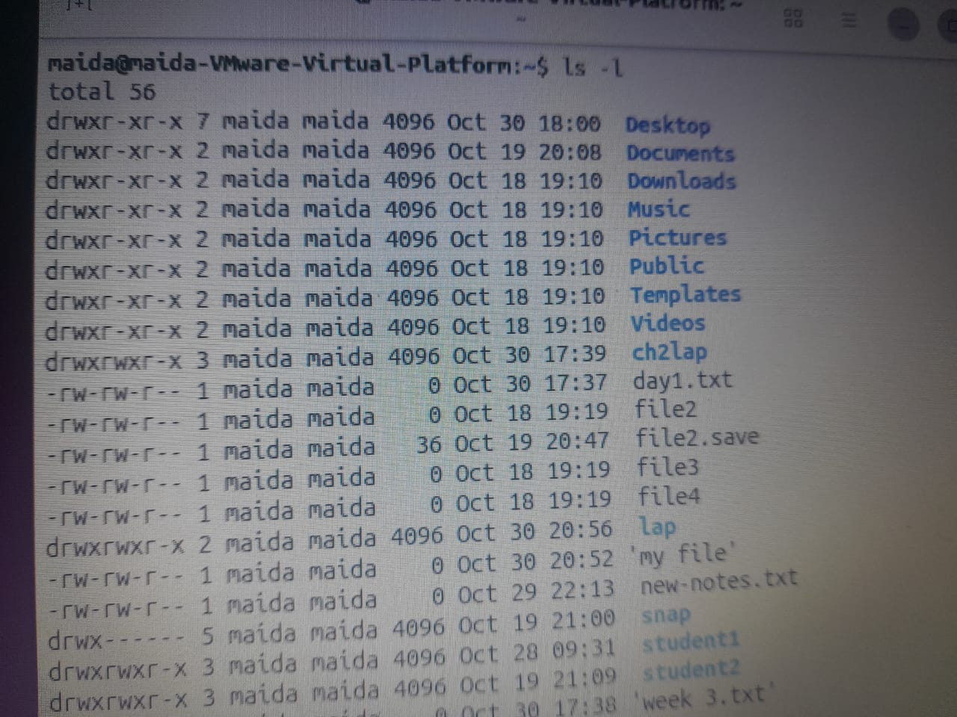

Form 3: ls -a
Shows normal files and hidden files.
Practice
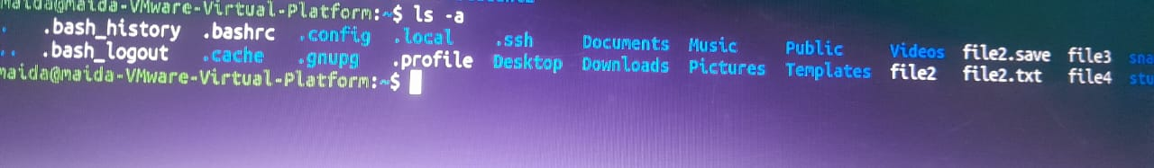
Form 4: ls -la
Shows a detailed list that includes hidden files.
Practice

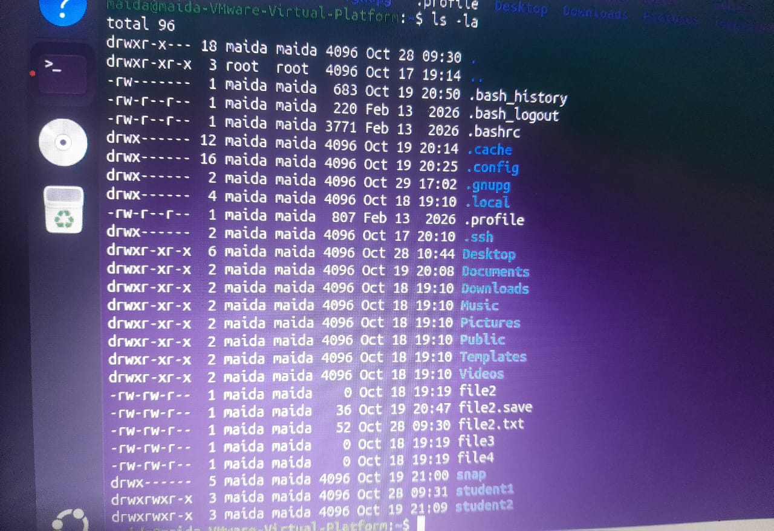

Form 5: ls /home
Shows the contents of the /home folder.
Practice
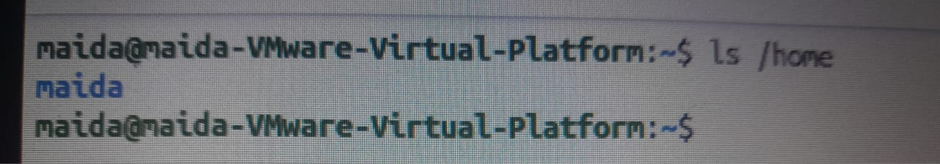
Command 6: cp
Meaning: The cp command (copy) makes a copy of a file, or copies files and folders.
Example: cp notes.txt notes-copy.txt
This command makes a new copy of notes.txt named notes-copy.txt, provided the original file exists.
Practice
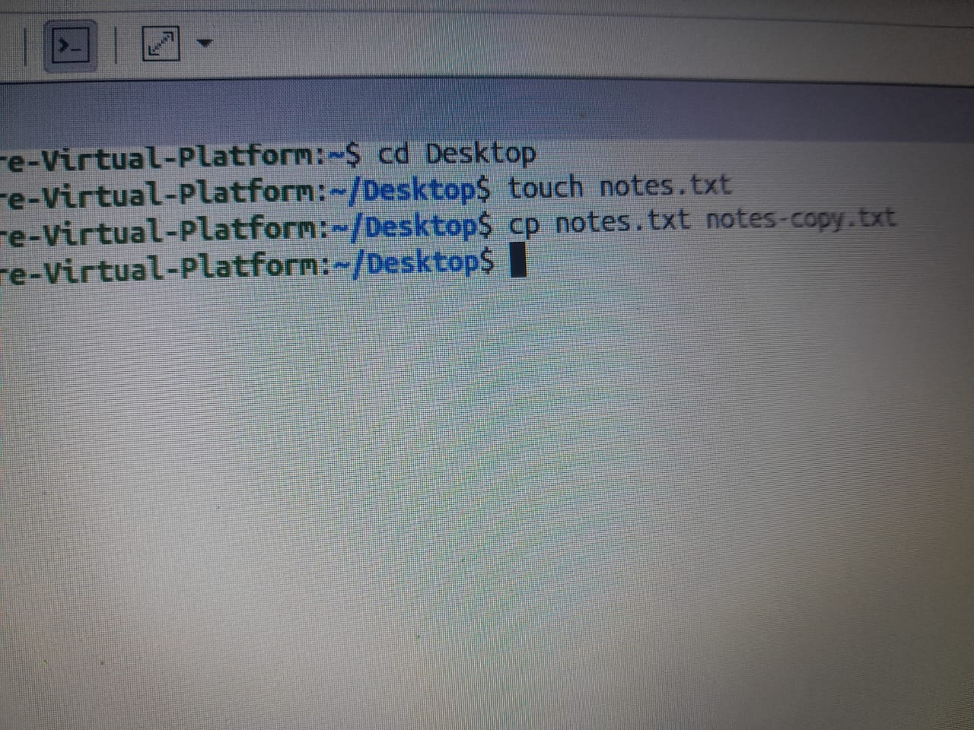

A whole folder can be copied like this:
cp -r school school-copy

The -r option (recursive) copies the folder and everything inside it.
Practice


Command 7: mv
Meaning: The mv command (move) moves a file or folder to another place, or renames it.

Example 1: Renaming a file
mv notes.txt new-notes.txt

This command renames notes.txt to new-notes.txt.
Practice

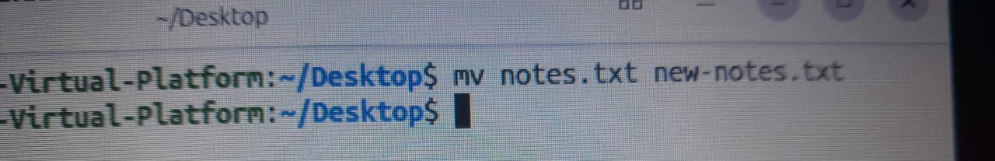

Example 2: Moving a file to another location
mv notes.txt /home/username/

Replace username with your real username. The file must already exist.
Practice

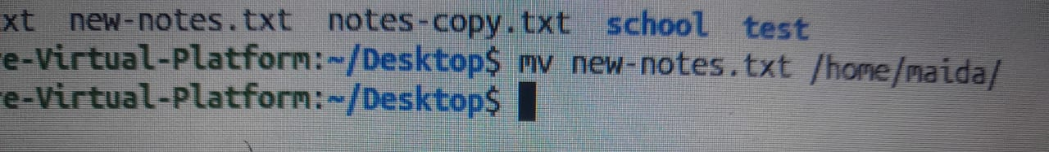

Command 8: apt
Meaning: apt is a tool for managing software on Linux (searching, installing, and updating programs on Ubuntu).
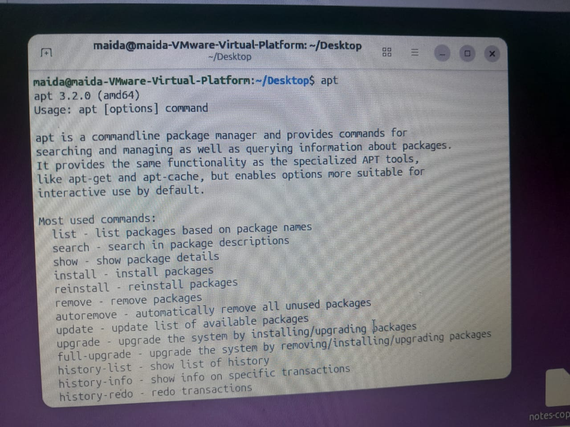

Form 1: sudo apt update
Refreshes the list of software available from the software repositories.
Practice
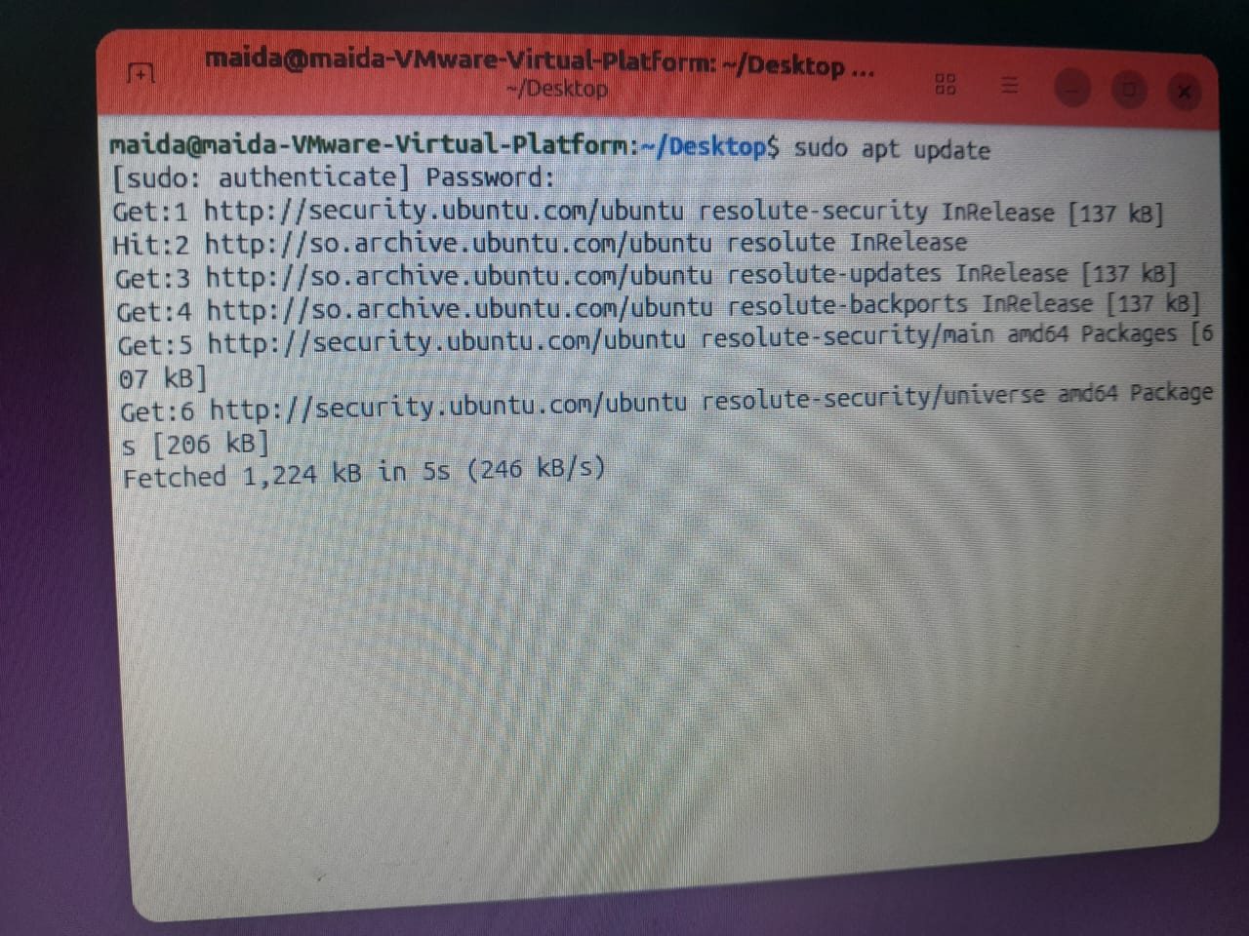

Form 2: sudo apt upgrade
Upgrades the installed programs when updates are available.
Practice
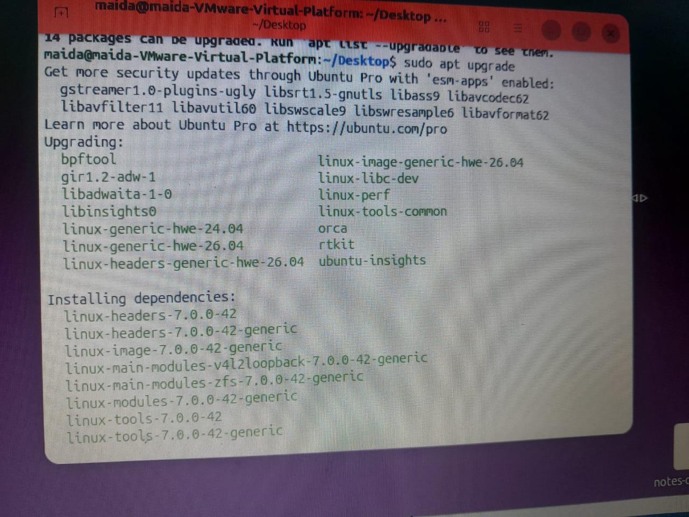

Chapter 2: Ubuntu System Architecture and the Shell

1. Ubuntu System Architecture
This section explains how Linux works.
Component | Meaning
Hardware | The physical parts of the computer, such as the CPU, RAM, and disk
Kernel | The core part that manages the hardware and the system
Shell | The part that receives and runs commands
Bash | The default shell used in Ubuntu
System Utilities | System programs such as ls and cp
Applications | Programs such as Firefox and LibreOffice
Users | The people who use the computer
Host | The real (physical) computer
Guest | The operating system running inside a virtual machine
Hypervisor | The software that creates and runs virtual machines

Practice steps:
- Open Ubuntu.
- Open the Terminal.
- Type the command below. It tells you which shell you are using.
Practice
echo $SHELL


2. Filesystem Hierarchy
Directory | Meaning
/ | Root, where the filesystem begins
/home | Where users' personal files are stored
/etc | System configuration files
/var | Logs and other changing (variable) data
/tmp | Temporary files
/boot | Files used to start the computer
/dev | Device files
/proc | Information about processes and the kernel
/sys | Information about devices and drivers

Practice:
/ home
/etc
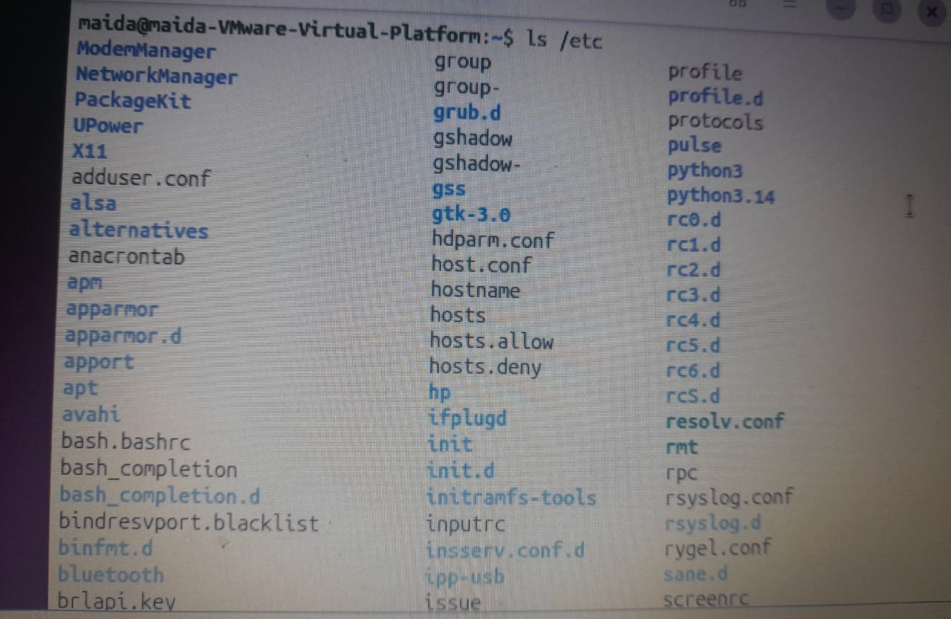

/var
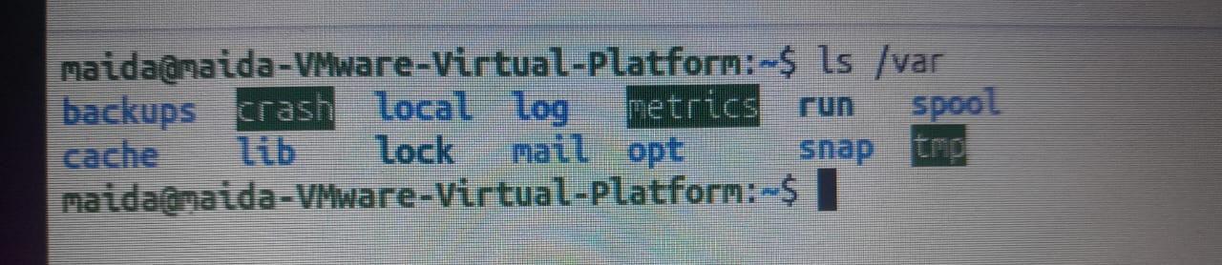
/usr
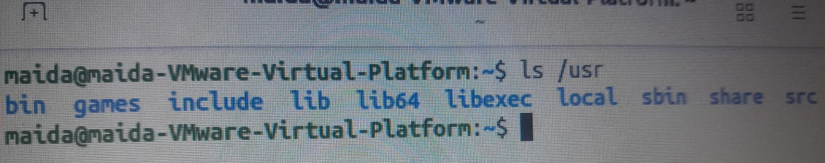
| /tmp
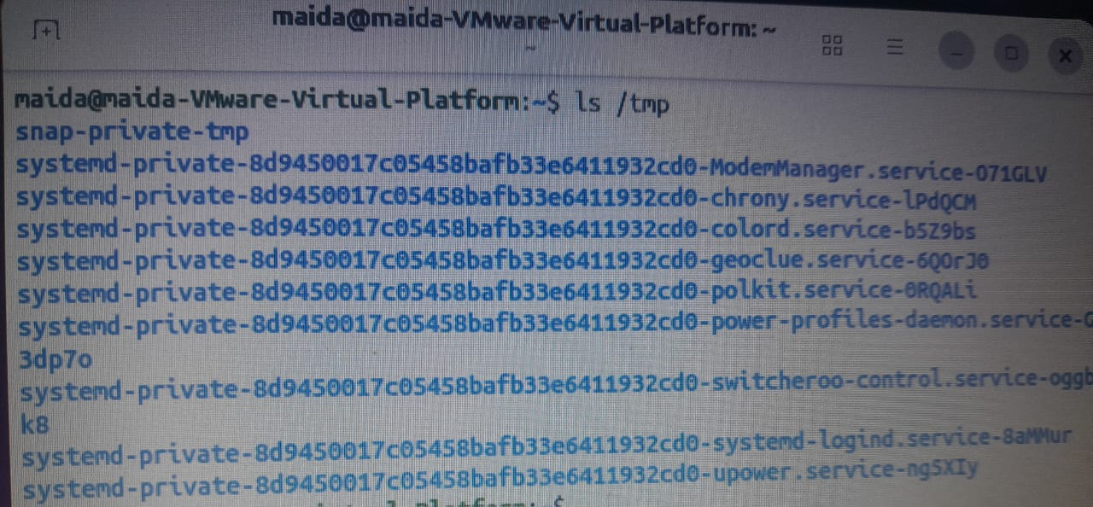

| /boot
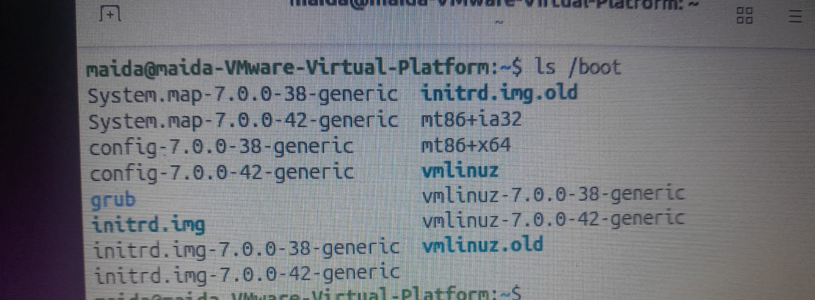

| /dev
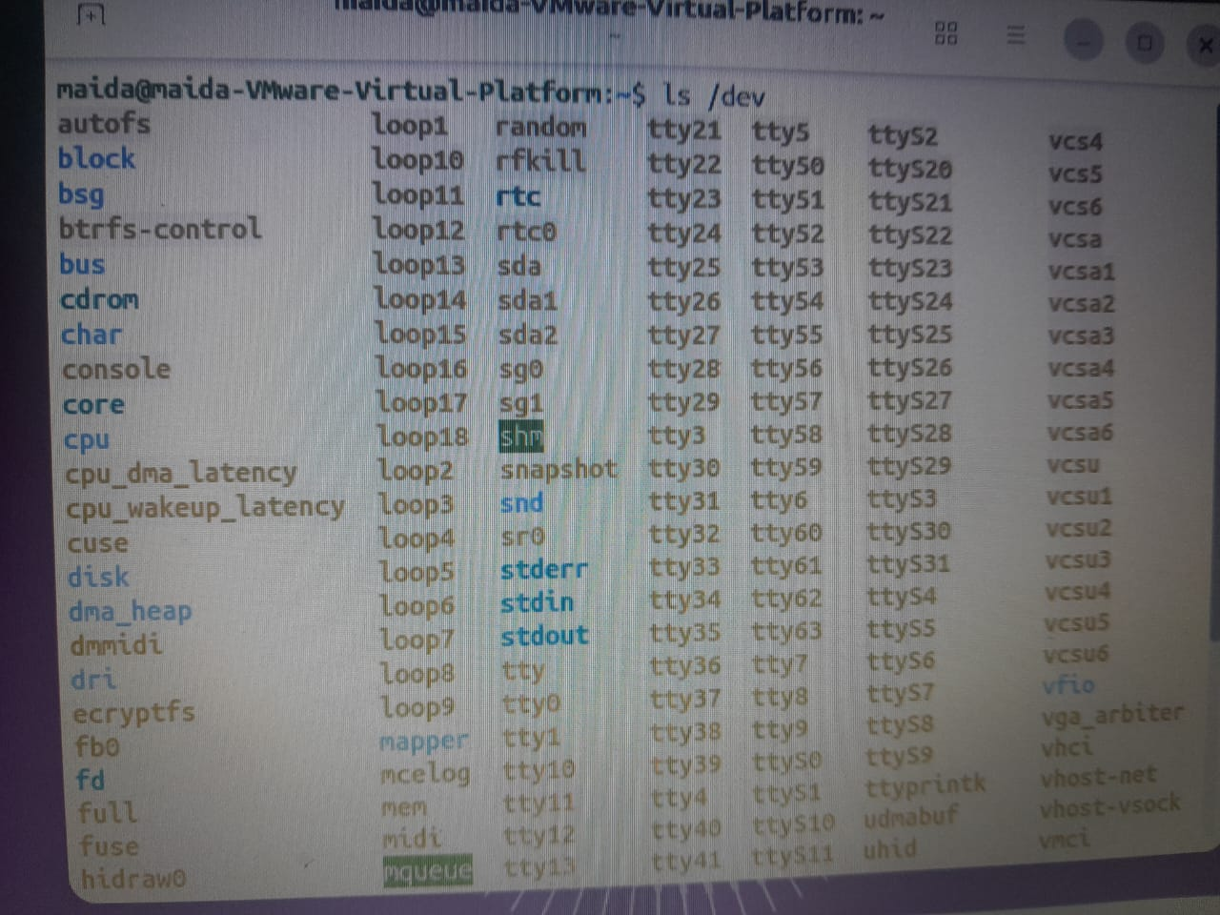

/proc
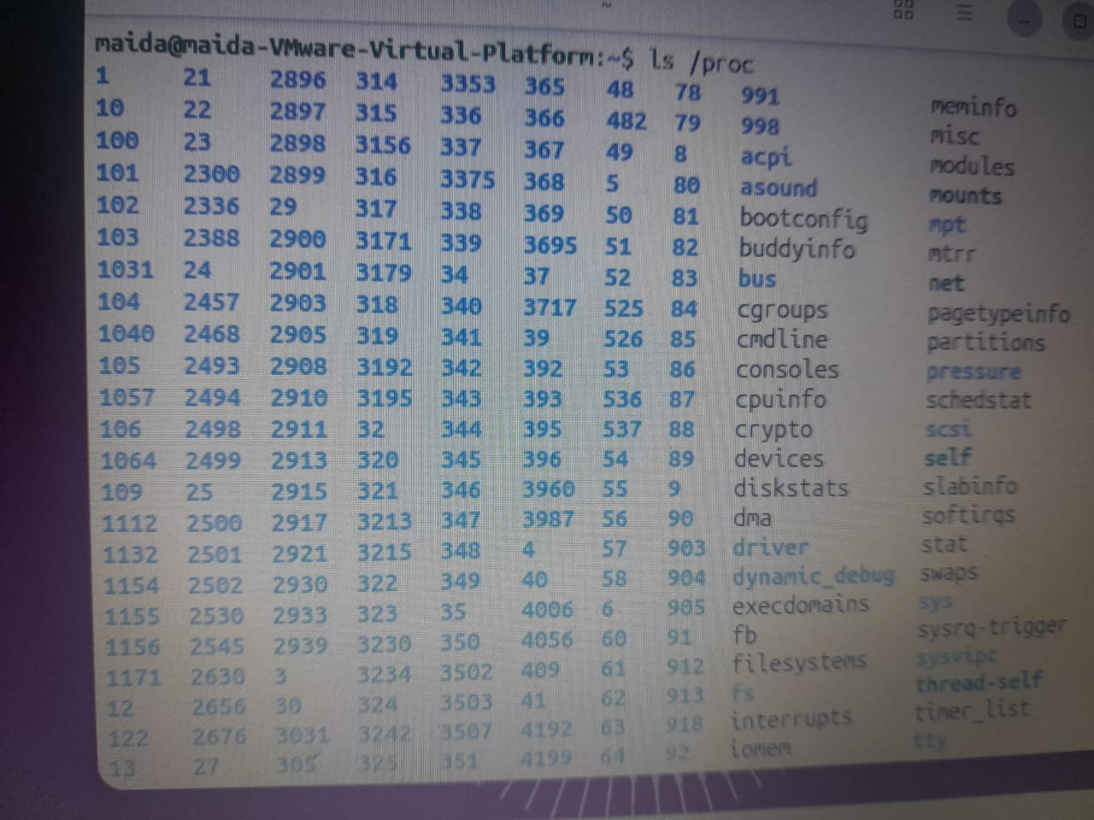

/sys

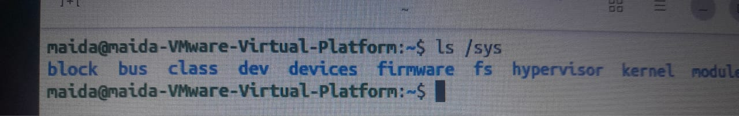

3. Terminal and Bash Commands
Command / Key | Meaning
echo $SHELL | Shows the shell you are using
history | Shows the commands you have used before
Ctrl + R | Searches your previous commands
↑ | Brings back the previous command
↓ | Moves to the next command in the history
Tab | Auto-completes a file or directory name
Tab Tab | Shows all possible matching names

| echo $SHELL

history
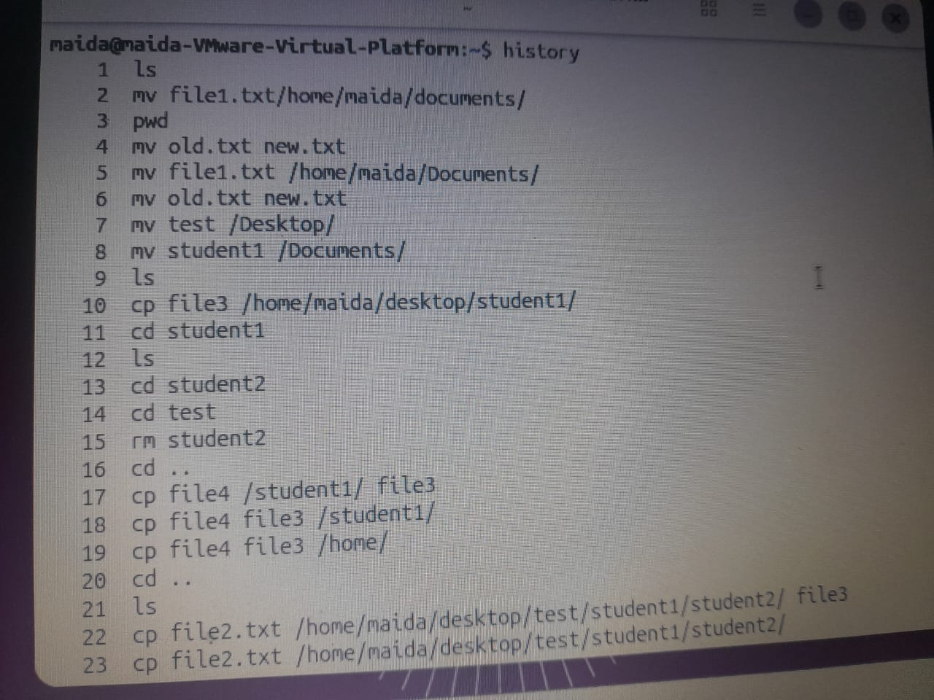

4. Command Syntax
A command has three parts:
- Command – the program to run.
- Option – changes how the command works.
- Argument – the file or directory the command works on.
Example:
ls -l /home
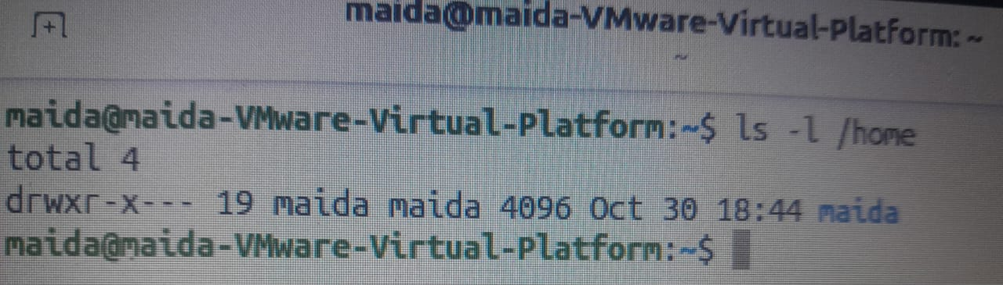

- ls = Command
- -l = Option
- /home = Argument

Important options
Option | Meaning
-a | Show hidden files
-l | Show detailed information about files
-h | Human-readable sizes (K, M, G)
-r | Recursive: work on directories and everything inside them (e.g. cp -r, rm -r)
-i | Interactive: ask for confirmation before overwriting or deleting

Many options also have a long form. For example, ls --all is the same as ls -a.
| -a
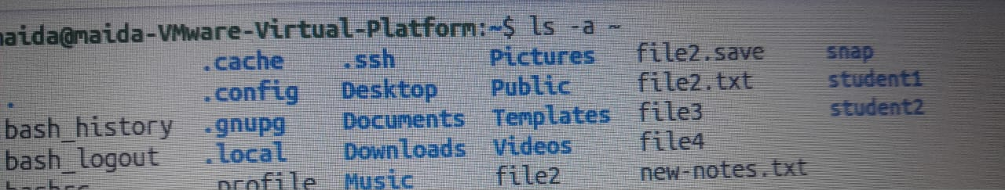
| -l

| -h
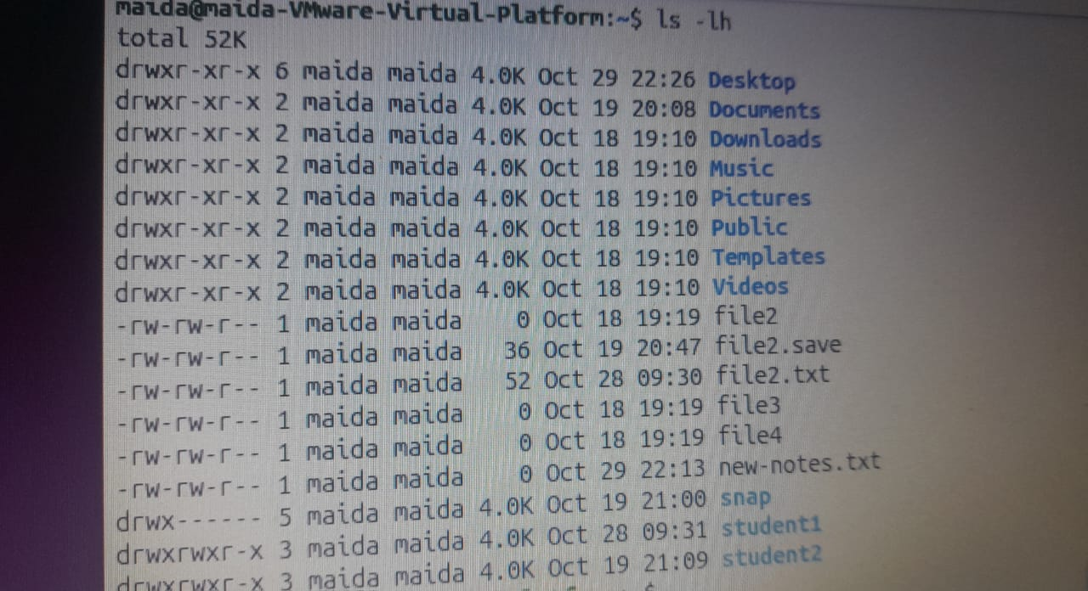

| -r
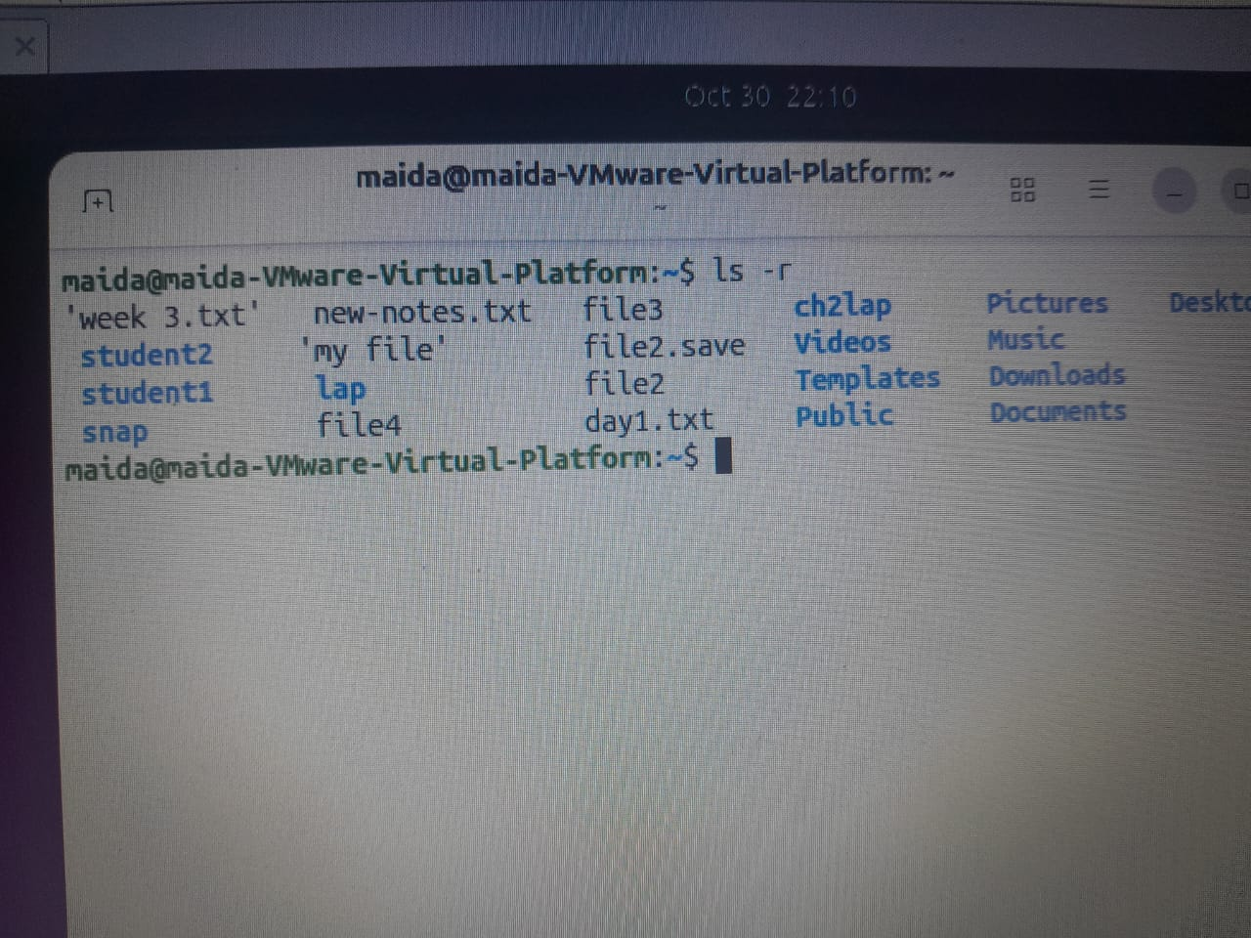

| -i
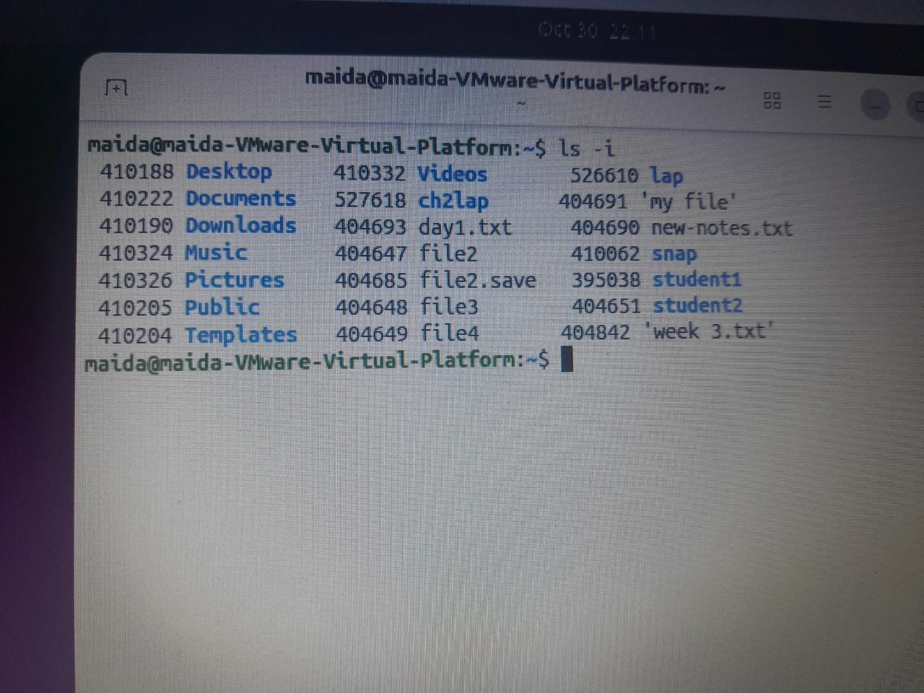

ls –all
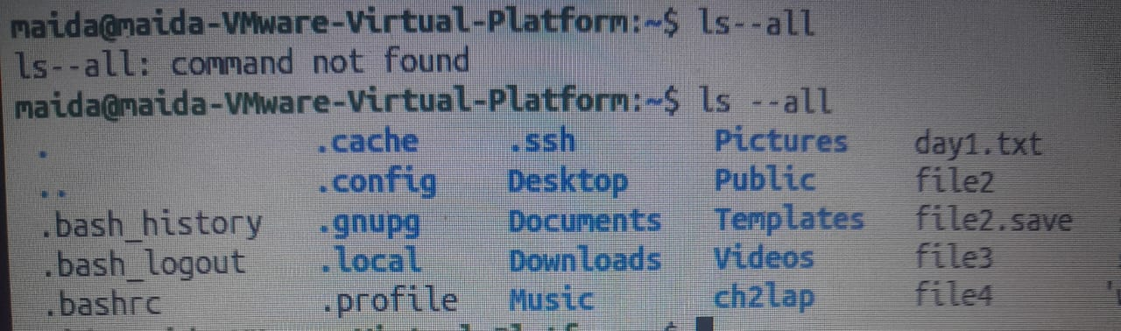

5. Getting Help
Use these commands when you want to learn how a command is used.
Command | Meaning
man ls | Opens the detailed manual for ls
ls --help | Shows a short help summary for ls
info ls | Opens additional documentation
help cd | Explains how cd is used
man rmdir | Explains rmdir

Keys to use inside the manual (man) page:
- Press Space to see the next page.
- Press b to go back.
- Type /word to search for a word (for example, /all).
- Press n to jump to the next result.
- Press q to quit.

Man ls
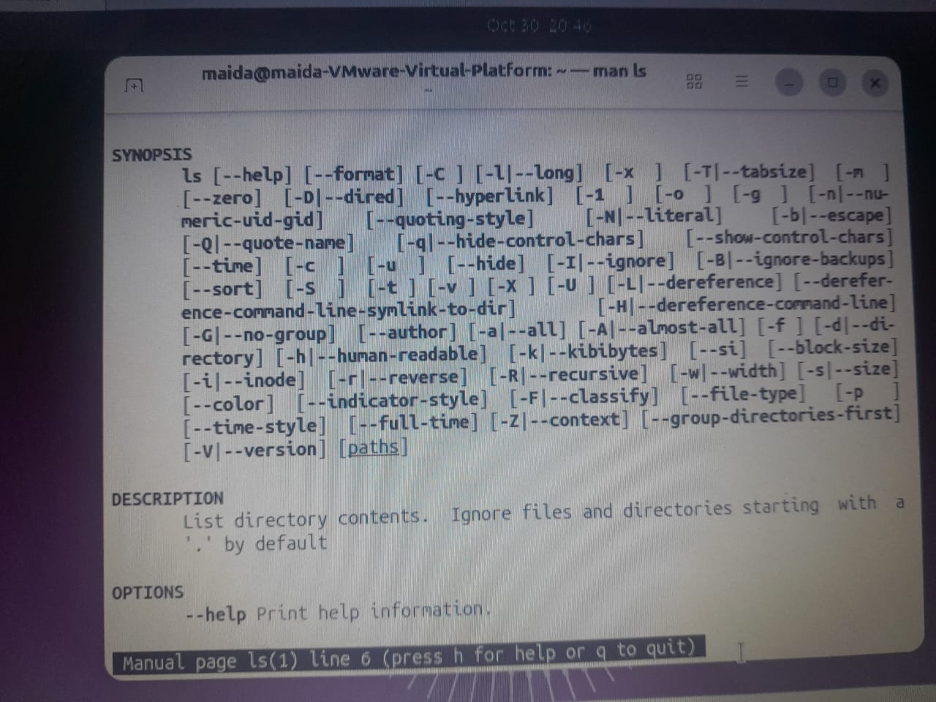

ls –help
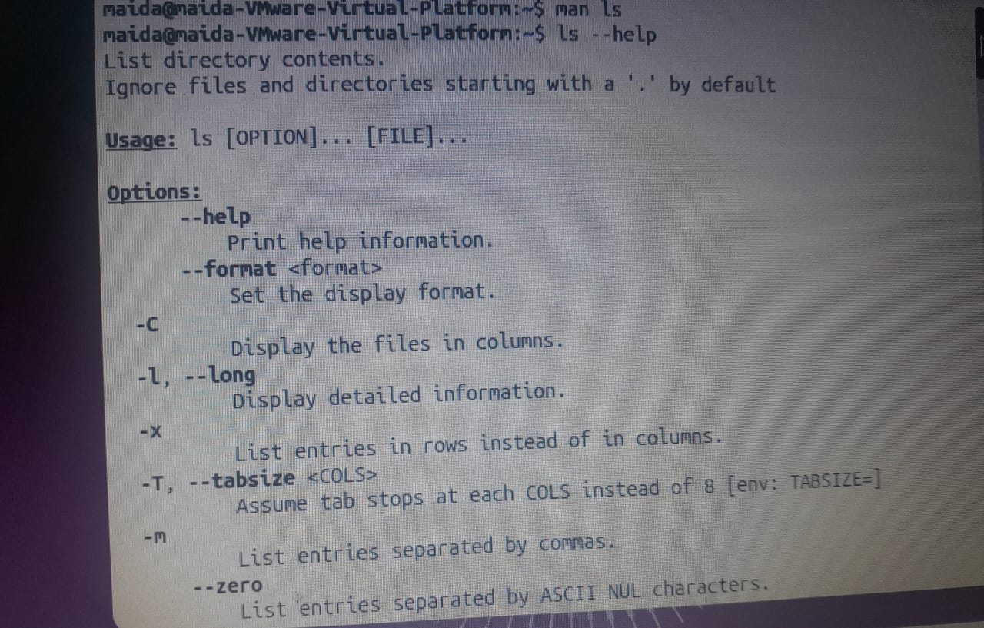

info ls
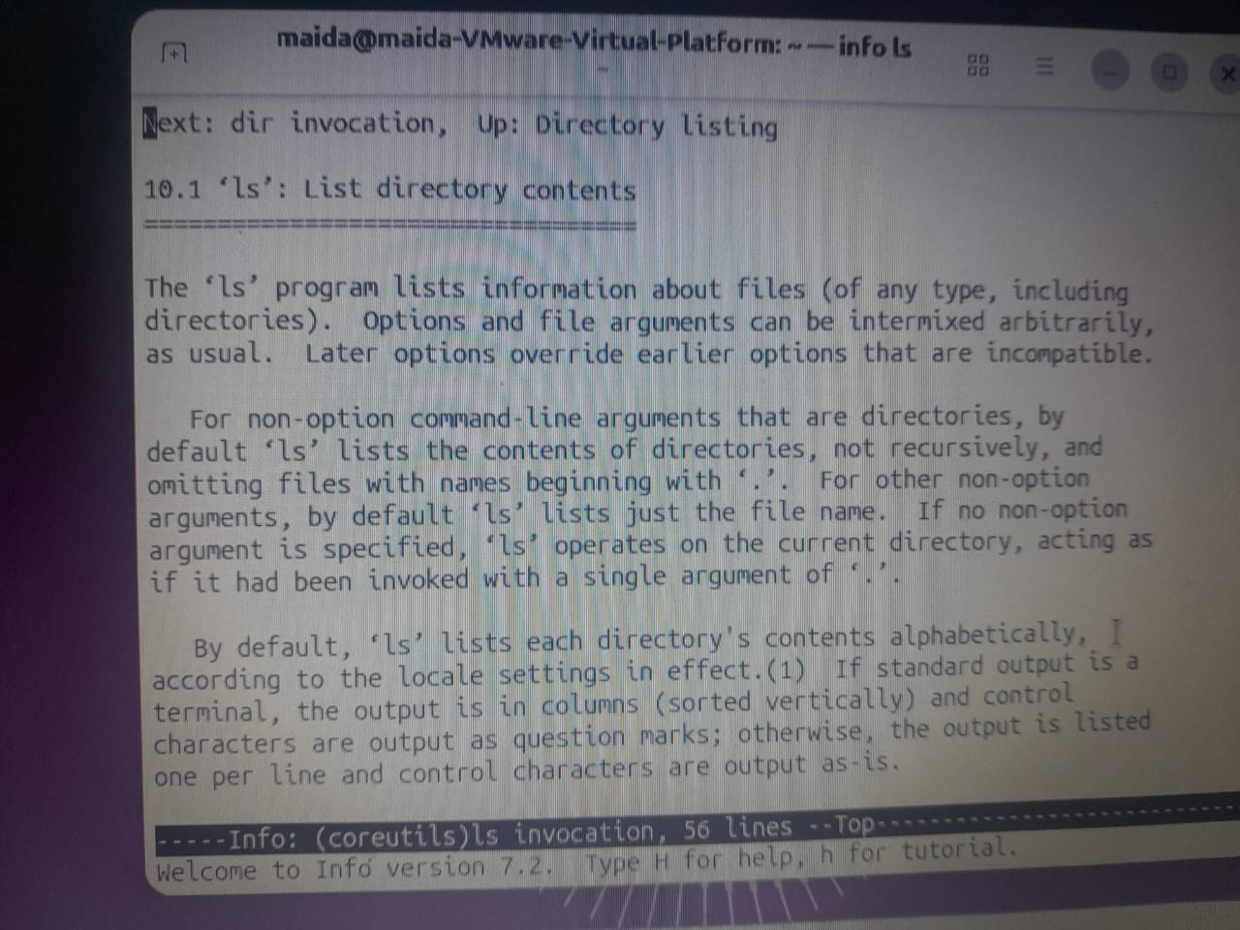

help cd
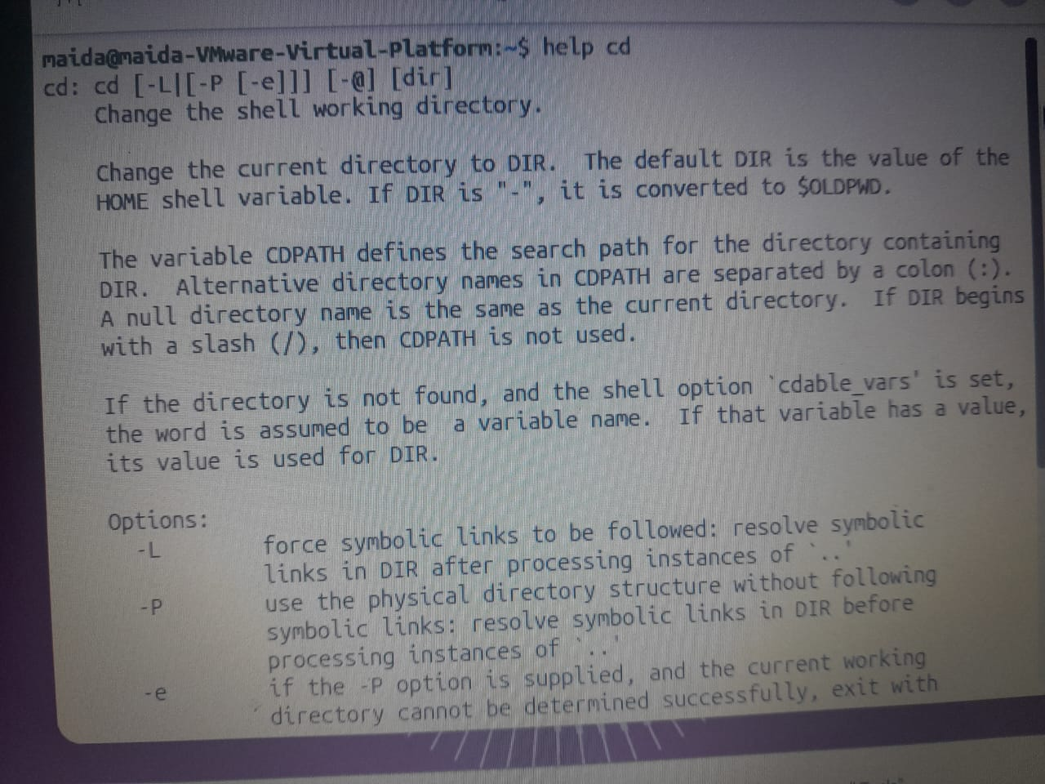

man rmdir
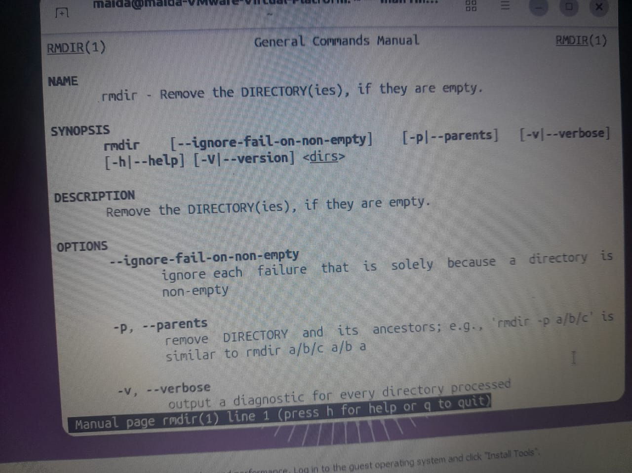

6. Quoting, Escaping, and Wildcards

A. Quoting
Command | Meaning
echo "Hello $USER" | Prints Hello followed by the username
echo 'Hello $USER' | Prints $USER exactly as written
touch "new file" | Creates a file whose name contains a space

echo "Hello $USER"

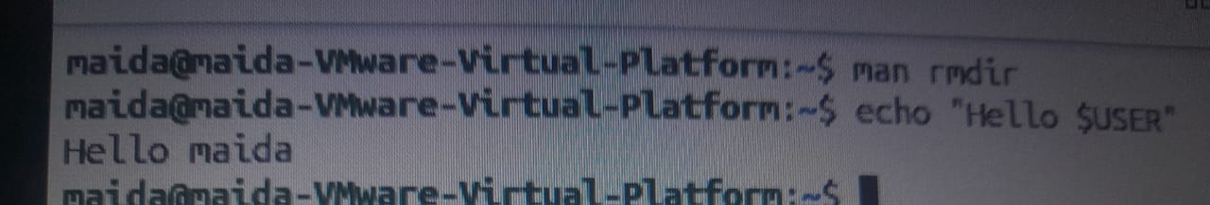
echo 'Hello $USER'
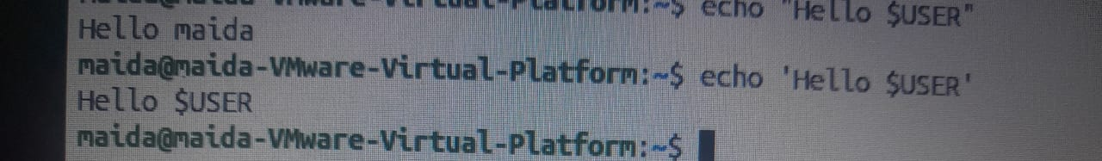

touch "new file"

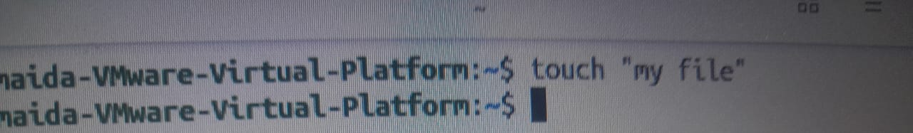

B. Escaping
The backslash \ removes the special meaning of a single character in Bash.
Command | Meaning
echo \$HOME | Prints $HOME as plain text
touch notes\*.txt | Creates a file whose name contains *

mkdir "My Files"
cd My\ Files
pwd
cd ..

echo \\$HOME
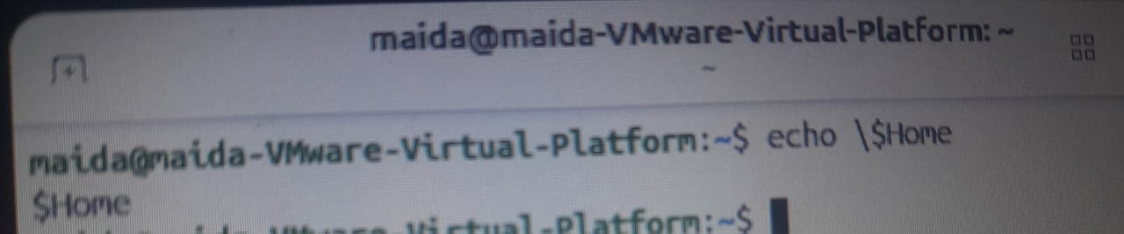

touch notes\\*.txt


mkdir "My Files"

cd My\ Files
pwd
cd ..

C. Wildcards
Wildcard | Meaning
* | Any characters
? | Exactly one character
[abc] | One character from a, b, or c
[0-9] | One digit from 0 to 9

mkdir lab
cd lab
touch lab1.txt lab2.txt lab10.txt
ls *.txt

mkdir lap


cd lap


touch lab1.txt lab2.txt lab10.txt
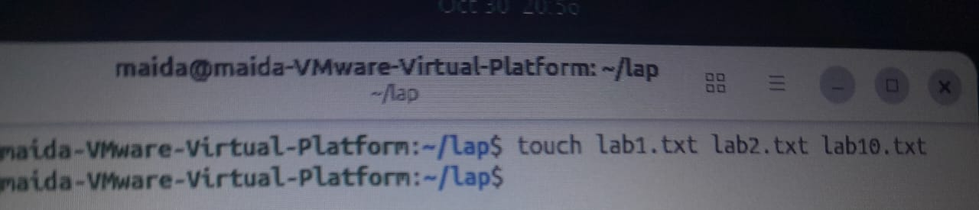
ls *.txt
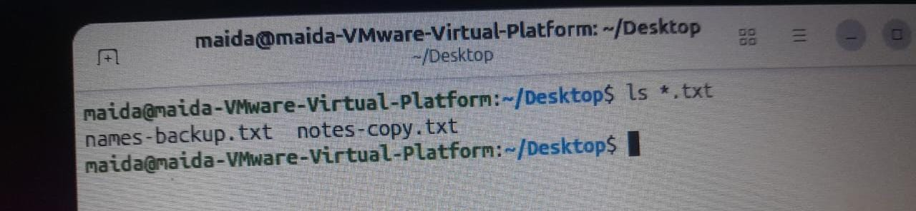

7. Variables and PATH
Command | Meaning
echo $HOME | Shows the home directory
echo $USER | Shows the username
echo $PATH | Shows the places where Bash looks for programs
COURSE=linux | Creates a variable named COURSE (no spaces around =)
echo $COURSE | Shows the value of the variable
export COURSE | Passes the variable on to programs started by Bash
ls /usr/bin/ls | Confirms where the ls program is located
ls -a ~ | Shows the files in your home directory, including hidden ones

~/.bashrc is the file where a user's Bash settings are stored.
echo $HOME
echo $USER
echo $PATH
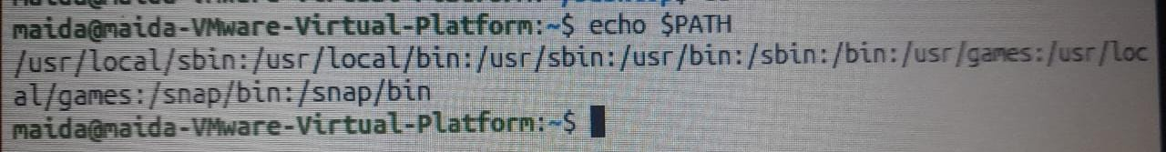
COURSE=linux

echo $COURSE

export COURSE

ls /usr/bin/ls

ls -a ~
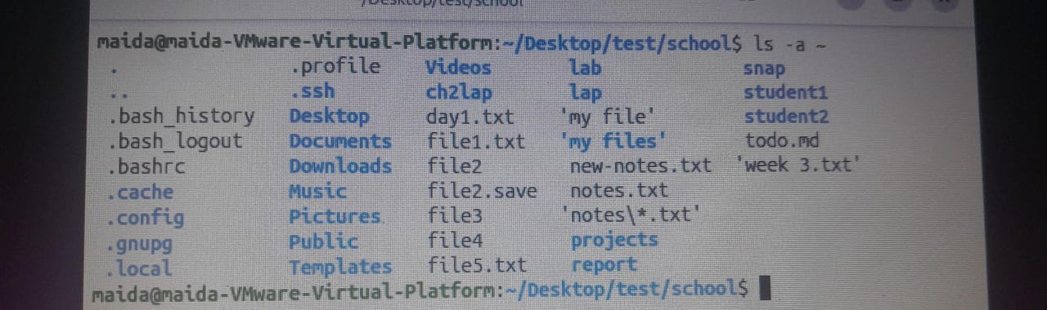
`~/.bashrc
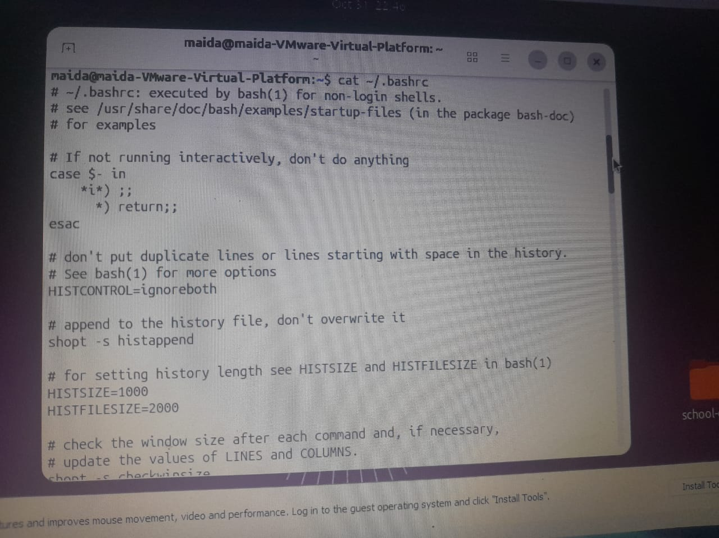

8. Paths and Filenames
Path | Meaning
Absolute path | An address that starts from the root (/)
Relative path | An address that starts from where you are now
. | The current directory
.. | The directory one level above
~ | The user's home directory

Practice
cd /home # go to /home
cd .. # go back one directory
cd ~ # go to your home directory
cd ~/Documents
cd . # stay in the current directory
cd ../.. # go up two levels

Practice
cd /home
cd ..
cd ~

cd ~/Documents
cd .
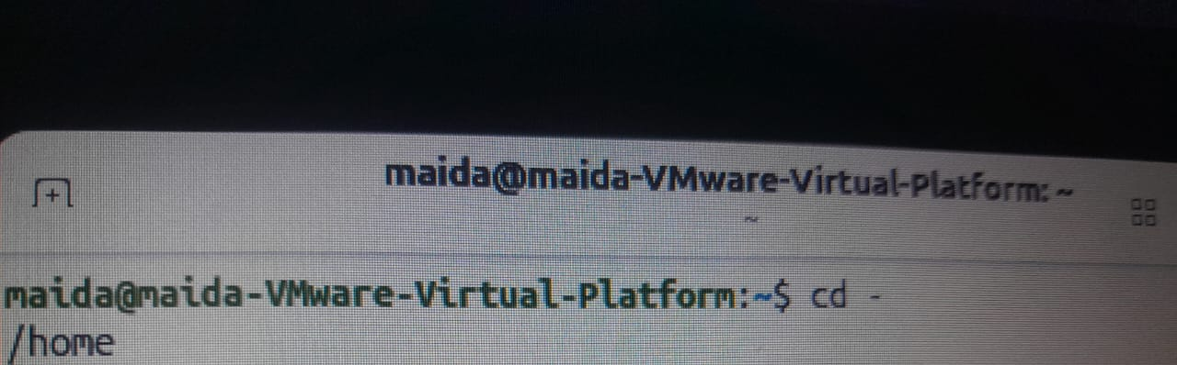
Cd ../..


9. Navigation Commands
Command | Meaning
pwd | Shows where you are now
cd | Takes you back to your home directory
cd /etc | Takes you to /etc
cd .. | Takes you back one directory
cd ~ | Takes you to your home directory
cd - | Takes you back to the previous directory
ls | Lists files and directories
ls -a | Lists hidden files too
ls -l | Shows detailed file information
ls -lh | Shows details with human-readable sizes
ls -lah | Combines all three options
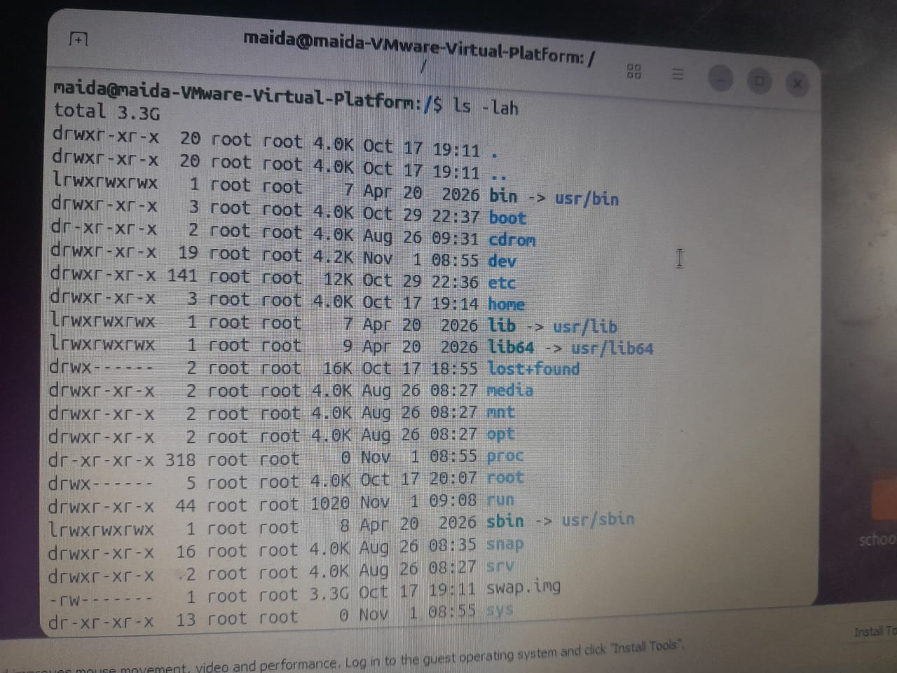

10. Creating and Managing Files
This is the most important part for practice.

A. touch
Meaning: Creates a new empty file.
Practice
touch notes.txt
touch todo.md
touch file1.txt file5.txt

touch notes.txt

touch todo.md

touch file1.txt file5.txt

B. mkdir
Meaning: Creates a new directory.
Practice
mkdir week3
mkdir -p projects/linux
mkdir week3
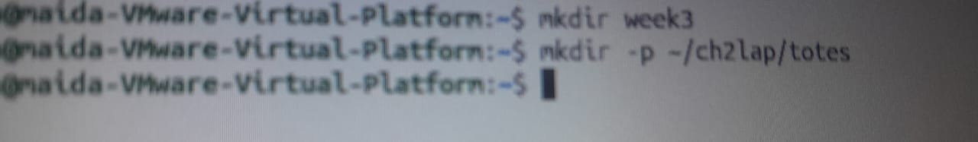
mkdir -p projects/linux
-p also creates the parent directories if they do not exist.

C. rmdir
Meaning: Deletes an empty directory only.
Practice
rmdir week3
rmdir week3
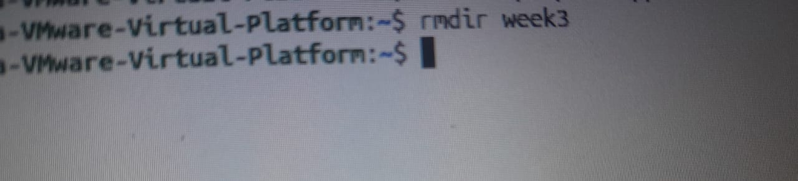

D. cp
Meaning: Copies a file or directory.
Command | Meaning
cp notes-copy.txt notes.bak | Makes a copy
cp notes.txt backup/ | Copies the file into the backup directory
cp -r school school-copy | Copies a whole directory
cp -i notes-copy.txt school/ | Asks before overwriting

cp notes -copy .txt test/
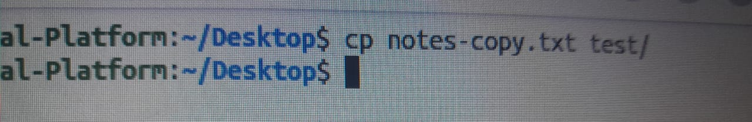
cp -r school school-copy
cp -i notes -copy .txt school/
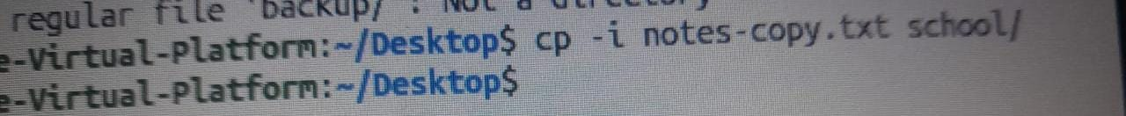

E. mv
Meaning: Moves a file or renames it.
Command | Meaning
mv notes.txt old.txt | Renames the file
mv file.txt backup/ | Moves the file into backup
mv -i file.txt backup/ | Asks before overwriting
Practice
touch draft.txt
mv draft.txt final.txt
mkdir documents
mv final.txt documents/
ls documents

mv notes.txt old.txt
mv file.txt backup/

mv -i file.txt backup/
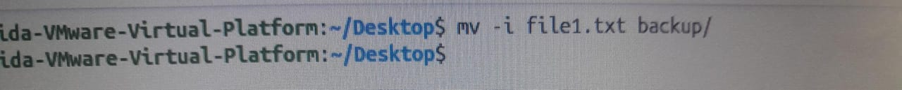

touch draft.txt

mv draft.txt final.txt
mkdir documents

ls documents


F. rm
Meaning: Deletes files or directories.
Command | Meaning
rm notes.txt | Deletes a file
rm -i file2.txt | Asks for permission first
rm -r backup | Deletes a directory and everything in it
rm -rf school | Deletes the directory without asking for confirmation

Warning: rm has no Recycle Bin and no Undo. Do not practise on your important files, and avoid rm -rf.

Practice
touch delete.txt
rm -i delete.txt

rm notes.txt
rm -i file2.txt
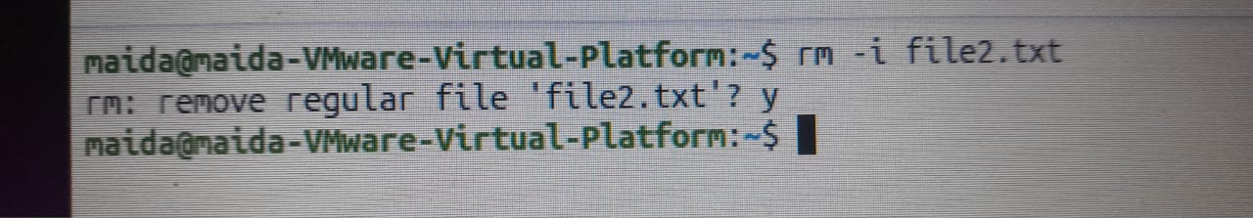
When prompted, type y to delete or n to cancel.
rm -r backup

rm -rf school
touch delete.txt
rm -i delete.txt
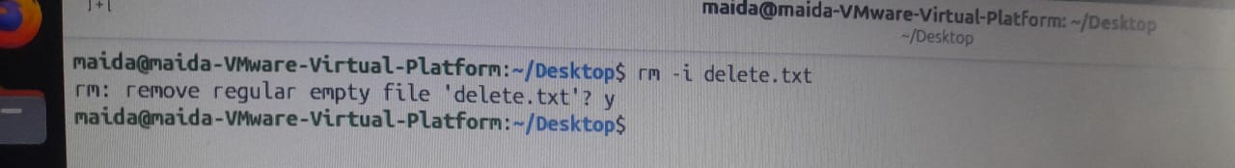

Chapter 3: Text Processing, Searching, Archiving, and Editors
Note: The practice commands below use sample files such as names.txt, notes.txt, app.log, and cities.txt. Part 6 (Practice Workspace) shows how to create them, so do that part first if you want to follow along.

Part 1: Viewing and Searching Files
This part covers how to read files, find files, and search for specific text inside a file.

1. cat – Reading a file
Meaning: cat displays the text inside a file. It can also join several files together.
Practice
cat names.txt
cat notes.txt words.txt
cat -n names.txt

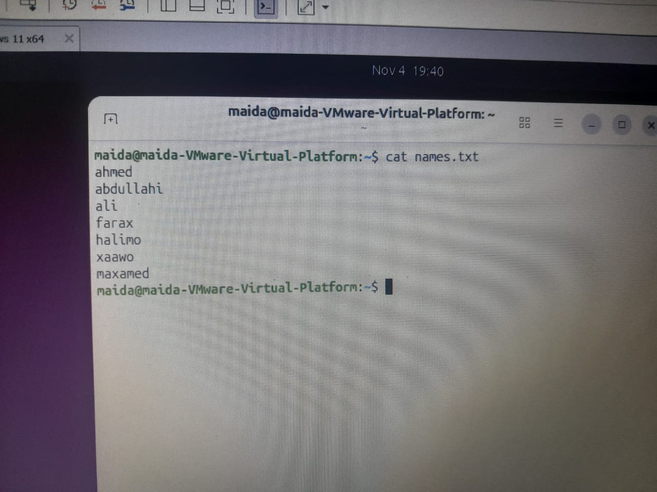

-n adds a number to each line.

Cat notes.txt words.txt
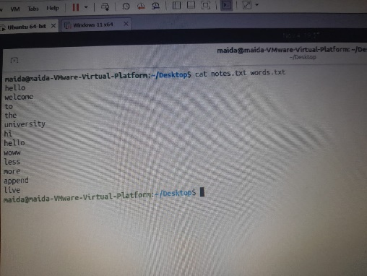
Cat -n names.txt
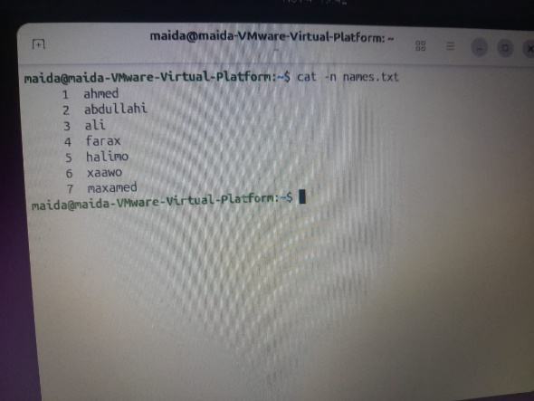

2. less – Reading a long file
Meaning: Lets you read a long file page by page, scrolling up and down.
Practice
less notes.txt
less long.txt

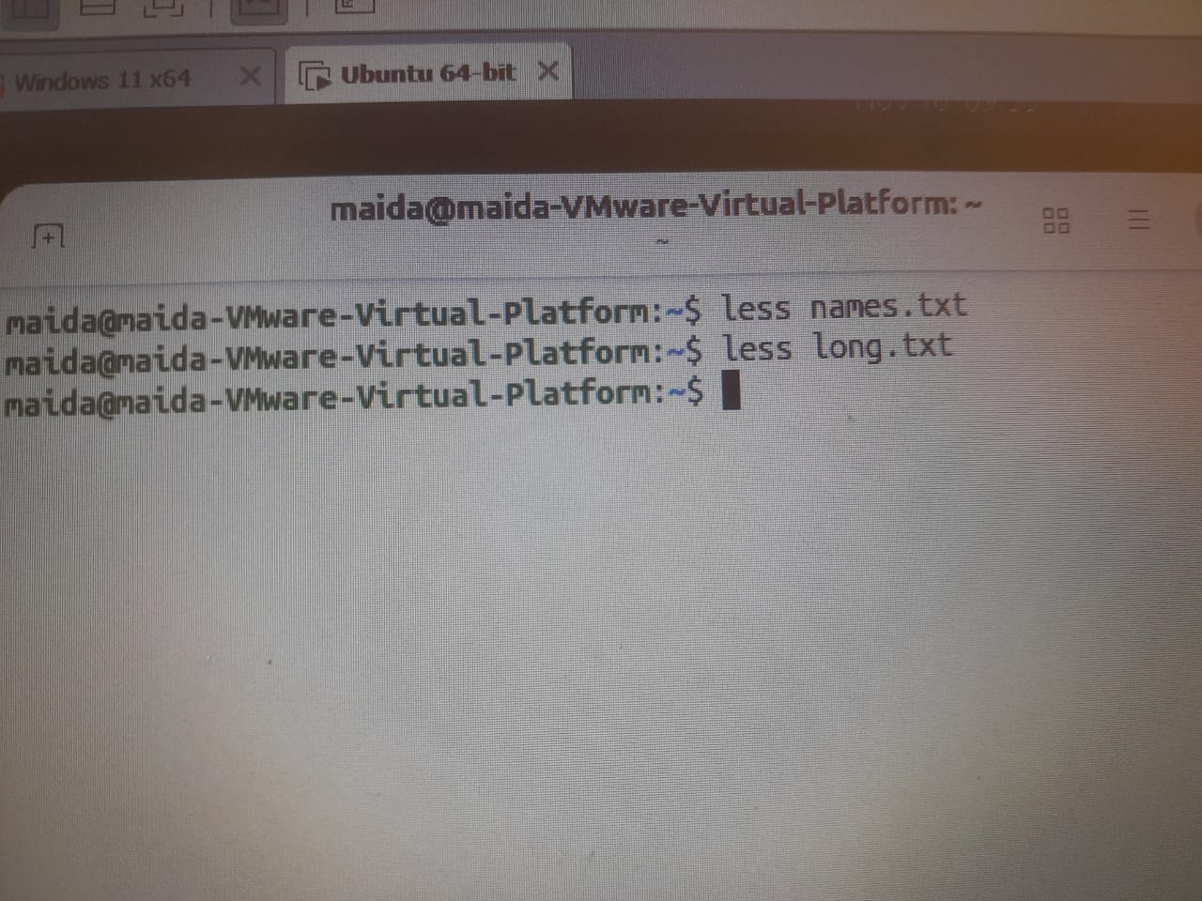
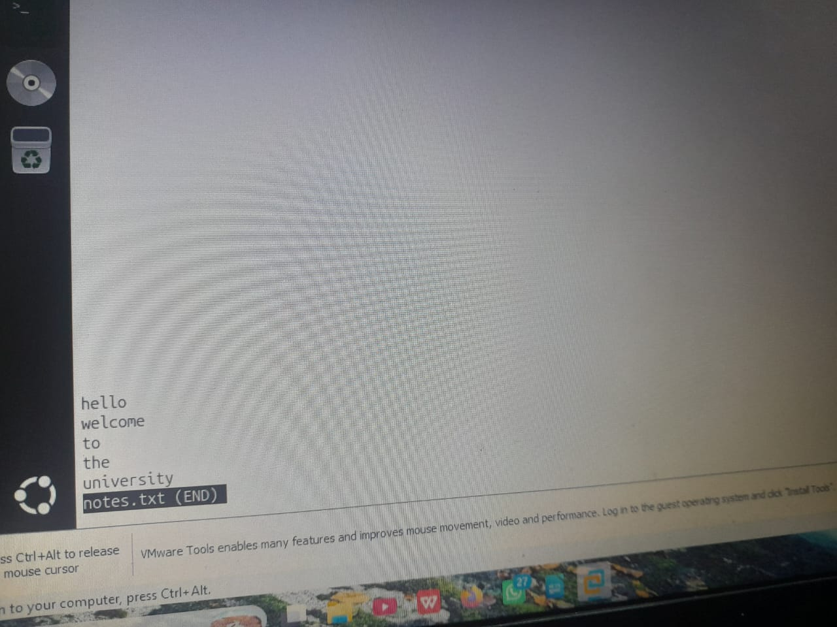

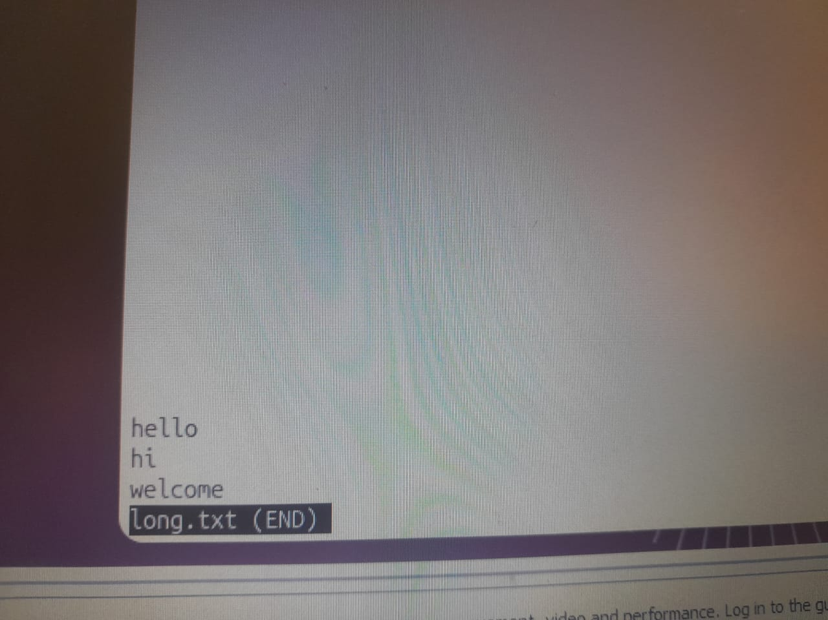

Important keys:
- Space – next page
- b – previous page
- /word – search for a word
- n – next search result
- q – quit

3. more – Reading a file page by page
Meaning: Displays a long file one screen at a time.
Practice
more notes.txt

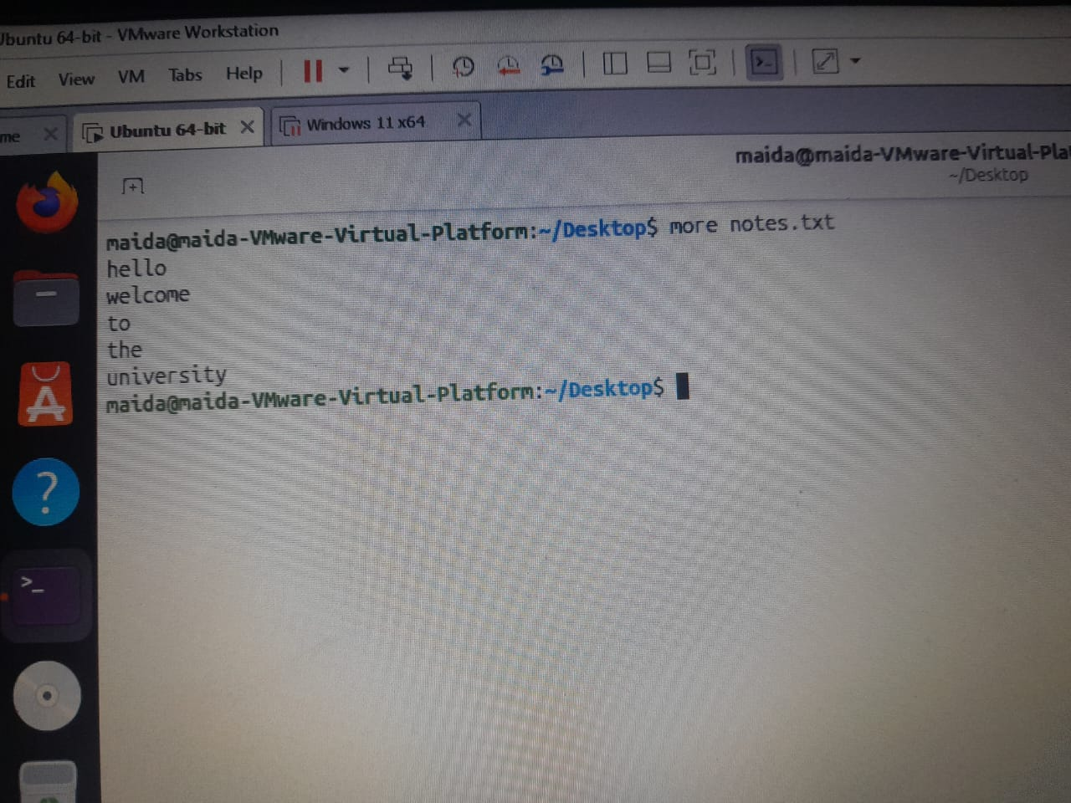
Press q to quit.

4. head – Reading the start of a file
Meaning: Displays the first 10 lines of a file unless you specify another number.
Syntax
head -n number filename

Practice
head -n 3 names.txt
head -n 5 words.txt

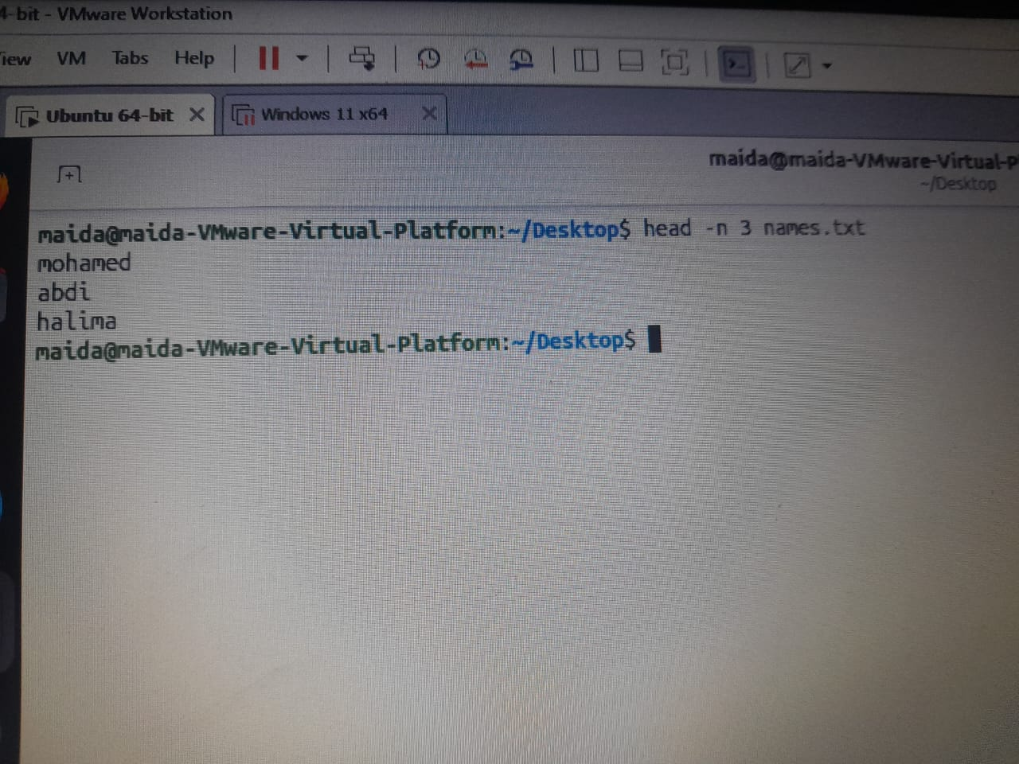



5. tail – Reading the end of a file
Meaning: Displays the last 10 lines of a file unless you specify another number.
Syntax
tail -n number filename

Practice
tail names.txt
tail -n 3 names.txt
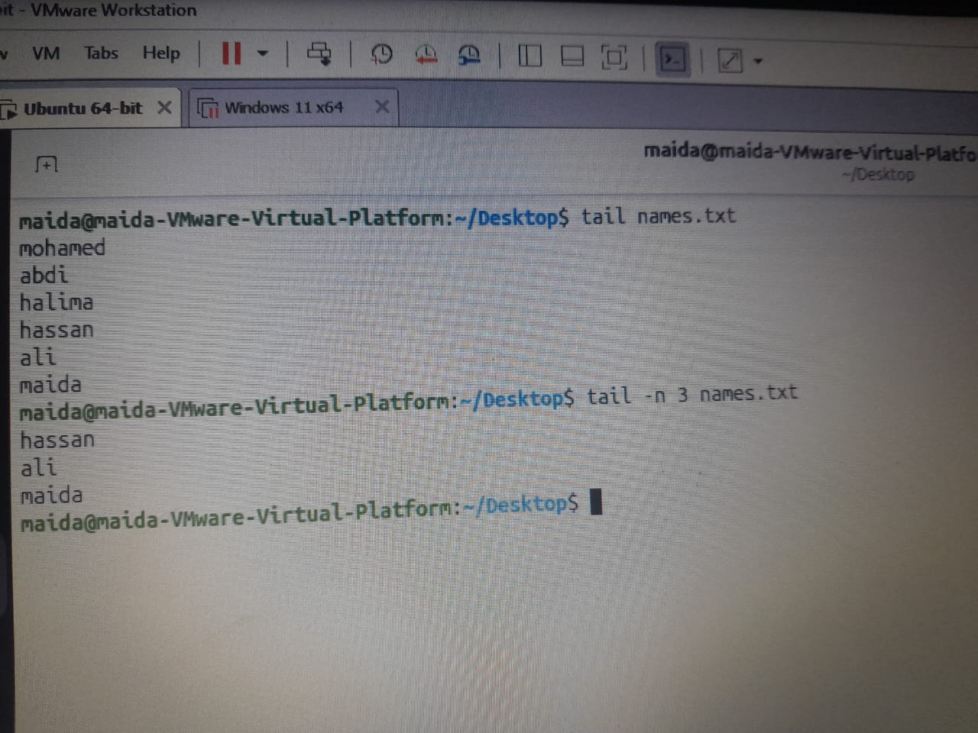

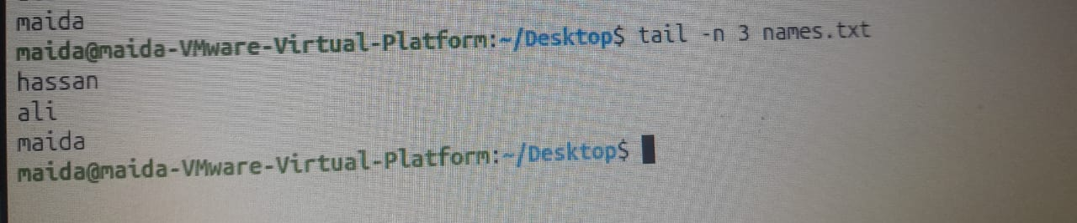

6. tail -f – Following changes to a file
Meaning: Automatically follows new text added to a file, especially log files.
Practice
tail -f app.log
tail -n 2 -f app.log
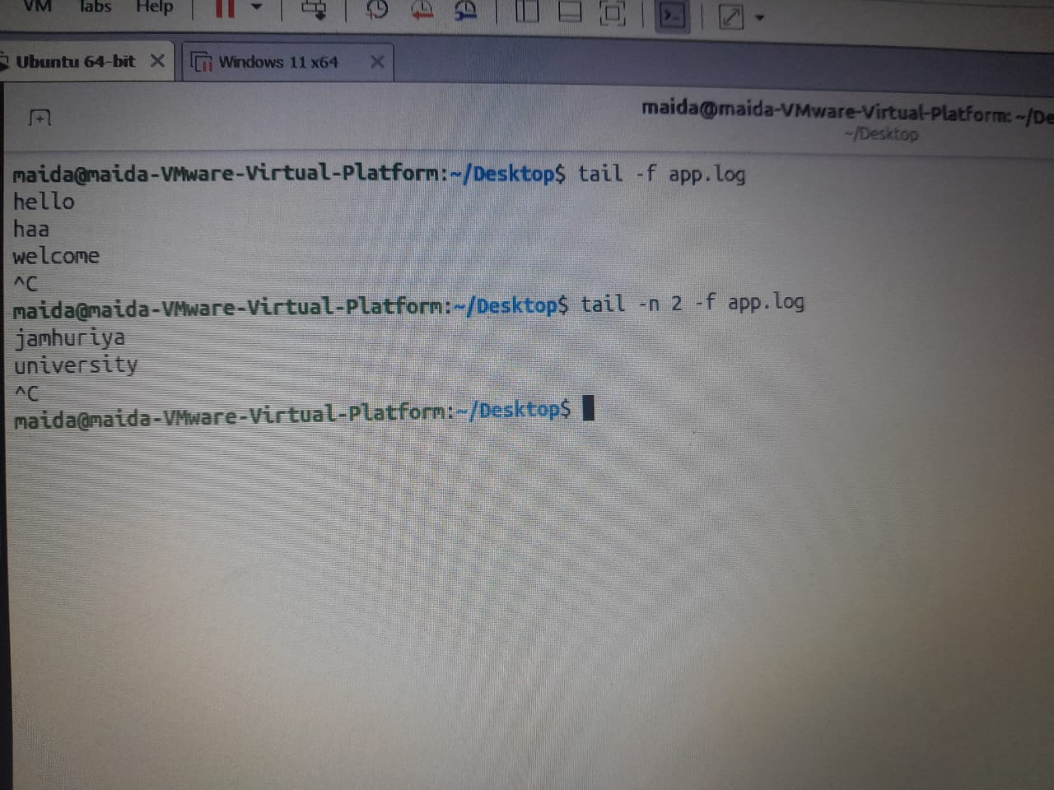

To stop, press Ctrl + C.

7. file – Identifying the file type
Meaning: Tells you the real type of a file.
Syntax
file filename

Practice
file notes.txt
file names.txt
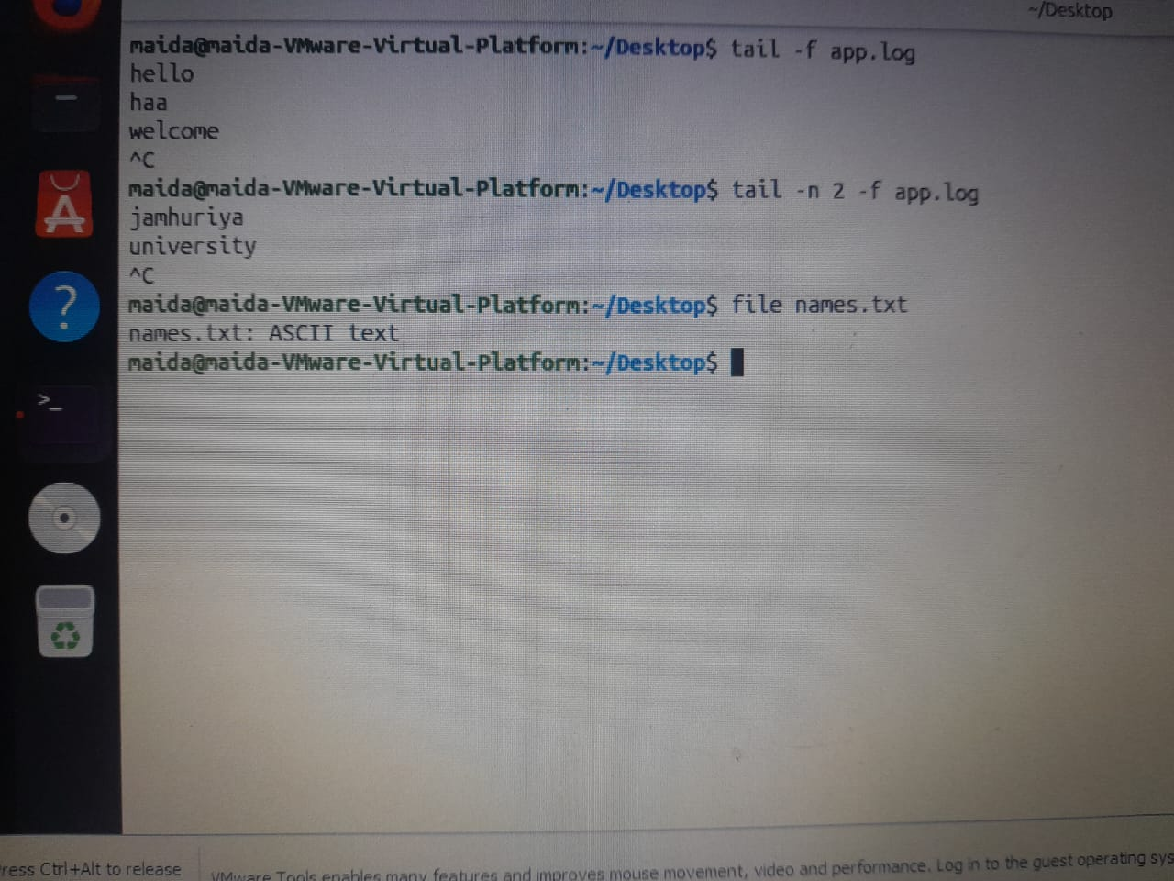

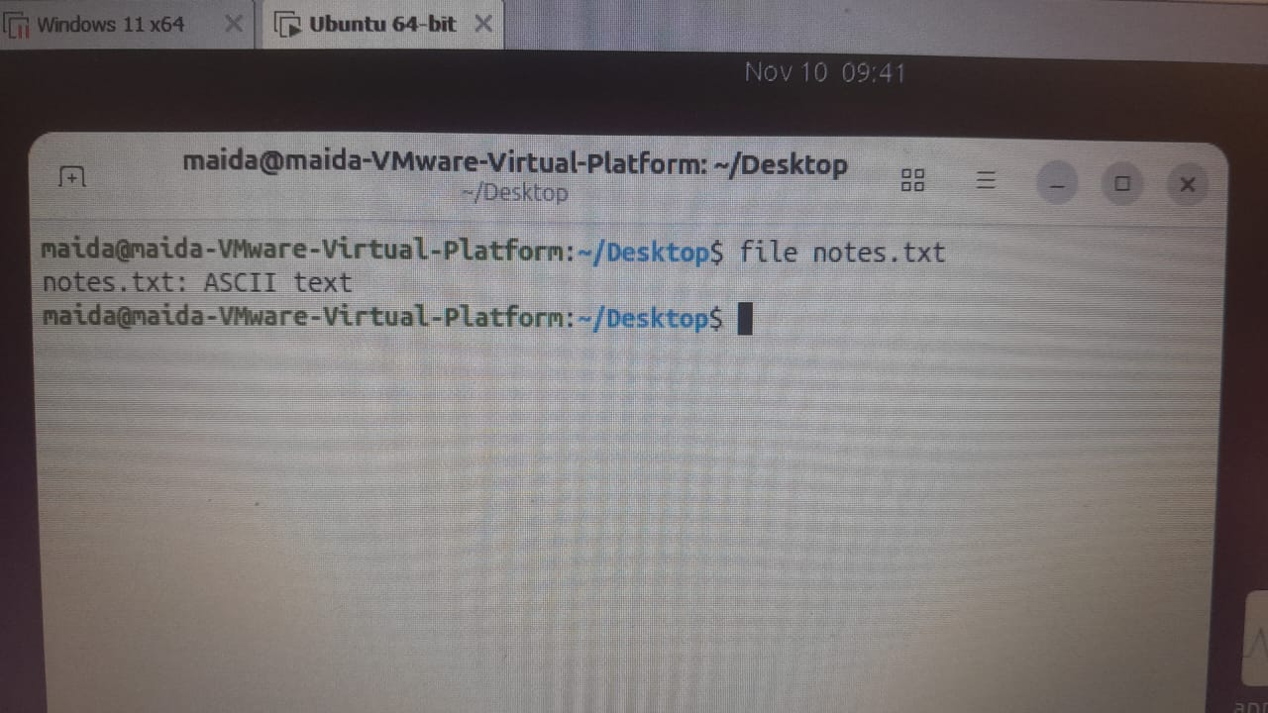

8. stat – File information
Meaning: Displays details about a file, such as size, permissions, owner, inode, and modification time.
Syntax
stat filename

Practice
stat names.txt

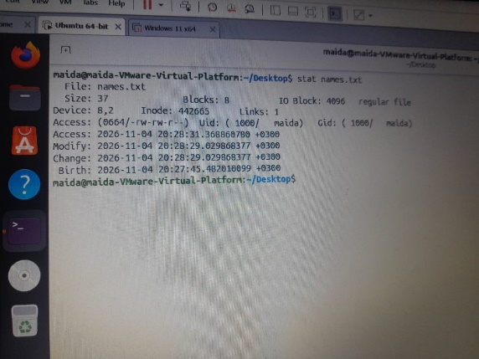

9. ls -l – Detailed file listing
Meaning: Lists files and directories with their permissions, owner, size, and last-modified date.
Syntax
ls -l

Practice
ls -l
ls -l names.txt
ls -li notes.txt
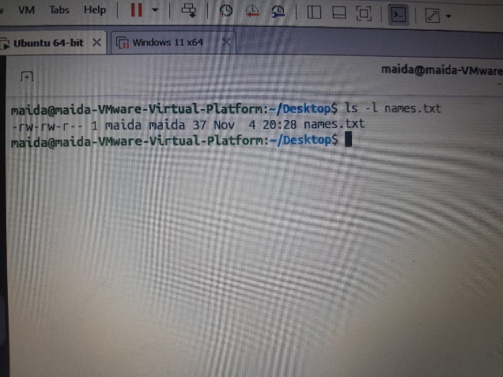

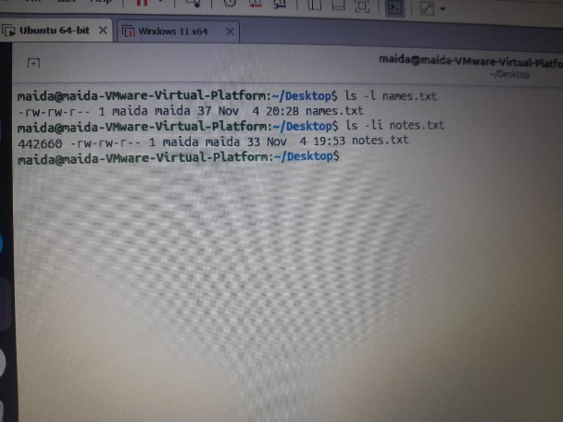

10. which – Finding where a command is located
Meaning: Finds the location of an executable command in your PATH.
Syntax
which command

Practice
which ls
which cat
which tar

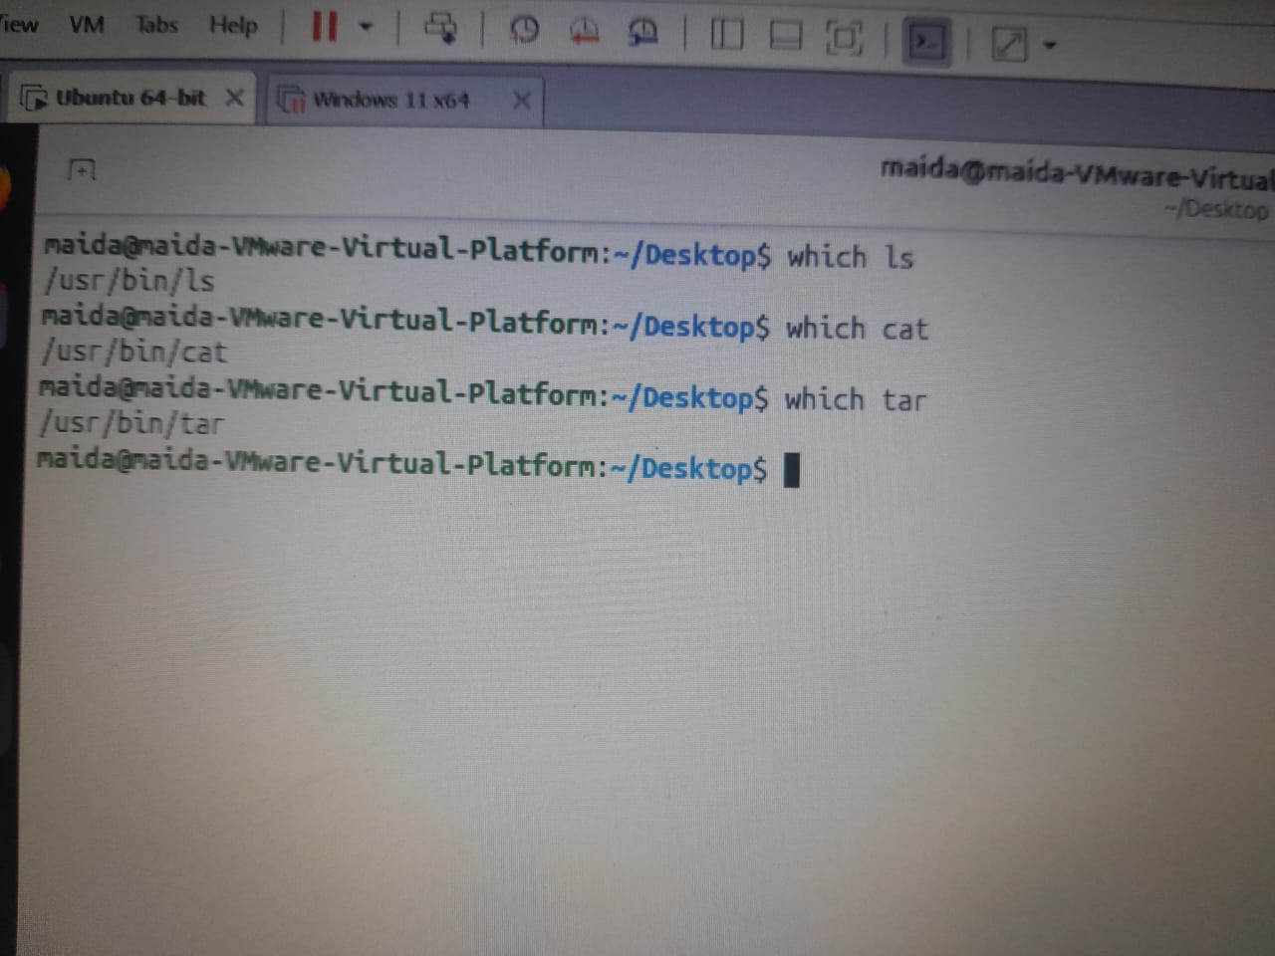

11. type – Identifying the type of a command
Meaning: Tells you whether a command is a shell built-in, an executable, an alias, or a function.
Syntax
type command

Practice
type cd
type ls
type echo

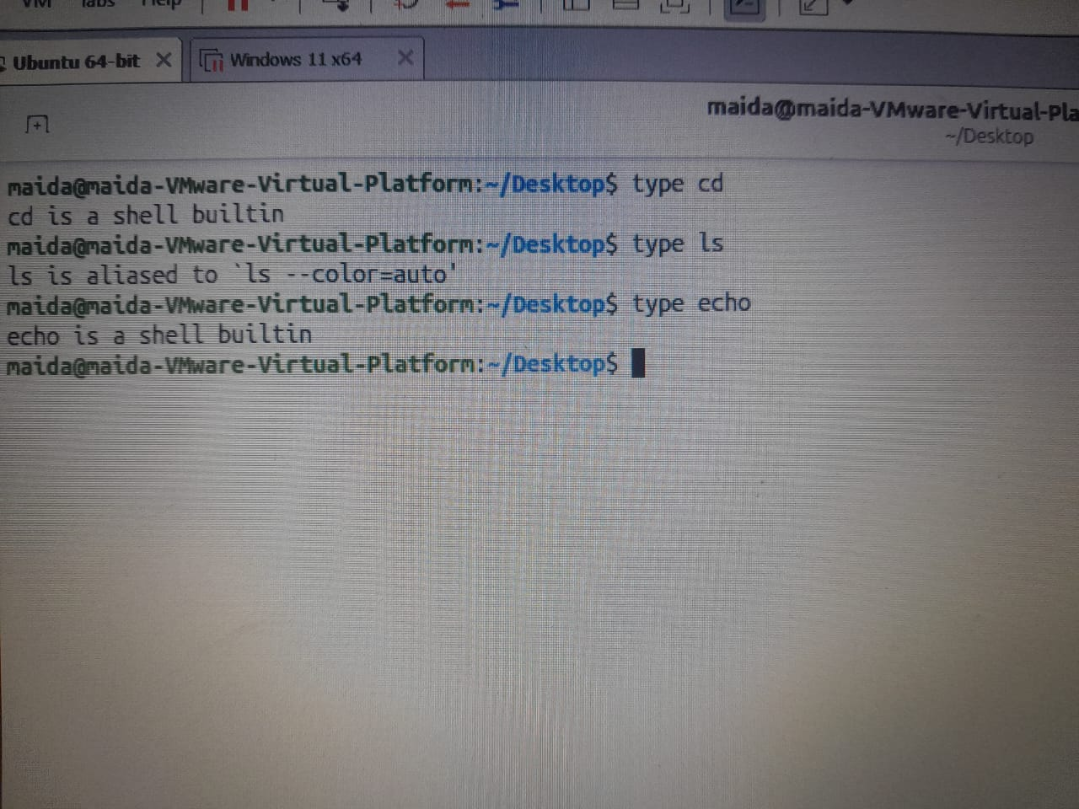

12. command -v – Checking a command
Meaning: Shows how the shell recognizes a command and where it can be found.
Syntax
command -v command

Practice
command -v ls
command -v tar
command -v cd
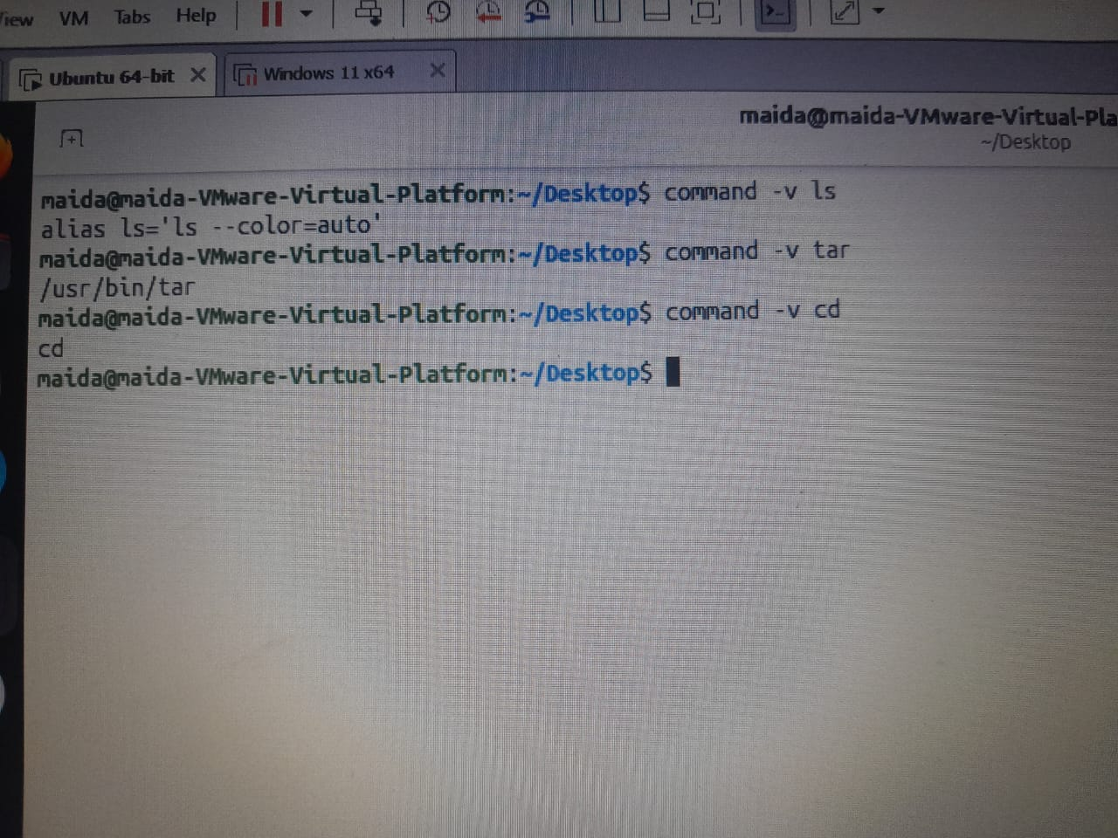

13. whereis – Locating a command
Meaning: Finds the executable binary, source code, and manual pages related to a command.
Syntax
whereis command

Practice
whereis ls
whereis tar
whereis bash





14. find – Searching for files and directories
Meaning: Searches for files and directories by name, type, size, and modification time.
Syntax
find location condition

Practice
find . -name 'names.txt'
find . -name '*.txt'
find cd -type d

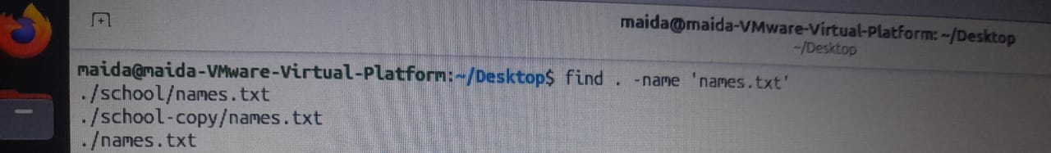

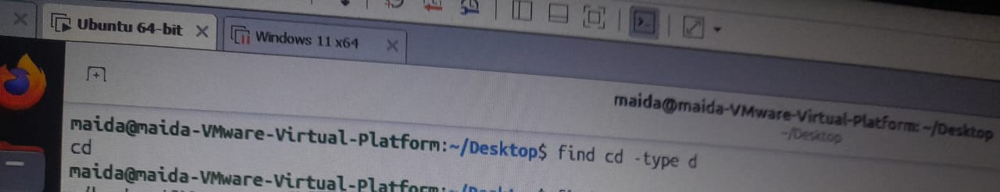
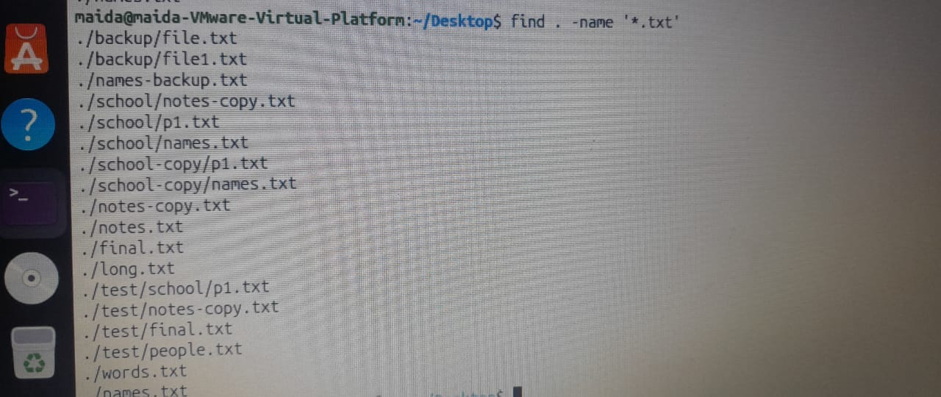
Meaning of the parts:
- . – the current directory
- -name – search by file name
- -iname – search by name, ignoring upper/lower case
- -type f – search for files
- -type d – search for directories

Find by size
Meaning: Finds files based on their size.
find location -size size

Practice
find . -name 'names.txt' -size +10c
find . -size -10cm
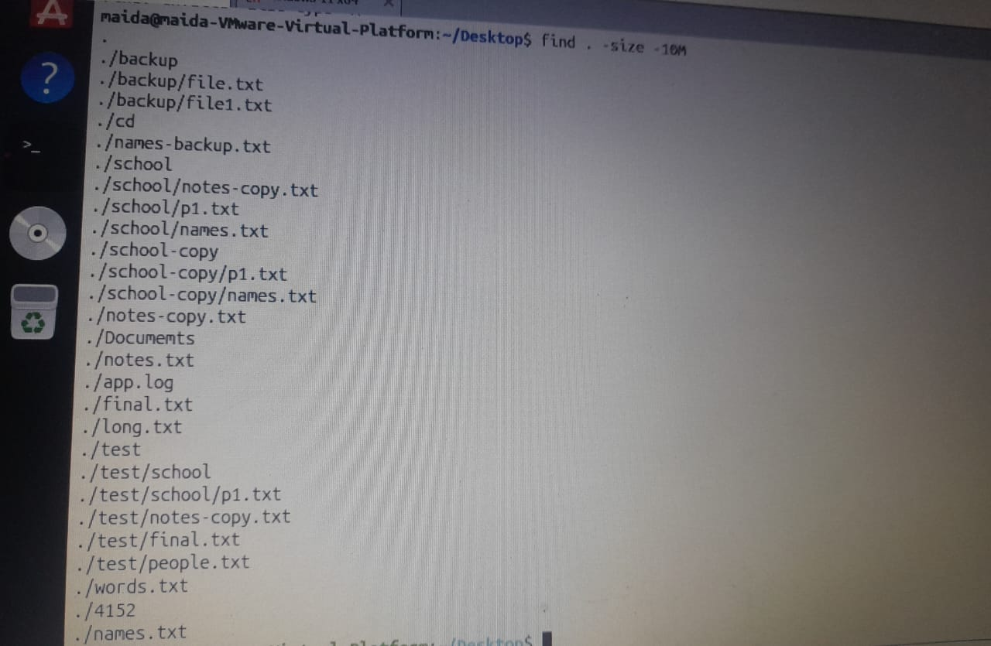
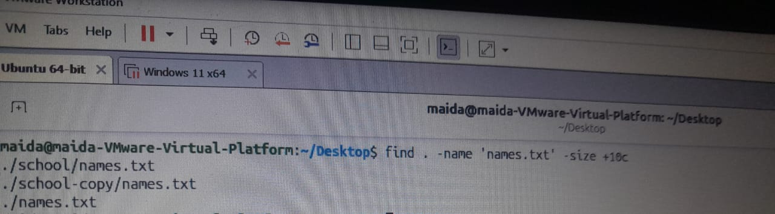

Size symbols:
Symbol | Meaning
+ | Greater than
- | Less than
c | Bytes
k | KiB
M | MiB
G | GiB

Find by time
Meaning: Finds files based on when they were last modified.
find location -mmin minutes
Practice
find . -type f -mmin -30
find . -type f -mmin +30

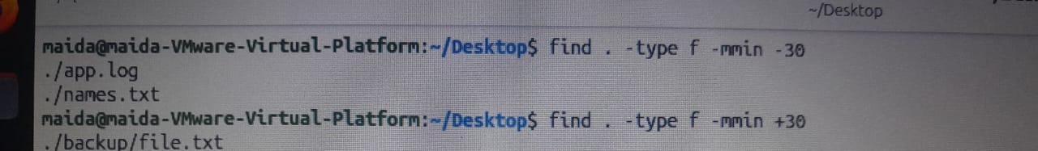

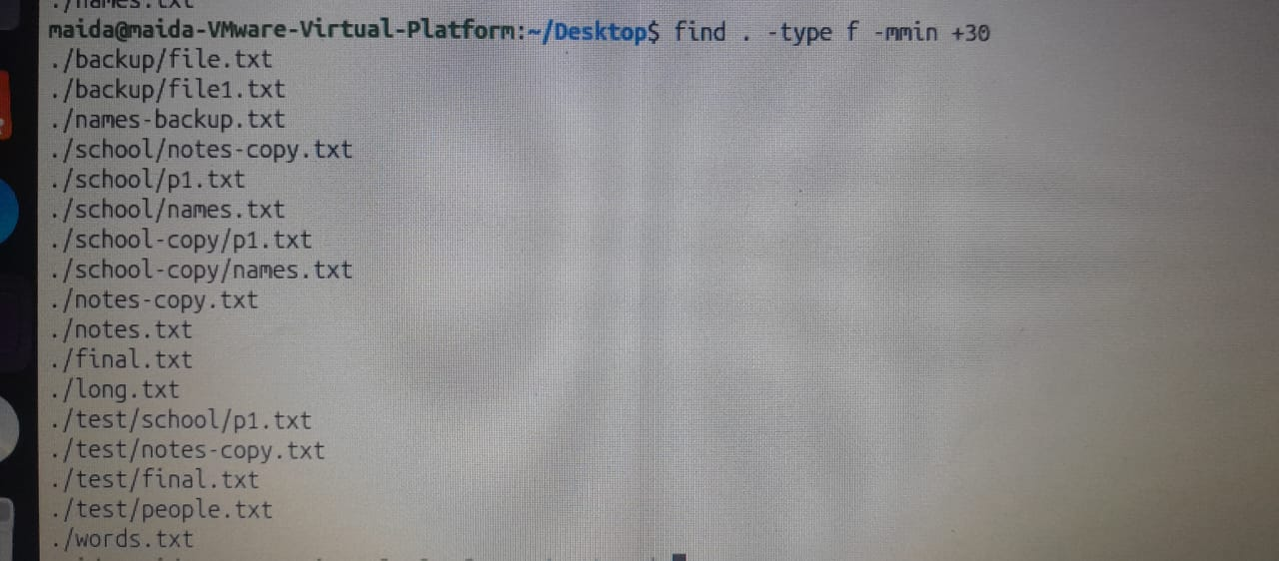

-30 means modified within the last 30 minutes; +30 means modified more than 30 minutes ago.

15. locate – Fast file search
Meaning: Finds files quickly using a pre-built database.
Syntax
locate filename

Practice
locate names.txt
locate notes.txt
locate app.log

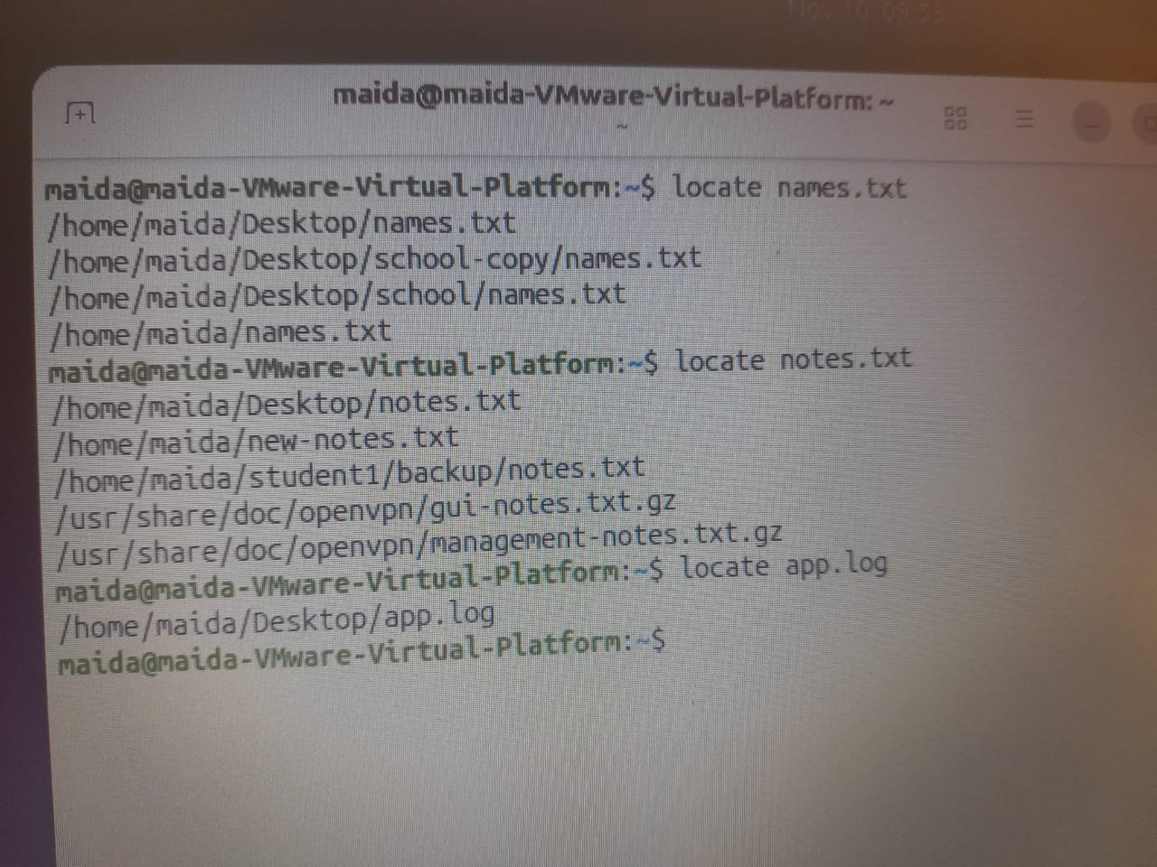

16. updatedb – Updating the database
Meaning: Updates the database that locate uses.
Syntax
sudo updatedb

Practice
sudo updatedb
locate recent.txt

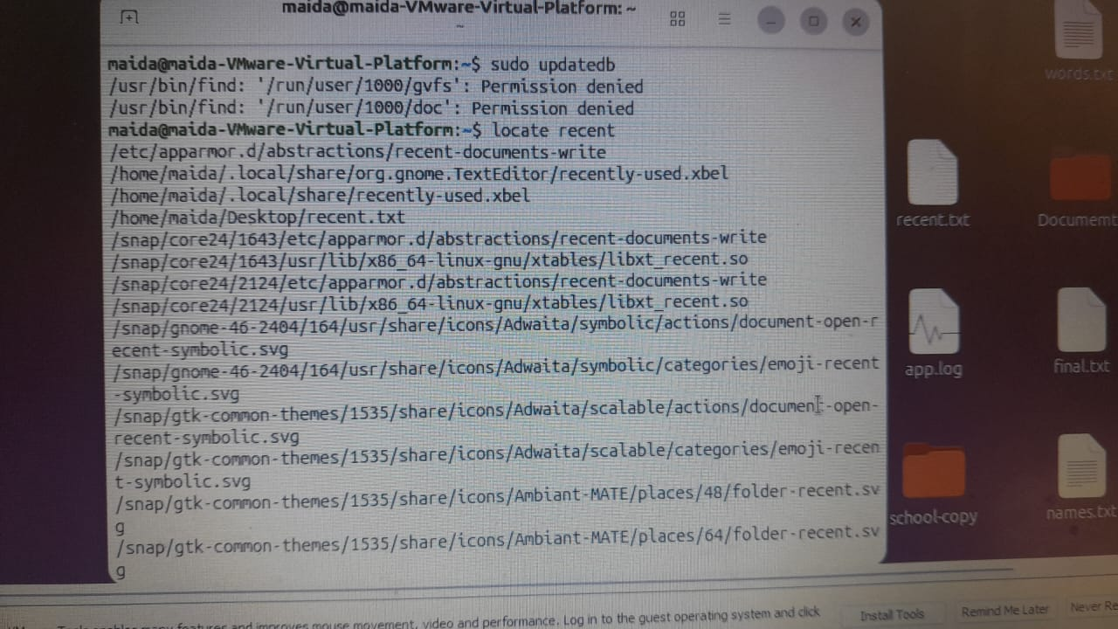

17. grep – Searching for text inside a file
Meaning: Searches for a word or specific text inside a file and displays every matching line.
Syntax
grep 'word' filename

Practice
grep 'Ali' names.txt
grep 'ERROR' app.log
grep -n 'hello' word.txt
grep -i 'error' app.log

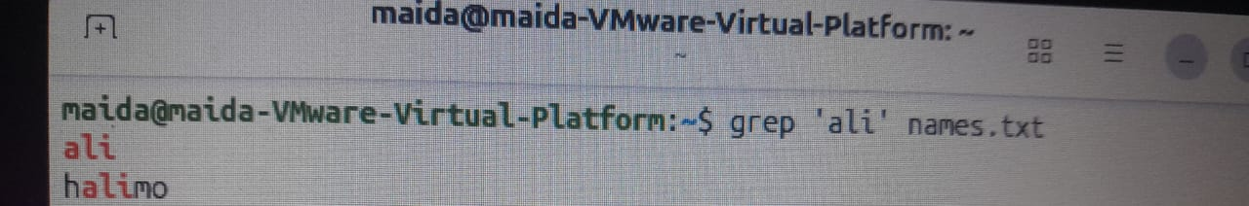

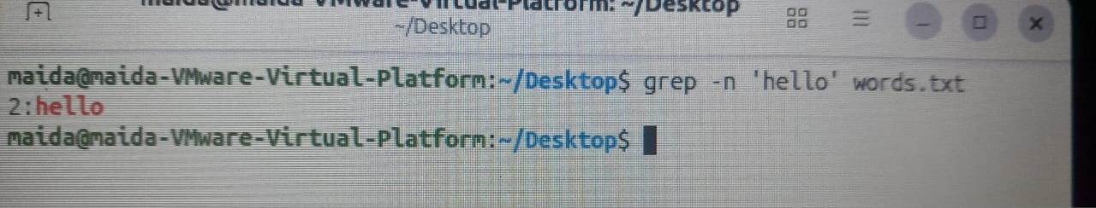

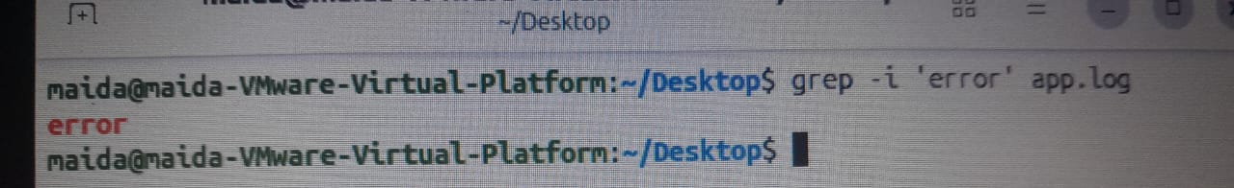
Options:
- -n – show line numbers
- -i – ignore the difference between upper and lower case

18. grep -v – Excluding text
Meaning: Displays every line that does not match the word being searched for.
Syntax
grep -v 'word' filename

Practice
grep -v 'ERROR' app.log
grep -v 'Ali' names.txt
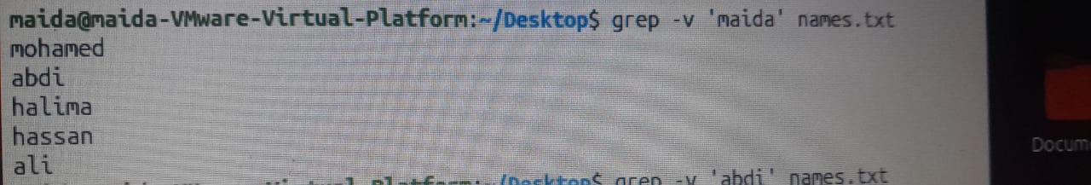

19. grep -r – Searching inside directories
Meaning: Searches for text in the files of a directory and all its subdirectories.
Syntax
grep -r 'word' directory

Practice
grep -r 'Linux' project
grep -rn 'java' project

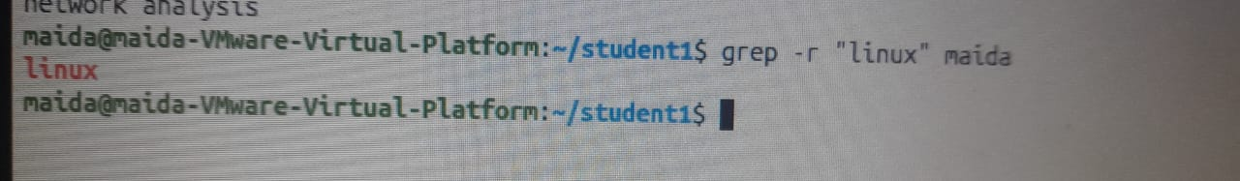

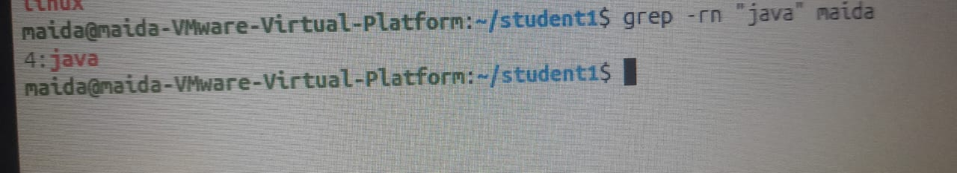

-r searches through subdirectories, and -n shows line numbers.

Regular Expressions (Regex) in grep
A regular expression is a way of searching for text using special symbols.
Symbol | Meaning | Example
. | Any single character | b..h
* | Zero or more of the preceding character | lo*g
^ | Start of a line | ^root
$ | End of a line | bash$
[ ] | One character from those listed | [0-9]

Practice
grep '^Ali' names.txt
grep 'failed$' app.log
grep 'gr[ae]y' words.txt
grep '[0-9]' scores.txt

Part 2: Redirection, Pipes, and Text Processing
This part covers how to save output, pass data to other commands, and process text.

20. Standard Streams – the three paths data takes
Linux has three standard streams:
Name | Number | Meaning
STDIN | 0 | Input a command receives
STDOUT | 1 | Normal output
STDERR | 2 | Error messages

21. > – Saving output
Meaning: Saves a command's output to a file. If the file already exists, its old content is erased and replaced.
Syntax
command > filename

Practice
printf 'First\n' > actions.txt
ls names.txt > files.txt
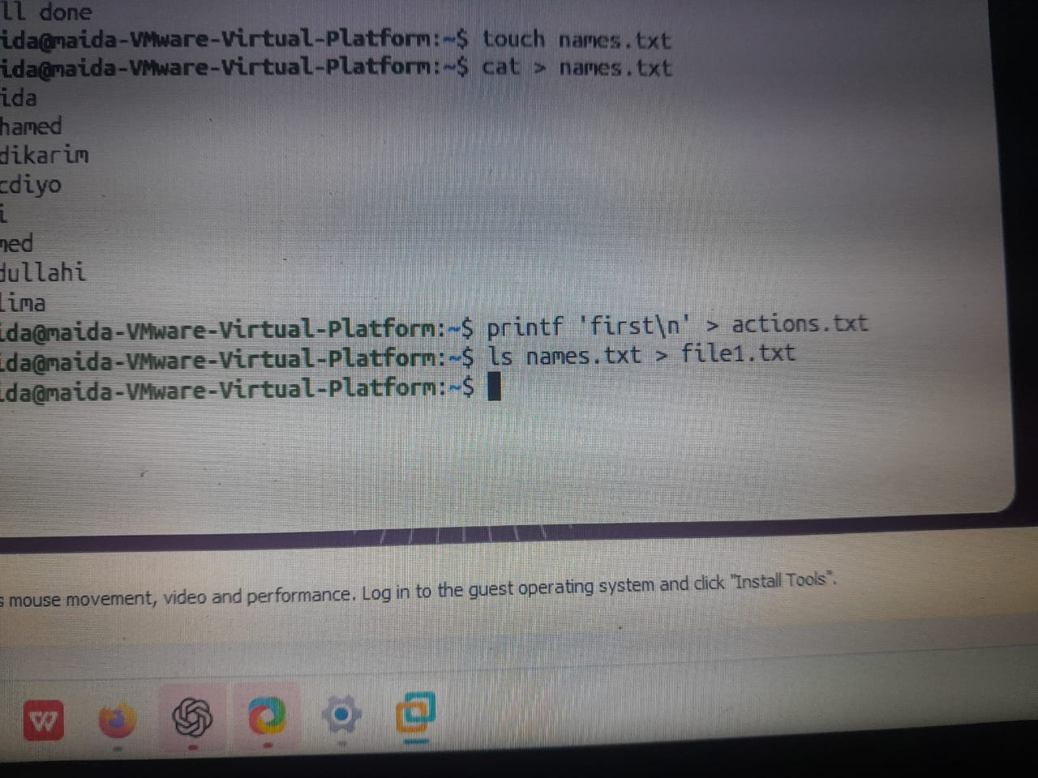

22. >> – Appending text to a file
Meaning: Adds new text to the end of a file without erasing the existing content.
Syntax
command >> filename

Practice
printf 'Second\n' >> actions.txt
echo 'New line' >> notes.txt

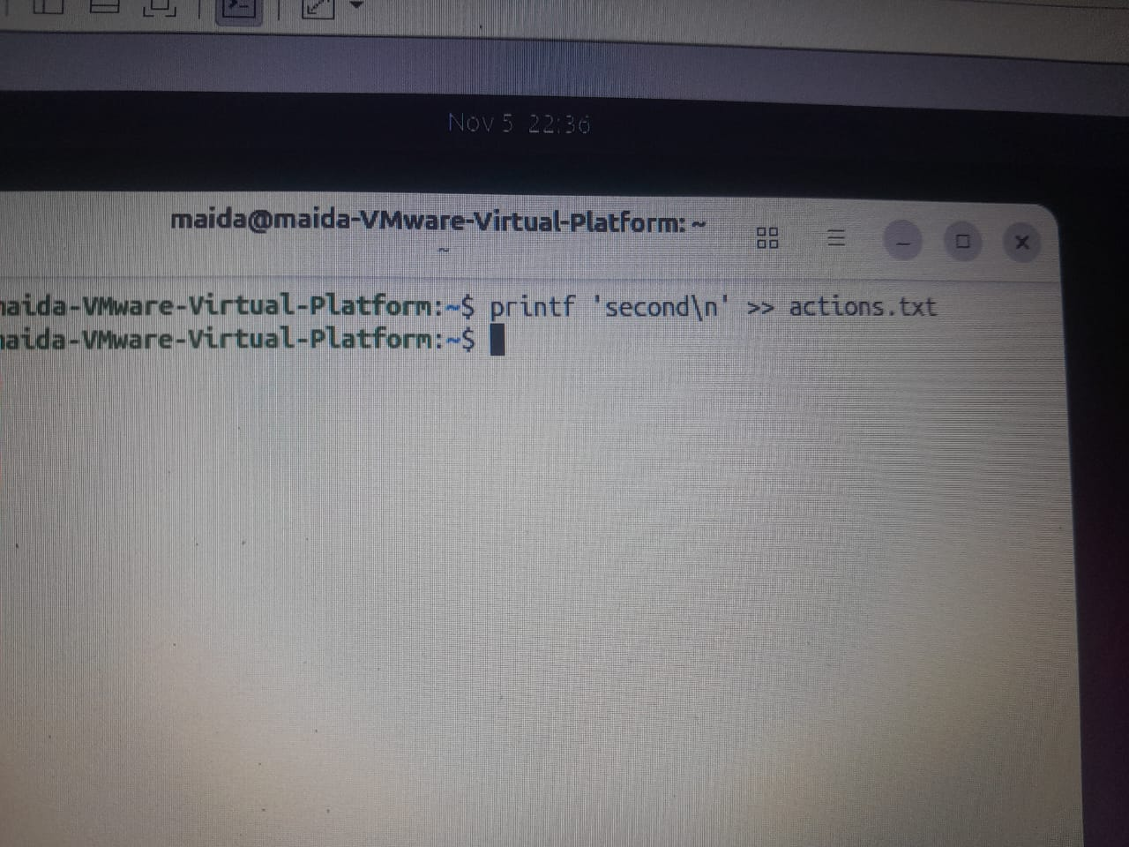



23. 2> – Saving error messages
Meaning: Saves error messages to a separate file.
Syntax
command 2> filename

Practice
ls names.txt missing.txt 2> err.txt
ls missing.txt 2> errors.txt

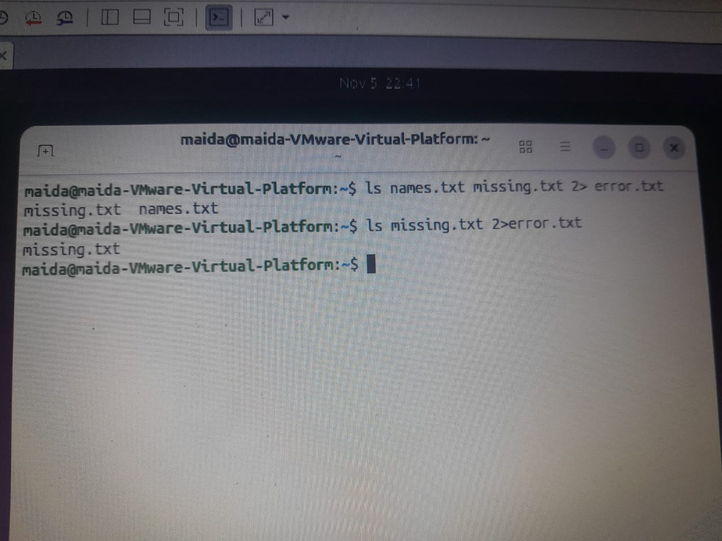

2 refers to STDERR.

24. < – Reading input from a file
Meaning: Feeds a file into a command so it reads its data from STDIN.
Syntax
command < filename

Practice
wc -l < names.txt
tr 'a-z' 'A-Z' < names.txt

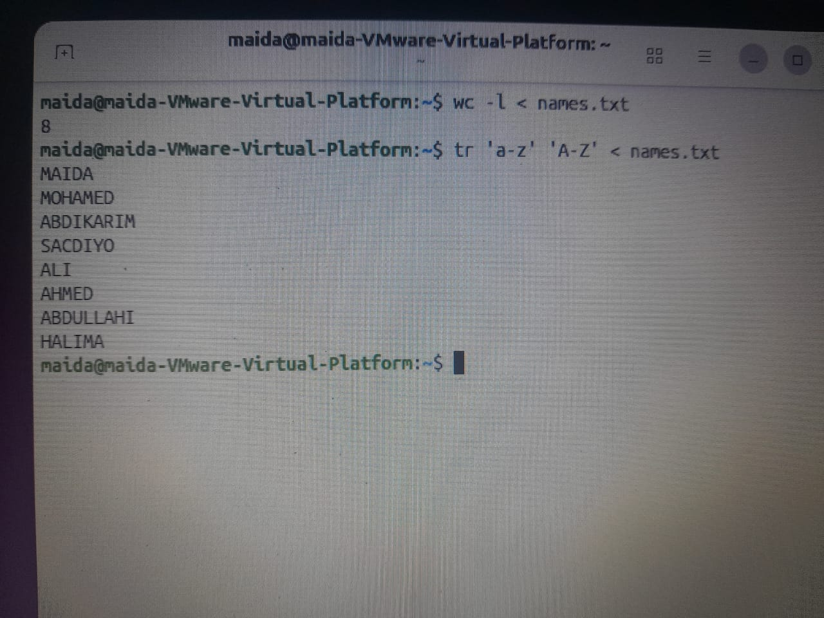

25. | – The pipe operator
Meaning: Sends the output of the first command to the second command.
Syntax
command1 | command2

Practice
cat names.txt | wc -l
grep 'ERROR' app.log | wc -l
grep 'Mogadishu' cities.txt | wc -l

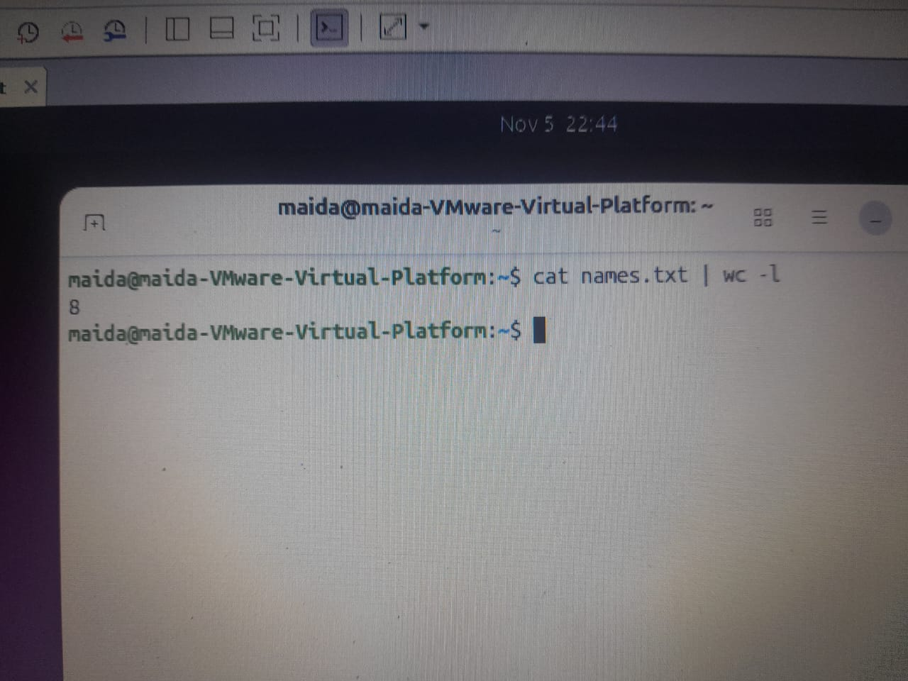

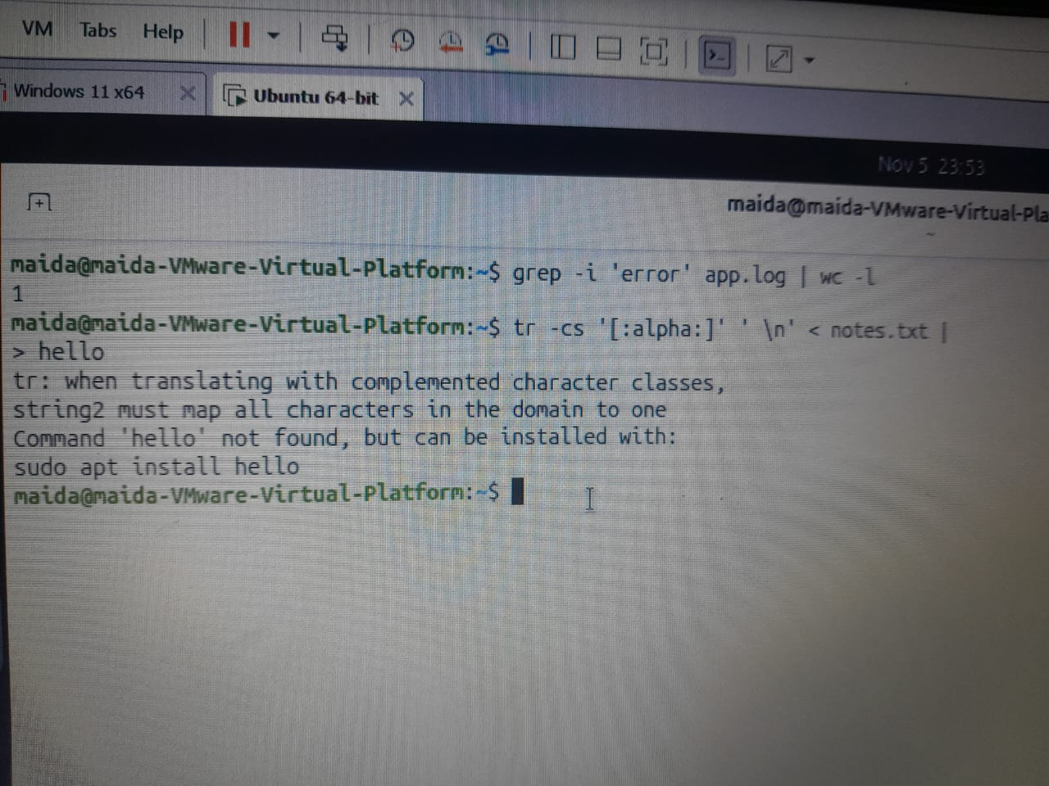

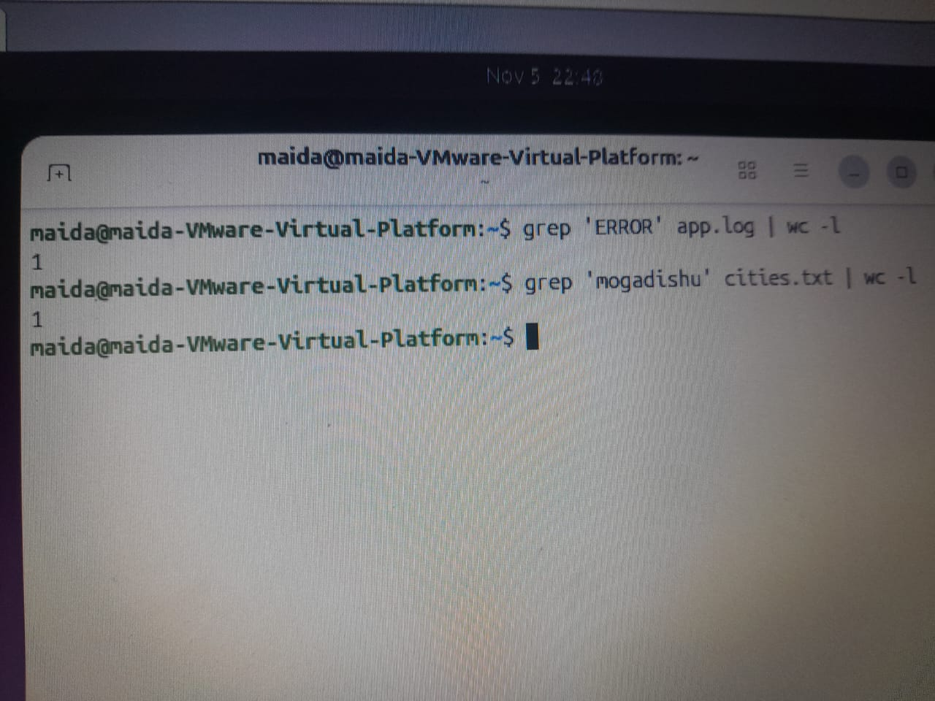

26. ; – Chaining commands
Meaning: Lets you run several commands one after another. The next command runs even if the previous one fails.
Syntax
command1 ; command2

Practice
printf 'one\n' ; printf 'two\n'
pwd ; ls
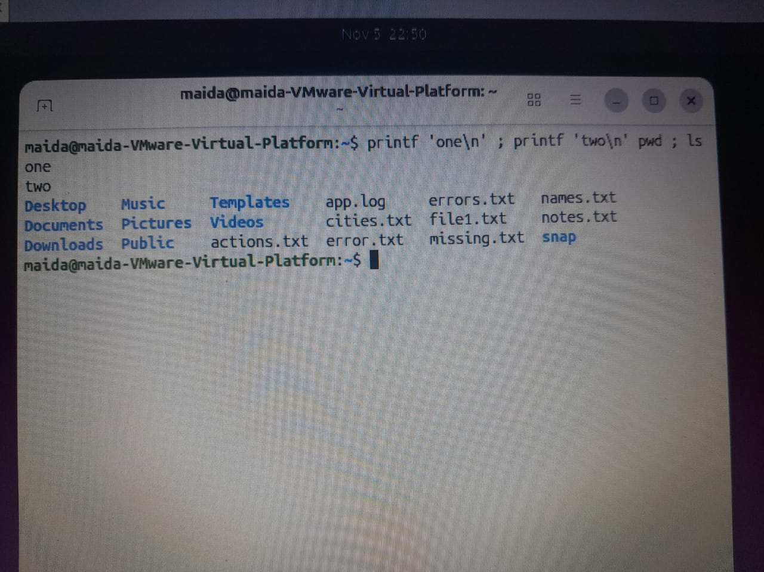

27. && – Run the next command only if the first succeeds
Meaning: The second command runs only if the first command finishes successfully.
Syntax
command1 && command2

Practice
mkdir -p scratch && echo OK > scratch/status.txt
pwd && ls

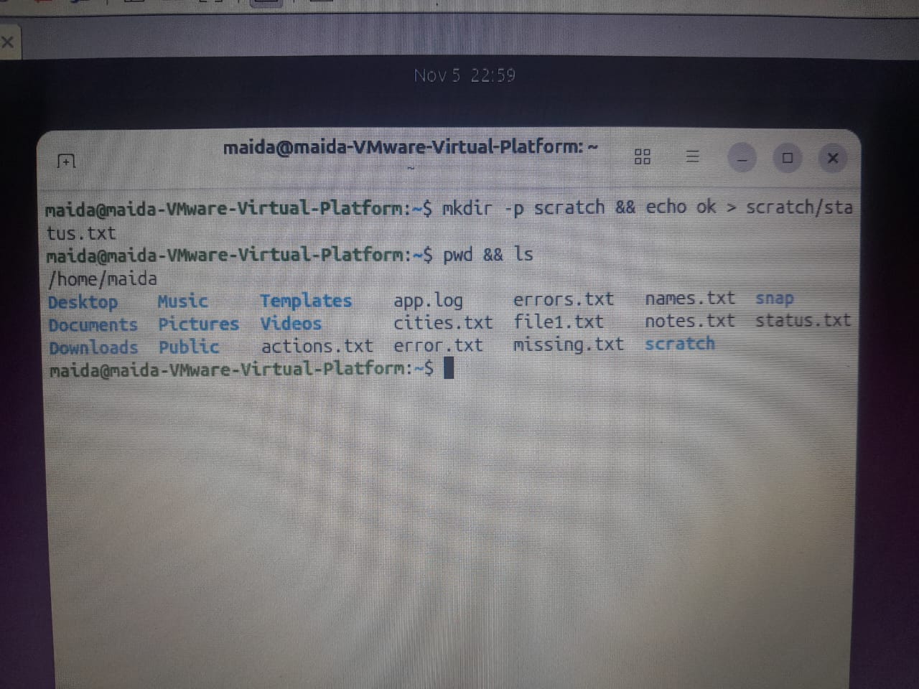

28. || – Run the next command only if the first fails
Meaning: The second command runs only if the first command fails.
Syntax
command1 || command2

Practice
test -f missing.txt || echo 'Not found'
mkdir test-folder || echo 'Folder creation failed'

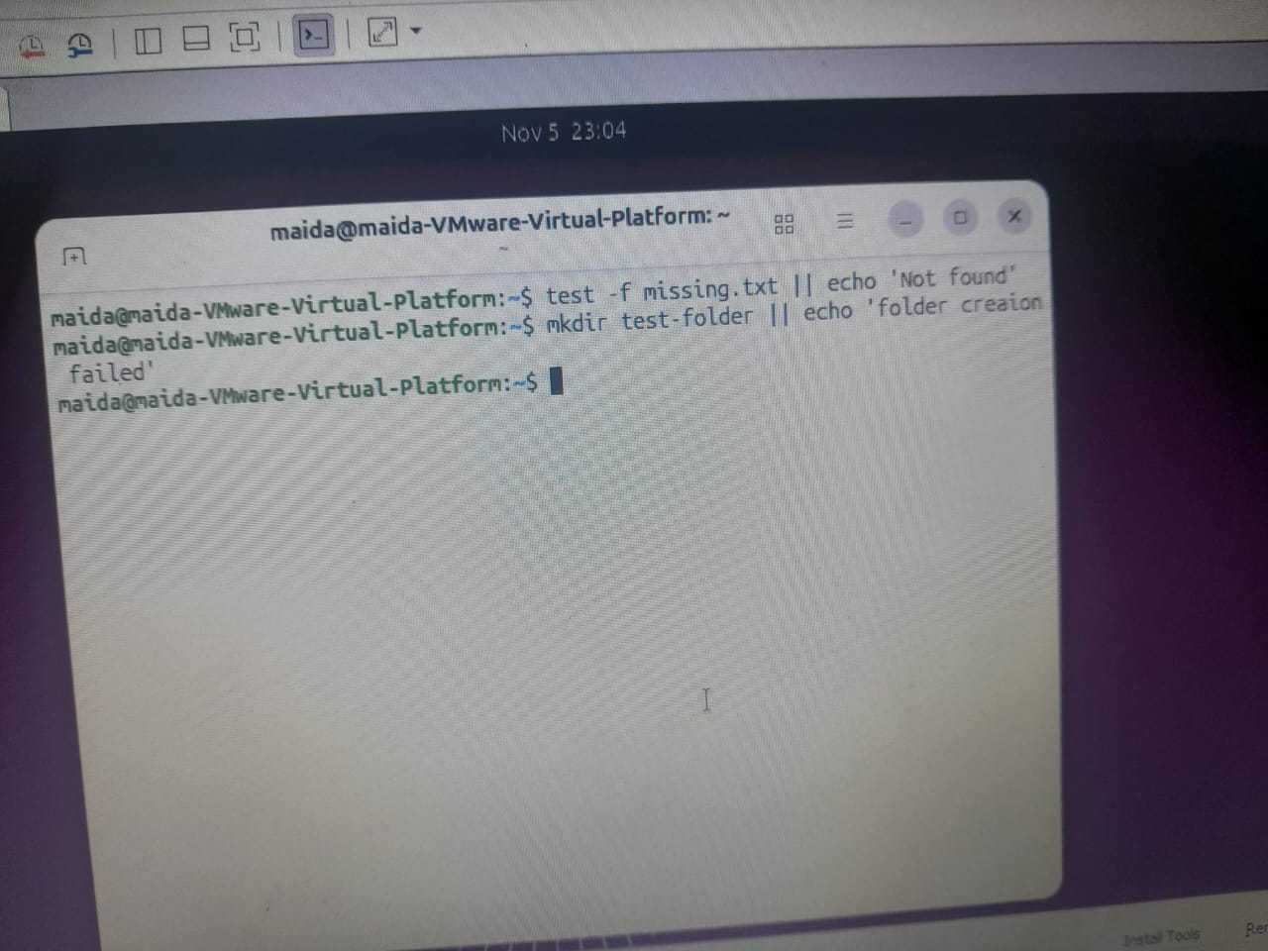

29. $? – Checking the status of a command
Meaning: Shows the exit status of the last command.
- 0 – the command succeeded.
- Non-zero – the command failed or returned an unsuccessful status.
Syntax
echo $?

Practice
ls
echo $?

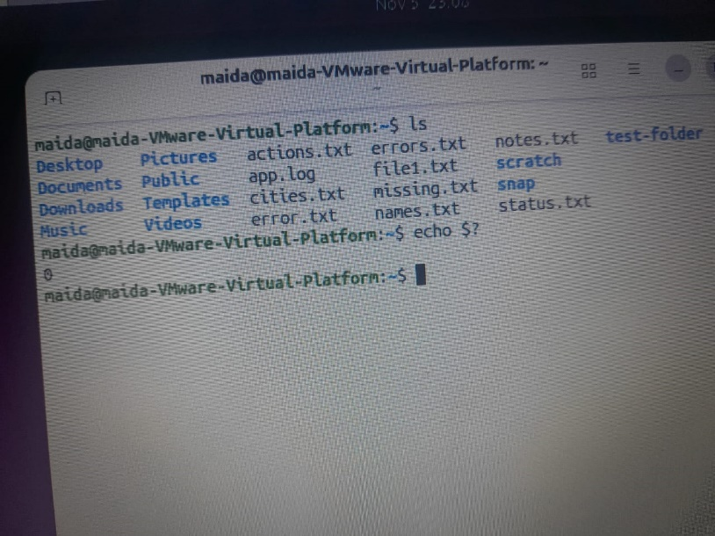
ls missing.txt
echo $?

30. sort – Sorting text
Meaning: Sorts text in alphabetical or numeric order.
Syntax
sort filename
sort -n filename
sort -r names.txt

Practice
sort names.txt
sort scores.txt
sort -n names.txt
sort -rn names.txt

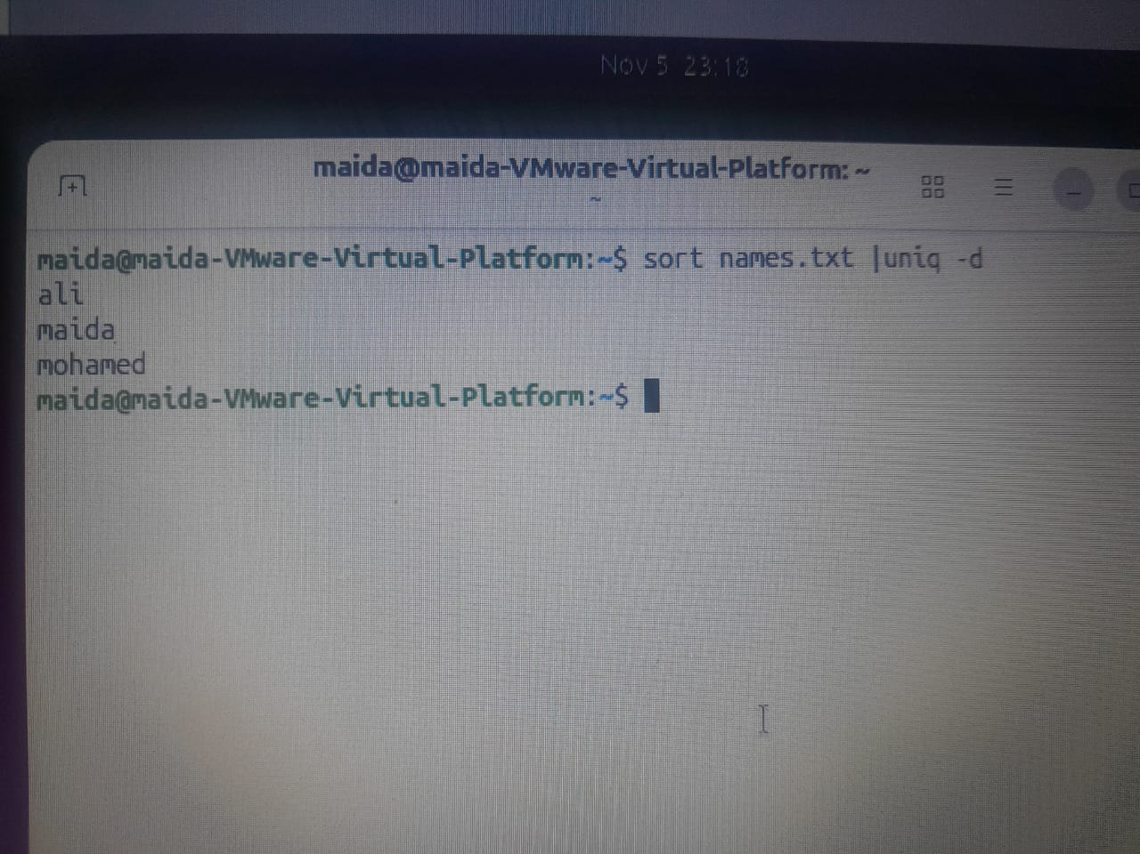

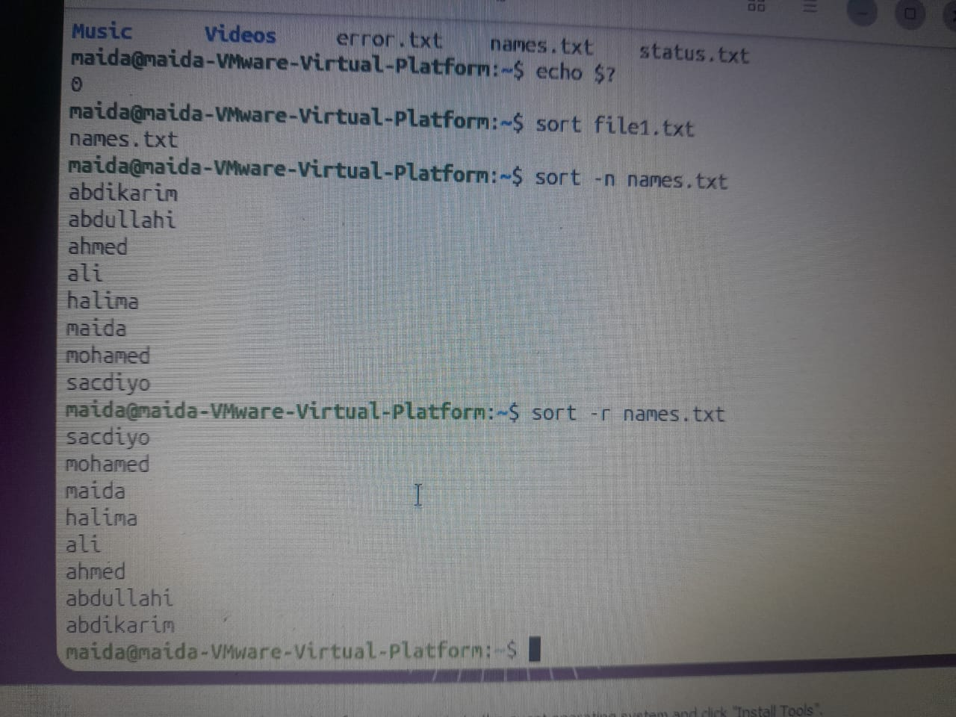

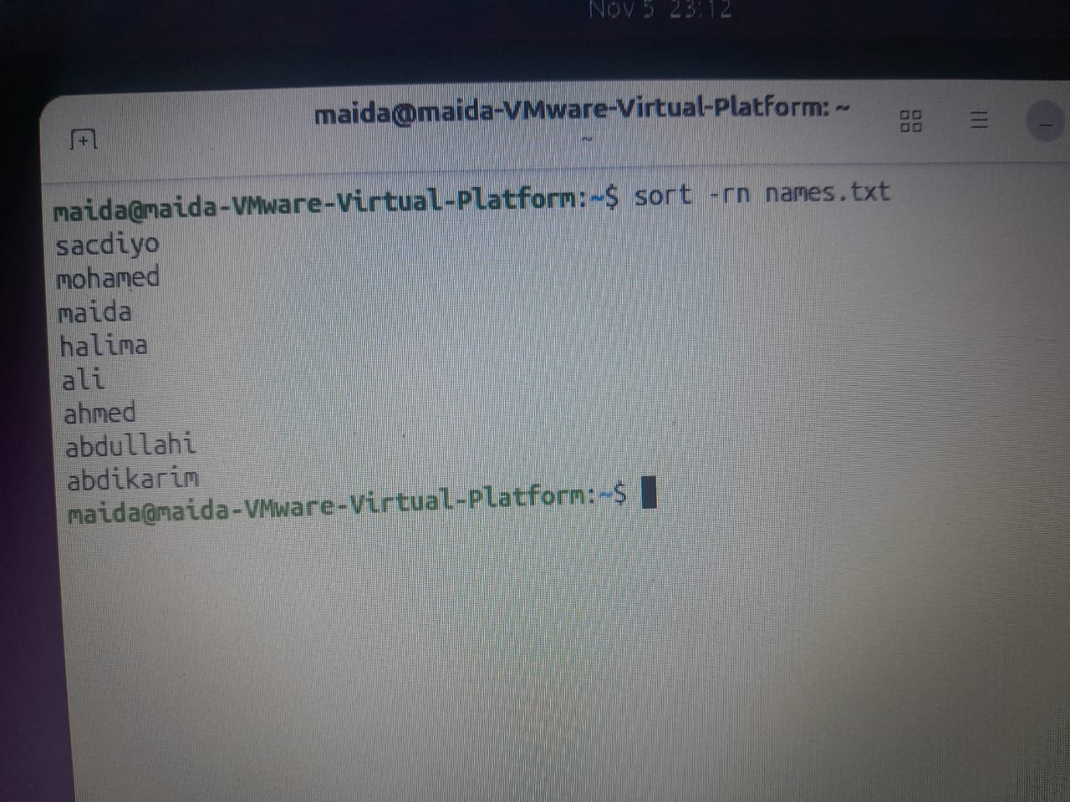

Options:
- -n – sort numerically
- -r – reverse the order

31. uniq – Removing duplicate text
Meaning: Removes identical lines that are next to each other. Sort the file first so duplicates are adjacent.
Syntax
uniq filename

Practice
sort cities.txt | uniq
sort cities.txt | uniq -c
sort cities.txt | uniq -d

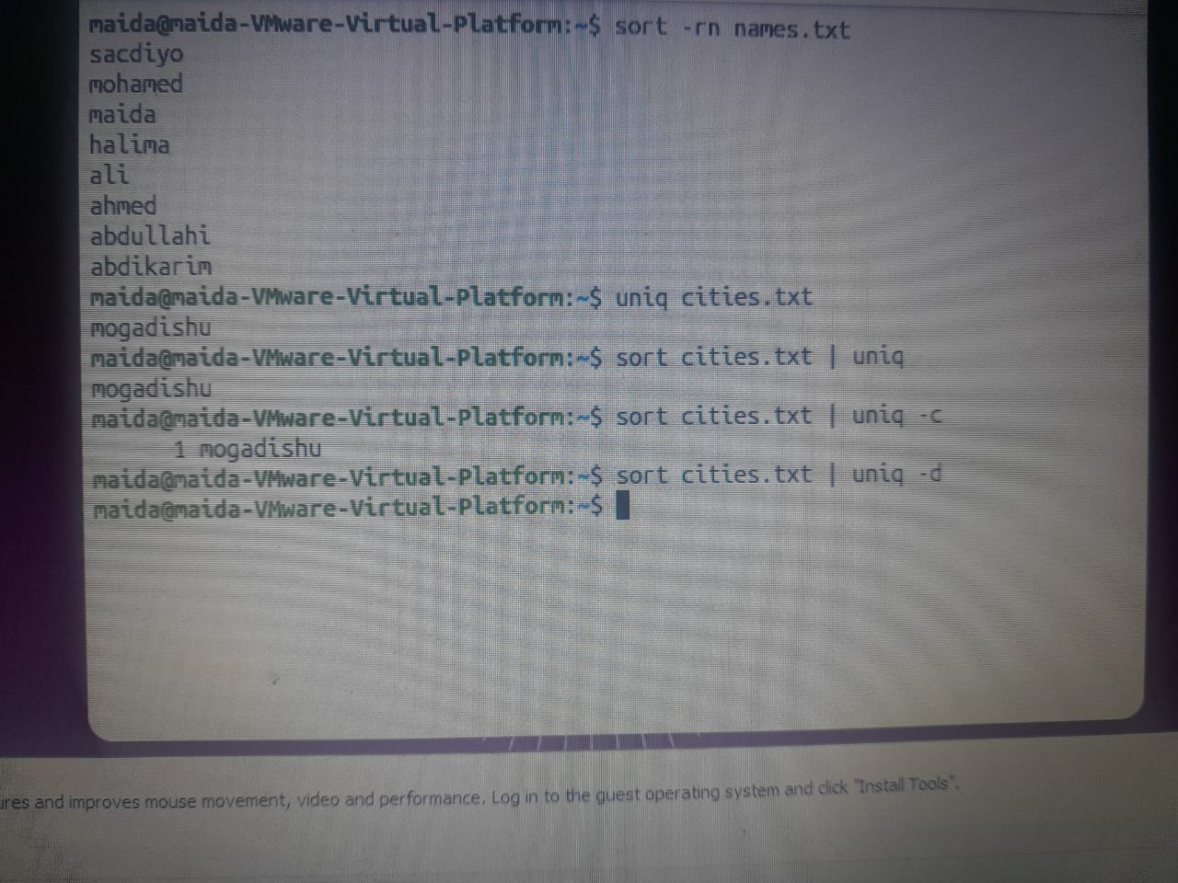

Options:
- -c – count how many times each line appears
- -d – show only the repeated lines

32. cut – Extracting part of the text
Meaning: Extracts specific parts of a file, such as characters or fields.
Syntax
cut -c range filename
cut -d delimiter -f field filename

Practice
cut -d: -f1 file1.txt
cut -d: -f 1,3 names.txt
echo "somalia" | cut -c 1-4

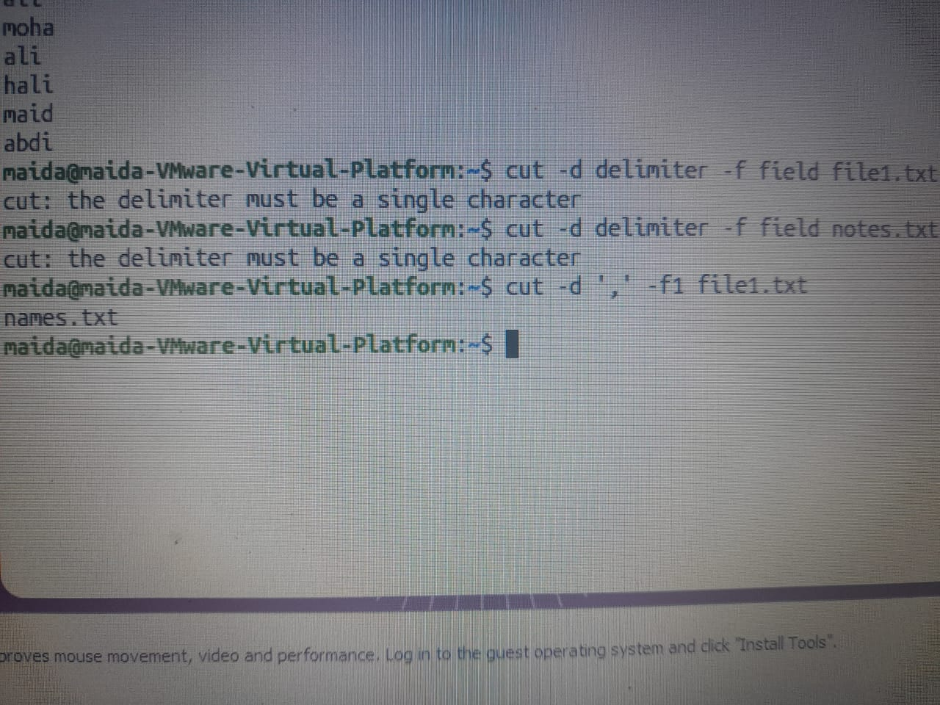

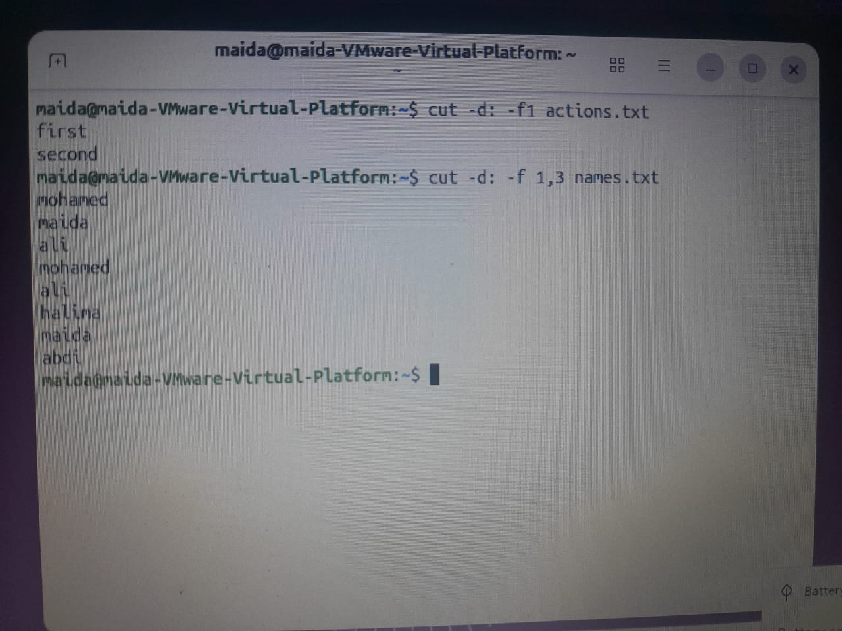

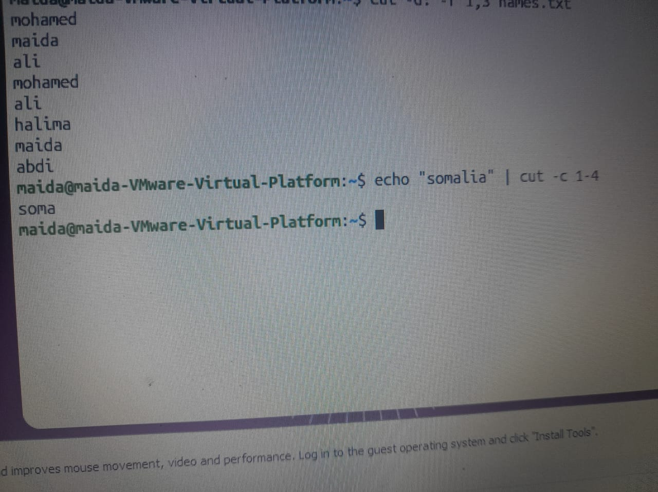
Options:
- -d – the delimiter that separates the data
- -f – the field you want
- -c – the characters you want

33. paste – Combining files
Meaning: Merges the lines of different files side by side, using a tab by default.
Syntax
paste file1 file2

Practice
paste names.txt notes.txt
paste -d, names.txt notes.txt
paste -s -d, names.txt

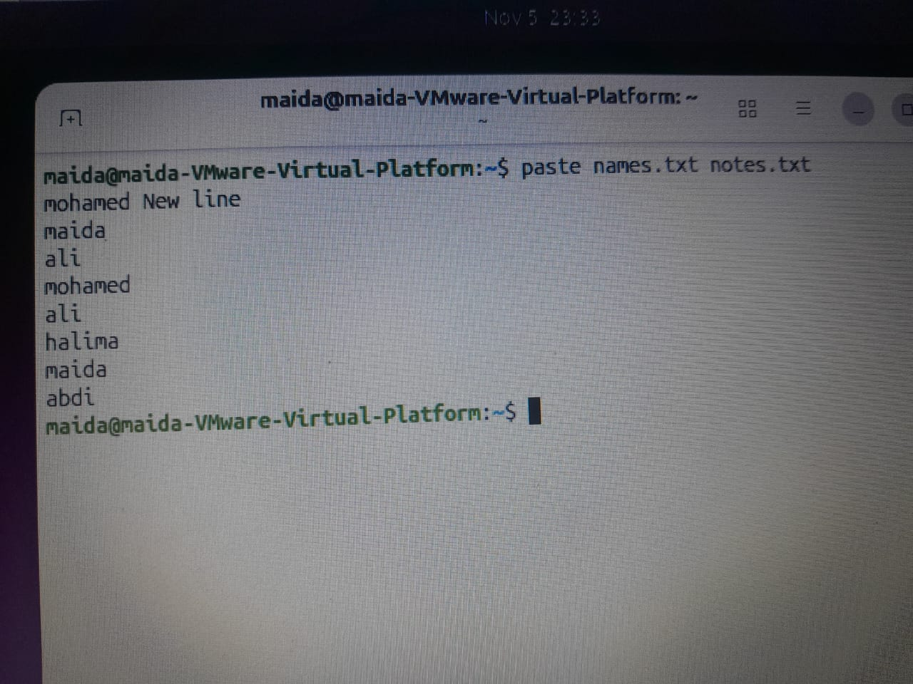
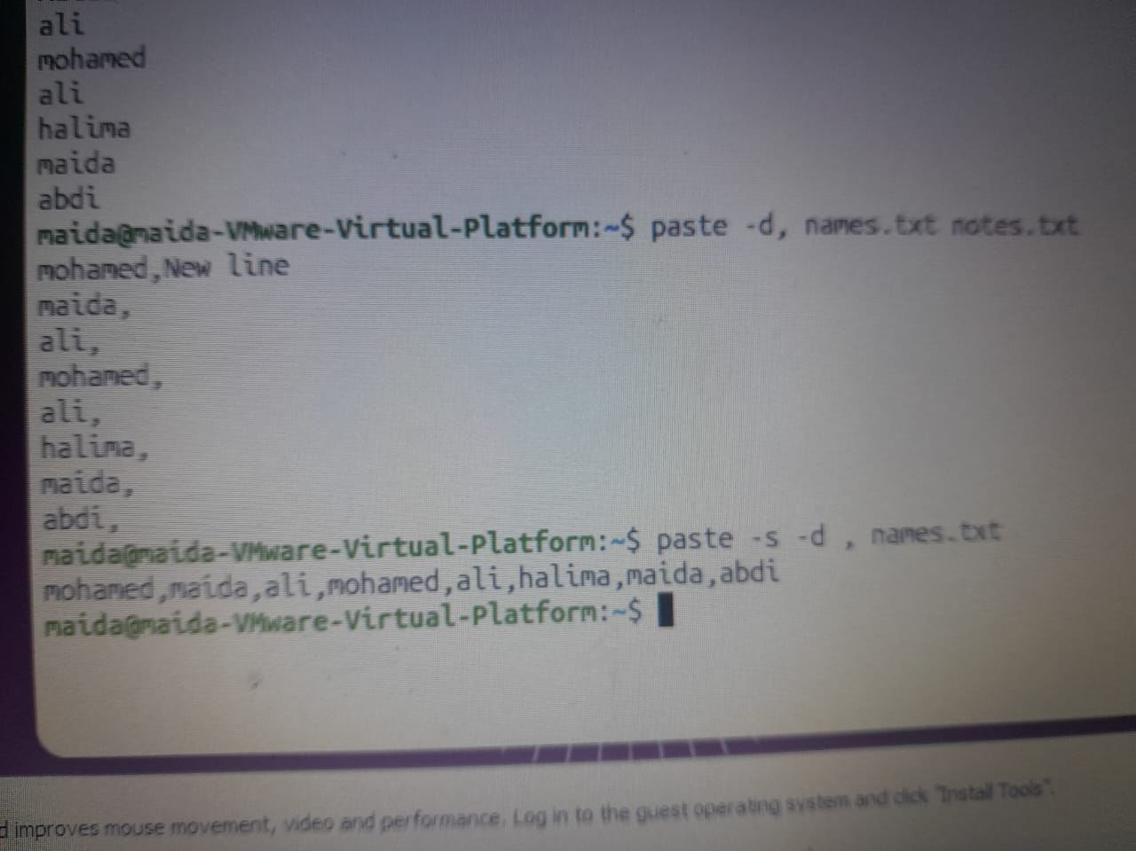
Options:
- -d – choose the separator
- -s – merge the lines of a file into a single line

34. wc – Counting text
Meaning: Counts lines, words, bytes, or characters.
Syntax
wc filename
wc -l filename
wc -w filename
wc -c filename
wc -m filename

Practice
wc names.txt
wc -l notes.txt
wc -w file1.txt
wc -c names.txt
wc -m notes.txt
echo -n "Somalia" | wc -m
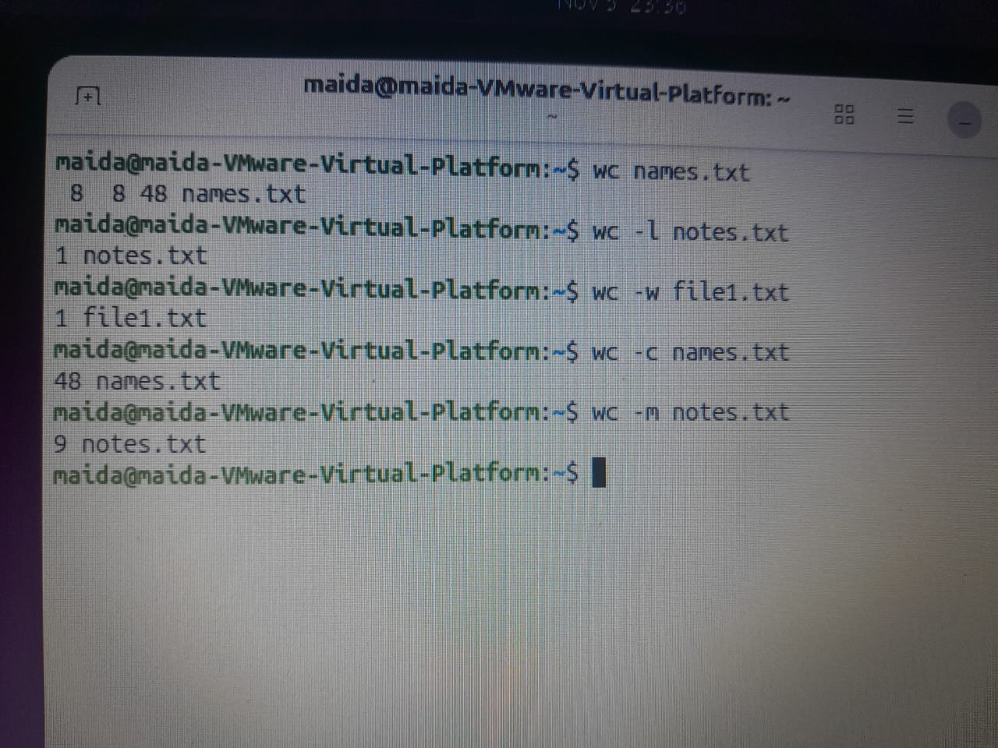

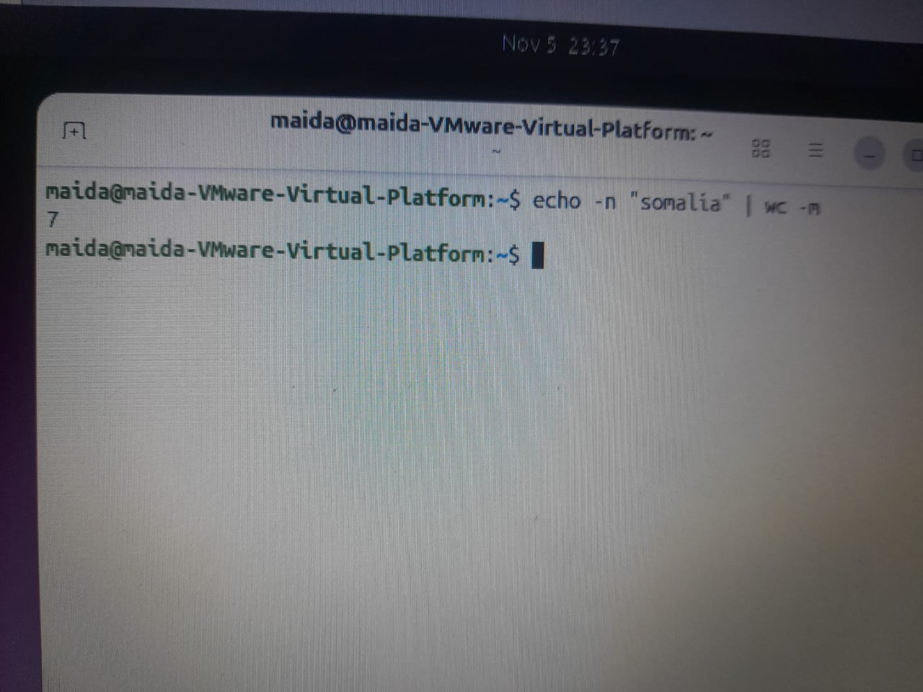

Options:
- -l – count lines
- -w – count words
- -c – count bytes
- -m – count characters

35. tr – Replacing or deleting characters
Meaning: Replaces, deletes, or squeezes repeated characters.
Syntax
tr 'set1' 'set2'

Practice
tr 'a-z' 'A-Z' < names.txt
echo 'too many' | tr -s ' '

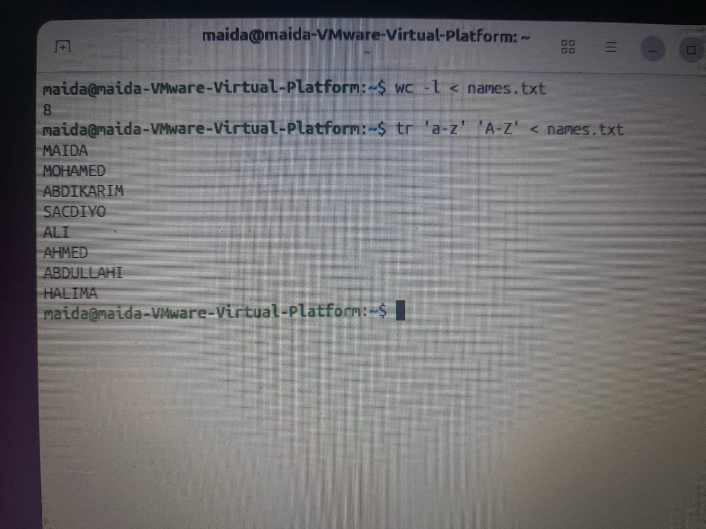

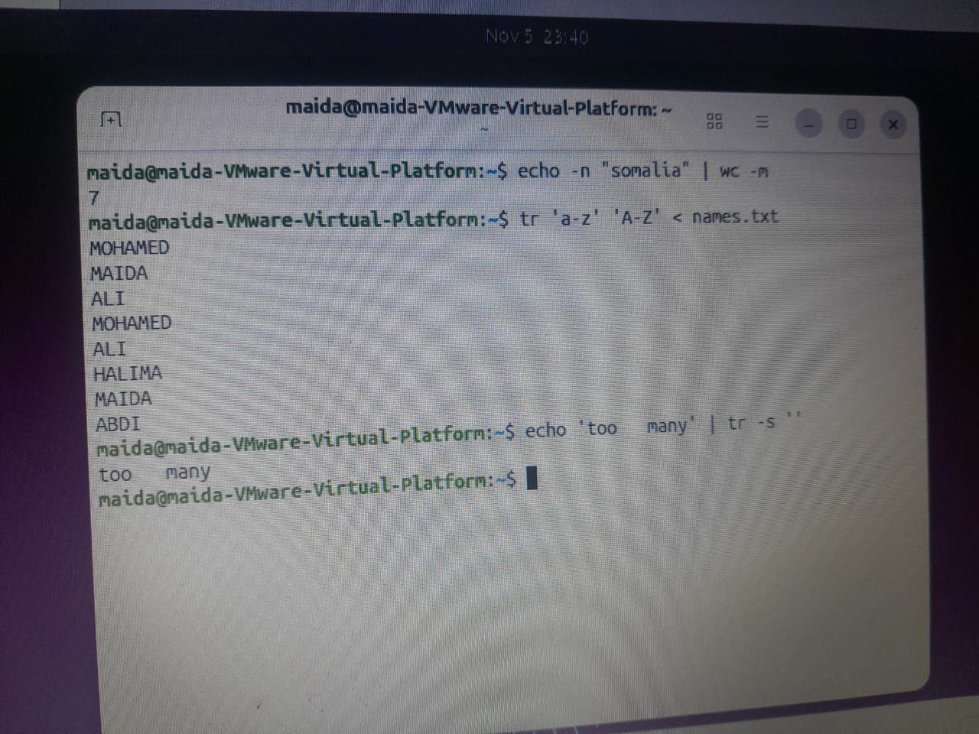
Options:
- -d – delete the selected characters
- -s – squeeze repeated characters into one

Pipeline Practice
Meaning: A pipeline lets you chain several commands together to filter, count, or organize data.
Practice 1: Extract the third field and sort it.
cut -d: -f3 names.txt | sort
cut -d: -f3 users.txt | sort | uniq -c

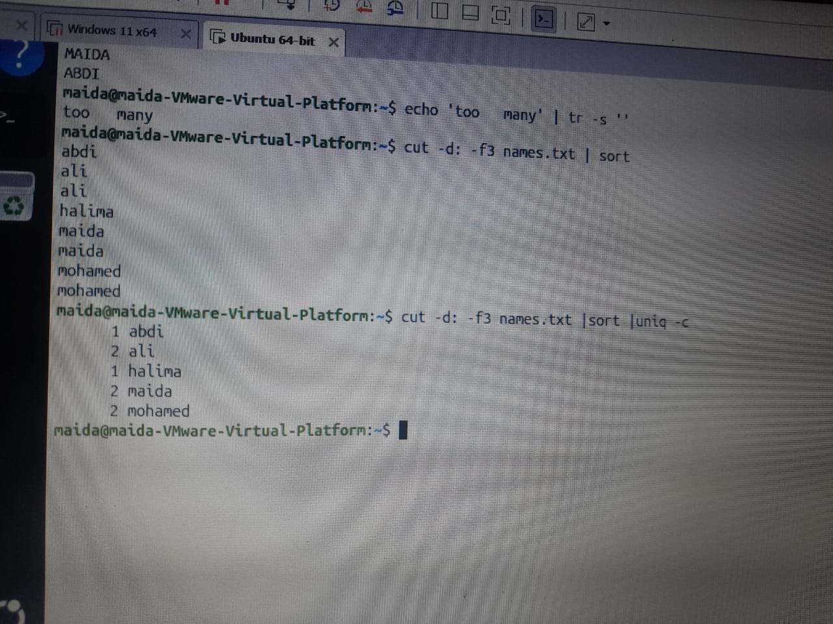

Practice 3: Count the lines that contain "error" (any letter case).
grep -i 'error' app.log | wc -l

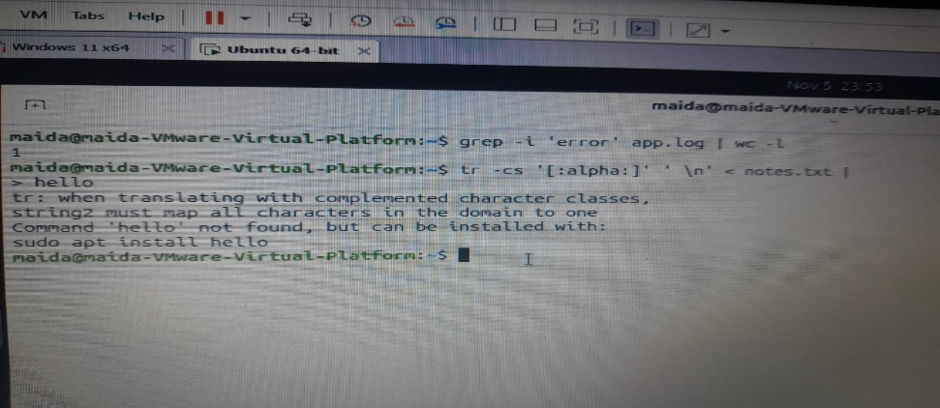

Practice 4: Split the text into words, convert them to lower case, count each word, and show the most frequent one.
tr -cs '[:alpha:]' '\n' < names.txt
tr-cs '[:alpha:]' \n''< names.txt sort | uniq -c

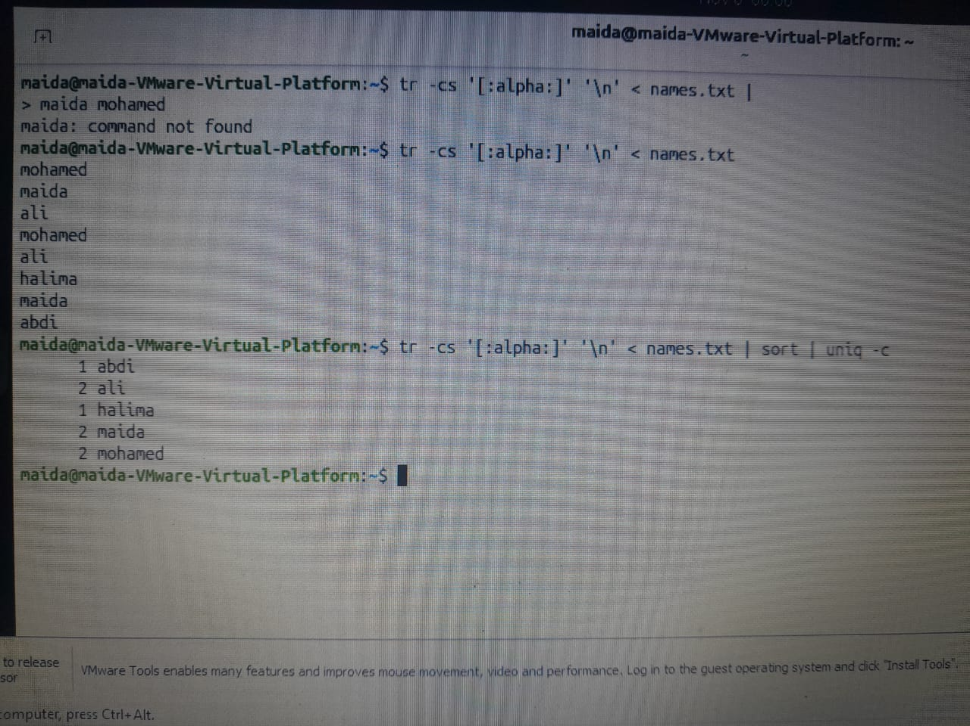

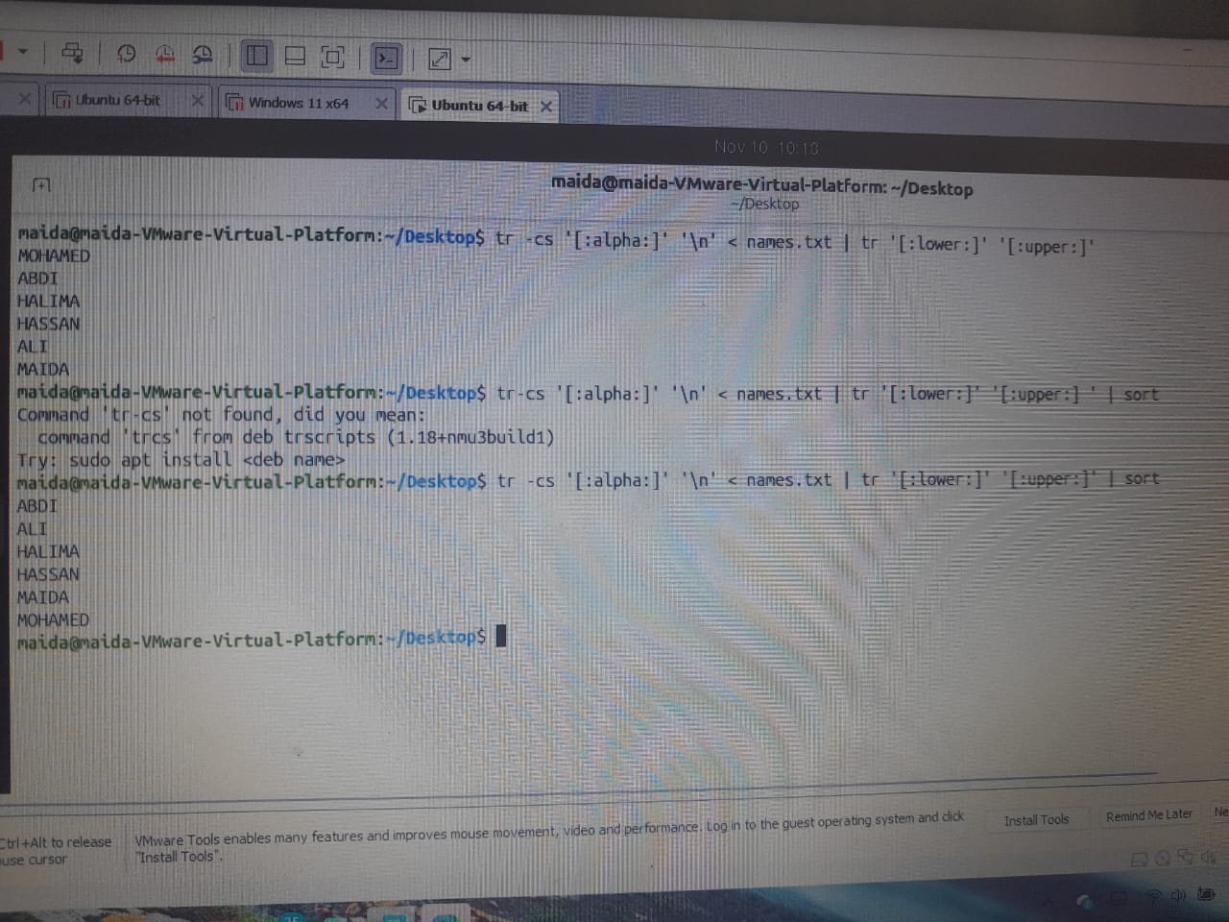

Part 3: Archives and Compression
This part covers how to bundle files together and reduce their size.
Note: When you use -k (keep the original), the original file still exists, so decompressing it afterwards will refuse to overwrite it. Delete or rename the original first, or add -f to force it.

36. tar – Bundling files
Meaning: Combines files or directories into a single archive file.
Syntax
tar -cf archive.tar filename

Practice
tar -cf notes.tar notes.txt names.txt
tar -cvf app.tar app.log/

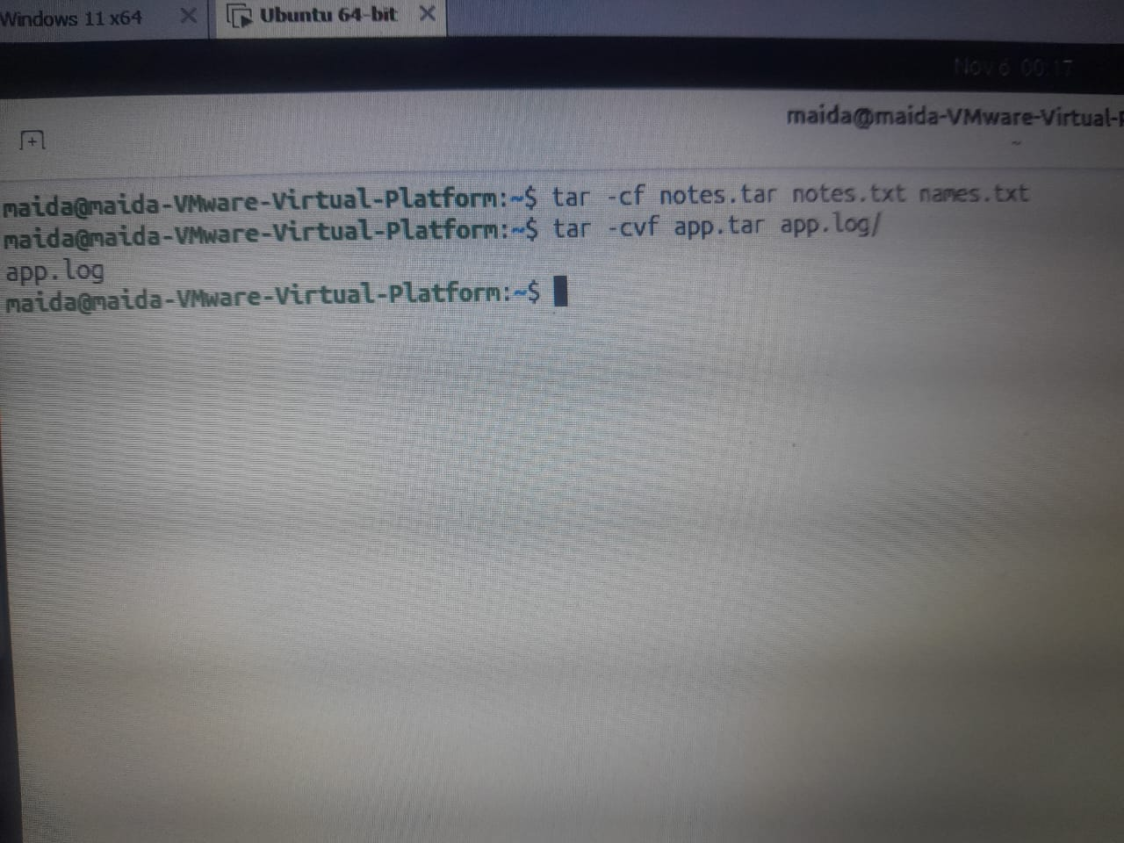

Options:
Option | Meaning
-c | Create a new archive
-x | Extract an archive
-v | Show the files being processed
-f | Name of the archive file
-t | List the contents of an archive
-z | Use gzip
-j | Use bzip2
-J | Use xz
-C | Choose the directory to extract into

37. tar -t – Viewing the contents of an archive
Meaning: Shows the files inside an archive without extracting it.
Practice
tar -tf archive.tar

tar -tf app.tar
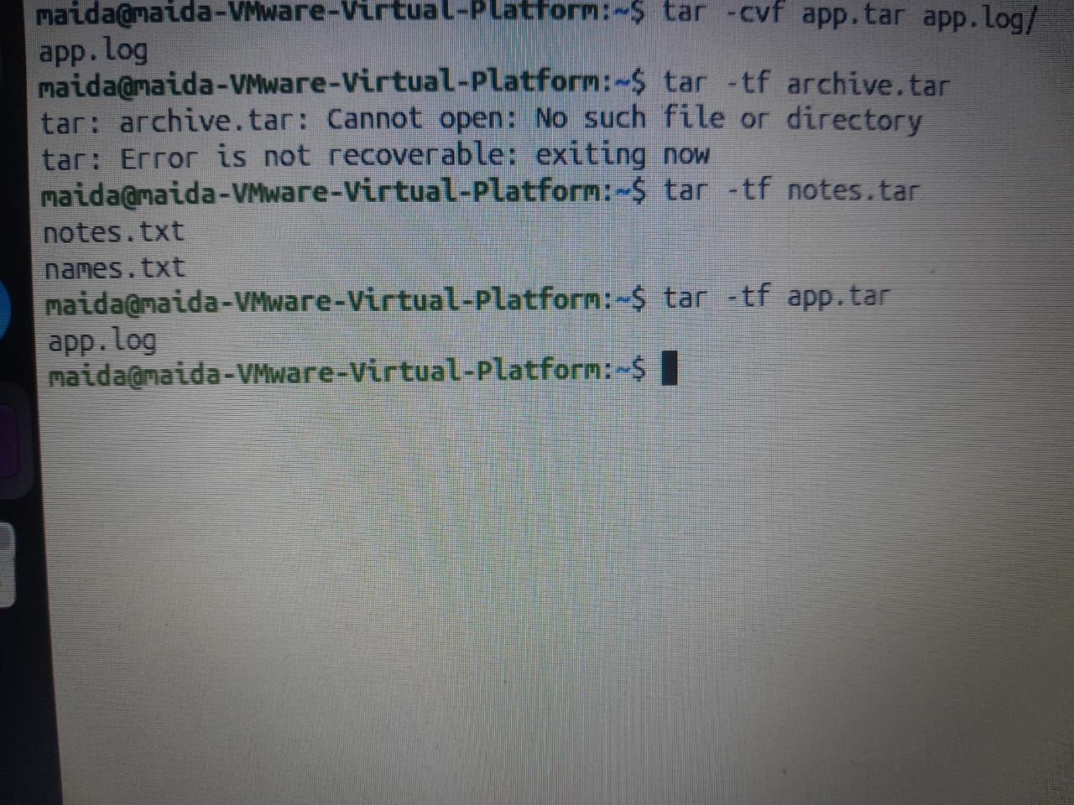

38. tar -x – Extracting an archive
Meaning: Extracts the files inside an archive.
Syntax
tar -xf archive.tar

Practice
mkdir -p restored-tar
tar -xf project.tar -C restored-tar

39. tar -czf – Archive with gzip
Meaning: Bundles files and then compresses them with gzip.
Syntax
tar -czf archive.tar.gz directory

Practice
tar -czf app.tar.gz app.log/
tar -tzf project.tar.gz

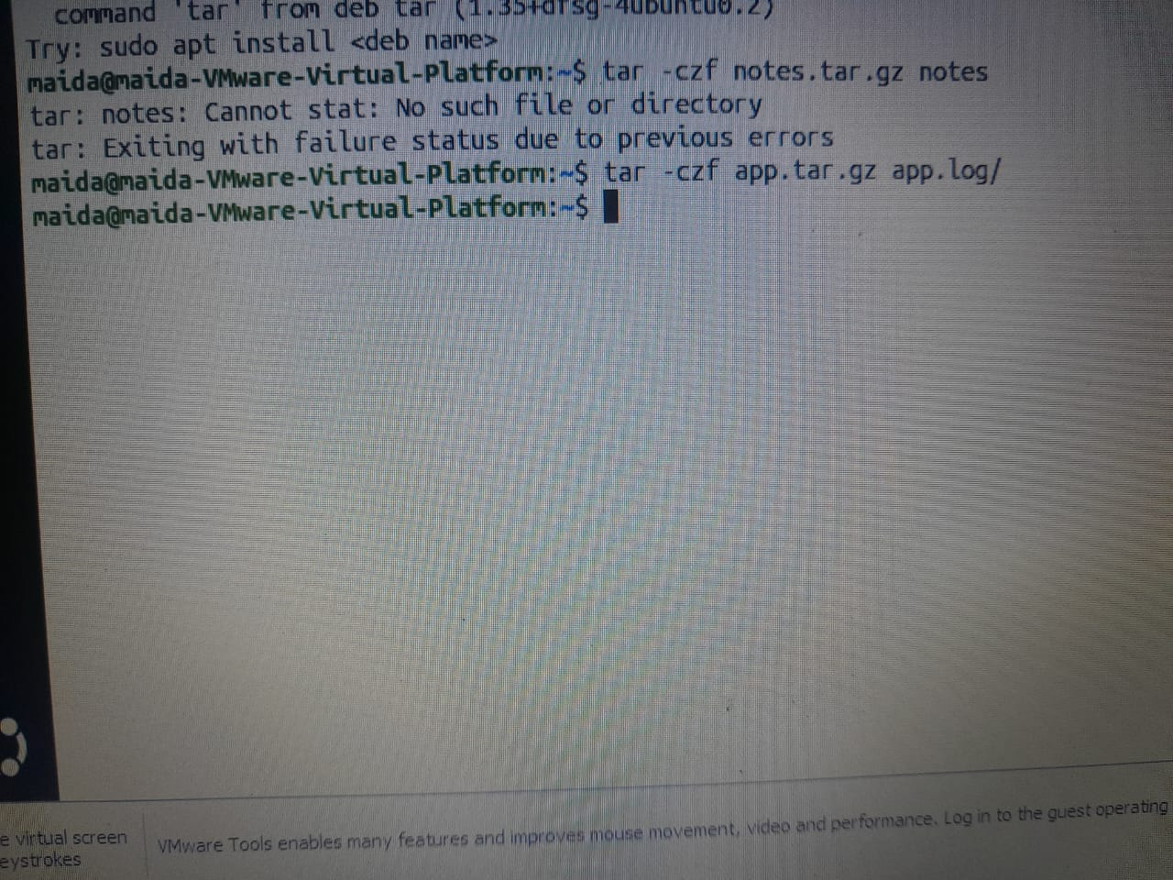

40. tar -cjf – Archive with bzip2
Meaning: Bundles files and then compresses them with bzip2.
Syntax
tar -cjf archive.tar.bz2 directory

Practice
tar -cjf project.tar.bz2 project/

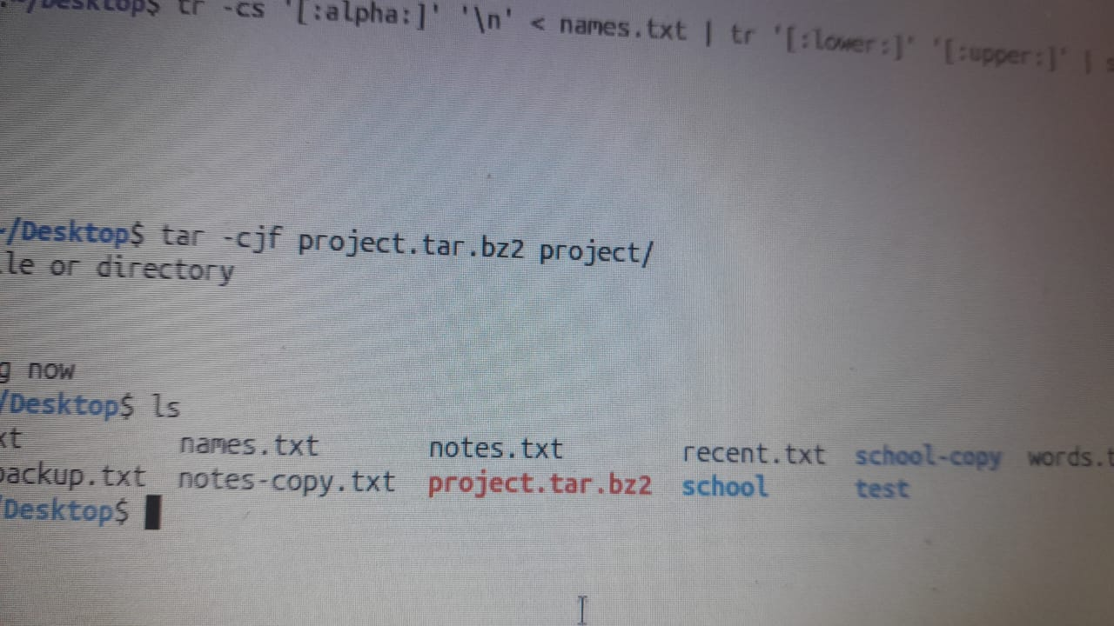

41. tar -cJf – Archive with xz
Meaning: Bundles files and then compresses them with xz.
Syntax
tar -cJf archive.tar.xz directory

Practice
tar -cJf words.tar.xz test/

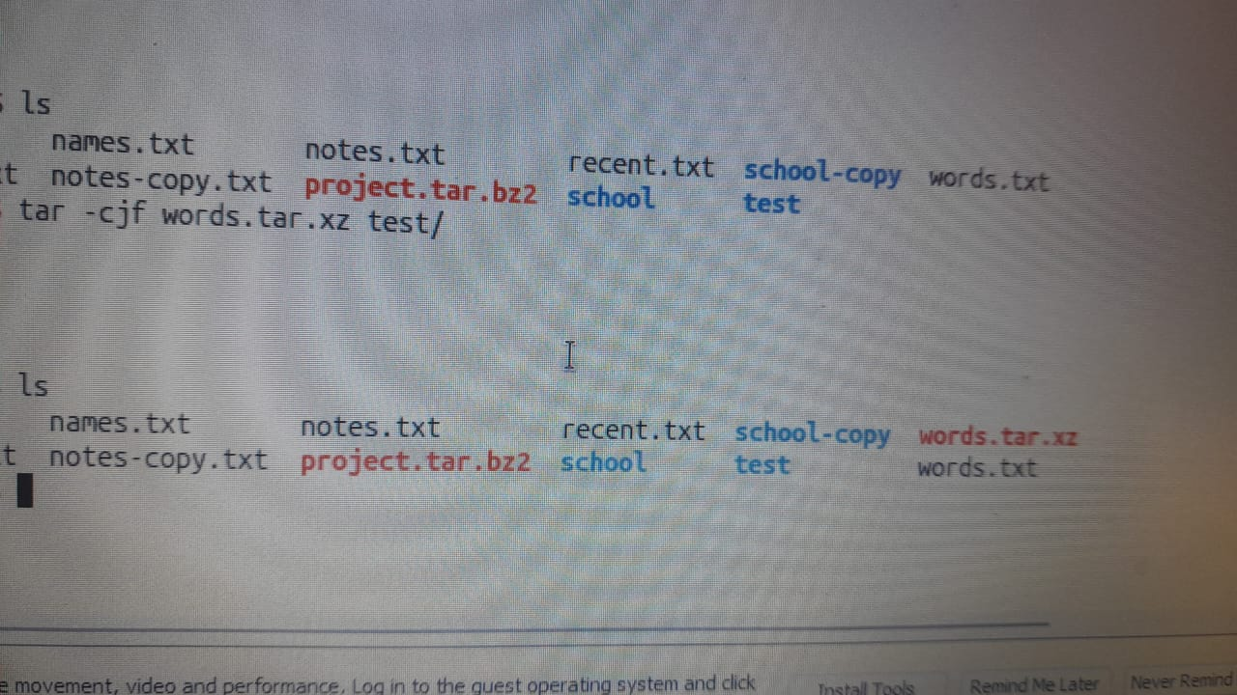

42. gzip – Compressing a file
Meaning: Reduces the size of a file; it usually creates a .gz file.
Syntax
gzip filename

Practice
gzip actoins.txt
gzip -k -9 actions.txt

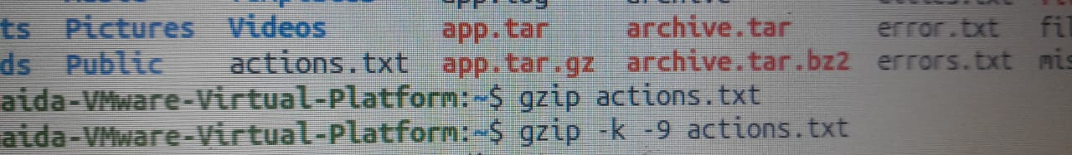
Options:
- -k – keep the original file
- -9 – maximum compression
Note: gzip notes.txt replaces the original with notes.txt.gz. To try -k, first restore the file with gunzip notes.txt.gz.

43. gunzip – Decompressing a gzip file
Meaning: Restores a file compressed as .gz.
Syntax
gunzip filename.gz

Practice
gunzip notes.txt.gz
gunzip -c notes.txt.gz

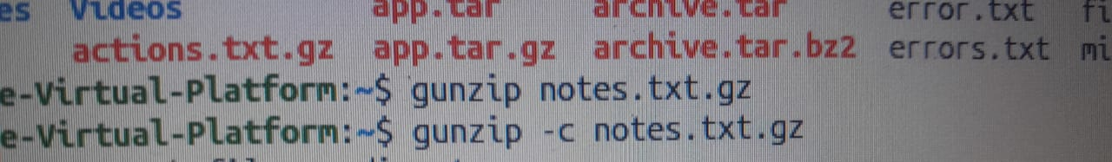
-c displays the file's contents without removing the compressed file.

44. bzip2 – Compressing a file
Meaning: Compresses a file with bzip2.
Syntax
bzip2 filename

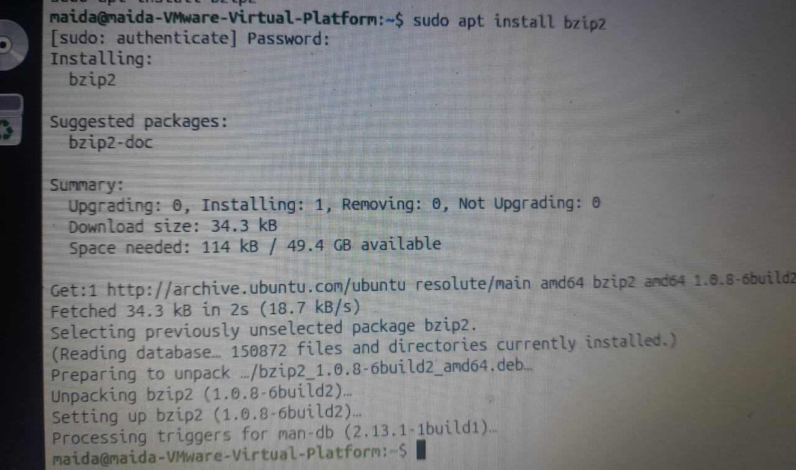
Practice
bzip2 -k app.log



45. bunzip2 – Decompressing a bzip2 file
Meaning: Decompresses a file that was compressed with bzip2.
Syntax
bunzip2 filename.bz2

Practice
bunzip2 app.log.bz2

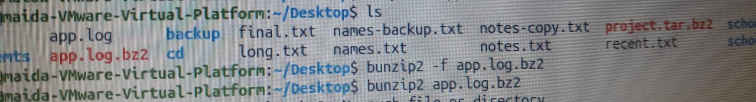

46. bzcat – Reading a bzip2 file
Meaning: Displays the text inside a compressed bzip2 file without first extracting a new file.
Syntax
bzcat filename.bz2

Practice
bzcat app.log.bz2
bzcat app.log.bz2 | head -n 1

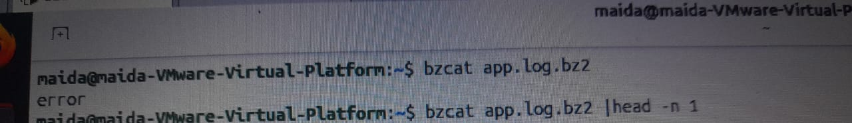

47. xz – Compressing a file
Meaning: Reduces the size of a file using xz compression.
Syntax
xz filename

Practice
xz -k app.log


-k keeps the original file.

48. unxz – Decompressing an xz file
Meaning: Decompresses a file that was compressed with xz.
Syntax
unxz filename.xz

Practice
unxz app.log.xz



49. xzcat – Reading an xz file
Meaning: Displays the text inside a compressed xz file.
Syntax
xzcat filename.xz

Practice
xzcat app.log.xz | head -n 1

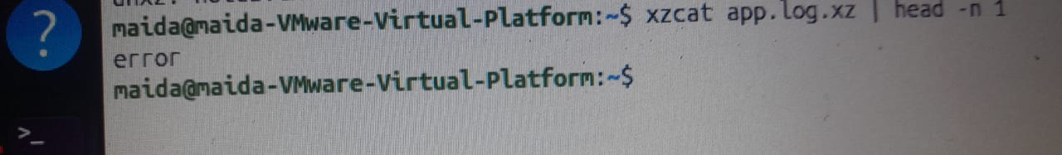

50. zip – Creating a ZIP archive
Meaning: Combines files and compresses them in ZIP format.
Syntax
zip archive.zip filename

Practice
zip project.zip README.md
zip -r project.zip project/

-r includes the directory and everything inside it.

51. unzip – Extracting a ZIP archive
Meaning: Extracts the files inside a ZIP archive.
Syntax
unzip archive.zip

Practice
unzip -l project.zip
unzip project.zip -d restored-zip

- -l – list the files inside the ZIP
- -d – choose where to extract

Part 4: Text Editors – Nano and Vim
This part covers two editors used to write and edit text in the Linux terminal.

52. nano – Writing and editing text
Meaning: Nano is a simple text editor used to create, open, and edit text files.
Syntax
nano filename

Practice
nano notes.txt
nano project

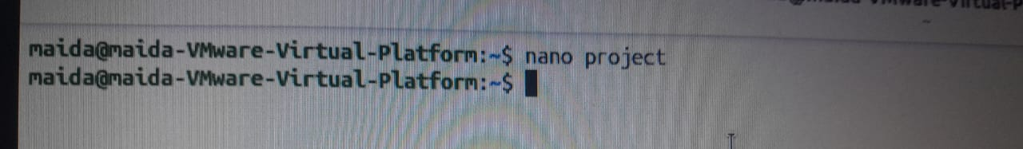

Nano shortcuts
Shortcut | Meaning
Ctrl + O | Save the file
Ctrl + X | Exit Nano
Ctrl + W | Search for text
Ctrl + K | Cut a line
Ctrl + U | Paste the cut text back
Ctrl + R | Insert another file
Ctrl + \ | Replace text
Alt + U | Undo the last change

Nano practice
- Press Ctrl + O to save.
- Press Enter to confirm the file name.
- Press Ctrl + X to exit.

53. vim – Text editor
Meaning: Vim is a text editor used to write and edit files inside the Linux terminal.
Syntax
vim filename

Practice
vim hello.txt
vim vim-practice.txt

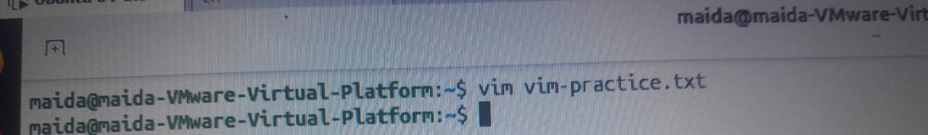

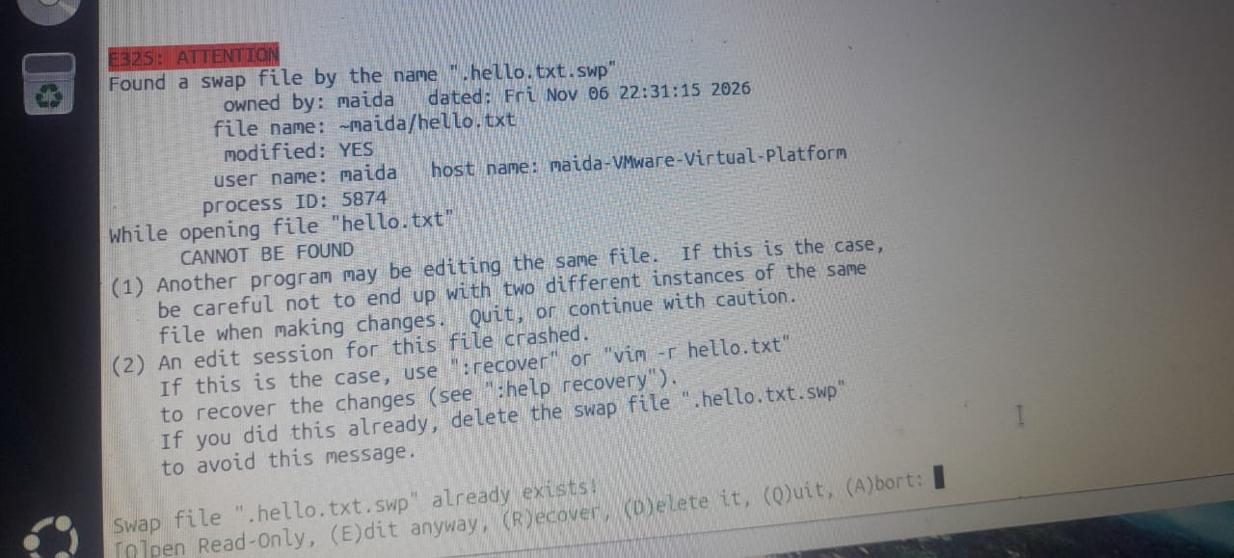

The three Vim modes
- Normal Mode – the mode Vim starts in. It is used for navigation and commands.
- Insert Mode – the mode used to type text.
- Command-line Mode – the mode used to save and quit Vim.

Vim commands
Command | Meaning
i | Enter Insert Mode
Esc | Return to Normal Mode
:w | Save the file
:q | Quit Vim
:wq | Save and quit
:q! | Quit without saving
: | Enter Command-line Mode

Vim practice
- Open the Terminal.
- Type vim vim-practice.txt.
- Press i.
- Write your text.
- Press Esc.
- Type :wq.
- Press Enter.

54. vi – Opening a text editor
Meaning: vi is a Linux text editor. On Ubuntu it usually opens Vim or a Vim-compatible editor.
Syntax
vi filename

Practice
vi hello.txt
vi notes.txt



55. vimtutor – Learning Vim
Meaning: Opens a training lesson that helps you learn how to use Vim.

Practice
vimtutor

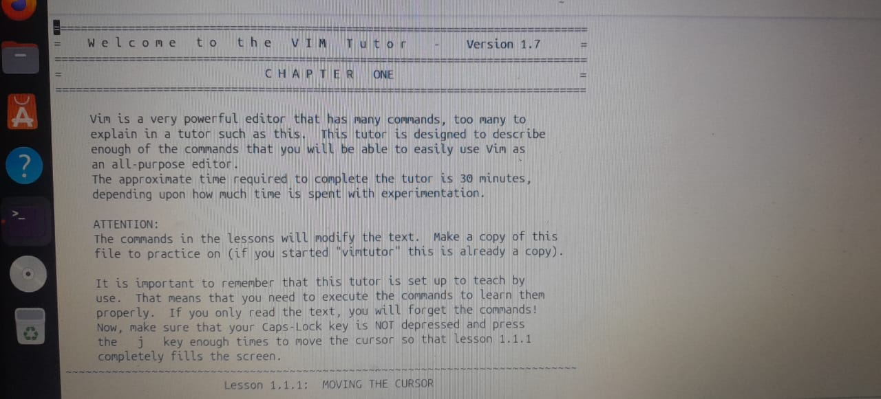

Part 5: Hard Links and Symbolic Links
This part explains how to give a Linux file another name, or link.

56. ln – Hard link
Meaning: Gives an existing file another name. Both names point to the same inode and the same file data.
Syntax
ln original-file new-link

Practice
cp notes.txt link-source.txt
ln link-source.txt link-hard.txt
ls -li link-source.txt link-hard.txt

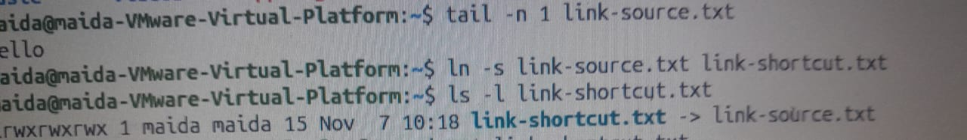

Another experiment:
echo "added" >> link-hard.txt
tail -n 1 link-source.txt

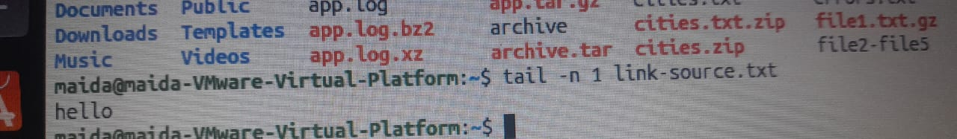
Both names share the same file data.

57. ln -s – Symbolic link
Meaning: Creates a symbolic (soft) link that stores the path of another file or directory.
Syntax
ln -s target-file link-name

Practice
ln -s link-source.txt link-shortcut.txt
ls -l link-shortcut.txt
cat link-shortcut.txt

58. ls -li – Viewing inodes and links
Meaning: Shows file details together with the file's inode number.
Syntax
ls -li filename

Practice
ls -li link-source.txt link-hard.txt
ls -l link-shortcut.txt

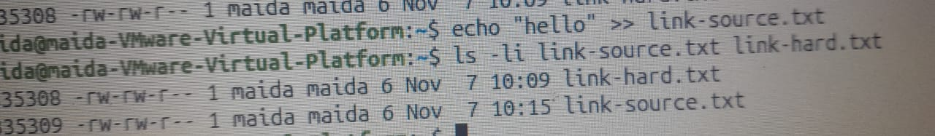

Hard link vs. symbolic link
Hard Link | Symbolic Link
Shares the inode of the original file. | Has its own inode.
Points to the same file data. | Stores the path of the target file.
Usually cannot be made for a directory. | Can point to a directory.
Cannot cross to another filesystem. | Can point to another filesystem.
Keeps working if the other name is deleted. | Breaks if the target is moved or deleted.

Part 6: Practice Workspace – Preparing Files
These are the starter commands used in Chapter 3 to prepare the practice files.

59. mkdir – Creating a directory
Meaning: Creates a new directory.
Syntax
mkdir directory-name

Practice
mkdir -p project/src
mkdir -p scratch



-p creates any required parent directories, even if they do not exist yet.

60. cd – Entering a directory
Meaning: Moves you into another directory.
Syntax
cd directory-name

Practice
cd ~/linux-ch3-lab
cd project
cd ..

61. printf – Preparing text
Meaning: Sends text to the terminal or to a file.
Syntax
printf 'text\n' > filename

Practice
printf 'Ali\nHodan\nYusuf\n' > names.txt
printf 'Mogadishu\nHargeisa\n' > cities.txt
printf 'INFO start\nERROR disk full\n' > app.log

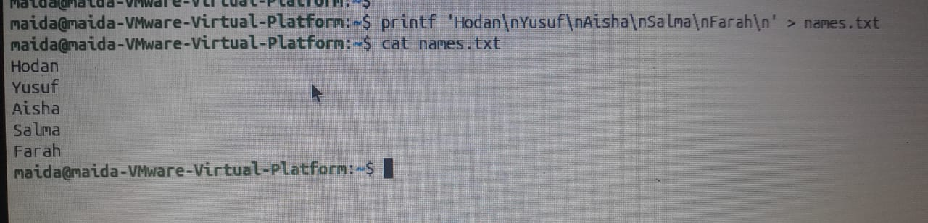

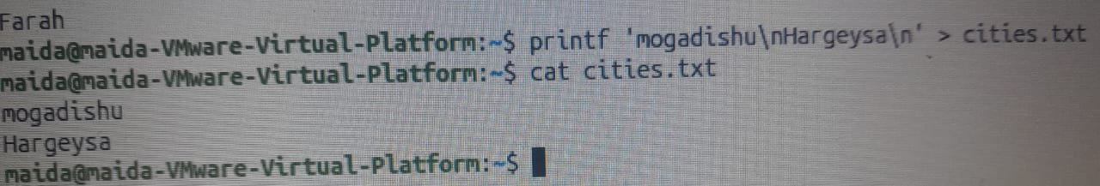

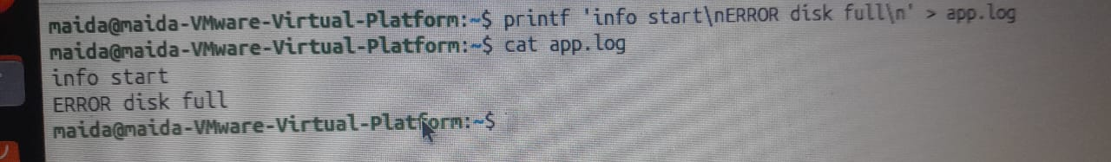

62. echo – Displaying text
Meaning: Displays text in the terminal or appends it to a file.
Syntax
echo 'text'

Practice
echo 'Hello Linux'
echo 'New line' >> notes.txt

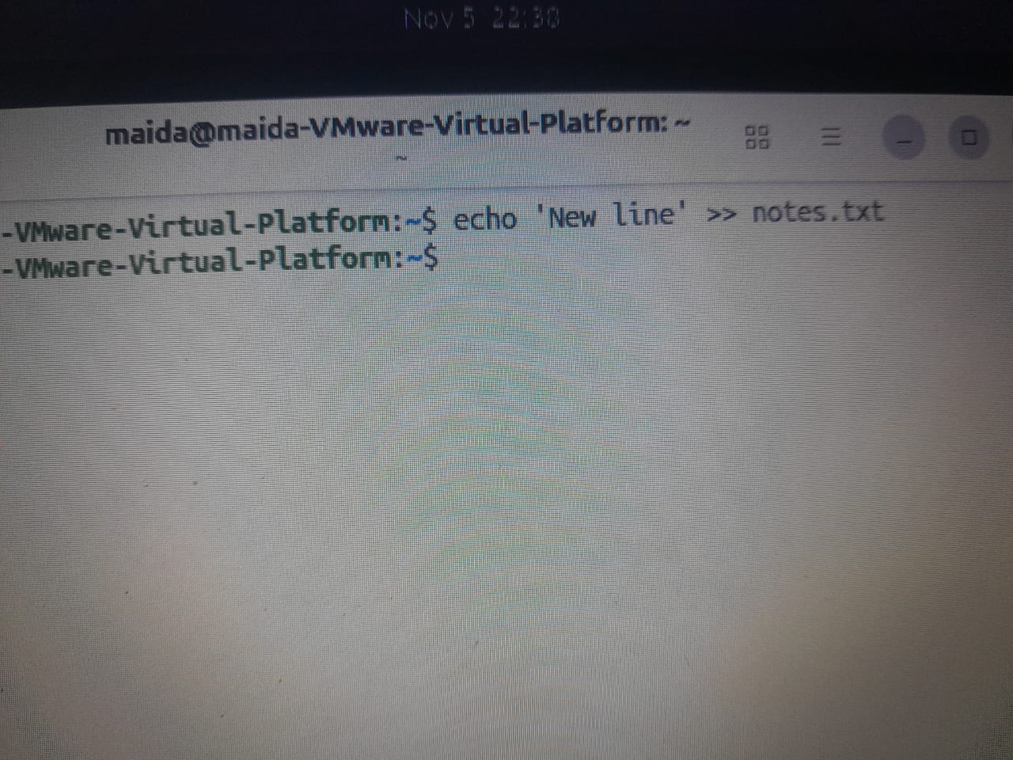

63. seq – Generating a sequence of numbers
Meaning: Prints consecutive numbers.
Syntax
seq start end

Practice
seq 1 10
seq 1 50

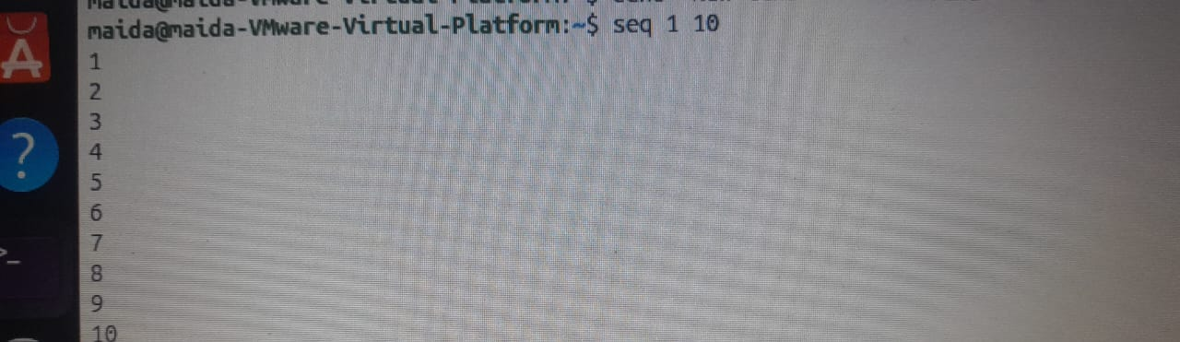

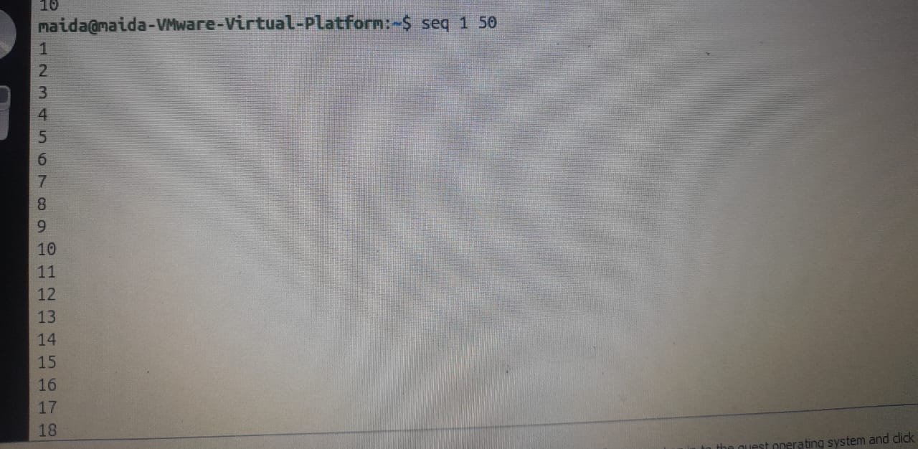

64. touch – Creating an empty file
Meaning: Creates a new empty file if it does not already exist.
Syntax
touch filename

Practice
touch recent.txt
touch test.txt

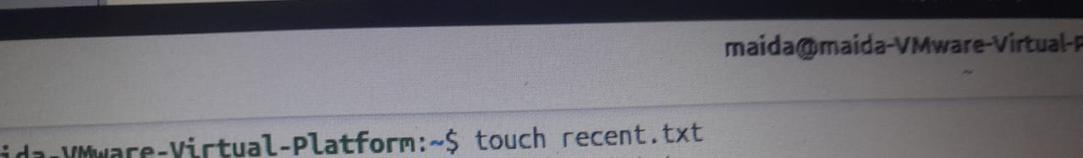



65. test – Checking a file condition
Meaning: Checks a condition, such as whether a file exists.
Syntax
test condition filename

Practice
test -f missing.txt
test -f names.txt

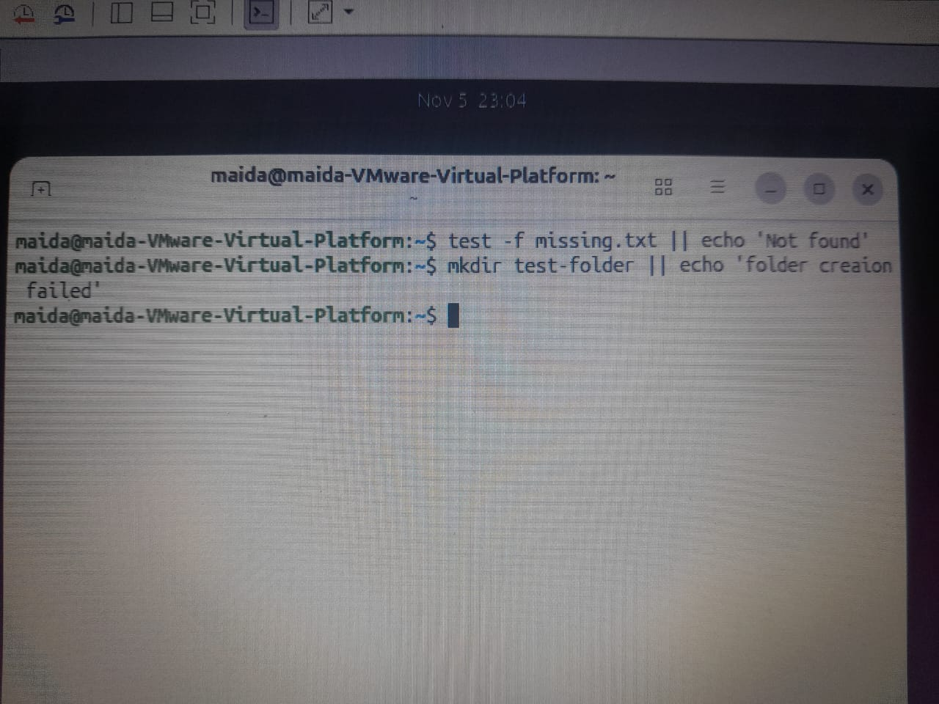


test prints nothing. Check the result with echo $? (0 means the file exists).

66. cp – Copying a file
Meaning: Makes another copy of a file.
Syntax
cp source destination

Practice
cp notes-copy.txt test/
cp names.txt names-backup.txt

67. mv – Moving or renaming a file
Meaning: Moves a file to another place or renames it.
Syntax
mv old-name new-name

Practice
mv notes-copy.txt notes-new.txt
mv file2 document/

Chapter 4: Process, Service, and System Management
Week 8 – Principles of Linux Operating Systems (CNS / BCA). Chapter 4 looks at what runs inside your Ubuntu virtual machine: processes, signals, system information, services, and logs.

Learning objectives
By the end of this chapter you will be able to:
- Explain what a process is, and identify its PID and PPID with ps, top, and /proc.
- Run commands in the foreground or background, and control them with jobs, bg, fg, Ctrl+Z, and Ctrl+C.
- Stop a process with kill, killall, or pkill, choosing SIGTERM before SIGKILL.
- Apply nice and renice to change a process's priority, and interpret its niceness value.
- Run uname, hostnamectl, uptime, free, lscpu, and lsblk, and read /proc and /sys to describe the system.
- Manage a service with systemctl, diagnose it with journalctl, /var/log, and dmesg, and shut down cleanly.

Contents
Section | Topic | Main commands
4.1 | Processes and jobs | ps · top · htop · jobs · bg · fg
4.2 | Signals, kill, and priority | kill · killall · pkill · nice · renice
4.3 | System information | uname · uptime · free · lsblk · /proc · /sys
4.4 | Services with systemd | systemctl status · start · stop · enable
4.5 | Logs, boot, and first troubleshooting | journalctl · /var/log · dmesg · shutdown

4.1 Processes and Jobs
Every command you type becomes a process. In this section we find processes, read their numbers, and move them between the foreground and the background of your terminal.

1. PID and PPID – a process is a running program
Meaning: When you run a program, the kernel loads it into memory and gives it a number, the PID (process ID). The process that started it is its parent; the parent's number is the PPID.
Command / Variable | Meaning
$$ | Holds the PID of the shell you are typing in
ps -o pid,ppid,comm | Shows the PID, PPID, and command name
ps -p PID -o pid,comm | Shows only the chosen process

Who started whom:
Process | PID / PPID | Role
systemd | PID 1 | Started by the kernel
gnome-terminal | PID 2301 | The window you opened
bash | PID 2318, PPID 2301 | Your shell
ps | PID 2455, PPID 2318 | The command you typed

Practice
echo $$ # PID of your shell (for example 2318)
ps -o pid,ppid,comm # ps is a child of bash: its PPID is the shell's PID
ps -p 1 -o pid,comm # PID 1 is systemd, the first process the kernel starts

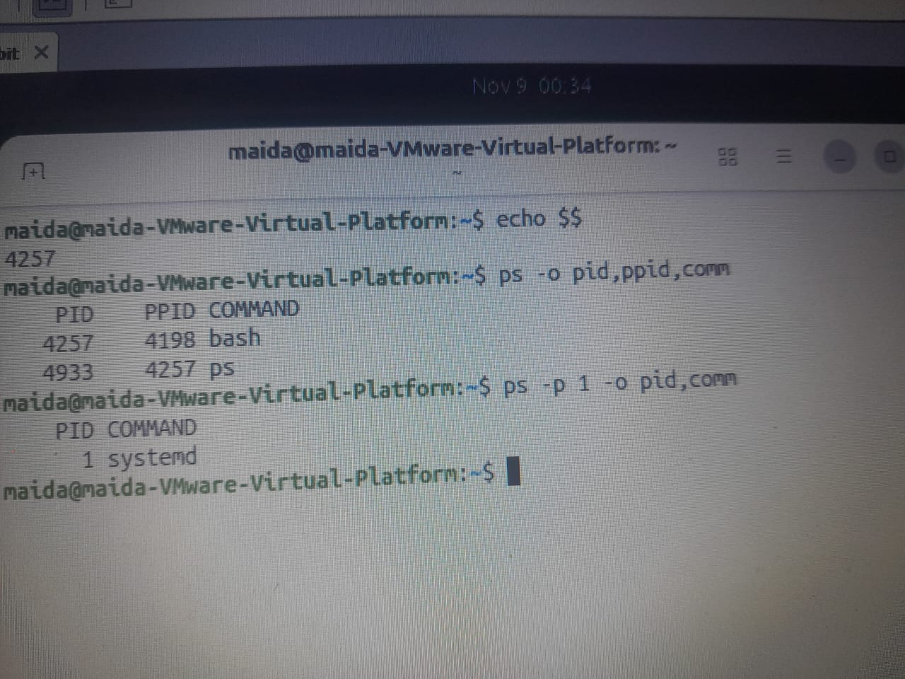

Common mistake: A PID is not permanent. Run ps again and the PID of ps itself changes every time.

2. ps – a snapshot of processes
Meaning: ps lists the processes that exist at the moment you press Enter. It does not refresh; run it again to see changes.
Syntax
ps [options]

Flag / Key | Meaning
(none) | Processes in this terminal
-f | Full format: owner, PPID, start time
-p PID | Only this process
-o COLS | Only the columns you name

Practice
ps
ps -f
ps -p 1 -o pid,user,comm

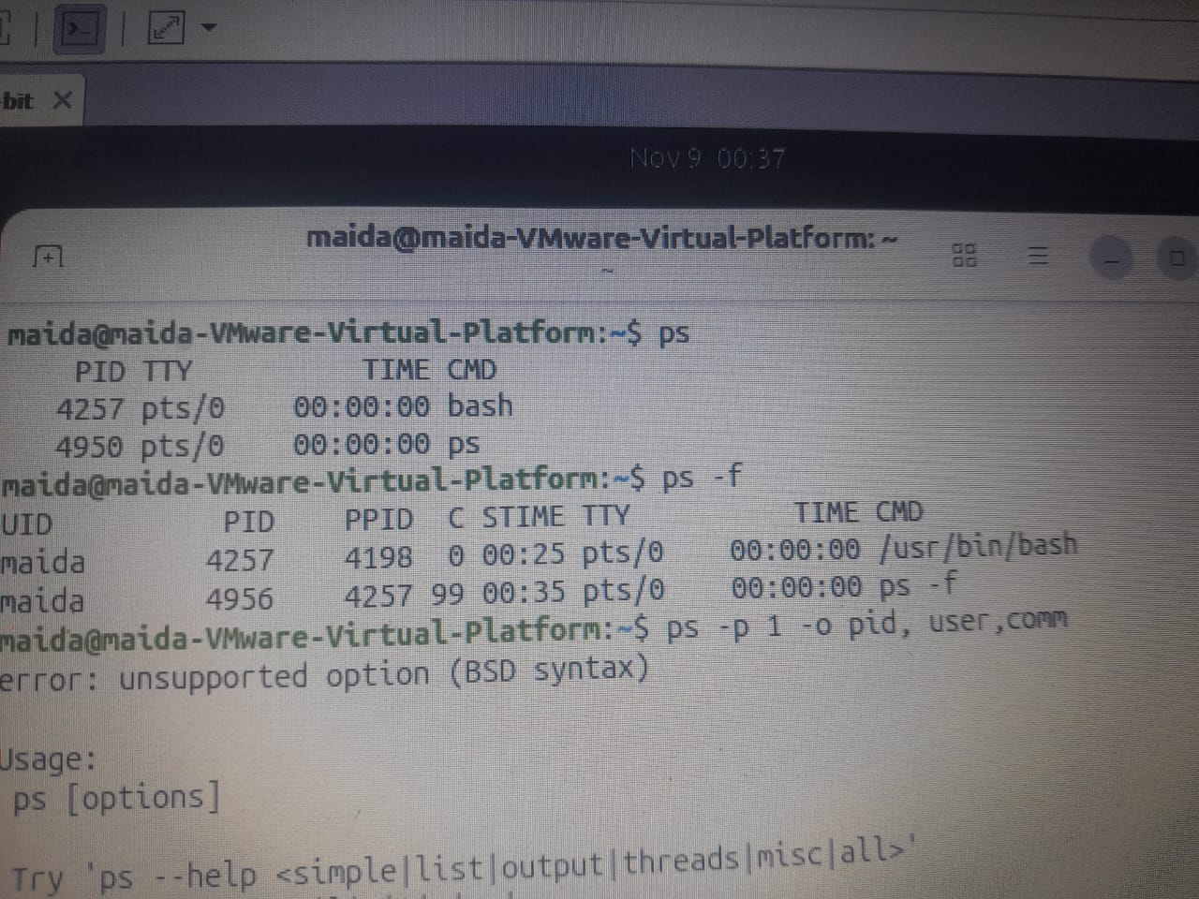

Common mistake: Plain ps shows only the processes of this terminal, not every process. Use ps aux for that.

3. ps aux – every process on the system
Meaning: ps aux shows every process from every user, with its CPU and memory use. The list is long, so page it with less.
Syntax
ps aux

Flag / Key | Meaning
USER | Who owns the process (root owns most system processes)
PID | The number you pass to kill, renice, and ps -p
%CPU %MEM | Its share of the processor and of RAM right now
STAT | R running, S sleeping, T stopped, Z zombie; + means foreground

Practice
ps aux | less # Space = next page, / = search, q = quit
ps aux --sort=-%mem | head -n 5 # biggest memory users first (the minus means largest first)
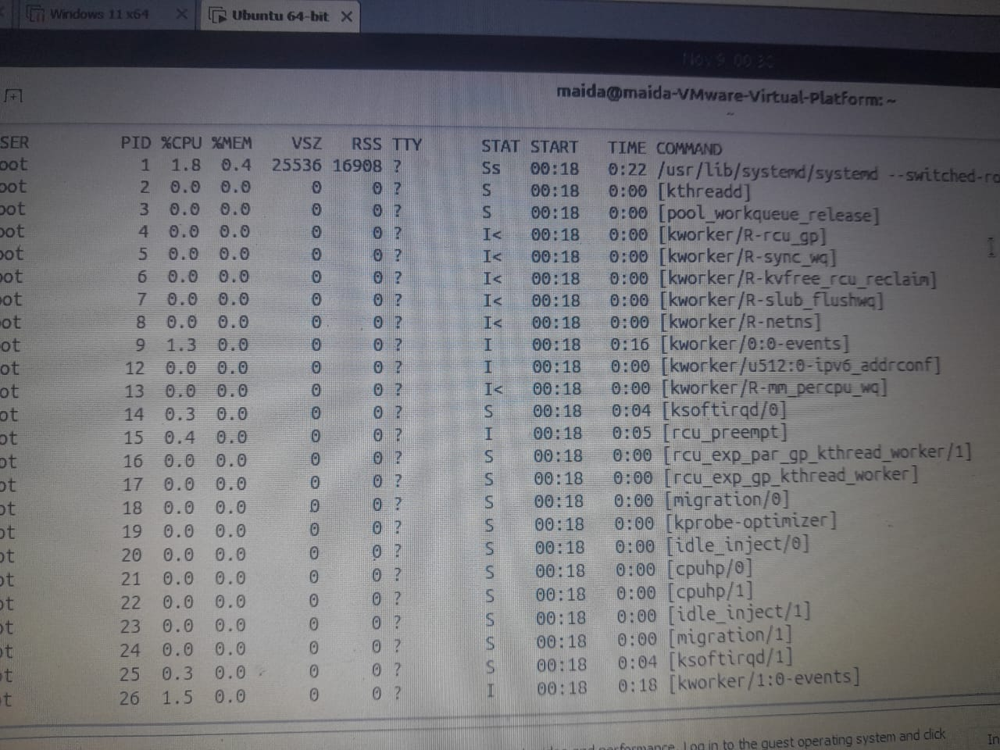

Common mistake: Typing ps -aux usually works but prints a warning. The BSD style is ps aux with no dash.

4. ps -ef and pstree – who started whom
Meaning: ps -ef is the full list in another style; its PPID column names each parent. pstree draws the same family as a tree.
Syntax
ps -ef
pstree -p [PID]

Flag / Key | Meaning
-e | Every process
-f | Full format, with PPID
-p (pstree) | Show PIDs in brackets

Names in [brackets] in ps output are kernel threads. They have no program file on disk.
Practice
ps -ef | head -n 4 # PID 1 and PID 2 have parent 0: the kernel itself
ps -ef | less # find your bash and read its PPID
pstree -p $$ # start the tree at your shell

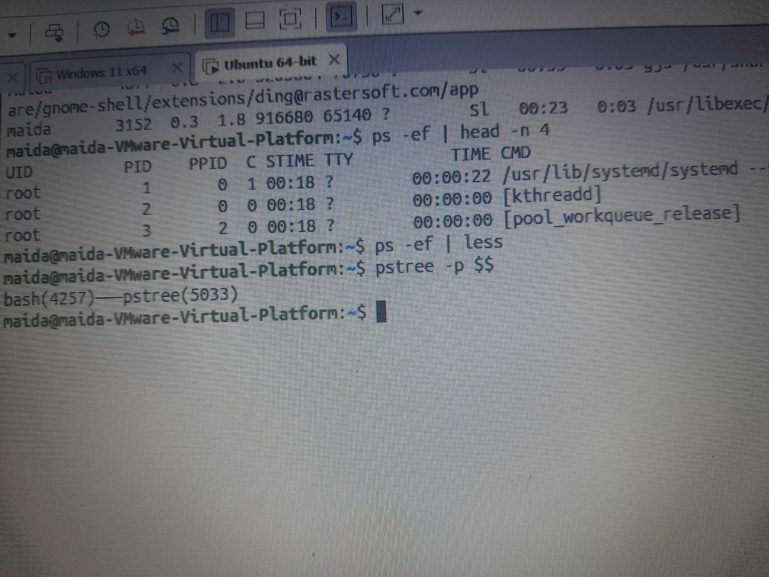

Common mistake: Do not mix styles such as ps -aux -ef. Pick one: aux or -ef.

5. top – a live view of processes
Meaning: top redraws the process list every few seconds, busiest first. Open it when the machine feels slow.
Syntax
top [-u USER]

Flag / Key | Meaning
Line 1 | Clock, time since boot, users, and the load average
Tasks | How many processes, and in which state
%Cpu(s) | id is idle time. A low id means the CPU is busy
P | Sort by CPU
M | Sort by memory
k | Kill a process
r | Renice a process
q | Quit

Practice
top # press M, then P, then q
top -u student # only your own processes

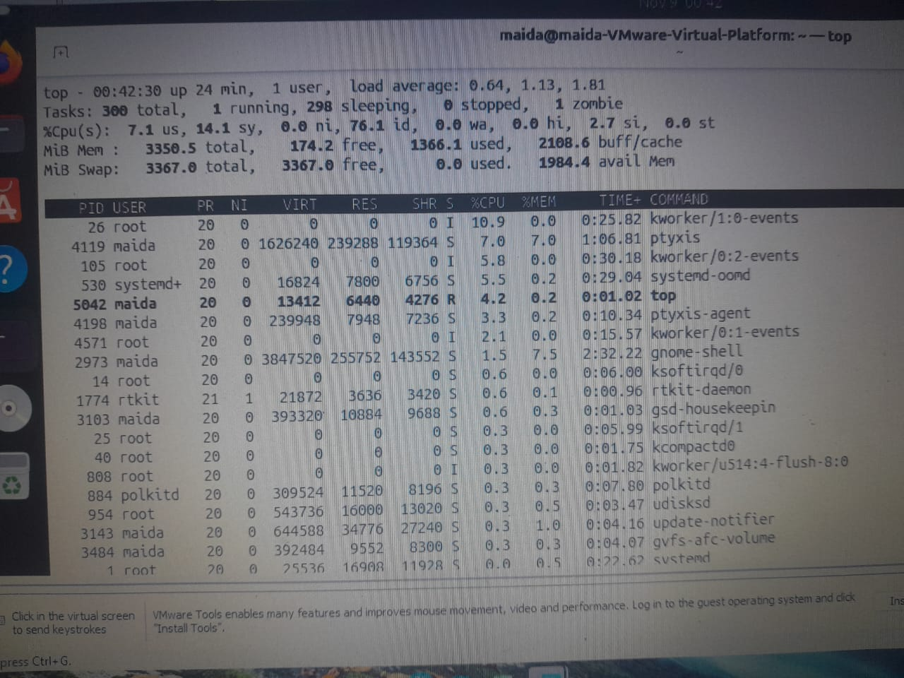

Common mistake: Pressing Ctrl+Z to leave top only pauses it. Press q to quit.

6. htop – a friendlier top (if installed)
Meaning: htop shows the same data with colour bars, mouse clicks, and function-key menus. If it is missing, top does the same job.
Syntax
htop [options]

Flag / Key | Meaning
-u USER | Only that user's processes
-t | Tree view
F6 | Choose the sort column
F9 | Send a signal to the selected process
F10, q | Quit

Practice
command -v htop # a path means htop is installed; no output means use top
htop
htop -u student
htop -t # children indented under their parent

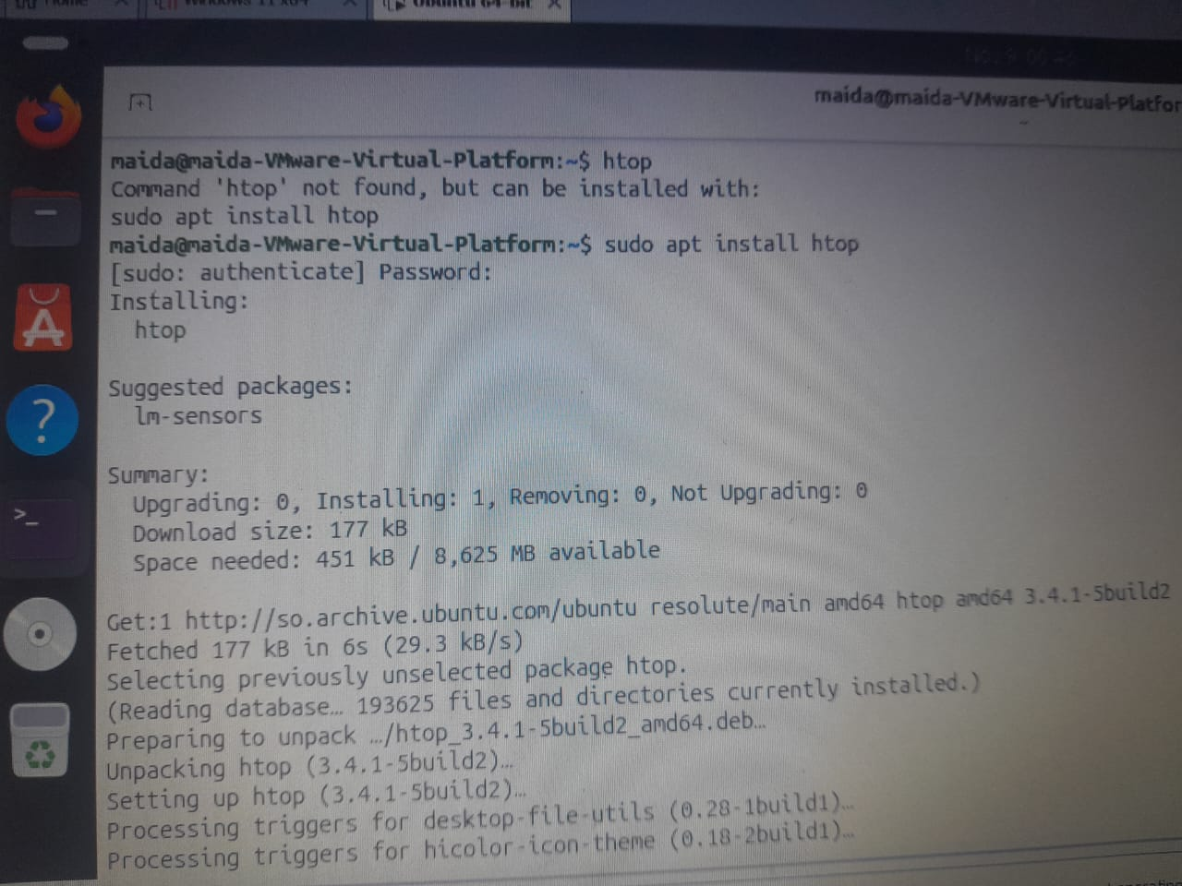

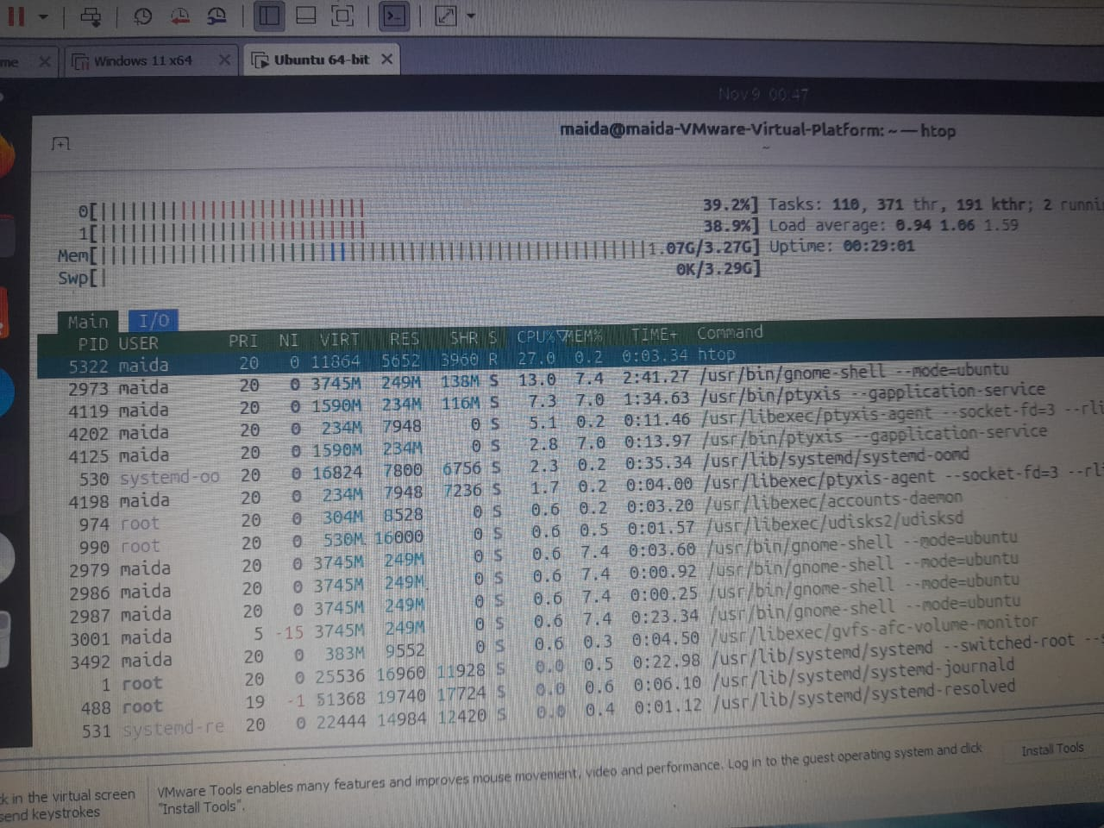

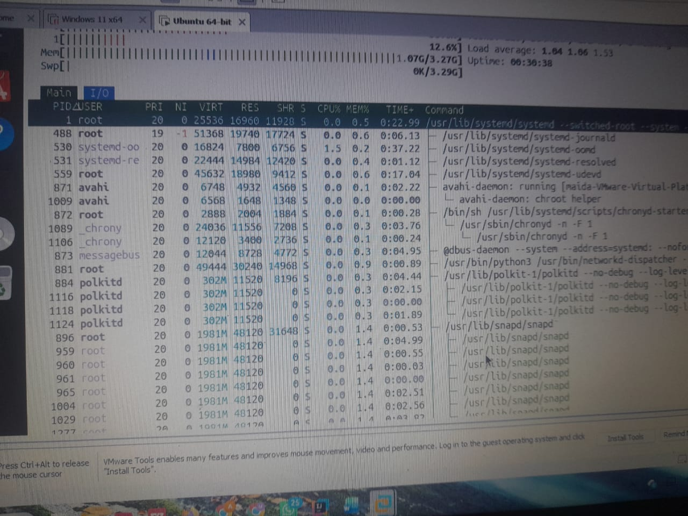

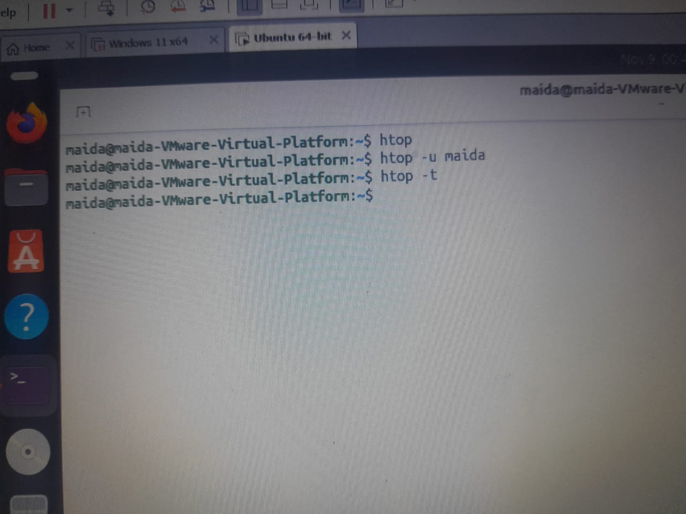

Common mistake: On a laptop, the F-keys may need the Fn key. Use the mouse on the bottom menu instead. (Installing software is covered in Chapter 6.)

7. Foreground and background
Meaning: A foreground job holds your terminal until it ends. Put & at the end of the command and it runs in the background, so the prompt comes back at once.
Syntax
command # foreground: the terminal waits
command & # background: the prompt returns; the shell prints a job number and a PID

Practice
sleep 30 # no prompt for 30 seconds
sleep 30 & # prints [1] 2541 ([1] = job number, 2541 = PID)
gnome-calculator & # the calculator opens and the prompt stays free

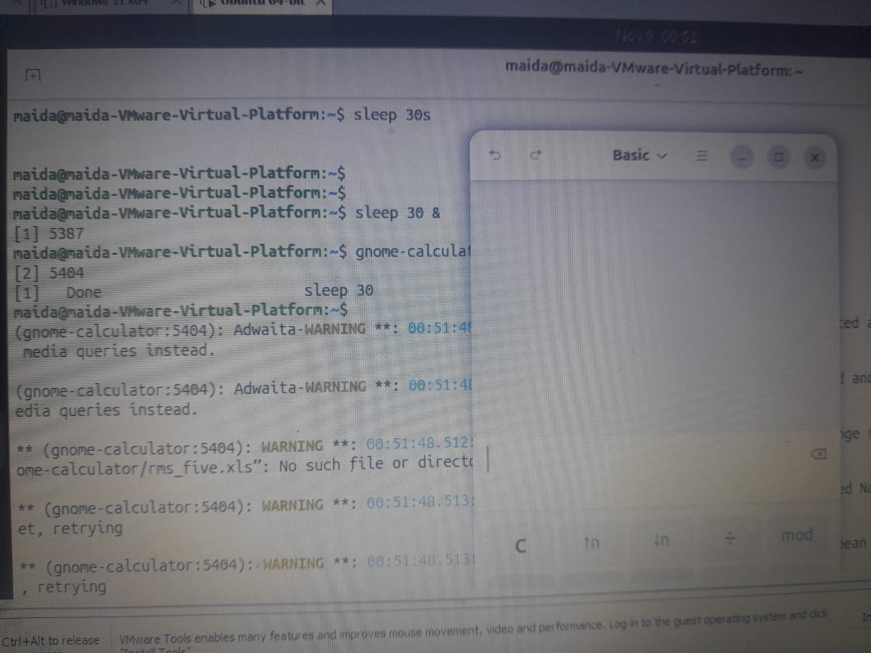

Common mistake: The & must be the last character of the line. & sleep 30 is wrong.

8. Ctrl+C and Ctrl+Z
Meaning: Two keys act on the foreground job. Ctrl+C asks it to stop. Ctrl+Z pauses it and gives you the prompt back.
Flag / Key | Meaning
Ctrl + C | Sends SIGINT. The job ends and the prompt returns
Ctrl + Z | Sends SIGTSTP. The job pauses (Stopped) and waits in the job list

Practice
sleep 100 # then press Ctrl+C: the job is gone
sleep 100 # then press Ctrl+Z: [1]+ Stopped sleep 100
top # then press Ctrl+Z; q is the clean way out of top

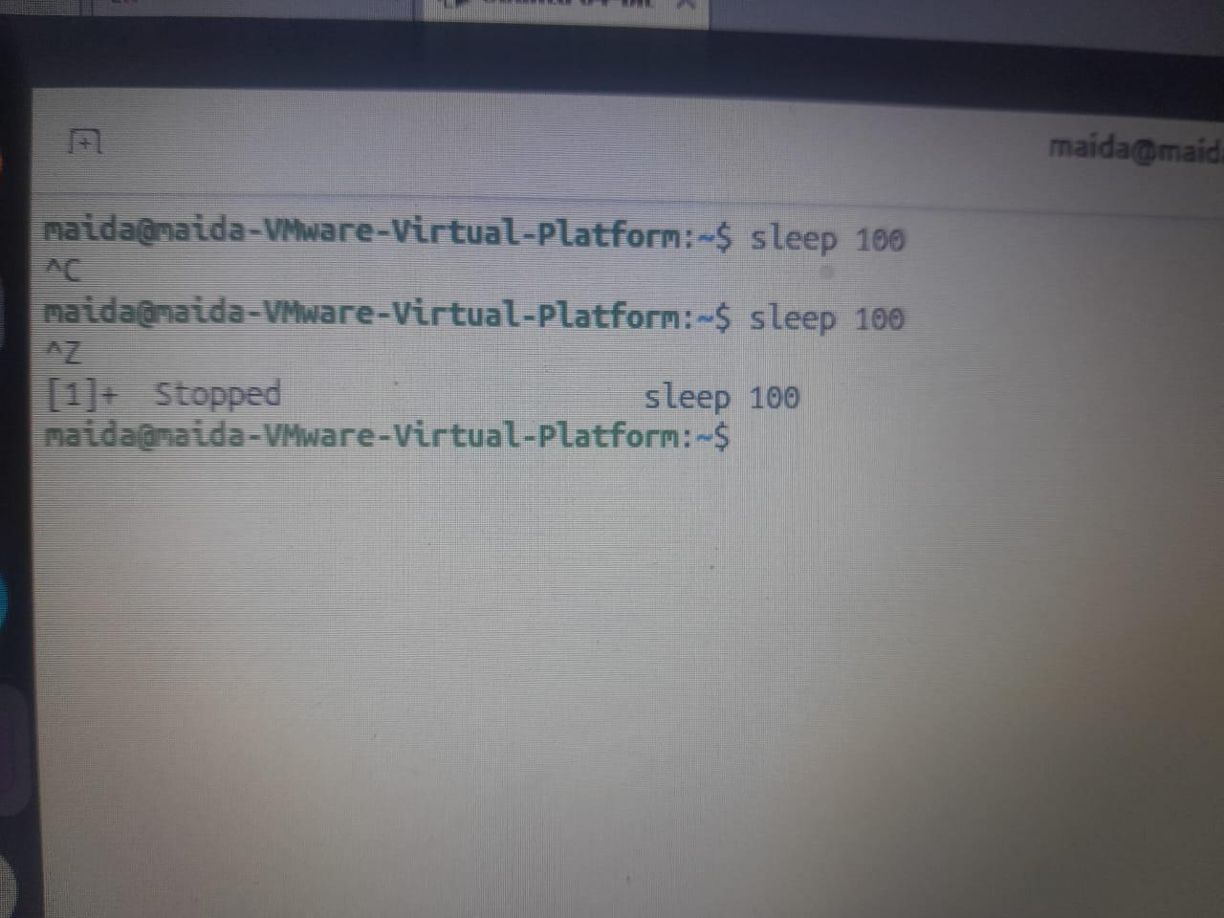

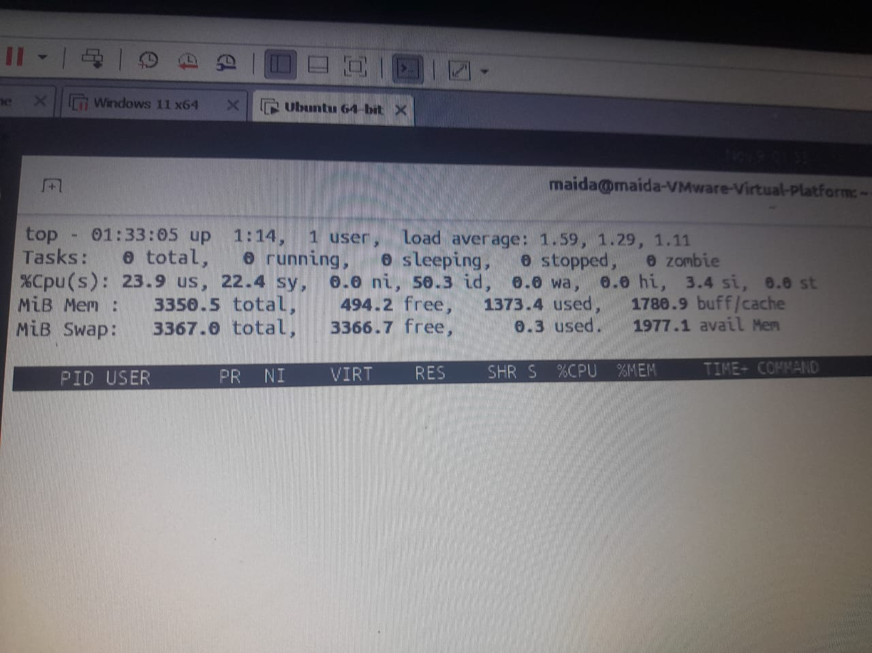

Common mistake: Do not use Ctrl+Z to quit. The program is still there, paused, and holding memory.

9. jobs, bg, and fg
Meaning: jobs lists what this shell is running or holding. bg resumes a stopped job in the background; fg brings a job back to the front.
Syntax
jobs [-l]
bg [%N]
fg [%N]

Flag / Key | Meaning
-l | Also show each job's PID
%N | The job number from jobs
(no %N) | The current job, marked +

Practice
jobs -l # two paused jobs; + is the one bg and fg use by default
bg %1 # job 1 carries on in the background
fg %2 # top fills the screen again; press q to quit it
fg # with no number, fg takes the current job; Ctrl+C ends it

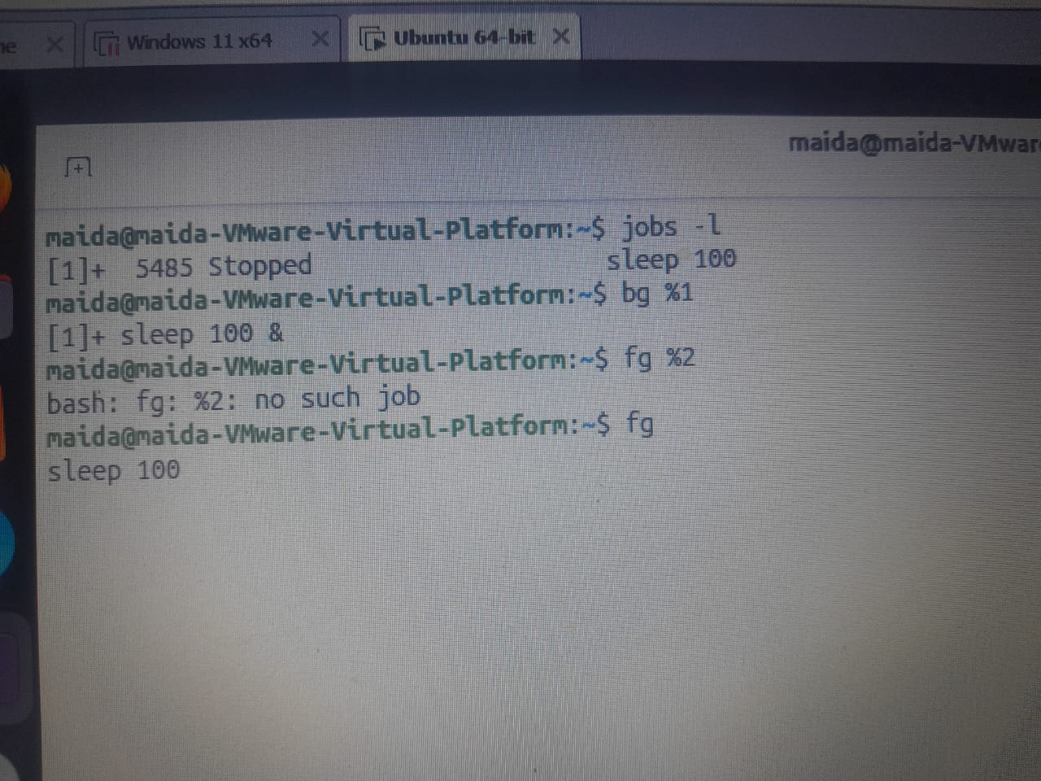

Common mistake: Type fg %1, not fg 1. Jobs belong to one terminal; another terminal's job list is empty.

4.2 Signals, kill, and Priority
A signal is a short message the kernel delivers to a process: finish up, reload, or end now. We send signals with kill, killall, and pkill, and we change how much CPU a process gets with nice and renice.

10. The four signals you need
Meaning: Each signal has a number and a name. You can use either with kill; names are easier to read in your notes.
Syntax
kill -l

No. | Name | How it is usually sent | What it asks the process to do
1 | SIGHUP | kill -HUP PID, or the terminal closes | Hang up. Many services read it as "reload your configuration"
2 | SIGINT | Ctrl+C in the terminal | Interrupt from the keyboard: stop what you are doing
9 | SIGKILL | kill -9 PID | End now. The kernel removes it; it cannot save or clean up
15 | SIGTERM | kill PID (the default) | Please finish and exit. It can save and close files first

Practice
kill -l # lists every signal
kill -l 15 # TERM
kill -l 9 # KILL

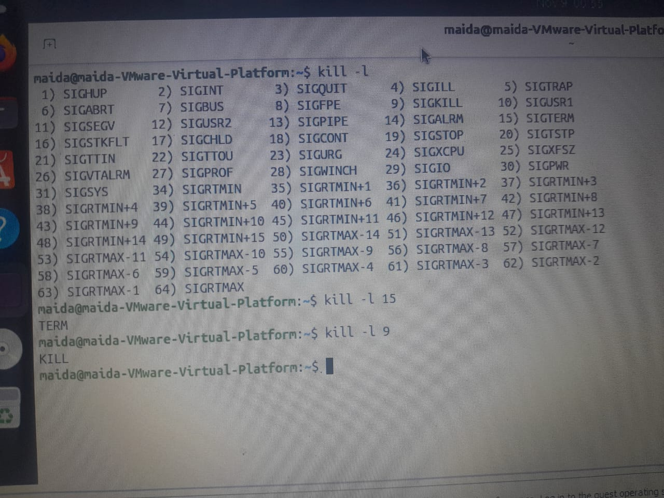

Common mistake: SIGHUP does not always end a program. For many services it means "reload", not "stop".

11. kill – send a signal to a PID
Meaning: kill sends a signal to one process by its number. Without a signal name it sends SIGTERM, the polite request to finish.
Syntax
kill [-SIGNAL] PID
kill %N

Flag / Key | Meaning
(none) | SIGTERM (15)
-TERM | The same, written out
-HUP | Hang up; many daemons reload
%N | A job number from jobs

Practice
sleep 500 & # prints [1] 2610
kill 2610 # default signal is TERM; the shell reports the job ended
kill -TERM 2612 # the same signal, named
kill %1 # a job number instead of a PID
sudo kill -HUP 905 # HUP tells rsyslogd to reopen its log files

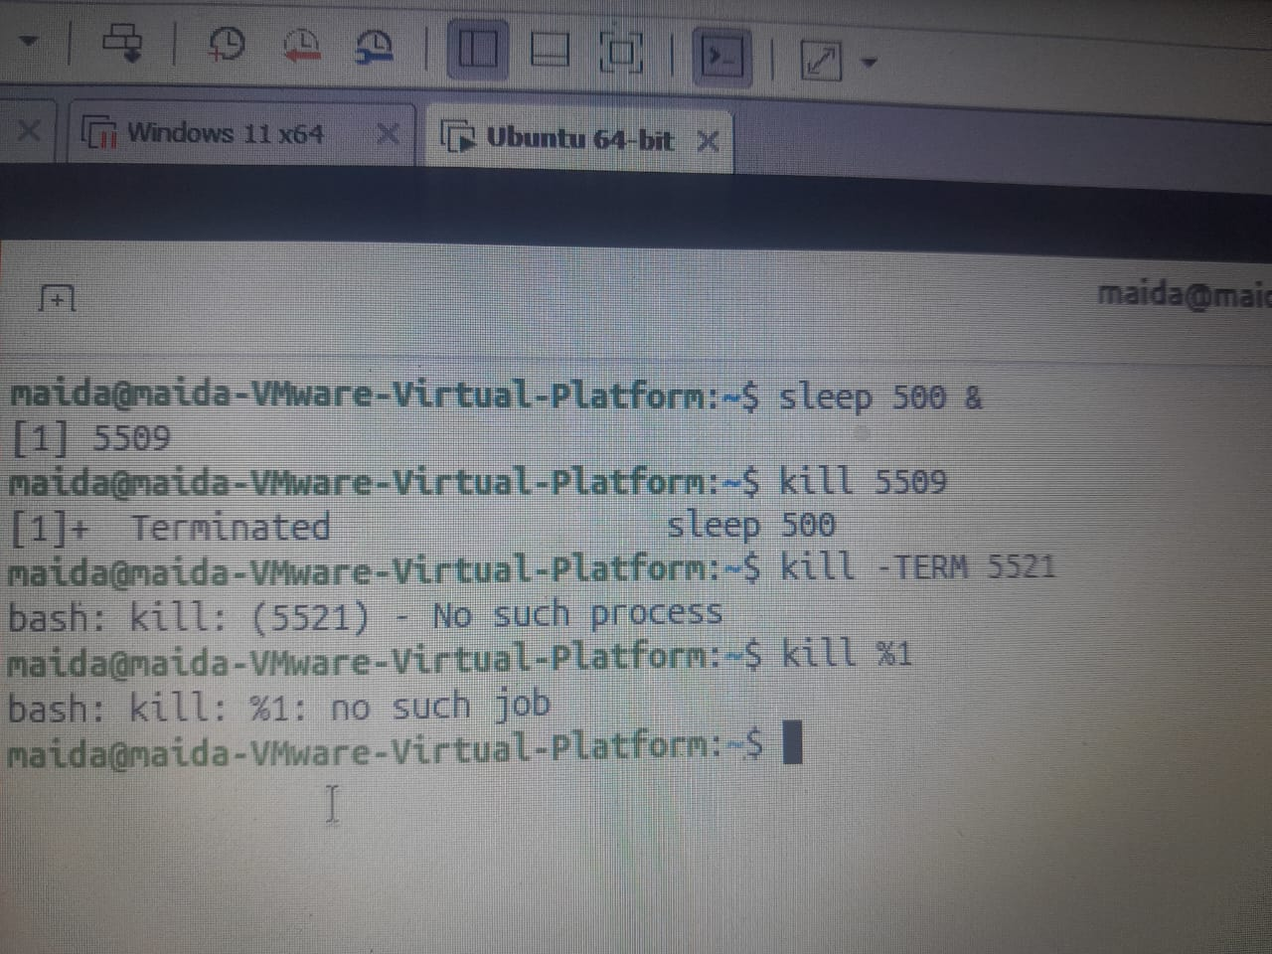

12. TERM first, KILL last
Meaning: SIGKILL ends a process without letting it save or clean up. Ask with TERM, wait a few seconds, check, and only then use -9.
Step | Action | Command
1 | Ask | kill PID
2 | Wait and check | ps -p PID
3 | Still there? Force it | kill -9 PID

Warning: kill -9 is the last resort. The process cannot save files or remove its lock files. Check the PID with ps -p before you press Enter.

Practice
kill 2650 # step 1: ask the stuck script to finish
ps -p 2650 # step 2: wait and check; still listed after a few seconds
kill -9 2650 # step 3: last resort; its unsaved work is lost

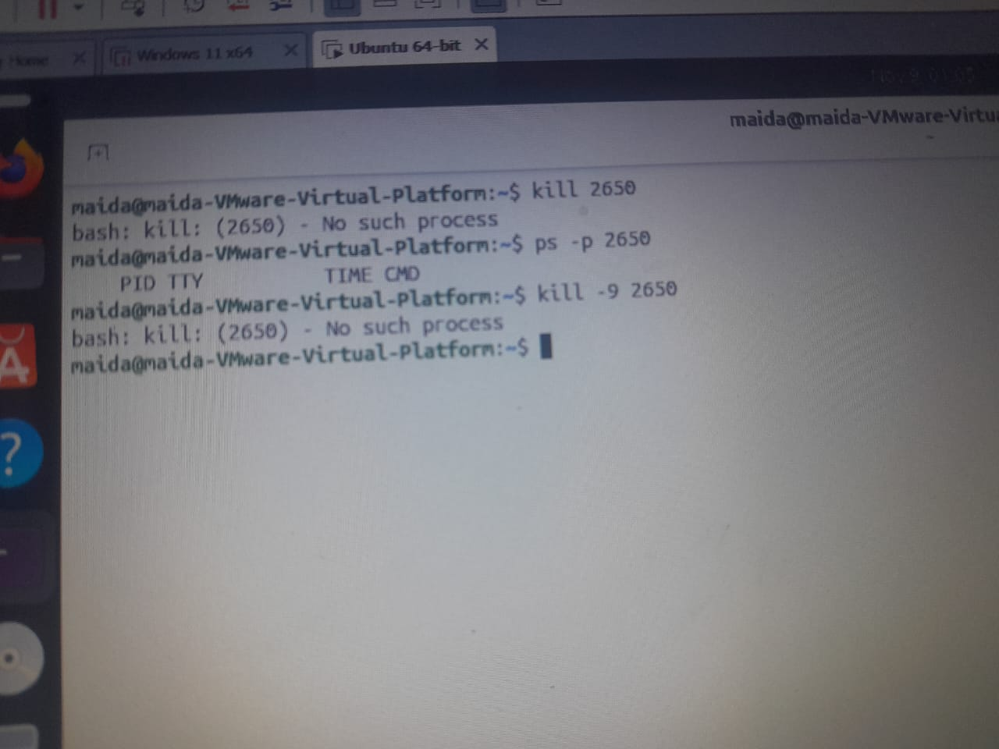

Common mistake: Reaching for kill -9 first out of habit. Most programs stop cleanly with TERM.

13. killall and pkill – by name
Meaning: When you know the name but not the PID, these commands find the matching processes for you. Check first with pgrep: a name can match more than you expect.
Syntax
pgrep -a NAME
pkill [-u USER] NAME
killall NAME

Flag / Key | Meaning
pgrep -a | Show PID and full command
-u USER | Only that user's processes
killall | Matches the exact name
pkill | Matches part of the name

Practice
pgrep -a sleep # look before you act: which processes match?
pkill -u maida sleep # TERM to every sleep you own
killall sleep # prints "sleep: no process found" if nothing is left

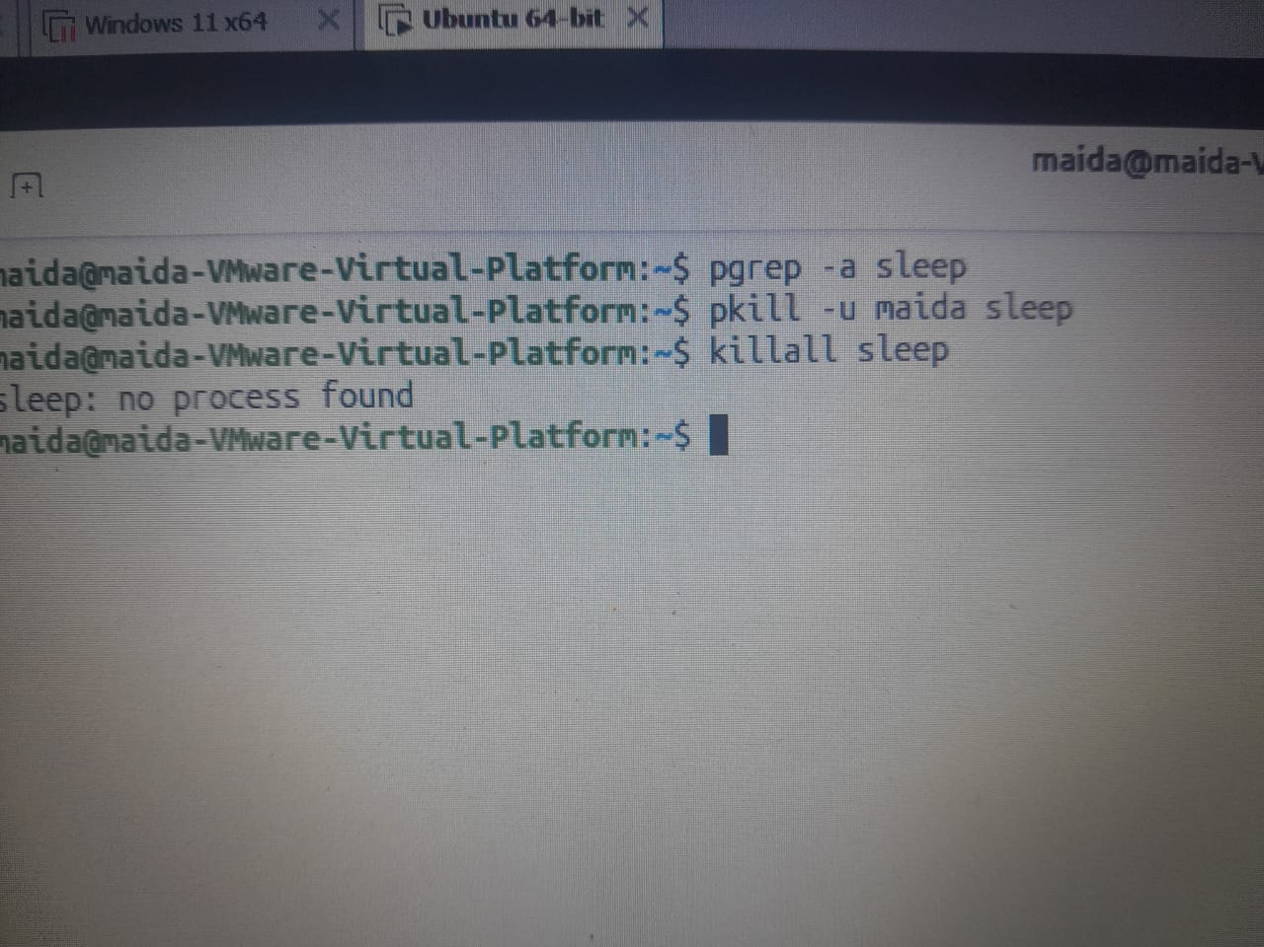
Common mistake: A short pattern such as pkill s matches far more processes than intended.

14. Live example: start, find, stop
Meaning: One complete run you can repeat in the lab: start a background sleep, find it three ways, and end it with TERM.
Practice
sleep 600 & # 1. Start -> [1] 3120
jobs -l # 2. Find (job list)
pgrep -a sleep # Find (by name)
ps -p 3120 -o pid,ppid,stat,cmd # Find (by PID); STAT S = sleeping
kill 3120 # 3. Stop -> [1]+ Terminated
jobs # 4. Confirm: no output, the list is empty
ps -p 3120 # only the header line: the PID is gone

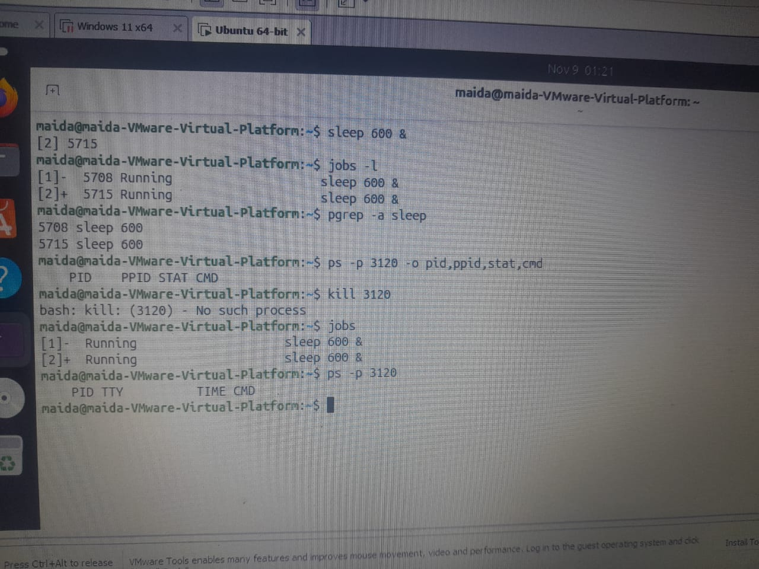

Common mistake: Your PID will be different from the one shown. Read it from your own screen.

15. nice – niceness and starting priority
Meaning: Niceness tells the scheduler how generous a process is with CPU time. It runs from -20 to 19. A higher number is kinder to others; new processes start at 0.
Syntax
nice -n N command

Flag / Key | Meaning
-n N | The niceness to start with
(none) | Print your current niceness
-20 … -1 | Greedier. Only an administrator can set it
0 | Default
1 … 19 | Kinder. Any user can raise it

Practice
nice # prints 0, the default
nice -n 10 sleep 300 & # a low-priority job; prints [1] 3301
ps -o pid,ni,comm -p 3301 # the NI column confirms niceness 10

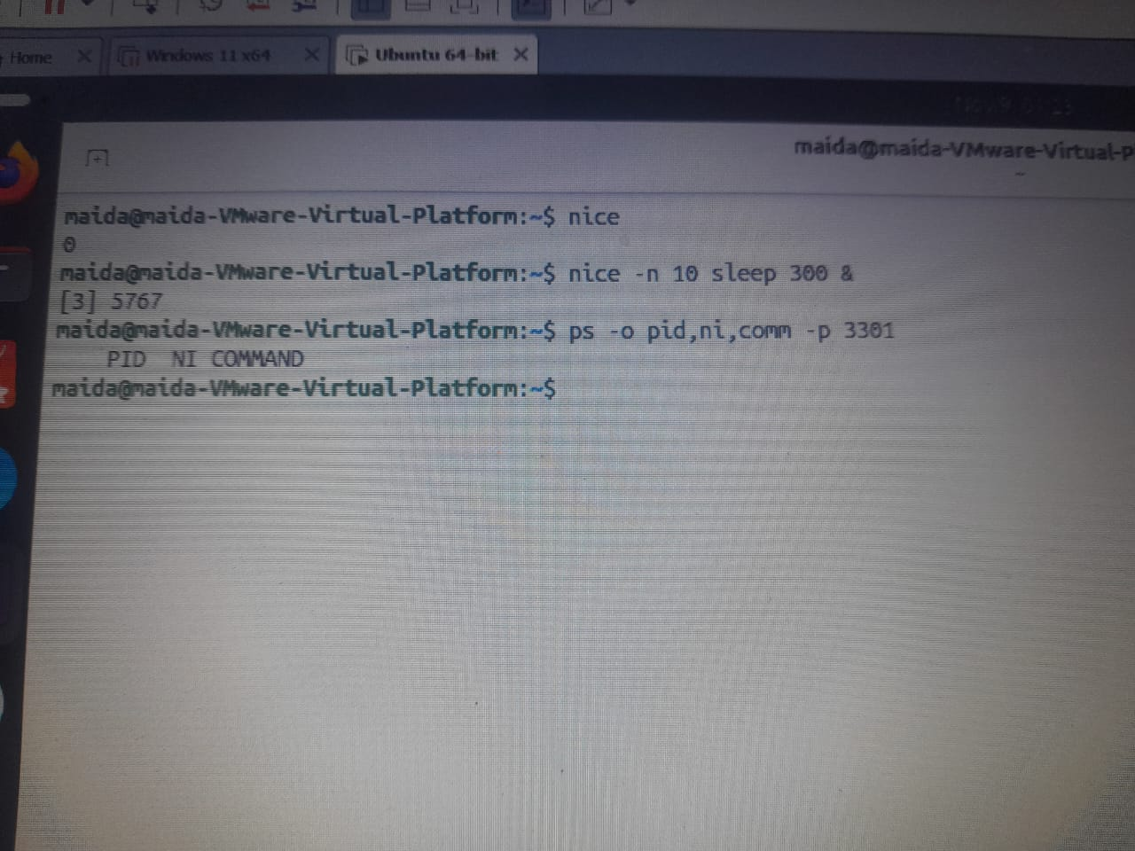

Common mistake: Niceness is not importance. A higher number means less CPU, not more.

16. renice – change a running process
Meaning: renice changes the niceness of a process that is already running. You can always make your own processes kinder; making them greedier needs sudo.
Syntax
renice -n N -p PID

Flag / Key | Meaning
-n N | The new niceness
-p PID | Which process
r in top | Type a PID to renice from inside top

Practice
renice -n 15 -p 3301 # allowed: kinder for your own process
renice -n 5 -p 3301 # Permission denied: a normal user cannot lower niceness
sudo renice -n 5 -p 3301 # the administrator can
top -p 3301 # watch the NI column for that one process

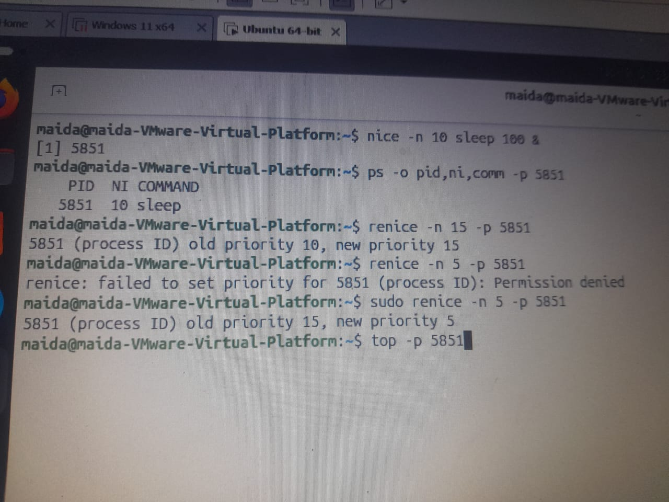

Common mistake: Forgetting -p, so renice reads the PID as something else and fails.

4.3 System Information
Before we fix anything, we need facts: which kernel is running, how long the machine has been up, how much memory and CPU it has, and which disks it sees. Several of these tools simply read files under /proc and /sys.

17. uname – kernel and machine facts
Meaning: uname prints facts about the running kernel and the hardware type it runs on.
Syntax
uname [-r] [-m] [-n] [-a]

Flag / Key | Meaning
-r | Kernel release
-m | Machine type (CPU architecture)
-n | Hostname
-a | All fields on one line

Practice
uname -r # kernel release, for example 6.8.0-85-generic
uname -m # x86_64 = 64-bit Intel or AMD (a Raspberry Pi shows aarch64)
uname -n # the hostname, the same one in your prompt
uname -a # everything at once, ready to paste into a lab report

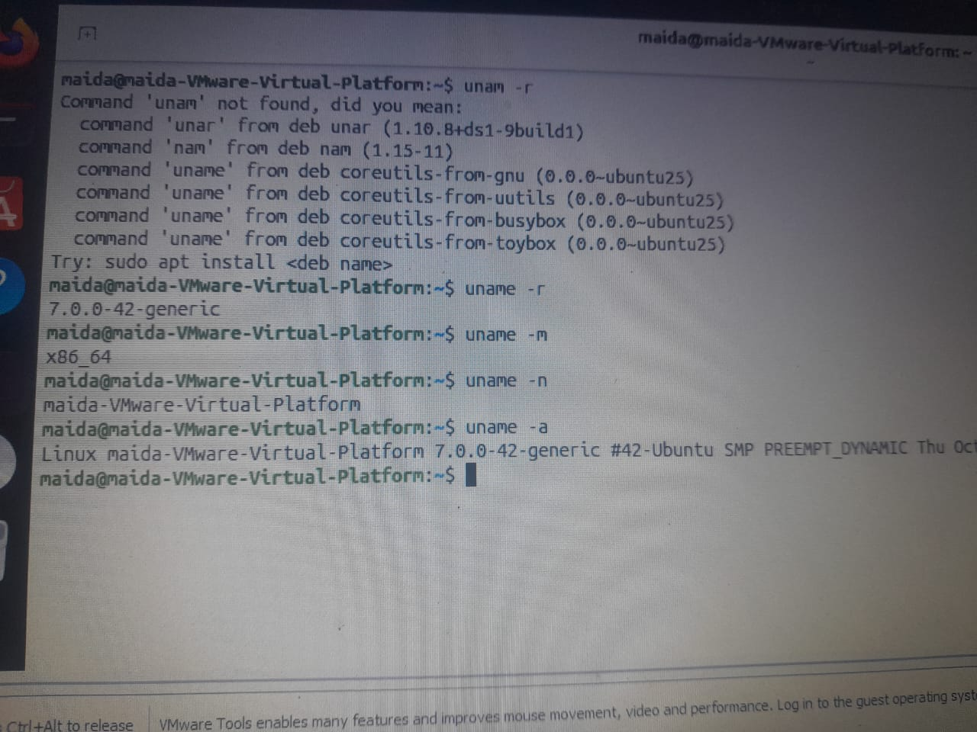

Common mistake: The kernel release is not the Ubuntu version. 6.8.0 is the kernel; 24.04 is the distribution.

18. hostnamectl – the system in one block
Meaning: hostnamectl shows the hostname together with the OS, the kernel, and whether the machine is virtual.
Syntax
hostnamectl [hostname]

Flag / Key | Meaning
(none) | The full summary
hostname | Print only the hostname

Practice
hostnamectl # "oracle" and "VirtualBox" show this is a virtual machine
hostnamectl hostname # only the name, nothing else

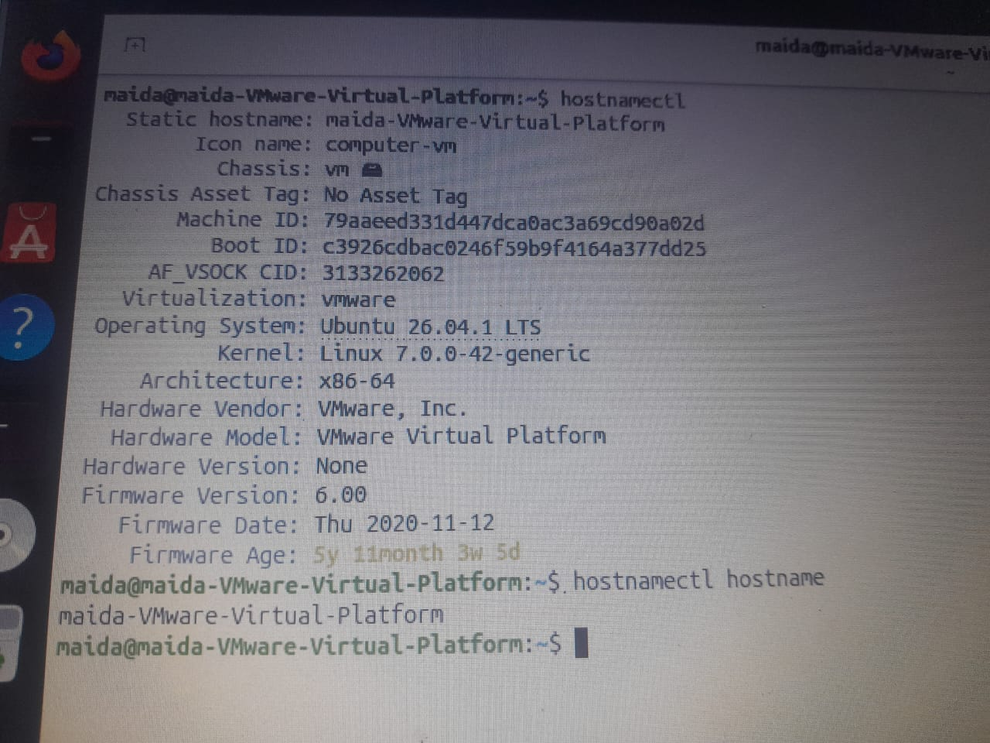

Common mistake: "Operating System" and "Kernel" are not the same thing. Compare them with uname -r. (Changing the hostname needs sudo; we only read it this week.)

19. uptime and the load average
Meaning: uptime shows the time, how long the system has been running, how many users are logged in, and the load average.
Syntax
uptime [-p] [-s]

Flag / Key | Meaning
-p | Time since boot, in words
-s | When the system booted
Load average | Three numbers: the last 1, 5, and 15 minutes. It counts processes running or waiting. Compare it with your CPU count from nproc: below it, there is spare capacity

Practice
uptime # load average: 0.08, 0.12, 0.10 (near zero means idle)
uptime -p # up 2 hours, 41 minutes
uptime -s # when it last booted; useful after an unexpected restart
nproc # 2 CPUs, so a load near 2.0 means both are busy

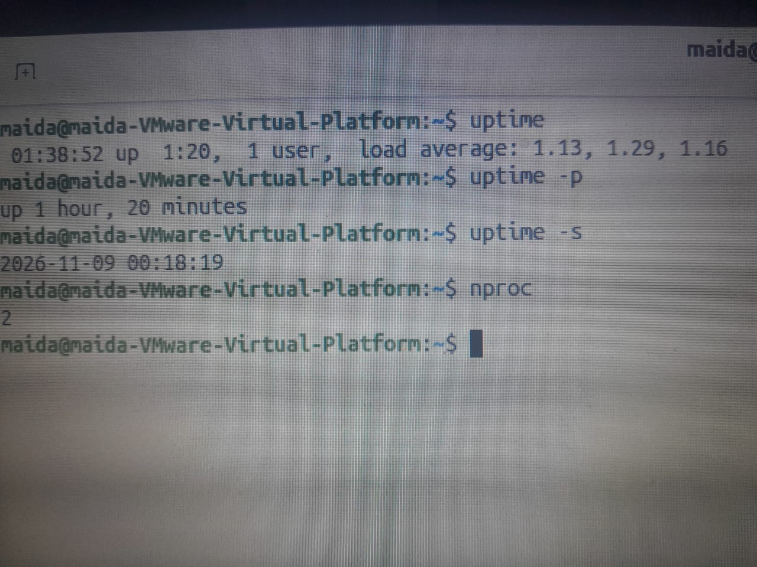
Common mistake: The load average is not a percentage. It is a count of processes, compared with the CPU count.

20. free -h – memory and swap
Meaning: free reports how much RAM and swap is in use and how much is still available to programs.
Syntax
free [-h] [-m] [-s N]

Flag / Key | Meaning
-h | Human units (Mi, Gi)
-m | Mebibytes
-s N | Repeat every N seconds; Ctrl+C stops

Practice
free -h # read the "available" column, not "free"
free -m # the same table in MiB
free -h -s 2 # a new table every 2 seconds while you open an app

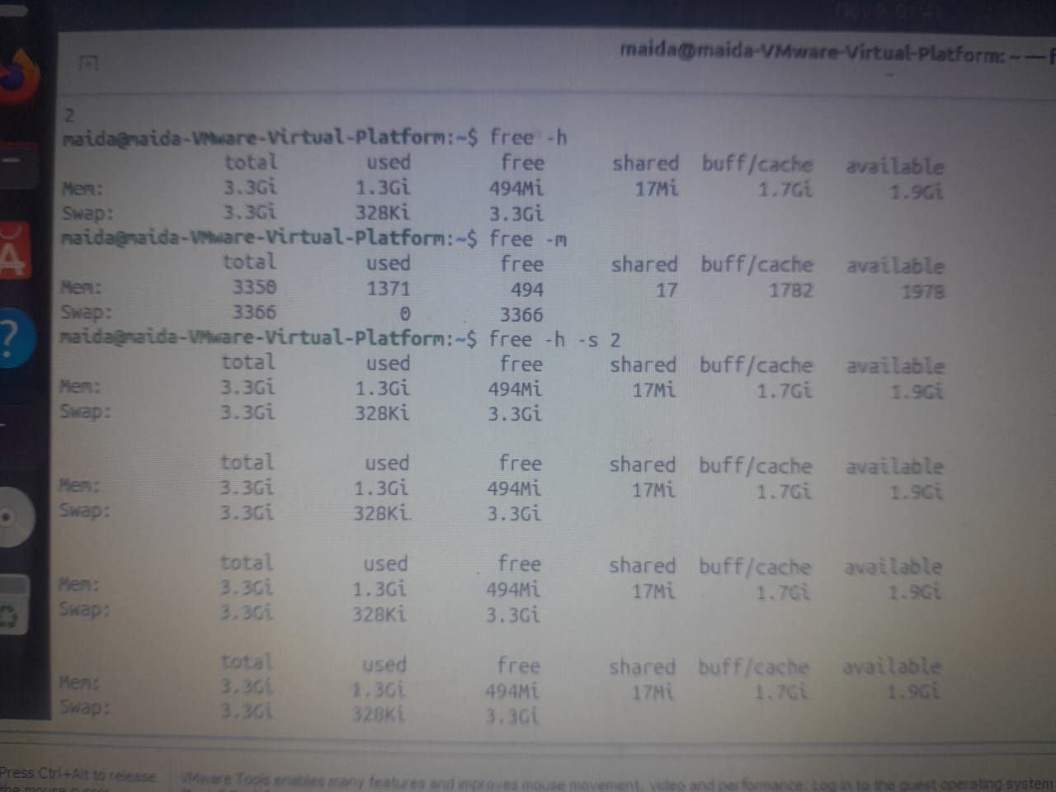

Common mistake: Do not panic at a small "free" value. Linux uses spare RAM as disk cache and gives it back when programs need it; the "available" column is the one that matters.

21. lscpu and nproc – the processor
Meaning: lscpu summarises the processor: architecture, number of CPUs, model, and whether it runs under a hypervisor. nproc prints only the number of CPUs.
Syntax
lscpu
nproc

Flag / Key | Meaning
lscpu | The full CPU summary
nproc | Only the number of CPUs

Practice
lscpu # a Hypervisor vendor line shows this is a VM
lscpu | less # Space for more, q to quit
nproc # just the count; use it next to the load average
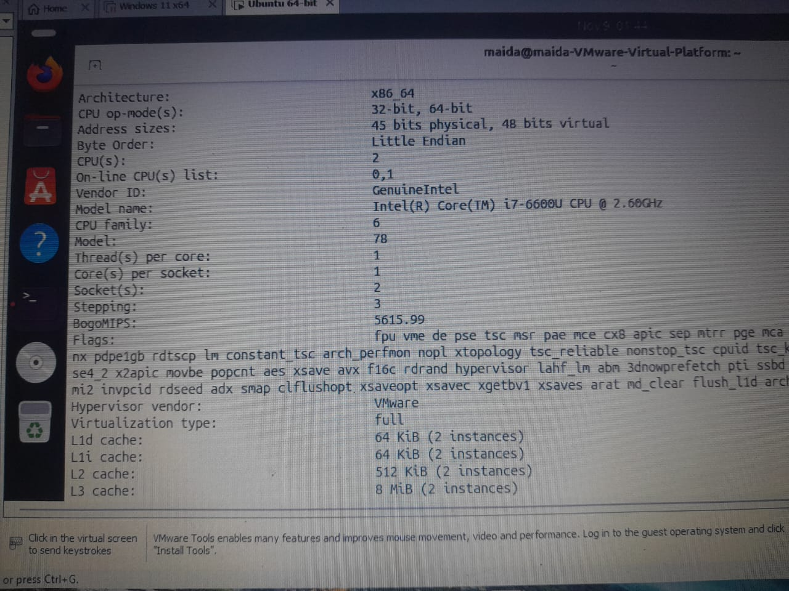

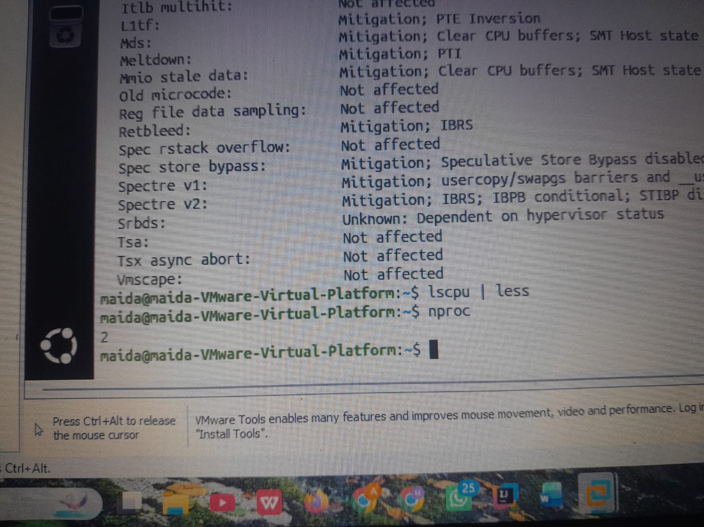

Common mistake: A VM shows the CPUs you gave it in VirtualBox, not every core of the host. Compare with the VM's System > Processor setting.

22. lsblk – what disks are here?
Meaning: lsblk lists the block devices the kernel can see: disks, their partitions, and the CD drive. Today we only ask what is attached.
Syntax
lsblk [options]

Flag / Key | Meaning
-e 7 | Hide loop devices
-d | Whole disks only
-o COLS | Choose the columns

Practice
lsblk -e 7 # one 25 GB virtual disk (sda) and the virtual CD drive (sr0)
lsblk -e 7 -d -o NAME,SIZE,MODEL # disks only, with the model

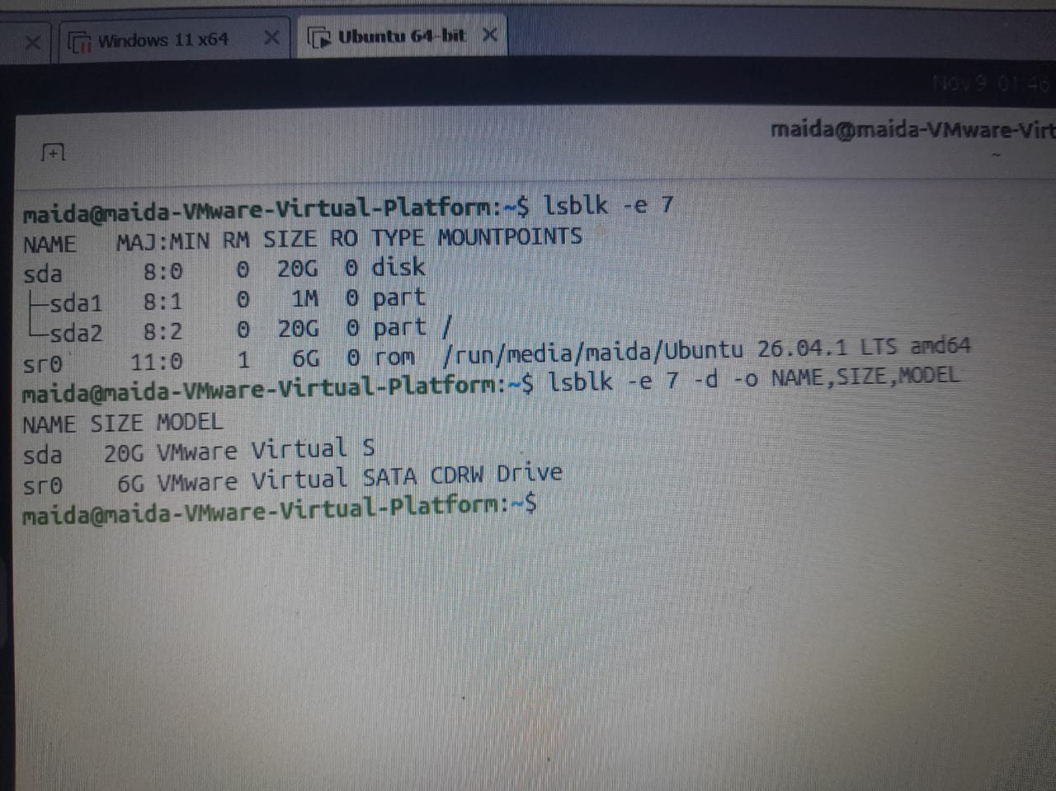
Common mistake: Each loop device is not a real disk. Loop devices come from snap packages. (Partitions and mounting are in Chapter 6.)

23. /proc – the kernel's live window
Meaning: /proc is not a folder on the disk. The kernel builds its files in memory each time you read them, so they always describe the system as it is now.
Location | Meaning
/home (a normal folder) | Files are stored on the disk; size is the bytes held; they stay after a reboot
/proc (a kernel interface) | Files are generated when you read them; they show size 0 but are full of text; numbered folders are PIDs

Practice
ls /proc # numbered folders are PIDs; named files describe the system
ls -l /proc/meminfo # size 0, yet full of text
cat /proc/uptime # seconds since boot; uptime reads this file
cat /proc/loadavg # the three load averages that uptime prints

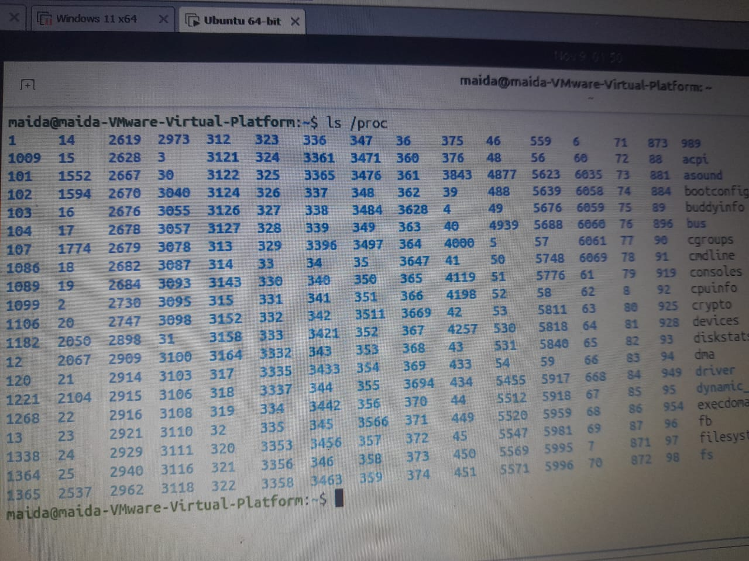

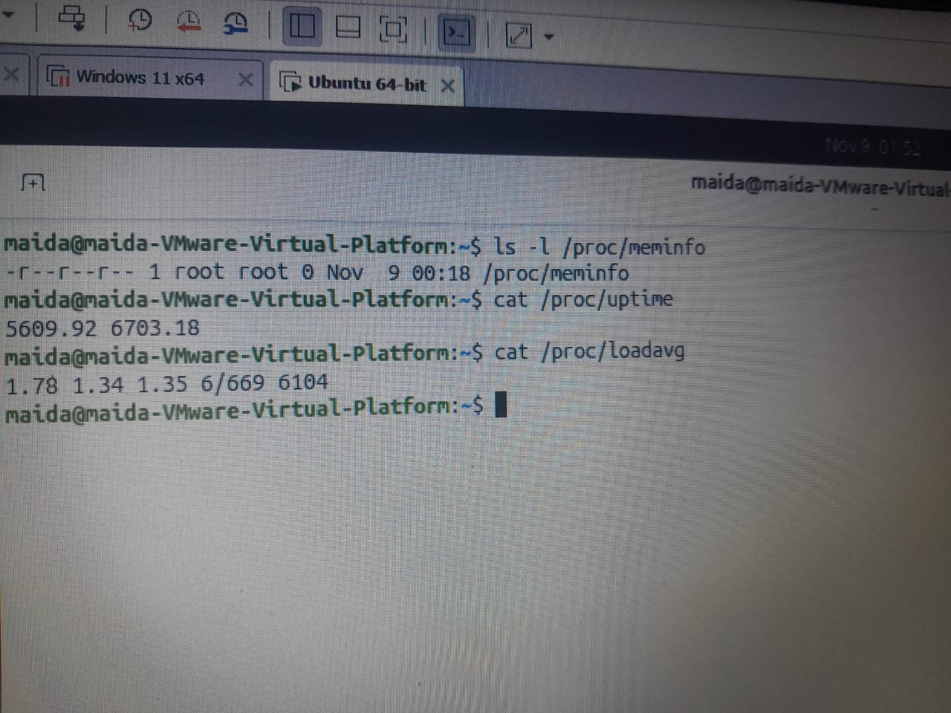

Common mistake: Do not try to edit or back up /proc like normal files. It is generated by the kernel; just read it.

24. /proc/<pid> – one folder per process
Meaning: Each running process has a folder named after its PID. Inside it, the kernel describes that process: name, state, parent, and more.
Syntax
/proc/PID/FILE

Flag / Key | Meaning
status | Name, state, PID, PPID
comm | The short command name
cmdline | The full command line
exe | A link to the program file
$$ | Your shell's PID, so /proc/$$ is your own shell's folder

Practice
ls /proc/$$ # every process gets the same set of files
head -n 7 /proc/$$/status # the PID and PPID that ps showed, read straight from the kernel
cat /proc/1/comm # systemd

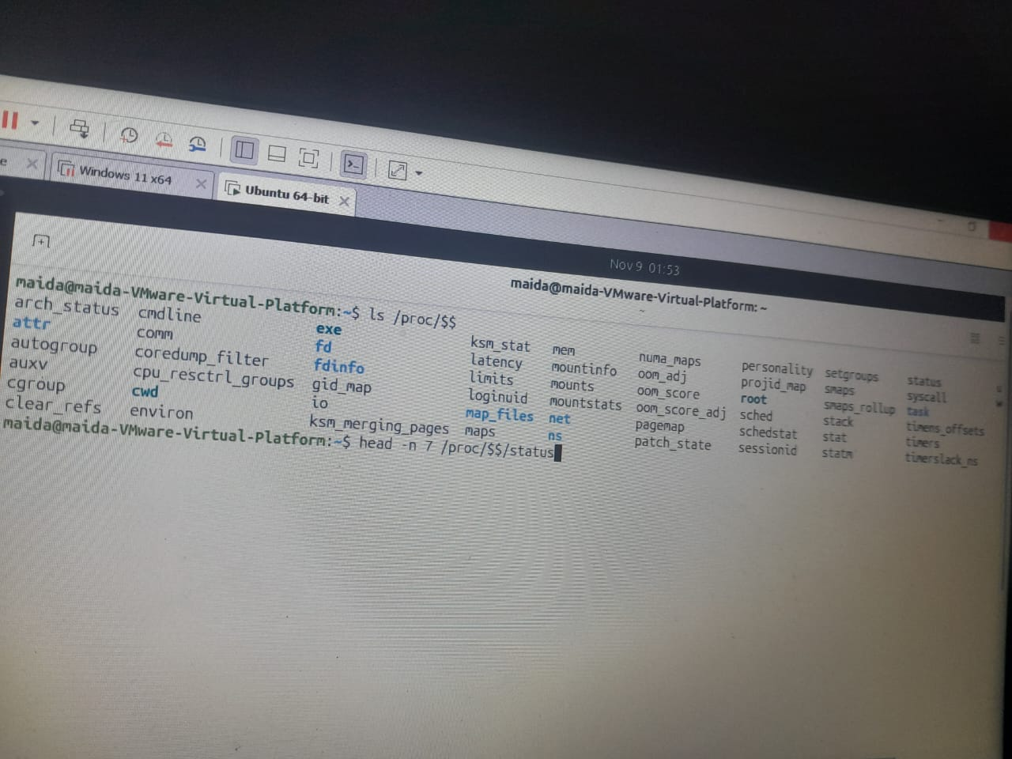

Common mistake: Do not type /proc/PID literally. Replace PID with a real number, or use $$ for your shell.

25. /proc/cpuinfo and /proc/meminfo
Meaning: lscpu and free are friendly readers of /proc files. You can read the raw files yourself and match the numbers.
Tool | Meaning
lscpu, nproc | Read /proc/cpuinfo
free | Reads /proc/meminfo
uptime | Reads /proc/uptime and /proc/loadavg
ps, top | Read /proc/<pid>/

Practice
grep -m 1 "model name" /proc/cpuinfo # the CPU model; lscpu shows the same text
grep -c ^processor /proc/cpuinfo # one block per CPU: the same count as nproc
head -n 3 /proc/meminfo # in kB; MemAvailable is free's "available" column

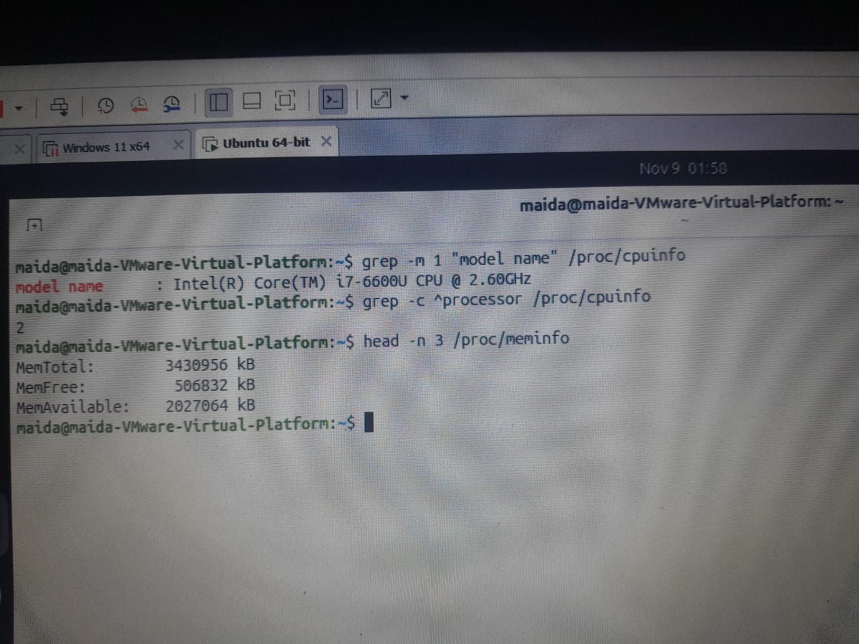

Common mistake: Do not expect identical numbers. free -h rounds to Gi; the raw file is in kB.

26. /sys – devices as files
Meaning: /sys is the kernel's map of hardware and drivers, sorted into categories. Like /proc, it lives in memory. We only read it.
Syntax
ls /sys/CATEGORY
cat /sys/.../FILE

Flag / Key | Meaning
block | Disks, as lsblk sees them
class | Devices grouped by type
class/net | One folder per network card

Practice
ls /sys # the top-level categories
ls /sys/block # the same disks lsblk listed
ls /sys/class/net # one folder per network interface
cat /sys/class/net/enp0s3/address # the network card's hardware address
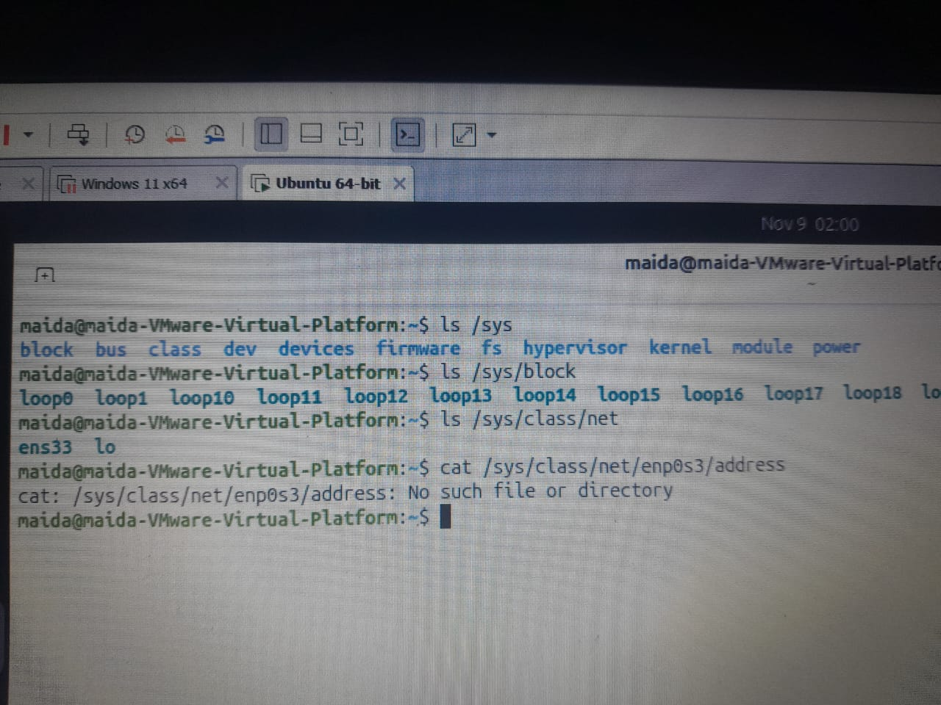
Common mistake: Interface names such as enp0s3 vary by machine. Use the name shown on your own VM. (Networking itself is in Chapter 7.)

4.4 Services with systemd
A service is a program that runs in the background for a long time, waiting for work: cron, the logging daemon, the SSH server. On Ubuntu, systemd starts them at boot, and we control them with systemctl.

27. systemd is PID 1
Meaning: The kernel starts one process, systemd. systemd then starts and watches every service, each described by a unit file ending in .service (for example cron.service, rsyslog.service, systemd-journald.service).
Practice
ps -p 1 -o pid,comm # the first process is systemd
systemctl cat cron # shows the unit file: what systemd runs
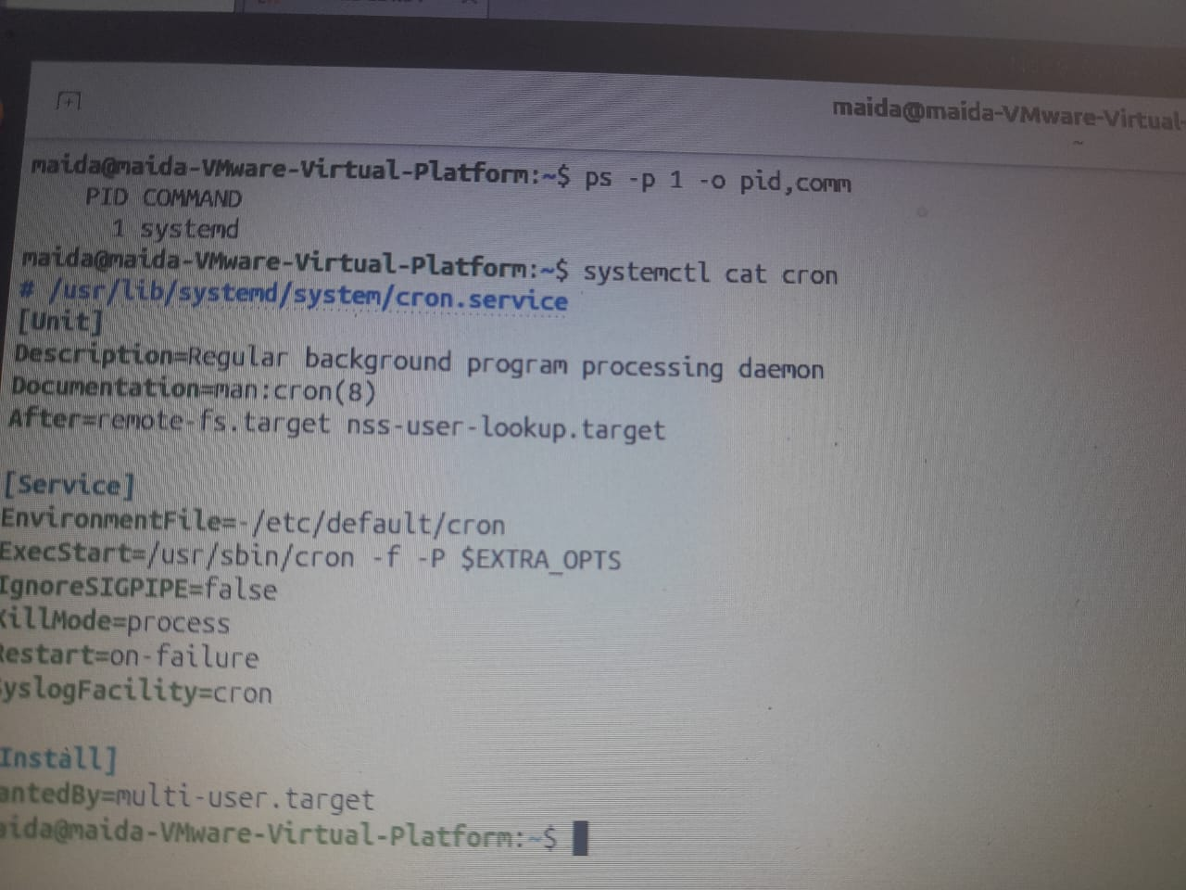
Common mistake: Here cron is only a safe service to practise on. We read unit files; we do not edit them. (Scheduling is in Chapter 8.)

28. systemctl status – your first question
Meaning: status is the first command to run for any service. It shows whether the service is enabled at boot, running now, and what it last logged.
Syntax
systemctl status UNIT

What you read | Meaning
Loaded … enabled | It will start at every boot
Active: active (running) | It is up right now. A red "failed" means trouble
Main PID | The service's process: the PID that ps and top show
Last lines | Its most recent log entries. More with journalctl -u

Practice
systemctl status cron # press q if a pager opens
systemctl is-active cron # active
systemctl is-enabled cron # enabled

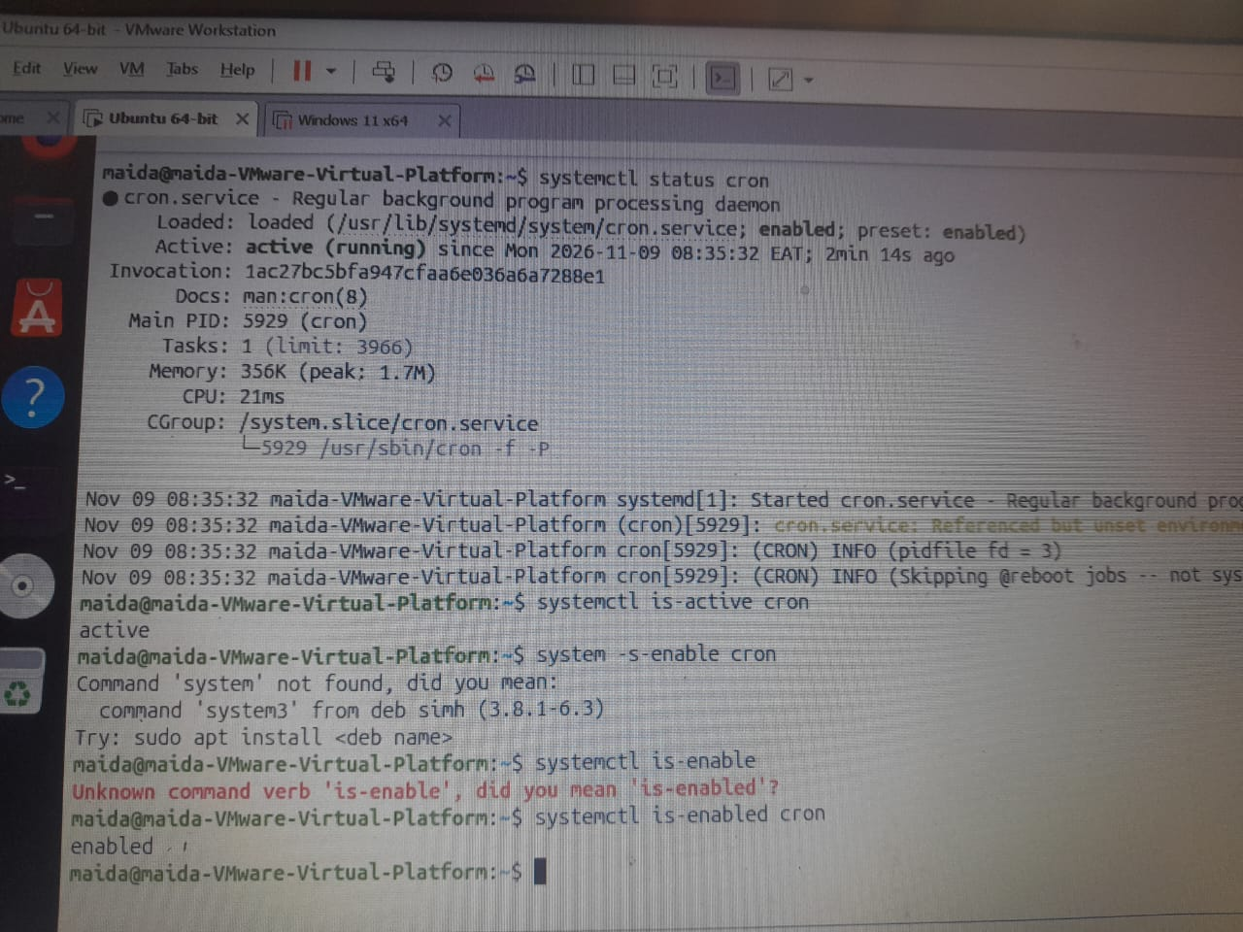

Common mistake: Do not read only the green dot. Read the "Loaded" line too: running now and enabled at boot are separate answers.

29. start, stop, restart
Meaning: These change what the service is doing right now. They need administrator rights, so we prefix them with sudo.
Syntax
sudo systemctl ACTION UNIT

Action | Meaning
start | Start it now
stop | Stop it now
restart | Stop, then start: a new PID

Practice
sudo systemctl stop cron # no output means it worked
systemctl is-active cron # inactive
sudo systemctl start cron
systemctl is-active cron # active
sudo systemctl restart cron
systemctl show -p MainPID cron # a new process: the PID changed

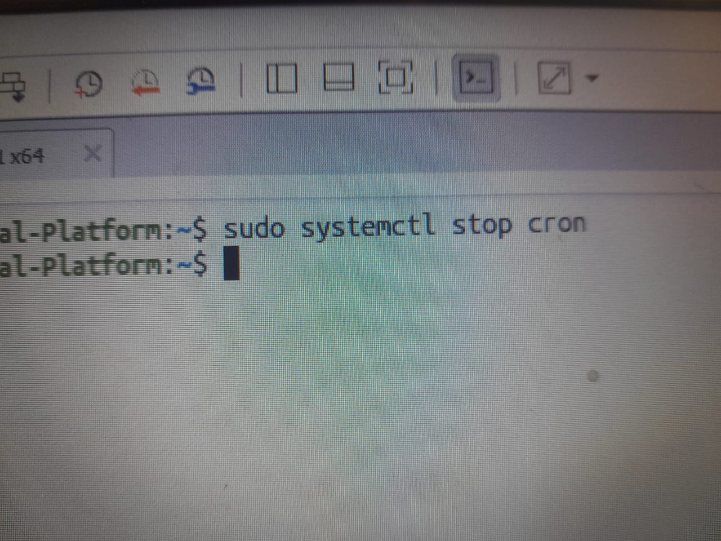

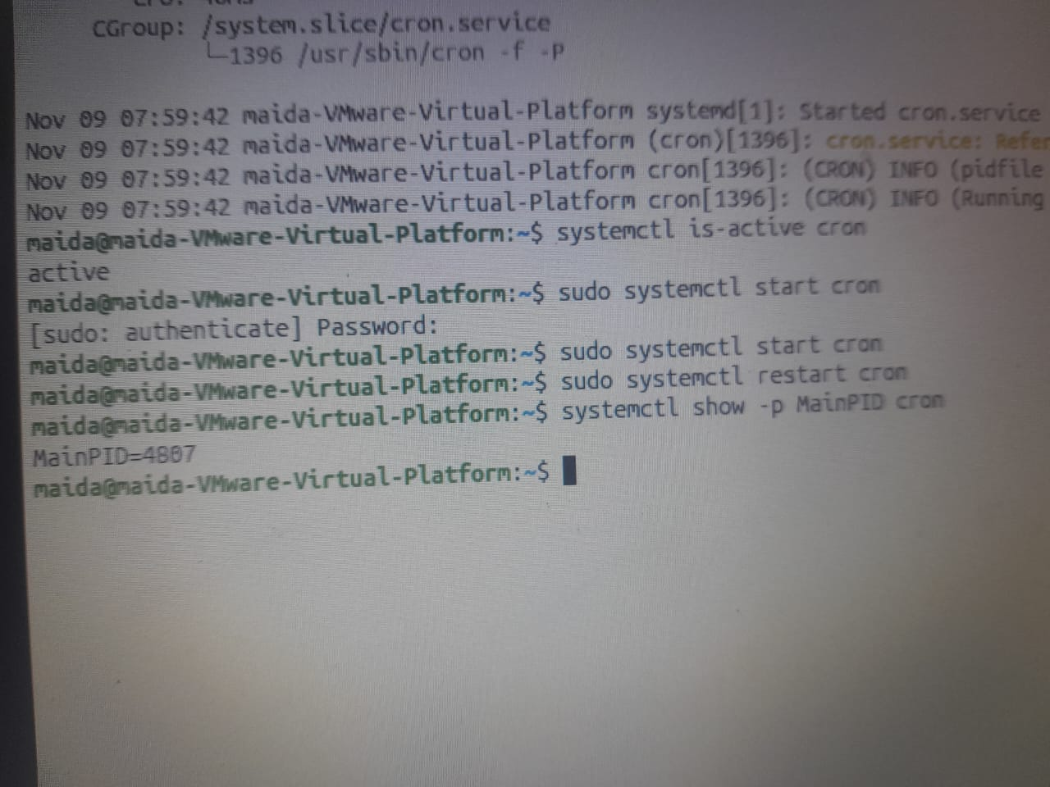

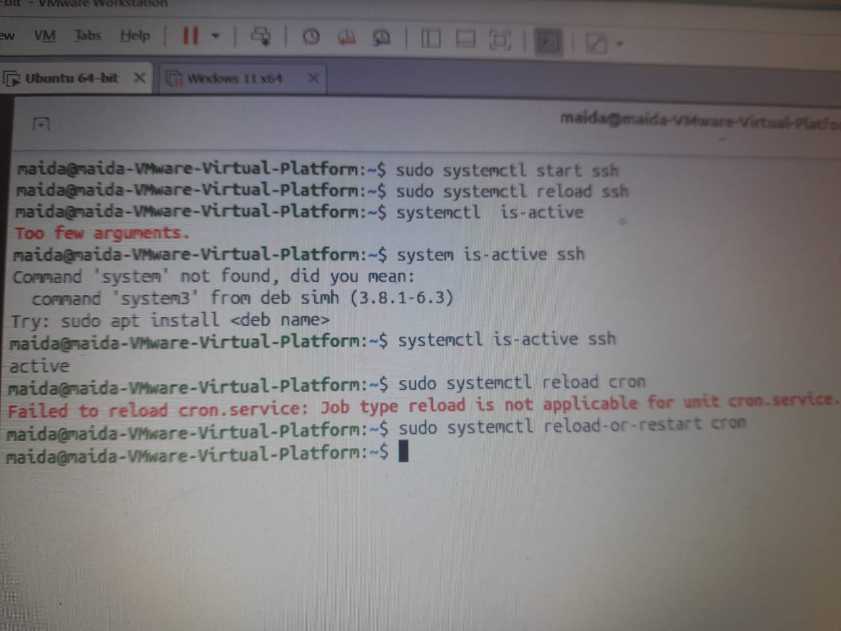

Common mistake: Typing systemctl start without sudo shows an authentication prompt or error. Check the result with is-active.

30. reload or restart?
Meaning: reload asks a running service to re-read its configuration without stopping. Not every service supports it, and systemctl tells you when it does not.
Syntax
sudo systemctl reload UNIT
sudo systemctl reload-or-restart UNIT

Action | Meaning
restart | Stops the service and starts it again. New PID. Connections drop for a moment. Works for every service
reload | Same process re-reads its config files (often done with SIGHUP from 4.2). No interruption, but only some services support it
reload-or-restart | Reload if the service supports it, otherwise restart

Practice
sudo systemctl reload ssh # if openssh-server is installed: settings reload, sessions stay up
sudo systemctl reload cron # fails: cron has no reload action
sudo systemctl reload-or-restart cron # reload if possible, otherwise restart

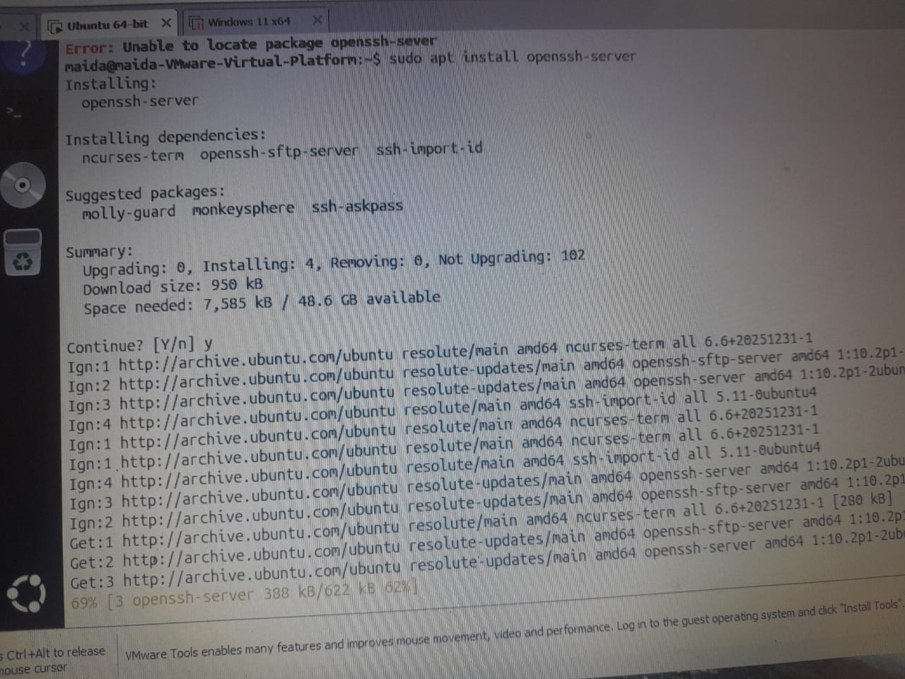

Common mistake: Restarting a busy server when reload would do. Restart drops its connections.

31. enable, disable, and --now
Meaning: enable and disable decide whether the service starts at the next boot. They leave the running process alone unless you add --now.
Syntax
sudo systemctl enable UNIT
sudo systemctl disable UNIT

Flag / Key | Meaning
enable | Start at every boot
disable | Do not start at boot
--now | Also start or stop it immediately

Practice
sudo systemctl disable cron # boot setting off; cron keeps running until stopped or reboot
systemctl is-enabled cron # disabled
sudo systemctl enable --now cron # enabled for boot and started now, in one command

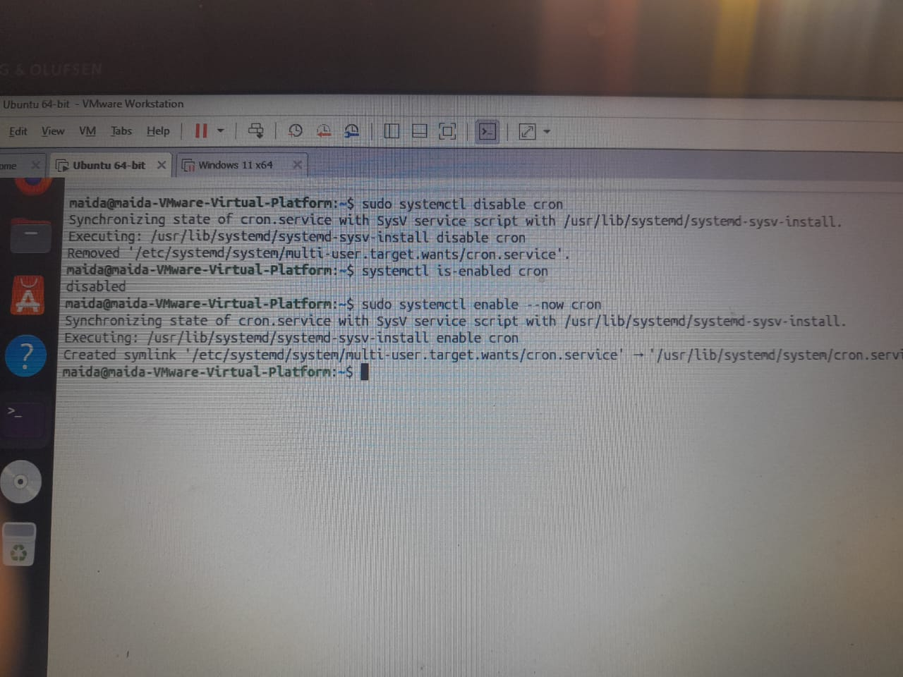
Common mistake: disable does not stop the service. It only changes what happens at the next boot.

32. stop is now; disable is at boot
Meaning: Two separate switches. One controls the process running now; the other controls what happens at the next boot.
Command | Right now | At next boot
stop | Ends | Starts again if enabled
disable | Keeps running | Does not start
disable --now | Ends | Does not start
enable --now | Starts | Starts

Warning: Do not stop or disable ssh on a machine you reach only over SSH: you cut off your own login. Make sure you have a console first, such as the VirtualBox window.

Practice
systemctl is-active cron # now?
systemctl is-enabled cron # at boot?

33. list-units – which services are running?
Meaning: list-units shows what systemd has loaded. Filter by type and state to see what is running, or whether anything failed.
Syntax
systemctl list-units --type=service --state=STATE

Flag / Key | Meaning
--type=service | Only services
--state=running | Only running units
--state=failed | Only failed units

Practice
systemctl list-units --type=service --state=running # q leaves the pager
systemctl list-units --type=service --state=failed # "0 loaded units listed" is a good sign

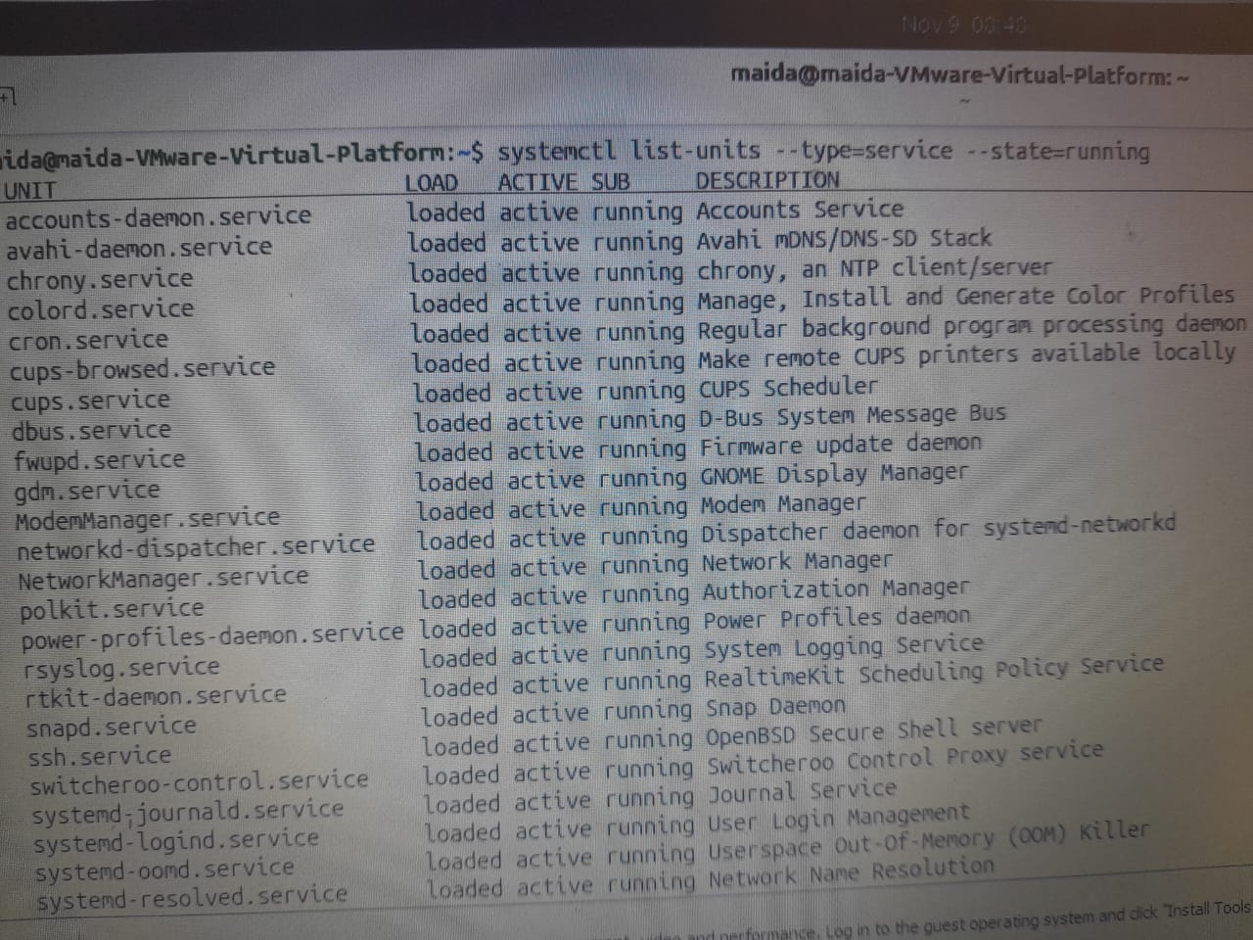

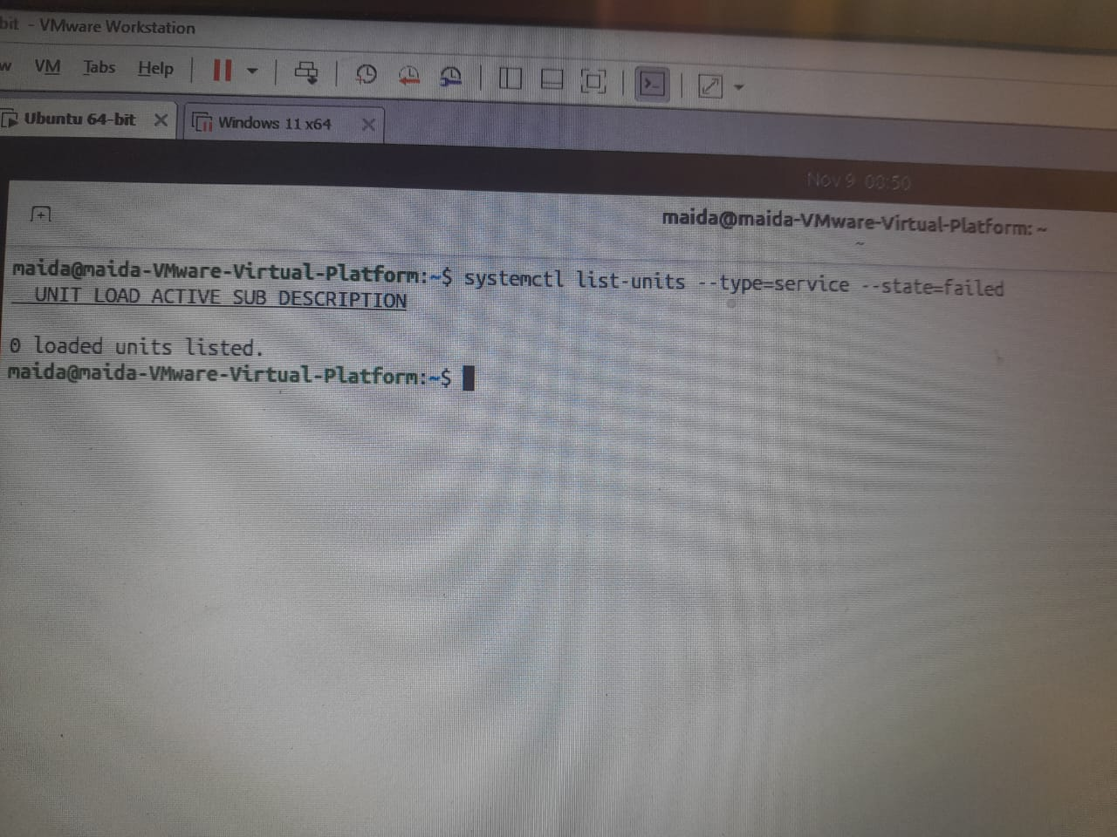

Common mistake: Do not write --type service=running. Type and state are two separate options.

4.5 Logs, Boot, and First Troubleshooting
When something fails, Linux has usually written down why. We read the systemd journal, the text logs in /var/log, and kernel messages. Then we shut down cleanly and follow a calm order when something breaks.

34. journalctl – reading the journal
Meaning: The systemd journal collects messages from the kernel and every service. journalctl reads it, oldest first, inside a pager.
Syntax
journalctl [options]

Flag / Key | Meaning
-n N | The last N entries
-b | This boot only
-p err | Errors and worse
G | Jump to the end (inside the pager)
q | Quit

Practice
journalctl -n 3 # time, host, program[PID], and the message
journalctl -b # everything since this boot; G jumps to the end, q quits
journalctl -b -p err # only errors from this boot: a short list worth reading

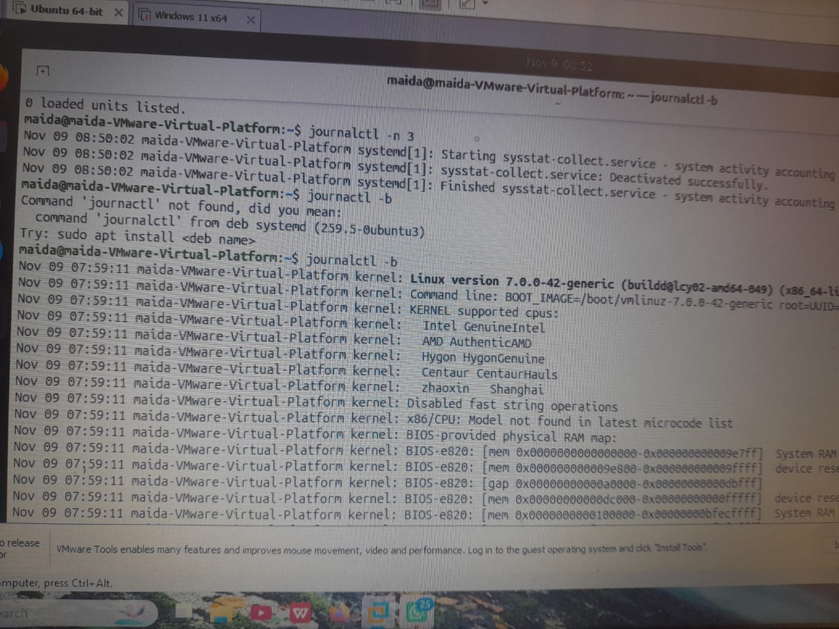

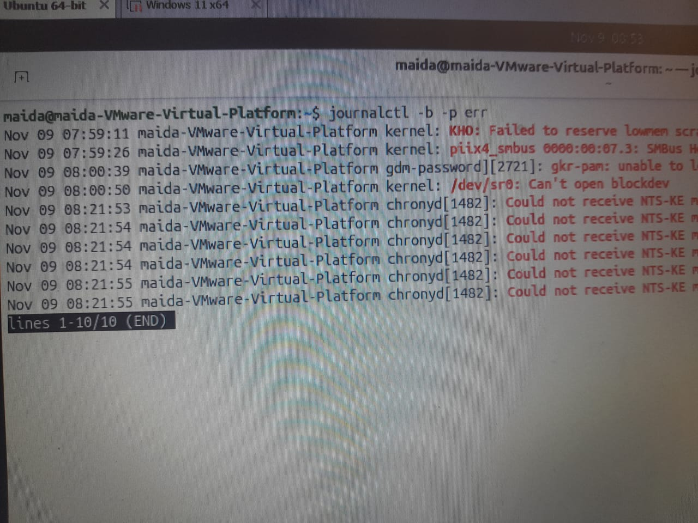

Common mistake: Do not scroll from the top of a huge journal. Use -n, -b, or G to start near the end. If you see "insufficient permissions", add sudo.

35. journalctl -u – one service's story
Meaning: -u narrows the journal to one unit. This is what you read after systemctl status shows a problem.
Syntax
journalctl -u UNIT [options]

Flag / Key | Meaning
-u UNIT | One service only
-n N | The last N entries
--since | A start time, such as "1 hour ago"
Practice
journalctl -u cron -n 4 # our stop and start from 4.4, recorded by systemd
journalctl -u cron --since "1 hour ago" # only the last hour
journalctl -u ssh -n 20 # if ssh is installed: its last 20 lines

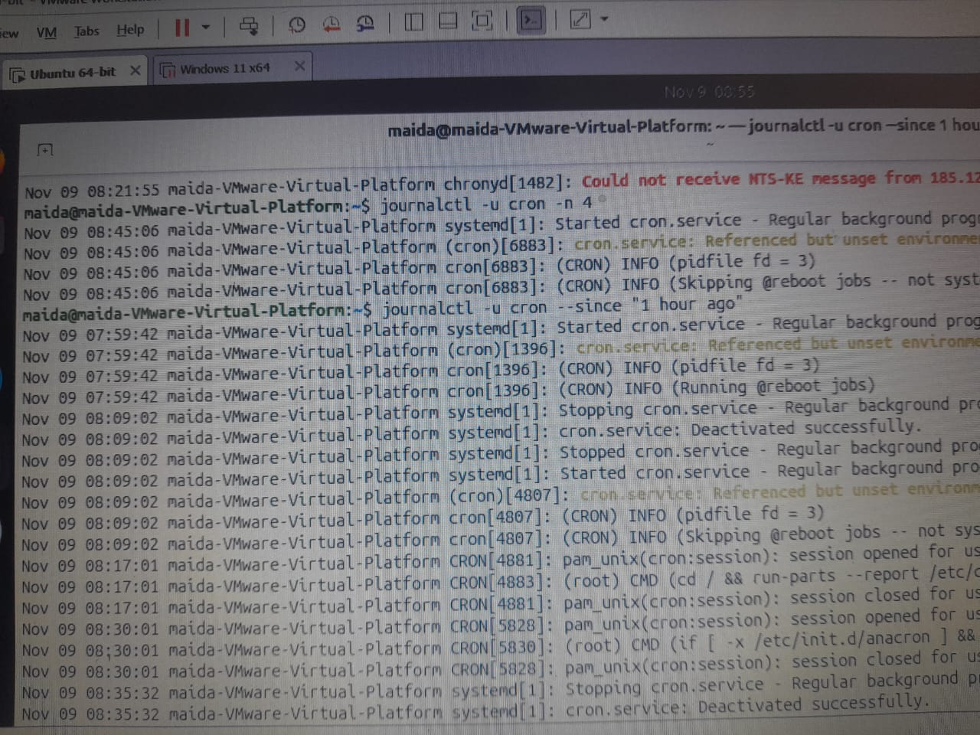
Common mistake: Forgetting the quotes in --since "1 hour ago", so the shell splits it into separate words.

36. journalctl -xe and -f
Meaning: -xe jumps to the end of the journal and adds explanations. -f follows the journal live: new lines appear as they are written.
Syntax
journalctl -xe
journalctl [-u UNIT] -f

Flag / Key | Meaning
-e | Jump to the end
-x | Add explanation text
-f | Follow new lines; Ctrl+C stops
logger | Write a test line

Practice
journalctl -xe # opens at the newest entries; use it right after an error
journalctl -f # first terminal: waits for new lines
logger "week 8 test from student" # second terminal: the line appears in the first at once
journalctl -u cron -f # follow one service only

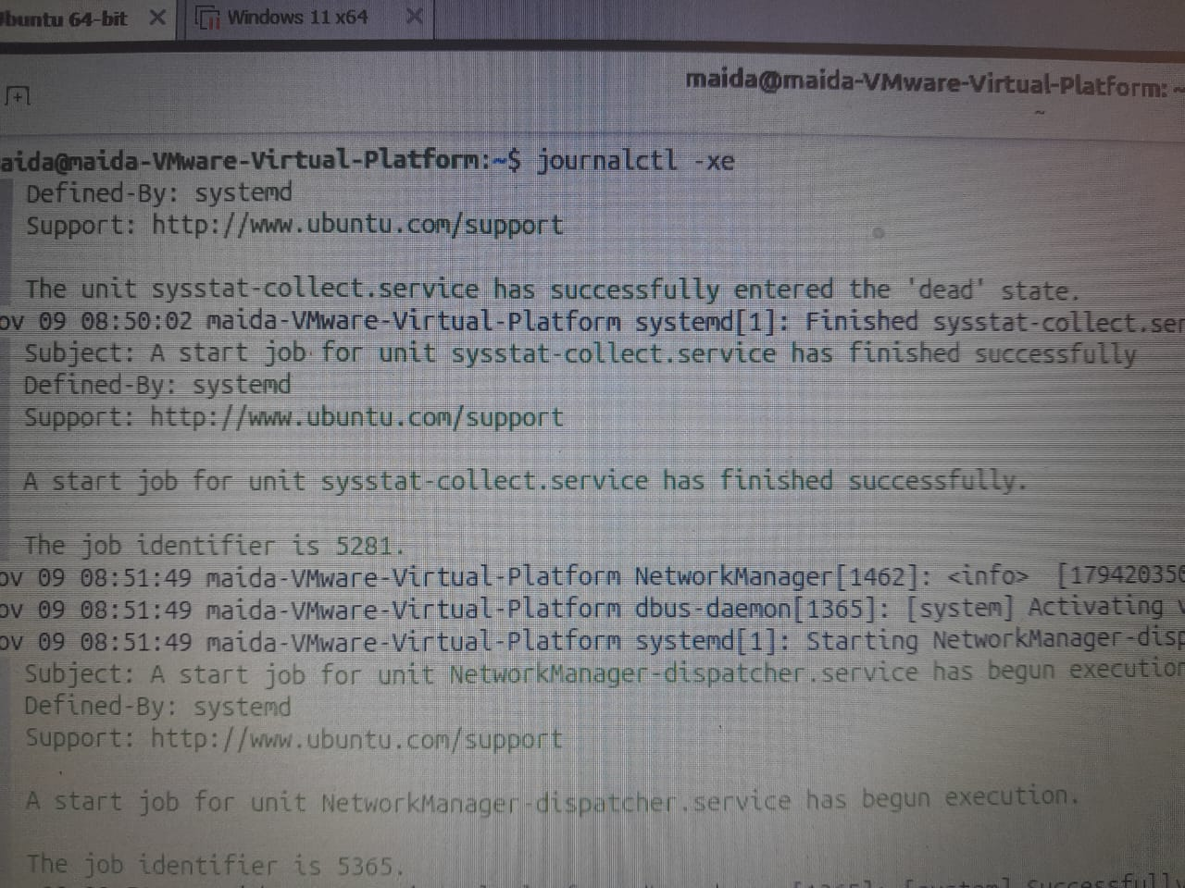

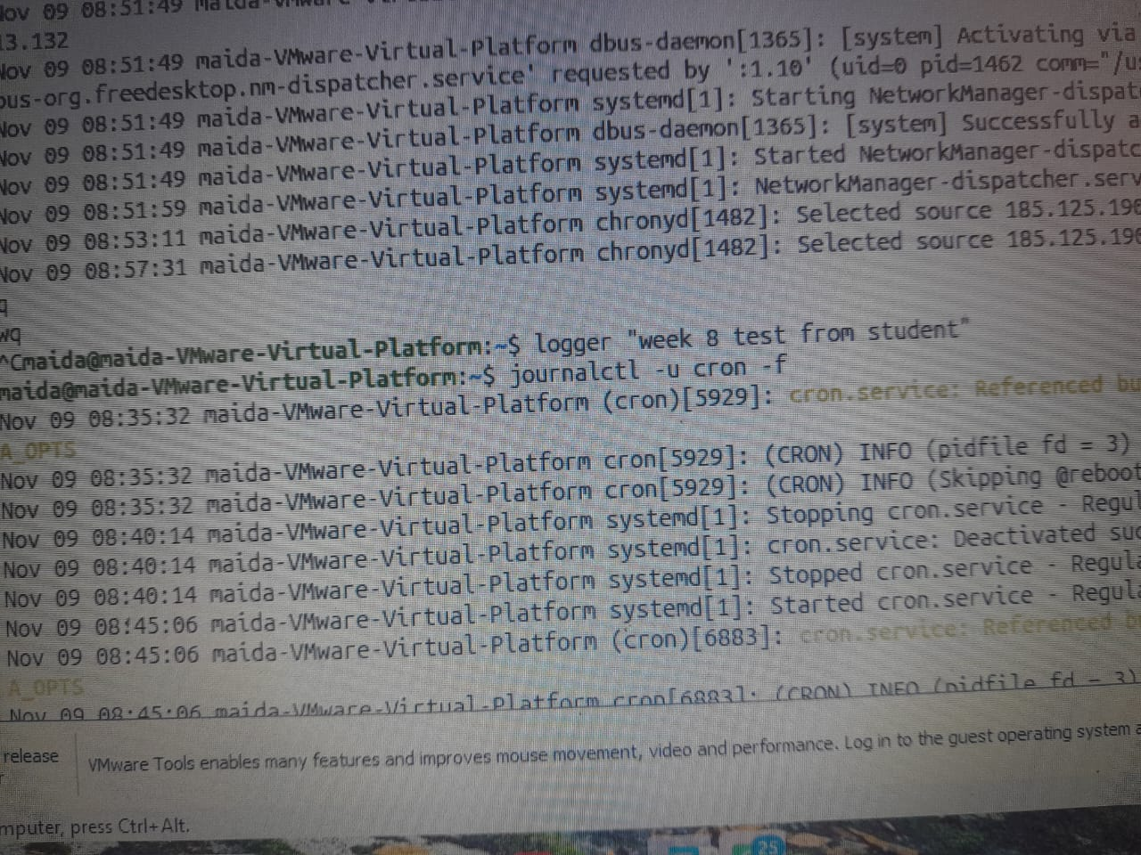

Common mistake: -f never finishes by itself. Stop it with Ctrl+C.

37. /var/log – the text logs
Meaning: Ubuntu also keeps classic text logs in /var/log, written by rsyslog next to the journal. You read them with the tools you already know.
Syntax
less /var/log/FILE
tail -f /var/log/FILE

File | Meaning
syslog | General system messages
auth.log | Logins, sudo, SSH
kern.log | Kernel messages
journal/ | The journal's own binary files

Practice
ls /var/log # plain text files, plus a few folders
less /var/log/syslog # / searches, q quits
tail -n 3 /var/log/kern.log # the three newest kernel lines
tail -f /var/log/syslog # follow new lines, like journalctl -f

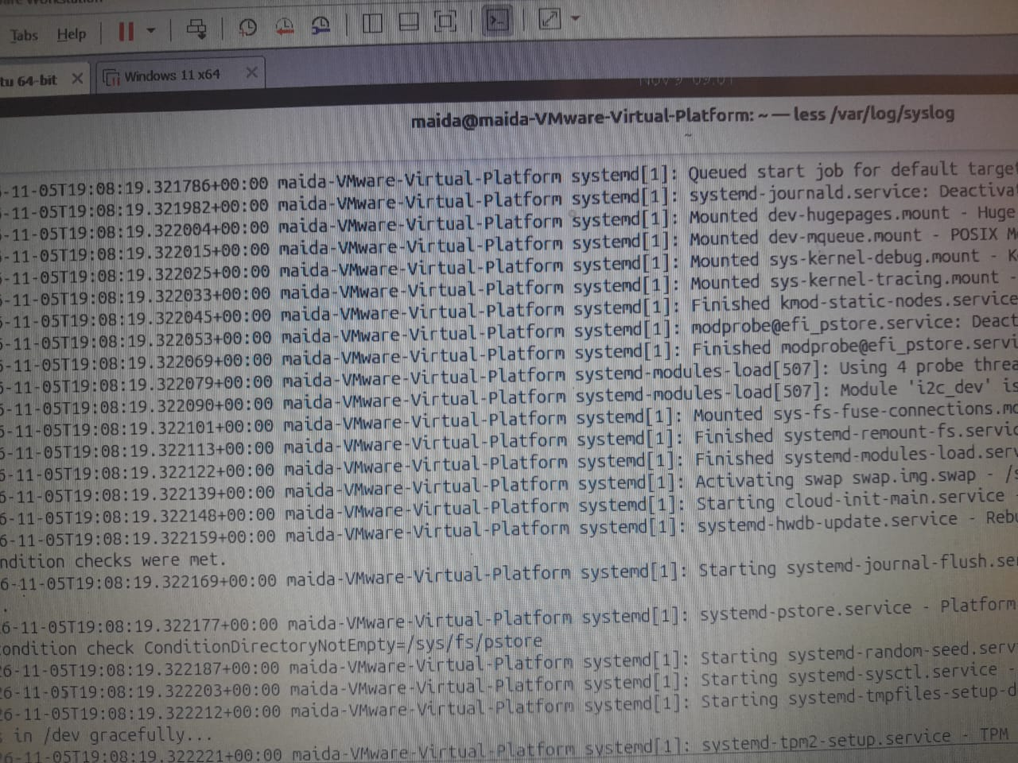

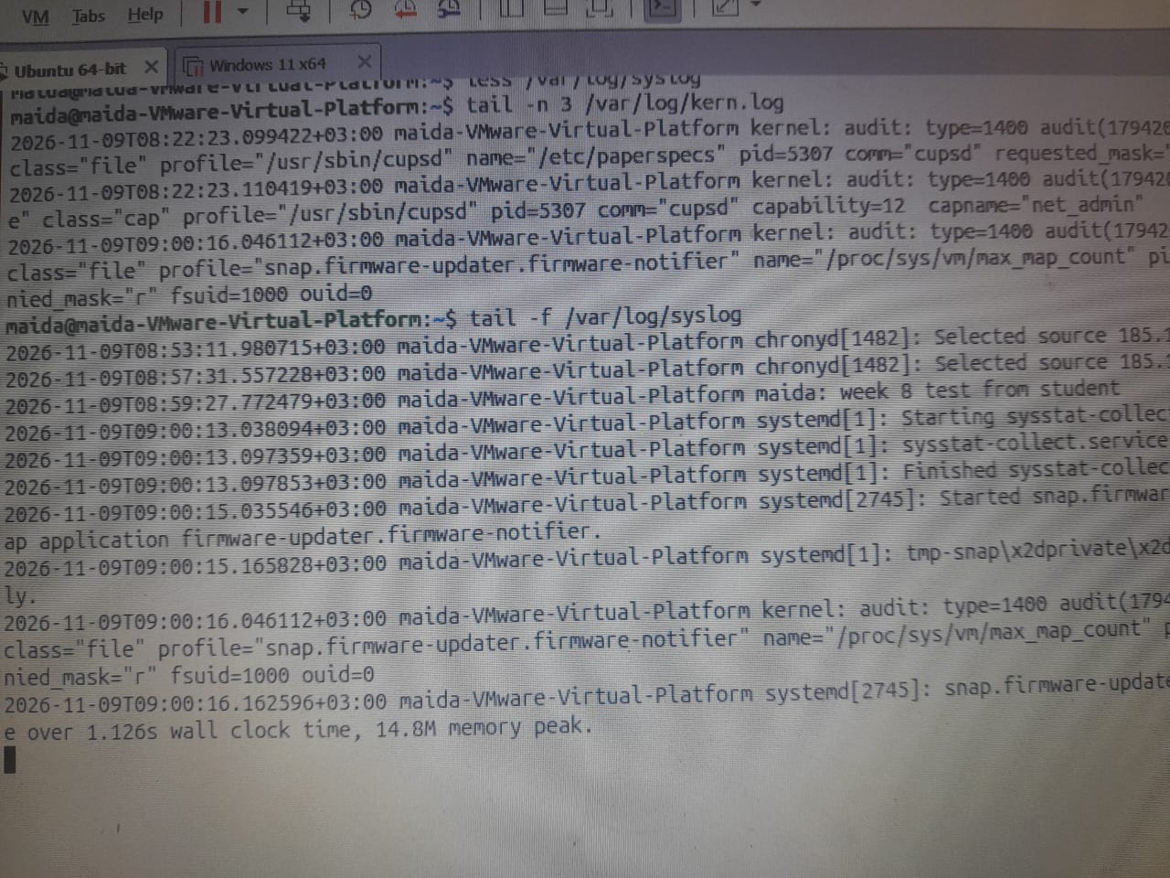

Common mistake: Do not open logs in nano or vim. A pager is safer; you cannot change the log by accident. Ubuntu has the journal and /var/log side by side, not one single log file.

38. auth.log – logins and sudo
Meaning: Every sudo command and every login is recorded. auth.log is the text file; the journal holds the same events. (sudo itself is in Chapter 5.)
Syntax
grep sudo /var/log/auth.log
journalctl _COMM=sudo
last

Practice
grep sudo /var/log/auth.log | tail -n 1 # who ran sudo, from which terminal, and the exact command
journalctl _COMM=sudo -n 1 # the same event from the journal
last -n 2 # logins and reboots, read from /var/log/wtmp

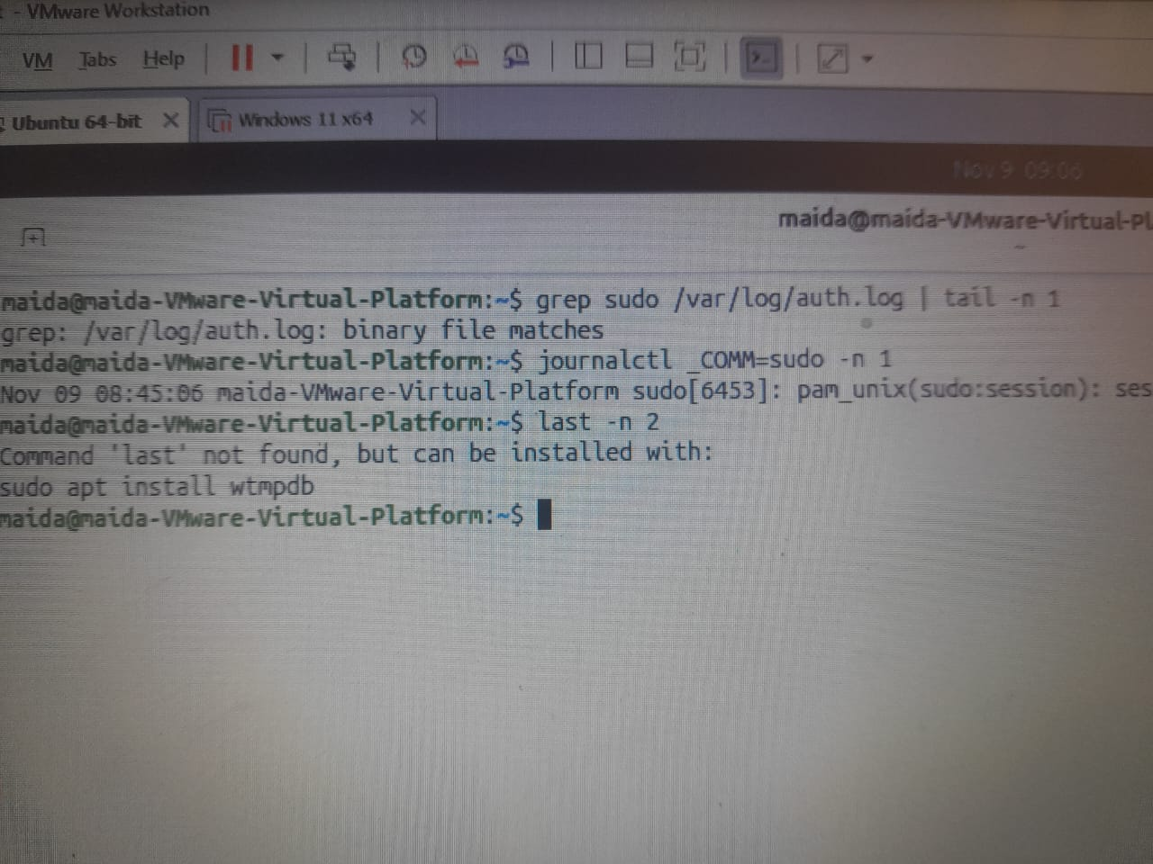

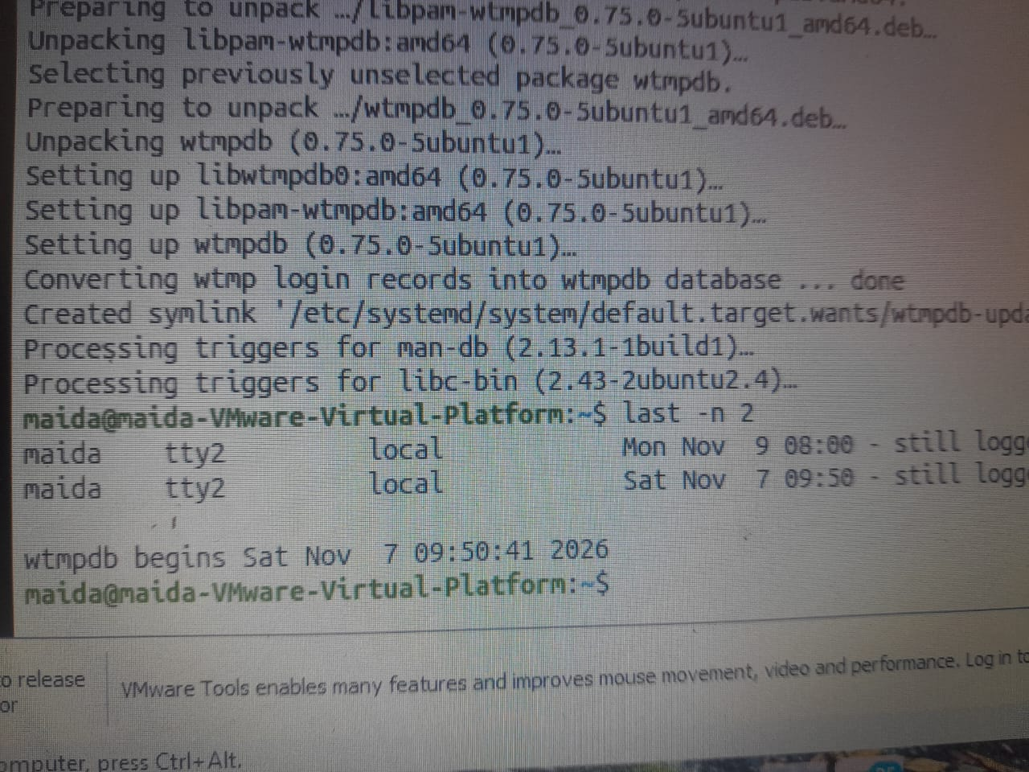

Common mistake: auth.log never shows passwords. It records who and what, never the password.

39. dmesg – kernel messages
Meaning: dmesg prints the kernel's own messages: hardware found at boot, drivers loaded, devices appearing. Ubuntu limits it to administrators.
Syntax
sudo dmesg [-T]
journalctl -k

Flag / Key | Meaning
-T | Clock times instead of seconds
-k | journalctl: kernel messages only
-b | This boot only

Practice
dmesg # "Operation not permitted" is expected for a normal user
sudo dmesg -T | tail -n 2 # the newest kernel messages, with readable times
sudo dmesg | less # page from the very first boot message
journalctl -k -b # the same kernel messages, through the journal

Common mistake: dmesg is not broken when it shows a permission error. It only needs sudo.
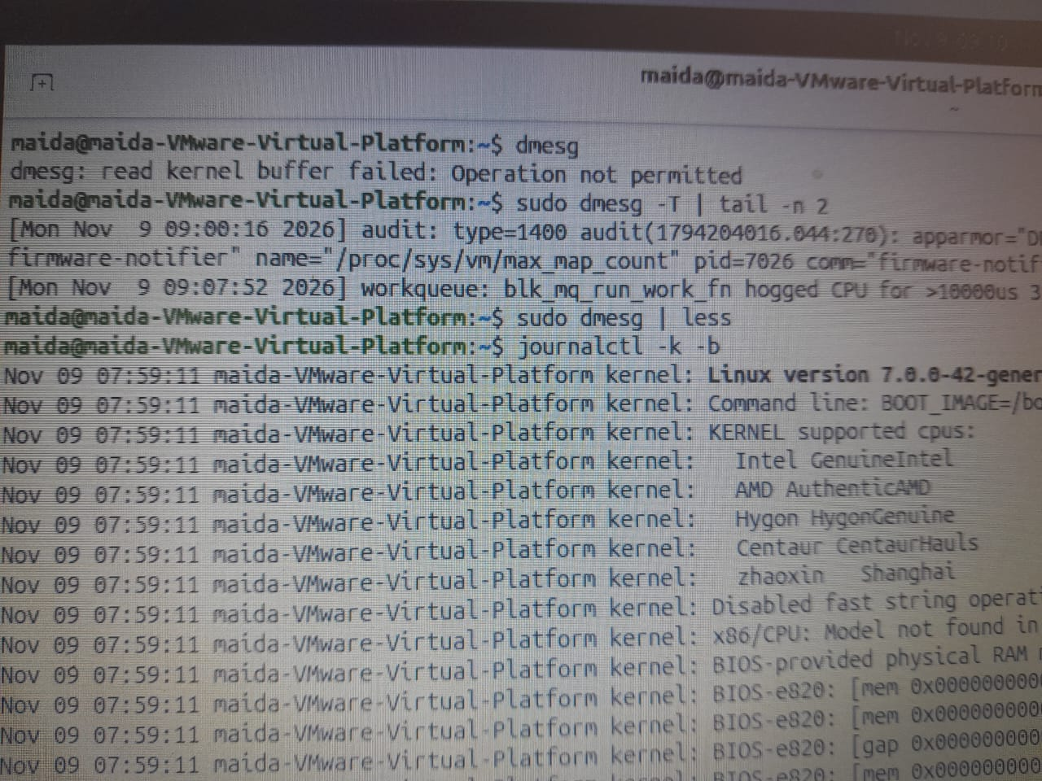

40. shutdown, reboot, poweroff
Meaning: Shut down from inside Linux so services stop in order and the disk is written cleanly. In VirtualBox, "Power off the machine" is pulling the plug.
Syntax
sudo shutdown [-r] TIME

Option | Meaning
now | Immediately
+N | In N minutes
-r | Reboot instead of power off
-c | Cancel a planned shutdown

Practice
sudo shutdown -r +5 "Rebooting for the lab" # schedules a reboot in 5 minutes
sudo shutdown -c # cancelled: nothing happens
sudo reboot # restart now
sudo poweroff # stop every service and switch off now

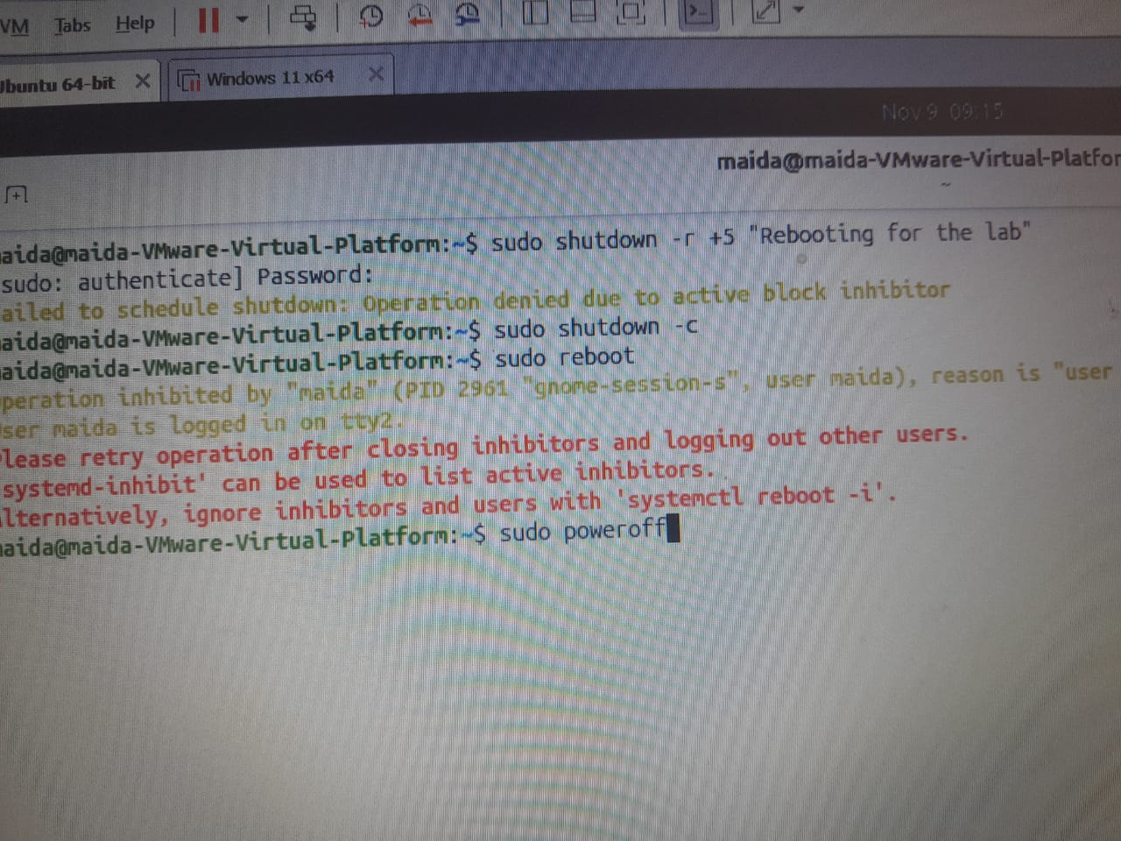

Common mistake: Do not close the VirtualBox window with "Power off". Use ACPI shutdown or sudo poweroff instead.

Warning: Take a VM snapshot before any boot experiment. If the VM does not come back, restore the snapshot instead of reinstalling.

41. A service misbehaves: a calm order
Do the same three steps every time, in the same order. The example uses ssh; with cron the steps are identical.
Step | Command | Question it answers
1 | systemctl status ssh | Is it running? What did it say last?
2 | journalctl -u ssh | The full story. Find the first error
3 | /etc/ssh/ | The config. What changed recently?

Practice
systemctl status ssh # step 1: read the Active line and the last log lines
journalctl -u ssh -n 20 # step 2: look for the first error, not the last
ls /etc/ssh # step 3: the config files
sudo sshd -t # check sshd_config for mistakes before restarting; no output means OK

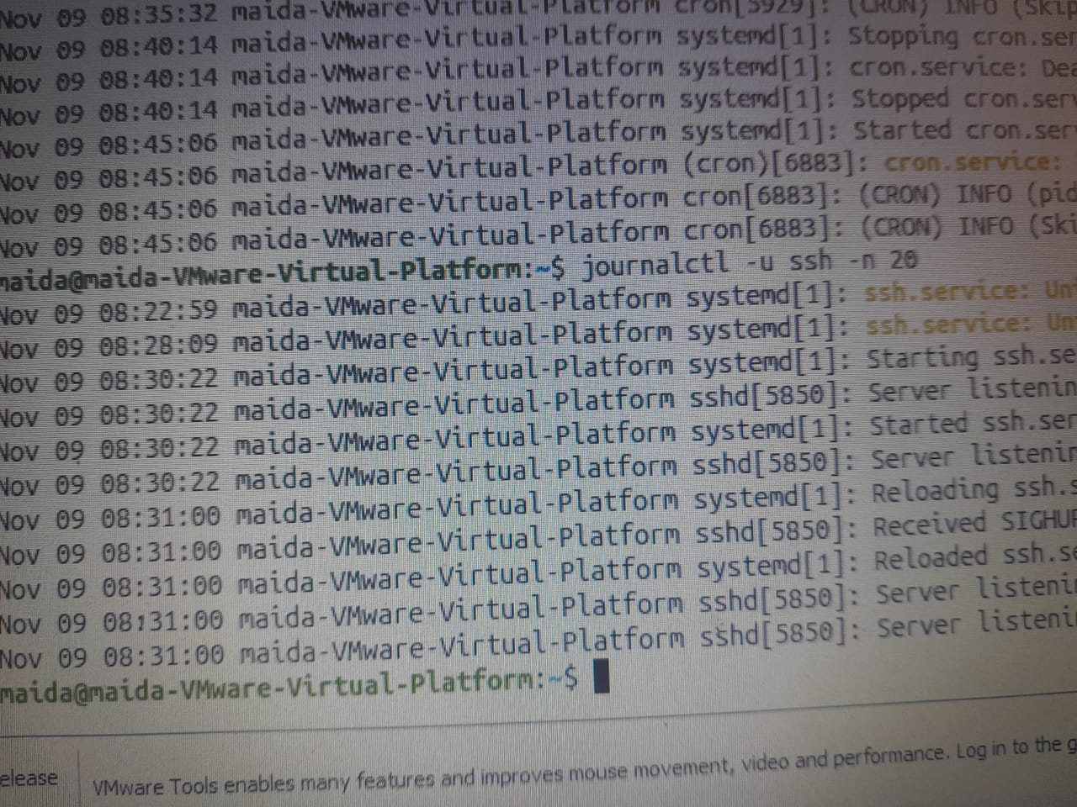

Common mistake: Do not restart again and again without reading the log. If the network itself looks down, that is Chapter 7. If ssh is not installed, practise with cron (config: /etc/crontab).

42. The machine is slow: a calm order
Three commands from this chapter, in order. Each one narrows the question before you act.
Step | Command | What to look at
1 | uptime | Load against nproc. Is it rising?
2 | free -h | Is little memory available? Is swap in use?
3 | top | Press P or M. Note the PID at the top

Practice
uptime # for example load 2.31 on a 2-CPU VM, and rising: something is busy
free -h # only 180Mi available: memory is short
top # press M, read the PID at the top, then choose: wait, renice, or kill with TERM



