Architecture
Fibonacci Fun is a small local web app. A FastAPI server serves three static pages and two image-analysis endpoints. All drawing and editing happens in the browser on a <canvas>, and the server only does the heavy image analysis.

System architecture
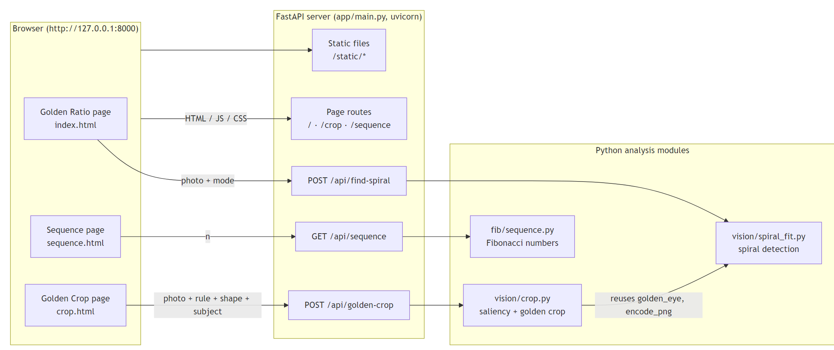
- The photo never leaves the machine. The browser uploads it to the local server for each analysis, and the server keeps nothing between requests.
- Pages are plain ES modules with no build step; python -m app (app/__main__.py) starts uvicorn and opens the browser.

Components
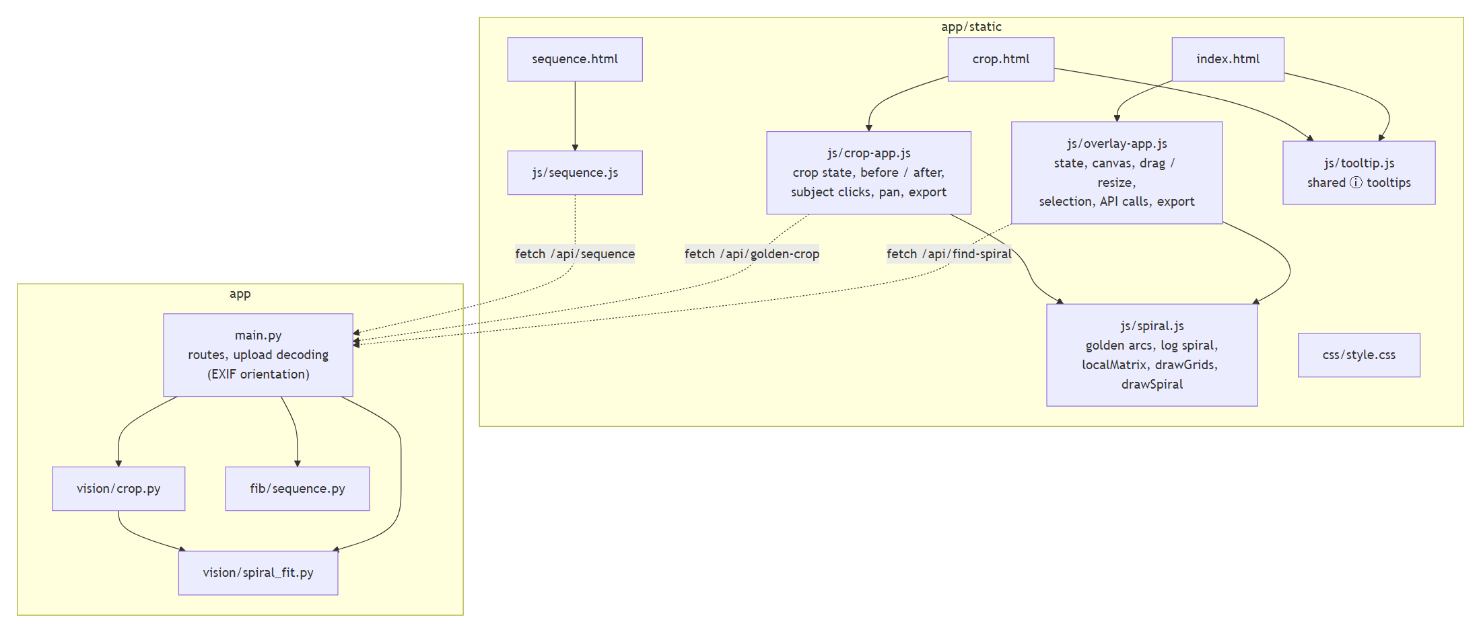
Component | Responsibility
app/main.py | FastAPI app, page routes, API routes, image decoding with ImageOps.exif_transpose so server coordinates match what the browser draws.
app/vision/spiral_fit.py | Edge-orientation field, golden and log spiral templates, coarse search, refinement, fit %, one-spiral-per-object selection.
app/vision/crop.py | Spectral-residual saliency, subject detection, rule target points, crop search and scoring.
app/fib/sequence.py | Pure Fibonacci sequence function.
static/js/spiral.js | Shared geometry and drawing. It mirrors the Python templates (goldenSteps ↔ golden_arcs, logSpiral ↔ log_spiral) so server matches line up with what is drawn.
static/js/overlay-app.js | Golden Ratio page: composition layer, list of detected spirals and the selected one, hit testing, drag / resize / rotate / flip, padding, PNG export.
static/js/crop-app.js | Golden Crop page: requests, before / after views, guides, subject clicks, panning the crop, cropped PNG export.
static/js/tooltip.js | One floating tooltip for every [data-tip] element (hover, focus, tap).

Spiral model (shared by server and browser)
A spiral is { cx, cy, w, h, angle, flip, growth }: an unrotated w × h box around its center, turned by angle degrees and optionally mirrored. growth is null for the golden arc spiral, or the growth per quarter turn for a log spiral. Both sides draw the curve in the same unit frame (aspect × 1, starting where the golden arcs start), so a match from the server lands exactly on the drawn overlay.

Flow: Find spirals
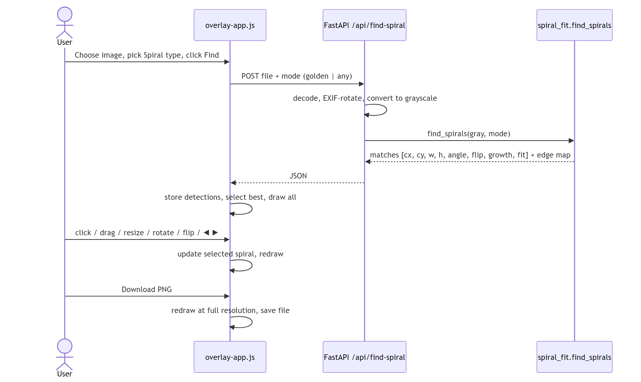

Algorithm: spiral detection
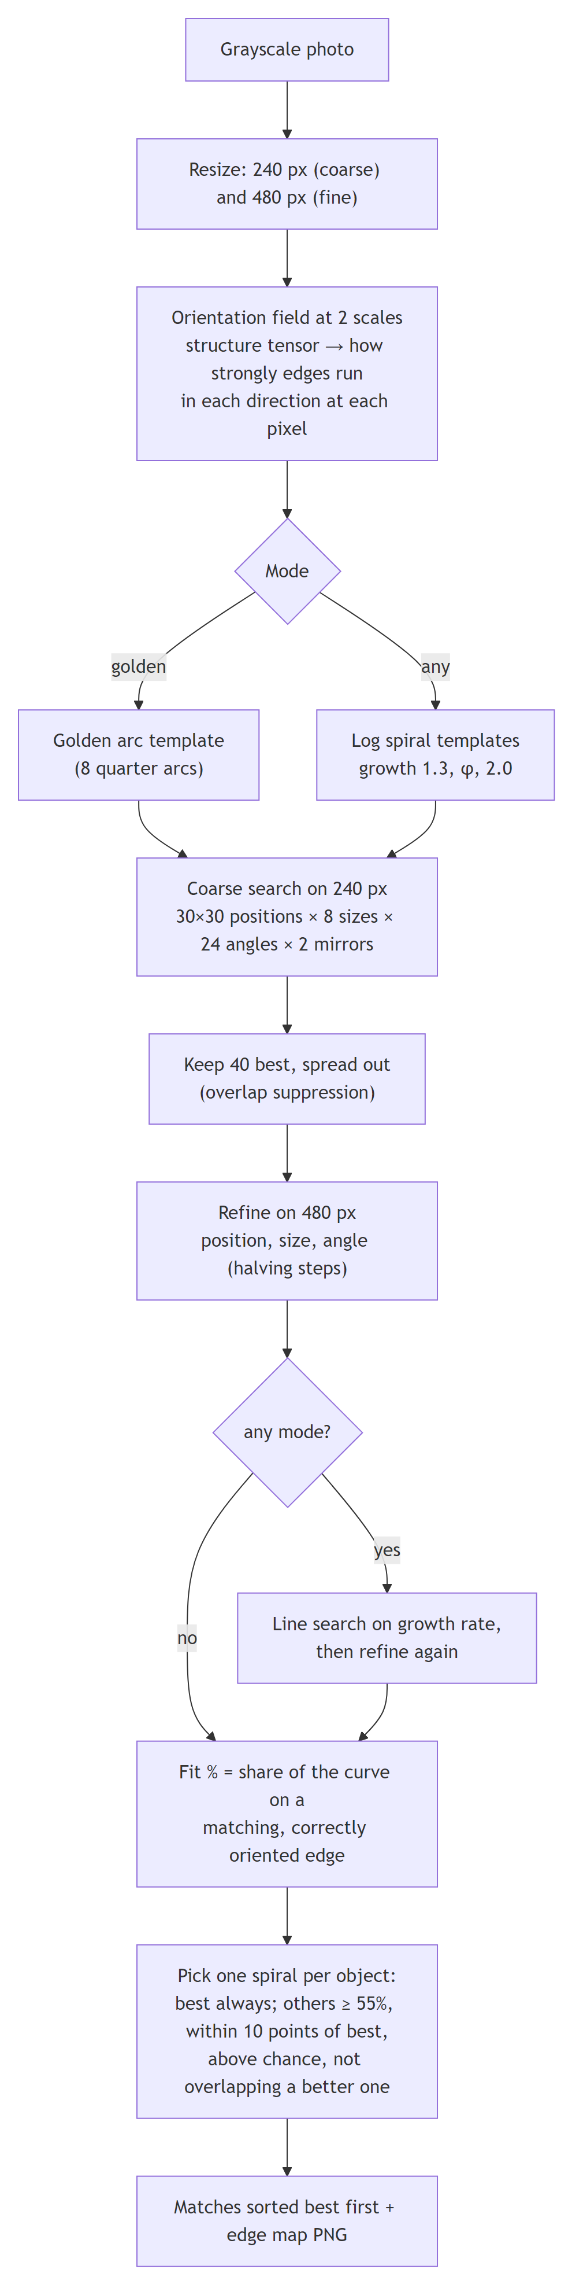
- Score (used for searching): the average of √(edge strength along the curve's direction), weighted toward the long outer arcs. Only the part of the curve that lies inside the photo counts, and at least 60% must be inside.
- Fit % (shown to the user): the weighted share of the curve that has a supporting edge. On the sample photos, random placements score a median of about 6–23%.

Flow: Golden crop
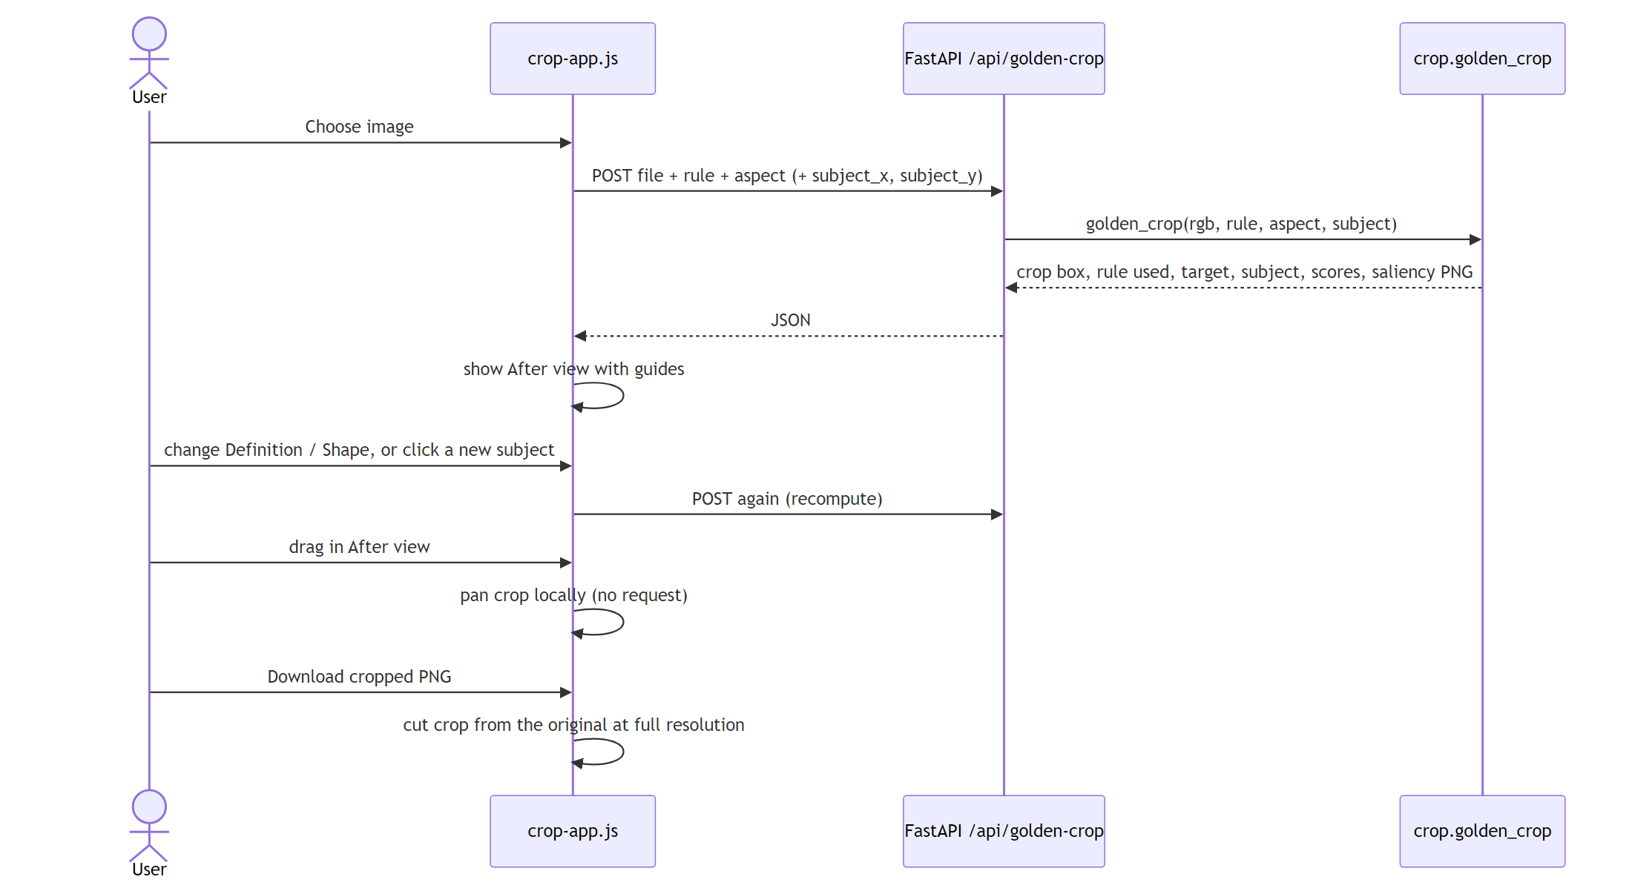

Algorithm: golden crop
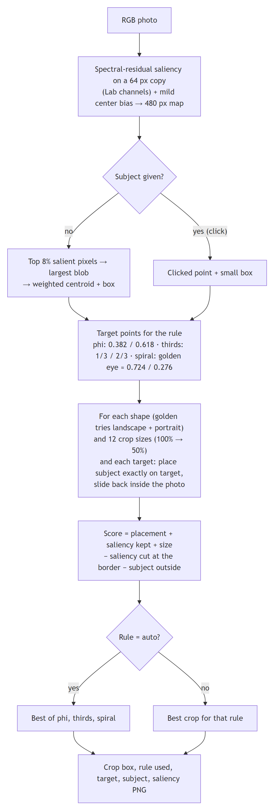

Page state: detected spirals (Golden Ratio page)
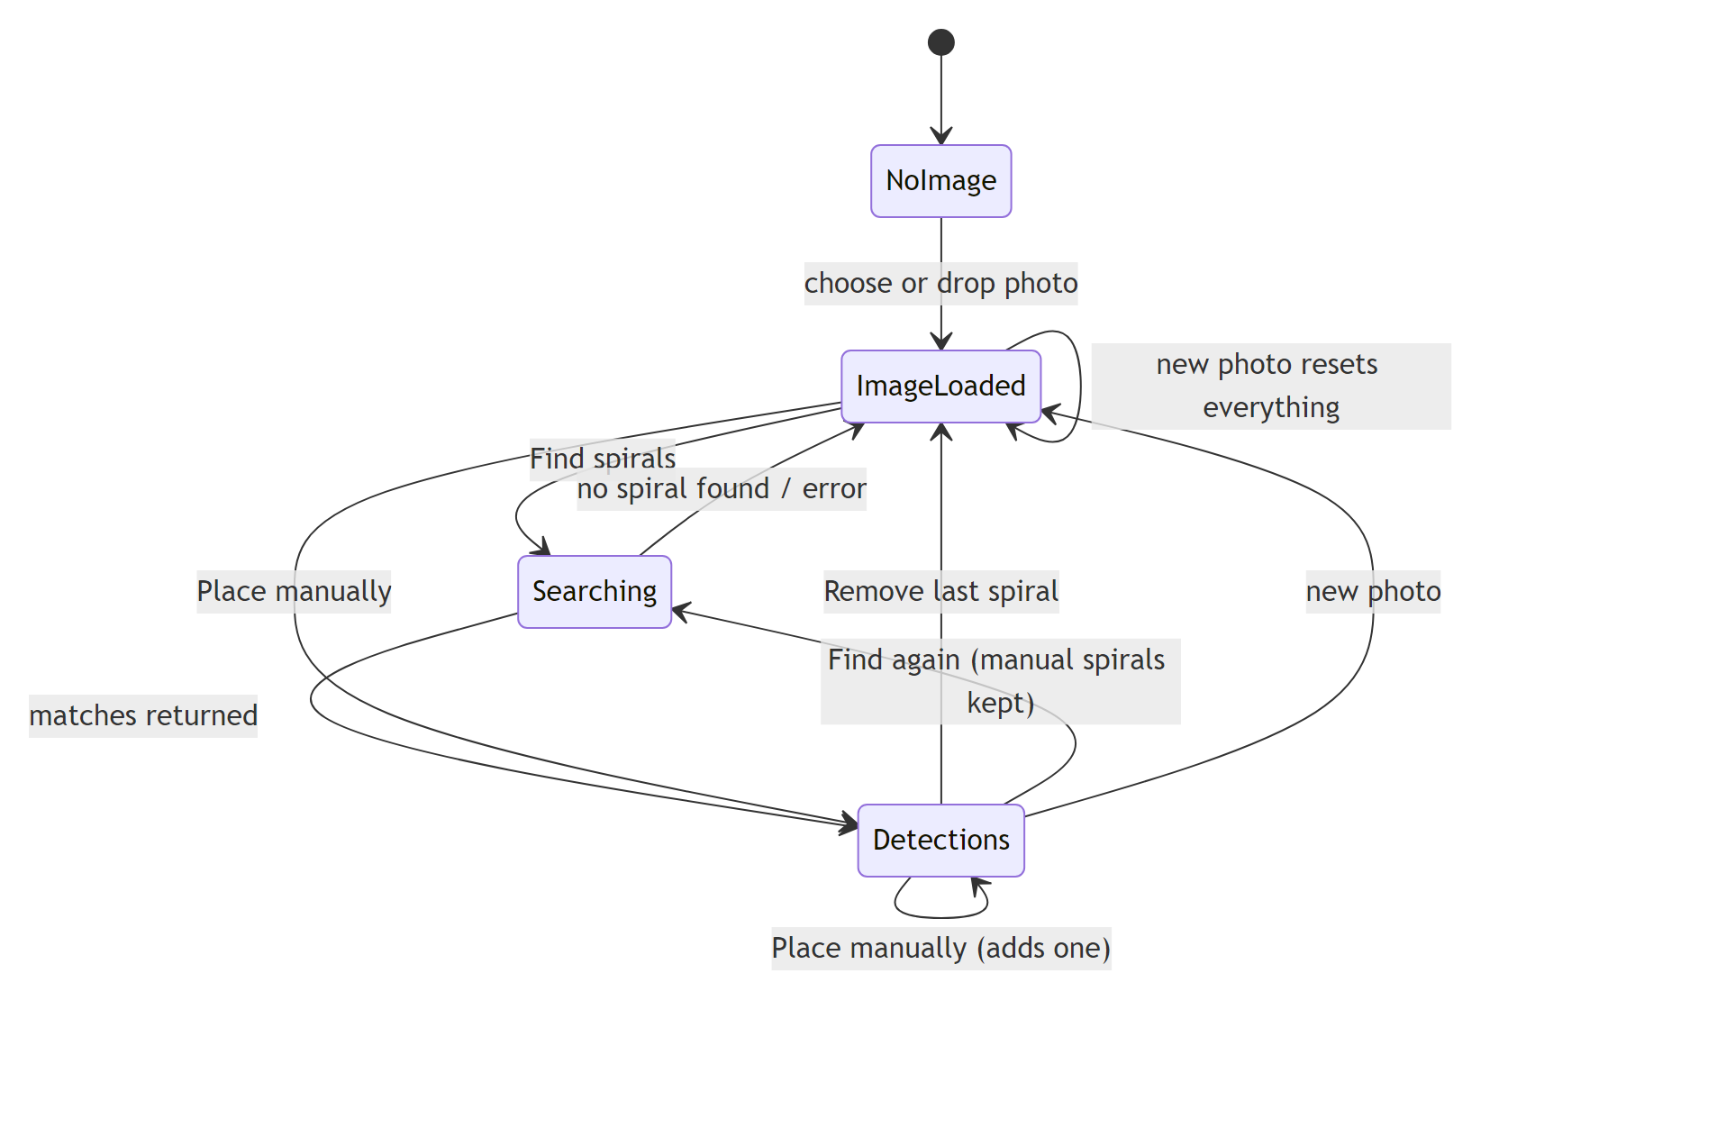

Design choices
- No build step, no frameworks. Vanilla ES modules and one stylesheet keep the app small and easy to run.
- Analysis on the server, drawing in the browser. NumPy and OpenCV do the heavy search, and the canvas handles smooth interaction and exports at any resolution.
- Shared geometry. The spiral templates are defined identically in Python and JavaScript, which lets the server return compact parameters instead of drawings.
- Honest scores. Fit % is an absolute measure checked against random placements, so a "strong" match is meaningfully better than chance.
- No extra dependencies. Saliency is implemented in NumPy because cv2.saliency is not part of opencv-python-headless.

