Fibonacci Fun
A just-for-fun local web app that looks for Fibonacci and golden-ratio structure in your photos: it traces golden and logarithmic spirals, overlays phi grids and the golden spiral for composition, crops photos so the subject sits on a golden point, and plays with the Fibonacci sequence.
Everything runs on your own computer. Photos are only sent to the local server at http://127.0.0.1:8000, never online.
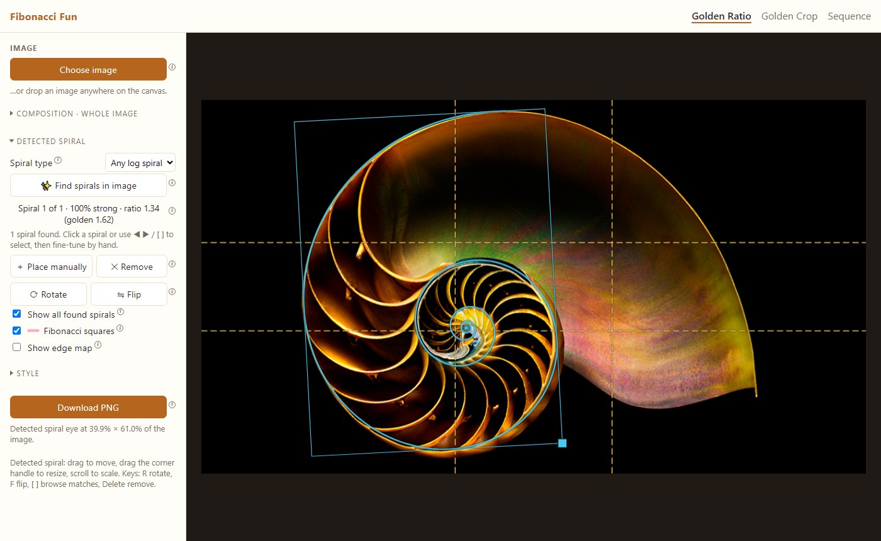
Find spirals: a nautilus shell traced as a logarithmic spiral with ratio 1.34

Features

Golden Ratio: spiral overlays and spiral detection
- Composition guides over the whole photo: phi grid (0.382 / 0.618), rule of thirds, the golden spiral and its Fibonacci squares, with rotate and flip.
- Frame modes: fit a true golden rectangle inside the photo, stretch to the photo, or pad the photo out to exactly 1 : 1.618 (blurred, black or white borders).
- Find spirals in image: searches every position, size and angle for curves in the photo that follow a spiral.
  - Golden mode matches only the true golden spiral (it grows 1.618× every quarter turn).
  - Any log spiral mode also matches tighter or looser spirals and reports their growth ratio. Nautilus shells come out at about 1.3, the known value.
  - Each match shows a fit %: how much of the spiral runs along a matching edge in the photo. Random placements usually score under 40%.
- Edit detections by hand: drag, resize, rotate, flip, place your own spiral, and step through several found spirals.
- Download PNG of the photo with the overlays at full resolution.
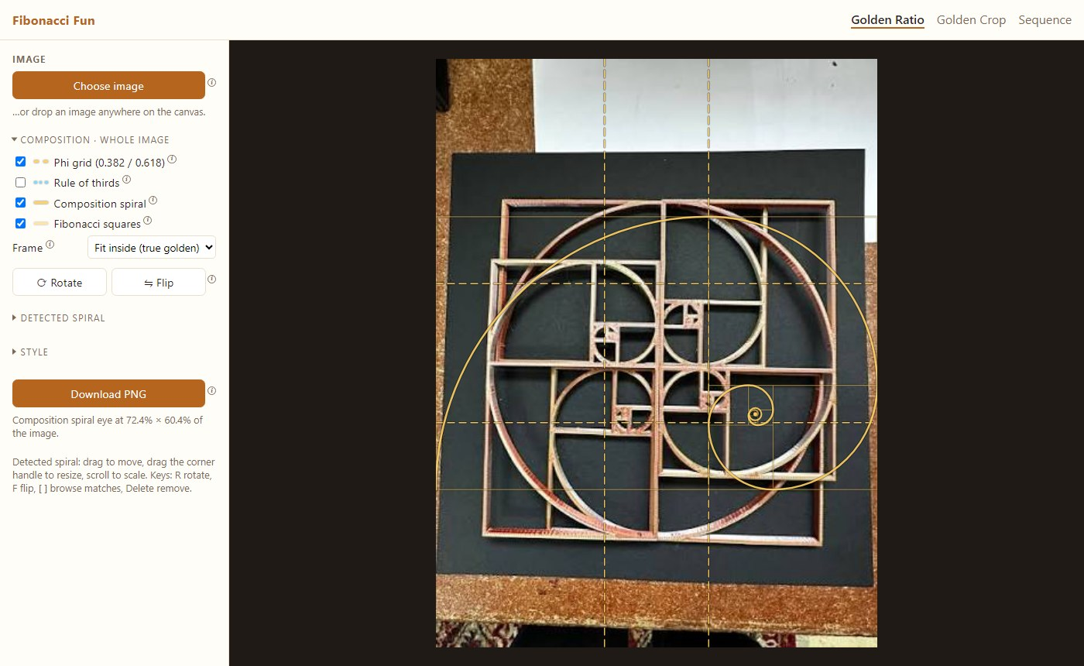
Composition spiral, Fibonacci squares and phi grid
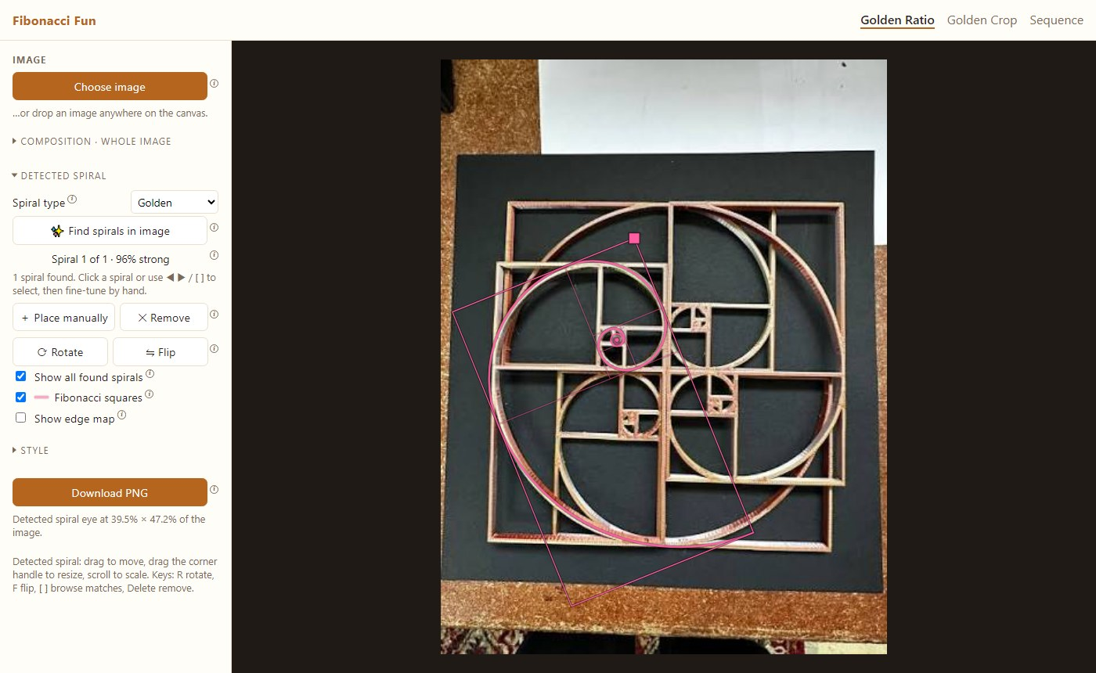
A golden spiral found in a golden-ratio frame, 96% fit

Golden Crop: re-crop a photo by golden-ratio rules
- Finds the most eye-catching area of the photo automatically (a saliency map), or you click the subject yourself.
- Crops so the subject lands on a chosen point:
  - Dramatic: a phi-grid crossing.
  - Interesting: a rule-of-thirds crossing.
  - Flowing: the golden spiral's eye.
  - Auto: tries all three and keeps the best.
- Crop shapes: golden 1 : 1.618 (landscape or portrait), the photo's own shape, 1:1, 4:5, 3:2 and 16:9.
- Before / After views, and a full-resolution Download cropped PNG.
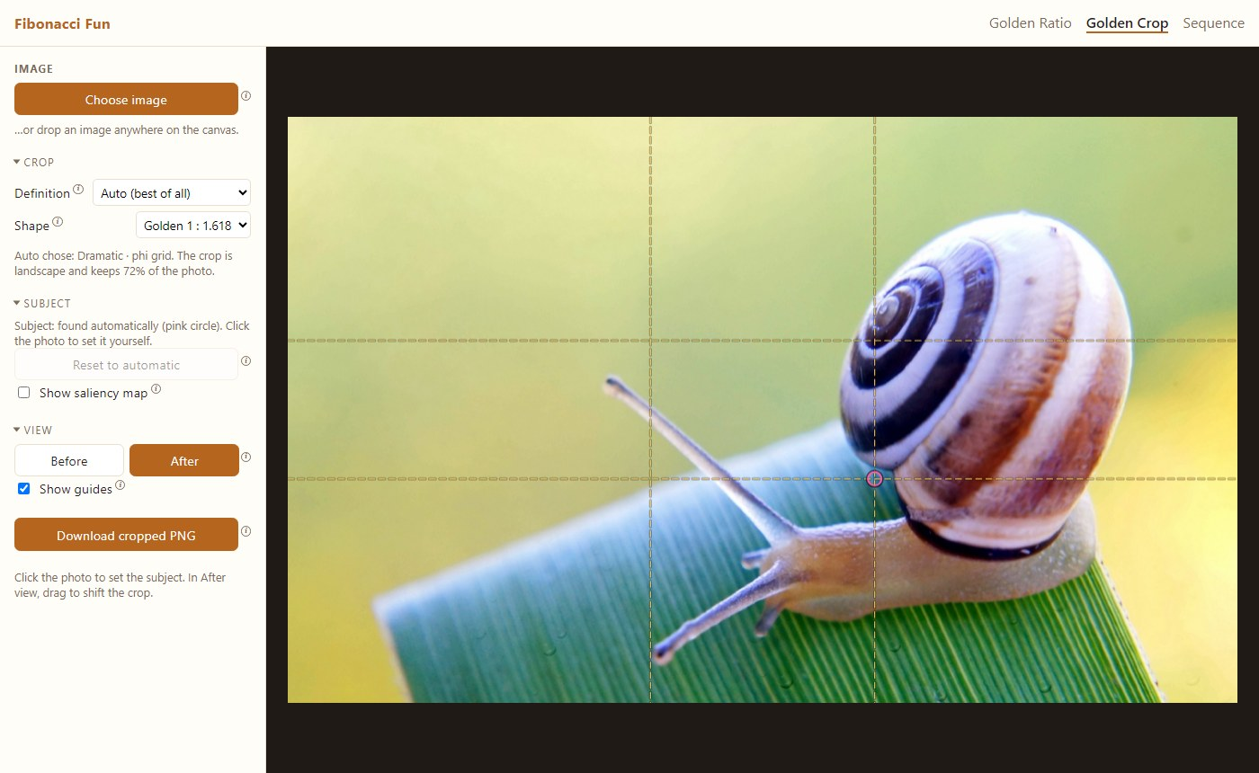
Golden Crop: the snail placed on a phi-grid crossing
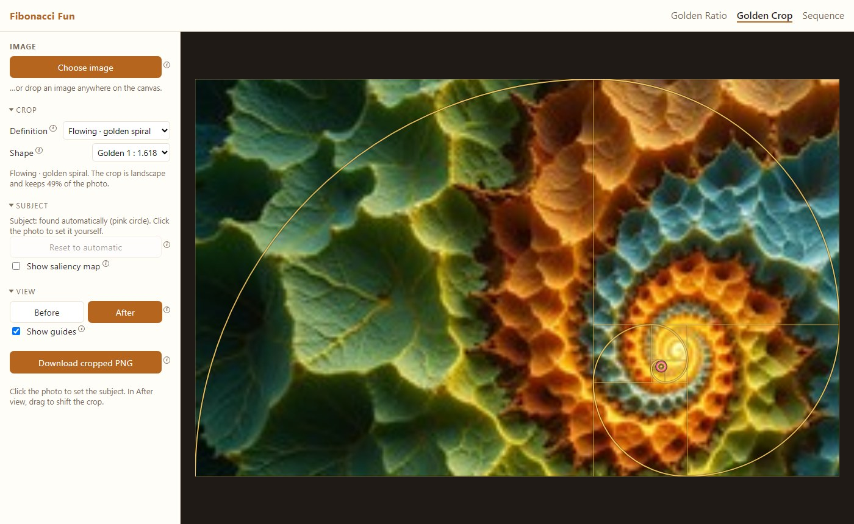
Flowing crop: the spiral's eye on the fractal's center

Sequence
Generates the first n Fibonacci numbers (up to 1000) and shows how the ratio of the last two approaches φ ≈ 1.6180339887.
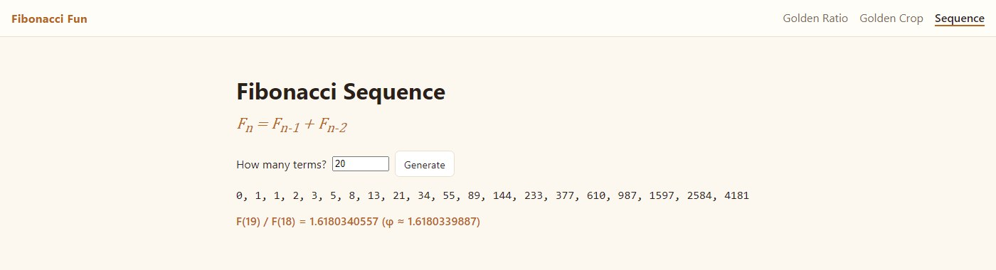
Fibonacci sequence page

Quick start (Windows, PowerShell)
Requirements: Python 3.12, and Node.js (only for the Prettier formatter).
py -3.12 -m venv .venv
.venv\Scripts\activate
pip install -r requirements-dev.txt
npm install
python -m app
python -m app starts the server and opens http://127.0.0.1:8000 in your browser. For auto-reload while developing, use uvicorn app.main:app --reload instead.

How it works (short version)
- Spiral detection (app/vision/spiral_fit.py):
  - The photo is turned into an edge-orientation field (a structure tensor at two scales).
  - A spiral template is scored by how well the edges under it run along the curve.
  - A coarse search over position, size, angle and mirror image is followed by a local refinement. In "any" mode, a line search over the growth rate also runs.
  - One spiral is kept per object.
- Golden crop (app/vision/crop.py):
  - Spectral-residual saliency finds the subject.
  - For each crop size, the subject is placed exactly on each target point of the rule.
  - Each crop is scored for placement, how much salient content it keeps, size, not slicing through salient areas at the edges, and keeping the subject whole.
More detail, with diagrams, is in docs/ARCHITECTURE.md. Step-by-step usage is in the User Manual.

Project layout
app/
main.py FastAPI app: pages and /api routes
__main__.py python -m app: start server, open browser
fib/sequence.py pure Fibonacci math
vision/
spiral_fit.py spiral detection (POST /api/find-spiral)
crop.py golden crop (POST /api/golden-crop)
static/
index.html Golden Ratio page js/overlay-app.js, js/spiral.js
crop.html Golden Crop page js/crop-app.js
sequence.html Sequence page js/sequence.js
js/tooltip.js shared ⓘ tooltips
css/style.css all styles
docs/ architecture, user manual, screenshots
IMGS/ sample photos

Development
- Stack: Python 3.12, FastAPI + uvicorn, OpenCV (headless), NumPy, Pillow; vanilla HTML/CSS/JS with <canvas> and no build step.
- Lint: ruff check .; ruff format --check .; npm run lint
- Format: ruff format .; ruff check --fix .; npm run format
- Code style rules (no blank lines inside bodies, no wrapped statements, 200-character lines) are in CLAUDE.md.

Known limitations
- Small spirals: Find reliably detects spirals that are large in the frame, about a quarter of the photo's height or more. At smaller sizes, ordinary texture matches the spiral as well as real spirals do, so small spirals (for example each tile of a collage) are not reported.
- Flowers and cones: sunflowers, pine cones and similar plants are families of many interleaved spirals, not one curve. They are not counted as spiral families.
- Automatic crop subject: the automatic subject guess can pick the wrong thing on busy photos. Click the real subject to fix it.

Image credits
Screenshots use sample photos from IMGS/. Make sure you have the right to publish any photo you add there.

