User Manual
This manual walks through every page and control of Fibonacci Fun. Every option in the app also has a small ⓘ next to it: hover it (or tap it, or Tab to it) for a one-line explanation.

Contents
- Starting the app
- Golden Ratio page
- Golden Crop page
- Sequence page
- Keyboard and mouse reference
- Understanding the numbers
- Tips and troubleshooting

1. Starting the app
- Open PowerShell in the project folder.
- The first time only, install everything:
py -3.12 -m venv .venv
.venv\Scripts\activate
pip install -r requirements-dev.txt
npm install
- Start the app:
.venv\Scripts\activate
python -m app
- Your browser opens at http://127.0.0.1:8000. If it doesn't, open that address yourself.
- To stop the app, press Ctrl+C in the PowerShell window.
The header links switch between the three pages: Golden Ratio, Golden Crop and Sequence. Photos stay on your computer: they are only sent to this local app.

2. Golden Ratio page
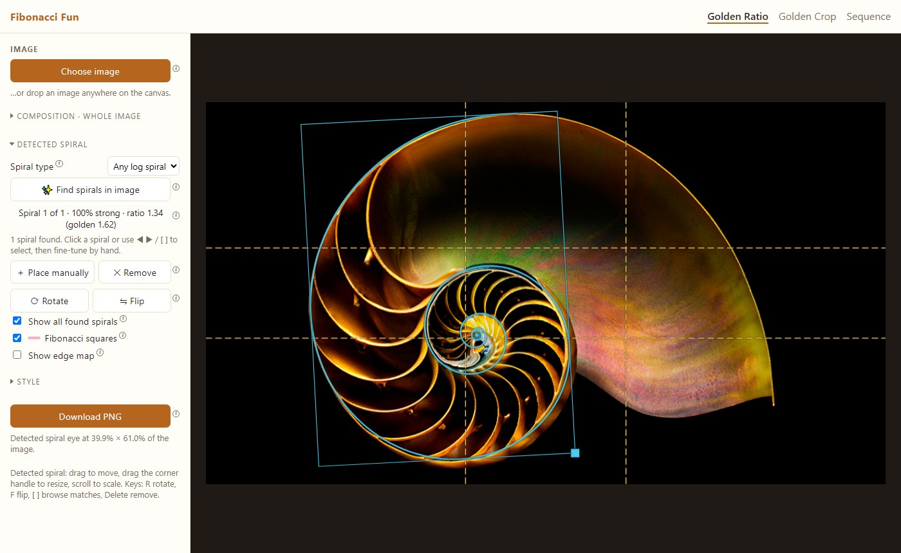
Golden Ratio page with a detected log spiral
The left panel has four parts: Image, and the collapsible sections Composition · whole image, Detected spiral and Style. The sections start collapsed; click a title to open or close it.

2.1 Load a photo
- Click Choose image, or drag a photo onto the dark canvas area.
- The photo appears with the phi grid switched on.

2.2 Composition · whole image
These guides always cover the whole frame. They help you judge the composition of the photo as it is.
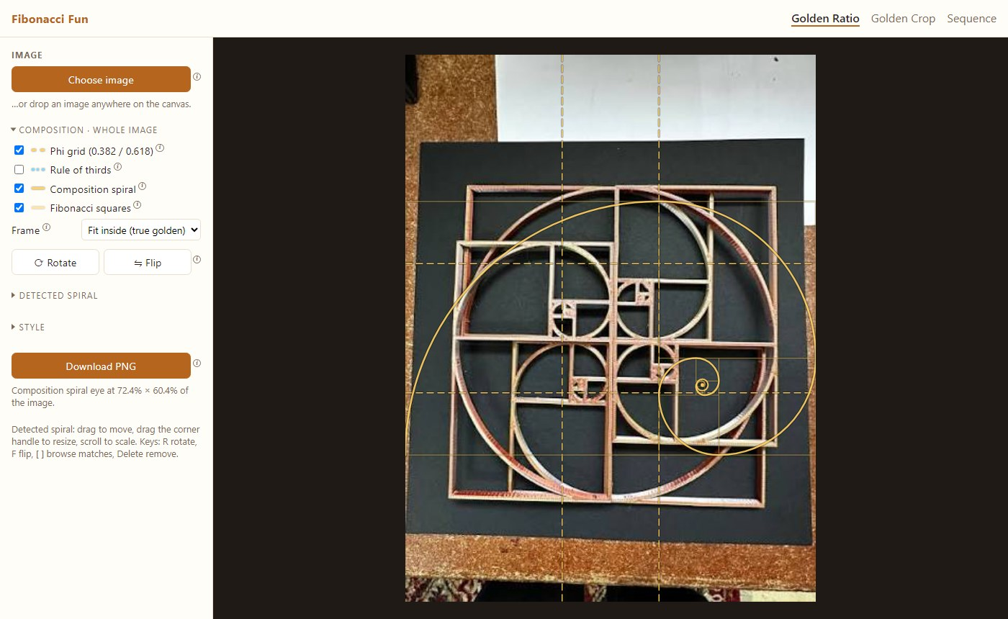
Composition guides
Control | What it does
Phi grid (0.382 / 0.618) | Lines at 38.2% and 61.8% of the frame, the golden-ratio cousin of the rule of thirds. Key subjects look good on the lines or where they cross.
Rule of thirds | The classic 1/3 and 2/3 grid, in blue, for comparison.
Composition spiral | A golden spiral over the frame. Put the main subject near its eye and let lines in the photo follow the curve.
Fibonacci squares | The squares the spiral is built from (1, 1, 2, 3, 5, 8, …).
Frame | Fit inside (true golden): the largest true 1 : 1.618 rectangle, centered, which may leave gaps. Stretch to image: fills the photo but squashes the spiral. Pad to golden: adds borders so the whole frame is exactly 1 : 1.618.
Padding | Appears in Pad mode. Fills the added borders with a Blurred photo, Black or White. It is included in the download.
⟳ Rotate / ⇋ Flip | Turn the composition spiral 90° or mirror it. Try the combinations to see which suits the photo.

2.3 Detected spiral: find spirals in the photo
- Open Detected spiral.
- Choose a Spiral type:
  - Golden: only the true golden spiral, which grows 1.618× every quarter turn. Takes about 2 seconds.
  - Any log spiral: also tighter or looser spirals, such as nautilus shells, and shows each one's growth ratio. Takes about 5–8 seconds.
- Click ✨ Find spirals in image.
- Found spirals are drawn on the photo, best first. The label shows, for example:
  - Spiral 1 of 1 · 96% strong (golden)
  - Spiral 1 of 1 · 100% strong · ratio 1.34 (golden 1.62) (any log spiral)
- If several spirals were found (one per object), use ◀ ▶ or click a spiral to select it. The selected one is drawn in full with its frame and resize handle; the others are thinner.
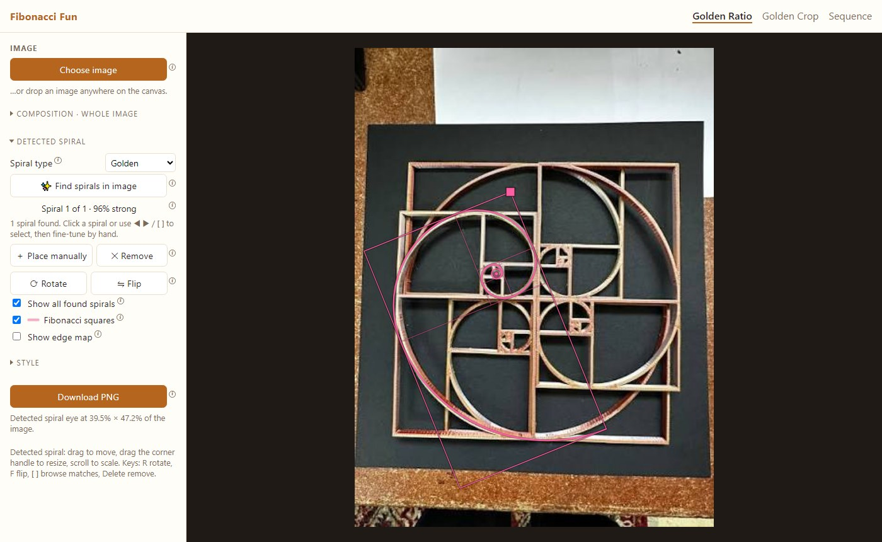
A golden match
Editing the selected spiral:
Action | How
Move | Drag inside its frame
Resize | Drag the square handle at its corner, or scroll the mouse wheel over it
Rotate 90° | ⟳ Rotate or the R key
Mirror | ⇋ Flip or the F key
Delete | ✕ Remove or the Delete key
Add your own | ＋ Place manually, then drag it into place

Other options:
- Show all found spirals: untick it to see only the selected spiral.
- Fibonacci squares: shows the squares inside detected golden spirals. Log spirals have no squares.
- Show edge map: shows the edges the search looked at (available after Find). Bright lines are what the spiral tries to follow, which is useful for understanding a match.
Running Find again replaces the found spirals but keeps the ones you placed manually.

2.4 Style
Control | What it does
Composition color | Color of the grids and composition spiral
Golden spiral color | Color of detected golden spirals (pink by default)
Log spiral color | Color of detected non-golden spirals (blue by default)
Opacity | How see-through the overlay lines are
Line width | Thickness of the lines, on screen and in the download
Spiral eye | Marks the point the spiral winds into. Its position is also written under the Download button.

2.5 Download
Download PNG saves the photo at full resolution with everything currently shown, except the resize handle. In Pad mode the padding is included.

3. Golden Crop page
Golden Crop re-crops a photo so its subject sits on a golden point.
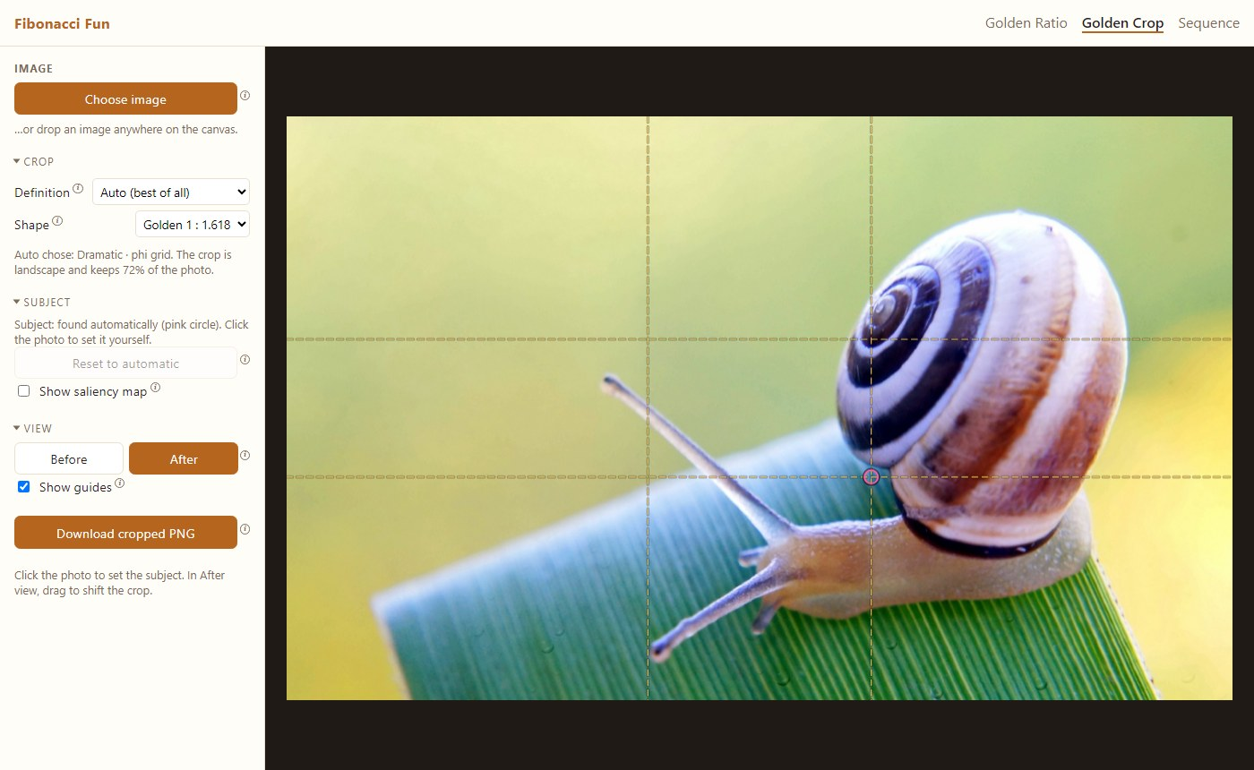
Golden Crop, After view

3.1 Quick use
- Click Choose image (or drop a photo).
- The page shows the After view: the suggested crop with its guides.
- Click Download cropped PNG to save it.

3.2 Crop
Control | Options
Definition | Auto (best of all) tries all three rules and keeps the best, and the panel says which it chose. Dramatic · phi grid puts the subject on a 0.382 / 0.618 crossing. Interesting · rule of thirds puts it on a 1/3 / 2/3 crossing. Flowing · golden spiral puts it at the spiral's eye.
Shape | Golden 1 : 1.618 (landscape or portrait, whichever works better), Keep original, Square 1 : 1, Portrait 4 : 5, Classic 3 : 2, Wide 16 : 9.

The text under these controls tells you the rule used, whether the crop is landscape, portrait or square, and how much of the photo it keeps. These rules are photographers' rules of thumb, not laws, so try a few and keep the one you like.
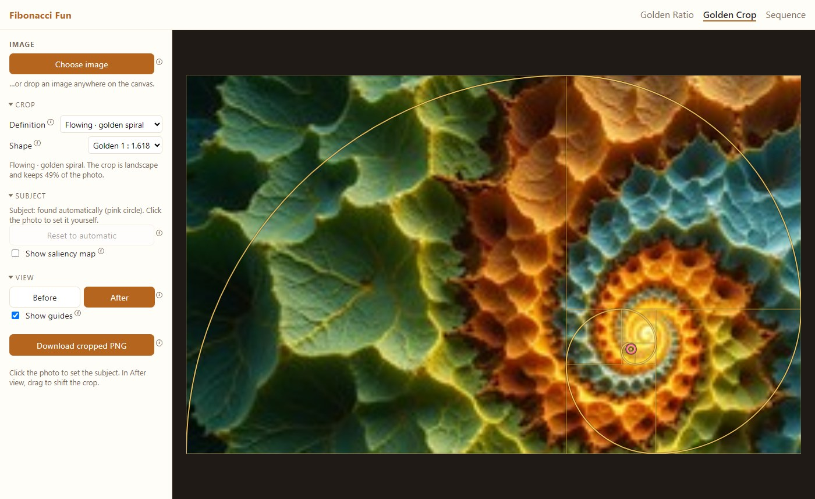
Flowing crop with the golden spiral

3.3 Subject
- The subject is found automatically and marked with a pink circle.
- If it picked the wrong thing, click the real subject on the photo (in either view) and the crop is recomputed.
- Reset to automatic goes back to the automatic guess.
- Show saliency map shows how eye-catching each area is: brighter means more eye-catching. The automatic subject is the brightest area.
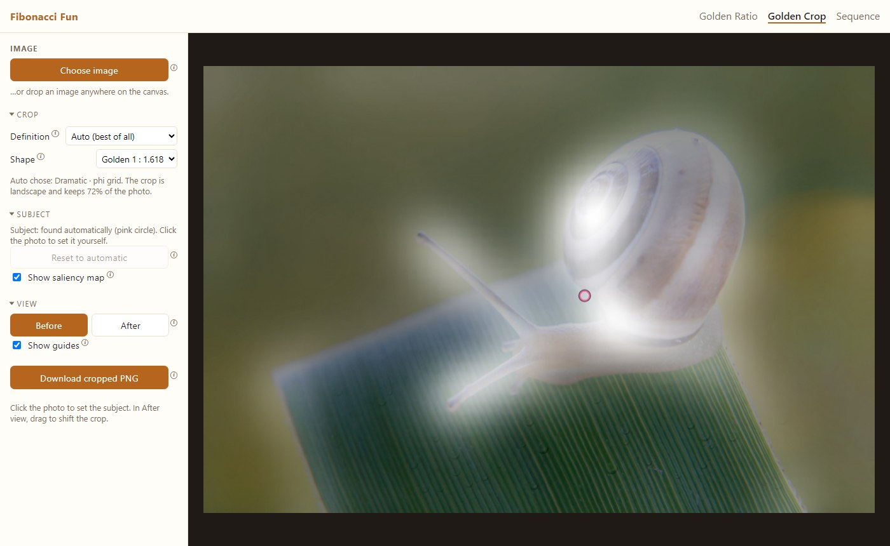
Saliency map in the Before view

3.4 View
- Before: the original photo, untouched (only the subject circle is shown).
- After: the cropped result. Drag the picture to shift the crop by hand.
- Show guides: turns the phi grid, thirds lines or spiral on the After view on or off.

3.5 Download
Download cropped PNG saves only the cropped area, at full resolution, without guides or markers.

4. Sequence page
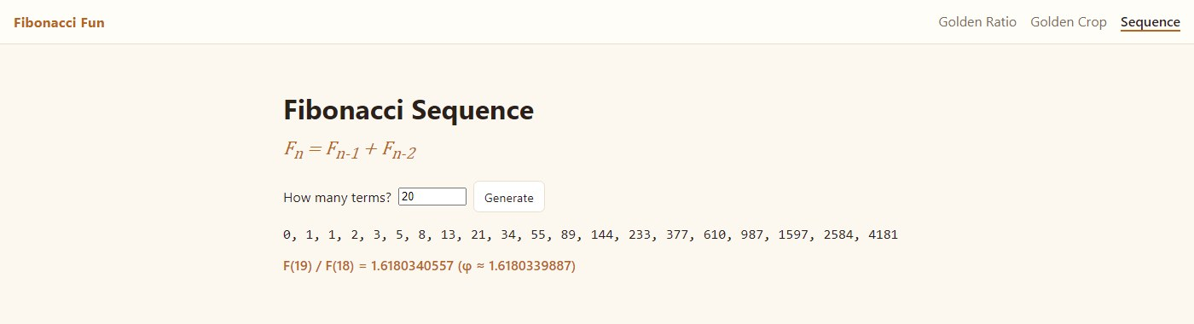
Sequence page
- Enter How many terms? (1 to 1000).
- Click Generate.
- The page lists the numbers, and shows the ratio of the last two next to φ ≈ 1.6180339887. The ratio gets closer to φ the more terms you ask for.

5. Keyboard and mouse reference
Golden Ratio page, acting on the selected detected spiral:
Key / gesture | Action
R | Rotate 90°
F | Flip (mirror)
[ / ] | Previous / next found spiral
Delete or Backspace | Remove the selected spiral
Drag inside the frame | Move
Drag the corner handle | Resize
Mouse wheel over the spiral | Scale
Click another spiral | Select it

Golden Crop page:
Gesture | Action
Click on the photo | Set the subject there
Drag in the After view | Shift the crop

Everywhere: hover, tap or Tab to an ⓘ to read its tip, and press Esc to close it.

6. Understanding the numbers
Fit % (detected spirals) is how much of the spiral's curve runs along a matching edge in the photo, in the right direction.
Fit | Label | Meaning
85% and up | strong | The curve follows the photo very closely
70–84% | good | Clearly spiral-shaped
55–69% | fair | Partly spiral-shaped
below 55% | weak | Probably chance

On the sample photos, random placements score a median of about 6–23%, so a strong or good match is far above chance.
Ratio (Any log spiral mode) is how much the spiral grows every quarter turn. A true golden spiral is 1.62 (φ). Nautilus shells are typically about 1.3, and looser spirals are 2 and above.
Spiral eye position is given as a percentage across and down the image (or the padded frame in Pad mode).

7. Tips and troubleshooting
- Find picks the wrong object or nothing useful. Find works best when the spiral is large in the frame, about a quarter of the photo's height or more. Crop the photo closer to the spiral first, or use ＋ Place manually.
- A shell is traced poorly in Golden mode. Most real shells aren't golden spirals. Switch Spiral type to Any log spiral.
- Flowers like sunflowers and pine cones. They are made of many interleaved spirals, not one curve, so Find does not trace them as one spiral.
- Golden Crop cuts part of the subject. The automatic subject may be only the brightest part of an object. Click the center of the real subject, or try another Definition or Shape.
- "Could not read that image." Use a common format (JPEG, PNG, WebP). Phone photos are rotated automatically.
- The page doesn't open. Check that python -m app is still running and nothing else uses port 8000.

