Generatre Synthetic Data (Fv, T, RGB) Algorithm
Mosheat Alon-Moses, May 2025

Contents
Introduction 2
Generate Fv, T Data 3
Flame heights 3
Fv Vectors 3
T vectors 4
Fv Matrix 5
T Matrix 6
Generate RGB Image 7
sootCalculation.mat 7
Run through SootImage 7
Results 8
Known Issues and Future Work 10
Appendix A – Accepting Data Restrictions 11
Appendix B – Generate Data (Matlab Code) 12
Generate Fv 12
Generate T 12
Appendix C – SootImage (Matlab Code) 12

Introduction
Our research relies on flame RGB images for investigating soot properties. My role is to create a deep learning model for extracting the soot properties upon a given RGB digital camera image of an axisymmetric laminar flame. For me to train such a model, I need data. Existing simulators have their downside as they are slow, not very accurate and complicated for configuration. There was a big need for creating such synthetic data.
Victor created a few Matlab files calculating properties of 3 vectors of the flame. After filtering out problematic data- based on a linear interpolation, I completed values of Fv (soot fractions volume) and T (temperature) in each pixel of the flame. I then used Victor’s sootImage for creating an RGB image of the flame upon the given generated data.

Generate Fv, T Data
Generating the data is done with a few random picks. Therefore, there are a few restrictions that must be verified before the data generated is accepted for next steps.
Once the two heights (h_top, h_maxFv), three Fv vectors (fbase, fmaxFv, ftop) and three T vectors (tbase, tmaxFv, ttop) are generated as detailed below- the data goes through a number of verification steps as detailed in Appendix A. If verification fails- the data is regenerated until all terms and restrictions are met.

Flame heights
To generate the flame’s contour, I begin with randomly generating 2 heights:
- h_top - the top (currently, it isn’t the tip of the flame, but it is the top height of the flames we produce)
- h_maxFv – this is a height that holds the maximum Fv (soot fractions volume) value of the flame
First, I draw a random number between 200 and 400 as the flame’s h_maxFv.
Next, I draw another random number between 200 and 400 and add it to h_maxFv. This is the flame’s h_top.
h_maxFv = random.randint(200,400) #random height for max fv
h_top = random.randint(200,400) + h_maxFv #random height for top flame

When relating to the base of the flame, height 0.

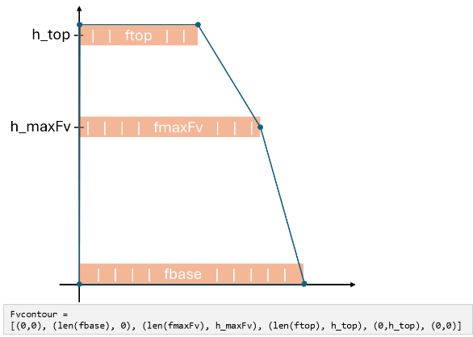
Fv Vectors
Once I have h_maxFv and h_top heights, I run Matlab functions to generate 3 vectors of soot fractions volume in every height (base, maxFv, top):
fbase = generatef(1)
fmaxFv = generatef(4)
ftop = generatef(7)
Now I know the size of each vector in every height, I can create the flame’s Fv contour.
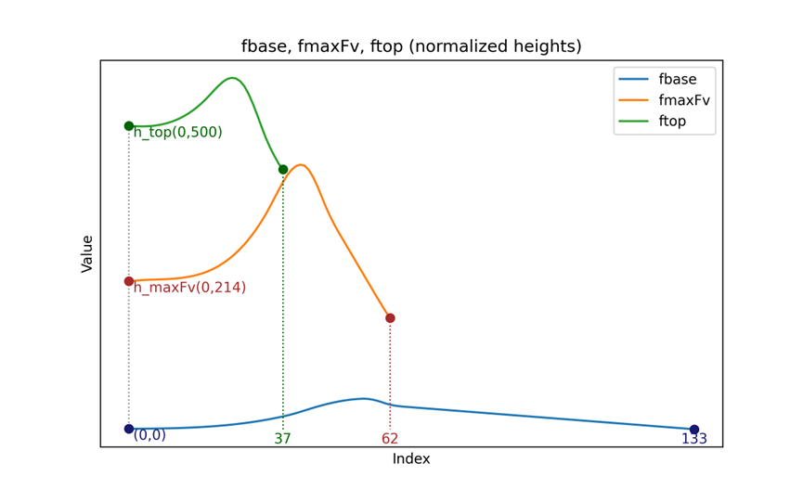
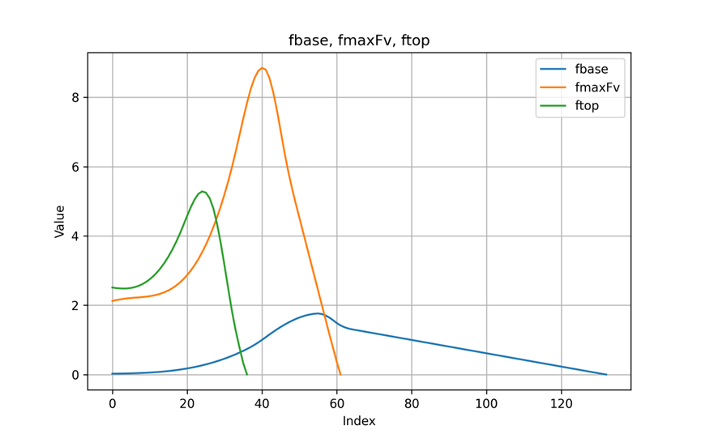
The Fv contour will be the flame’s edges I will regard to when dealing with both the soot fractions volume and the temperature properties.
Notice fmaxFv holds the highest Fv value and len(fbase)>len(fmaxFv)>len(ftop). Both restrictions are by definition.
See Appendix A for all restrictions.

T vectors
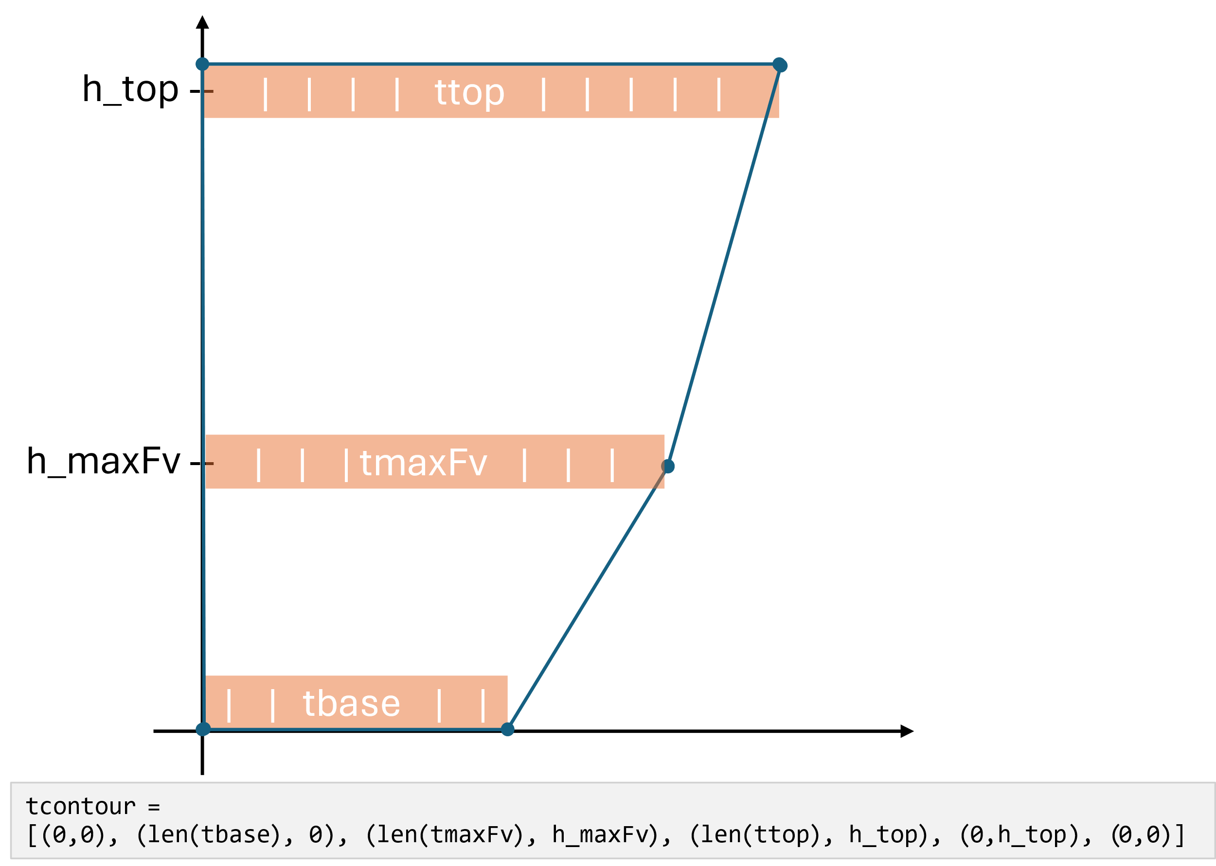
Next, I generate the temperature vectors. Here too I regard h_maxFv and h_top heights. I run Matlab functions to generate 3 vectors of temperature in every height (base, maxFv, top):
tbase = generateT(1)
tmaxFv = generateT(4)
ttop = generateT(7)
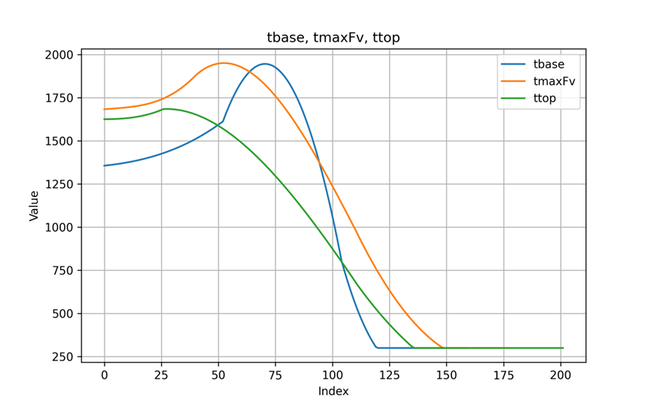
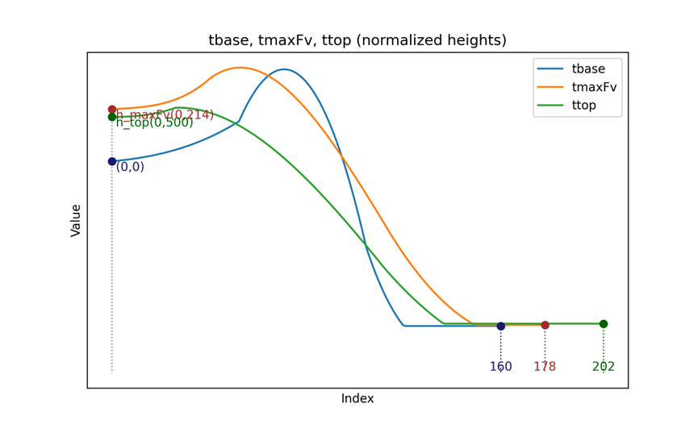
For some reason, the T vectors are generated vertically, so I transpose them before continuing.
Flame’s T contour is different than flame’s Fv contour. It is generally wider, and there is no rule as for which section (ttop, tmaxFv or tbase) is wider.
In any case- populating tmatrix is done according to flame’s Fv contour.
See Appendix A for all restrictions for accepting the generated data.

Fv Matrix
After generating the 3 Fv vectors, I want to populate the Fv matrix. I run on each (x,y) in the Fv matrix (fvmat).
- Create a matrix fvmat with shape of:
width = len(fbase) + 50
height = h_top + 10
- Initialize fvmat with zeros and attend only the cells within the Fv contour. This way- values outside the contour remain 0.
- Insert fbase at y=0, fmaxFv at y=h_maxFv and ftop at y=h_top.
- For cells on the Fv contour submit the value 0.1.
- Fill in the missing data inside the Fv contour boundaries by calculating a linear interpolation between the bottom vector and the top vector, depending on the weight calculated according to the Y position. This means when weight is 0, I’ll get values as bottom_vector[x]; when weight is 1, I’ll get values as top_vector [x]; and for values in between, I’ll get a blend. By doing this I get smooth transitions from the base to the top as I move vertically.
This is done in two regions- one between fbase and fmaxFv and the other one between fmaxFv and ftop.
In each region I calculate:
- weight = (y - 0) / (h_maxFv-0)
- Because the bottom vector is longer than the top vector, I have 2 cases-
  - If x is within the range of top vector:
Interpolate between bottom_vector[x] and top_vector [x] using the formula:
(1 - weight) * bottom_vector[x] + weight * top_vector[x]
  - If x is outside the range of top_vector (so top_vector[x] does not exist), and the current matrix value is 0:
Interpolate between base[x] and a small constant value of 0.1, using the same weight:
(1 - weight) * bottom_vector[x] + weight *0.1
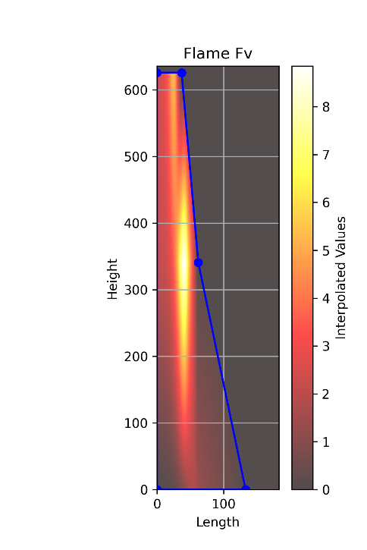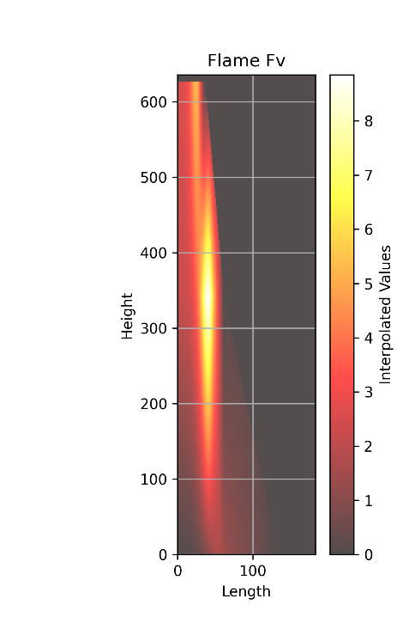

T Matrix
After generating the 3 T vectors, I want to populate the T matrix. I run on each (x,y) in the T matrix.
- Create a matrix tmat with shape of:
width = max(len(tbase), len(tmaxFv), len(ttop)) + 50
height = h_top + 10
- Initialize tmat with 300 (units are in Kalvin, so this is the zero value) and attend only the cells within the Fv contour. This way- values outside the contour remain 300.
* Reminder- populating tmatrix is done according to flame’s Fv contour.
- Insert tbase at y=0, tmaxFv at y=h_maxFv and ttop at y=h_top.
- For cells on the Fv contour submit the value 300.
- Fill in the missing data inside the Fv contour boundaries by calculating a linear interpolation between the bottom vector and the top vector, depending on the weight calculated according to the Y position. This means when weight is 0, I’ll get the value as bottom_vector[x]; when weight is 1, I’ll get the values as top_vector [x]; and for values in between, I’ll get a blend. By doing this I get smooth transitions from the base to the top as I move vertically.
This is done in two regions- one between tbase and tmaxFv and the other one between tmaxFv and ttop.
- In each region I calculate:
- weight = (y - 0) / (h_maxFv-0)
- Because (by definition) the shortest temperature vector is longer than fbase (the longest Fv vector) and because we are interested in the Fv contour, we use the following 2 cases:
  - If x is within the range of fbase vector:
Interpolate between bottom_vector[x] and top_vector [x] using the formula:
(1 - weight) * bottom_vector[x] + weight * top_vector[x]
  - If x is outside the range of fbase vector (so top_vector[x] does not exist), and the current matrix value is 300:
Interpolate between top[x] and a constant value of 300, using the same weight:
matrix[y, x] = (1 - weight) * 300 + weight * top_vector [x].item()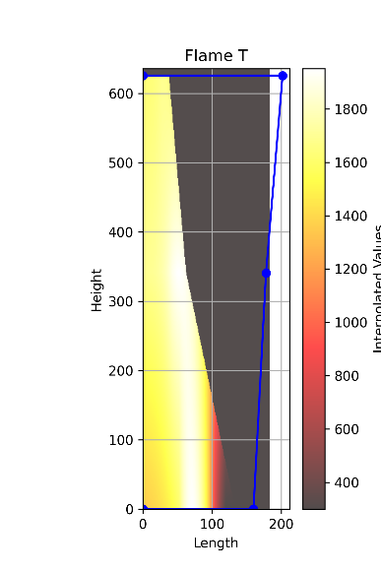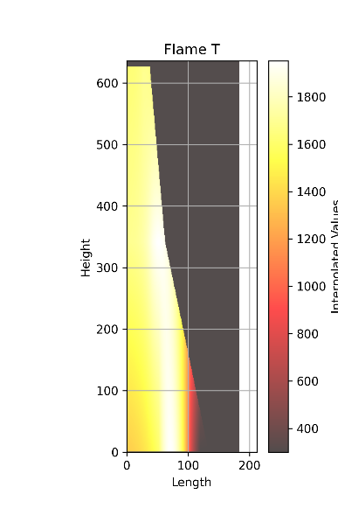
Flame T is populated according to Flame Fv contour. In blue- T contour

Generate RGB Image

sootCalculation.mat
At this point I have 2 matrices for T and Fv.
Next, I want to generate the flame RGB. Generating the flame RGB is done using Victor’s SootImage tool.
The tool gets as an input a sootCalculation.mat file that holds in it 4 matrices: T, fv, r, z.
fv is fvmatrix, saved as is.
T is tmatrix clipped to fvmarix shape:
tmatrix = tmatrix[:fvmatrix.shape[0], :fvmatrix.shape[1]]
r is a vector, size as the smaller side of the matrices. Values are from 0 in steps of 0.0662 (pixel size).
z is a vector, size as the larger side of the matrices. Values are from 0 in steps of 0.0662 (pixel size).


Run through SootImage
Using sootImage tool (MATLAB files) with sootCalculation.mat as an input, I get the following files:
CFDImage.mat- holding the flame’s RGB image matrix
redMatrixCFD.mat- holding the flame’s R image matrix
greenMatrixCFD.mat- holding the flame’s G image matrix
blueMatrixCFD.mat- holding the flame’s B image matrix
Last thing I do is to generate an image out of CFDImage.mat and save an info.txt about the run.

Results
For the DL model, I need data from:
- Input- RGB flame image
- Output- Soot Fraction Volume in every pixel of the flame
- Output- Temperature in every pixel of the flame
Using the processes and algorithms described above, I can create a dataset without the costly resources of a simulator.
Generating a sample takes approximately 30 seconds, varying in correspondence with the drawn size of the flame and times generated until conditions are met.
The following files are generated by the sample:
File name | Description
info.txt | Summary of run, holding info such as h_maxFv and h_top, Fv and T Data (generated vectore, sizes, shapes, contours) and r, z shapes
ttop.csv | Top of flame’s temperature vector generated using Matlab function generateT(7)
tbase.csv | Base of flame’s temperature vector generated using Matlab function generateT(1)
tmaxFv.csv | Temperature vector at the height of the maximum soot fraction volume (h_maxFv) in the flame, generated using Matlab function generateT(4)
T_interpolated_matrix.csv | Matrix holding all values of flame’s temperature in Fv contour (cut to size of Fv matrix)
ftop.csv | Top of flame’s soot fraction volume vector generated using Matlab function generatef(7)
fbase.csv | Base of flame’s soot fraction volume vector generated using Matlab function generatef(1)
fmaxFv.csv | Soot fraction volume vector at the height of the maximum soot fraction volume (h_maxFv) in the flame, generated using Matlab function generatef(4)
Fv_interpolated_matrix.csv | Matrix holding all values of flame’s soot fraction volume
CFDImage.mat | MAT file holding flame RGB image 3D matrix
sootCalculation.mat | Mat file holding Fv, T, r, z matrices. This object is the input of sootImage tool and output of DL model
redMatrixCFD.mat | Mat file holding red matrix of the RGB flame image
greenMatrixCFD.mat | Mat file holding green matrix of the RGB flame image
blueMatrixCFD.mat | Mat file holding blue matrix of the RGB flame image
T_flame_plot_noContour.png | Plot of flame’s temperature values in each pixel (in Kelvin scale, ranging from 300 and up)
T_flame_plot_Contour.png | Plot of flame’s temperature values in each pixel (in Kelvin scale, ranging from 300 and up) with the contour according to the generated base, maxFv and top vectors (Note: the contour is according to the T vectors, The map is after cutting to Fv size)
Fv_flame_plot_noContour.png | Plot of flame’s soot fraction volume values in each pixel (in ppm scale, ranging from 0 and up)
Fv_flame_plot_Contour.png | Plot of flame’s soot fraction volume values in each pixel (in ppm scale, ranging from 0 and up) with the contour according to the generated base, maxFv and top vectors.
flame_CFDImage_image.png | RGB flame image

Not all files are needed for our deep learning model. I saved data I thought might help us investigate results in the future.
The files we need for our deep learning model are:
- Input- CFDImage.mat
- Output- sootCalculation.mat (or T_interpolated_matrix.csv and Fv_interpolated_matrix.csv)

Known Issues and Future Work
- The flame is not generated up to its tip, but up to a random height between 400-800.
- The mathematical relation between T and Fv is not considered.
- Add that if there is a temperature value higher than 2375- loose sample.

Appendix A – Accepting Data Restrictions
When running the generatef.m and generateT.m functions, we are dealing with some randomicity of data. To provide data physically and mathematically as accurate as possible, a few restrictions and conditions were defined:
- h_maxFv, h_top, fbase, fmaxFv, ftop, tbase, tmaxFv, ttop set was not used before.
- len(fbase)>len(fmaxFv)>len(ftop).
- The max value of fmaxFV is greater than max value of fbase and of ftop.
- All T vectors’ length must be greater than fbase length.
* There is no restriction as to which vector is longer between the T vectors.

Appendix B – Generate Data (Matlab Code)

Generate Fv

Generate T

Appendix C – SootImage (Matlab Code)

