Generate Synthetic Data (Fv, T, RGB) Algorithm
Mosheat Alon-Moses, November 2025

Contents
Introduction 2
Generate Fv, T Data 3
Flame heights 3
Fv Vectors 3
T vectors 4
Fv Matrix 5
T Matrix 5
Generate RGB Image 7
sootCalculation.mat 7
Run through SootImage 7
Results 8
Known Issues and Future Work 10
Appendix A – Accepting Data Restrictions 11
Appendix B – Linear Interpolation 12
Appendix C – Full T matrix 13

Introduction
Our research relies on RGB flame images for investigating soot properties. My role is to create a deep learning model for extracting the soot properties from a given RGB digital camera image of an axisymmetric laminar flame. To train such a model, I need data. Existing simulators have their downside as they are slow, not very accurate and complicated to configure. There was a need to create such synthetic data.
Victor created a few MATLAB scripts that calculate properties of 3 vectors at strategic heights of the flame. After filtering out problematic data, I’ve calculated values of Fv (soot fractions volume) and T (temperature) in each pixel of the flame based on a linear interpolation. I then used Victor’s sootImage code to create an RGB image of the flame upon the given generated data.

Generate Fv, T Data
Generating the data is done with a few random picks. Therefore, there are a few restrictions that must be verified before the generated data is accepted for the next steps.
Once the three heights (h_{top}, h_{maxFv}, h_{tip}), three Fv vectors (f_{base}, f_{maxFv}, f_{top}) and three T vectors (t_{base}, t_{maxFv}, t_{top}) are generated as detailed below, the data goes through several verification steps as detailed in Appendix A. If verification fails, the data is regenerated until all terms and restrictions are met.

Flame heights
To generate the flame’s contour, I begin by randomly generating 3 heights:
- h_{tip} – the highest point of the flame, a single point on the y axis (x=0)
- h_{top} - the top height of the flames before converging to the tip
- h_{maxFv} – this is a height that holds the maximum Fv (soot fractions volume) value of the flame
- Note: I am also relating to the flame’s base- always at height 0
First, I draw a random number between 200 and 400 as the flame’s h_{maxFv}.
Next, I draw another random number between 200 and 400 and add it to h_{maxFv}. This is the flame’s h_{top}.
Last, I draw a random number between 60mm and 80mm and convert it to pixels as the flame’s h_{tip}.
h_{maxFv} = random.randint(200,400)
h_{top}= random.randint(200,400) + h_{maxFv}
h_{tip} = int(round((random.randint(60,80)) / mm_per_pixel)) #mm_per_pixel=0.0662

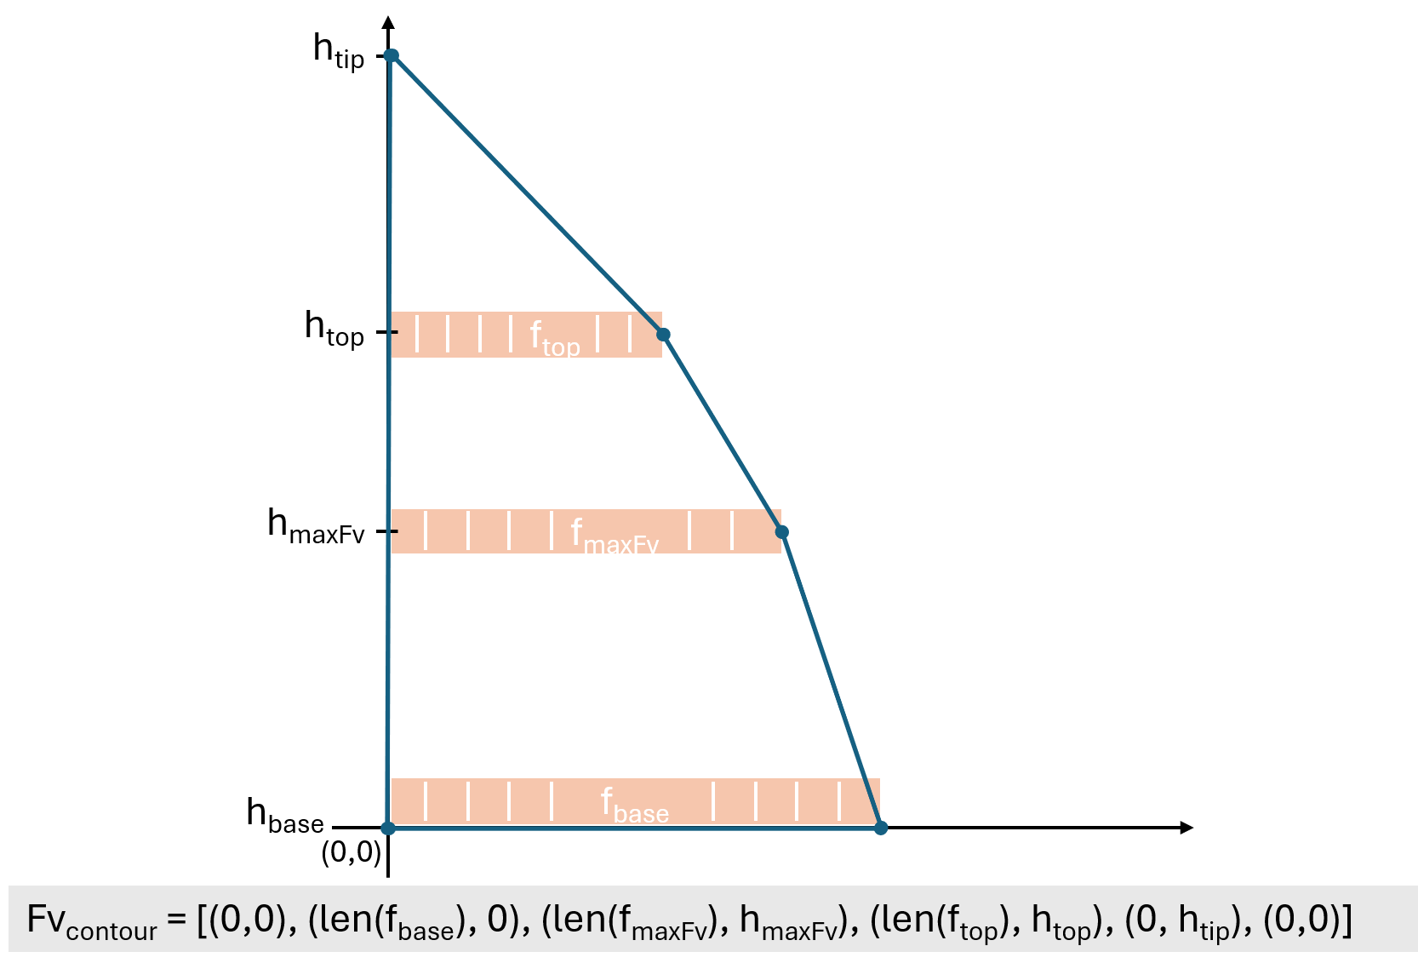
Fv Vectors
Once I got h_{tip}, h_{maxFv} and h_{top} heights, I ran Matlab functions to generate 3 vectors of soot fractions volume in every height (base, maxFv, top):
f_{base} = generatef(1)
f_{maxFv} = generatef(4)
f_{top} = generatef(7)
f_{tip} gets the constant value of 0.0.
Now that I know the size of each vector at every height, I can create the flame’s Fv contour.
The Fv contour will be the flame’s edges that I will refer to when dealing with both the soot fractions volume and the temperature properties.
Notice f_{maxFv} holds the highest Fv value and len(f_{tip})=1>len(f_{base})>len(f_{maxFv})>len(f_{top}). These restrictions are by definition.
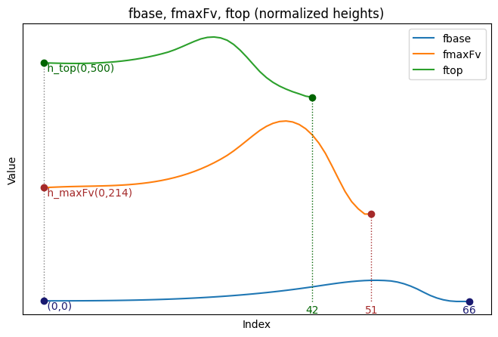
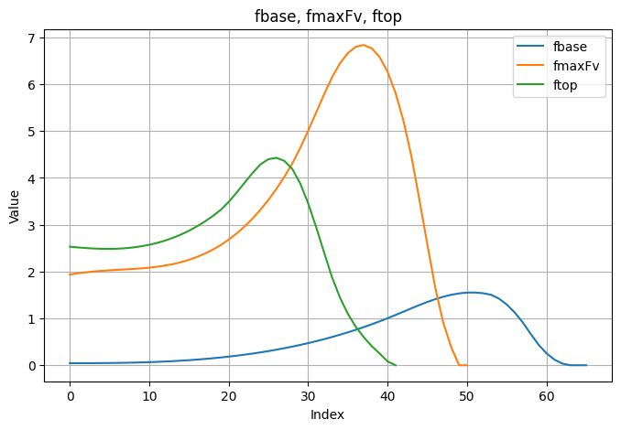
See Appendix A for all restrictions.
f_{tip} is at (0, 938) with a constant value of 0.0

T vectors
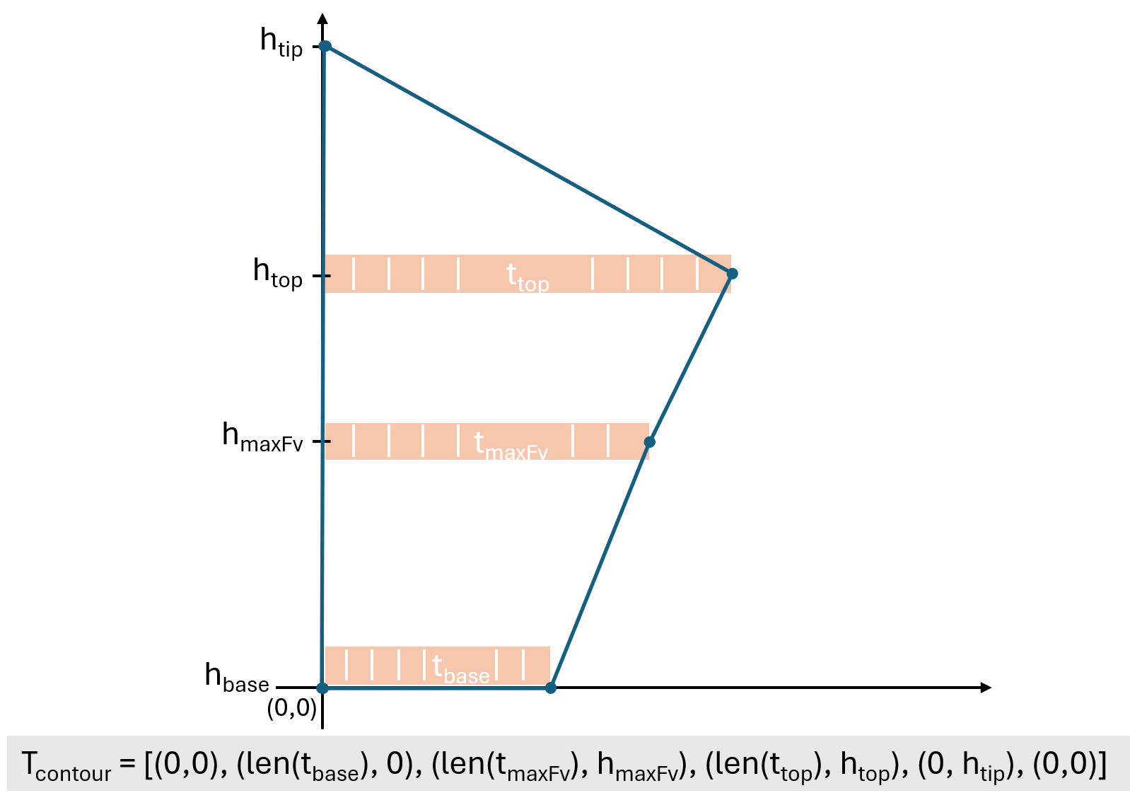
Next, I generate the temperature vectors. Here, too, I regard h_{tip} , h_{maxFv} and h_{top} heights. I run MATLAB functions to generate 3 vectors of temperature at every height (base, maxFv, top):
t_{base} = generateT(1)
t_{maxFv} = generateT(4)
t_{top} = generateT(7)
t_{tip} gets a random integer between 1700 and 1900.
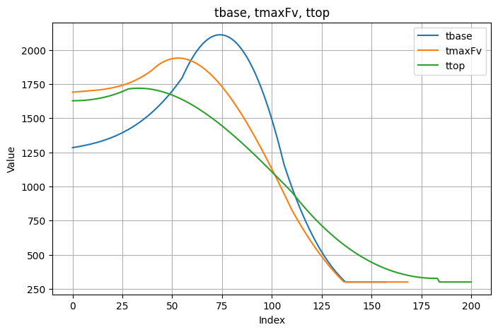
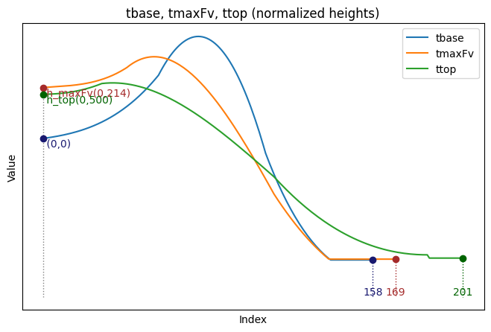
For some reason, the T vectors are generated vertically, so I transpose them before continuing.
Flame’s T contour is different than flame’s Fv contour. It is generally wider, and there is no rule as to which section (t_{top}, t_{maxFv,} or t_{base}) is wider.
In any case, populating the T matrix is done according to flame’s Fv contour.
t_{tip} is at (0, 938) with a drawn value of 1894
See Appendix A for all restrictions for accepting the generated data.

Fv Matrix
After generating the Fv vectors, I need to populate the Fv matrix. I run on each (x,y) in the Fv matrix.
- Create an Fv matrix with shape:
width = len(f_{base}) + 50
height = h_{top} + 10
- Initialize Fv matrix with zeros and attend only to the cells within the Fv contour. This way- values outside the contour remain 0.
- Insert f_{base} at y=0, f_{maxFv} at y=h_{maxFv}, f_{top} at y=h_{top} and f_{tip} at y=h_{tip}.
- For cells on the Fv contour, submit the value 0.1.
- Fill in the missing data inside the Fv contour boundaries by calculating a linear interpolation between the bottom vector and the top vector, depending on the weight calculated according to the Y position. This means when weight is 0, I’ll get values as bottom_vector[x]; when weight is 1, I’ll get values as top_vector [x]; and for values in between, I’ll get a blend. By doing this, I get smooth transitions from the base to the top as I move vertically.
This is done in three regions- one between f_{base} and f_{maxFv} and the other one between f_{maxFv} and f_{top} (see Appendix B – Linear Interpolation for more details).
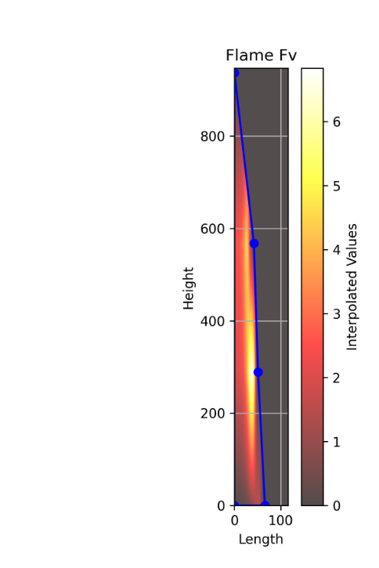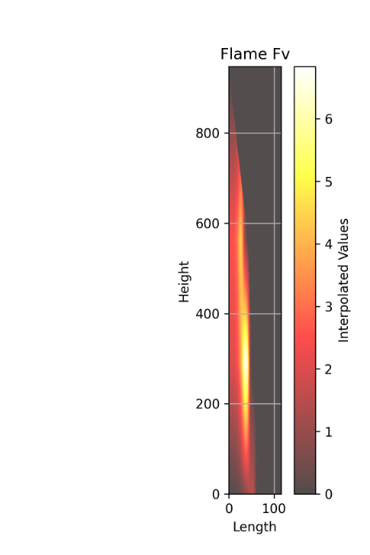

T Matrix
After generating the T vectors, I need to populate the T matrix. I run on each (x,y) in the T matrix.
- Create a T matrix with shape:
width = max(len(t_{base}), len(t_{maxFv}), len(t_{top})) + 50
height = h_{top} + 10
- Initialize T matrix with 300 (units are in Kelvin, so this is the zero value) and attend only to the cells within the Fv contour. This way- values outside the contour remain 300.
* Reminder- populating the T matrix is done according to the flame’s Fv contour.
(I added a print of the full temperature map, i.e., inside the flame’s T contour. See Appendix C – Full T matrix for details. It is not part of the synthetic data generation).
- Insert t_{base} at y=0, t_{maxFv} at y=h_{maxFv}, t_{top} at y=h_{top} and t_{tip} at y=h_{tip}.
- For cells on the Fv contour, submit the value 301. Note: the calculation of values on the contour between the top and the tip is different. However, it is not relevant since it is outside of the Fv contour. See Appendix C – Full T matrix for details).
- Fill in the missing data inside the Fv contour boundaries by calculating a linear interpolation between the bottom vector and the top vector, depending on the weight calculated according to the Y position. This means when weight is 0, I’ll get values as bottom_vector[x]; when weight is 1, I’ll get values as top_vector [x]; and for values in between, I’ll get a blend. By doing this, I get smooth transitions from the base to the top as I move vertically.
This is done in three regions- one between t_{base} and t_{maxFv} and the other one between t_{maxFv} and t_{top} (see Appendix B – Linear Interpolation for more details).
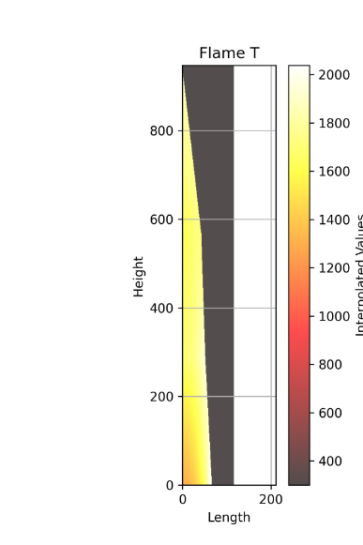
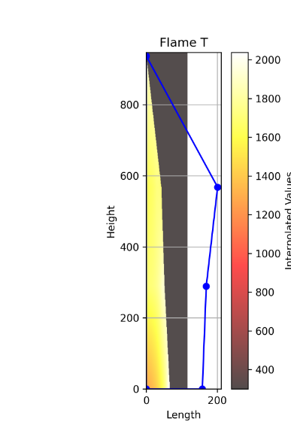
Flame T is populated according to Flame Fv contour. In blue- T contour

Generate RGB Image

sootCalculation.mat
At this point, I have 2 matrices, for T and for Fv.
Next, I need to generate the flame RGB. Generating the flame RGB is done using Victor’s SootImage tool.
The tool gets as input a sootCalculation.mat file that holds in it 4 matrices: T, fv, r, z.
fv is the Fv matrix, saved as is.
T is the T matrix clipped to the Fv matrix shape:
tmatrix = tmatrix[:fvmatrix.shape[0], :fvmatrix.shape[1]]
r is a vector of the size of the smaller side of the matrices. Values are from 0 in steps of 0.0662 (pixel size).
z is a vector of the size of the larger side of the matrices. Values are from 0 in steps of 0.0662 (pixel size).


Run through SootImage
Using sootImage tool (MATLAB files) with sootCalculation.mat as an input, I get the following files:
CFDImage.mat- holding the flame’s RGB image matrix
redMatrixCFD.mat- holding the flame’s R image matrix
greenMatrixCFD.mat- holding the flame’s G image matrix
blueMatrixCFD.mat- holding the flame’s B image matrix
The last thing I do is to generate an RGB image from CFDImage.mat (flame_CFDImage_image.png) and save an info.txt log of the run.

Results
For the DL model, I need data from:
- Input- RGB flame image
- Output- Soot Fraction Volume in every pixel of the flame
- Output- Temperature in every pixel of the flame (inside Fv contour)
Using the processes and algorithms described above, I can create a synthetic dataset without the costly resources of a simulator.
Generating a sample takes approximately 30-50 seconds, varying in correspondence with the drawn size of the flame and the number of times generated until conditions are met.
The following files are generated by the sample:
File name | Description
info.txt | Summary of the run, holding info such as h_{maxFv} and h_{top}, Fv and T Data (generated vectors, sizes, shapes, contours) and r, z shapes
ttop.csv | Top of flame’s temperature vector generated using MATLAB function generateT(7)
tbase.csv | Base of flame’s temperature vector generated using MATLAB function generateT(1)
tmaxFv.csv | Temperature vector at the height of the maximum soot fraction volume (h_{maxFv}) in the flame, generated using MATLAB function generateT(4)
T_interpolated_matrix.csv | Matrix holding all values of flame’s temperature in Fv contour (cut to the size of Fv matrix)
ftop.csv | Top of flame’s soot fraction volume vector generated using MATLAB function generatef(7)
fbase.csv | Base of flame’s soot fraction volume vector generated using MATLAB function MATLAB (1)
fmaxFv.csv | Soot fraction volume vector at the height of the maximum soot fraction volume (h_{maxFv}) in the flame, generated using MATLAB function generatef(4)
Fv_interpolated_matrix.csv | Matrix holding all values of flame’s soot fraction volume
CFDImage.mat | mat file holding flame RGB image 3D matrix
sootCalculation.mat | mat file holding Fv, T, r, z matrices. This object is the input of sootImage tool and the output of the DL model
redMatrixCFD.mat | mat file holding the red matrix of the RGB flame image
greenMatrixCFD.mat | mat file holding the green matrix of the RGB flame image
blueMatrixCFD.mat | mat file holding the blue matrix of the RGB flame image
T_flame_plot_noContour.png | Plot of flame’s temperature values in each pixel (in Kelvin scale, ranging from 300 and up)
T_flame_plot_Contour.png | Plot of flame’s temperature values in each pixel (in Kelvin scale, ranging from 300 and up) with the contour according to the generated base, maxFv and top vectors (Note: the contour is according to the T vectors, the map is after cutting to Fv size)
Fv_flame_plot_noContour.png | Plot of flame’s soot fraction volume values in each pixel (in ppm scale, ranging from 0 and up)
Fv_flame_plot_Contour.png | Plot of flame’s soot fraction volume values in each pixel (in ppm scale, ranging from 0 and up) with the contour according to the generated base, maxFv and top vectors.
flame_CFDImage_image.png | RGB flame image
T_orig_flame_plot_contour.png | Plot of flame’s temperature values in each pixel (in Kelvin scale, ranging from 300 and up) with the contour according to the generated base, maxFv and top vectors (Note: this is only for knowledge, not part of the pipeline)
T_orig_flame_plot_noContour.png | Plot of flame’s temperature values in each pixel (Note: this is only for knowledge, not part of the pipeline)
T_Orig_interpolated_matrix.csv | Matrix holding all values of flame’s temperature (Note: this is only for knowledge, not part of the pipeline)

Not all files are needed for our deep learning model. I saved data I thought might help us investigate results in the future.
The files we need for our deep learning model are:
- Input- CFDImage.mat
- Output- sootCalculation.mat (or T_interpolated_matrix.csv and Fv_interpolated_matrix.csv)

Known Issues and Future Work
- The mathematical relation between T and Fv is not considered.
- Add that if there is a temperature value higher than 2375- loose sample.

Appendix A – Accepting Data Restrictions
When running the generatef.m and generateT.m functions, we are dealing with the randomness of data. To provide data physically and mathematically as accurately as possible, a few restrictions and conditions were defined:
- h_{maxFv}, h_{top}, f_{base}, f_{maxFv}, f_{top}, t_{base}, t_{maxFv}, t_{top} set was not used before.
- len(f_{base})>len(f_{maxFv})>len(f_{top}).
- The max value of f_{maxFv} is greater than the max value of f_{base} and of f_{top}.
- All T vectors’ length must be greater than f_{base} length.
* There is no restriction as to which vector is longer between the T vectors.

Appendix B – Linear Interpolation
The flame is divided by the h_{base}, h_{fvmax}, h_{top} and h_{tip} into 3 regions. Each (x,y) point is related to the relevant region by its y value:
0 < y < h_{maxFv}: base region.
h_{maxFv} < y < h_{top}: mid region.
h_{top} <= y <= h_{tip}: top region.
In each region, I calculate a vertical linear interpolation between the top and the bottom vectors. Because they are not the same length, I have a case to calculate it when I have only one of them (this is also the reason I’m not using numpy interpolation function.
When dealing with Fv matrix- the bottom vector is always longer than the top vector and therefore, once x is longer than the top vector (but not on the contour)- I change the calculation a bit.
With temperature, it is a bit more complicated since there is no restriction as to which vector is longer between the T vectors, so I built a generalization for both cases.
The interpolation process:
For every region:
- Calculate the weight:
weight = (y – bottom_height) / (top_height - bottom_height)
- For Fv the bottom vector is longer than the top vector, and for T it could be either. So, I have 2 cases-
  - If x is within the range of the shorter vector (let’s assume top):
Interpolate between bottom_vector[x] and top_vector [x] using the formula:
matrix[y, x] = (1 - weight) * bottom_vector[x] + weight * top_vector [x]
  - Else if x is outside the range of the top_vector (so top_vector[x] does not exist), and the current matrix value is 0 (meaning it is not on the contour):
Interpolate between bottom_vector[x] and the last item of the top vector, using the same weight:
matrix[y, x] = (1 - weight) * bottom_vector[x] + weight * top_vector -1]
For T, it is the same idea, except I need to first calculate which is the shorter vector.

Appendix C – Full T matrix
As mentioned, the T matrix is calculated within the Fv contour.
For additional information, I calculate it again for the full flame, i.e., within the T contour. This is not part of the pipeline and is not used by SootImage for calculating the flame.
Even more, outside of the Fv contour, we cannot see the flames, and therefore that area is not relevant for us.
The code uses the same function to calculate the temperatures both in Fv contour and in T contour. The difference is the contour passing.


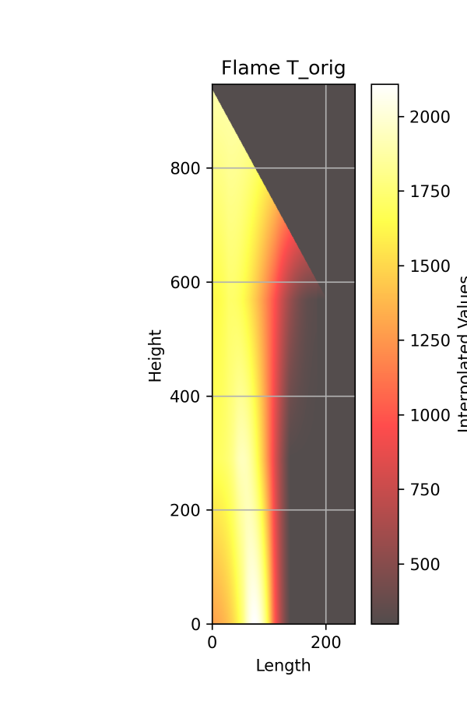
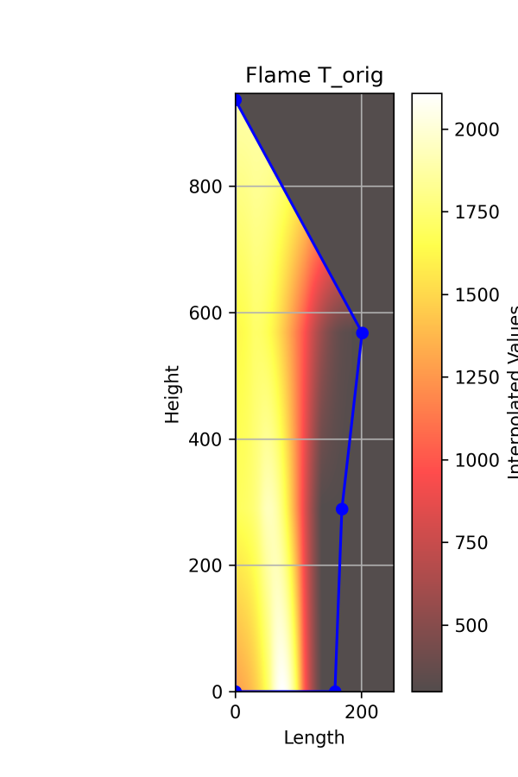
All flame is calculated as described in T Matrix and in Appendix B – Linear Interpolation, except for the contour part between t_{top} and t_{tip}. In this section, I am calculating the distance between the two points- (len(t_{top}), h_{top}) and (0, h_{tip}) and the distance between (len(t_{top}), h_{top}) and the current (x,y) and normalize it. Now I know how far the current point is along the line. The value at (x,y) is a linear interpolation on this straight line.
On the left – T matrix calculated in Fv contour (with T contour drawn). On the right- T matrix calculated in T contour

