**NeuroGlideX: Enabling Control in Children with Autism and Dyslexia**
I am Maan Shah studying in grade VIII in Lakshdham High School, Mumbai.
**Overview: **
NeuroGlideX is an innovative project meant to aid children and people with autism and dyslexia to enhance their control and aiming ability, particularly aiming at building up motor coordination with technology. With the addition of an **MPU6050 sensor**, this system assists in converting the user's bodily movements (like hand gestures) to actions in a digital world. The project uses **neural control** for enabling smoother and more intuitive gaming experiences, allowing users to interact with digital worlds with greater ease.
**Project Objectives:**
- To give children and people with autism and dyslexia a natural, simple way of controlling, aiming and movement in video games.
- To apply **brain-driven technology** (e.g., motion sensors) for greater physical interaction with virtual systems.
- To assist users in developing coordination, concentration, and motor skills in a fun, easy-to-access, and interactive manner.
**Key Features:**
- **Smooth Aim Control:** Physical movement is translated into accurate in-game movement by the system, enabling users to engage in games naturally with body movements.
- **Button Integration:** Intuitive button controls, e.g., left-click and right-click, enable the user to control and interact with the system in a hassle-free manner.
- **Accessibility:** With simplicity and accessibility in its development, NeuroGlideX provides a substitute for conventional input devices, opening the door for gaming to be more accessible for users with varying abilities.
**Conclusion:**
NeuroGlideX is more than a game device; it is a learning, development, and empowerment tool. It is a combination of state-of-the-art technology paired with an emphasis on accessibility, creating a new means for children and adults with autism and dyslexia to improve their coordination and control in the virtual world. With its simplicity and adjustable settings, NeuroGlideX has the potential to revolutionize how people access technology in an inclusive and supportive environment.

Thank You!

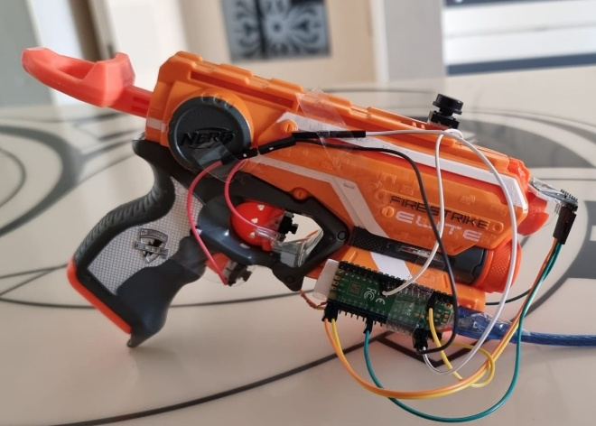
NeuroGlideX

