**Canteen Management System**

**A Project Report**

***Submitted by***

**MAANAAV MOTIRAMANI**

**DHYEY SANGHAVI**

**AAJINKYA SINGH**

***Under the Guidance of***

## Prof. KRISHNA SAMDANI

## B. TECH INTEGRATED

## COMPUTER ENGINEERING

## At



**MUKESH PATEL SCHOOL OF TECHNOLOGY, MANAGEMENT AND ENGINEERING**

**DECLARATION**

I, **MAANAAV MOTIRAMANI**, Roll No. **C069** B.Tech Integrated (Computer Engineering), understand that plagiarism is defined as anyone or combination of the following:

1. Un-credited verbatim copying of individual sentences, paragraphs or illustration (such as graph diagrams, etc.) from any source, published or unpublished, including the internet.
2. Un-credited improper paraphrasing of pages paragraphs (changing a few words phrases, or rearranging the original sentence order)
3. Credited verbatim copying of a major portion of a paper (or thesis chapter) without clear delineation of who did wrote what. (Source: IEEE, The institute, Dec. 2004)
4. I have made sure that all the ideas, expressions, graphs, diagrams, etc., that are not a result of my work, are properly credited. Long phrases or sentences that had to be used verbatim from published literature have been clearly identified using quotation marks.
5. I affirm that no portion of my work can be considered as plagiarism and I take full responsibility if such a complaint occurs. I understand fully well that the guide of the seminar/ project report may not be in a position to check for the possibility of such incidences of plagiarism in this body of work.

|  |  |  |
| --- | --- | --- |
| Signature of the Student: | Signature of the Student: | Signature of the Student: |
|  |  |  |
| Name: Maanaav Motiramani | Name: Dhyey Sanghavi | Name: Aajinkya Singh |
|  |  |  |
| Roll No: C069 | Roll No: C089 | Roll No: C099 |
|  |  |  |
| Place: Mumbai | Place: Mumbai | Place: Mumbai |
|  |  |  |
| Date: 27/9/19 | Date: 27/9/19 | Date: 27/9/19 |
|  |  |  |

I, **Dhyey Sanghavi**, Roll No. **C089** B.Tech Integrated (Computer Engineering), understand that plagiarism is defined as anyone or combination of the following:

1. Un-credited verbatim copying of individual sentences, paragraphs or illustration (such as graph diagrams, etc.) from any source, published or unpublished, including the internet.
2. Un-credited improper paraphrasing of pages paragraphs (changing a few words phrases, or rearranging the original sentence order)
3. Credited verbatim copying of a major portion of a paper (or thesis chapter) without clear delineation of who did wrote what. (Source: IEEE, The institute, Dec. 2004)
4. I have made sure that all the ideas, expressions, graphs, diagrams, etc., that are not a result of my work, are properly credited. Long phrases or sentences that had to be used verbatim from published literature have been clearly identified using quotation marks.
5. I affirm that no portion of my work can be considered as plagiarism and I take full responsibility if such a complaint occurs. I understand fully well that the guide of the seminar/ project report may not be in a position to check for the possibility of such incidences of plagiarism in this body of work.

|  |  |  |
| --- | --- | --- |
| Signature of the Student: | Signature of the Student: | Signature of the Student: |
|  |  |  |
| Name: Maanaav Motiramani | Name: Dhyey Sanghavi | Name: Aajinkya Singh |
|  |  |  |
| Roll No: C069 | Roll No: C089 | Roll No: C099 |
|  |  |  |
| Place: Mumbai | Place: Mumbai | Place: Mumbai |
|  |  |  |
| Date: 27/9/19 | Date: 27/9/19 | Date: 27/9/19 |
|  |  |  |

I, **AAJINKYA SINGH**, Roll No. **C099** B.Tech Integrated (Computer Engineering), understand that plagiarism is defined as anyone or combination of the following:

1. Un-credited verbatim copying of individual sentences, paragraphs or illustration (such as graph diagrams, etc.) from any source, published or unpublished, including the internet.
2. Un-credited improper paraphrasing of pages paragraphs (changing a few words phrases, or rearranging the original sentence order)
3. Credited verbatim copying of a major portion of a paper (or thesis chapter) without clear delineation of who did wrote what. (Source: IEEE, The institute, Dec. 2004)
4. I have made sure that all the ideas, expressions, graphs, diagrams, etc., that are not a result of my work, are properly credited. Long phrases or sentences that had to be used verbatim from published literature have been clearly identified using quotation marks.
5. I affirm that no portion of my work can be considered as plagiarism and I take full responsibility if such a complaint occurs. I understand fully well that the guide of the seminar/ project report may not be in a position to check for the possibility of such incidences of plagiarism in this body of work.

|  |  |  |
| --- | --- | --- |
| Signature of the Student: | Signature of the Student: | Signature of the Student: |
|  |  |  |
| Name: Maanaav Motiramani | Name: Dhyey Sanghavi | Name: Aajinkya Singh |
|  |  |  |
| Roll No: C069 | Roll No: C089 | Roll No: C099 |
|  |  |  |
| Place: Mumbai | Place: Mumbai | Place: Mumbai |
|  |  |  |
| Date: 27/9/19 | Date: 27/9/19 | Date: 27/9/19 |
|  |  |  |

**Table of Contents**

|  |  |  |  |  |  |
| --- | --- | --- | --- | --- | --- |
| **CHAPTER NO.** | | **TITLE** | | **PAGE NO.** | |
| I | | Abstract | |  | |
| 1. | | INTRODUCTION | | 8-14 | |
| 1.1 | | VENDOR BASED | | 8-8 | |
| 1.2 | | STUDENT BASED | | 9-10 | |
| 1.3 | | FLOWCHART | | 11-11 | |
| 1.4 | | EXISITING SYSTEM | | 12-12 | |
|  | |  | |  | |
| 2. | | TOOLS & TECHNIQUES | | 14-16 | |
|  | |  | |  | |
|  | |  | |  | |
| 3. | | SIMULATIONS & RESULTS | |  | |
| 4. | | CONCLUSION | |  | |
| 5. | | FUTURE WORK | |  | |
| 6. | | REFRENCES | |  | |
|  | | Appendix A | |  | |

**Table of Figure**

|  |  |  |  |
| --- | --- | --- | --- |
| **CHAPTER NO.** | **FIGURE NO.** | **FIGURE NAME** | **PAGE NO.** |
|  |  |  |  |
| 1. | 1.1 | Name of the figure |  |
| 2. |  |  |  |
| 3. |  |  |  |
| 4. |  |  |  |
| 5. |  |  |  |
| 6. |  |  |  |
|  |  |  |  |

**ABSTRACT**

**1. INTRODUCTION**

CMS is an app developed by Maanaav Motiramani, Dhyey Sanghavi and Aajinkya Singh. It is an app which helps the students of MPSTME (Mukesh Patel School of Technical Management and Engineering) to efficiently order from the canteen without wasting time and additional effort. The app allows a student to order food prior to the break by which he/she does not have to wait for food to be prepared and enjoy their break. We came up with this idea while we were waiting in a queue on the canteen to order from the menu. We suddenly acknowledged the amount of time atrophied by the students of MPSTME in a long queues. This project is our genuine stride towards saving some time and we hope you all will bolster our attempt. The code for this app is mainly divided into two parts-

**1.1. VENDOR BASED:**

The vendor based code give the college management an access to student details who have their account registered on their SAP id. The app has two ways to access, if you access it by vendor based code you get two options:

1. To get details about the student user by entering the SAP id. Once you enter the SAP id, it accesses a file which has all the details related to the student and displays its name, SAP id and mail id.

2. To exit the code without getting any details.

Due to restrain of time we have only two options, rest of the options and its details have been kept in future work.

**1.2. STUDENT BASED:**

The student based code gives the student user the options to Place order, Access to the wallet, Change password, View Account details, Add money, etc.

Once you start the code, it asks the student user whether he or she has already has an account or if they want to create a new account. If the user already has an account it takes input for the existing username i.e. SAP id and checks if they have an account already registered on the SAP id by accessing a file which has all the details of existing accounts and checks whether it contains an account on that SAP id. It then takes the input of his password and logs in to his account. While if the user selects the option to create a new account it gives an option to enter the SAP id (username) but it sets your default password as “admin”. But you get an option after your account is created to change the default password to a desired password.

After login the user gets an options menu on his/her screen which has options for different services provided like:1. New Order 2. View Account details 3. Access Wallet 4. Logout.

If the user wants to order food he or she shall select 1 and it will then redirect them to the menu from where the user can select what does he or she wants to order from various categories available. We have only kept a few categories out of many to try and make the code as small as possible, but we can add more categories and food items for the code. After selection user gets an option to order again from the same category, order from different category or proceed to cart. After proceeding to the cart the user has an option to either go back to the options menu, or cancel the order, or cancel the order and add another item. All these functionalities are possible by using “goto” statements. If the user does select the option to check out the app redirects the user to the wallet and asks for an option to use a coupon which in turn gives discount on the total amount and the amount then is deducted from the wallet.

If the user wants to view details such as past order, username, password, total amount present in the wallet, etc. He or she has to select 2 as their option from the services provided. The code does so by accessing a file which has all the details about all the accounts created and which already exist.

While if the user wants to add money via credit/debit card or mobile wallets, view balance, etc. He or she can do it by selecting 3 from the services provided. There are more things we could not do for the wallet like to store credit card details, phone number for mobile wallet and others due to lack of time period which we have mentioned in the future work part.

And the last service provided is for logging out of the account by selecting 4 from the services provided.

Once you select your food item you get an options menu to 1.Go to cart 2.Add more 3.Edit order. If user selects 1 he or she is redirected to the cart where they can view their items which they have selected and then choose to pay from the wallet to place order.

If the user wants to add more items, he or she will select 2 from the options menu and will be redirected to the menu where they can either order from the same category or different category.

If the user wants to cancel the order before moving to the cart and add another item instead of the selected one, he or she can select option 3 from the options menu.

And then finally after placing the order the user can logout from the account.

**1.3. FLOW CHART**

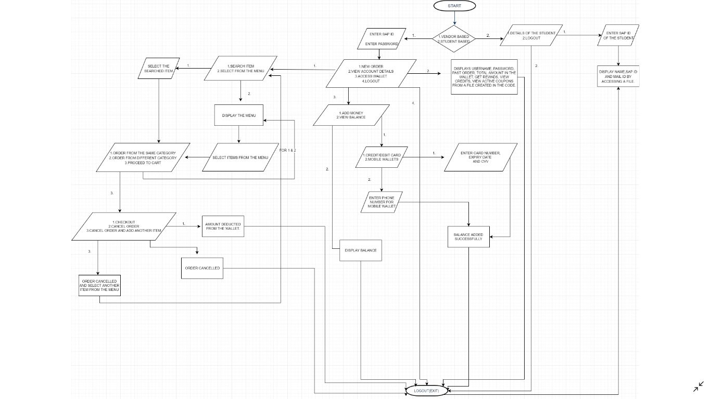  
: FLOWCHART

**1.4. EXISTING SYSTEM:**

There is already an app for Canteen Management for students of MPSTME created by students of MPSTME. Using this app students can pre order food, view menu, etc. Its a good app for students and has good features. However there are some flaws which we tend to resolve by keeping the current functionalities intact and bringing more to the table.

**1.4.1. FLAWS IN THE EXISTING SYSTEM**

In this app you can add money to your wallet only and only by paying money to the canteen for which a user has to go to the counter and only then he/she can order. By doing this a user has to go to the canteen and add money to their wallet while he/she can just pay for the food on the counter. This app can be used even by the students, not studying in MPSTME. There is no additional discount given to regular users.

There is no given time for ordering and adding money to the wallet which in turn creates complexes in the management. The app even takes order on holidays, at nights, even if the college and canteen are not functioning. The app even takes orders when the item is out of stock or unavailable in the canteen which again creates a fuss.

**1.5. FUNCTIONALITIES WE TEND TO GIVE**

**1.5.1 RESOLVING FLAWS BY ADDING THESE FUNCTIONALITIES**

In our app a user can either pay through wallet for which he/she can pay money online or pay by cash on receiving the order. Either ways the user only has go to the counter for collecting food and not wait in long queues for adding money. Unlike the other app only and only students of MPSTME can use this app because, we have used SAP id for registration of the users. This in turn makes things easier for the users as well as the canteen management for using the app and storing data of the users. We also have a feature in our app by which if the user fulfils certain criteria then he is eligible for a coupon code which in turn gives the user certain discount on the next order.

In our app, it only takes order when the canteen is functional and does not take order when it is not. The same thing goes for adding money in the wallet. In our app, we tend to keep a stock details for the management so if the canteen runs out of stock it automatically stops taking order for that particular item.

**1.5.2 EXISTING AND ADDITIONAL FUNCTIONALITIES**

In our app the user gets two options while ordering:1. Immediate order 2. Schedule order

In immediate order, the order gets ready within 15 minutes of ordering. While if the user wishes to take the food at a particular time, the second option would be the best choice. However the time period for scheduling should be more than 15 minutes and less than 3 hours.

We also give the vendor based app for the management alongside the student based code. The main idea of this app is to save paper by producing e-receipts instead of paper bill. We also plan to add a functionality for changing the language of the app, creating a user login for faculty, saving the payment options and details, adding new SAP ids for new batch of students and also change in menu with respect to time. There ore many other functionalities like search item, order food, view account details, cash on delivery, password reset, etc. which are available in our app but already exist in the current app.

**2. TOOLS AND TECHNIQUES**

**2.1. TOOLS**

We have used different kinds of tools for this project such as different types of IDEs, notepad, Microsoft Office(power point, word, etc.), Google docs, GitHub.

The code for this app is written on different IDEs. Such as:

1. Code Blocks by Aajinkya Singh

2. Dev C++ by Dhyey Sanghavi

3. Visual Studio by Maanaav Motiramani

**2.1.1. CODE BLOCKS:**

Code::Blocks is a free, open-source cross-platform IDE that supports multiple compilers including GCC, Clang and Visual C++. It is developed in C++ using wxWidgets as the GUI toolkit. Code::Blocks is being developed for Windows and Linux (the latest macOS version is 13.12)

We have used Code Blocks as it is simpler to use.

**2.1.2. DEV C++:**

Dev-C++ is a free full-featured integrated development environment (IDE) distributed under the GNU General Public License for programming in C and C++.

It is bundled with, and uses, the MinGW or TDM-GCC 64bit port of the GCC as its compiler. Dev-C++ can also be used in combination with Cygwin or any other GCC-based compiler.

Dev-C++ is generally considered a Windows-only program, but there are attempts to create a Linux version: header files and path delimiters are switchable between platforms. Dev C++ is more customisable and has a better UI.

**2.1.3. VISUAL STUDIO:**

Microsoft Visual Studio is an integrated development environment (IDE) from Microsoft. It is used to develop computer programs, as well as websites, web apps, web services and mobile apps. Visual Studio uses Microsoft software development platforms such as Windows API, Windows Forms, Windows Presentation Foundation, Windows Store and Microsoft Silverlight. It can produce both native code and managed code.

Visual studio has dark mode and its error handling is much better than Code Blocks and

Dev C++.

**2.2. TECHNIQUES:**

**2.2.1. FUNCTIONALITIES AND CONCEPTS:**

We have used many different functionalities and concepts such as:

1. File Handling

2.Class Inheritance

3. Exception Handling

4. Friend Function

5. Type conversion

6. And other basics like If else, for loop, while loop, etc.

**2.2.2. LIBRARIES USED:**

1. window.h

2. time.h

3. fstream

4. graphics.h

5. iostream

6. iomanip

7. unistd.h

8. string

9. dos.h

10. stdlib.h

11. cstdlib.h

**2.2.3 USER DEFINED FUNCTIONS CLASSES:**

class wallet  
1. void walletfile(string noho)  
2. void time(int hr,int minit, int day,int mn,int yr,int my_d)  
3. void coupons()  
4. void display()  
5. void credit_debit()  
6. void display_amount()  
  
 class login: public wallet   
7. login()  
8. void account()  
9.void existing_account()  
10. int new_account()  
11. friend string history(login A);  
12. friend void acc_det(login X,meni Y,string test);  
13. void filenamee(string xo)  
14. int order(string c)   
15. void checkout_amount(double aout,string sr)  
16. friend void acc_det(login X,meni Y,string test);  
17. void acc_det(login X,meni Y,string test)  
18. string history(login A)  
19. int main()

**3. SIMULATION AND RESULTS**

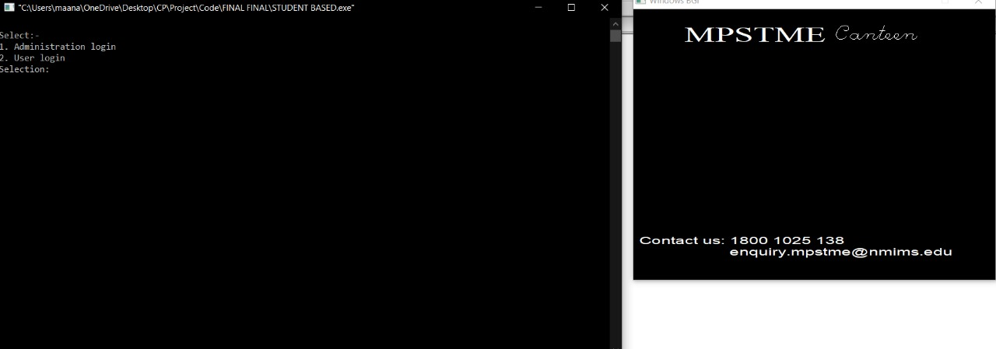  
FIG 3.1 LOGIN

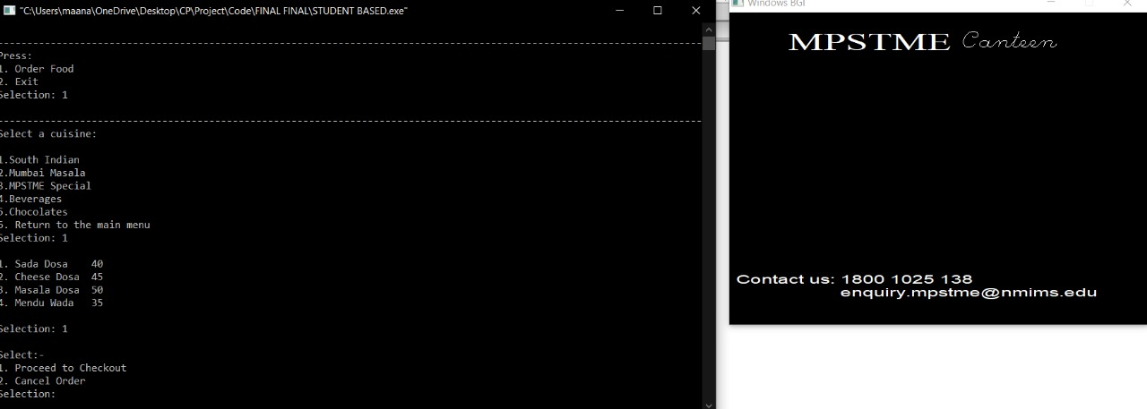  
 FIG 3.2 MAIN MENU

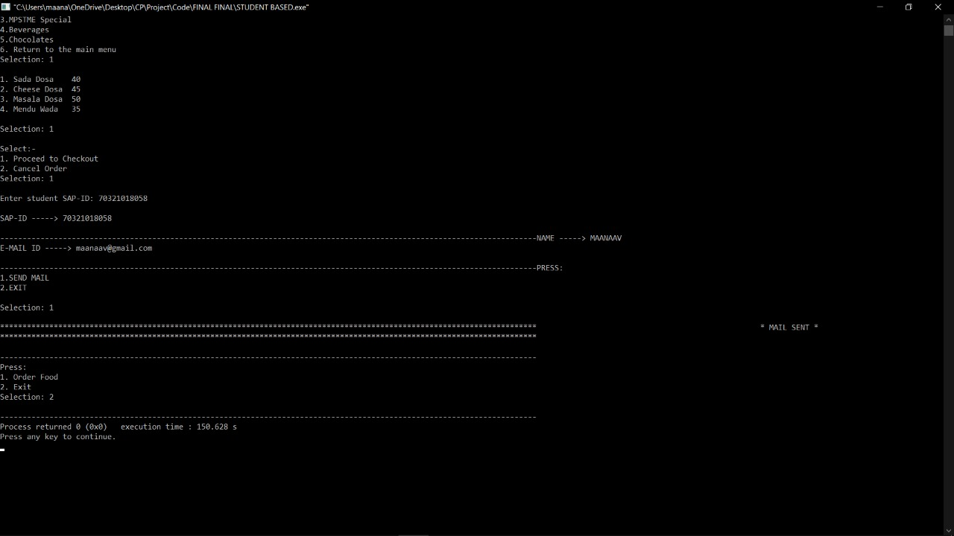  
 FIG 3.3 FOOD MENU

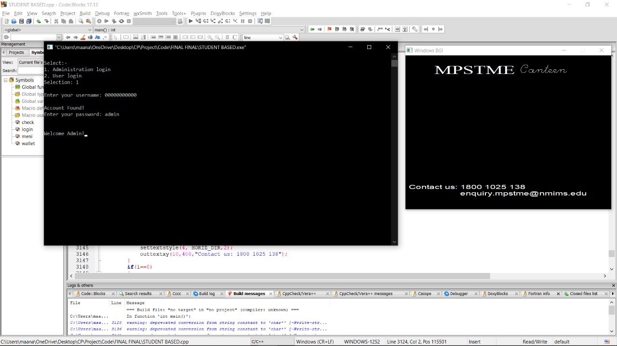 FIG 3.4 ADMIN LOGIN

**4. CONCLUSION**

This code simply acts like an online food delivery app but instead of food getting delivered at your doorstep, the student has to take the food from the canteen counter. This code basically allows the user to create an account, view menu, order, etc. Even if the user does not want to order from the app he can basically use the app to view the menu and then can order by going to the canteen itself.

We hereby conclude that we were able to add the functionalities mentioned in the introduction with the help of concepts and IDEs mentioned in tools and techniques.

**5. FUTURE WORK**

We had plans to add a feature in the app, but due to time constraint we failed to do that. The suggested updates in the upcoming app would be as follows :

**LANGUAGE CHANGE:**

There could be a feature in the app which allows the students and the vendor to choose language of their own choice. We had plans to do it by using a switch case for different languages and then replicate all the “cout” statements (display statements) and paste it in a translator and then paste it again in the code.

**ADDING NEW SAP ids:**

For the new batch of students we have to add new batch of SAP ids to allow them to register whereas we have to remove the SAP ids of the students those who have graduated. These changes are in the files containing all the SAP ids for vendor based code.

**ADDING NEW LOGIN FOR FACULTY:**

For the faculty members instead of using SAP id as username we can use their unique id given by the college. This also means that we have to make a new file for unique ids of the faculty.

**TIME VARYING CHANGES IN THE MENU:**

This sub topic contains changes in the menu file with respect to time. The menu file which can only be accessed by the canteen management changes with respect to time. Changes such as change in price, number of items, etc. These changes can be temporary as well as permanent.

**RESETTING THE PASSWORD:**

We could not add another feature which is for changing the password after you already changed it once and resetting the password if one forgets it. We plan to do so by asking the user to approach to the canteen management and then the management can change the old password to the user desired password.

**ADD A FEATURE FOR THE MANAGEMENT TO KEEP HIS STOCK OF FOOD:**

We tend to add a feature in the vendor based app (code) to allow management to keep a tally of their stocks which in turn will update the menu. For example, if some item is out of stock users may not be able to order that particular item.

**CASH ON DELIVERY:**

We have made our app in such a way that the users only have to use their wallet to order which in turn is a way of online payment. However we felt a need for cash payment for the students who do not have any mode of online payment. So we tend to add a feature by which a student can order food from the app but can pay the amount offline in cash at the counter and shall receive the receipt on his mail id and the app and will be counted as his past order, so that he can use it as credits.

**STORING PAYMENT DETAILS:**

In our current app the user has to add his payment details every time he adds money to the wallet. We aim to ease this out by storing the payment details like credit/debit card number, phone number for mobile wallet, etc. so the user does not have to enter them again and again.

We shall also add an option to change these details whenever the user wants to.

**6. REFERENCES**

System Time:  
[1] YouTube: https://www.youtube.com/watch?v=CUVNB1Pr968, 16/09/2019  
[2] Geeksforgeeks: https://www.geeksforgeeks.org/print-system-time-c-3-different-ways/, 16/09/2019  
Graphic Library:  
[3] YouTube: https://www.youtube.com/watch?v=FeNjROVLtwo , 29/09/2019  
[4] YouTube: https://www.youtube.com/watch?v=TEMhWt9WwTA , 29/09/2019  
[5] YouTube: https://www.youtube.com/watch?v=WPU3IqtHqtQ , 29/09/2019  
[6] Geeksforgeeks: https://www.geeksforgeeks.org/include-graphics-h-   
 codeblocks/ , 30/09/2019  
[7] cs.Colorado: https://www.cs.colorado.edu/~main/bgi/dev-c++/ , 29/09/2019  
[8] YouTube: https://www.youtube.com/watch?v=97_QUdXnCBM , 30/09/2019

Memset():  
[9] GeeksforGeeks: https://www.google.com/amp/s/www.geeksforgeeks.org/memset-c-example/amp/, 16/09/2019  
Sleep:  
[10] Stackoverflow: https://stackoverflow.com/questions/1658386/sleep-function-in-c, 27/09/2019  
String to char:  
[11] GeeksforGeeks: https://www.google.com/amp/s/www.geeksforgeeks.org/convert-string-char-   
 array-cpp/amp/, 29/09/2019  
Concatenate Two Strings:  
[12]Programiz.com: https://www.programiz.com/cpp-programming/examples/concatenate-string, 29/09/2019  
Char array to int:  
[13]Stackoverflow.com: https://stackoverflow.com/questions/6093414/convert-char-array-to-single-int, 30/09/2019