Full Stack Java Developer
Capstone Project Problem Statement



mAadhar Application
Problem statement:
Develop an application to automate the process of applying for an Aadhar Card by making it smoother for Indian citizens.
Scenario:
Varniraj Service PVT. LTD is closely working with “The Government of India” to help them get a solution for processing applications for Aadhaar Card. Application is intended to register citizens and let them display ID to process their Aadhar Card application.

Expected Deliverables:
Features of the application:
- Registration
- Login
- Apply for a new Aadhar Card
- Place a request for updating Aadhar details
- Apply for a duplicate Aadhar Card
- Admin: Approve Aadhar Application and issue new Aadhar number
- Apply to close Aadhaar card (due to death)

Recommended technologies:
- Database: MySQL
- Backend: Java Programming (Spring Boot, JPA, Hibernate)
- Frontend: Angular, Bootstrap, and HTML/CSS
- Automation and testing technologies: Selenium and TestNG
- DevOps tools/technologies: Git, GitHub, Jenkins, and Docker
- Optional implementation: Kubernetes, AWS

Project development guidelines:
- The project will be delivered within four sprints with every sprint delivering a Minimal Viable Product.
- It is mandatory to perform proper sprint planning with user stories to develop all project components.
- The learner should use the above-mentioned technologies for different layers of the project.
- The web application should be responsive and should fetch or send data dynamically without hard-coded values.
- The learner must maintain the version of the application over GitHub, and every new change should be sent to the repository.
- The learner must implement a CI/CD pipeline using Jenkins.
- The learner should also deploy and host the application on an AWS EC2 instance.
- The learner should also implement automation testing before the application enters the CI/CD pipeline.
- The learner should use Git branching to perform basic automation testing of the application in it separately.
- The learner should make a rich frontend of the application, which is user-friendly and easy for the user to navigate through the application.
- There will be two portals in the application, the admin and user portal.

Admin Portal:
The admin portal deals with all the backend data generation. The admin user should be able to:
- Login through admin credentials
- Approve new Aadhaar Card request
- Verify request for duplicate Aadhaar
- Display all issued Aadhaar Card
- Delete Aadhaar card details for dead citizen

User Portal:
It deals with user activities. The end-user should be able to:
- Sign in to apply for a new Aadhar Card
- Login to see the Aadhar number assigned by the admin
- Update address, phone number, and date of birth of Aadhaar Card
- Request duplicate Aadhaar Card

Frontend Validation:
- For admin: The password should have at least: One Uppercase, one lowercase, one special character (@,#,&….), and one number.
- For citizens: The password should consist of only digits.

Backend Validation:
- Mobile number validation should be applied.
- Password length should not be less than 6 characters.
- For citizens: The home page would authenticate only if the mobile number provided in Aadhaar is matching with the password.

Sample Input data for Backend REST API:
- To register new citizens:

HTTP Method: POST
URL: http://localhost:6789/AadharApp/citizens

Request Body:
{
"name": "Uttam Patel",
"dob": "2011-08-23",
"address": "2/5 Heerabagh Flats",
"emailId": "uttampatel0811@gmail.com",
"mobileNo": "7976694711",
"gender": "Male"
}

- Apply for Aadhar Card using an existing citizen ID:

HTTP Method: POST
URL: http://localhost:6789/AadharApp/issueAadhar

RequestBody:
{
"citizenId": 1002,
"passportId": null,
"issueDate": "2020-04-25"
}

Sample login page:
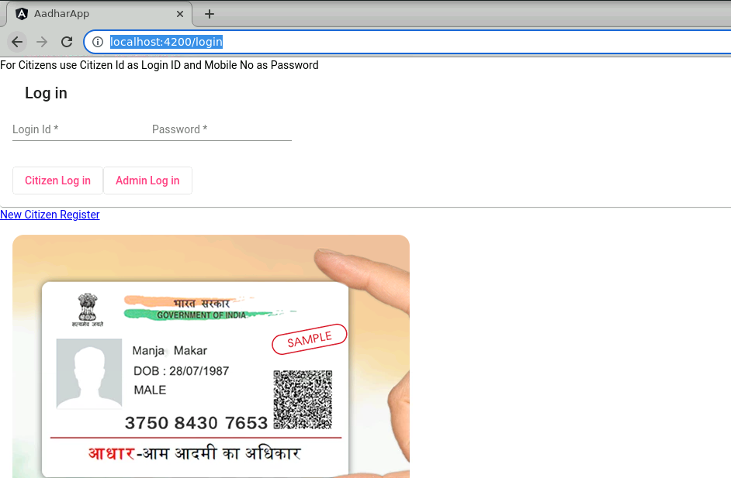
Sample user portal:
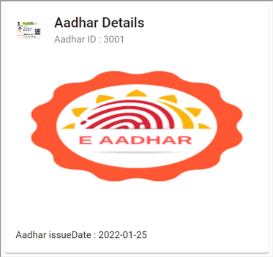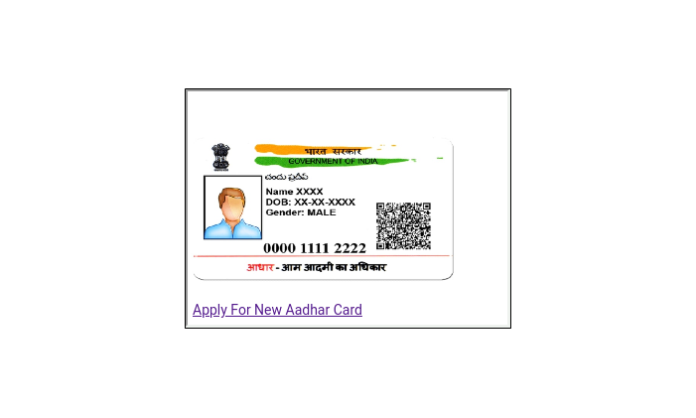

Sample admin portal:
