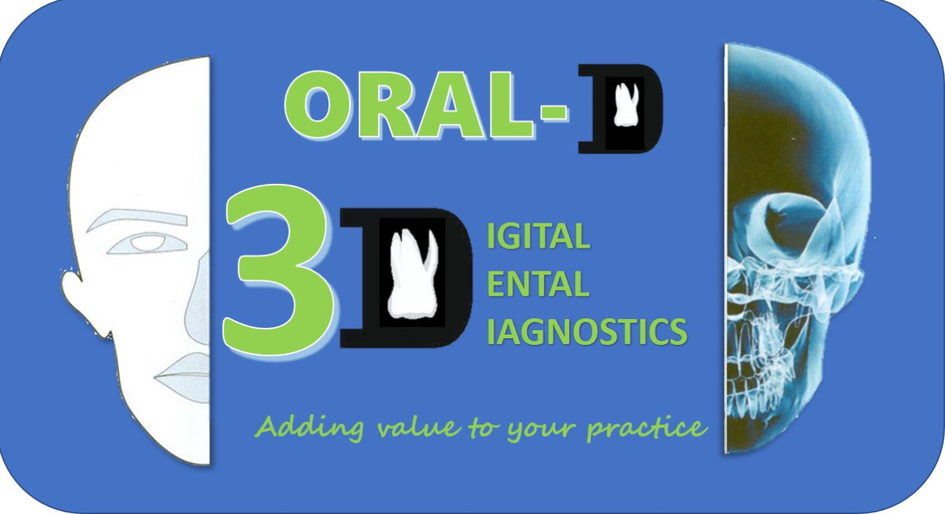

**[DOUBLE ROAD] SHANTHINAGAR PH: 080-42114509, [MATHIKERE] PH: 080-41238377, [BANASHANKARI] PH: 080-49555697, [FRAZER TOWN] PH: 080-48145384, [VIJAYNAGAR] PH: 080-43702465, [BANNERGHATTA ROAD] PH:080-4952465, [INDIRANAGAR] PH: 40935266, #1207/B, NEW KANTHRAJ URS ROAD, BALLAL, CIRCLE(ASHOK CIRCLE) NEXT TO MAHESH PRASAD HOTEL, OPP. TO FEATHERLIST SHOW ROOM, CHAMRAJPURAM, MYSURU-570005 PH:0821-4268472, [MANGALORE]PH: 8296475334, [ELECTRONIC CITY] PH: 935348184, [J.P. NAGAR] PH: 080-41523184, [YELAHANKA], PH: 080-41123924.[VARTHUR-WHITEFIELD] PH:9743485028, [BTM LAYOUT] PH: 9743485028, [KENGERI SATELLITE TOWN]PH: 9741553222, [SAJAPURA ROAD ]9743485028/ 9513379777 TEL 080-46382352, [HYDERABAD] MOB: 9945630234 TEL: 040-35705089.**

**SCAN REPORT**

| **Patient Name: KAMALA^66YRS F [OPG]3D[25]**  **KVP: 120** | **AREA of Study: study_region**  **TYPE OF STUDY : Posterior Implant Study** | **Date:16/3/23** |
| --- | --- | --- |
| **Referred By: DR. SUJEETH SHETTY** | **Resolution : 150 microns** | **Exposure Parameters: 120,8.00 ma** |

**Axial, sagittal and coronal sections were obtained, and lateral sections along the arch were made and assessed to make the following report...**

**Findings:**

***[to be filled…]***

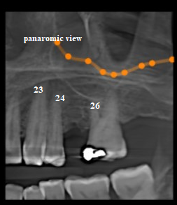 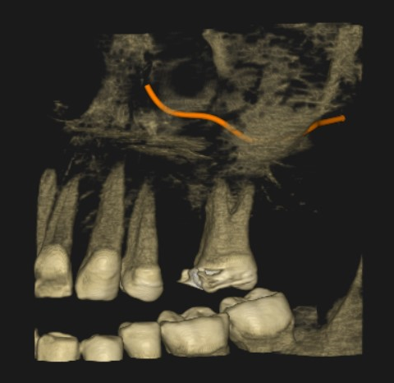

**DIMENSIONS OF BONE IN REGION:**

[to be filled…]

| **REGION** | | |
| --- | --- | --- |
| **Length varies from**  ***The height of the bone is measured from the crest to the floor of maxillary sinus.*** | **Labio/buccopalatal width at 2mm, 6mm and 10mms from the crest.**  ***The buccopalatal width is measured from the buccal cortical plate to the palatal cortical plate at 2, 6 & 10mms from the crest.*** | **Bone quality** | |
| **25 REGION**  **[slice 17 to 22]** | | ***Crestal bone:*** []  ***Buccal bone***: is thin and intact.  ***palatal bone:*** is thin and intact.  ***Cancellous bone***: shows moderately dense trabecular pattern.  ***D2 TO D3*** | |
| [to be filled] |  |  | |
| ***The length is around 8mm from the crest to the sinus floor***.  ***Shows deficient bone length.***  ***The ridge is straight.*** | ***The width is around 3mm close to the crest and this gradually increases as we go apically.***  ***Shows deficient buccopalatal width till 6mm and is good as we go apically.*** |  | |

# Observation:

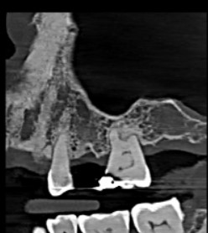

* Left maxillary sinus is clear and shows no pathology.

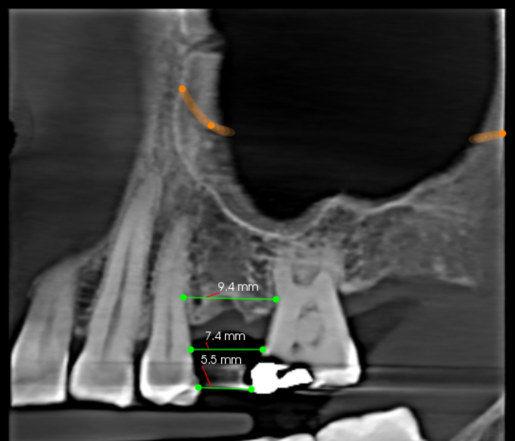

**RADIOLOGIC IMPRESSION:**

| **VIRTUAL IMPLANT** |
| --- |
| A virtual implant is placed from Nobel Biocare company based on the length and width of the bone available, this is just to give an idea and should not be considered final. |

| **VIRTUAL IMPLANT** | **LENGTH** | **HEAD DIAMETER** | **APICAL DIAMETER** | **ANY REMARKS** |
| --- | --- | --- | --- | --- |
| [] | 00mms | 00mms | 00mms | Placed in 00 region.  Parallel to 00. |

* **VIRTUAL IMPLANT SHOULD NOT BE CONSIDERED FINAL.**

**DISCLAIMER:**

***The radiographic findings must be correlated with clinical findings and appropriate diagnostic tests. This is a consultative report only and is not intended to be a definitive diagnosis or treatment plan. Above report cannot be used for medico-legal purpose.***

***Thank you for the referral of this patient and the opportunity to serve your practice.***