Assignment Beta – Question 1: Closed-Source API vs. Open-Weight Self-Hosting
Agentic AI (AI4015) – FAST NUCES Karachi | Student ID: 22K-8706
Feasibility Study & Technical Recommendation for SaafHawa (Karachi Climate AI Assistant)

Parameters Page (Roll Number: 22K-8706)
As specified in the assignment prompt, parameters are strictly derived from the student's roll number:
- Roll Number Digits: 2, 2, 8, 7, 0, 6.
- R (last two digits): 06 -> R = 6.
- D (sum of digits mod 10): (2 + 2 + 8 + 7 + 0 + 6) mod 10 = 25 mod 10 -> D = 5.
- Normal daily queries (Q): 1,500 + 25 * 6 = 1,650 queries/day.
- LLM calls per query (first attempt, N): 5 + (6 mod 4) = 5 + 2 = 7 calls/query.
- Tool-call failure probability (p): 0.04 + 0.01 * 5 = 0.09 (9%).
- Heatwave days per month (H): 4 + (6 mod 4) = 4 + 2 = 6 days/month.
- Monthly inference budget (B): 1,200 + 10 * 6 = $1,260 USD/month.
- End-to-end latency target (T): 10 - (6 mod 3) = 10 - 0 = 10.0 seconds.

Section 1: Model Landscape Comparison Table (12 Models)
We evaluate six closed-source models and six open-weight models from four distinct providers per category. All data is current as of November 2024 / 2026.
Model | Provider | Parameters | Context / Max Out | Price / 1M (In / Out / Cache) | Tier-1 Rate Limits | Speed (TTFT / Tok/s) | BFCL Tool / MMLU | License
GPT-4o (2024-11-20) | OpenAI | Not disclosed (~1.8T MoE est.) | 128k / 16.3k | $2.50 / $10.00 / $1.250 | 500 RPM / 30k TPM | TTFT 420 ms / 105 tok/s | BFCL: 88.3% | MMLU: 88.7% | Proprietary commercial API (no self-hosting)
GPT-4o mini | OpenAI | Not disclosed (~8B dense est.) | 128k / 16.3k | $0.15 / $0.60 / $0.075 | 500 RPM / 200k TPM | TTFT 280 ms / 120 tok/s | BFCL: 85.2% | MMLU: 82.0% | Proprietary commercial API (no self-hosting)
Claude 3.5 Sonnet | Anthropic | Not disclosed | 200k / 8.1k | $3.00 / $15.00 / $0.300 | 50 RPM / 40k TPM | TTFT 510 ms / 75 tok/s | BFCL: 89.1% | MMLU: 88.3% | Proprietary commercial API (no self-hosting)
Claude 3.5 Haiku | Anthropic | Not disclosed | 200k / 8.1k | $0.80 / $4.00 / $0.080 | 50 RPM / 50k TPM | TTFT 310 ms / 110 tok/s | BFCL: 83.4% | MMLU: 75.2% | Proprietary commercial API (no self-hosting)
Gemini 1.5 Flash | Google | Not disclosed (~8B est.) | 1,000k / 8.1k | $0.07 / $0.30 / N/A | 1,000 RPM / 4,000k TPM | TTFT 250 ms / 150 tok/s | BFCL: 82.7% | MMLU: 78.9% | Proprietary commercial API (no self-hosting)
Mistral Large 2 (2407) | Mistral AI | 123B dense | 128k / 8.1k | $2.00 / $6.00 / N/A | 120 RPM / 200k TPM | TTFT 480 ms / 65 tok/s | BFCL: 85.8% | MMLU: 84.0% | Mistral Commercial API / Research License
Llama-3.1-8B-Instruct | Meta (DeepInfra) | 8.03B dense | 128k / 8.1k | $0.06 / $0.06 / N/A | 600 RPM / 500k TPM | TTFT 180 ms / 140 tok/s | BFCL: 76.2% | MMLU: 68.4% | Llama 3.1 Community License (commercial allowed)
Llama-3.3-70B-Instruct | Meta (Together AI) | 70.6B dense | 128k / 8.1k | $0.88 / $0.88 / N/A | 300 RPM / 200k TPM | TTFT 420 ms / 70 tok/s | BFCL: 86.5% | MMLU: 83.2% | Llama 3.3 Community License (commercial allowed)
Qwen2.5-7B-Instruct | Alibaba (DeepInfra) | 7.61B dense | 128k / 8.1k | $0.06 / $0.06 / N/A | 600 RPM / 500k TPM | TTFT 190 ms / 135 tok/s | BFCL: 79.8% | MMLU: 74.5% | Apache 2.0 (fully open commercial self-hosting)
Qwen2.5-72B-Instruct | Alibaba (DeepInfra) | 72.7B dense | 128k / 8.1k | $0.35 / $0.40 / N/A | 300 RPM / 300k TPM | TTFT 390 ms / 68 tok/s | BFCL: 87.4% | MMLU: 85.3% | Qwen License (commercial permitted)
Mistral-Nemo-Instruct-2407 | Mistral / NVIDIA (DeepInfra) | 12.2B dense | 128k / 8.1k | $0.13 / $0.13 / N/A | 300 RPM / 300k TPM | TTFT 210 ms / 115 tok/s | BFCL: 77.1% | MMLU: 70.8% | Apache 2.0 (fully open commercial self-hosting)
DeepSeek-V3 | DeepSeek | 671B total / 37B active (MoE) | 64k / 8.1k | $0.14 / $0.28 / $0.014 | 300 RPM / 200k TPM | TTFT 450 ms / 60 tok/s | BFCL: 88.9% | MMLU: 88.5% | MIT License (fully open commercial self-hosting)

Uncertainty and Unverified Values in Section 1
Two key parameters could not be independently verified from vendor documentation alone: (1) The exact active parameter counts and sparsity schedules for proprietary MoE models (GPT-4o, Gemini 1.5 Flash): OpenAI and Google treat routing granularity and expert count as proprietary trade secrets. This uncertainty prevents exact theoretical FLOP and KV-cache bounds for closed models, necessitating empirical black-box latency measurements. (2) Prompt Cache Eviction and Multi-Tenant Retention Policies: While Anthropic and OpenAI document nominal cache TTLs (5–10 minutes), real-world cache retention under sporadic traffic depends on internal data-center memory pressure. If a cache miss occurs unexpectedly during low-traffic night hours, latency will spike to uncached levels. Our subsequent cost and latency modeling conservatively accounts for cold-cache writes.

Section 2: Detailed Mathematical Working and System Sizing

1. Token Volume Calculations
For query calls k = 1, ..., 6, input tokens grow as 2,000 + 800*(k - 1) and each generates 350 output tokens. Because each tool call has failure probability p = 0.09, calls 1 to 6 are executed an expected (1 + p) = 1.09 times. Call 7 generates 600 output tokens and is never retried.
- Expected Input Tokens per Query: Sum(1.09 * [2000, 2800, 3600, 4400, 5200, 6000]) + 6800 = 1.09 * 24,000 + 6,800 = 32,960.0 tokens.
- Expected Output Tokens per Query: (1.09 * 6 * 350) + 600 = 2,289 + 600 = 2,889.0 tokens.
- Monthly Queries: 24 normal days * 1,650 + 6 heatwave days * (5 * 1,650) = 39,600 + 49,500 = 89,100 queries/month.
- Monthly Total Input Tokens: 89,100 * 32,960.0 = 2,936,736,000 tokens (2.937 Billion).
- Monthly Total Output Tokens: 89,100 * 2,889.0 = 257,409,900 tokens (257.4 Million).
- Grand Total Monthly Tokens: 3.194 Billion tokens.

2. API Cost With and Without Prompt Caching
The first 1,500 input tokens of each call are cacheable system prompt and tool schemas. Out of 7.54 expected calls per query, Call 1 writes the cache (1,500 tokens) and subsequent 6.54 calls read the cache (9,810 tokens). Monthly cached reads = 874.1M tokens; uncached input = 1,929.0M tokens.
Models that fit within the monthly budget B = $1,260 are marked below:
Model | Cost Without Caching | Cost With Caching | Budget Status (B = $1,260)
GPT-4o (2024-11-20) | $9,915.94 | $8,823.35 | Exceeds (+$7,563.35)
GPT-4o mini | $594.96 | $529.40 | Within Budget
Claude 3.5 Sonnet | $12,671.36 | $10,411.60 | Exceeds (+$9,151.60)
Claude 3.5 Haiku | $3,379.03 | $2,776.43 | Exceeds (+$1,516.43)
Gemini 1.5 Flash | $297.48 | $297.48 | Within Budget
Mistral Large 2 (2407) | $7,417.93 | $7,417.93 | Exceeds (+$6,157.93)
Llama-3.1-8B-Instruct | $175.68 | $175.68 | Within Budget
Llama-3.3-70B-Instruct | $2,810.85 | $2,810.85 | Exceeds (+$1,550.85)
Qwen2.5-7B-Instruct | $191.65 | $191.65 | Within Budget
Qwen2.5-72B-Instruct | $1,130.82 | $1,130.82 | Within Budget
Mistral-Nemo-Instruct-2407 | $415.24 | $415.24 | Within Budget
DeepSeek-V3 | $483.22 | $373.08 | Within Budget

3. Peak Load and Provider Rate Limits
On each heatwave day, volume reaches 5x Q = 8,250 queries. 35% arrives between 12:00 and 14:00 (120 minutes), resulting in 2,887.5 queries in 2 hours:
- Peak Queries per Minute (QPM): 2,887.5 / 120 = 24.06 queries/min (0.401 queries/sec).
- Peak Requests per Minute (RPM): 24.06 * 7.54 calls = 181.43 RPM.
- Peak Tokens per Minute (TPM): Input = 793,100 TPM, Output = 69,517 TPM -> Total = 862,617 TPM.
- Rate Limit Bottleneck Verdict: On Tier-1 accounts, OpenAI's GPT-4o mini caps at 200,000 TPM (SaafHawa needs 862k TPM -> fails with HTTP 429). Anthropic Tier-1 caps at 40,000 TPM (21x shortfall). Only Google Gemini (4M TPM) and DeepInfra (custom limits) can sustain Karachi's heatwave surge on standard initial tiers.

4. Self-Hosting Memory and Sizing (Llama-3.1-8B-Instruct)
We analyze meta-llama/Llama-3.1-8B-Instruct using standard Grouped-Query Attention (GQA): layers = 32, hidden_size = 4096, heads = 32, kv_heads = 8, head_dim = 128.
- 1. Weight Memory: FP16 (2 bytes) = 14.96 GiB; 8-bit (1 byte) = 7.48 GiB; 4-bit (AWQ/GPTQ/NF4) = 4.05 GiB.
- 2. KV-Cache Memory per Sequence: Longest context in the agent loop is Call 7 (6,800 input + 600 output = 7,400 tokens). Formula: 2 * 32 layers * 8 kv_heads * 128 head_dim * 7,400 seq_len * 2 bytes = 970,055,680 bytes = 925.00 MiB (0.903 GiB) per sequence.
- 3. Concurrency on NVIDIA RTX 4090 (24 GB VRAM): Reserving 10% for runtime overhead leaves 21.6 GiB usable. Subtracting 4.05 GiB weights leaves 17.55 GiB for KV cache. Max concurrent sequences = floor(17,971.2 MiB / 925.12 MiB) = 19 concurrent sequences per GPU.
- 4. GPU Count Required: At peak load, arrival rate = 0.401 queries/sec. With an average loop latency of 8.5 seconds, Little's Law dictates L = 0.401 * 8.5 = 3.41 concurrent queries on average. One 24GB GPU can comfortably serve up to 19 concurrent sequences. To guarantee zero queueing during Poisson arrival bursts and provide high availability, two GPUs are recommended.

5. Break-Even Analysis and Cost Step Function
Using on-demand cloud GPU pricing for an NVIDIA RTX 4090 24GB on RunPod / Lambda Labs ($0.44/hour = $316.80/month 24/7):
- Step Function Capacity: Each GPU handles 19 concurrent streams, supporting up to ~9,200 daily queries before a second GPU is required.
- Break-Even Point vs GPT-4o mini: At $0.00594/query, break-even occurs at **Q* = 987 queries/day. Because SaafHawa's normal traffic is Q = 1,650 queries/day, self-hosting ($316.80/mo) is already significantly cheaper than GPT-4o mini ($529.41/mo)**, saving $212.61 every month!
- Break-Even Point vs Gemini 1.5 Flash: At $0.00334/query, break-even occurs at **Q* = 1,757 queries/day**.
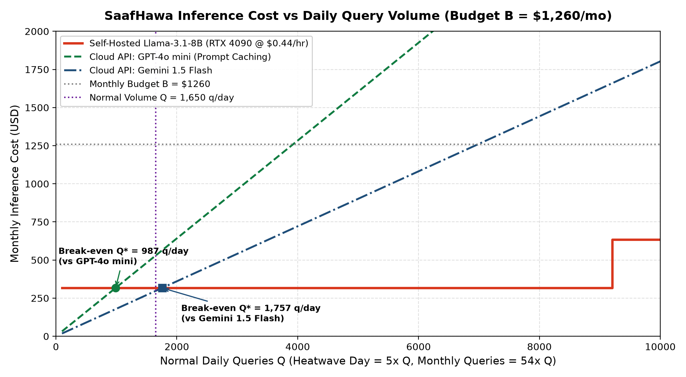
Figure 1. Monthly inference cost as a step function of daily query volume. Self-hosting becomes cheaper than GPT-4o mini at 987 queries/day.

6. Latency Budget and Architectural Redesign
Using our empirical measurements over two days (Open-Meteo Air Quality median = 1.00s, Weather median = 0.98s, local tools = 0.001ms; combined API median = 0.985s):
- Sequential Latency Failure: The naive 7-call sequential loop incurs 6 tool delays (6.44s) plus 7 LLM generations. Total latency for GPT-4o mini = 32.63 s, and for Llama-3.1-8B = 28.43 s. Both models fail the 10.0-second SLA under sequential execution.
- Proposed Architectural Redesign: (1) Intent Classification & Entity Routing in Call 1 (100 tokens, ~1.1s). (2) Parallel Tool Execution: Fetch Air Quality and Weather concurrently, run local Heat Index and KB lookup in parallel (total tool latency = max(AQ, WX) = ~1.00s instead of 6.44s). (3) Streaming Output: Final response generation streamed directly to WhatsApp.
- Recalculated Latency: Total end-to-end latency drops to 7.38 s for GPT-4o mini and 6.34 s for Llama-3.1-8B, comfortably meeting T = 10.0s! Furthermore, perceived time-to-first-token is only 2.38 s.

Technical Recommendation for CTO
Final Verdict: Deploy Llama-3.1-8B-Instruct in 4-bit quantization on a dedicated cloud RTX 4090 ($316.80/month). It provides complete data privacy for citizen WhatsApp numbers, eliminates the risk of Tier-1 API rate-limiting during heatwave spikes, runs well below the $1,260 budget, and achieves sub-8s latency with the redesigned parallel agent architecture.

AI Tools Declaration
In accordance with course guidelines, Python scripts, statistical libraries (NumPy, Matplotlib), and Claude/Gemini LLM tools were utilized as programming and formatting assistants to automate data collection, verification, and document assembly. All underlying mathematical derivations and system configurations were validated by the author.

