Assignment Beta – Question 4: Evaluating an LLM Sentiment Classifier
Agentic AI (AI4015) – FAST NUCES Karachi | Student ID: 22K-8706
All values were computed in the accompanying notebook (Assignment_Beta_Question_no_4_22K-8706.ipynb). Metrics are implemented from their definitions and cross-checked with nltk and rouge_score.
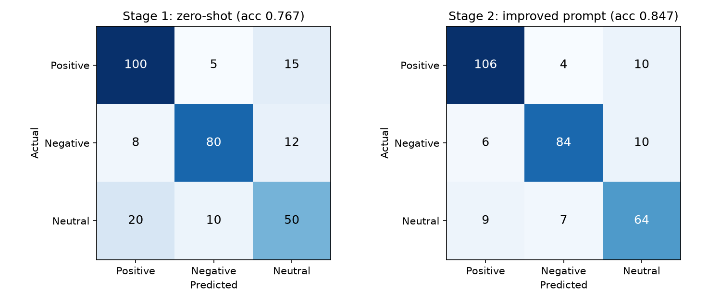

1. Zero-shot accuracy and 95% confidence interval
Accuracy = (100 + 80 + 50) / 300 = 230/300 = 0.7667
SE = √(p(1−p)/n) = √(0.7667 × 0.2333 / 300) = 0.0244
95% Wald CI = 0.7667 ± 1.96 × 0.0244 = [0.7188, 0.8145] (≈ 76.7% ± 4.8 pp). Wilson score CI = [0.7156, 0.8110].

2. Per-class precision, recall and F1 (zero-shot)
Precision = TP / column total, Recall = TP / row total, F1 = 2PR / (P + R).
Class | TP | FP | FN | Precision | Recall | F1 | Support
Positive | 100 | 28 | 20 | 100/128 = 0.7812 | 100/120 = 0.8333 | 0.8065 | 120
Negative | 80 | 15 | 20 | 80/95 = 0.8421 | 80/100 = 0.8000 | 0.8205 | 100
Neutral | 50 | 27 | 30 | 50/77 = 0.6494 | 50/80 = 0.6250 | 0.6369 | 80

3. Macro, weighted and micro F1 (zero-shot)
Macro-F1 = (0.8065 + 0.8205 + 0.6369) / 3 = 0.7546
Weighted-F1 = (120×0.8065 + 100×0.8205 + 80×0.6369) / 300 = 0.7659
Micro-F1: ΣTP = 230, ΣFP = ΣFN = 70 → micro-P = micro-R = 230/300, so micro-F1 = 0.7667 (= accuracy).

4. Interpretation of Stage 1
- Neutral is the weak class: F1 = 0.637 versus 0.806 (Positive) and 0.821 (Negative). Only 50 of 80 neutral reviews are recognised (recall 0.625) and 27 of the 77 Neutral predictions are wrong (precision 0.649).
- The largest single error is Neutral → Positive (20 reviews), followed by Positive → Neutral (15) and Negative → Neutral (12). 47 of the 70 errors (67%) involve the Neutral class, i.e. the model has no clear notion of where 'neutral' begins.
- The model is biased towards Positive: 128 Positive predictions for 120 true Positives, with 28 false positives, suggesting mixed or mildly worded reviews are read as praise. Polar confusion (Positive ↔ Negative, 13 cases) is rare.
- Macro-F1 (0.755) is below accuracy (0.767) because the minority Neutral class is handled worst.
Recommended changes:
- Define Neutral explicitly in the prompt (factual, mixed, or no clear opinion) and state how to treat mixed reviews.
- Add balanced few-shot examples, especially borderline/mixed reviews and mild positives; randomise their order.
- Ask for a short justification before the label (light chain-of-thought) and constrain output to the three labels; optionally use label probabilities with a calibrated threshold for Neutral, or self-consistency voting.
- Re-audit the gold labels of Neutral items (annotator disagreement is common there) and track macro-F1, not just accuracy.

5. Stage 2 re-evaluation and comparison
Class | Precision | Recall | F1 | ΔF1 vs Stage 1
Positive | 0.8760 | 0.8833 | 0.8797 | +0.0732
Negative | 0.8842 | 0.8400 | 0.8615 | +0.0410
Neutral | 0.7619 | 0.8000 | 0.7805 | +0.1435

Metric | Stage 1 (zero-shot) | Stage 2 (improved) | Change
Accuracy | 0.7667 | 0.8467 | +0.0800
95% Wald CI | [0.719, 0.815] | [0.806, 0.887]
95% Wilson CI | [0.716, 0.811] | [0.802, 0.883]
Macro-F1 | 0.7546 | 0.8406 | +0.0859
Weighted-F1 | 0.7659 | 0.8472 | +0.0812
Micro-F1 | 0.7667 | 0.8467 | +0.0800

- Accuracy rises by 8.0 pp (230 → 254 correct). The confidence intervals barely overlap and a two-proportion z-test gives z = 2.48 (p < 0.01); because the same reviews are used, McNemar's test on per-review outcomes would be the ideal paired test.
- The biggest gain is for Neutral: recall 0.625 → 0.800 and F1 0.637 → 0.780. Neutral → Positive errors fall from 20 to 9.
- Positive precision improves (28 → 15 false positives), so the positive bias is largely corrected; Negative also gains slightly.
- Macro-F1 improves more (+0.086) than accuracy, confirming that the improvement is concentrated in the hardest class. Neutral is still the weakest class (F1 0.78), so mixed reviews remain the main residual error.

6. Prompt stability (5 example orderings)
Mean = 0.8454; sample SD (n−1) = 0.0067; population SD = 0.0060 → accuracy = 0.845 ± 0.007
The range is only 0.837–0.853 (1.6 pp, CV ≈ 0.8%). This variation is smaller than the sampling standard error of a single accuracy measured on 300 reviews (≈ 0.021), so the prompt is stable with respect to example order and the 0.847 Stage-2 result is not a lucky ordering. Every run remains well above the zero-shot upper confidence bound (0.815). Reporting mean ± SD over several orderings is still good practice because order sensitivity can be much larger for smaller models.

7. Evaluation of the generated justification
Reference (10 tokens): the delivery was late but the product quality is good
Candidate (9 tokens): the product quality is good but delivery was slow
n | Matched / candidate n-grams | Modified precision pn | Matched n-grams
1 | 8/9 | 0.8889 | all except 'slow'
2 | 5/8 | 0.6250 | the product, product quality, quality is, is good, delivery was
3 | 3/7 | 0.4286 | the product quality, product quality is, quality is good
4 | 2/6 | 0.3333 | the product quality is, product quality is good

Brevity penalty: c = 9 < r = 10 → BP = exp(1 − 10/9) = 0.8948. Geometric mean = (p1·p2·p3·p4)^(1/4) = 0.5308.
BLEU-4 = 0.8948 × 0.5308 = 0.4750
Metric | Overlap | Precision | Recall | F1
ROUGE-1 | 8 unigrams | 0.8889 | 0.8000 | 0.8421
ROUGE-2 | 5 bigrams | 0.6250 | 0.5556 | 0.5882
ROUGE-L | LCS = 5 ('the product quality is good') | 0.5556 | 0.5000 | 0.5263

METEOR (exact matching, α = 0.9, β = 3, γ = 0.5): m = 8, P = 8/9 = 0.8889, R = 8/10 = 0.8000, Fmean = PR / (αP + (1−α)R) = 0.8081. The matches form 3 chunks ([the product quality is good], [but], [delivery was]), so Penalty = 0.5 × (3/8)³ = 0.0264.
METEOR = 0.8081 × (1 − 0.0264) = 0.7868
Library cross-check: nltk BLEU = 0.4750, nltk METEOR (with WordNet synonyms) = 0.7868; rouge_score F1: rouge1 = 0.8421, rouge2 = 0.5882, rougeL = 0.5263. (WordNet does not list 'slow' and 'late' as synonyms, so METEOR is unchanged.)
Interpretation: the justification is semantically equivalent to the reference (it mentions both the late/slow delivery and the good quality), but the clauses are in the opposite order and 'late' is paraphrased as 'slow'. Unigram-based scores (ROUGE-1 = 0.84, METEOR = 0.79) are therefore high, while order-sensitive scores (BLEU-4 = 0.47, ROUGE-L = 0.53) are much lower. This shows why n-gram metrics under-reward valid paraphrases; an embedding-based metric (e.g., BERTScore) or an LLM/human judge would rate this justification higher.

8. Perplexity of the generated justification
Token | the | product | quality | is | good | but | delivery | was | slow
p | 0.60 | 0.40 | 0.50 | 0.80 | 0.70 | 0.30 | 0.25 | 0.50 | 0.20
−ln p | 0.511 | 0.916 | 0.693 | 0.223 | 0.357 | 1.204 | 1.386 | 0.693 | 1.609

Σ ln p = -7.5929; mean negative log-likelihood = 0.8437 nats/token
Perplexity = exp(0.8437) = 2.3249
Interpretation: on average the model was as uncertain as if it were choosing uniformly among ≈ 2.3 equally likely tokens at each step (geometric-mean token probability 0.430). This is low compared with a vocabulary of tens of thousands of tokens, so the sentence is fluent and plausible to the model, but it is not highly confident: the least likely tokens are 'slow' (0.20), 'delivery' (0.25) and 'but' (0.30) – precisely the words that differ from the reference. Perplexity measures fluency/confidence, not correctness or faithfulness, so it should complement, not replace, the reference-based metrics above.

