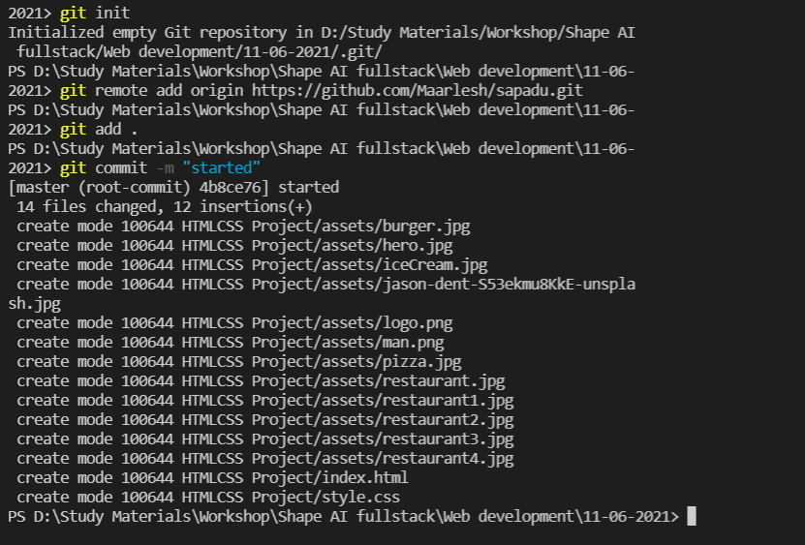

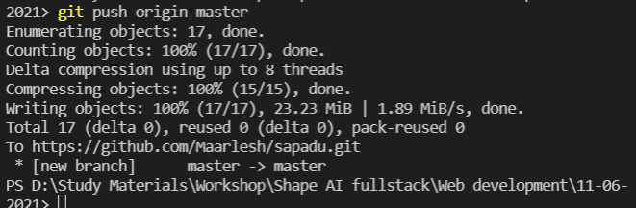

This is wat we are gonna build

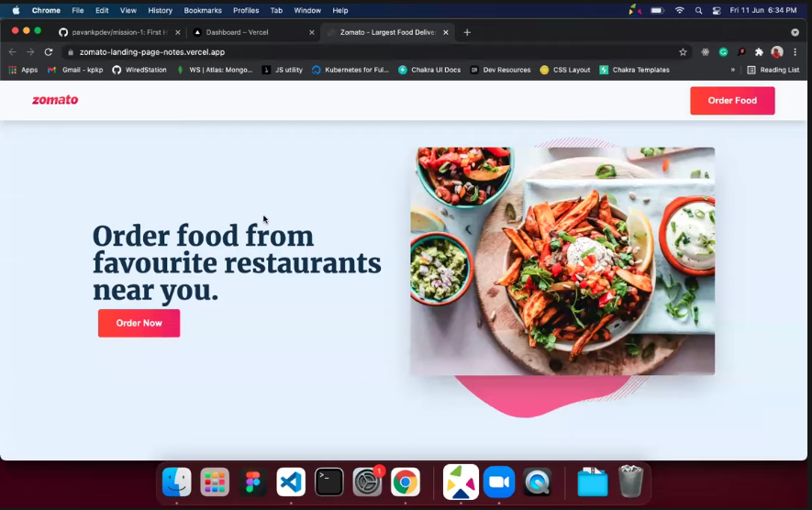

Go to google fonts

There will be many fonts choose on and then select this style then It will produce link for html copy and paste it there

BEM is one the approach for writing css there are many approaches but BEM is quite successful

First to build Is nav bar and global button with gradient u can use it anywhere

In css first remove all the default browser settings

Remove margin,padding

Then add box model to be safe and easy usage the model



This section is called the hero section as it conveys a lot in the browser

Container makes sure the content is in the center of the screen

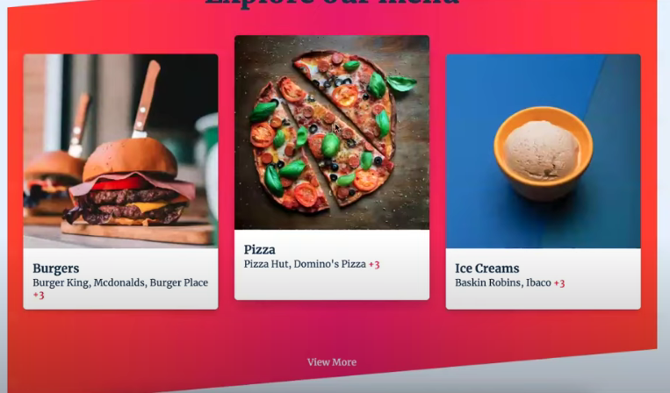

This Is the model for the explore menu