Reproducible Research Peer Assessment 1

M Hamersma

December 2019

# Movement Activity Monitoring

## 1. Loading and preprocessing data

The script will run correctly if the file “activity.csv” has been downloaded and unzipped to the working directory. Library the dplyr and ggplot packages.

setwd("~/R5")  
library(dplyr)

##   
## Attaching package: 'dplyr'

## The following objects are masked from 'package:stats':  
##   
## filter, lag

## The following objects are masked from 'package:base':  
##   
## intersect, setdiff, setequal, union

library(ggplot2)  
activity <- read.csv("activity.csv", stringsAsFactors = FALSE)  
activity$date <- as.Date(activity$date)  
names(activity)

## [1] "steps" "date" "interval"

## 2. Calculate total number of steps per day and plot histogram

Convert to a data table using dplyr, group the table by date, then create a new dataframe called **stps** containing the total number of steps per day, called **dailysteps**.

act <- tbl_df(activity)  
stps <- act %>% group_by(date) %>% summarise(dailysteps = sum(steps))  
g1 <- ggplot(stps, aes(x = date, y = dailysteps)) + geom_bar(stat = "identity") + ggtitle("Steps per day")  
print(g1)

## Warning: Removed 8 rows containing missing values (position_stack).

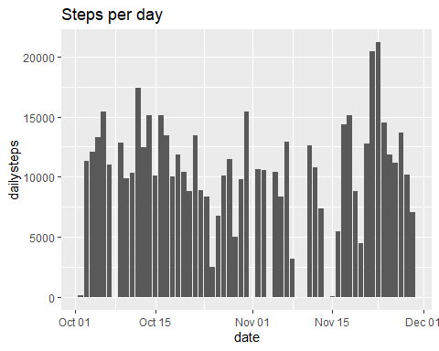

## 3. Mean and Median Steps per day

meanstps <- as.integer(mean(stps$dailysteps, na.rm=TRUE))  
medianstps <- as.integer(median(stps$dailysteps, na.rm=TRUE))

The Mean number of steps per day is **10766** and the median is **10765**. Reported in Integer, as decimals on such a large number is meaningless.

## 4. Average Daily Activity Pattern

Calculate the average steps per interval into a new dataframe called **stps2**, then plot the **steps (y)** against the **interval (x)**.

stps2 <- act %>% group_by(interval) %>% summarise(intervalsteps = mean(steps, na.rm=TRUE))  
g2 <- ggplot(stps2, aes(x = interval, y = intervalsteps)) + geom_line() + ggtitle("Average Steps per Interval")  
print(g2)

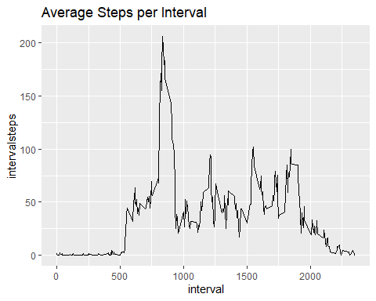

## 5. Interval with Maximum Steps

Determine the maximum of the averages, then identify the interval number with that value.

max_interval <- max(stps2$intervalsteps)  
stps3 <- stps2 %>% filter(intervalsteps == max_interval)  
max_interval_no <- as.integer(stps3[1,2])  
max_interval <- as.integer(stps3[1,1])

The Interval with the maximum average steps is number **206**, averaging **835** steps.

## 6. Count the records with missing values

is_complete <- complete.cases(act)  
missing_val <- sum(!is_complete)

There are **2304** records with missing values.

## 7. 8. and 9. Replace (impute) the missing values with Averages for that Interval

Find the records in the original dataframe **act** where steps = NA, then replace with it with the average for that interval from the stps2 data frame, saving in new imputed dataframe **act_imputed**

interval_avg <- act %>%  
 group_by(interval) %>%  
 summarise(avg_steps = mean(steps, na.rm = TRUE))  
  
act_imputed <- act  
  
for (i in 1:nrow(act_imputed))   
{  
 if (is.na(act_imputed[i, "steps"]) == TRUE)   
 {  
 intervalno <- as.integer(act_imputed[i, "interval"])  
 imputed_value <- interval_avg[interval_avg$interval == intervalno, "avg_steps"]  
 act_imputed[i, "steps"] <- imputed_value  
 }   
 else   
 {  
 act_imputed[i, "steps"] <- act[i, "steps"]  
 }  
}

## 9. Histogram of steps with NA repalce with daily average

Convert to a data table using dplyr, group the table by date, then create a new dataframe called **stps_imputed** containing the total number of steps per day, called **dailysteps**, and calculate the mean and median

stps_imputed <- act_imputed %>% group_by(date) %>% summarise(dailysteps = sum(steps))  
g3 <- ggplot(stps_imputed, aes(x = date, y = dailysteps)) + geom_bar(stat = "identity") + ggtitle("Steps per day missing values imputed from daily average")  
print(g3)

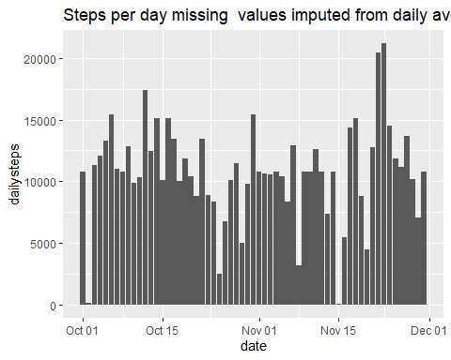

meanstps_imputed<- as.integer(mean(stps_imputed$dailysteps, na.rm=TRUE))  
medianstps_imputed <- as.integer(median(stps_imputed$dailysteps, na.rm=TRUE))

The Mean number of steps per day when imputing missing values is **10766** vs 10766 and the median is **10766** vs 10765.

## 10. Compare the steps on weekdays versus weekends

First define if the date falls in a weekend or not, then double-plot with facets wrap on weekday indicator.

act_imputed$date <- as.Date(act_imputed$date)  
act_imputed$weekday_indicator <- ifelse(weekdays(act_imputed$date) %in% c("Saturday", "Sunday"), "Weekend", "Weekday")  
  
stps4 <- act_imputed %>% group_by(interval, weekday_indicator) %>% summarise(interval_steps = mean(steps, na.rm = TRUE))  
  
ggplot(stps4, aes(x = interval, y = interval_steps)) +  
 geom_line(color = "blue") +  
 facet_wrap(~weekday_indicator)

