|  |  |
| --- | --- |
| Assignment: | Sound Localization |
| Course: | The Auditory System |
| Context: | Master Neurophysics |
| Authors: | Marc van Wanrooij |
| Date, version: | 29 September 2021 |

Lab Assignment 02: Sound Localization

## Background

Sound localization plays an important role in directing attention to objects and events in our surrounding environment. This is not a trivial process, as the sensory cells for hearing are tuned to the frequency of a sound, and not its location. Sound localization is possible because of the geometry of the head and the ears. This geometry yields binaural and monaural cues (as obtained in Lab Assignment 01) which our brains can process to determine sound source direction.

### Scope of this assignment

You will participate in a sound-localization experiment (Fig. 1) in which you are asked to generate a rapid head movement toward a peripheral sound source (duration 150 ms), as soon as it appears.

Three different sounds will be presented: broad-band noise (band width (BW) 0.2 – 20 kHz), low-pass filtered noise (BW: 0.2-1.5 kHz) and high-pass filtered noise (BW: 3.0-20 kHz). Stimuli also have different intensities, randomly varied between 40 and 70 dBA. The experiment will take about an hour.

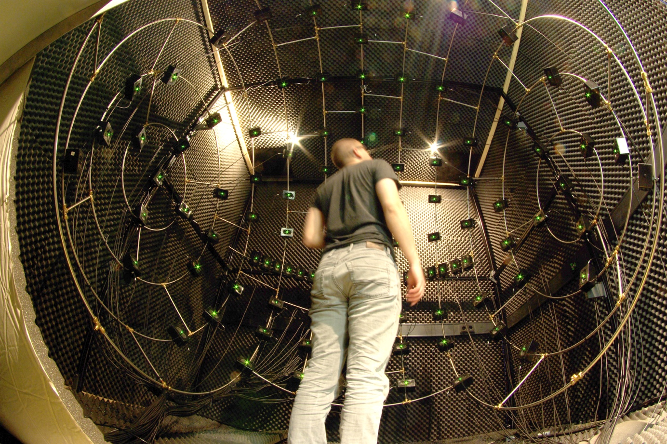

**Fig. 1. Sound localization setup.** You will be seated in an anechoic room with 128 speakers positioned predominantly in the frontal hemisphere.

After the experiments, your data collected will be returned to you (after pre-processing), and you will write a brief report on this.

## Learning Outcomes

*This assignment has been developed to support you to achieve the following learning outcome:*

* You record your own sound localization behavior
* You can analyze your own sound localization behavior
* You write a brief report

*These learning outcomes correspond to the following course learning goals:*

At the end of this section, you will be able to:

* Describe the three sound localization cues (**ITD/IPD**, **ILD/IID**, **spectral shape cues**) accessible to humans and their features (**binaural/interaural** vs **monaural**, frequency range, horizontal/**azimuth** vs vertical/**elevation** localization)
* Explain the **cone of confusion**
* Graph the (expected) **stimulus-response** plot for **azimuth** and **elevation** for **broad-band**, **high-pass** and **low-pass** **noise** stimuli
* Explain the different results in the graphs in terms of availability (**frequency range**) and integration of cues (**duplex theory**)
* Graph and explain the stimulus-response plot of a single-sided deaf individual (a **monaural** subject)
* Describe the direction and frequency dependence of the binaural difference and the spectral cues of humans

### Criteria for the product

#### Your design is effective and challenging (product)

With regards to the result, the most important elements of the evaluation of your didactic design are its its effectivity and its challenging nature.

* A design is effective when the course is an appropriate tool by which the student can achieve the learning outcomes.
* The challenging aspect of the design is achieved by applying the principle of ‘constructive friction’.

## Products

* You will have measured your sound localization behavior in the weeks from Monday 4 to Friday 15 October 2021 (deadline **a**).
* You will produce a brief report before or on Wednesday October 20, 2021 (deadline **b**). The report should contain an Introduction, Methods, Results, and a Discussion.

## Instruction

Work for one week on your brief report on HRTFs.

### a. Sound localization experiment

* Make an appointment with a student assistant (e.g. [snandan.sharma@donders.ru.nl](mailto:snandan.sharma@donders.ru.nl), nina.haukes@donders.ru.nl).
* Let me ([marc.vanwanrooij@donders.ru.nl](mailto:marc.vanwanrooij@donders.ru.nl)) know once you have done this.
* Also, let me know if you are hindered in visiting the lab, so we can think of an alternative assignment.
* Familiarise yourself with the methods and tools:
  + *Lectures videos and slides of week 3, part 6, week 4, part 8.*
  + *Chapter 7: pages 171-179, 184-199 (acoustic localization cues) of the book The Auditory System and Human Sound-Localization Behavior. 2016.*
* Visit the lab and perform a sound-localization experiment.

### b. Create a brief report on the sound-localization experiment

##### Produce a brief report of this measurement using the guidelines below. The report should contain an Introduction, Methods, Results, and a Discussion.

* In the Introduction you should briefly describe the sound localizationcues, and predict how localization behaviour is affected by a sound’s frequency content.
* In the Methods, give a concise description of the stimuli (frequency content, locations), the task, and relevant information on the subject (i.e. you; e.g. the subject is a normal-hearing adult with no known visual or vestibular disorders that could affect the motor response).
* In the Results, present your data in graphs (note: indicate variables!) of the stimulus-response relations for azimuth and elevation for **each** of the three stimulus types, and apply linear regression to quantify the results (see below for Matlab-related hints). Describe the results.
* In the Discussion, explain the differences in (expected) results.

## Data analysis and visualization

The data consists of a N x 6 matrix whose columns contain:

stimulus azimuth | stimulus elevation | stimulus frequency-band (1=BB, 2=HP, 3=LP) | stimulus level | response azimuth | response elevation, and each row indicates trial number.

### Graph stimulus-response plot

Stimulus azimuth is presented in the first column, while response azimuth is encoded in the 5th column. You can make a stimulus response, simply by typing:

stimaz = Data(:,1); % stimulus azimuth in first column

resaz = Data(:,5); % response azimuth in 5th column

plot(stimaz,resaz,’ko’); % plot responses as a function of azimuth

In the last line you plot black open circles (‘ko’). Perfectly accurate and precise sound localization responses should fall on the x=y (unity) line. Let’s modify the graph to visualize whether this also holds for your responses, first by limiting the x- and y-axe ranges to lie between -90 and +90 deg (from complete left/down to complete right/up, for azimuth/elevation), and make the plot square (so that the x- and y-axis occupy the same space:

axis square;

xlim([-90 90]);

ylim([-90 90]);

and then we will plot the x=y line:

plot([-90 90],[-90 90],’:’);

You can save the figure by using the print command:

print(‘png’,'-r70',’stimres.png’);

You will now have plotted all responses to all stimuli, but you are interested in whether the various sound frequency-bands elicit different responses. You can select the data you are interested in as follows. The frequency-band is stored in column 3:

freq = Data(:,3);

To select for broadband noises create a ‘logical’ selection vector by finding all data equal to 1 (=the index for broadband sounds):

sel = freq==1;

This vector contains only 0s (when the sound is not broadband) and 1s (when the sound is broadband). By using this selection vector, Matlab will keep only those values where the selection vector is 1 and remove those where the selection vector is 0:

stimaz = Data(sel,1); % stimulus azimuth in first column

resaz = Data(sel,5); % response azimuth in 5th column

subplot(2,3,1)

plot(stimaz,resaz,’ko’); % plot responses as a function of azimuth

Note that you also used a subplot, to graph the stimulus-response plot in the upper left corner of the figure.

Redo these steps to plot the stimulus-response relationships for azimuth and elevation and all three frequency bands, each in a separate subplot.

Label these plots correctly and give them an appropriate title.

### Linear regression

Next up, you will quantify the stimulus-response relationship through linear regression. The simplest way of doing this is via:

B = regstats(resaz,stimaz,’linear’);

B contains lots of parameters related to linear regression. For now, you will only deal with the slope and the offset:

slope = B.beta(2);

offset = B.beta(1);

Determine the slopes and offsets for azimuth and elevation and all three frequency bands, and put them in a table.

## Follow-up

In the video clips and lectures of week 4, part 8, the topic of “learning of sound localization” will be discussed. In week 6, you will have guest lectures from researchers working on sound localization by hearing-impaired persons.