How to use your coupon code ?

Launch [Leo Aventure Cat](https://play.google.com/store/apps/details?id=net.maarti.leo_adventure_cat) then go to the Shop menu and select your product:

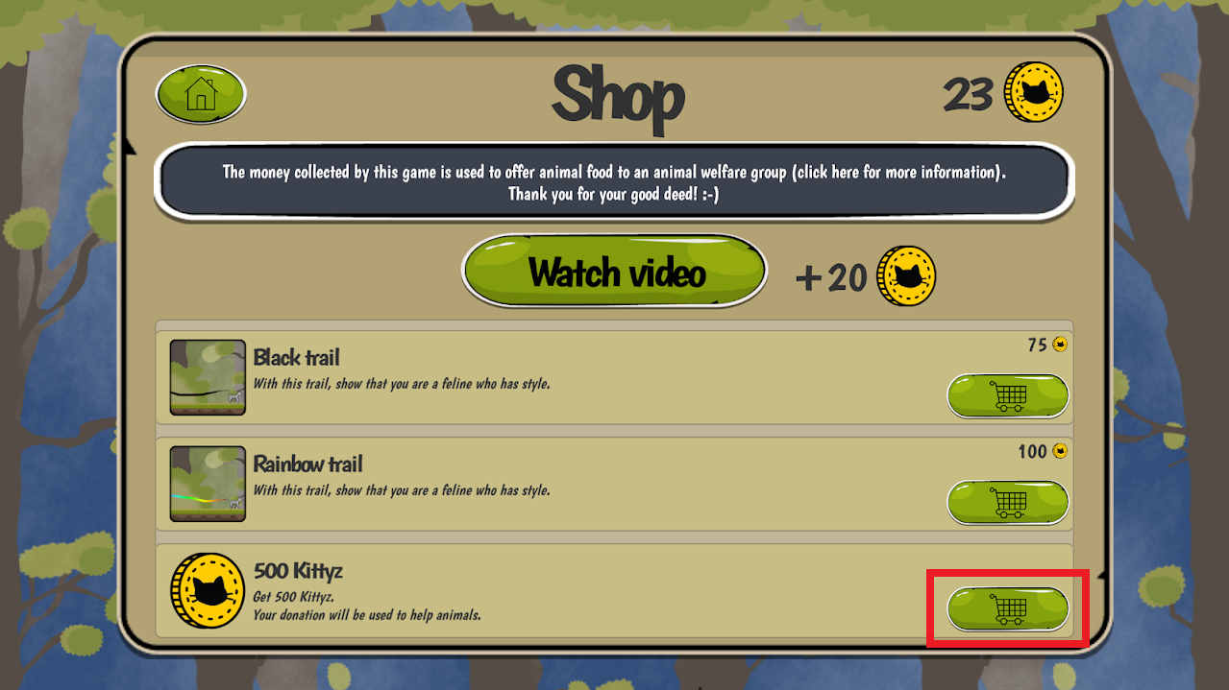

Click the down arrow near the payment method:

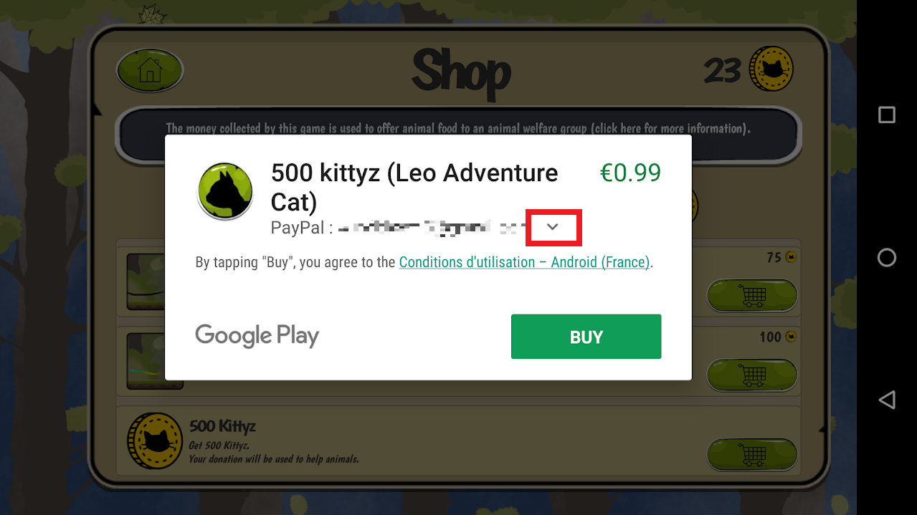

Click the « Redeem » option then enter your code:

