Web Assembly Revolution

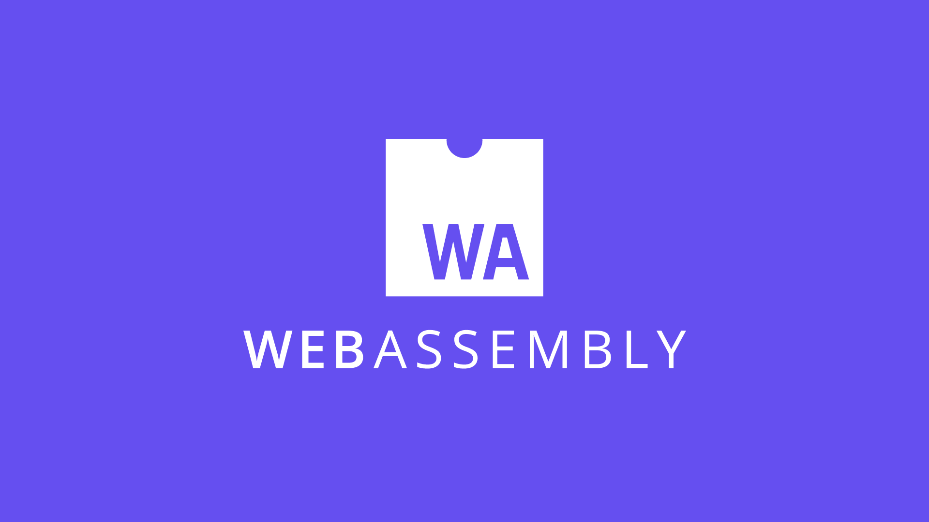
Make the web faster

William MARTIN

2019


WebAssembly (abbreviated Wasm) is a binary instruction format for a stack-based virtual machine. Wasm is designed as a portable target for compilation of high-level languages like C/C++/Rust, enabling deployment on the web for client and server applications.

Unleash all the buzzwords !

This is the description of what is WebAssembly (Wasm for those interested) directly picked from the Wasm website (https://webassembly.org/). At first, it’s not very descriptive, quite complicated. We will go through what is Wasm, what it does, why it was created, why it is a revolution and can we go beyond ?

I - What is WebAssembly

WebAssembly can be easily descripted, it is a way of taking code written in programming languages other than JavaScript and running that code in the browser. So when people say that WebAssembly is fast, what they are comparing it to is JavaScript.

Now, I don’t want to imply that it’s an either/or situation — that you’re either using WebAssembly or using JavaScript. In fact, Wasm creators expect that developers will use both WebAssembly and JavaScript in the same application.

But it is useful to compare the two, so you can understand the potential impact that WebAssembly will have.

A bit of background

JavaScript was created in 1995. It wasn’t designed to be fast, and for the first decade, it wasn’t fast.

Then the browsers started getting more competitive.

In 2008, a period that people call the performance wars began. Multiple browsers added just-in-time compilers, also called JITs (link on what is JIT compiler). As JavaScript was running, the JIT could see patterns and make the code run faster based on those patterns.

The introduction of these JITs led to an inflection point in the performance of JavaScript. Execution of JS was 10x faster. (figure 1.1)

With this improved performance, JavaScript started being used for things no one ever expected it to be used for, like server-side programming with Node.js. The performance improvement made it feasible to use JavaScript on a whole new class of problems. (figure 1.2)
We may be at another one of those inflection points now, with WebAssembly.

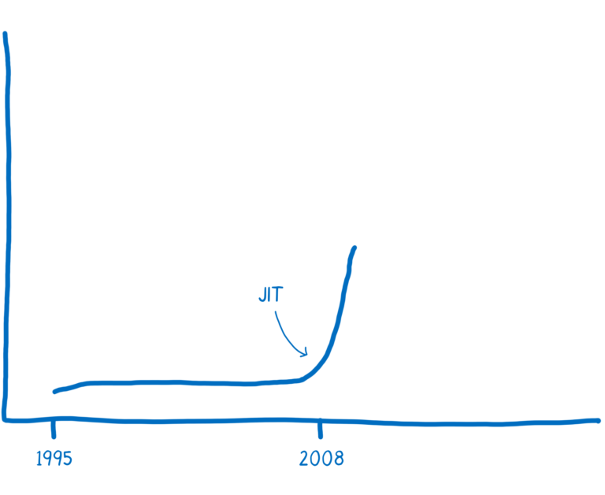
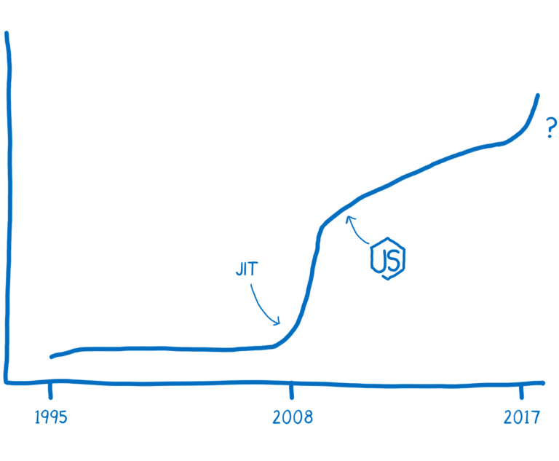
Figure 1.2
Figure 1.1

To fully understand the power of WebAssembly, you will need a bit of comprehension of what is assembly. But assembly is not the subject of this work so I recommend you to read this very good article (https://hacks.mozilla.org/2017/02/a-crash-course-in-assembly/).

II - What WebAssembly does

During all my life, I loved to see things by example, I will keep the same approach this time to show what WebAssembly does.

WebAssembly modules define functions that can be used from JavaScript. So just like you download a module like lodash from npm today and call functions that are part of its API, you will be able to download WebAssembly modules in the future.
So let’s see how we can create WebAssembly modules, and then how we can use them from JavaScript.

When you’re delivering code to be executed on the user’s machine across the web, you don’t know what your target architecture the code will be running on.

So WebAssembly is a little bit different than other kinds of assembly. It’s a machine language for a conceptual machine, not an actual, physical machine.

Because of this, WebAssembly instructions are sometimes called virtual instructions. They have a much more direct mapping to machine code than JavaScript source code. They represent a sort of intersection of what can be done efficiently across common popular hardware. But they aren’t direct mappings to the particular machine code of one specific hardware.

The browser downloads the WebAssembly. Then, it can make the short hop from WebAssembly to that target machine’s assembly code. (figure 2.1)

Figure 2.1

As said before (or you can expect) WebAssembly is compiled. So we need a compiler tool chain.

The compiler tool chain that currently has the most support for WebAssembly is called LLVM. There are a number of different front-ends and back-ends that can be plugged into LLVM. (LLVM glossaire)

There is other ways to create Wasm modules :
https://github.com/rsms/wasm-util
https://developer.mozilla.org/en-US/docs/WebAssembly/Understanding_the_text_format

Let’s say that we wanted to go from C to WebAssembly. We could use the clang front-end to go from C to the LLVM intermediate representation.

Once it’s in LLVM’s IR, LLVM understands it, so LLVM can perform some optimizations.
To go from LLVM’s IR (intermediate representation) to WebAssembly, we need a back-end.

There is one that’s currently in progress in the LLVM project. That back-end is most of the way there and should be finalized soon. However, it can be tricky to get it working today.

There’s another tool called Emscripten which is a bit easier to use at the moment. It has its own back-end that can produce WebAssembly by compiling to another target (called asm.js) and then converting that to WebAssembly.

It uses LLVM under the hood, though, so you can switch between the two back-ends from Emscripten.
Figure 2.3

Memo :
Emscripten includes many additional tools and libraries to allow porting whole C/C++ codebases, so it’s more of a software developer kit (SDK) than a compiler. For example, systems developers are used to having a filesystem that they can read from and write to, so Emscripten can simulate a file system using IndexedDB.

Regardless of the toolchain you’ve used, the end result is a file that ends in .wasm. I’ll explain more about the structure of the .wasm file below. First, let’s look at how you can use it in JS.

II.i Loading a .wasm file in Javascript

