MaaserMart

Software Design Document

Shaul Khayyat, Yosef Wolf, Benjamin Yazdi

2026-11-01

Practicum in Software Development

Table of Contents
1. Definitions and Acronyms
1.1. Terms
1.2. Acronyms and Abbreviations
2. Introduction
2.1. Purpose
2.2. Scope
2.3. Intended Reader
2.4. References
2.4.1. Forward trace — SRS sections to design sections
2.4.2. Forward trace — functional requirements to design sections
2.4.3. Forward trace — non-functional requirements to mechanisms
2.4.4. Backward trace — design sections to SRS items
2.4.5. External Sources
3. Goals and Constraints
3.1. Design Goals (SRS: Other Non-Functional Requirements)
3.2. Constraints (SRS: Design and Implementation Constraints)
4. Architecture (High-Level Design)
4.1. Architectural Overview
4.2. Component Diagrams
4.3. Deployment Shape
4.3.1. Decision
4.3.2. Alternatives
4.4. Internal Organization
4.4.1. Decision
4.4.2. Alternatives
4.5. Language and Framework
4.5.1. Decision
4.5.2. Alternatives
4.6. Template Engine
4.6.1. Decision
4.6.2. Alternatives
4.7. Interactivity
4.7.1. Decision
4.7.2. Alternatives
4.8. Database
4.8.1. Decision
4.8.2. Alternatives
4.9. Database Hosting
4.9.1. Decision
4.10. Web Server
4.10.1. Decision
4.10.2. Alternatives
4.11. Application Server
4.11.1. Decision
4.11.2. Alternatives
4.12. Request Concurrency
4.12.1. Decision
4.12.2. Alternatives
4.13. Static Files
4.13.1. Decision
4.13.2. Alternatives
4.14. Email
4.14.1. Decision
4.14.2. Alternatives
4.15. Logging
4.15.1. Decision
4.15.2. Alternatives
4.16. Error-Handling Strategy
4.16.1. Decision
4.16.2. Alternatives
5. Database Design
5.1. Entity-Relationship Diagram
5.2. Data Dictionary
5.2.1. USER
5.2.2. ROLE_ASSIGNMENT
5.2.3. RABBI_PROFILE
5.2.4. CHARITY_OWNER
5.2.5. APPROVAL_REQUEST
5.2.6. NEW_CHARITY_REQUEST
5.2.7. OWNER_CLAIM_REQUEST
5.2.8. EDIT_REQUEST
5.2.9. CHARITY
5.2.10. LOCATION
5.2.11. DOMAIN
5.2.12. CHARITY_DOMAIN
5.2.13. CHARITY_LOCATION
5.2.14. LINK
5.2.15. REVIEW
5.2.16. HASKAMA
5.2.17. EVENT
5.2.18. TRANSACTION
5.2.19. TICKET
5.2.20. Indexes
5.2.21. Derived Values
5.3. Modeling Decisions
6. Low-Level Design
6.1. Module Responsibilities and Interfaces
6.2. Tracer Bullet Modules (detailed)
6.2.1. Login (one system, four role dashboards) — SRS FR 14–16
6.2.2. Signup — member, charity owner, rabbi — SRS FR 14–16
6.2.3. Charity List — SRS FR 1
6.2.4. Filter — SRS FR 2
6.2.5. Sort — SRS FR 3
6.2.6. Search — SRS FR 4
6.2.7. Charity Page — SRS FR 8
6.2.8. Reviews (write path on the charity page) — SRS FR 9
6.2.9. Haskama — SRS FR 13
6.2.10. Member History — SRS FR 5, FR 6
6.2.11. Recommendations — SRS FR 7
6.2.12. Charity Owner Stats — SRS FR 10
6.2.13. Admin Access — SRS FR 12
6.2.14. Charity Addition — SRS FR 17
6.2.15. Edit Charity
6.3. Non-Tracer Modules (vague)
6.3.1. Maaser Tools (SRS FR 20–22)
6.3.2. Chatbot (SRS FR 11)
6.3.3. Tickets (SRS FR 18, FR 19)
6.3.4. Technical Supporter
6.4. Key Algorithms
6.4.1. Recommendations
6.4.2. Maaser Calculator
6.4.3. Trending
6.5. Error Handling per Module
7. User Interface Design
7.1. Page Inventory
7.1.1. Authentication
7.1.2. Public
7.1.3. Member
7.1.4. Charity Owner
7.1.5. Rabbi
7.1.6. Admin
7.1.7. Technical Supporter
7.1.8. System
7.2. Navigation
7.3. Wireframes — Tracer Bullet Screens
7.3.1. Login
7.3.2. Signup
7.3.3. Signup chooser
7.3.4. Dashboard chooser
7.3.5. Charity listing
7.3.6. Charity page
7.3.7. Member dashboard
7.3.8. Charity owner dashboard
7.3.9. Admin approval queue
7.3.10. Admin ticket queue
7.3.11. Charity request
7.3.12. Help
7.3.13. Report
7.4. Wording and Tone Requirements
8. Use Cases
8.1. Actors
8.2. List of Use Cases
8.3. UC-01 — Log in
8.4. UC-02 — Sign up (member, owner, rabbi)
8.5. UC-03 — Find a charity (list, filter, sort, search)
8.6. UC-04 — View a charity page
8.7. UC-05 — Write a review
8.8. UC-06 — Give a haskama
8.9. UC-07 — View member history
8.10. UC-08 — View recommendations
8.11. UC-09 — View charity owner stats
8.12. UC-10 — Administer approvals and queues
8.13. UC-11 — Request or add a charity
8.14. UC-12 — Edit a charity
9. Open Questions
10. Build / Buy List
10.1. Built
10.2. Bought or Rented
10.3. Open-Source (used, not bought)

Definitions and Acronyms
This section defines the terms, acronyms, and abbreviations used throughout the document.

Terms
- Tracer Bullet — a thin, end-to-end slice of a feature that is built first and in full detail, so that the design is validated against real requirements before the rest of the system is built (Hunt and Thomas, The Pragmatic Programmer).
- MaaserMart — the system described in this document: a directory of Jewish charities that uses a member's history to help him find charities to donate to.
- Tzedaka — the Hebrew word for charity: giving money to charities that are worthwhile from a Jewish religious standpoint (SRS 1.4.1).
- Maaser — the obligation on all Jews to give one tenth of their income to tzedaka (SRS 1.4.4).
- Haskama — an approval from a Rabbi (SRS 1.4.2).
- Rabbi — a person who gives haskamos to charities; he must be a leader of a Jewish community or a Jewish teacher (SRS 1.4.3).
- Charity — an entity that can be donated to on MaaserMart, optionally associated with a charity owner (SRS 1.4.7).
- Charity Owner — the user who owns an account associated with a charity; a charity need not have one, and may have several (SRS 1.4.8).
- Member — a user with an account who uses MaaserMart to find tzedaka organizations to donate to (SRS 1.4.6).
- Guest — a user of MaaserMart who does not have an account (SRS 1.4.5).
- Administrator (Admin) — the user who runs MaaserMart and decides the items in the approval and ticket queues.
- Charity Page — the page showing a single charity: its description, links, reviews, and haskamas.
- Member Dashboard — the signed-in page showing a member's history and recommendations.
- Charity Owner Dashboard — the signed-in page showing a charity's engagement numbers, reviews, and haskamas.
- Haskama Page — the signed-in page where a Rabbi manages his haskamas.
- Approval Queue — the list of pending items (signups, charity additions, and edits) awaiting an admin decision.
- Ticket Queue — the list of help requests and reports awaiting an admin response.

Acronyms and Abbreviations
- SRS — Software Requirements Specification (the requirements document this design traces to).
- UC — Use Case.
- FR — Functional Requirement.
- NFR — Non-Functional Requirement.
- ERD — Entity-Relationship Diagram.
- DTL — Django Template Language.
- ORM — Object-Relational Mapper.
- WSGI — Web Server Gateway Interface.
- UI — User Interface.
- TOS — Terms of Service.
- AWS — Amazon Web Services.
- RDS — Amazon Relational Database Service.
- SQS — Amazon Simple Queue Service.
- SES — Amazon Simple Email Service.

Introduction
This section states the purpose, scope, and intended reader of the design document.

Purpose
This is the design document for the MaaserMart system. It assumes knowledge of the SRS of MaaserMart.

Scope
This document covers architecture, high-level design, and some low-level design. It covers the database schema, gives detailed design for the tracer-bullet modules, and leaves the remaining modules vague.

Intended Reader
The intended reader is familiar with the idea of MaaserMart, as well as with its requirements document. In addition, the intended reader is expected to understand basic technological terms.

References
This section lists the external sources used and traces this design to the MaaserMart Software Requirements Specification (the SRS).

Forward trace — SRS sections to design sections
This table maps every SRS section to the design section that satisfies it.

SRS section | Design section
1.4 Definitions | Definitions and Acronyms
1.6 Project Scope | Introduction (Scope)
2.2 Product Perspective | Introduction (Scope), Goals and Constraints
2.3.1 Charity List | Charity List, Filter, Sort, Search
2.3.2 Charity Page | Charity Page, Reviews
2.3.3 Member Page | Member History, Recommendations
2.3.4 Charity Owner Page | Charity Owner Stats, Edit Charity
2.3.5 Administration Page | Admin Access
2.3.6 Haskama Page | Haskama
2.3.7 ChatBot | Chatbot
2.3.8 Maaser Tools | Maaser Tools
2.3.9 Help pages | Tickets
2.4 User Classes | Use Cases (Actors), Login, Signup, Data Dictionary (USER, ROLE_ASSIGNMENT)
2.5 Operating Environment | Goals and Constraints, User Interface Design
2.6 Assumptions and Dependencies | Goals and Constraints, Architecture (Database Hosting, Request Concurrency, Email), Build / Buy List
2.7 Design/Implementation Constraints | Goals and Constraints (Constraints)
3.1 Functional Requirements 1–22 | the functional-requirement table below
3.2 External Interfaces (UI) | User Interface Design (Page Inventory, Navigation, Wording and Tone)
3.3 Performance Requirements | the non-functional table below
3.4 Other Non-Functional Reqs | the non-functional table below
4 Testing | Tests under each tracer-bullet module, Error Handling per Module

Forward trace — functional requirements to design sections
This table maps every functional requirement to the design section that satisfies it.

FR | Requirement | Design section
FR 1 | Charity List | Charity List
FR 2 | List filters | Filter
FR 3 | List sorting | Sort
FR 4 | List searching | Search
FR 5 | Member Dashboard | Member History, Recommendations
FR 6 | Member History | Member History
FR 7 | Member Recommendations | Recommendations
FR 8 | Charity Display | Charity Page
FR 9 | Charity Reviews | Reviews
FR 10 | Charity Owner Dashboard | Charity Owner Stats
FR 11 | Chatbot | Chatbot
FR 12 | Administrator Dashboard | Admin Access
FR 13 | Rabbi Dashboard | Haskama
FR 14 | Member Signup | Login, Signup
FR 15 | Charity Owner Signup | Login, Signup
FR 16 | Rabbi Signup | Login, Signup
FR 17 | Charity Request | Charity Addition
FR 18 | Help | Tickets
FR 19 | Report | Tickets
FR 20 | Maaser History | Maaser Tools
FR 21 | Income History | Maaser Tools
FR 22 | Maaser Calculator | Maaser Tools, Key Algorithms (Maaser Calculator)

Forward trace — non-functional requirements to mechanisms
This table maps every non-functional requirement to the design mechanism that satisfies it.

NFR | SRS measure (source) | Design mechanism
Scalability | serve thousands of users at once; handle thousands of charities (3.3.1) | PostgreSQL indexes on the list/filter/search columns; paginated queries
Robustness | 99% monthly uptime; clear error message; never leak data (3.3.2) | friendly 403/404/500 pages; transactional rollback; Celery retries with backoff; no identifiers in error output
Performance | ≤1 GB RAM; must not add ≥1 s to other applications (3.3.3) | DTL templates with no build step; monolith; minimal client JS (HTMX + Alpine); static files served by Caddy
Speed | perceived response under 0.25 s (3.3.4) | indexes keep reads fast and cheap; slow work (email, AI) moved to the Celery/SQS queue
Privacy | identities, visits, income, and donation history never disclosed; owners see counts only (3.4.1) | charity pages expose aggregates, never attribution; logs are admin-only; errors and poll responses carry no identifiers
Auditability | log default list order, visits/clicks, reviews, recommendation I/O, support access, admin changes, errors, chatbot use (3.4.2) | EVENT rows for visits, clicks, and reviews; django-auditlog for admin changes; the recommendation algorithm logs its inputs and outputs
Maintainability | maintainable by three students (3.4.3) | modular monolith, one module per feature, split into views/logic/data; service functions as the module interface
User Friendly | no manual needed for ≥90% of users (3.4.4) | one-click navigation between pages; wording and tone rules for an Orthodox-Jewish audience
Report | members and guests can report charities (3.4.5) | Tickets module (report path)

External Sources
- [1] Django Software Foundation. "FAQ: Installation." Django documentation. https://docs.djangoproject.com/en/stable/faq/install/
- [2] Django Software Foundation. "Writing your first Django app, part 2." Django documentation. https://docs.djangoproject.com/en/stable/intro/tutorial02/
- [3] Oracle. "Atomic DDL." MySQL 8.0 Reference Manual. https://dev.mysql.com/doc/refman/8.0/en/atomic-ddl.html
- [4] PostgreSQL Global Development Group. "Data Definition." PostgreSQL documentation. https://www.postgresql.org/docs/current/ddl.html
- [5] Django Software Foundation. "Databases." Django documentation. https://docs.djangoproject.com/en/stable/ref/databases/
- [6] Gunicorn. "Design." Gunicorn documentation. https://docs.gunicorn.org/en/stable/design.html
- [7] Django Software Foundation. "How to use Django with Gunicorn." Django documentation. https://docs.djangoproject.com/en/stable/howto/deployment/wsgi/gunicorn/
- [8] Pylons Project. "Waitress." Waitress documentation. https://docs.pylonsproject.org/projects/waitress/en/stable/
- [9] Pylons Project. "Waitress issue #342." GitHub. https://github.com/Pylons/waitress/issues/342
- [10] Granian. "v1.0.0." GitHub releases. https://github.com/emmett-framework/granian/releases/tag/v1.0.0
- [11] Django Software Foundation. "Asynchronous support." Django documentation. https://docs.djangoproject.com/en/stable/topics/async/
- [12] ASGI. "Asynchronous Server Gateway Interface." https://asgi.readthedocs.io/
- [13] dramatiq-sqs. PyPI. https://pypi.org/project/dramatiq-sqs/
- [14] Celery. "Using Amazon SQS." Celery documentation. https://docs.celeryq.dev/en/stable/getting-started/backends-and-brokers/sqs.html
- [15] WhiteNoise. "WhiteNoise." https://whitenoise.readthedocs.io/en/latest/
- [16] Amazon Web Services. "Request production access (Moving out of the Amazon SES sandbox)." Amazon SES Developer Guide. https://docs.aws.amazon.com/ses/latest/dg/request-production-access.html
- [17] django-auditlog. "django-auditlog." https://django-auditlog.readthedocs.io/en/latest/
- [18] concurrent-log-handler. PyPI. https://pypi.org/project/concurrent-log-handler/
- [19] Dyspatch. "Python Templating Performance Showdown: Django vs Jinja." https://www.dyspatch.io/blog/python-templating-performance-showdown-django-vs-jinja/
- [20] Pallets. "API — autoescaping." Jinja documentation. https://jinja.palletsprojects.com/en/stable/api/#autoescaping
- [21] Django Software Foundation. "Release process." Django documentation. https://docs.djangoproject.com/en/stable/internals/release-process/
- [22] endoflife.date. "Django." https://endoflife.date/django
- [23] Amazon Web Services. "New Free Tier update: new customers can get started and explore AWS with up to $200 in credits." AWS News Blog. https://aws.amazon.com/blogs/aws/new-free-tier-update-new-customers-can-get-started-and-explore-aws-with-up-to-200-in-credits/
- [24] Amazon Web Services. "Amazon RDS pricing." https://aws.amazon.com/rds/pricing/
- [25] Amazon Web Services. "Amazon SQS pricing." https://aws.amazon.com/sqs/pricing/
- [26] Amazon Web Services. "Amazon SQS message lifecycle." Amazon SQS Developer Guide. https://docs.aws.amazon.com/AWSSimpleQueueService/latest/SQSDeveloperGuide/sqs-message-lifecycle.html
- [27] htmx. "htmx documentation." https://htmx.org/docs/
- [28] Caddy. "Automatic HTTPS." Caddy documentation. https://caddyserver.com/docs/automatic-https

Goals and Constraints
This section lists the design goals and the constraints that shape the design.

Design Goals (SRS: Other Non-Functional Requirements)
- Rapid design, development, and maintenance of code.
- Inexpensive infrastructure.
- Scalability (ability to remain maintainable and robust, despite high usage and lots of data)
- Auditability
- Privacy
- Ease of use (intuitive UI and UX)
- Ability to keep data up-to-date and adapt to match new data and requirements.

Constraints (SRS: Design and Implementation Constraints)
- Team consists of three college students (the authors).
- Must be written in the span of four months.
- Must run in a modern browser.
- Must use cloud technology, as per course requirements.
- Budget is limited to around two-hundred dollars a year.
- AWS RDS, and one other AWS service, must be used (SRS 2.6 Dependencies).
Note on SRS deviation: the SRS lists AWS RDS and AWS SNS as its dependencies. This design uses AWS SQS for the task queue and AWS SES for email instead of SNS, because it needs point-to-point task delivery and email rather than pub/sub fan-out.

Architecture (High-Level Design)
This section presents the architecture: the deployment shape, the internal organization, and the technology chosen for each decision area, together with the alternatives considered.

Architectural Overview
This table summarizes the decision made in each area of the architecture.

Decision Area | Decision
Deployment Shape | Monolith, always on
Internal Org | Modular monolith
Language/Framework | Python + Django
Template Engine | DTL
Interactivity | HTMX + Alpine
Database | PostgreSQL
DB Hosting | AWS RDS free tier
Web Server | Caddy
App Server | Gunicorn
Request Concurrency | WSGI + Celery + SQS
Static Files | Caddy
Email | AWS SES
Technical Logging | ConcurrentRotatingFileHandler
Audit Logging | django-auditlog
Error Handling | Friendly 403/404/500, inline form  errors, 5s retry

Component Diagrams
This section shows the parts of the system and how they connect, first for a page request and then for a background email.
The page-request path is shown in Figure 1.
Figure 1: Component diagram: the page-request path (Browser → Caddy → Gunicorn → Django → PostgreSQL).
The background email path is shown in Figure 2.
Figure 2: Component diagram: the background email path (Django → SQS → Celery → SES).

Deployment Shape
This decision area selects how MaaserMart is deployed.

Decision
The code will be deployed as a monolith; that is, as a single cohesive program that is intended to be always on.

Alternatives
- Microservices - This could have been deployed as many individual programs that communicate with each other. This was rejected for a few reasons. First, the primary appeal of a microservice deployment is its robustness (even if one part fails, the rest of the system stays alive). MaaserMart is in no way mission critical, and so that advantage is not so vital. It adds operational complexity - setting up and debugging multiple deployments and databases - which would be difficult to manage in our small team and limited time. Therefore, the advantage is not worth the complexity.
- Serverless - This could have been deployed to only start up when in actual use. However, that leads to a cold start wait (especially given our framework decision), and we did not want MaaserMart to start sluggishly. In addition, our chosen framework (Django) does not natively work well with serverless deployments, and we would need to use ecosystem workarounds.
- EDA - This could have been deployed with an event-driven architecture. However, as with microservices, the advantages (resiliency) are not so important for MaaserMart, and there is great complexity added. In particular, it is a new mental model for the coders, and it would be wise to stay on familiar ground.

Internal Organization
This decision area selects how the code is organized internally.

Decision
The code will be written in a modular monolith. Each functionality is coded as its own module, with the code in the module split into views, logic, and data (models).

Alternatives
- Unstructured monolith - This code could have had no separation at all. This would not be the right shape. Firstly, the lack of organization would make the code very difficult to read, to trace, and to debug. For a continuing project, each of those is integral. Secondly, it is important to separate code and data from views, so that, if MaaserMart becomes very successful, other views (such as mobile apps) can be added.
- Layered monolith - This code could have been layered, with one module holding views, one holding logic, and one holding data. However, as MaaserMart is a system with many functionalities, it would be more intuitive to separate by those many functionalities, rather than to group them together.
- Hexagonal - The code could have been written as a core, surrounded by adapters. As before, the many functionalities of MaaserMart makes this difficult, and it does not generally align with our chosen framework (Django). In addition, since logic, data, and views will be separated, its primary advantage (defining ports to plug in adapters) can be achieved without the ceremony. (Also, the authors worked on a hexagonal project and found that the structure made it very difficult to read and trace the code.)

Language and Framework
This decision area selects the implementation language and web framework.

Decision
The code will be written in Python, using Django. This will enable it to be written quickly, be read easily, and come with batteries included.

Alternatives
- next.js - The code could have been written in next.js and react. However, the coders have more experience in Python and can read it quickly. In addition, Django comes with batteries included (such as sign-in pages, admin pages, and more), which will make this project easier. Django is also a more stable framework: feature releases ship roughly every eight months, and long-term-support releases get about three years of security support, so resources do not go stale as quickly [21][22].
- Spring boot - The code could have been written in Java, using Spring Boot. However, Spring Boot has a lot of boilerplate code and is not so good for fast iteration, due to this. In a small project, with three people and a short timeframe, fast iteration is necessary.

Template Engine
This decision area selects the engine that renders HTML.

Decision
The code will use DTL (Django's builtin template engine) to make HTML pages. It is the assumed standard, it is secure, and it works well with Django.

Alternatives
- Jinja - The code could use Jinja to make HTML. Jinja is often claimed to be much faster than DTL, but reputable benchmarks put the two close together, and rendering HTML is rarely the bottleneck anyway [19]. Jinja2 autoescapes templates by default, so it is not inherently less secure [20]. The main objection is its permissive design: Jinja lets you code logic into the template, which, for us, is a vulnerability, since it is important to us to separate the logic from the view. In addition, Jinja does not work with Django's admin or auth views, so we would have to rewrite something we otherwise get for free. Also, as it is not the standard for Django, there will be less resources on using Jinja in a Django project.
- Mako - The code could use Mako to make HTML. It is as fast as Jinja and allows even complex logic in the template. However, all the disadvantages of Jinja apply here; in particular, its ability to put python functions in the template means that separation of logic and views is likely to erode.

Interactivity
This decision area selects the client-side libraries for page interactivity.

Decision
MaaserMart will use HTMX (for server-side data) and Alpine.js (for client-side data). This was chosen because it is mature, light, and easy to write.

Alternatives
- React, Vue, or Svelte - each of these is more powerful than HTMX and Alpine.js. However, the power will not likely be needed, since our layouts are pretty basic and simple. These introduce a build step and a dependency on npm. In addition, they will make for a lot more coding. Therefore, they do not seem worthwhile.
- jQuery - This used to be standard, but is now considered outdated. Since many of its features (like ensuring it works on all browsers) are obsolete, and it is harder to write than HTMX, it does not make sense to use it.
- HotWire - HotWire is similar to HTMX, but it was designed for Ruby on Rails, and its fork for Django is small. Therefore, we will not use it.

Database
This decision area selects the database system.

Decision
We will use PostgreSQL. It is recommended by Django for production [1][2], it has very mature transactional DDL [4], and it aligns best with Django's ORM [5].

Alternatives
- MySQL - We could use MySQL instead of PostgreSQL, for the same price. However, it is not the database Django recommends for production [1], it has atomic but not transactional DDL (DDL implicitly commits) [3], whereas PostgreSQL's DDL is fully transactional [4], and Django's ORM is far more tested on PostgreSQL [5].
- Oracle - OracleDB costs more money on RDS, so we will not use it.

Database Hosting
This decision area selects where the database is hosted.

Decision
We will use RDS, because that is a design constraint. Note that AWS changed its Free Tier in 2025: new accounts get a free plan with $100 in credits at signup plus up to $100 more from activities, valid for six months, rather than the older 12-month free tier [23]. After the credits are used, RDS is billed at normal rates [24], so the database is a recurring cost within our roughly $200/year budget rather than a permanent free resource.

Web Server
This decision area selects the web server that sits in front of the application.

Decision
We will use Caddy, for its simple syntax and its automatic handling of HTTPS [28].

Alternatives
- nginx - nginx is the standard for Django. However, it is harder to write, although there are more tutorials, and it requires additional tools to handle HTTPS certificates.
- Apache Web Server - We could use apache web server. However, it has more complex syntax, is heavier, and does not handle HTTPS certificates automatically.

Application Server
This decision area selects the application server that runs Django.

Decision
We will use Gunicorn. It is the WSGI server Django's deployment documentation demonstrates, and it comes with a robust concurrency model (multiple workers and threads) and a restarter [6][7].

Alternatives
- Waitress - Waitress is very simple and works on any OS [8]. But, it only has one process, so it cannot restart itself, and it can only use one CPU core for CPU bound work [9].
- uWSGI - uWSGI is very configurable, but, because of that, it is difficult to write configurations for it. As a small team, we want to choose simplicity over having more options, especially since Gunicorn fits our needs (and we do not need the extra configurability).
- Granian - Granian is written in Rust, so it likely is very fast. But, the speed of the application server is unlikely to be a bottleneck, and Granian, although past 1.0 [10], is smaller and less widely used than Gunicorn.

Request Concurrency
This decision area selects how the system handles requests and background work at the same time.

Decision
We will use WSGI, because it is far simpler. We will use a queue, in SQS, with celery. The queue will be used for email requests and for the chatbot. Note that Celery's SQS transport has no remote control or events and needs a separate result backend, which matters for the chatbot's poll_status [14].

Alternatives
- ASGI - ASGI's benefit is high concurrency over long-lived, non-ORM I/O (streaming, long-polling, WebSockets); our load is ordinary request/response plus background tasks, which WSGI threads and a queue already cover. Adopting ASGI also adds a coding cost: in async mode the ORM must be reached through sync_to_async, transactions are not available, and blocking code raises SynchronousOnlyOperation [11][12].
- WSGI, with a different queue configuration:
  - with no queue - this would be simpler. But, then the chatbot can slow the system for everyone (if enough people use it simultaneously), and we would have to add semaphores per worker, which is complex as well. In addition, emails could not be retried, and would also block the system.
  - Without SQS - We could run Redis locally, which enables monitoring the queue. But, the free tier of SQS is more than enough, and it works well [25].
  - With dramatiq - Dramatiq is another broker for SQS. However, its SQS support is immature (experimental, small message size) [13], and it is not the industry standard.

Static Files
This decision area selects how static files are served.

Decision
We will use Caddy, our web server, to handle static files. We are already using Caddy, so it does not add much complexity. We will not use a CDN, since all files will be hosted in one location (NY).

Alternatives
- a different web server - we could use an alternate web server, like nginx. But, that would be silly, since we are already using Caddy.
- WhiteNoise - WhiteNoise is simpler and more integrated into Django: it is in-process WSGI middleware that serves files, using sendfile where available, rather than a separate server [15]. Still, it is an additional dependency we do not need, since Caddy is already in front of the app and serves static files natively.

Email
This decision area selects how MaaserMart sends email.

Decision
We will use AWS SES. While it is complex to setup, it is a widely used tool, with lots of tutorials. It is quite cheap, and scales well. (AWS rejects throttled sends rather than dropping them; our queue handles that by returning them to the queue.) A build task is to request SES production access: in the SES sandbox, sending is capped and limited to verified recipients [16].

Alternatives
The alternatives are postmark, mailgun, and sendgrid, and the problem with each is the same - their free tier is not sufficient for our use, and scaling up is expensive.

Logging
This decision area selects how technical and audit logging are implemented.

Decision

Technical Logging
We will use ConcurrentRotatingFileHandler, which lets multiple workers (since we will use Gunicorn, we will have multiple workers) write logs to one log file [18]. It is not reliable on network filesystems such as NFS or EFS, but our logs live on the instance's local disk.

Audit Logging
We will use django-auditlog, which saves logs automatically whenever a change is made [17].

Alternatives

Technical Logging
- Socket handler and a separate process - We could have sent logs over a socket handler to a separate process which manages them. But, setting up the second process adds complexity.
- Logging to stdout - We could have used regular stdout to manage logs. But, since we want to log to a file, we would have to make sure it goes to a file and that the file is rotated, which are things we are likely to forget to do once in a while.

Audit Logging
- Django simple history or reversion - we could use one of these, which saves a snapshot each time a change is made, But, this can quickly grow too big, and would have to be pruned, meaning we will lose data and will have extra complexity. Its gains - rollbacks - are not really helpful for us. (Simple History uses a DB, where we have limited space, and reversion serializes, which means it is difficult to filter the data.)
- Django admin logentry - Django automatically logs whenever the admin makes a change. But, this only logs things the admin does, and this only logs that changes happened, so it is insufficient for our needs.
- Custom logging - We could write a logger ourselves, logging every time something important happens. However, this is difficult, and we would likely miss a few places.

Error-Handling Strategy
This decision area selects how the system handles and reports errors.

Decision
For form errors, we will use the error handling build into Django, showing field specific messages. For network failures, we will retry, for up to five seconds, while showing the user a "connecting" indicator [27]. (For network requests that use SQS, the queue will just put it back in the queue if it does not work; we will limit how many times it is tried.) For 400s and 500s, we will use Django's templates to write easily understood and friendly pages.

Alternatives
The alternatives would really be to leak more details to the user (usually not a good idea, and generally disconcerting) and to not retry on network failures (which would not be a good idea, since they tend to be transient).

Database Design
This section defines the data model: the entity-relationship diagram, the data dictionary, and the modeling decisions.

Entity-Relationship Diagram
This section gives the entity-relationship diagram for the MaaserMart database; the tables are detailed in the Data Dictionary that follows.
The diagram is shown in Figure 3.
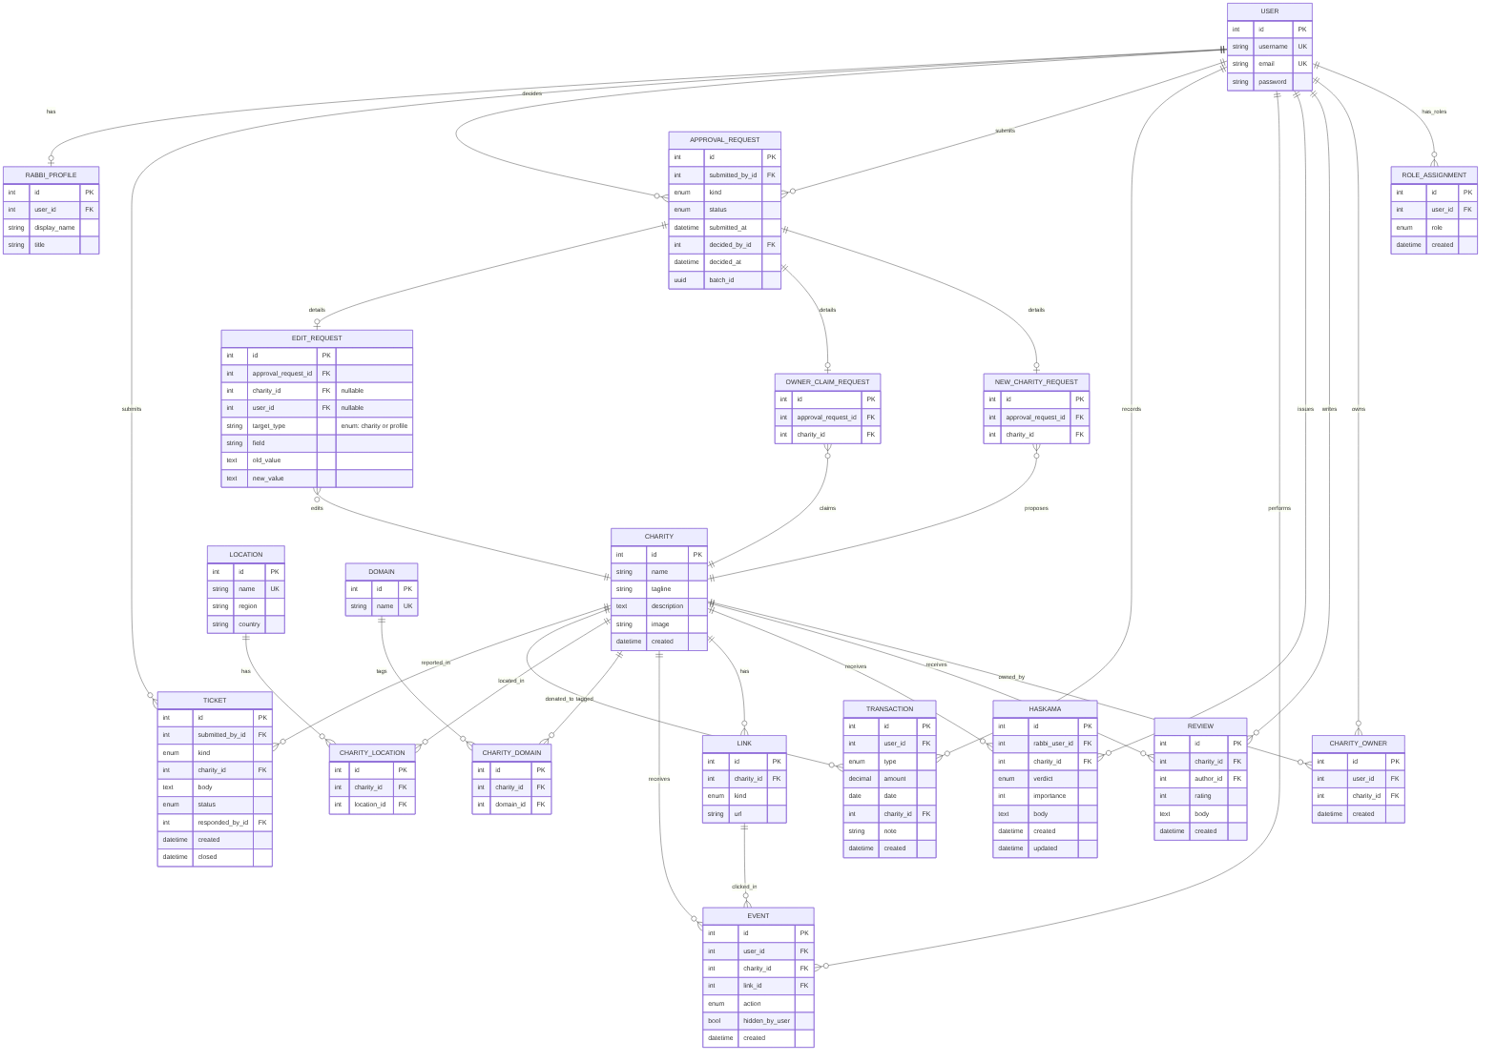 Figure 3: Entity-relationship diagram for the MaaserMart database.

Data Dictionary
This section defines every table, its columns, and its relationships.

USER
- Purpose: Holds information for all registered users in the system.
- Relationships: none outgoing (no foreign keys). Referenced by: ROLE_ASSIGNMENT.user_id, RABBI_PROFILE.user_id, CHARITY_OWNER.user_id, APPROVAL_REQUEST.submitted_by_id, APPROVAL_REQUEST.decided_by_id, EDIT_REQUEST.user_id, REVIEW.author_id, HASKAMA.rabbi_user_id, EVENT.user_id, TRANSACTION.user_id, TICKET.submitted_by_id, TICKET.responded_by_id
- Columns:
  - id — int, non-nullable, PK
  - username — String, non-nullable, unique
  - email — String, non-nullable, unique
  - password — String, non-nullable

ROLE_ASSIGNMENT
- Purpose: Matches user to their role.
- Relationships:
  - user_id → USER (many-to-one, on delete: CASCADE)
- Columns:
  - id — int, non-nullable, PK
  - user_id — int, non-nullable, FK
  - role — Enum (Rabbi, technical supporter, member, charity owner), non-nullable. Admin status is determined by isSuperUser.
  - created — datetime, non-nullable

RABBI_PROFILE
- Purpose: A rabbi's public display name and title.
- Relationships:
  - user_id → USER (one-to-one, on delete: CASCADE)
- Columns:
  - id — int, non-nullable, PK
  - user_id — int, non-nullable, FK, unique
  - title - string, nullable
  - display_name — string, non-nullable

CHARITY_OWNER
- Purpose: Holds charity owners and the charities they own.
- Relationships:
  - user_id → USER (many-to-one, on delete: CASCADE)
  - charity_id → CHARITY (many-to-one, on delete: CASCADE)
- Columns:
  - id — int, non-nullable, PK
  - user_id — int, non-nullable, FK
  - charity_id — int, non-nullable, FK
  - created — datetime, non-nullable

APPROVAL_REQUEST
- Purpose: Table holding all requests submitted to the admins.
- Relationships:
  - submitted_by_id → USER (many-to-one, nullable, on delete: SET_NULL)
  - decided_by_id → USER (many-to-one, nullable, on delete: SET_NULL)
- Columns:
  - id — int, non-nullable, PK
  - submitted_by_id — int, nullable, FK
  - kind — enum (new_charity, owner_claim, edit, rabbi), non-nullable
  - status — enum (pending, rejected, approved), non-nullable
  - submitted_at — datetime, non-nullable
  - decided_by_id — int, nullable, FK
  - decided_at — datetime, nullable
  - batch_id — uuid, non-nullable

NEW_CHARITY_REQUEST
- Purpose: Holds requests for a charity to be added.
- Relationships:
  - approval_request_id → APPROVAL_REQUEST (one-to-one, on delete: CASCADE)
  - charity_id → CHARITY (many-to-one, on delete: PROTECT)
- Columns:
  - id — int, non-nullable, PK
  - approval_request_id — int, non-nullable, FK
  - charity_id — int, non-nullable, FK

OWNER_CLAIM_REQUEST
- Purpose: Holds requests from an aspiring charity owner and the charity he wants to own
- Relationships:
  - approval_request_id → APPROVAL_REQUEST (one-to-one, on delete: CASCADE)
  - charity_id → CHARITY (many-to-one, on delete: PROTECT)
- Columns:
  - id — int, non-nullable, PK
  - approval_request_id — int, non-nullable, FK
  - charity_id — int, non-nullable, FK

EDIT_REQUEST
- Purpose: Holds requests to edit a page
- Relationships:
  - approval_request_id → APPROVAL_REQUEST (one-to-one, on delete: CASCADE)
  - charity_id → CHARITY (many-to-one, on delete: PROTECT)
- Columns:
  - id — int, non-nullable, PK
  - approval_request_id — int, non-nullable, FK
  - charity_id — int, nullable, FK
  - user_id - int, nullable, FK
  - target_type - enum (charity or profile).
  - field — Enum (name, description, tagline, image, location, website_donate, website_about, website_contact, title), non-nullable
  - old_value — text, nullable
  - new_value — text, non-nullable

CHARITY
- Purpose: Holds information about each proposed or active charity
- Relationships: none outgoing (no foreign keys). Referenced by: CHARITY_OWNER.charity_id, REVIEW.charity_id, HASKAMA.charity_id, LINK.charity_id, EVENT.charity_id, CHARITY_DOMAIN.charity_id, CHARITY_LOCATION.charity_id, TRANSACTION.charity_id, TICKET.charity_id, NEW_CHARITY_REQUEST.charity_id, OWNER_CLAIM_REQUEST.charity_id, EDIT_REQUEST.charity_id
- Columns:
  - id — int, non-nullable, PK
  - name — String, non-nullable
  - tagline - string, nullable
  - description — text, nullable, unique
  - image — string, nullable, unique
  - created — datetime, nullable

LOCATION
- Purpose: A list of locations
- Relationships: none outgoing. Referenced by: CHARITY_LOCATION.location_id
- Columns:
  - id — int, non-nullable, PK
  - name — String, non-nullable
  - region — string, non-nullable
  - country — string, non-nullable

DOMAIN
- Purpose: A list of domains
- Relationships: none outgoing. Referenced by: CHARITY_DOMAIN.domain_id
- Columns:
  - id — int, non-nullable, PK
  - name — string, non-nullable

CHARITY_DOMAIN
- Purpose: Maps charities to their domains
- Relationships:
  - charity_id → CHARITY (many-to-one, on delete: CASCADE)
  - domain_id → DOMAIN (many-to-one, on delete: PROTECT)
- Columns:
  - id — int, non-nullable, PK
  - charity_id — int, non-nullable,
  - domain_id — int, non-nullable,

CHARITY_LOCATION
- Purpose: Maps charities to their locations
- Relationships:
  - charity_id → CHARITY (many-to-one, on delete: CASCADE)
  - location_id → LOCATION (many-to-one, on delete: PROTECT)
- Columns:
  - id — int, non-nullable, PK
  - charity_id — int, non-nullable,
  - location_id — int, non-nullable,

LINK
- Purpose: Holds links of each charity and where they point
- Relationships:
  - charity_id → CHARITY (many-to-one, on delete: CASCADE)
- Columns:
  - id — int, non-nullable, PK
  - charity_id — int, non-nullable, FK
  - kind — Enum (website_donate, website_about, website_contact), non-nullable
  - url — string, non-nullable

REVIEW
- Purpose: Holds information about user reviews
- Relationships:
  - charity_id → CHARITY (many-to-one, on delete: CASCADE)
  - author_id → USER (many-to-one, on delete: CASCADE)
- Columns:
  - id — int, non-nullable, PK
  - charity_id — int, non-nullable, FK
  - author_id — int, non-nullable, FK
  - rating — int (1-5), non-nullable
  - body — text
  - created — datetime, non-nullable

HASKAMA
- Purpose: holds information about a rabbi's haskama
- Relationships:
  - rabbi_user_id → USER (many-to-one, on delete: CASCADE)
  - charity_id → CHARITY (many-to-one, on delete: CASCADE)
- Columns:
  - id — int, non-nullable, PK
  - rabbi_user_id — int, non-nullable, FK
  - charity_id — int, non-nullable, FK
  - verdict — enum (approve, disapprove), non-nullable
  - importance — int, nullable (1–10 per SRS 2.3.6)
  - body — text, nullable
  - created — datetime, non-nullable
  - updated — datetime, non-nullable

EVENT
- Purpose: holds information about pages visited and other events
- Relationships:
  - user_id → USER (many-to-one, nullable, on delete: SET_NULL)
  - charity_id → CHARITY (many-to-one, on delete: PROTECT)
  - link_id → LINK (many-to-one, nullable, on delete: SET_NULL)
- Columns:
  - id — int, non-nullable, PK
  - user_id — int, nullable, FK
  - charity_id — int, non-nullable, FK
  - link_id — int, nullable, FK
  - action — enum (view, link_click, reject, charity_updated), non-nullable
  - hidden_by_user — bool, non-nullable
  - created — datetime, non-nullable

TRANSACTION
- Purpose: holds income and maaser history, for maaser tracking
- Relationships:
  - user_id → USER (many-to-one, on delete: CASCADE)
  - charity_id → CHARITY (many-to-one, nullable, on delete: SET_NULL)
- Columns:
  - id — int, non-nullable, PK
  - user_id — int, non-nullable, FK
  - type — enum (income, donation), non-nullable
  - amount — decimal, non-nullable
  - date — date, nullable
  - charity_id — int, nullable, FK
  - note — String, nullable
  - created — datetime, non-nullable

TICKET
- Purpose: hold help requests and reports
- Relationships:
  - submitted_by_id → USER (many-to-one, nullable, on delete: SET_NULL)
  - charity_id → CHARITY (many-to-one, nullable, on delete: SET_NULL)
  - responded_by_id → USER (many-to-one, nullable, on delete: SET_NULL)
- Columns:
  - id — int, non-nullable, PK
  - submitted_by_id — int, nullable, FK
  - kind — enum (help, report), non-nullable
  - charity_id — int, nullable, FK
  - body — text
  - status — enum (responded, not_responded, closed), non-nullable
  - responded_by_id — int, nullable, FK
  - created — datetime, non-nullable
  - closed — datetime, nullable

Indexes
- EVENT — (charity_id, action, created) — most-visited sorting, trending window, and Charity.last_updated
- EVENT — (user_id, created) — member history, newest first
- EVENT — (link_id) — per-link click counts for the charity owner page
- REVIEW — (charity_id) — reviews on the charity page; average rating on the list page
- HASKAMA — (charity_id) — haskamas on the charity page
- TRANSACTION — (user_id, type) — maaser calculator (sum donations, sum income)
- APPROVAL_REQUEST — (status, submitted_at) — admin approval queue, oldest first
- TICKET — (status, created) — admin ticket queue, oldest first

Derived Values
- Charity.last_updated — derived from date of last change.
- Average rating — derived from each rating
- Visit count — derived from events
- Click count — derived from events
- Trending — derived from events
- Maaser owed — derived from transactions

Modeling Decisions
- Derive data. We do not store derived data, since it goes stale.
- Separate conceptually different things into different tables while keeping conceptually similar ones together. Therefore, for example, there is one table holding all events, and per event, there are different tables (since they are different and need different columns).
- Non-approved charities are in the charity table, but are hidden. This makes things a lot simpler, since they have the same fields as a charity. It also works well conceptually - it is a charity.
- Rejected charities and requests are retained. This helps with audits.
- Do not duplicate data. For example, pending status is saved only in the approval table, and not on each charity.
- Some facts live in the code, not the DB. For example the need to accept TOS is a form constraint, and admin status is provided by Django.

Low-Level Design
This section gives the low-level design: module responsibilities and interfaces, the detailed tracer-bullet modules, and the key algorithms.

Module Responsibilities and Interfaces
- charities
  - Owns: CHARITY, LOCATION, DOMAIN, CHARITY_DOMAIN, CHARITY_LOCATION, LINK, REVIEW, HASKAMA
  - Exposes: apply_charity_edit(charity_id, field, new_value) create_charity(…) public read queries for list / filter / sort / search / page
  - Depends on: events (writes EVENT action='charity_updated')
- events
  - Owns: EVENT
  - Exposes: events.services.record_event(charity_id, action, link_id, user_id) history queries for a member
  - Depends on: nothing (string FKs only)
- accounts
  - Owns: USER, ROLE_ASSIGNMENT, CHARITY_OWNER
  - Exposes: signup, login, password reset grant_ownership(user_id, charity_id) grant_role(user_id, role)
  - Depends on nothing.
- tools
  - Owns: TRANSACTION
  - Exposes: income and donation CRUD, maaser calculation
  - Depends on nothing.
- approvals
  - Owns: APPROVAL_REQUEST, NEW_CHARITY_REQUEST, OWNER_CLAIM_REQUEST, EDIT_REQUEST
  - Exposes: submit_request(…), decide_request(…) the admin pending queue
  - Depends on: charities, accounts (calls their write services on approval)
- support
  - Owns: TICKET
  - Exposes: submit_report(…), submit_help(…), admin ticket queue
  - Depends on: nothing.
- chatbot
  - Owns: no models
  - Exposes: enqueue_question(…), poll_status(task_id)
  - Depends on: nothing structural; the Celery task calls the AI API
- recommendations
  - Owns: no models
  - Exposes: recommend_for(user_id) -> ranked charity ids
  - Depends on: events, charities.
- dashboards
  - Owns: no models
  - Exposes: the four landing pages (member, owner, rabbi, admin)
  - Depends on: charities, events, accounts, tools, approvals, support, recommendations
To remain modular, modules will not call each other unless they directly depend on each other. Then, they will call public service functions of the module they depend on. Dashboard depends on almost everything, while events depends on nothing.

Tracer Bullet Modules (detailed)
This section details each tracer-bullet module: its path, URL, permissions, models, services, views, templates, failure paths, and tests. The selected tracer bullets are the fifteen modules detailed below: Login; Signup; Charity List; Filter; Sort; Search; Charity Page; Reviews; Haskama; Member History; Recommendations; Charity Owner Stats; Admin Access; Charity Addition; and Edit Charity. We split them into fine-grained, end-to-end slices rather than a few large ones so that each slice stays small enough to design, build, and test on its own, while together they still cover every layer: accounts, the public list and charity page, the member and owner dashboards, and the admin approval queue. Everything else (Maaser Tools, the Chatbot, Tickets, and the Technical Supporter view) is a non-tracer module and is described only in outline.

Login (one system, four role dashboards) — SRS FR 14–16
Login authenticates a user and sends each role to the right dashboard.

Path
User clicks on login button or on a protected page and enters credentials. User lands as an authorized user, on their dashboard or the protected page. (If user has multiple dashboards (like if he is a member and rabbi), he gets a selection of dashboards.)

URL
/login/ - This is the login page. We will use Django's ?next, so that, if the user clicks on the protected page, it will take them there after login. If the user reached login directly by clicking on the login button (so there is not next=), they will reach /dashboard/ or, if they have multiple roles /choose-dashboard/.

Permissions
The login page is accessible to all, but to actually log in, one must be a registered user - that is, a member, rabbi, charity owner, technical supporter, or admin.

Models touched
Writes to USER (Django writes last_login by default) and Django's session table (again, a Django default).
Reads from USER and ROLE_ASSIGNMENT

Service functions
accounts.services.find_role(user) - returns a list of roles that user has. Pending roles are not returned.

View
The view calls a helper, which does this: If there is a next, the user is redirected there. If there is no next, the find_role(user) function is called. If more than one role is returned, a chooser page is built, with buttons mapping to each role, and the user is redirected there. If not, the user is redirected to his dashboard. The view holds a mapping of user classes and their dashboards.

Template
Login form template - shows the login form and accepts credentials chooser template - shows one button for each role the user holds. Each button directs to that role's dashboard.

Failure paths
User does not enter in credential -> cannot be submitted, and the problematic field is highlighted.
User enters in wrong credential -> shows a message, saying wrong credentials, on top of the login form. Which credentials are wrong is not disclosed. After five wrong tries, the user is locked out for one hour. The user is not told about this until he is locked out.

Tests
White box - unit tests on find_role(user) - with one role, multiple roles, no roles, pending roles.
Black box - users of varying roles login -> stops users entering wrong credentials and redirects other users to the proper page, as defined above.

Signup — member, charity owner, rabbi — SRS FR 14–16
Signup creates an account for a member, a charity owner, or a rabbi.

Path
User clicks on signup button and is able to pick role to sign-up for: member, charity owner, and Rabbi.
Each redirects to its own signup page:
Each begins with: enters username, password, and email address and agrees to TOS.
Selects member -> User receives email with code and enters in code, and clicks submit. Then, user is redirected to whicheve page login would redirect him (next, dashboard, chooser).
Selects Rabbi -> User sees box of hashkafa and selects agree. He also enters his name and title. Then, user receives email with code and enters in code, and clicks submit. User then sees a pending page, telling him his application is pending. (When approved, he receives an email.)
Selects Charity Owner -> User selects existing charity or new charity.
Existing charity -> User types the name of his charity into a box. As he types, he sees a dropdown of charities. He selects his.
New charity -> User enters the details of his charity. Details held in session until verification.
Then, user receives email with code and enters in code, and clicks submit. User then sees a pending page, telling him his application is pending. (When approved, he receives an email.)
In each page, if the user is already signed in to any role, the username, password, email, and code fields are not shown.

URL
/signup/ - the page where you select what you will sign up for.
/member_signup/ - the page where you sign up as a member
/owner_signup/ - the page where you sign up as a charity owner
/rabbi_signup/ - the page where you sign up as a rabbi
/pending/ - the page that shows pending status

Permissions
The page can be accessed by anyone, and anyone can sign up. However, a member cannot sign up for another member account and a rabbi cannot sign up for another rabbi account.

Models touched
writes to user, roles, approval request, new_charity_request, owner_claim_request, charities, link, charity_location, charity_domain, session.
Reads from user, roles, approval request (to see and reject duplicate requests), charities, session.

Service functions
accounts.services.enqueue_email(email) -> enqueues email to that email address
accounts.services.submit_member_signup(username, email, password) → creates USER and ROLE_ASSIGNMENT(member). approvals.services.submit_rabbi_request(user, name, title) → creates APPROVAL_REQUEST(kind='rabbi'), RABBI_PROFILE row
approvals.services.submit_owner_claim(user, charity_id) → creates APPROVAL_REQUEST(kind='owner_claim') and its OWNER_CLAIM_REQUEST row.
approvals.services.submit_new_charity(user, name, tagline, description, image, locations, domains, links) → creates the hidden CHARITY row, its junction rows, APPROVAL_REQUEST(kind='new_charity'), and NEW_CHARITY_REQUEST. Each of these returns an int, mapping to success, failure due to existing user, failure due to application present, failure due to other causes.
charities.services.list_charities(filters, sort, page, page_size, search) -> Searches the name column of the CHARITY DB for string, and returns a list.

View
View loads the signup page with buttons to link to each signup type. If the user is already signed in, a form not showing username, password, email, and code is displayed. If not, the regular signup form is displayed. When the user enters email and clicks send, it calls enqueue_email(email), and shows whether it was successful. When searching charities, after entering each characters, list_charities(string) is called. Pressing submit then calls the proper submit method, dependent on the form, and shows success. If successful, it shows pending or calls the same helper that login calls.

Template
Submit template - shows buttons for each type of signup.
Guest Member form - shows input for username, password, email, and verification code, a checkbox for TOS, with TOS explained in a paragraph above it, and a submit button.
Guest charity owner form - shows input for username, password, email, and verification code, a checkbox for TOS, with TOS explained in a paragraph above it, and a radio button for existing charity and for new charity. Each unlocks one option - a search bar where you select from a dropdown that opens or an input for name, tagline, details, three inputs for the different types of links, domains (multiple), and locations (multiple). There is a submit button.
Guest rabbi form - shows input for username, password, email, name, and title, and verification code, a checkbox for TOS, with TOS explained in a paragraph above it, the same for hashkafic agreement, and a submit button.
There is a User version of each page, without username, email, code, or password.
Pending - A simple page that shows that the request is pending.

Failure paths
Request is pending -> Top of form says request is already pending, with rejection.
Username already exists -> Username field says already taken, with rejection.
Email already has member account, rabbi account, or charity owner account for that charity -> Email fields says so.
New charity has the same name as existing charity -> Name field says so, with no rejection.

Tests
White box - unit tests for each service method, with cases where the user has the role, does not have the role, and has the role among others.
Black box - real users try signing up in the above cases.

Charity List — SRS FR 1
Charity List shows the paginated list of all charities.

Path
Visitor clicks the main listing page or visits the main landing page. He sees a listing of every charity in the system, paginated, in alphabetical order.

URL
/listing/ - the page holding all the listing. The page number is a page= attribute and the amount per page is per_page= attribute.

Permissions
This is open to everyone.

Models touched
Writes none.
Reads: CHARITY, REVIEW, NEW_CHARITY_REQUEST, APPROVAL_REQUEST.

Service functions
charities.services.list_charities(filters, sort, page, page_size, search) → (items, total) Items is a list, by default returned in alphabetical order.

View
View holds a variable holding amount of items per page. That variable, together with the page number is sent to list_charities and a list of charities is returned. The page then displays each one, in order of the list.

Template
Listing_Page - a page similar to amazon's product page. In the display area, there are rows - one per charity.

Failure paths
No charities returned - a message saying no charities found

Tests
White box - unit test of list_charities default run
Black_box - have authorized and unauthorized users reach this page, or maasermart.com, have them set different page amounts and cycle between pages.

Filter — SRS FR 2
Filter narrows the charity list by the selected criteria.

Path
User selects filters. After clicking submit, the charity listing displays only charities that match those filters, starting with page 1.
There are seven groups of filters. Selecting multiple within a group (where relevant) is an OR and between groups is an AND.
- Domains
- Locations
- Haskamos
- min_rating
- min_reviews
- min_approving_haskamas
- max_disapproving_haskamas

URL
Parameters: `domain` (repeatable), `location` (repeatable), `haskama_rabbi` (repeatable, username), `min_rating`, `min_reviews`, `min_approving_haskamas`, `max_disapproving_haskamas`, `page`, `page_size`. Setting a filter resets page to 1.

Permissions
This can be set by anoyone, even a guest.

Models touched
Writes: none.
Reads: `CHARITY`, `CHARITY_DOMAIN`, `DOMAIN`, `CHARITY_LOCATION`, `LOCATION`, `REVIEW`, `HASKAMA`, `USER`, `NEW_CHARITY_REQUEST`, `APPROVAL_REQUEST`.

Service functions
charities.services.list_charities(filters, sort, page, page_size, search) -> returns items and amount. filter is a dict.
accounts.services.search_rabbis(string) -> returns rabbis whose names match string

View
Same as charity listing

Template
Same as charity listing. The filters are similar to Amazon's.

Failure paths
Matches nothing -> message saying nothing matching that was found

Tests
white box -> unit tests on the service methods
black box -> users picking multiple filters, for each group.

Sort — SRS FR 3
Sort orders the charity list by the selected option.

Path
User selects on option from a dropdown. Default is alphabetical. There is also by trending, most popular (most events), highest reviews, most haskamos, most recently added, and most recently updated. Each has a high to low and low to high button.
The user is then shown page 1 of the charities displayed, in that order. Trending is explained in the algorithms section.

URL
Parameters: sort= and direction=

Permissions
This is able to be used by anyone.

Models touched
Writes nothing.
Reads charity, reviews, haskamos, new_charity_request, edit_request, approval_request, and events

Service functions
charities.services.list_charities(filters, sort, page, page_size, search) . Sort that is input here is a tuple with mechanism and direction. When nothing recognizable is input, or when nothing is input, it defaults to alphabetical a->z.

View
The user selects a sorting algorithm and a direction. This calls list_charities with an input of that tuple. The charities listed and amount are returned and the charities are displayed, starting on page 1.

Template
Same as charity listing.

Failure paths
Tie -> Alphabetical tiebreaker

Tests
White box -> unit test, testing each sort.
black box -> have a user pick different sorts and see what is displayed.

Search — SRS FR 4
Search returns the charities that match the typed query.

Path
There is a search bar on top. The user types in it, and presses submit. Then, only charities matching the search term are shown. There is a toggle for advanced search, where user can pick options, like full words only, or searching in the tagline. Page 1 of the search is shown, and filters and sort remain on.

URL
parameters - search term and one parameter for each option in advanced search.

Permissions
This is available to everyone.

Models touched
Writes nothing.
Reads charities.

Service functions
charities.services.list_charities(filters, sort, page, page_size, search) , which takes search, a dict, holding the term and advanced options.

View
The view calls list_charities, and gets back the results, which it displays in a row.

Template
Same as charity Listing.

Failure paths
Nothing found -> Message saying nothing was found.

Tests
white box -> unit test, with different strings and advanced options
black box -> have users search different words. In particular, see if it is easy to find things.

Charity Page — SRS FR 8
Charity Page shows the full details of a single charity.

Path
User clicks on a charity, and gets to a page which shows the charity image, the charity name, locations and domains, a tagline, a description, and has a links section (with three links - about, contact, donate), a haskama section, and a review section. It also says when the page was last updated.

URL
/charity_id/ - id is the charity id.

Permissions
This page can be seen by everyone.

Models touched
Writes events.
Reads charities, links, reviews, events, charity_locations, charity_domains, locations, domains, haskamas, new_charity_request, approval_request, event.

Service functions
events.services.record_event(charity_id, action, link_id, user_id) -> Failed writes do not fail the page
charities.services.get_charity_page(charity_id) → dict with name, tagline, description, image, links, locations, domains, reviews, haskamas, avg_rating, review_count, last_updated

View
The view uses the charity ID to call get_charity_page, and gets back the data it needs to display. It displays them on the page. On loading, it calls record_event to record that it was visited. On clicking a link, it goes to that link and calls record_event, with a link_id. It records which user visited, if the user is logged in.

Template
One template for every charity, filled in by the values returned from get_charity_page()

Failure paths
Could not get data from DB -> Error message in that field.
No data -> Message saying that.
Links are dead -> Not really our problem.

Tests
White box -> unit tests against SQL queries on get_charity_page()
Black_box -> Visit pages and see everything renders correctly

Reviews (writing, from the charity page) — SRS FR 9
Reviews let a signed-in member write a review on a charity page.

Path
On the charity page, a user hits the review button. If the user is not signed in as a member, it redirects to the login page. If the user is signed in, the user gets stars to fill in and a text box to write the review in. If the user has already left a review, this opens his review to be edited. At the bottom is the submit button; when the user clicks that button, the review is live.

URL
/charity_id/ - see above

Permissions
Only a member can write a review.

Models touched
Writes to reviews.
Reads from role_assignment, reviews.

Service functions
charities.services.get_user_review(user_id, charity_id) → the user's REVIEW row for that charity or None.
accounts.services.user_has_role(user, role) → bool.
charities.services.save_review(user_id, charity_id, rating, body) → creates or updates the review, if the user has the right permissions (the first check is html only). It calls user_has_role(user_id, member)

View
The user clicks the button, which checks user_has_role(). If user has role, it then calls get_user_review. It opens up his review for him to edit, or, if None is returned, opens up a new review for him to write. When the user clicks submit, it calls save_review().

Template
The charity page, with a review box open. The login page.

Failure paths
User does not have permissions -> login page
user already wrote review -> This shows him his review and lets him edit.

Tests
white box - unit test - make sure that get_user_review returns the right review or None
black_box - have people (guests, members, rabbis, those who already wrote reviews) write reviews.

Haskama — SRS FR 13
Haskama lets a rabbi record an approval for a charity.

Path
On Rabbi's dashboard, the rabbi clicks add a haskama. A search bar opens, and he searches for the charity he wants to write a haskama for. He then gets a box in which to fill out details and he clicks submit. (If the rabbi has already written a haskama, it lets him edit it.) There will be a similar option to reviews, where the Rabbi can add a haskama from the charity page.

URL
Same as rabbi's dashboard.

Permissions
Must be a rabbi.

Models touched
Writes to haskamos.
Reads from charity, new_charity_request, approval_requests, haskama, role_assignment.

Service functions
charities.services.get_haskama(user_id, charity_id) -> returns the haskama or None
charities.services.list_charities(filters, sort, page, page_size, search) -> returns charities matching search
charities.services.save_haskama(review, user_id) -> checks the role of id (see method above) and posts the haskama (dict).

View
The view opens a search box. As the rabbi types, list_charities is called with what he writes. One is selected. It then calls get_haskama. It then opens the box empty or with the haskama. When the Rabbi clicks submit, it calls save_haskama().

Template
Rabbi dashboard template, with box open.
Charity page template, with haskama open in editing box.

Failure paths
already wrote haskama -> Lets him edit it.

Tests
Same as review.

Member History — SRS FR 5, FR 6
Member History shows a member's past activity on his dashboard.

Path
The user navigates to the member dashboard. One column is the history. It is in chronological order, with a time tag. Each entry has an x, so it can be hidden. There is a clear all button, which does a bulk hide.

URL
/member_dashboard/

Permissions
Must be a member.

Models touched
writes events. Reads events, charities

Service functions
events.services.get_history(user_id) -> Gets history, returning only what is not hidden.
events.services.hide_history(user_id, event_id) -> hides the event.
events.services.hide_all_history(user_id) -> hides all history.

View
The view calls get_history. clicking clear all calls hide_all_history and clicking x calls hide_history.

Template
member dashboard

Failure paths
No History -> Shows no history found

Tests
white box -> unit test on get_history, before and after hiding.
black box -> Have a user perform some actions and see that it is in history. Hide history and see it not show up.

Recommendations — SRS FR 7
Recommendations suggests charities to a member based on his history.

Path
The user navigates to his dashboard. One column is recommendations, and it uses the recommendation algorithm. It displays recommendations, and each has an x, so the user can reject it.

URL
/member_dashboard/

Permissions
Must be member

Models touched
writes EVENT (via record_event).
reads EVENT, CHARITY, CHARITY_DOMAIN, DOMAIN, CHARITY_LOCATION, LOCATION, NEW_CHARITY_REQUEST and APPROVAL_REQUEST

Service functions
events.services.record_event(charity_id, action, link_id, user_id) -> reject recommendations
recommend_for(user_id) -> get recommendations

View
The view calls recommend_for to get recommendations. If the user rejects one, it calls record_event and then calls recommend_for, to update the list.

Template
member dashboard

Failure paths
not enough data -> says not enough data to recommend.

Tests
Unit test -> Test the algorithm with different history lists etc.
Black box - ask users if it is on point.

Algorithm
Recommendation algorithm (recommendations.services.recommend_for(user_id))
Some numbers here are TBD - we will test with different numbers and find which make intuitive outputs.
Inputs: user_id, x, y, z thresholds (percentages, constants in settings, values TBD), min_history (minimum qualifying events before the algorithm runs; TBD).
Step 1 — Build the history set:
Qualifying events: EVENT rows for this user with action IN ('view', 'link_click')
Include rows where hidden_by_user = True (they stay in the denominator).
Exclude action IN ('reject', 'charity_updated').
Step 2 — Denominators:
Total = count of all qualifying events for this user, hidden or not.
If total < min_history → return empty list.
Step 3 — Per-charity share:
For each charity the user interacted with: numerator = count of that charity's qualifying events with hidden_by_user = False
share(charity) = numerator / total
A hidden row therefore lowers its charity's share without changing total, so hiding one item does not inflate every other charity's percentage.
Step 4 — Tier 1 (single-charity signal)
Charities where share(charity) > x.
Step 5 — Tier 2 ((domain, location) pair signal)
For each (domain, location) pair present in the user's history:
pair_share = sum of share(charity) for that user's charities in the pair
if pair_share > x + z: candidates += other published charities in that pair
Step 6 — Tier 3 (domain-only or location-only signal)
For each domain d: domain_share = sum of share over the user's charities in d
For each location l: location_share = sum of share over the user's charities in l
if domain_share > x + y → candidates += other published charities in d I
f location_share > x + y → candidates += other published charities in l
Step 7 — Assemble
Result = Tier 1 candidates, then Tier 2, then Tier 3.
Deduplicate: a charity appearing in several tiers keeps its highest tier.
Within each tier, order alphabetically by name.
Exclude:
- unpublished charities
- charities the user rejected
Step 8 — Audit
Log to the technical log: user_id, the computed shares per domain/location, the triggered tiers, and the returned charity ids.
Returns: Ordered list of charity ids (or objects).

Charity Owner Stats — SRS FR 10
Charity Owner Stats shows an owner the engagement on his charities.

Path
Owner enters their dashboard. If the owner has one dashboard - he is there. If he has multiple - he gets an overview, and links to each.

URL
/charity-owner-dashboard-charity-id/
/charity-owner-overview/

Permissions
Must be a charity owner (and own the charity displayed)

Models touched
Writes to none.
Reads charity, charity_owner, event, link, review, haskama, new_charity_request, approval_request

Service functions
accounts.services.get_owned_charities(user_id)- returns a list of charities the user owns.
charities.services.get_charity_data(charities) - If there is one, returns the charity data in a dict. If there are multiple, returns the overview in a dict.

View
View first calls get_owned_charities. If there are multiple, then it shows buttons to each one, plus calls get_charity_data to show an overview. If there is one, or if the user clicks one of the button, it calls get_charity_data with just one charity, giving stats for that one charity.

Template
owner dashboard
owner overview / selector

Failure paths
Owner has no charities -> Owner is not an owner, so has already been redirected to login
Owner has multiple charities -> Overview and buttons

Tests
White box -> get_owned_charities returns all owned charities for users with none, one, or many (even for two with the same name). get_charity_data returns the data for none, one, many, even with the same name.
Black box -> Different charity owners are able to login and view their data.

Admin Access — SRS FR 12
Admin Access gives the administrator the approval queue, the ticket queue, and the Django admin.

Path
Admin clicks on his dashboard. He can now see three things - links to approval queue, links to ticket queue, and Django admin. The ticket queue is a queue of help or report tickets. The admin can open one, and reply to it, and can delete one. The approval queue is a list of requests asking for approval. The admin can open one, look at it, and accept or reject.

URL
/admin/ - the built-in Django admin page.
/admin/approval/ - approval queue
/admin/tickets/ - ticket queue

Permissions
Only accessed by admins.

Models touched
admin page - this is a built-in Django view that can read and write everything.
approval page - writes approval_request, role_assignment, event, charity_owner, charities, charity_location, charity_domain. reads APPROVAL_REQUEST, CHARITY, USER, ROLE_ASSIGNMENT, DOMAIN, CHARITY_DOMAIN, LOCATION, CHARITY_LOCATION, LINK, RABBI_PROFILE.
ticket page - reads tickets, writes tickets.

Service functions
approvals.services.get_requests() -> returns requests, ordered chronologically. returns a list of dict pairs (request type and request object)
get_tickets() -> returns tickets, ordered chronologically
approvals.services.decide_request(request_id, approve/reject, user_id) -> returns success (and sends email to user)
grant_ownership(user_id, charity_id) -> grants ownership to an owner over a charity.
grant_role(user_id, role) -> grants a role to the user.
resolve_ticket(ticket_id, user_id, text, close/respond) -> returns success

View
The view shows the admin dashboard, using Django's built-in dashboard. It also has links added to the custom dashboard. Clicking on tickets calls get_tickets(). Clicking on one allows you to respond or to close, calling resolve_ticket. Clicking on approvals brings you to the approval queue, which lets you click on an approval to see it and the reject or approve, which calls decide_request. Each choice also sends an email to user informing them of the decision, within that method.

Template
Django admin dashboard, with links added approval queue ticket queue

Failure paths
insufficient permissions -> Page not shown
race condition (where another admin approves, etc) -> Returns failure and displays a message saying the status was already updated

Tests
white box -> unit tests on the methods, to ensure they return the right outputs, in the right order.
black box -> Create request, have admin respond to it, see system change.

Charity Addition — SRS FR 17
Charity Addition lets a user propose a new charity for approval.

Path
User clicks the charity addition button and is taken to a form, where they fill in the details of a charity. They then click submit. If the user is an admin, the charity is automatically approved. If not, it is put on the pending list for the admin. If the charity shares a name with another, the user is shown the other and asked - did you mean this?

URL
/charity-add/

Permissions
Anyone can request a charity to be added.fi

Models touched
writes charity, charity_domain, charity_location, link.
reads charity, charity_domain, charity_location, link, role_assignment, approval_request, domain, location.

Service functions
charities.services.list_charities(filters, sort, page, page_size, search) -> Finds charities with the same name.
charities.services.create_charity(user_id, charity) -> Creates the charity request. returns int for worked (admin), submitted, and failed.

View
It shows the form. The user enters the name and clicks - search for duplicates. Then user gets a list of possible duplicates. If the user chooses to continue anyway, the user submits details of the charity. If it is not exactly identical to another charity, it is then added to the pending list (if the request is not by admin) or created and published, by calling create_charity.

Template
charity addition page, with all the fields necessary for a charity.

Failure paths
charity exists -> user is shown charities that exist. He can pick whether to continue.
Blank fields -> Some fields are nullable. For others, it errors on the form.

Tests
white box -> unit tests on searching charity.
black box -> add a charity, both admin and non-admin.

Edit Charity
Edit Charity lets a user propose a change to a charity.

Path
User navigates to a charity page and clicks edit (or clicks edit from their owner dashboard). Each field in the charity page (other than haskamas and reviews) becomes editable. Clicking submit sends the approval request. If done by an admin, it is approved automatically. If a different edit is queued for that field, it tells the user, and he must confirm he still wishes to make his change.

URL
/charity-id/

Permissions
Must be admin or charity owner of that charity

Models touched
writes links, charity, charity_domain, charity_location, approval_request, edit_request.
reads charity, edit_request, approval_requests, charity, charity_domain, charity_location, link, domain, location, role_assignment.

Service functions
charities.services.has_permission_to_edit(user_id, charity_id) - returns if user can edit this charity.
charities.services.check_edits(edits) - edits is a dict of field and value pairs of all things edited. It returns those that have a pending edit.
approvals.services.submit_edit(edits, user_id) - edits is a dict of field and value pairs of all things edited. This submits the edits to pending or approved.

View
view calls has_permission_to_edit. If yes, it opens up each field as an editable box. The user can edit, and then clicks submit on bottom of the page. It calls check_edits to see if he has made edits in any pending field. If he has, he is shown it and asked whether he wants to continue. If he wants to, or there are no other pending edits, it calls submit_edit.

Template
same as charity page, but editable, with submit button on bottom

Failure paths
another edit is pending -> user is asked and shown the edit.
the charity is not his -> He cannot create the edit request.

Tests
white box - unit tests on three service methods.
black box - have real users submit, sometimes while one is pending.

Non-Tracer Modules (vague)
These modules lie outside the tracer bullets and are described only in outline.

Maaser Tools (SRS FR 20–22)
Access to members only, writes and reads from transaction, service functions adding transaction and calculating maaser owed. Assumption is all amounts per user are in one currency (and it does not matter which).

Chatbot (SRS FR 11)
access to members, charity owners, and rabbis. Lives in a panel with HTMX, system prompt includes charity data, and links to Sefaria, as well as a tone. Questions are put on the celery queue and HTMX polls.

Tickets (SRS FR 18, FR 19)
Access to everyone. Users click on a button, pick report or help. If report, they search for the charity, select, and enter message. If they pick help, they enter their message. An email field is provided for guests, and it must be verified. A response is sent to their email. writes Ticket table. service functions are the search, checking if we have the user's id, and sending the email and submitting the ticket.

Technical Supporter
Access to his dashboard, which holds help tickets. For each, he can respond, or click a button asking permission to view logs. He can then view, for each, approved logs. New service functions are get_help_tickets, and ask_for_log_permission(help_id).

Key Algorithms
This section defines the non-trivial algorithms in the system.

Recommendations
see above

Maaser Calculator
returns (income / 10) - donations. income is the sum of all transactions marked income and donation is the sum of all marked donation, for that member.

Trending
each charity gets a score, and the charities are ordered in terms of that score. The score is assigned by multiplying events in the past week by 3 and events in the past month by 2.

Error Handling per Module
Not repeated here: the generic 500 page, the friendly 403/404/500 templates, inline form errors, the 5-second browser retry, and record_event's swallow-and-log rule. Those are the architectural policy and appear in the Architectural Overview.

Module | Error | User sees | Logged as
accounts | Verification code wrong | Form re-renders, "code is incorrect", field marked | INFO, email + attempt count
accounts | Verification code expired | Form re-renders, resend button | INFO
accounts | Code attempts exceeded | "Too many attempts, request a new code" | WARNING
accounts | Verification email never arrives | Nothing — user is stuck on the code box | ERROR when SES retries exhaust; no user-facing signal
accounts | Duplicate username or email | Form re-renders, says by the problematic field what the error is | INFO
accounts | Session lost mid-signup | Form re-renders empty; session-held charity details are gone | Not logged
accounts | Login attempt while DB unavailable | Generic 500 page | ERROR via django.request
approvals | Request already decided | "Already decided by X at Y" — no error styling | INFO
approvals | Stale edit: old_value no longer matches current | "This field has changed since the request was made" — request left pending | WARNING
approvals | Concurrent approval of same row | Second admin sees the "already decided" result, not a 500 | INFO
charities | Hidden or unpublished charity requested | Generic 404 page | Not logged
charities | Duplicate name on add | Existing published charity shown, "did you mean this" | INFO
charities | Second submission of the same review (two tabs) | IntegrityError caught, "your review was just saved, reload" | WARNING
charities | Multi-table add fails partway | Whole request rolls back; "could not add, try again" | ERROR
support | Guest ticket with no submitter | Accepted; admin queue shows "guest" | Not logged
support | Reply email fails after retries exhaust | Ticket still marked actioned; no signal to the user | ERROR, ticket id
tools | Negative maaser balance | Clamped to zero – you cannot give maaser before the fact. | Not logged
tools | Invalid amount entered | Inline form error | Not logged
chatbot | AI timeout / rate limit / retries exhausted / bad key | Poll returns a terminal "couldn't get an answer, try again" | ERROR (see Chatbot entry above)
chatbot | Enqueue failure at submit | "Could not submit, try again" — synchronous | ERROR
chatbot | Status polled for unknown or foreign task | 404 | WARNING
chatbot | Usage cap reached | "You've reached the chatbot limit" | INFO
queue | Worker process not running | Tasks accumulate in SQS; chatbot polls forever, emails never send [26] | ERROR on the server; nothing user-facing
queue | SQS unreachable | Submit-time enqueue fails synchronously; background retries lost [26] | ERROR
email | SES throttled (sandbox 1/sec) | Nothing — Celery retries with backoff [16] | WARNING
email | SES sandbox: recipient unverified | Send fails permanently; user never receives the mail [16] | ERROR

- No leaks: error pages, poll responses, and log lines seen by anyone but the admin (or technical supporter with permission) carry no user identifiers, charity names, or transaction amounts. Tracebacks go to the technical log, which only admins can read.
- Three timing classes, three different mechanisms: synchronous (submit-time enqueue, form validation) → the user is told immediately; asynchronous (queue work) → Celery retries, the user sees a terminal state on poll; browser-side (page fetches) → the 5-second retry with a visible indicator.

User Interface Design
This section describes the user interface: the page inventory, navigation, wireframes, and wording rules.

Page Inventory
This section lists every page with its URL, the roles that can reach it, and the requirements it serves.

Authentication
This subsection lists the pages used to create an account and to sign in.

Page | URL | Roles | Purpose | FRs
Signup landing | signup | all | Choose member / owner / rabbi | 14-16
Member signup | member_signup | all | Create account | 14
Owner signup | owner_signup | all | Create account + claim or propose charity | 15
Rabbi signup | rabbi_signup | all | Create account + hashkafa + profile | 16
Pending | pending | pending applicants | "Your application is under review" | 15, 16
Login | login | all | Authenticate | 14
Dashboard chooser | choose-dashboard | multi-role users | Pick a dashboard | —

Public
This subsection lists the pages anyone, including a guest, can reach.

Page | URL | Roles | Purpose | FRs
Charity listing | listing | all | Browse; filter/sort/search/paginate as states | 1-4
Charity page | charity_id | all | Full charity view; review form (member), edit form (owner), haskama form (rabbi) as role states | 8, 9, 13
Charity request | charity-add | all | Guest/member proposes a charity | 17
Help | help | all | Submit a help request | 18
Report | report | all | Report a charity | 19

Member
This subsection lists the pages available to a signed-in member.

Page | URL | Roles | Purpose | FRs
Member dashboard | member_dashboard | member | Landing; summary | 5
History | member_dashboard | member | Views and clicks; hide items | 6
Recommendations | member_dashboard | member | Recommended charities; reject | 7
Income history | member_dashboard/income | member | Income records | 21
Donation history | member_dashboard/donations | member | Donation records | 20
Maaser calculator | member_dashboard/maaser | member | Amount still owed | 22

Charity Owner
This subsection lists the pages available to a signed-in charity owner.

Page | URL | Roles | Purpose | FRs
Owner overview | /charity-owner-overview/ | charity owner | All owned charities | 10
Owner stats | /charity-owner-dashboard-charity-id/ | charity owner (of that charity) | Views, clicks, reviews, haskamas | 10

Rabbi
This subsection lists the pages available to a signed-in rabbi.

Page | URL | Roles | Purpose | FRs
Rabbi dashboard | rabbi_dashboard | rabbi | Charities to review; own haskamas | 13

Admin
This subsection lists the pages available to an administrator.

Page | URL | Roles | Purpose | FRs
Django admin | admin | admin | Raw data CRUD, audit history, logs | 12
Approval queue | admin/approvals | admin | Pending requests, grouped by batch | 15-17
Ticket queue | admin/tickets | admin | Open tickets, reply, close | 18, 19

Technical Supporter
This subsection lists the page available to the technical supporter.

Page | URL | Roles | Purpose | FRs
Tech supporter page | /tech-supporter/ | tech supporter | Non-tracer; read-only diagnostic view | 2.4

System
This subsection lists the error pages.

Page | URL | Roles | Purpose | FRs
403 | — | all | Permission denied | 3.3.2
404 | — | all | Not found | 3.3.2
500 | — | all | Server error | 3.3.2

Chatbot is a persistent panel, not a page. Its polling endpoint is not in the inventory.

Navigation
There is a tab on top of the page, always visible. It contains links to login, signup, help, report charity, request charity, dashboard, maaser-tools, and charity listing. When logged in, login becomes log out. The back link (in the browser) always returns you the previously visited page. There is a chatbot icon on the corner of each page and opens in a panel. Search lives in a search bar on the listing page, sort in a dropdown on the listing page, and filter in checkboxes on the side of the listing page. Some pages or panels are blocked by login pages (such as maaser tools, dashboards, chatbot).

Wireframes — Tracer Bullet Screens
This section shows wireframes for the tracer-bullet screens described in the page inventory.

Login
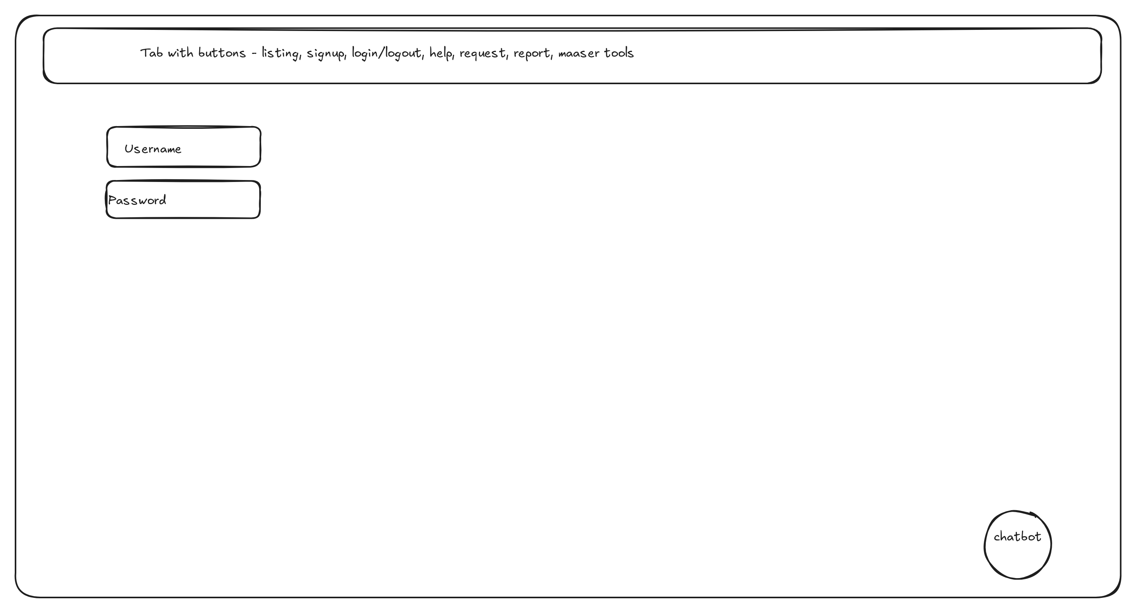

Signup
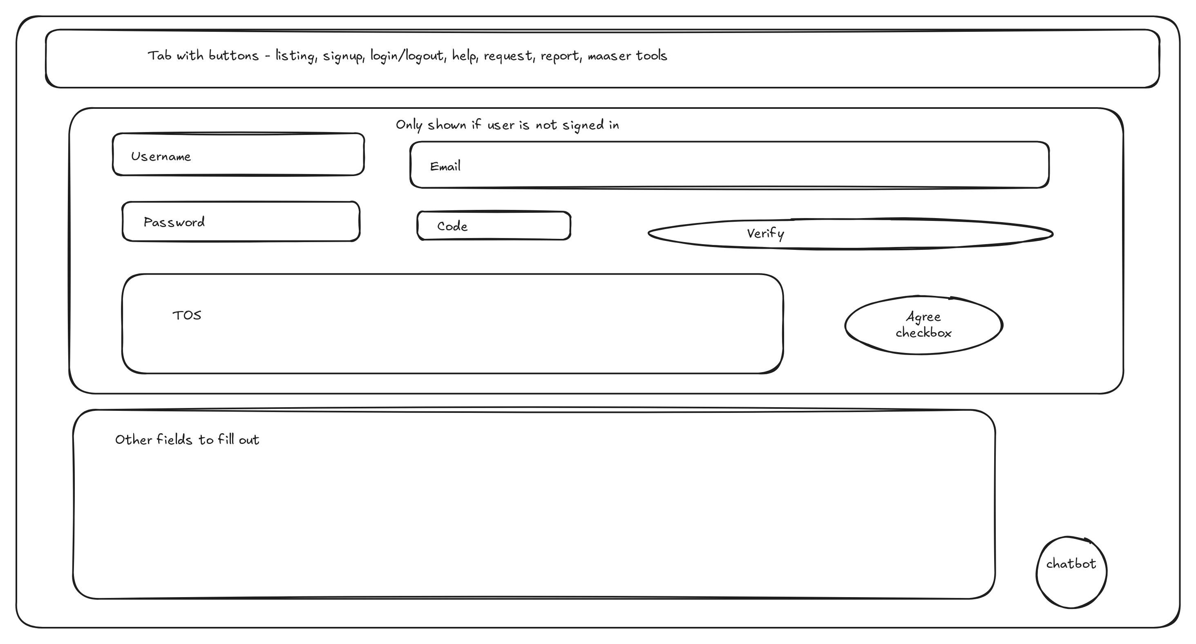

Signup chooser
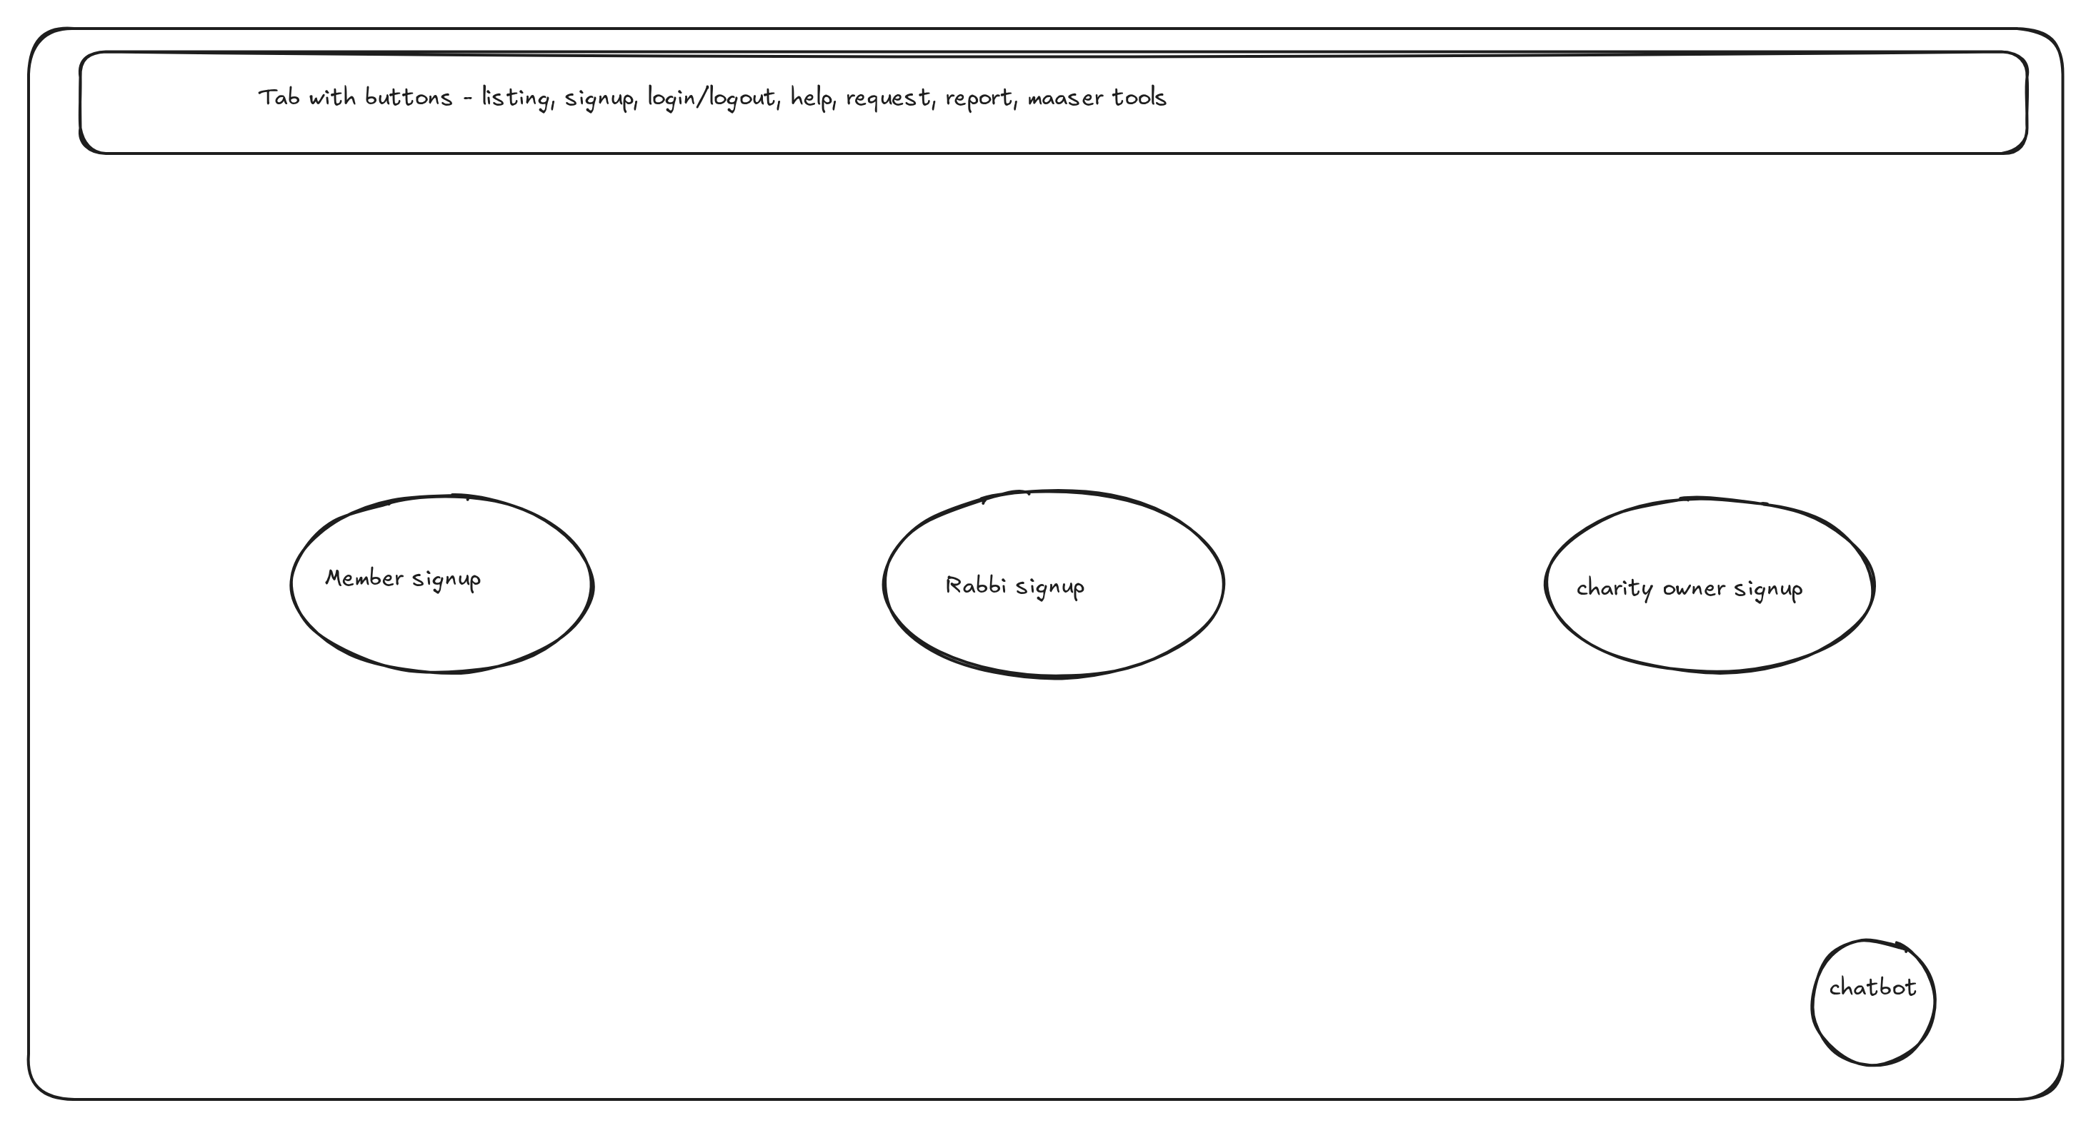

Dashboard chooser
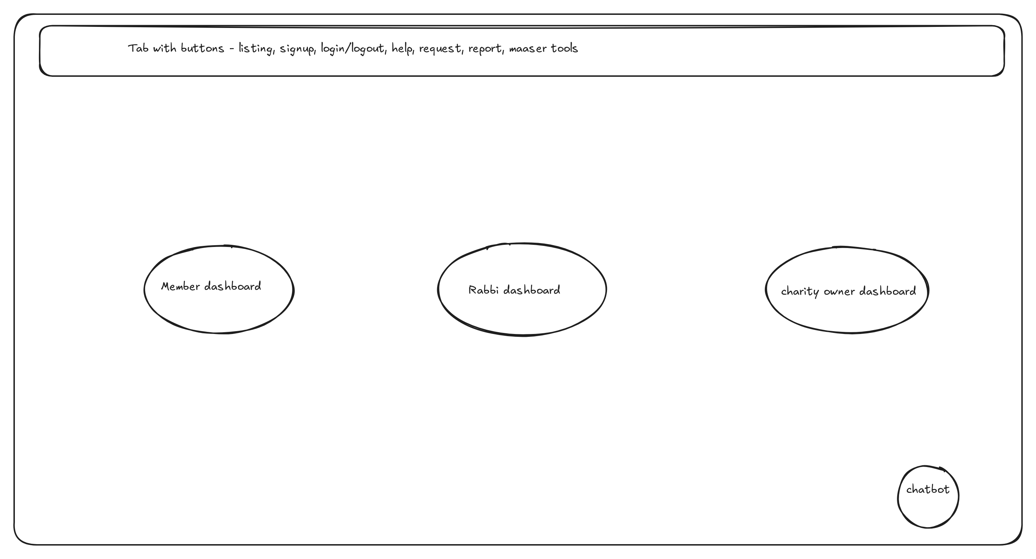

Charity listing
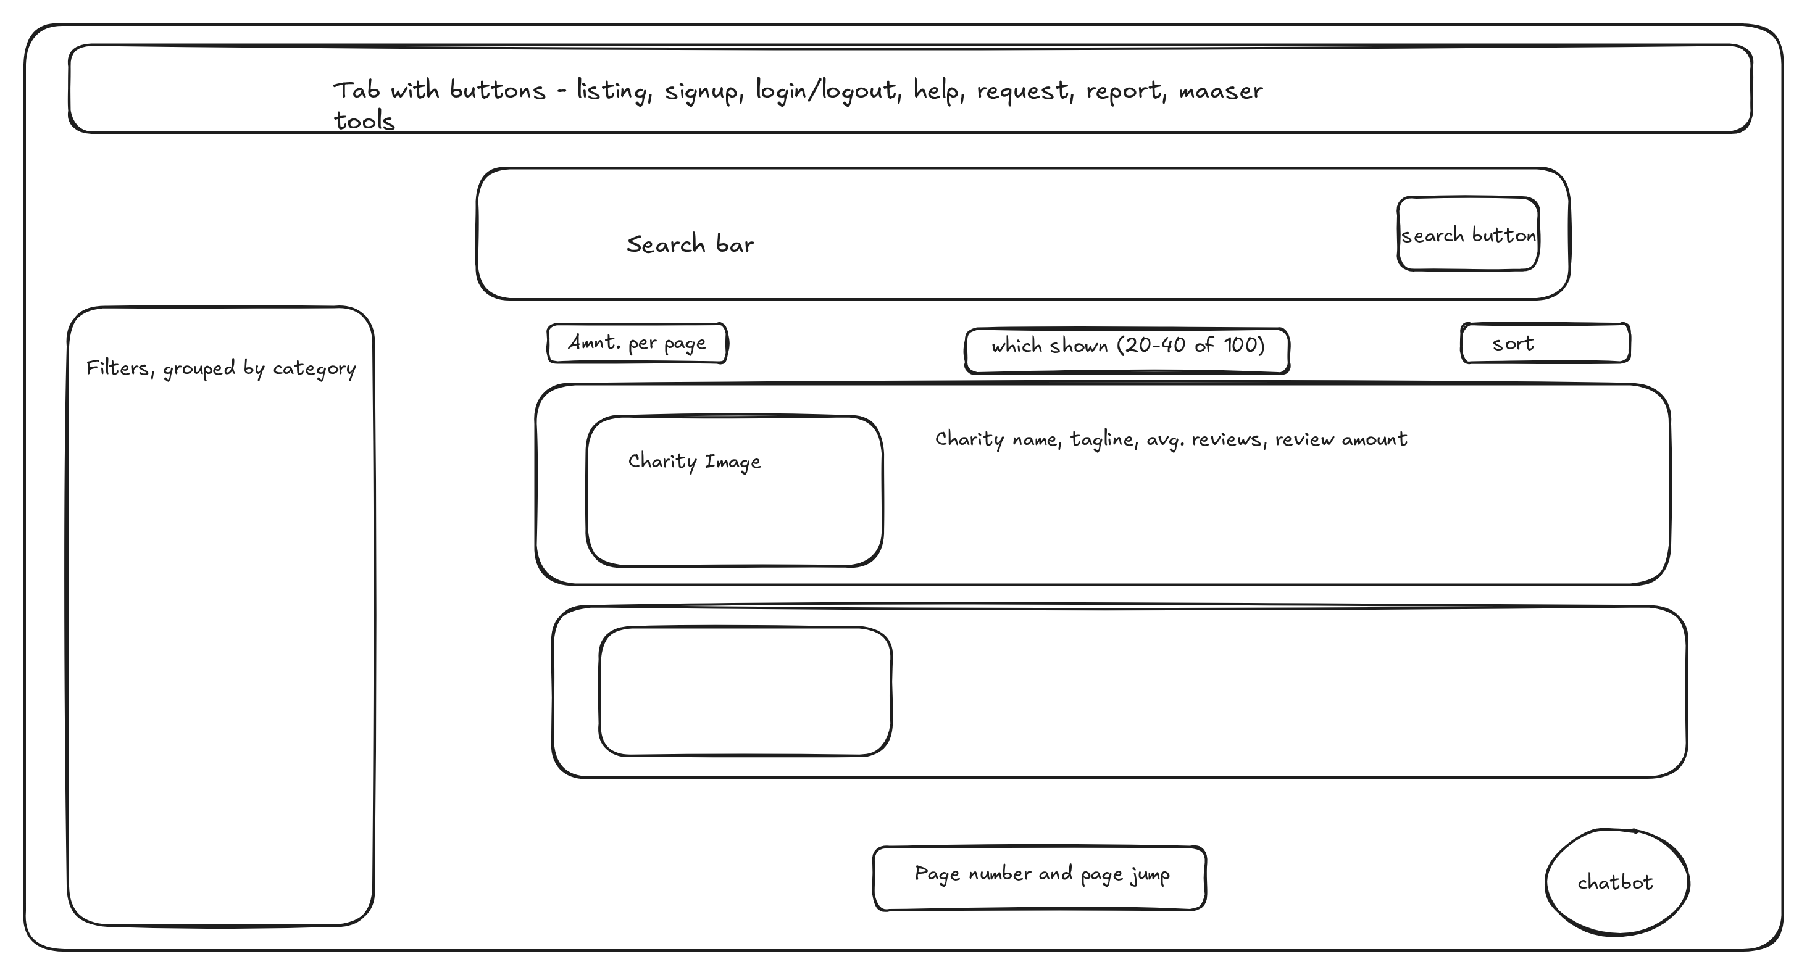

Charity page
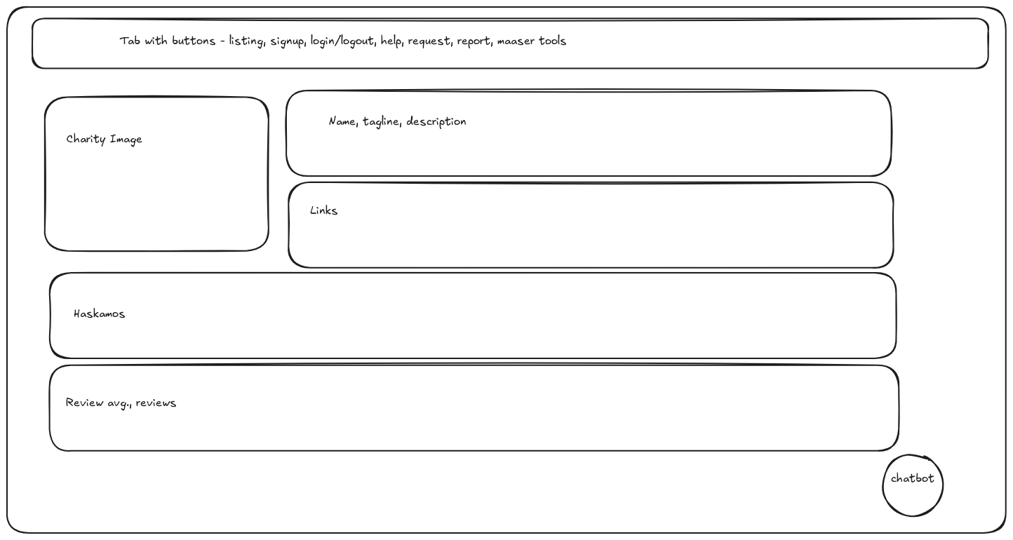

Member dashboard
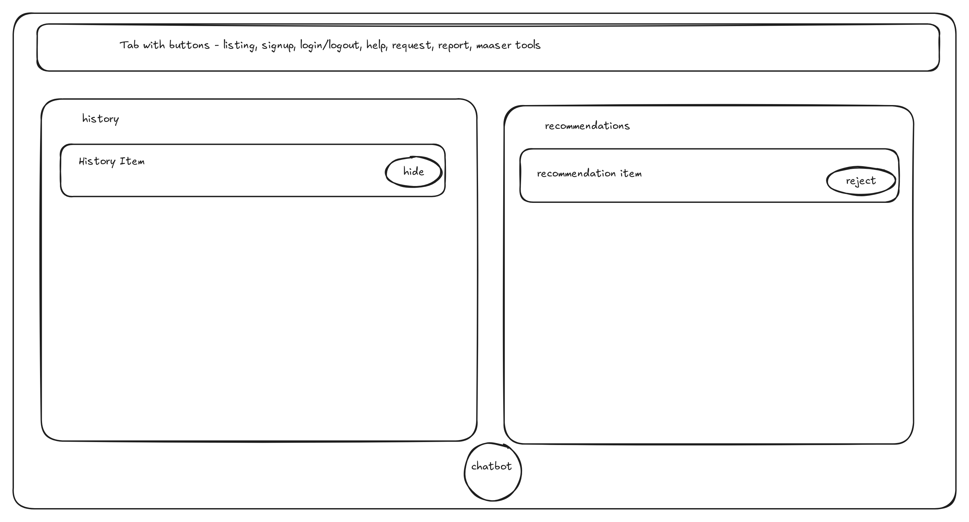

Charity owner dashboard
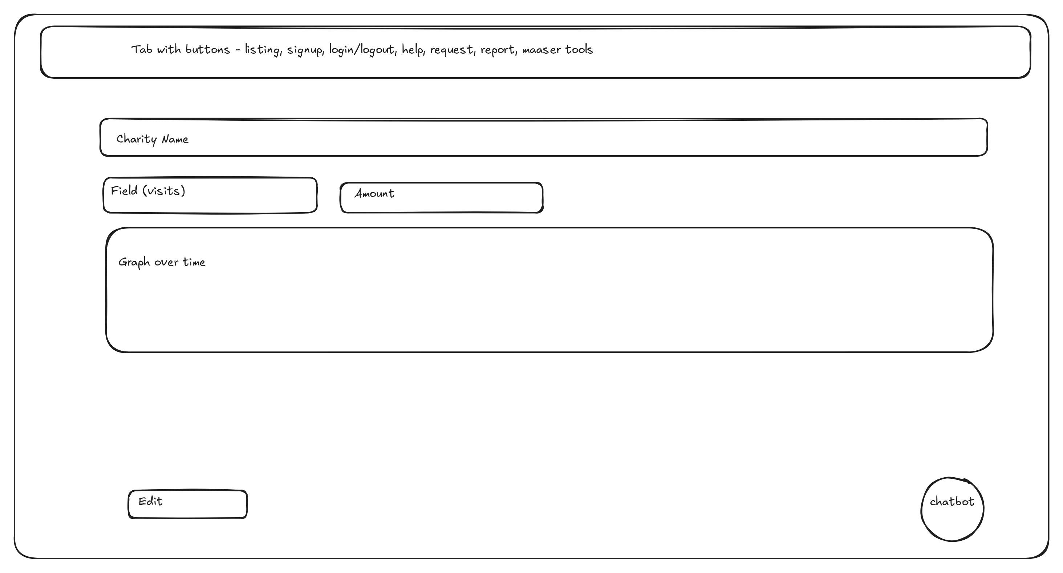

Admin approval queue
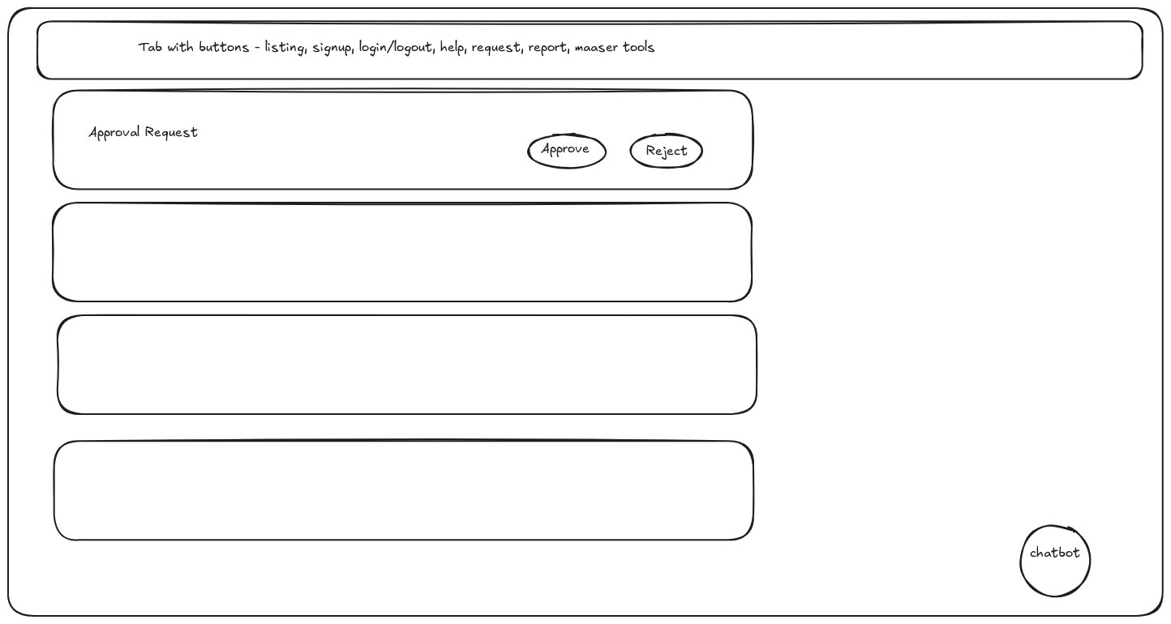

Admin ticket queue
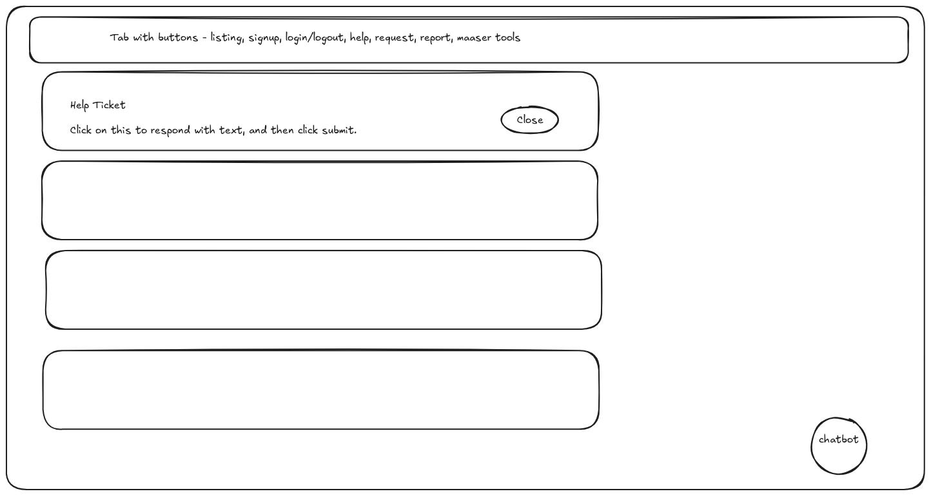

Charity request
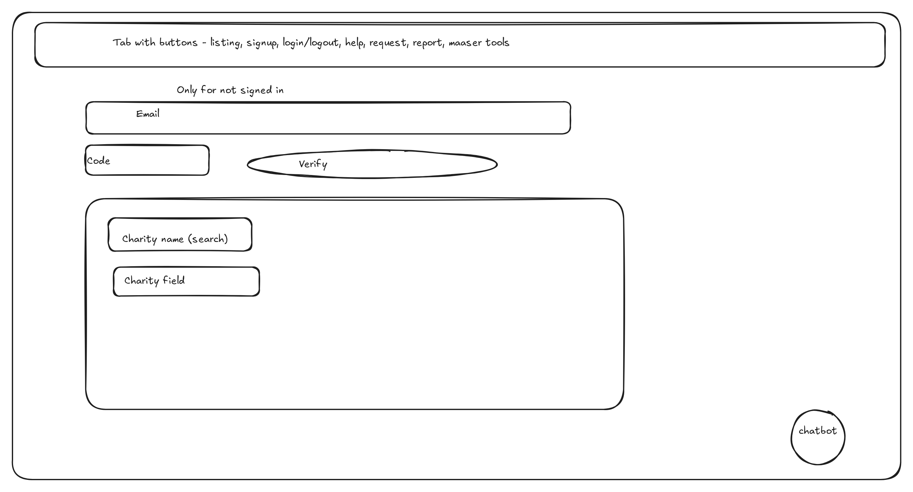

Help
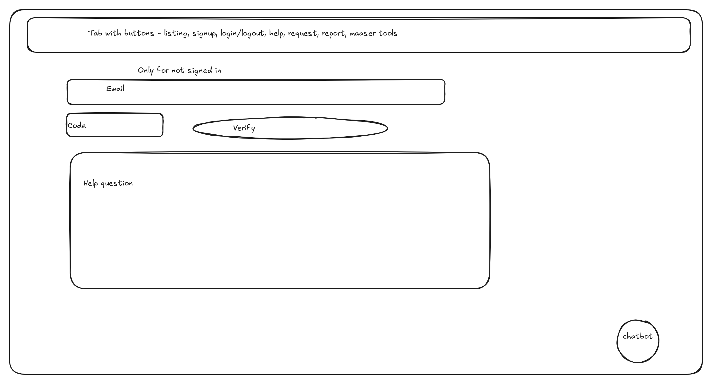

Report
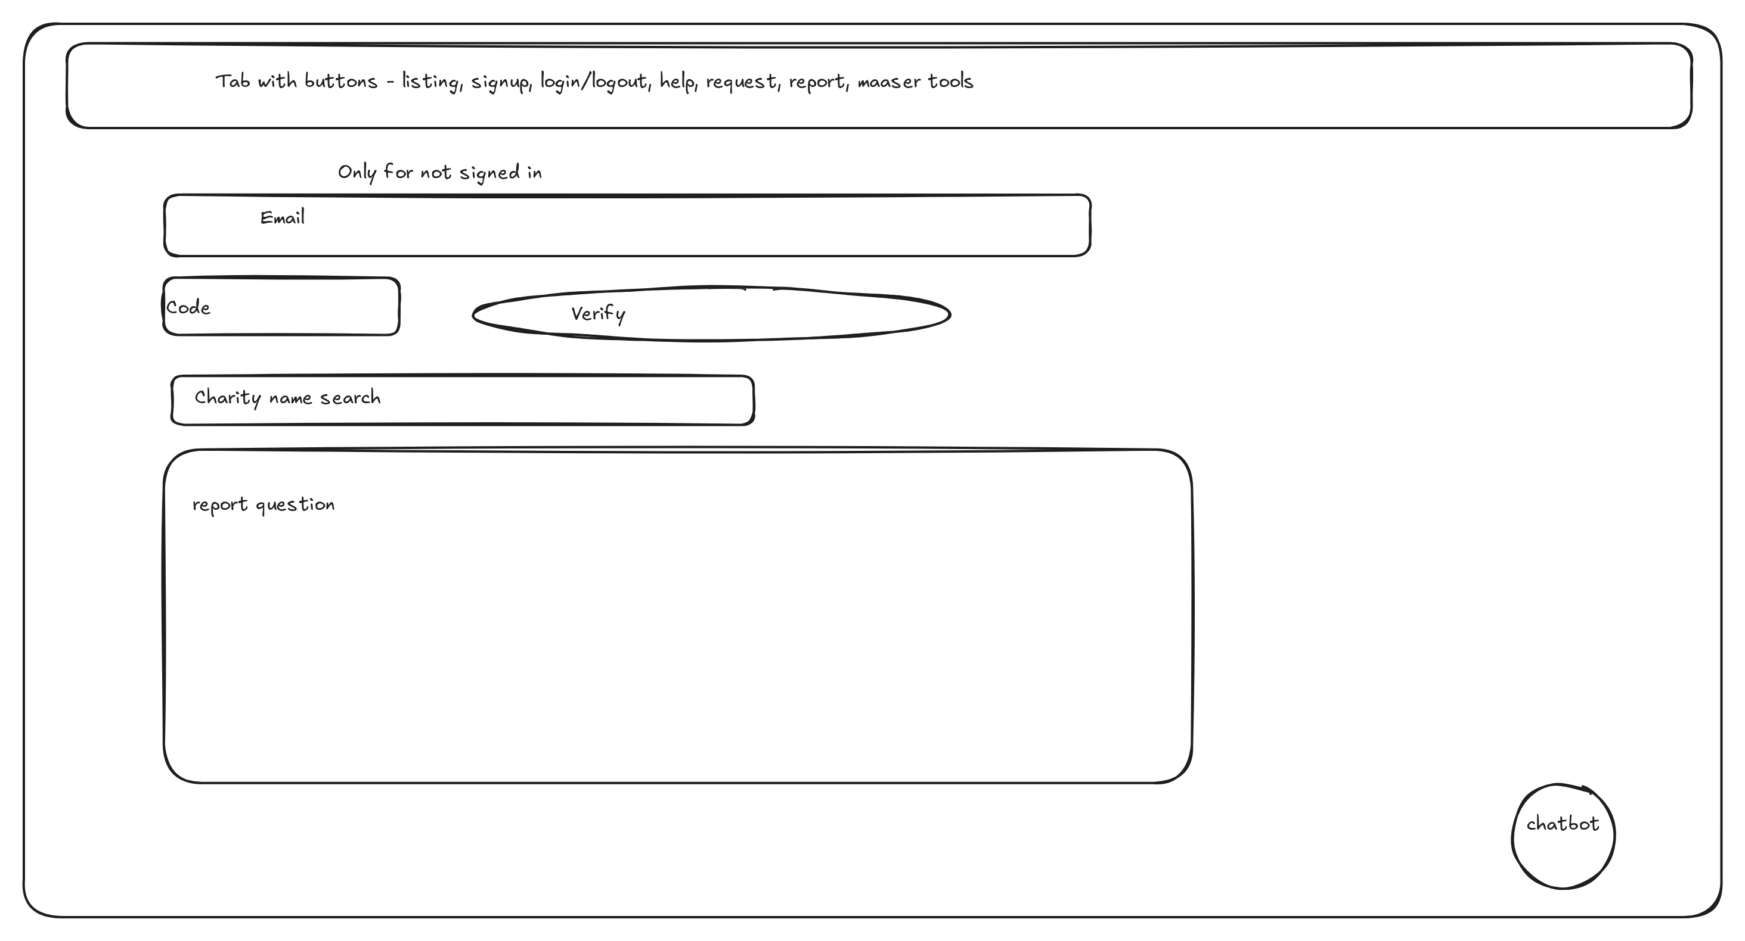

Wording and Tone Requirements
Charity -> Tzedaka
Bible -> Torah
These are examples, and more will likely come up.
(Orthodox Jewish terminology per SRS 3.2.1)

Use Cases
This section gives the actors and the detailed use cases for the tracer-bullet features.

Actors
- Guest — A guest is someone who uses MaaserMart without an account.
- Member — A member is someone who uses MaaserMart to find charities and manage their donations.
- Charity Owner — A charity owner is someone who uses MaaserMart to list their charity.
- Rabbi — A Rabbi is someone who gives haskamos to various charities on MaaserMart.
- Administrator — An sdnimistrator is someone who manages the MaaserMart system.
- Technical Supporter — A technical supporter is someonw who solves technical problems with the MaaserMart system.

List of Use Cases
- UC-01: Log in
- UC-02: Sign up (member, owner, rabbi)
- UC-03: Find a charity (list, filter, sort, search)
- UC-04: View a charity page
- UC-05: Write a review
- UC-06: Give a haskama
- UC-07: View member history
- UC-08: View recommendations
- UC-09: View charity owner stats
- UC-10: Administer approvals and queues
- UC-11: Request or add a charity
- UC-12: Edit a charity

UC-01 — Log in
This use case describes how a registered user signs in.

Field | Value
Use case name | Login
ID | UC-01
Priority | High
Primary actor | Any registered user (before they sign in)
Source | SRS 3.1.14 (Signup/Sign-in) and SRS 2.4 (User Classes)
Use case type | Business
Level | Detail
Interested Stakeholders | All registered users
Brief description | A page where users can log into their accounts
Goal | A logged in user - and only a logged in user - can reach the next page.
Success Measurement | The user's session is created and they arrive at the next page or their dashboard
Precondition | User has an account
Trigger | User clicks login, or attempts to reach a page which is only accessible to logged-in users.
Relationships | UC-02 (needs it first); leads to UC-06–UC-10 by role
Typical flow of events | 1. User opens the login page, or tries to open a page that requires login.  2. System shows the login form.  3. User enters username and password and submits.  4. System checks the credentials.  5. System creates the session and sends the user on: to ?next if there is one; otherwise to the dashboard, or to the dashboard chooser if the user has several roles.  Alternate:  3a. Credentials are wrong - system re-shows the form with an error, and the user may retry, up to five times.
Assumptions | The user remembers their username and password
Implementation Constraints | Uses Django's built-in authentication (django.contrib.auth). Must handle the ?next= parameter safely using Django's url_has_allowed_host_and_scheme

UC-02 — Sign up (member, owner, rabbi)
This use case describes how a guest creates an account and how an existing user adds a role.

Field | Value
Use case name | Signup
ID | UC-02
Priority | High
Primary actor | Guests
Source | SRS 3.1.14–3.1.16 and SRS 2.4 (User Classes)
Use case type | Business
Level | Detail
Interested Stakeholders | Guests, users who are signed in but want another role, admin (who approves)
Brief description | Allows guests to sign up for a role. Allows members of one role to sign up for other roles.
Goal | User's account is created (sometimes in a pending state)
Success Measurement | User's account exists on the DB, sometimes the account is added to the admin's pending queue
Precondition | The user has a functioning email address, and does not have an account associated with it.
Trigger | User clicks the signup button
Relationships | UC-01 (account it creates); leads to UC-06–UC-10 by role
Typical flow of events | 1. User clicks the signup button.  2. System shows the signup form.  3. User enters the details (username or email, and a password) and agrees to the terms and conditions.  4. System sends a confirmation email.  5. User opens the link in the email to confirm the address.  6. System creates the account and signs the user in, with information and a dashboard to view.  Alternates:  3a. If the user is already signed in and is adding another role, the details are filled in automatically and email confirmation is skipped.  6a. For a role that needs admin approval (owner or rabbi), the account is created in a pending state and added to the admin's pending queue; the user can sign in only after the admin approves.
Assumptions | Functioning email and internet access
Implementation Constraints | Celery and SQS for email sending. Verification code lives in Django session

UC-03 — Find a charity (list, filter, sort, search)
This use case describes how a user browses, filters, sorts, and searches the charity list.

Field | Value
Use case name | Charity Listing
ID | UC-03
Priority | High
Primary actor | Everyone
Source | SRS 3.1.1–3.1.4 and SRS 2.3.1 (Charity List)
Use case type | Business
Level | Detail
Interested Stakeholders | Everyone
Brief description | The page that lists all charities, enables you to sort, search, and filter.
Goal | The user can find the charity (or charities) he is looking for, in the order he wants.
Success Measurement | All published charities in the page the user requests, matching constraints given by the user are shown in the order the user requests.
Precondition | The DB contains matching charities.
Trigger | User navigates to listing page.
Relationships | UC-04 (each listed charity)
Typical flow of events | 1. User opens the charity listing page.  2. System shows all published charities (by default in no particular order).  3. User optionally picks filters (domain, location, haskamas, rating), a sort order (alphabetical, most visited, most recently updated, trending), and/or a search term; choices can be combined.  4. System returns the matching published charities in the requested order.  Alternate:  4a. No charity matches, so system shows a message saying there are no results.
Assumptions | User understands what each term means.
Implementation Constraints | Full page loads (so back works), everything is stored in URL parameters, checks only for published charities, uses Django's annotate, parameters are clamped, case-insensitive search.

UC-04 — View a charity page
This use case describes how a user views one charity page and how each role edits from it.

Field | Value
Use case name | Charity Page
ID | UC-04
Priority | High
Primary actor | Everyone
Source | SRS 3.1.8 and SRS 2.3.2 (Charity Page)
Use case type | Business
Level | Detail
Interested Stakeholders | Everyone
Brief description | The page that shows details about a charity.
Goal | User visits the page and can learn more about the charity, and see its links, reviews, and haskamos. Charity owners can update the page, Rabbis can leave haskamas, and members can write reviews.
Success Measurement | Page exists
Precondition | Charity exists and is published (approved by admin)
Trigger | User clicks on a charity in the listing.
Relationships | UC-03 (the listing it is reached from)
Typical flow of events | 1. User clicks on a charity in the main listing.  2. System shows the charity page: the description (including domain, location, and haskamas), the links (website, donate, contact), the reviews, and when it was last updated.  3. Depending on his role, the user can edit parts of the page: a charity owner can edit the description, name, tagline, links, image, domains, and location; a rabbi can add or edit his haskama; a member can add or edit his review.
Assumptions | The charity page is public: members and guests can read it without signing in.
Implementation Constraints | Server-rendered Django templates (DTL); only published charities are shown; edits by role are routed to UC-05, UC-06, and UC-12.

UC-05 — Write a review
This use case describes how a member writes or edits a review.

Field | Value
Use case name | Write
ID | UC-05
Priority | High
Primary actor | Member
Source | SRS 3.1.9 and SRS 2.3.2 (Charity Page)
Use case type | Business
Level | Detail
Interested Stakeholders | Member, everyone (can read)
Brief description | Users can leave reviews and ratings on a charity. Member submits a rating and review of a charity. Those can be seen by everyone.
Goal | User can show their feelings towards a charity
Success Measurement | The review posted is in the review table and is shown properly and incorporated into avg. and review numbers.
Precondition | User is signed in as a member.
Trigger | User clicks add
Relationships | UC-04 (the charity page it is written on)
Typical flow of events | 1. User visits a charity page.  2. If he is a member, he clicks to write a review.  3. He gives a rating (required) and may write text.  4. He submits.  5. The review is shown on the charity page.  Alternates:  2a. If he is not a member, he can read reviews but cannot write one.  2b. If he has already written a review, clicking to add lets him edit that one instead of writing a second.
Assumptions | User will leave appropriate reviews.
Implementation Constraints | A rating is required; one review per member per charity; stored in REVIEW; the charity's average rating and review count are recomputed.

UC-06 — Give a haskama
This use case describes how a rabbi gives or changes a haskama.

Field | Value
Use case name | Haskama
ID | UC-06
Priority | High
Primary actor | Rabbi (read by everyone)
Source | SRS 3.1.13 and SRS 2.3.6 (Haskama Page)
Use case type | Business
Level | Detail
Interested Stakeholders | Everyone
Brief description | Rabbis leave haskamos, with a rating and details, about charities.
Goal | Rabbi can express approval or disapproval.
Success Measurement | Rabbi's haskama is in the DB and displayed on the charity and can be filtered.
Precondition | User is a Rabbi, approved by admin.
Trigger | Rabbi clicks add haskama on the charity page.
Relationships | UC-04 (charity page); UC-01, UC-02 (account and role)
Typical flow of events | 1. Rabbi clicks to add a haskama on the charity page.  2. He fills in approve or disapprove, and optionally how important (1–10) and a text message.  3. He submits.  4. The haskama is stored, shown on the charity page, and can be filtered by.  Alternate:  1a. If he has already written one, clicking to add lets him change the existing haskama instead of writing a second.
Assumptions | Rabbis will not be afraid to express their opinion.
Implementation Constraints | Haskama importance is 1–10 (SRS 2.3.6); stored in HASKAMA; one haskama per rabbi per charity, editable in place.

UC-07 — View member history
This use case describes how a member views and edits his history.

Field | Value
Use case name | History
ID | UC-07
Priority | High
Primary actor | Member
Source | SRS 3.1.5–3.1.6 and SRS 2.3.3 (Member Page)
Use case type | Business
Level | Detail
Interested Stakeholders | Members
Brief description | Shows members a list of pages they visited and links they clicked, each with the option to hide.
Goal | Member can view (and hide) their history.
Success Measurement | Events are logged in the DB, they are shown to user and user can hide them.
Precondition | Member is signed in
Trigger | Member visits dashboard.
Relationships | UC-04 (visited pages); UC-01, UC-02 (account)
Typical flow of events | 1. Member goes to his dashboard.  2. System shows his history: the charities he has visited and the links he has clicked.  3. Member can hide entries from the history, or clear it all.
Assumptions | The amount of history events will not be too overwhelming.
Implementation Constraints | History is read from the EVENT table (view and link_click actions); entries can be hidden (hidden_by_user) or cleared.

UC-08 — View recommendations
This use case describes how a member views and rejects recommendations.

Field | Value
Use case name | Recommendations
ID | UC-08
Priority | High
Primary actor | Member
Source | SRS 3.1.7 and SRS 2.3.3 (Member Page)
Use case type | Business
Level | Detail
Interested Stakeholders | Member
Brief description | Member can see and reject recommendations, ranked by how good they are
Goal | User sees charities he may want to visit.
Success Measurement | There is a strong overlap between history, and its domains and locations, and recommendations.
Precondition | User is signed in as a member and has a populated history
Trigger | Member goes to his dashboard
Relationships | UC-04 (recommended charities); UC-01, UC-02 (account); UC-07 (history)
Typical flow of events | 1. Member goes to his dashboard.  2. System shows recommended charities drawn from his history (visits and past rejections).  3. Member can reject a recommendation, which removes it from the list.  4. A rejected recommendation is never shown again.
Assumptions | Our algorithm will predict charities the user will want.
Implementation Constraints | Recommendations are computed from EVENT visits and past rejections; a rejected recommendation is excluded permanently.

UC-09 — View charity owner stats
This use case describes how an owner views statistics for his charities.

Field | Value
Use case name | Owner stats
ID | UC-09
Priority | Medium
Primary actor | Owner, fueled by actions by members and guests
Source | SRS 3.1.10 and SRS 2.3.4 (Charity Owner Page)
Use case type | Business
Level | Detail
Interested Stakeholders | Charity Owner
Brief description | A place where the owner can see stats for each charity, or all charities he owns.
Goal | Owner can see statistics for his charities.
Success Measurement | Events are stored and can be aggregated per user and per charity.
Precondition | User is a charity owner.
Trigger | User goes to charity owner dashboard
Relationships | UC-04 (charity pages); UC-01, UC-02 (account)
Typical flow of events | 1. Owner goes to the charity owner dashboard.  2. If he owns several charities, system shows an overview, and he clicks the button for the charity he wants.  3. System shows that charity's dashboard: page views and link clicks (numbers only, with no individual attribution), plus its reviews and haskamas.
Assumptions | Charity Owner cares to see these stats
Implementation Constraints | Stats are aggregated per charity from EVENT; only aggregate counts are shown, never individual attributions.

UC-10 — Administer approvals and queues
This use case describes how an admin works the approval and ticket queues.

Field | Value
Use case name | Admin
ID | UC-10
Priority | High
Primary actor | Admin
Source | SRS 3.1.12 and SRS 2.3.5 (Administration Page); approvals in 3.1.15–3.1.16
Use case type | Business
Level | Detail
Interested Stakeholders | Admin, everyone who needs to request or ask help
Brief description | A place where admin can see and change everything in the DBs, and a custom view to see the ticket queue and approval queue.
Goal | Admin sees the queues, sees the whole system, and can reply to items in the queue and change anything.
Success Measurement | Admin can do everything.
Precondition | Admin is a Django admin. There are items in the queues.
Trigger | Admin goes to his dashboard.
Relationships | UC-03, UC-04 (items it approves)
Typical flow of events | 1. Users submit to the approval queue or the ticket queue.  2. Admin navigates to his dashboard and clicks the link to one of these queues.  3. Admin responds to that item.  4. If it is a user request or a charity owner request, the user is accepted.  5. An email goes to the person who sent it.
Assumptions | The admin is a trusted operator of the site.
Implementation Constraints | Django admin for bulk changes plus a custom view for the ticket and approval queues; each decision emails the submitter (SES).

UC-11 — Request or add a charity
This use case describes how a user requests that a charity be added.

Field | Value
Use case name | Charity Addition
ID | UC-11
Priority | Medium
Primary actor | Everyone
Source | SRS 3.1.17 and SRS 2.3.9 (Help pages)
Use case type | Business
Level | Detail
Interested Stakeholders | Everyone
Brief description | User submits a charity to be added to the charity list.
Goal | Charity the user submitted is sent to the admin to approve.
Success Measurement | Addition is made in approval queue for the charity.
Precondition | None.
Trigger | User clicks the request charity button and submits details,
Relationships | UC-10 (approval queue); UC-03, UC-04 (existing charities)
Typical flow of events | 1. User clicks the request charity button.  2. User enters the name (and optionally details) of the charity.  3. System checks whether a charity with the same name already exists.  4. If one does, system warns the user, and he confirms he still wants to add it.  5. User submits, and the request goes to the admin's approval queue.  6. The admin approves, and the charity is added to the charity listing.  Alternate:  6a. If the admin rejects it, the charity is not added.
Assumptions | People will care to add charities.
Implementation Constraints | Duplicate names are checked case-insensitively and produce a warning, not a block; requests are stored as pending additions in the approval queue.

UC-12 — Edit a charity
This use case describes how a charity owner edits a charity, subject to admin approval.

Field | Value
Use case name | Charity Edit
ID | UC-12
Priority | High
Primary actor | Charity Owner
Source | SRS 2.3.4 (Charity Owner Page) and SRS 3.1.12 (Administrator Dashboard)
Use case type | Business
Level | Detail
Interested Stakeholders | Everyone
Brief description | A way for charity owners to edit details about their charities.
Goal | Charity owner can edit charity and get it on the approval queue.
Success Measurement | The edit is placed in the approval queue.
Precondition | Person editing is a charity owner.
Trigger | Charity owner navigates to charity page, edits, and submits.
Relationships | UC-04 (the charity page); UC-10 (approval queue)
Typical flow of events | 1. Charity owner goes to the charity page.  2. He edits the fields he wants.  3. When he is done editing all the fields, he submits.  4. The changes go to the admin's approval queue.  5. The admin accepts or rejects the change.  6. The charity owner receives an email with the decision.
Assumptions | Charity owners will keep their charities updated.
Implementation Constraints | Owner edits are stored as an EDIT_REQUEST and applied only after admin approval; the owner is emailed on the decision.

Open Questions
This section lists the questions that remain open for further analysis.
- Recommendation thresholds, and how many recommendations to show.
- The scope of the chatbot.
- Whether scheduled income and donation entry is supported.
- Whether a charity owner's identity is verified (for example, by ID).
- Currency handling.
- The policy for verified versus unverified charities (if we institute a more formal verification method).

Build / Buy List
This section lists the components of MaaserMart as built or bought; the reason for each decision is given in full with the relevant choice in the Architecture section.

Built
These components are written by the team.

Component | Why we build it
Django application (the nine modules: accounts, charities, events, tools, approvals, support, chatbot, recommendations, dashboards) | This is the product itself; it is our own logic, and no off-the-shelf equivalent exists.
Custom admin queues view (approvals and tickets) | Tailored to our approval and help workflow, built on top of the Django admin.
Templates (DTL) and HTMX / Alpine interactions | Thin, server-rendered pages; a separate front-end framework is not worth the build step.

Bought or Rented
These components are paid for; every bought component is listed here.

Component | Why we buy it
AWS RDS (PostgreSQL) | Required by the design constraint (SRS 2.7); managed hosting means we do not run our own database.
AWS SQS | Managed queue for background work (email and chatbot); its free tier is more than enough.
AWS SES | Cheap, widely used email sender that scales; the free tiers of Postmark, Mailgun, and SendGrid are not sufficient.
Host instance (always-on server) | The monolith deployment shape needs one always-on host; for now this is the developers' laptop (no cost), and the same instance also runs Caddy, Gunicorn, and Celery.
Domain name | A public web address is required; costs about $10.49 a year (SRS 1.6).
Chatbot AI API (third party) | Supplies the chatbot's answers; an external dependency (SRS 2.6). The chatbot and this API are left out of the component diagrams.

Open-Source (used, not bought)
These components are free and open-source, so they are used rather than bought.

Component | Why we use it
Django | Chosen framework: batteries included, stable, and fast to build with.
PostgreSQL | Chosen database: fits Django's ORM and has transactional DDL.
Caddy | Web server and static-file server: simple syntax and automatic HTTPS.
Gunicorn | WSGI application server demonstrated in Django's deployment docs.
Celery | Consumes the SQS queue and performs the background work.
HTMX + Alpine.js | Mature, lightweight interactivity without a build step.

