Protein Surface Models for New Generation Cell Simulation
COMP 4905 Honours Project

Carleton University
Alex Gawronski
Dr. Michel Dumontier
School of Computer Science
August 14, 2009
Abstract:

The purpose of the project was to create molecular surface models of all the proteins in the Protein Data Bank (PDB) to be used in the Next Generation Cell Simulation (NGCS) framework. The models require a representation of the surface geometric mesh, electrostatic potential values and locations of ligand binding sites. Also the output of the procedure must be in a standard semantic web format.
The protein ids were retrieved from the Protein Data Bank using a PHP script. The PDB files were downloaded by the molecular visualization tool Chimera using these ids. The geometric mesh models were created using the MSMS method and exported in X3D format. The electrostatic potential values were generated by DelPhi with a modified structure produced by Dock Prep. The ligand pockets were discovered using python code and Chimera commands. Finally the output was captured in Notation 3 files.
Testing revealed no errors and a low running time. The meshes provided were sufficiently detailed for NGCS. The electrostatic potential values reflect those generated by other researchers. Ligand pockets were effectively annotated in complex protein structures with multiple types and instances of ligands. This procedure produced models suitable for use in the NGCS project.

Acknowledgements:

I would like the thank my supervisor, Dr. Michel Dumontier, project leader Leo Chepelev and Mykola Konyk for all there input throughout the project. Their knowledge on the subject matter was paramount to the success of the project.
I would also like to thank the developers of Chimera for creating a very useful and easy to use tool for molecular analysis. Special thanks goes to Elaine Meng and Eric Pettersen who patiently answered all my questions and promptly fixed Chimera bugs.
I would also like to express my appreciation for Jose Cruz-Toledo's help in obtaining protein ids from the protein data bank.
Finally thanks to the developers of DelPhi, Dock 6 and MSMS for providing such great free tools for use in molecular analysis.

Table of Contents
1.Introduction: 8
2.Background: 9
3.Implementation: 15
3.1 Preliminary Script: 15
3.2 Molecular Surface Meshes: 15
3.3 Electrostatic Potential; 21
3.4 Ligand Pockets: 25
3.5 Adding the Model to a Triplestore: 27
4.Results 29
5.Discussion 31
5.1 Applications 31
5.2 Future Work 32
6.Conclusion 34

List of Figures
FIGURE 1: Illustration of the solvent excluded/accessible surfaces created through the MSMS method 9
FIGURE 2: Example of surface normal 10
FIGURE 3: Triangulation procedure for algorithm 2 of MSMS 18
FIGURE 4: Illustration of rolling procedure to fill gaps in the SES 18
FIGURE 5: An example of a radial singularity and how it is resolved. 19
FIGURE 6: Excerpt from used charge and radii files 21
FIGURE7: Current N3 file structure 26
FIGURE8: Polygon mesh of 1YTI generated from project script. 27
FIGURE9: Comparison of electrostatic coloring of 12GS, from obtained data. 28
FIGURE10: Comparison of electrostatic colouring of 1MYK, from obtained data. 28
FIGURE11: Ligand pocket of Raloxifene from estrogen receptor protein. 29
FIGURE12: Ligand pocket of sulfate from estrogen receptor protein. 29

List of Tables
TABLE 1: Comparison of molecular visualization tools based on export mesh format support 17
TABLE 2: DelPhi parameter descriptions and chosen values. 22

Introduction:
Amino acids are the building blocks of life. 20 standard amino acids exist, which can be bound together through peptide bonds into chains called polypeptides. These polypeptides can fold onto themselves into a wide variety of shapes and can join with other polypeptides to form the final structure. This final structure is called a protein. Proteins can be used to build cellular components or act as enzymes for biological processes. Regardless of purpose, the shape of the protein is directly related to it's function [Horton et al., 2006]. An important part of this structure is the area accessible to other molecules, which is the molecular surface.
Considering this, having an accurate model of the molecular surface is essential for simulating cellular functions. These models are important for a variety of different levels that cell simulation tools try to model. At the lowest level there is molecular dynamics simulations. At this level the simulation models consider all the electrostatic energies on the protein surface to determine if it will interact with another protein or molecule [Allen, 2004]. Mid-level simulations have all reactions predefined and therefore not relying on surface electrostatics within the simulation. However the orientation often is important at this level requiring structural features, such as binding sites, to be mapped to a location on the surface. Furthermore the size an shape may be considered when moving particles in the simulation. At the highest level, shape and orientation are not considered. However a surface mesh may be used for visualization purposes. The New Generation Cell Simulator (NGCS) will be a framework that will support any level of simulation. Therefore a molecular surface model containing all this information would be required.
This project is focused around the creation of these models for all the protein structures in the Protein Data Bank (PDB). These protein structures are derived from X-ray crystallography or nuclear magnetic resonance (NMR) spectroscopy experiments. These experiments discover the locations of all the atoms in all amino acids that make up a protein. They also may include information about complexed ligands. From this data all the required information for the molecular surface models can be retrieved or derived. These models will be significant addition to the NGCS project which will increase the level of accuracy and visual appeal of the simulations.

Background:
The protein model created in this project is made up of three major components. These are the molecular surface mesh, the electrostatic charges and the ligand pockets. Furthermore this project also includes creating a semantic web standard format file that can be included in a triplestore database.
A variety of tools were used to accomplish these tasks. There are many available tools for doing this kind of molecular surface analysis. The most useful tools are ones which combine a variety of smaller tools and make them available from a single interface. The most popular instances of such tools are PyMol, Visual Molecular Dynamics (VMD) and Chimera. They all allow the user to visualize and modify molecular structures. Furthermore they provide a wide range of analysis tools. Only a subset of these tools were used in this project centred around electrostatic, molecule repair and identifying structures. They will be explored in detail in the following paragraphs.
Molecular surface meshes are graphical representations of van der Waals surface. The van der Waals surface is determined by finding the topological boundary of the set of spheres around all the atoms in a molecule. This is then smoothed by finding the solvent excluded surface (SES) of the molecule. This is done using a solvent probe with a given radius that is passed over the van der Waals surface. The border of the area that this probe can reach is the SES as seen in fig. 1 [Sanner et al., 1996] . From this data a graphical surface can be created. Visualizations programs initiate this process by importing data of the molecule structure, usually a PDB file. They then run algorithms to calculate the SES and create a model to represent the surface. This model varies between tools but in most cases includes a series of vertices and faces. This model is then rendered and displayed to the user.
A molecular surface mesh is simply a variation of surface model where the surface is described by vertices, edges and geometric shapes, usually triangles, called a polygon mesh. There are many variations of polygon meshes each with advantages and disadvantages. Generally they can be placed in three groups: vertex-face, quad-edge, vertex-vertex, and winged-edge. The simplest is vertex-face, which is just a list of vertices and a list of faces. These types of formats are easy to work with but are the most costly in terms of performance. Quad-edge formats contain only vertices with four edges per vertex with no information about faces. Faces are derived implicitly from the vertices and edges. This approach reduces file size and memory usage. Vertex-vertex mesh only have information about vertices and all other data is derived from them. This reduces the amount of data stored but is more difficult to work with since determining faces from vertices is not a trivial task. However this format allows for efficient transformations to mesh [Smith, 2006]. The final format, winged-edge, includes data about vertices, edges and faces. This has the highest memory and storage requirement but allows for constant-time traversal of the surface represented by the mesh [Baumgart, 1975].
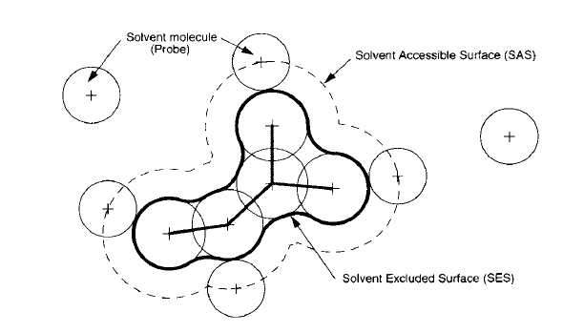FIGURE 1: Illustration of the solvent excluded/accessible surfaces created through the MSMS method
The majority of mesh formats used in molecular modelling are vertex-face mesh formats. The commonly used formats include WaveFront (OBJ), stereolithography (STL), Virtual Reality Modelling Language (VRML) and X3D formats. They vary in two ways, how the data is structured and what additional data is held in the format. OBJ and STL are basic lists while VRML and X3D have hierarchical structures, with X3D having a Extensible Markup Language (XML) style structure. The VRML and X3D formats hold additional information on textures and colouring, while OBJ refers to a separate file and STL lacks additional information entirely. Many mesh formats, including all four mentioned here, also include vertex normals which are normalized averages of the faces` surface normals. Surface normals are vectors perpendicular to the surface as shown in figure 2. These values are used in shading and lighting
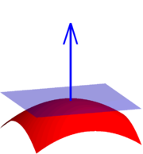FIGURE 2: Example of surface normal
models. Furthermore these mesh formats often have binary versions as well as the normal ASCII versions, which are useful in reducing file size. Molecular visualization tools almost always export to at least one of these formats. Once the data is exported it can be made available to rendering programs, or in the case of this project, the NGCS framework.
The next part of the molecular surface model is the annotation of electrostatic potential values. Electrostatic potential is the negative or positive potential energy at a given point. They are associated with a static electric field generally measured in kT/e, where k = Boltzmann's constant, T = temperature and e = elementary charge [Parsegian and Gingell, 1972]. In the case of molecular surfaces, the electrostatic potential is the energy at the SES derived from the partial atomic charges.
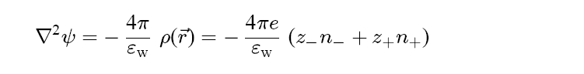 EQUATION 1
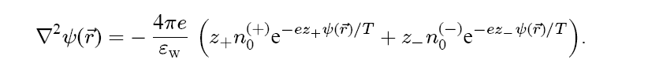 EQUATION 3
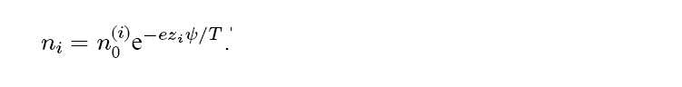 EQUATION 2
The accepted method for calculating these values is using the Poisson-Boltzmann method. The formula is derived from the Poisson equation, Eq. (1), which models the relation between the electric potential (ψ) and the charge distribution (ρ) considering the dielectric
constant of the solvent, water (εw). However the ions in solution are mobile and adjust to the electrostatic potential making this equation insufficient. The ion density fits the Boltzmann distribution depending on the electrostatic potential and ion entropy (T) as seen in Eq. (2). This can be factored into the charge distribution in the Poisson equation, forming the complete Poisson-Boltzmann equation Eq.(3) [Andelman, 1995].
There are two major tools, called Poisson-Boltzmann solvers, for calculating electrostatic potential: Adaptive Poisson-Boltzmann Solver (APBS) and DelPhi. Both tools use numerical analysis to approximate a solution to the Poisson-Boltzmann equation. APBS uses box methods, inexact Newton methods, and algebraic multilevel method while DelPhi uses the Finite difference method. Explanations of these methods are outside the scope of this project. Both tools have similar input parameters. They allow the user to specify the interior/exterior dielectric constants that determine how electric fields behave within a substance. They also allow customization of the solvent salt concentration and ion radii. The tools differ in the way force fields, the potential energy, are determined. APBS needs the force field to be calculated beforehand, generally using Assisted Model Building with Energy Refinement (AMBER). DelPhi derives the same data from the input parameter files, which include a list of partial charges and atomic radii. Every major molecular visualization tool contains some connection to one of these tools or a different Poisson-Boltzmann Solver. The output data is then integrated into the tools internal model, often as volumetric data. This data can then be used for docking or colouring surfaces by electrostatic potential.
The final part of the model is the ligand pockets. A ligand is any substance that binds with a biomolecule to form a complex. For example, in the complex of an enzyme with an inhibitor, the inhibitor would be a ligand. Ligands bind to electrostatically charged region on a protein called an binding site. A binding site is often shaped like the ligand that it binds with, often forming a “pocket” shape. Identifying these binding sites is very important to scientist who use this information to design pharmaceutical drugs and to better understand how proteins function. The process involved with drug design is called “docking” where many different molecules are tested to see if they can bind to a ligand pocket of the target protein [An et al., 2005].
The finished models are stored in the Bio2RDF triplestore database. A triplestore database is a database that holds large numbers of “triples” rather than tables. Triples are made up of three parts: subject, predicate and object. For example, consider the statement “Bob is a Person”. “Bob” would be the subject, “is a” would be the predicate and “Person” would be the object. The standard format for triplestores is the Resource Description Framework (RDF) and various equivalent formats. In this framework all components of the triple are either a Uniform Resource Identifier (URI) or a string literal. The URI is a reference to some namespace within an ontology that defines the class being used. The entire model could be visualized as a directed graph where the nodes are the subjects and objects and the edges are the predicates. This model is an important part of the semantic web project. The semantic web vision is to give meaning to all data available on the web to make it machine-readable [Antoniou and Van Harmelen, 2004]. This is a powerful concept that may revolutionize the way we use the web.

Implementation:
The components of the project were implemented in the order they were introduce in the previous segment. This section will go into detail of how each of these components were implemented.

3.1 Preliminary Script:
Before the surface models can be built there is some necessary preparation that must be done. This includes retrieving all the four-character protein ids from the PDB, parsing these ids, and running the visualization program. The first step of obtaining the PDB ids was accomplished using a short Hypertext Preprocessor (PHP) script. The parameters of this script are boolean flags for which types of structures to obtain from the PDB: protein, DNA, RNA or hybrid. This is useful even though the scope of this project is only proteins, it may be extended to include all structures. When the script runs it creates an XML query which is then sent to http://www.rcsb.org/pdb/rest/search. When the results return they are echoed, which can then be piped to a file. In the case of this project this is a file of all the protein ids. This file is then parsed using a simple Linux script which runs each protein id as a argument for the visualization program. The actual PDB file is then downloaded by the program.

3.2 Molecular Surface Meshes:
Before generating meshes some decisions had to be made. This includes deciding which tool to use and which file format to export to. All of the three major molecular visualization
tools, VMD, PyMol and Chimera, have their advantages and disadvantages. When deciding which of these tools to use, three main factors were considered: the ability to export to usable formats, an easy to work with command line interface and an interface with Poisson-Boltzmann solvers.
When the export formats of the tools were investigated, VMD was found to support the most formats (table 1). However it was decided that the best format to use was X3D, which was only supported by Chimera. The reason for this was that in the early stages of the project, the ability to store colour and texture data while having easy vertex parsing was the most important factor for mesh format. The colouring was important since the original idea was to derive electrostatic potential values from colouring. This was abandoned when more was known about the Chimera surface model. X3D supports storing colour and texture, while OBJ and STL do not. The X3D format also contains a simple list of vertices, faces and normals which VRML does not. Other formats are not as well supported and therefore not seriously considered. So in this regard, Chimera was the best choice.

TABLE 1: Comparison of molecular visualization tools based on export mesh format support
Format | VMD | Chimera | PyMol
VRML-1/2* | x | x | x
Wavefront (obj)* | x | x | x
x3D* |  | x
STL* | x |  | x
tachyoninternal | x
tachyon | x
RenderMan | x | x
Gelato | x
ART | x
PostScript | x
RayShade | x
Radiance | x
Raster3D | x

The next factor was the command line interface and scripting functionalities. All three of the tools support command line and scripting, but there exists variation in the way they are implemented. VMD has a script library but it is largely tailored for Linux environments which would have been an inconvenient choice. PyMol has the most robust script library, all of which is in python, a relatively easy to use scripting language. Chimera does not provide a script library however they provide a different approach to scripting using a command file. A command file is simply a list of commands, identical to the command line interface commands, that are evaluated in the order they are listed. This had a large appeal considering the time constraints of the project. However this format is very limited in the sense of syntax (no loops or complex data structures) and lacking direct access to the model. To deal with this issue Chimera includes a
runCommand() function that can be accessed through a python script. This function allows any command that can be used in the command line interface to be used from a python script. Therefore the power of python scripting is combined with the simplicity of the command line interface. Again Chimera was superior to the other tools.
The final factor was the interface with Poisson-Boltzmann solvers. VMD and PyMol have interfaces to APBS while Chimera has an interface for DelPhi. All three tools support importing output files from both PB solvers. Regardless APBS and DelPhi are not easy tools to use on their own and therefore this factor was still relevant. Test cases were done for each of the tools. VMD failed returning a very non-descriptive error message of “invalid molecule”. PyMol failed due to no partial charges on the atoms of the molecule. There did not seem to be any way to add these charges without using an outside tool. Since DelPhi has charge data within an input file the Chimera test was successful. And thus Chimera was the best for this factor as well. Considering all three factors Chimera was clearly the best choice.
With the tool and format chosen, the meshes could now be created. Firstly an internal surface model had to be generated. This is invoked in the script using a “surface” command. Chimera uses the Maximal Speed Molecular Surface (MSMS) method to generate the molecular surface. This method is a combination of four algorithms. The first algorithm computes the “reduced surface” which is triangle mesh. This is done by rolling a probe over the molecule to find the solvent-accessible atoms. These atoms become the vertices of a rough triangular mesh around the molecule. From the reduced surface the SES can be calculated with the second algorithm. This algorithm uses the centre of the probe as the fourth point for each triangle, creating pyramids. From that, parts of the SES can be calculated by using the atomic and probe
radii as shown in figure 3.
By rolling the probe from each of these arced, triangular segments, more of the SES can be discovered (figure 4). The remainder of the SES is determined from the radii of the solvent accessible atoms.
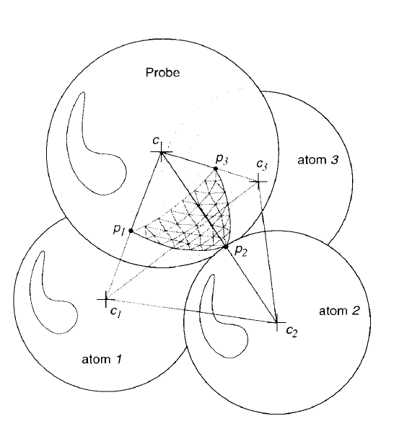FIGURE 3: Triangulation procedure for algorithm 2 of MSMS
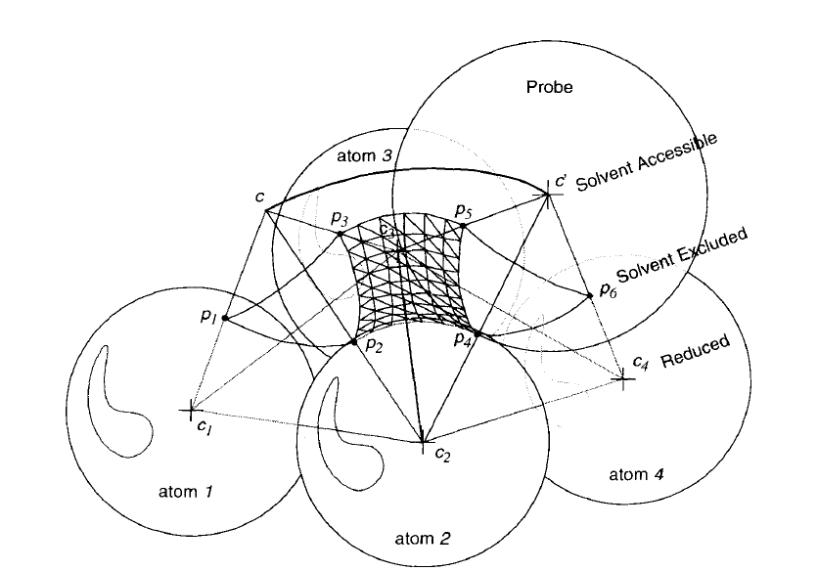FIGURE 4: Illustration of rolling procedure to fill gaps in the SES
This process is not perfect since in some cases the triangular arc mesh from one position intersects with another. This is called a radial singularity which is dealt with by algorithm 3. This algorithm simply splits the edge on which the probe rotated on, allowing the probe to sit between the two atoms (figure 5). This is the most general case; other unique cases are also dealt with using this algorithm. The fourth and final algorithm triangulates the generated SES based on a vertex density parameter [Sanner et al., 1996] . After the MSMS surface is generated it is exported to a X3D file using the “export” command.

3.3 Electrostatic Potential;
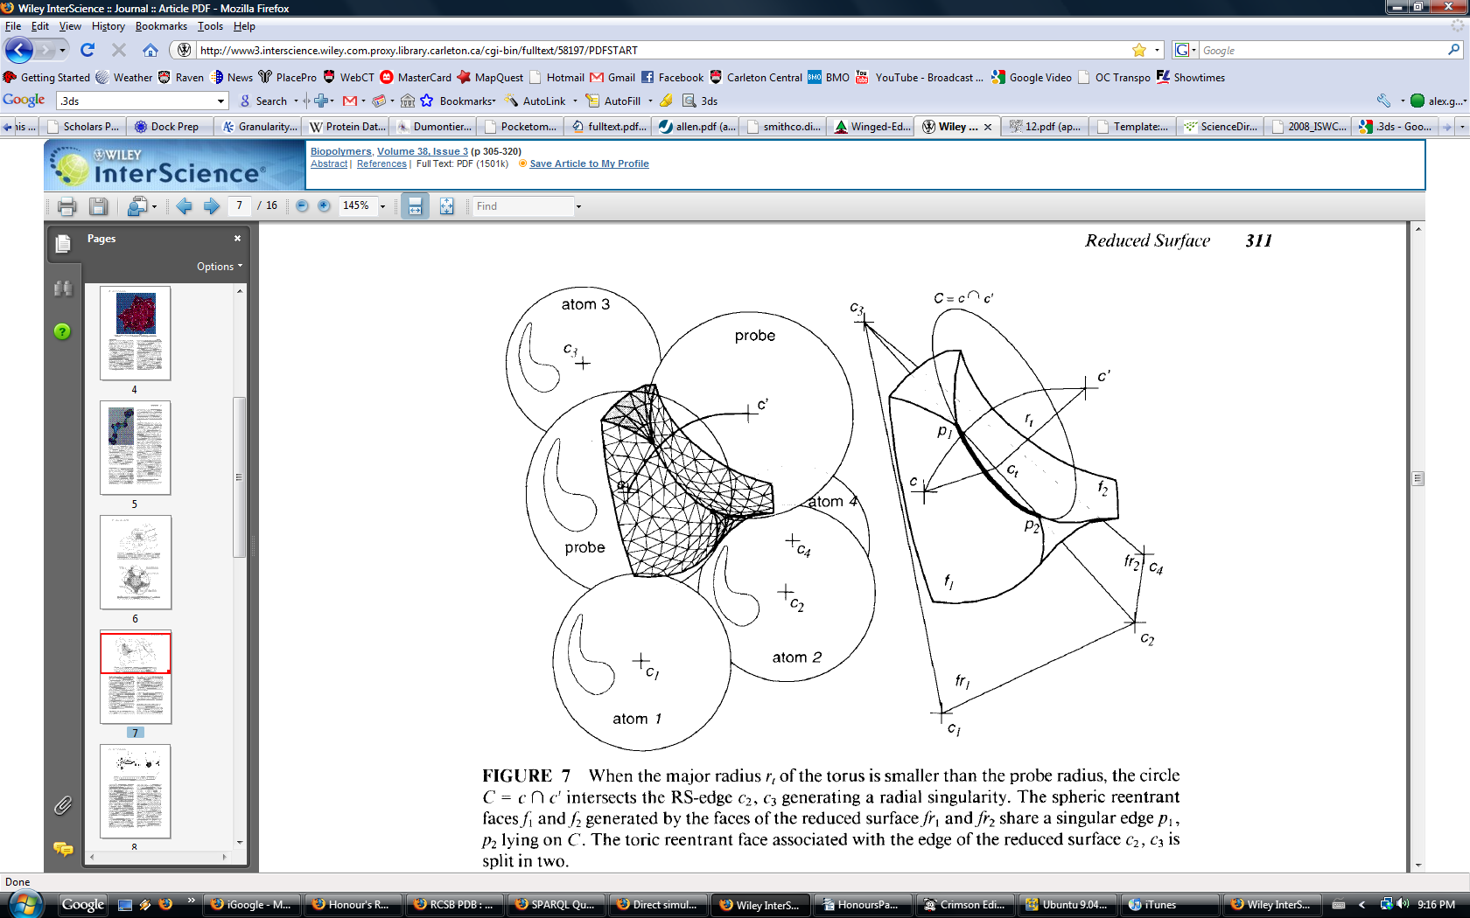FIGURE 5: An example of a radial singularity and how it is resolved.
Since Chimera was the chosen tool, DelPhi was used to determine electrostatic potential values. Before DelPhi can run some modifications must or should be made. All these functions are provided by a popular tool called Dock Prep. Dock Prep carries out the following functions:

- Delete solvent
- Delete non-complexed ions
- If alternate atom locations, keep only highest occupancy
- Convert nonstandard residues to standard
- Fix incomplete side chains
- Add hydrogens
- Add charges

Deleting solvents and non-complexed ions is done since DelPhi adds solvent and ions based on input parameters, which are used to probe the surface. If DelPhi attempted to probe the structure with these atoms included it would skew the results. At this step the script was modified to also delete ligands since only the main surface is needed. For atoms that may have different locations, they are set to the location that is most commonly seen which will give the most applicable end result. The nonstandard residue conversion step involves the heterogeneous residues MSE, CSL and UMS/5BU. These are converted to methionine, CMP and UMP respectively. This done to avoid errors that may occur if no charges/radii are assigned for these residues. For the Incomplete side chain step, the Dunbrack rotamer library is used to swap incomplete residues to a equivalent complete residues. Finally hydrogens and charges are added, however the addition of charges was disabled since DelPhi has its own charge list. The hydrogens are placed in optimal locations by Chimera based on hydrogen bond interactions [Moustakas et al., 2006]. This modified structure is then written to a PDB file with the “write” command.
Once the preparation step is completed, the parameter file must be generated. An example file is shown in table 2. With this parameter file DelPhi has all the required data to solve the Poisson Boltzmann equation.
TABLE 2: DelPhi parameter descriptions and chosen values.
Parameter | Purpose
in(pdb,file="2jfaH.pdb") | The input PDB file of the structure modified be Dock Prep.
in(siz,file="amber.siz") | The radii file, list of all possible amino acid separated into atoms and given radii values. [Tsail et al., 1999] (Figure 6)
in(crg,file="amber.crg") | The charge file, list of all possible amino acid separated into atoms and given partial charge values [Tsail et al., 1999] (Figure 6)
out(phi,file="2jfa.phi") | Output file as a phimap, a grid with electrostatic potential values.
indi=2 | Interior dielectric. This is set to two by recommendation of the DelPhi developers for such a large set of proteins (default).
exdi=80.0 | Exterior dielectric constant of the solvent (water default)
prbrad=1.4 | Radius of probe (water default)
salt=0.15 | Salt concentration in mol/L. Value of NaCl in isotonic solution [Scatchard et al., 1938].
ionrad=2.0 | Radius of salt ions (NaCl default)
nonint=20 | Number of iterations of the non-linear calculations (full PB equation)

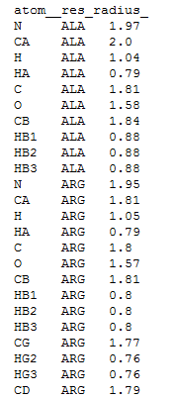

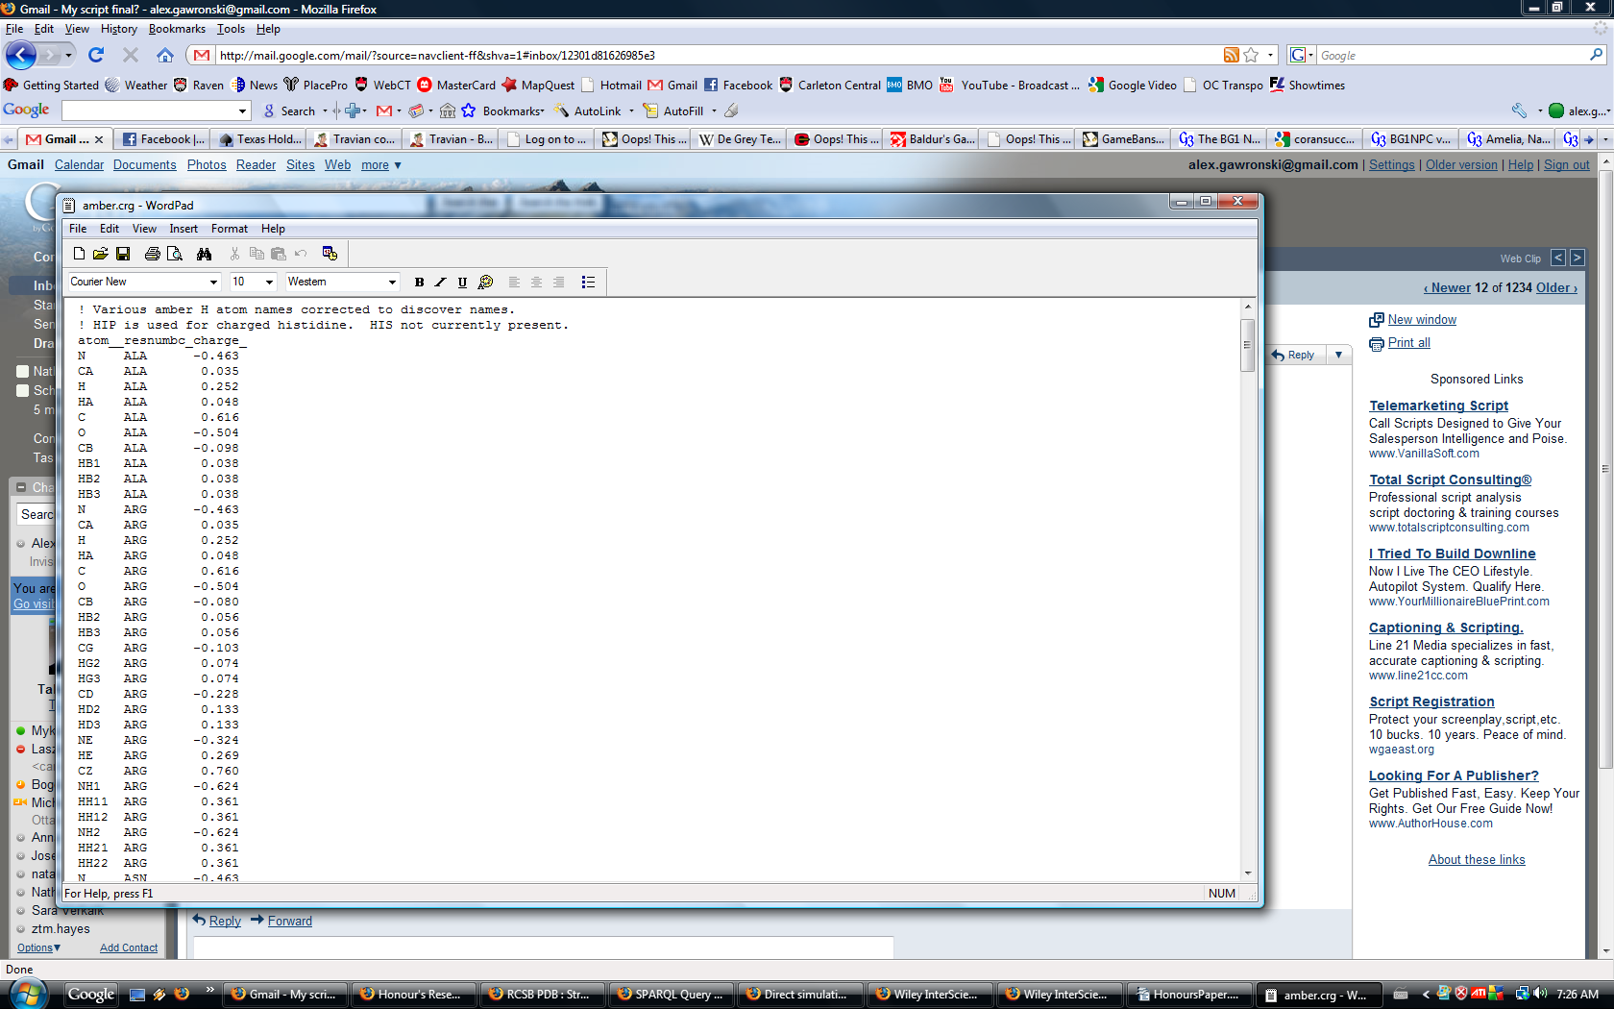
FIGURE 6: Excerpt from used charge and radii files
In table 2 the term “non-linear iterations” was introduced. This refers to the two versions of the Poisson-Boltzmann equations. The one previously introduced is the full non-linear equation, but there is another linear equation (Eq. 4) that approximates the solution. The term on the right hand side of the equation is the Debye–Huckel screening length, which is a threshold for what interactions to consider. Ions outside this threshold are too far to have a considerable effect and can therefore be ignored [Andelman, 1995]. DelPhi uses the linear version by default but allows iterations of the non-linear by specifying the “nonint” parameter. This has a significant effect on performance and can be adjusted depending on the system running the procedure.
Once the DelPhi calculations are complete the data in the form a phimap are imported into Chimera as volumetric data. At this point the “scolor” or surface colouring command is called. This function maps the volumetric data from the phimap to each vertex in the MSMS surface model. Here the code was modified to call a function within the python script to retrieve this mapping. No actual colouring occurs since Chimera runs in no-graphics mode. The mapping is collected with other data which is then outputted as a N3 file, which will be covered later in this section.
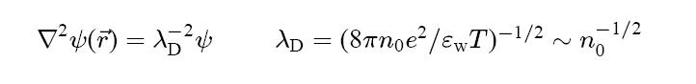 EQUATION 4

3.4 Ligand Pockets:
This procedure identifies all the ligand pockets in a protein. The algorithm is composed of three components. The algorithm begins with retrieving the Chimera molecule model to obtain the residue list. This list is then looped through checking each residue for a property called “isHet”. This property is true if the residue is nonstandard, or heterogeneous, which means different from the norm. However since the residue list contains the ligands as well, and many ligands are not standard residues, they are put into the heterogeneous category as well. This way specific ligands are obtained so they can be worked with individually. This is crucial since there may be more then one instance of the same kind of ligand in a PDB file.
When one of these “residues” are found, first it is checked to see if it's actually a ligand. There is no actual property in the Chimera residue model to identify it as a ligand. However there is a command called “select” that can select ligands with the parameter “ligand”. The pocket finding procedure requires that the ligand be selected using “select” command. If nothing is selected the procedure will not occur. Therefore if the “select” command was called with the parameters of the residue id and “ligand”, only real ligands will remain selected. The algorithm can run with only the “select” statement to check for ligands, but it is faster to initially filter using “isHet”. Furthermore peptide ligands would fail since they are a chains of residues, and require a separate procedure.
With the ligand found, the pocket finding procedure can continue. This is done by using a “zone” parameter in the select command. This will select all residues which are a specified number of angstroms away from the current selection. The zone was set to less than 0.5 angstroms between surfaces since it is the default for finding ligand pockets. This is derived from the ideal max distance between the centre of a protein solvent accessible atom and the centre of a ligand atom (max SAS) of 3.5 angstroms. Considering the average atomic radius for atoms in organic molecules of 1.5 angstroms, 0.5 angstroms is a suitable threshold [An et al., 2005]. Once the command is called, all the residues that make up the pocket should be selected as well. The ligand is still selected at this point so it must be deselected using the “~select ligand” command. From the selection the residue ids can be derived and are stored to memory in a multidimensional array, assigned to the id of the ligand.
As mentioned earlier, peptides, which are short amino acid chains, will not work with the first algorithm. They need to be identified and dealt with separately which makes up the next two components of the ligand pocket finding procedure. To identify the peptides, the residue list is traversed. Each residue is checked for what chain they belong to. A “chain” is a part of the tertiary structure of a protein where multiple chains of amino acids are bound together to form the complete protein. The number of residues belonging to each chain is stored in memory within a multidimensional array.
The final component loops through the chains discovered in the previous step. If the chain is less than or equal to 40 residues in length it is deemed a peptide and the pocket finding procedure continues [Chang et al., 2006]. This value is intentionally high to guarantee the finding of all peptides and it does not increase errors since the peptide is checked with the method mentioned earlier . This procedure is identical to the one used in the previous component with one difference. This procedure deselects residues around non-peptide ligands. This is because some non-peptide ligands are given the same chain id as a peptide ligand, or a short chain may not be a ligand but will have non-peptide ligands associated with it. With these situations handled, all ligand pockets of a protein are stored in memory ready to be written to an N3 file.

3.5 Adding the Model to a Triplestore:
When the script nears the end of execution and the collected data is stored in memory. The molecular surface mesh is held as a MSMS surface model with the electrostatic potential values mapped to each vertex in that model. The ligand pockets are stored in a multidimensional array indexed by residue (since a single residue may be mapped to multiple ligands). This data must now be outputted in a usable format. The chosen format, mentioned briefly in previous segments, is Notation 3 (N3) format. This format is equivalent to the RDF format mentioned in the background section, but is more readable. For example the RDF triple
“<http://someURI/Bob> <http://someOtherURI/species> "Homo sapiens"
would be
“tag1:Bob is tag2:species Homo sapiens”.
Before the data is written to triples it needs to be organized into a single, easily readable, data structure. The first step is to retrieve all the data from the Chimera MSMS surface model. This should be trivial but the Chimera model separates the surface into “surface pieces” for some internal purpose. Therefore each of these pieces must be retrieved and processed separately. For each piece the vertices are obtained. These vertices are then passed into the “colorMap” to retrieve the volumetric data which are the electrostatic potential values. Each of these vertices are mapped to an atom which are mapped to a residue in the surface model. Now that the residues are known they can be used to access the ligand pocket array. With this procedure complete, the data can be entered into an multidimensional array with one entry per vertex with residue, electrostatic potential and pocket mapped to it.
With that finished the process of creating a N3 file is relatively simple using the RDFLib python library. Firstly an empty instance of “Graph” is created. Next namespaces objects are created and bound to tags. These objects can be treated like arrays where the keys are the names of the classes or relationships referred to, and the value is the complete URI. Subjects can then be created as “BNodes” which are blank subjects or objects. These nodes are then given meaning using the defined namespaces. The structure of the N3 file is shown in figure 7. Once the graph is fully populated it is written to a N3 file. The script now clears all temporary files and continues on to the next protein until a model is created for every protein in the PDB.
[ a :mesh;
:represents [ a bio:Protein;
bio:label "1yti";
nulo:hasPart [ a bio:AminoAcid;
bio:label "A:73:GLY";
nulo:hasPart [ a :vertex;
:charge "4.0675";
:x "-13.6196";
:y "-2.91552";
:z "-19.4464"],
[ a :vertex;
:charge "4.39062";
:x "-13.4953";
:y "-2.74797";
:z "-19.946"],
[ a :vertex;
:charge "4.52548";
:x "-13.4656";
:y "-2.72668";
:z "-19.9842"],
FIGURE 7: Current N3 file structure

Results
The script was tested with 300 hundred proteins on a Linux virtual machine with one 3.6Ghz core and 512Mb ram. No errors were encountered and the average running time was approximately 12 seconds per protein (not including N3 output writing). Extended performance testing still needs to be done on the system that will be used to run the entire set of proteins. The specific components were qualitatively tested due to a lack of comparable data.
Arbitrary proteins were chosen and rendered using a separate rendering program. The number of vertices and faces is acceptable for the application in the NGCS (figure 8).
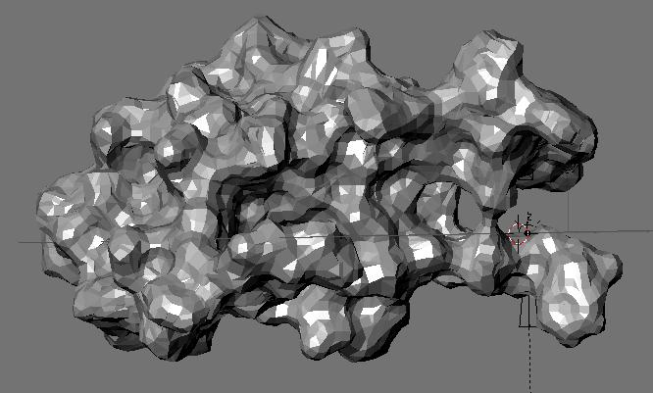FIGURE 8: Polygon mesh of 1YTI generated from project script.
To test electrostatic potential calculations, various images of proteins coloured by electrostatic potential were compared to images generated by Chimera with the electrostatic potential values created from the script. The colouring appears to be consistent for the proteins tested (figures 9,10).
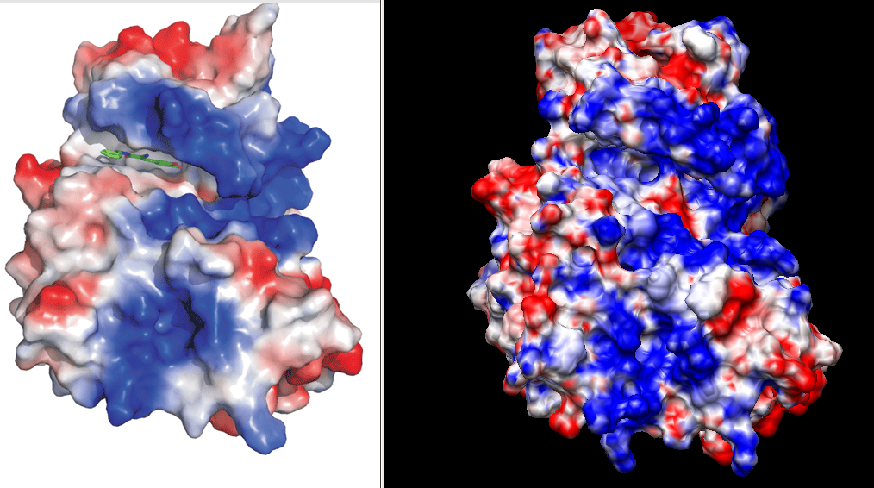
FIGURE 9: Comparison of electrostatic coloring of 12GS, from obtained data.
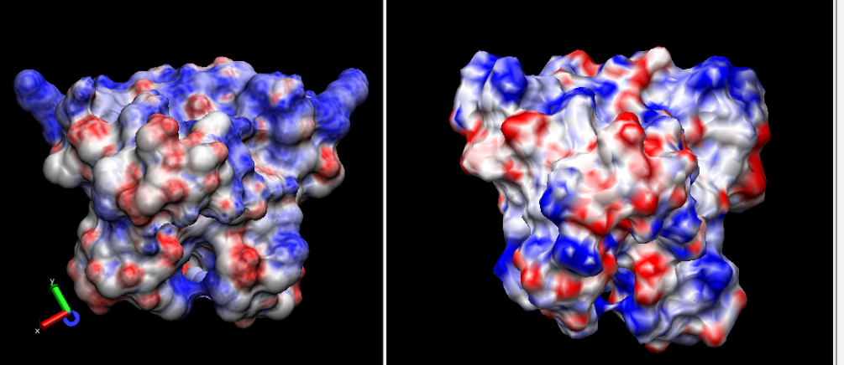FIGURE 10: Comparison of electrostatic colouring of 1MYK, from obtained data.
The ligand pocket finding procedure was tested with Estrogen Receptor Alpha LBD in Complex with an Affinity-Selected Corepressor peptide (2JFA). This PDB file contains multiple instances of non-peptide ligands and two instances of peptide ligands which covers all the cases handled by the script. All ligand pockets were found and annotated separately. When rendered they appear to fit the ligands well (figure 11,12). Other proteins were tested will similar successful results.

Discussion
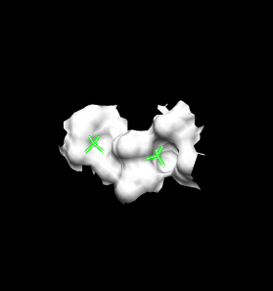FIGURE 12: Ligand pocket of sulfate from estrogen receptor protein.
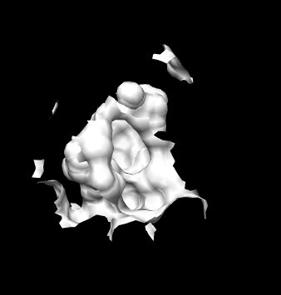FIGURE 11: Ligand pocket of Raloxifene from estrogen receptor protein.

5.1 Applications
These results indicate that the script is ready to be used in a large scale run on all the proteins in the PDB. The models satisfy the requirements for use in the NGCS project. When the NGCS integrates the meshes and the annotated data, functionality will be directly associated with the structure. At the lower levels of the framework, when two molecules collide in the simulation, the surfaces in contact will be known from the mesh representing the two structures. From these surfaces the list of vertices can be obtained and with them electrostatic values. If the values of the surfaces compliment each other the reaction can go forward [Allen, 2004]. For middle levels, the general locations of the pockets come into consideration. If a ligand comes into contact with a protein, the model can be queried to discover if there is a known interaction. If the interaction is found the reaction can move forward. Furthermore at this level the general orientation of the protein can be consider as well since the pockets are mapped to their physical location on the surface. Finally at the highest level the mesh file can be used to improve the visual appeal of the simulation.
Even outside the context of cell simulation models such as this may be useful. Specifically the information on pockets and ligands is useful. A collection such as this is sometimes referred to as a “pocketome” which furthers understanding of molecular functions and assists in drug design. With the addition of electrostatic potential values, high-throughput analysis of new drugs can be done using a pocketome [An et al., 2005].

5.2 Future Work
With the completion of this project there will be molecular surface models for all proteins in the PDB. However this does not include the DNA, RNA and Hybrid entries. In the future the procedure of this project can be expanded to handle these structures as well. The surface mesh portion should be able to handle these structures fairly well. For electrostatic potential calculations different input parameters and charge/radii files would have to be used dynamically, depending on the input structure. The largest challenge may be in the ligand pocket procedures, which may have to be drastically different depending on the Chimera model and PDB representations.
More specific additions to the procedure can also be made. Currently the focus of the project is on the protein surface, yet the ligand surfaces may be interesting as well. A separate model for these structures may be a good addition to the NGCS framework. It terms of electrostatics, the DelPhi procedure can be made more dynamic based on the input structure. Using general, all purpose parameters may cause some inaccuracies. Furthermore accuracy can be increased by a procedure called focusing. Focusing in DelPhi is the process of taking the output of one run as the input of the next run. In addition to this, increasing the number of iterations in the approximation procedure would also increase accuracy. These functions were not implemented since the extra running time required would cripple the performance. This ties with the next improvement which involves parallelization. Parallelization is process of splitting up work on to different cores in a multi-core system. This would greatly increase the speed of the script and allow for more computationally intensive calculations. A final useful addition would be the discovery of protein-protein interaction sites. This however may be unobtainable with the approach used in this project.
The N3 structure in this document is the first proposal and should go through further iterations to finalize the design. Furthermore data that is contain in the X3D mesh file should also be integrated within the N3 file allowing all the output data to be easily accessible.

Conclusion
This project involved the creation and utilization of various algorithms to build robust molecular surface models for all the proteins in the protein data bank. These models include geometric polygon meshes to visualize the SES of proteins, per vertex electrostatic potential values and a complete pocketome of ligand binding sites. The data of these models are stored in Notation 3 format for effective retrieval at runtime by NGCS. This was accomplish successfully using Chimera, Dock Prep and DelPhi and mix of python code and Chimera commands. NGCS can now use these models in various levels of cell simulation for visualization and reaction determination.
References:
An J., Totrov M., Abagyan R., (2005) Pocketome via Comprehensive Identification and Classification of Ligand Binding Envelopes, Mol. Cell Proteomics, Vol. 4, Issue 6. pp. 752. 2005

Andelman D., (1995) Electrostatic Properties of Membranes: The Poisson–Boltzmann Theory, Elsevier Science B.V. Handbook of Biological Physics, Vol. 1

Antoniou G., Van Harmelen F., (2004) A semantic Web primer, MIT Press

Baumgart B., (1975) Winged-Edge Polyhedron Representation for Computer Vision, National Computer Conference

Chang ST, Ghosh D, Kirschner DE, Linderman JJ. (2006) Peptide length-based prediction of peptide-MHC class II binding, Bioinformatics. Vol. 22, pp. 2761-7.

Horton R.H., Moran L.A., Scrimgeour K.G., Perry M.D., Rawn D.J. (2006) Principles of Biochemistry, Pearson Education Inc.

Michael P. A. (2004) Introduction to Molecular Dynamics Simulation, Computational Soft Matter: From Synthetic Polymers to Proteins, Vol. 23, pp. 1-28

Moustakas D.T., Lang T., Pegg S., Pettersen E., Kuntz I.D., Brooijmans N., Rizzo R.C., (2006) Development and validation of a modular, extensible docking program: DOCK 5, J. Computer Aided Mol. Des., Vol. 20, pp. 601–619

Parsegian V.A., Gingell D., (1972) On the Electrostatic Interaction across a Salt Solution between Two Bodies Bearing Unequal Charges, Biophysical Journal, Vol. 12, Issue 9, pp. 1192-1204

Sanner M.F., Olson A.J., Spehner JC., (1996), Reduced surface: An efficient way to compute molecular surfaces, Biopolymers, pp. 305-320

Scatchard, G., Hamer, W.J., and Wood, S.E. (1938) Isotonic solutions. The chemical potential of water in aqueous solutions of sodium chloride, potassium chloride, sulfuric acid, sucrose, urea and glycerol at 25°C, J. Am. Chem. Soc., Vol 6, pp. 3061-3070.

Smith C., (2006) On Vertex-Vertex Meshes and Their Use in Geometric and Biological Modeling, University of Calgary

Tsai1 J., Taylor R., Chothia C., Gerstein M., (1999) The Packing Density in Proteins: Standard Radii and Volumes, J. Mol. Biol., Vol. 290, pp. 253-266
Appendix:
getPDBByMolType.php: Script provided Jose Toledo-Cruz for retrieving PDB protein ids.
Parameters: -protein Y|N -dna Y|N -rna Y|N -hybrid Y|N
<?php
if($argc < 3){
die("Usage: getPDBByMolType.php <-protein Y|N> <-dna Y|N> <-rna Y|N> <-hybrid Y|N>\n");
}//if
else{
if($argv[1] == "-protein" && $argv[3] == "-dna" && $argv[5] =="-rna" && $argv[7] == "-hybrid"){
$optionArr["containsProtein"] = $argv[2];
$optionArr["containsDna"] = $argv[4];
$optionArr["containsRna"] = $argv[6];
$optionArr["containsHybrid"] =$argv[8];
require_once("MyXmlWriter.php");
$qArr = makeQueryArr($optionArr);
$xmlQuery = writeXMLQuery($qArr);
$url = "http://www.rcsb.org/pdb/rest/search";
$response = executeQuery($xmlQuery, $url);
$rArr = explode("\n", trim($response));

foreach($rArr as $k=>$v){
echo "$v\n";
}//foreach

}else{
die("Usage: getPDBByMolType.php <-protein Y|N> <-dna Y|N> <-rna Y|N> <-hybrid Y|N>\n");
}//else

}//else

function executeQuery($aQry, $url){
$ch = curl_init(); // initialize curl handle
curl_setopt($ch, CURLOPT_URL,$url); // set url to post to
curl_setopt($ch, CURLOPT_RETURNTRANSFER,1); // return into a variable
curl_setopt($ch, CURLOPT_TIMEOUT, 4); // times out after 4s
curl_setopt($ch, CURLOPT_POSTFIELDS, $aQry); // add POST fields
$result = curl_exec($ch); // run the whole process
return $result;
}//executeQuery

function writeXMLQuery($qArr){
$xml = new MyXmlWriter();
$xml->push('orgPdbQuery');
foreach($qArr as $a){
$xml->element($a[0], $a[1]);
}//foreach
$xml->pop();
return $xml->getXml();
}//writeXML

function makeQueryArr($arr){
//This function makes the query array that is ready for writeXMl
$returnMe = array(
array("queryType", "org.pdb.query.simple.ChainTypeQuery"),
array("containsProtein","-"),
array("containsDna","-"),
array("containsRna", "-"),
array("containsHybrid","-"),
);

foreach($arr as $k=>$v){
if($k == "containsProtein"){
$returnMe[1][1] = $v;
}//if
if($k == "containsDna"){
$returnMe[2][1] = $v;
}//if
if($k == "containsRna"){
$returnMe[3][1] = $v;
}//if
if($k == "containsHybrid"){
$returnMe[4][1] = $v;
}//if
}//foreach

return $returnMe;
}//makeQueryArr
?>

MyXmlWriter.php: Helper class for getPDBByMolType.php to write XML Queries
<?php
class MyXmlWriter{
var $xml;
var $indent;
var $stack = array();
function XmlWriter($indent = ' ') {
$this->indent = $indent;
$this->xml = '<?xml version="1.0" encoding="utf-8"?>'."\n";
}
function _indent() {
for ($i = 0, $j = count($this->stack); $i < $j; $i++) {
$this->xml .= $this->indent;
}
}
function push($element, $attributes = array()) {
$this->_indent();
$this->xml .= '<'.$element;
foreach ($attributes as $key => $value) {
$this->xml .= ' '.$key.'="'.htmlentities($value).'"';
}
$this->xml .= ">\n";
$this->stack[] = $element;
}
function element($element, $content, $attributes = array()) {
$this->_indent();
$this->xml .= '<'.$element;
foreach ($attributes as $key => $value) {
$this->xml .= ' '.$key.'="'.htmlentities($value).'"';
}
$this->xml .= '>'.htmlentities($content).'</'.$element.'>'."\n";
}
function emptyelement($element, $attributes = array()) {
$this->_indent();
$this->xml .= '<'.$element;
foreach ($attributes as $key => $value) {
$this->xml .= ' '.$key.'="'.htmlentities($value).'"';
}
$this->xml .= " />\n";
}
function pop() {
$element = array_pop($this->stack);
$this->_indent();
$this->xml .= "</$element>\n";
}
function getXml() {
return $this->xml;
}
}
?>

MakeAllMeshes: Simple Linux script to run main script with all PDB ids. Pipe in pdbids.txt. This runs Chimera with the execMakeMeshes script with the PDB id as a parameter.
while read inputline;
do
./chimera --script execMakeMeshes.py -- $inputline
done

ExecMakeMeshes.py: Launcher for main script that uses the PDB id as a parameter. This also closes Chimera after execution.
import sys
from chimera import runCommand
from SurfaceColor import makeMeshes

proID = sys.argv[1]
makeMeshes.makeAllMeshes(proID)

runCommand('close session')
runCommand('stop confirmed')

MakeMeshes.py: The main script with two functions. The first, makeMeshes(proID), is the main thread and the second, printVertices(colorMap, xform), prints all data to a N3 file.
import os
import sys
import chimera
from chimera import runCommand, selection, openModels, Molecule
from DockPrep import prep
from SPARQL import SPARQLWrapper, JSON
from rdflib.Graph import Graph
from rdflib import URIRef, Literal, BNode, Namespace
from rdflib import RDF

curResID = 'none'
curProID = 'none'
path = '/home/vadmin/Chimera/bin/'
meshDir = ''
pocketMap = {}

def makeAllMeshes(proID):

global curResID
global curProID
global path
global meshDir
global pocketMap

#Insure input is a 4 character protein ID
proID = proID[0:4]

#Create a new directory for the protein
meshDir = proID + 'Mesh'
curProID = proID
os.mkdir(meshDir)
os.system("chmod 777 " + meshDir)

try:
#Fetch protein from the PDB
runCommand('open '+ proID)

#Initial prep for pocket search
runCommand('delete solvent')
runCommand('delete :HOH')

#Open protein model
model = openModels.list(modelTypes=[Molecule])[0]
RES_LIST = model.residues

#Pocket finding procedure
chains = []
counts = []
index = 0
print 'Counting Chain Lengths................'
for res in RES_LIST:
curChain = str(res.id.chainId)
if len(chains) == 0:
chains.append(curChain)
counts.append(1)
if curChain != chains[index]:
index = index + 1
chains.append(curChain)
counts.append(1)
else:
counts[index] = counts[index] + 1

print 'Finding Peptide Ligand Pockets................'
for i, chain in enumerate(chains):
if counts[i] < 40: #Less than 40 amino acids = peptide
runCommand('~select')
runCommand('select ligand & :.' + chain) #Check if actually ligand
runCommand('select selected zr<5.0') #Select pocket
runCommand('~select :/isHet zr<5.0') #De-select ligand
runCommand('~select ligand')
residues = selection.currentResidues() #Store pocket in memory
for res in residues:
if res in pocketMap:
pocketMap[res].append('|' + chain)
else:
pocketMap[res] = [chain]

print 'Finding non-Peptide Ligand Pockets................'
for res in RES_LIST:
if res.isHet: #Check if "heterogenous residue" which includes ligands
curResID = str(res.id)
runCommand('~select')
runCommand('select :' + curResID + ' & ligand') #Check if actually ligand
runCommand('select selected zr<5.0') #Select pocket
runCommand('~select :' + curResID)
residues = selection.currentResidues() #Store pocket in memory
for pocketRes in residues:
if pocketRes in pocketMap:
pocketMap[pocketRes].append('|' + res.type + '-' + curResID)
else:
pocketMap[pocketRes] = [res.type + '-' + curResID]

print 'Dock Prep................'
prep(openModels.list(modelTypes=[Molecule]))

print '\nRunning Delphi................'
runCommand('~select')
runCommand('write format pdb 0 '+ proID + 'H.pdb') #Write delphi-ready protein with hydrogens

#Create delphi parameter file
f = open(path + 'param_1', 'w')
f.write('in(pdb,file="'+ proID + 'H.pdb")\n') #Input/Output files
f.write('in(siz,file="amber.siz")\n')
f.write('in(crg,file="amber.crg")\n')
f.write('out(phi,file="'+ proID + '.phi")\n')
f.write('indi=2\n') #Interior dielectric constant
f.write('exdi=80.0\n') #Exterior dielectric constant (water)
f.write('prbrad=1.4\n')
f.write('salt=0.15\n') #Salt concentration and radius
f.write('ionrad=2.0\n')
f.write('nonit=20\n') #Non-linear iterations

f.close()
os.system("./runDelphi") #Run delphi

print '\nExporting Mesh................'
runCommand('select #0')
runCommand('export format X3D ./'+ meshDir + '/' + proID + '.x3d')

print '\nOpening Delphi Data................'
runCommand('~select')
runCommand('surface')
runCommand('open '+ proID + '.phi')
runCommand('scolor #0 volume #1 cmap -1,red:0,white:1,blue;')

print '\nRemoving Temp Files................'
os.remove(path + proID + 'H.pdb')
os.remove(path + proID + '.phi')

print '\nDONE: ' + proID
except:
f = open(path+ 'ErrorLog.txt', 'a')
f.write(proID + ' error: ' + str(sys.exc_info()[0]) + str(sys.exc_info()[1]) + '\n')
f.close()
raise

return

#Procedure called from surface coloring method
def printVertices(colorMap, xform):

global curProID
global path
global meshDir
global pocketMap

print '\nWriting Vertex Annotation................'
slist = chimera.openModels.list(modelTypes=[chimera.MSMSModel])
# Collect surface vertex chain id, residue id, and vertex x,y,z coordinates.
data = []
for s in slist:
va, ta = s.surface_piece.geometry # vertex and triangle arrays
values, outside = colorMap.volume_values(va, xform) #Get electrostatic charge values

for i,v in enumerate(va):
x,y,z = v
atom = s.atomMap[i]
elecPot = values[i]
r = atom.residue
pockets = ''
if r in pocketMap:
for pocket in pocketMap[r]:
pockets = pockets + pocket
data.append((r.id.chainId, r.id.position, r.type, x, y, z, elecPot, pockets))
data.sort()

print '\nBuilding triples................'

store = Graph()

# Bind a few prefix, namespace pairs.
store.bind("rdfs", "http://www.w3.org/2000/01/rdf-schema#")
store.bind("nulo", "http://ontology.dumontierlab.com/nulo#")
store.bind("bio", "http://ontology.dumontierlab.com/biochemistry-primitive#")
store.bind("", "#")
# store.bind("bio", "http://ontology.dumontierlab.com/biochemistry-complex")

# Create a namespace.

RDFS = Namespace("http://www.w3.org/2000/01/rdf-schema#")
NULO = Namespace("http://ontology.dumontierlab.com/nulo#")
BIO = Namespace("http://ontology.dumontierlab.com/biochemistry-primitive#")
myNS = Namespace('#')

mesh = BNode()
protein = BNode()
meshFile = BNode(curProID + '.x3d')

# Define my namespace classes and properties.
store.add((myNS.mesh, RDF.type, RDFS["class"]))
store.add((myNS.mesh, RDFS.label, Literal("mesh")))
store.add((myNS.represents, RDFS.domain, myNS.mesh))
store.add((myNS.represents, RDFS.range, BIO["Protein"]))
store.add((myNS.vertex, RDF.type, RDFS["class"]))
store.add((myNS.vertex, RDFS.label, Literal("vertex")))
store.add((myNS.x, RDFS.domain, myNS.vertex))
store.add((myNS.x, RDFS.range, RDFS["float"]))
store.add((myNS.y, RDFS.domain, myNS.vertex))
store.add((myNS.y, RDFS.range, RDFS["float"]))
store.add((myNS.z, RDFS.domain, myNS.vertex))
store.add((myNS.z, RDFS.range, RDFS["float"]))
store.add((myNS.charge, RDFS.domain, myNS.vertex))
store.add((myNS.charge, RDFS.range, RDFS["float"]))

store.add((mesh, RDF.type, myNS.mesh))
store.add((mesh, RDF.value, myNS[curProID + '.x3d']))
store.add((mesh, myNS.represents, protein))

store.add((protein, RDF.type, BIO["Protein"]))
store.add((protein, BIO["label"], Literal(curProID)))

last = ''
aminoAcid = BNode()

for aa in data:
if aa[2] != last:
aminoAcid = BNode()
store.add((aminoAcid, RDF.type, BIO["AminoAcid"]))
store.add((aminoAcid, BIO["label"], Literal(aa[0] + ":" + str(aa[1]) + ":" + aa[2])))
vertex = BNode()
store.add((vertex, RDF.type, myNS.vertex))
store.add((vertex, myNS.x, Literal(aa[3])))
store.add((vertex, myNS.y, Literal(aa[4])))
store.add((vertex, myNS.z, Literal(aa[5])))
store.add((vertex, myNS.charge, Literal(aa[6])))
store.add((aminoAcid, NULO["hasPart"], vertex))
store.add((protein, NULO["hasPart"], aminoAcid))
if aa[7] != '':
for ligand in aa[7].split('|'):
pocket = BNode()
store.add((pocket, RDF.type, BIO["Ligand"]))
store.add((pocket, BIO["label"], Literal(aa[6])))
store.add((aminoAcid, NULO["isSpatiallyRelatedTo"], pocket))
last = aa[2]
else:
vertex = BNode()
store.add((vertex, RDF.type, myNS.vertex))
store.add((vertex, myNS.x, Literal(aa[3])))
store.add((vertex, myNS.y, Literal(aa[4])))
store.add((vertex, myNS.z, Literal(aa[5])))
store.add((vertex, myNS.charge, Literal(aa[6])))
store.add((aminoAcid, NULO["hasPart"], vertex))

# Serialize the store as RDF/XML to the file foaf.rdf.
store.serialize(curProID + ".n3", format="n3", max_depth=3)

return

runDelphi: Simple Linux script to run DelPhi with the param_1 parameter file.
/home/vadmin/DELPHI_2004_LINUX_v2/delphi_static param_1

__init__.py in DockPrep: Default parameters for removing ligands and adding charges were modified for two functions to True and False respectively.
def prep(mols, addHFunc=AddH.hbondAddHydrogens, hisScheme=None,
mutateMSE=True, mutate5BU=True, mutateUMS=True, mutateCSL=True,
delSolvent=True, delIons=True, delLigands=True,
delAltLocs=True, incompleteSideChains="rotamers", nogui=False,
rotamerLib=defaults[INCOMPLETE_SC], rotamerPreserve=True, **kw):
def _postAddPrep(mols, addCharges=False, gaffType=False, nogui=False,
chargeModel=None, method=None, **kw):

__init__.py in SurfaceColor: Hook to makeMeshes.printVertices() was added.
def point_colors(self, vertices, vertex_xform):

values, outside = self.volume_values(vertices, vertex_xform)

#--------------Start of Alex's Code-----------------------------------
import makeMeshes
makeMeshes.printVertices(self, vertex_xform)
#--------------end of Alex's Code-----------------------------------

cmap = self.colormap
rgba = interpolate_colormap(values, cmap.data_values, cmap.colors,
cmap.color_above_value_range,
cmap.color_below_value_range)
if len(outside) > 0:
set_outside_volume_colors(outside, cmap.color_no_value, rgba)

return rgba

