One of the most anticipated features of the Rust programming language has arrived. However, the stable version for the async/.await is only available in the stable version of the Rust programming which is 1.4 or above. Therefore, this article will take a brief insight into how this async/.await feature works by creating a simple application which fetches some data from the internet.

What does Async Means??
The async features in Rust give the flexibility to run the task concurrently or in simple words allow to carry out the task in a single threat with multiple overlapping. Although multithreading is well-suited for applications which perform computationally intensive tasks. But the async feature is useful when there is usually very much waiting on the computation side. Such type of tasks are known as IO bounds.
Therefore, the asynchronous feature of the Rust allows performing various IO-bound tasks at the same time by keeping different tasks idle. The values that are waiting on the asynchronous programming are known as futures.

Async in Rust
Async is quite different in Rust as compared to other programming languages as it does not execute immediately and require an executor to launch a task.
To execute the async functions external libraries are used which are imported with the syntax async_std::task.
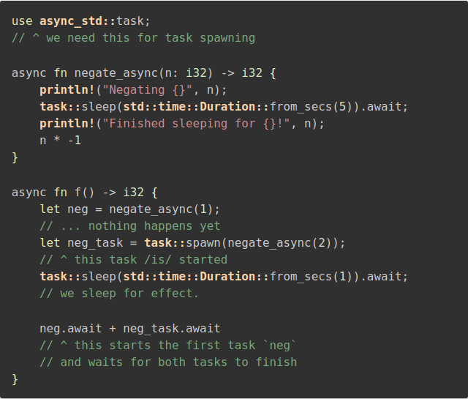
The negate-async parameter takes any signed parameter as an input and then sleep for five minutes and return the negated version of the integer. The first line let neg = negate_async(1); creates a future and then assign it to the negative variable. Now let neg_task = task::spawn(negate_async(2)); uses the spawn to execute the future. The program then sleeps for a few minutes and return for futures.
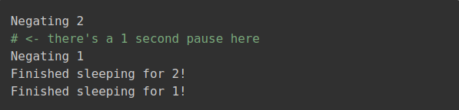
However, async require the external executor to execute the future. The two most prominent executor includes async_std and tokio.

Example
Now a basic application for a better understanding of the problem.
Create the project with cargo new and name it.
Add dependencies into cargo.toml file which includes async-std and surf.
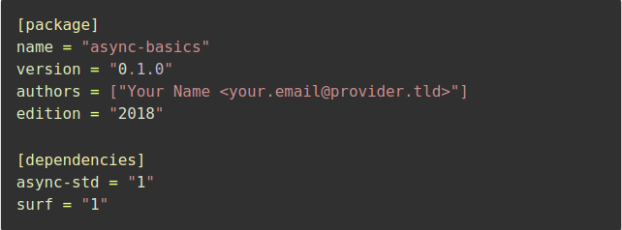
In the main.rs use these dependencies with the use statements. Now fetch the data with simple surf::get command. And execute the project with the surf.
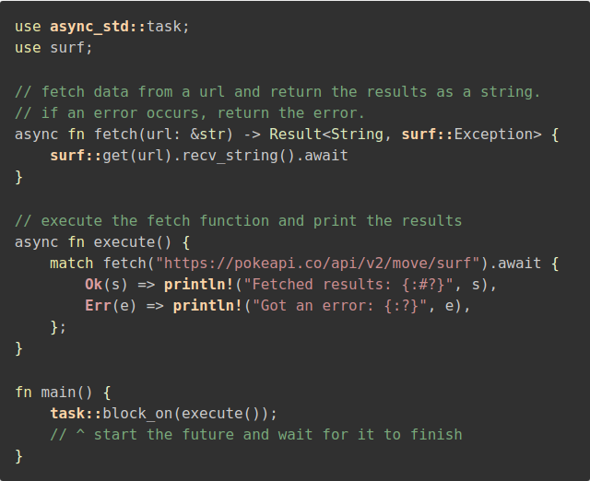
main simply comprise of block_on function which is required to start the application. Now cargo run your application.

