

Ben-Gurion University of the Negev Faculty of Engineering Science

School of Electrical and Computer Engineering

Dept. of Electrical and Computer Engineering

Fourth Year Engineering Project
Preliminary Design

Design and Implementation of a Hovering Autonomous Underwater Vehicle (HAUV)

Project Number: p-2026-031
Students (Name and ID) : Guy Hatzir - 207015272
Maayan Sarig - 206511776
Supervisor: Prof. Hugo Guterman
Email for contact: guyhatz@post.bgu.ac.il
sarigma@post.bgu.ac.il
Submitting date: 20/12/2025

1. Abstract 3
i. English Abstract 3
ii. Hebrew Abstract 3
2. Project Objectives 4
2.1. Operator–ROV Decoupling 4
2.2. Autonomous Mission Execution by the ROV 4
2.3. Autonomous USV Tracking of the ROV 5
2.4. Quantitative Real-Time Video Transmission via USV Relay 5
3. Spec Sheet 6
3.1. Product Proposal 6
3.2. Technology - Methodology 6
3.3. Research and work stages 8
3.4. Potential Applications 8
3.5. System Performance Specifications 9
3.6. System Schematic 9
4. Literature Review 9
5. Proposal Design (Firmware) 11
5.1. System Block Diagram Explanation 11
5.2. Project Constraints 12
5.3. Project Assumptions 12
6. Project Deliverables and Boundaries 12
6.1. Software Architecture 12
6.2. System Integration & Hardware Adaptation: 13
6.3. System Inputs and Outputs 13
7. Testing Plan 14
7.1. Dry Lab Test: 14
7.2. Pool Test: 14
7.3. Sea Trials: 14
8. Budget Estimate 14
8.1. External supply 14
8.2. Crew salaries 14
9. Gannt 15
10. Bibliography 15
11. Appendix 15

Abstract

English Abstract
Autonomous USV-Based Communication Relay for Extended-Range and Independent ROV Operations
Hatzir Guy, Sarig Maayan
guyhatz@post.bgu.ac.il sarigma@post.bgu.ac.il
Prof. Guterman Hugo
A Remotely Operated Vehicle (ROV) is typically controlled from a manned surface platform via a computer and joystick. The primary challenge is that conventional RF communication does not propagate underwater, necessitating a reliable, two-way communication link to the surface.
This project aims to enable the ROV to perform autonomous operations and be operated remotely, without the constant presence of a manned platform.
The project introduces an innovative concept: an Unmanned Surface Vehicle (USV) that serves as a communication relay between the ROV and the remote-control station. This floating unit will communicate with the main vessel via long-range RF links and transfer predefined missions to the ROV for execution. The USV will autonomously track the ROV movement, enabling it to execute missions far from the operator.
The expected outcome is the successful execution of autonomous scanning missions within a predefined area and transmitting live video to the remote operator, initiated by commands from the surface vessel, while maintaining stable communication between the ROV and the surface via the USV.
Keywords: ROV, USV, autonomous operation, RF, Remote Control, Underwater, relay, track.

ii. Hebrew Abstract
ממסר תקשורת אוטונומי מבוסס USV עבור פעולות ROV עצמאיות ובטווח רחב
חציר גיא, שריג מעין
guyhatz@post.bgu.ac.il sarigma@post.bgu.ac.il
פרופ. גוטרמן הוגו
רכב תת-ימי המופעל מרחוק (ROV) נשלט בדרך כלל מפלטפורמה ימית מאוישת באמצעות מחשב וג'ויסטיק. האתגר המרכזי נובע מכך שתקשורת רדיו (RF) קונבנציונלית אינה עוברת בתוך המים, עובדה המחייבת קיום ערוץ תקשורת דו-כיווני ואמין אל פני השטח.
פרויקט זה שואף לאפשר לROV לבצע פעולות אוטונומיות ולהיות מופעל מרחוק ללא נוכחות קבועה של פלטפורמה מאוישת. הפרויקט מציג קונספט חדשני: כלי שיט בלתי מאויש (USV) המשמש כממסר תקשורת בין ה ROV לבין תחנת השליטה המרוחקת. יחידה צפה זו תתקשר עם הספינה המרכזית באמצעות קישורי רדיו ארוכי טווח ותעביר לצוללת משימות מוגדרות מראש לביצוע. ה USV יעקוב באופן אוטונומי אחר תנועת ה ROV, ובכך יאפשר לו לבצע משימות במרחק רב מהמפעיל.
התוצאה הצפויה היא ביצוע מוצלח של משימות סריקה אוטונומיות בתוך אזור מוגדר מראש והעברת וידאו בשידור חי למפעיל המרוחק. המשימות יופעלו באמצעות פקודות מכלי השיט שעל פני המים, תוך שמירה על תקשורת יציבה בין הROV לפני השטח באמצעות ה USV.
מילות מפתח ,ROV, USV :הפעלה אוטונומית, תדרי רדיו, שליטה מרחוק, תת-ימי, ממסר, מעקב.

Project Objectives

Operator–ROV Decoupling
Objective:
Eliminate the direct physical connection between the operator and the Remotely Operated Vehicle (ROV), enabling an extended operational range between the operator and the underwater platform.
Success Metric:
Successful bidirectional transmission of command and telemetry data between the operator and the ROV over a minimum distance of 100 meters, with stable and continuous communication.

Autonomous Mission Execution by the ROV
Objective:
Enable the ROV to autonomously execute missions upon receiving high-level commands from the operator, without continuous manual intervention.
Success Metric:
Successful autonomous execution of a 20 × 20 square meter polygonal area scanning mission, including accurate trajectory following and successful recording and storage of mission video data.

Autonomous USV Tracking of the ROV
Objective:
Develop a USV capable of autonomously and continuously tracking the ROV while maintaining an appropriate relative position to support communication and tether management.
Success Metric:
Demonstrated ability of the USV to maintain a predefined maximum separation distance from the ROV, while ensuring that the cable remains within its specified safe tension range throughout the mission.

Quantitative Real-Time Video Transmission via USV Relay
Objective:
Provide continuous real-time video transmission from the ROV to the remote operator using the USV as an intermediate communication relay.
Success Metric:
Measured video streaming performance via the USV relay, achieving at least 50% of the effective bitrate (bits per second) obtained using a direct physical tether, while maintaining an end-to-end latency that does not exceed twice the baseline latency of the direct tether configuration.

Autonomous USV-Based Communication Relay for Extended-Range and Independent ROV Operations

Spec Sheet

Product Proposal
The primary purpose is to decouple the operator from the ROV’s immediate vicinity, breaking the limitation of a direct, physical tether from the main vessel. This new system allows an operator on the mother ship to function as a mission planner rather than just a pilot. The operator will use “QGroundControl” software to send high-level mission directives over long range (RF Link) to the USV (worker). The USV acts as a smart communication relay and local supervisor. It receives the mission and forwards commands to the ROV (Master) via an underwater cable tether. The ROV, which will be upgraded with its own autonomous navigation system, executes the complex mission independently while the USV autonomously follows it. This architecture is fundamental:
- Increase operational range beyond the typical ROV tether.
- Enable complex, large-scale autonomous surveys (e.g., scanning a large area) without continuous, fatiguing manual joystick control.

Technology - Methodology
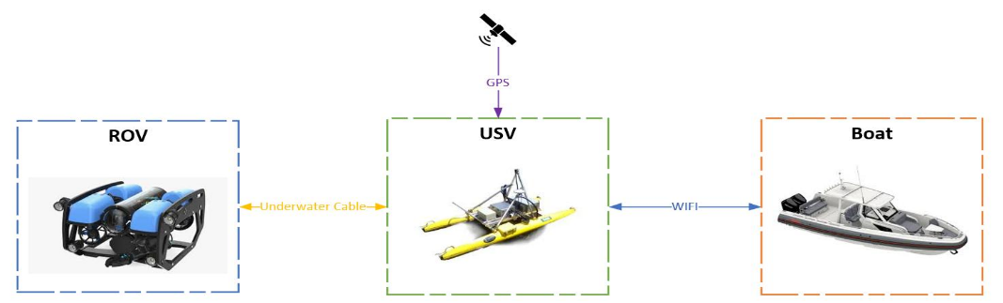
This architecture will be based on three separate, distributed control architectures:
Figure 1: Macro point of view

Mother Ship: The control protocol will be “MAVLink”, managed by the “QGroundControl” software system on the ship. This protocol will encapsulate TDMA packets for wireless transmission.
USV: A Raspberry Pi 4 (RP4) on the USV will act as a central communication hub and gateway. It will manage the RF link to the mother ship and the underwater cable link to the ROV (FXTI). The USV will be equipped with:
- GPS - antenna and receiver for its own location (for station keeping).
- FXTI - A media converter to transfer data from Ethernet to the underwater cable and vice versa.
The USV will be controlled by its own thrusters and sensors, managed by a flight controller to enable autonomous station keeping and heading stabilization. The platform will be based on a catamaran frame equipped with two thrusters, providing mechanical stability and redundancy. All electronic components will be housed in a waterproof enclosure mounted on the frame. In addition, a tension meter and an underwater cable angle sensor will be installed to monitor tether forces and geometry during ROV operation.
The computational core (“brain”) of the USV is built around an RPi 4, which serves as the main onboard processing unit and hosts the system firmware and middleware. The RPi 4 runs a ROS 2–based software architecture that enables modular, distributed control and communication. Within this framework, dedicated ROS 2 nodes are responsible for vehicle control, sensor interfacing, and system supervision, while a central relay node manages the bidirectional transfer of data packets between the ROV and the remote operator.
The relay node encapsulates and forwards telemetry, control commands, and high-bandwidth data streams such as video, while handling buffering, prioritization, and link status monitoring. Sensor data from the tension meter and cable angle sensor are processed in real time and published within the ROS 2 network, supporting closed-loop control strategies that maintain safe tether dynamics and stable relay positioning. This data will be used to keep the cable within its defined technical limits and, by doing so, allow the USV to follow the ROV.
ROV: The ROV functions as the primary autonomous agent. It is equipped with its own Raspberry Pi 4 companion computer and a flight controller running ArduSub firmware. Its methodology is to receive the complete mission (as MAVLink commands) from the USV via the underwater cable link. It then executes this mission autonomously, using its six thrusters and a suite of onboard navigation sensors (e.g., IMU, camera, and depth sensor).

Research and work stages
- Stage 1: ROV Firmware Upgrade: Integrate the Raspberry Pi 4, Navigator Flight Controller, and essential navigation sensors (IMU, depth, camera). Install and configure ArduSub firmware.
- Stage 2: USV Integration: Completion of ROS 2 infrastructure for integrated system-wide communication and control.
- Stage 3: Communications Link Development:
Underwater Link (USV-ROV): Integrate and test the underwater cable link (media converters).
Surface Link (Ship-USV): Integration and test long-range RF communication protocol and hardware over water.
- Stage 4: Software & Logic Development:
USV Relay Logic: Develop and debug the MAVLink routing/relay script for the USV's R.P.4.
USV Autonomy: Configure the USV's flight controller to follow the ROV based on data from the tension meter and angle sensor.
- Stage 5: System Integration & Testing

Potential Applications
- Marine Research: Autonomous ecological surveys, seabed mapping, and water quality sampling.
- Industrial Inspection: Automated inspection of subsea infrastructure (e.g., pipelines, cables, bridge pylons, vessel hulls).
- Aquaculture: Automated monitoring and inspection of fish farm nets and mooring systems.
- Search and Recovery (SAR): Deployment from a safe distance to autonomously scan a predefined search grid.

System Performance Specifications
Topic | Component | Value
Communication | Air - RF | 2.4/5 GHz, 7 KM
 | Underwater Cable | 300 meters
Navigation | GPS | 1.575 GHz
Buttery Life (ROV+USV) | Normal use | 2-3 hours w/18Ah
 | Light use | 4-6 hours w/18Ah
Depth | ROV | 100 meters
Table 1: System performance specifications

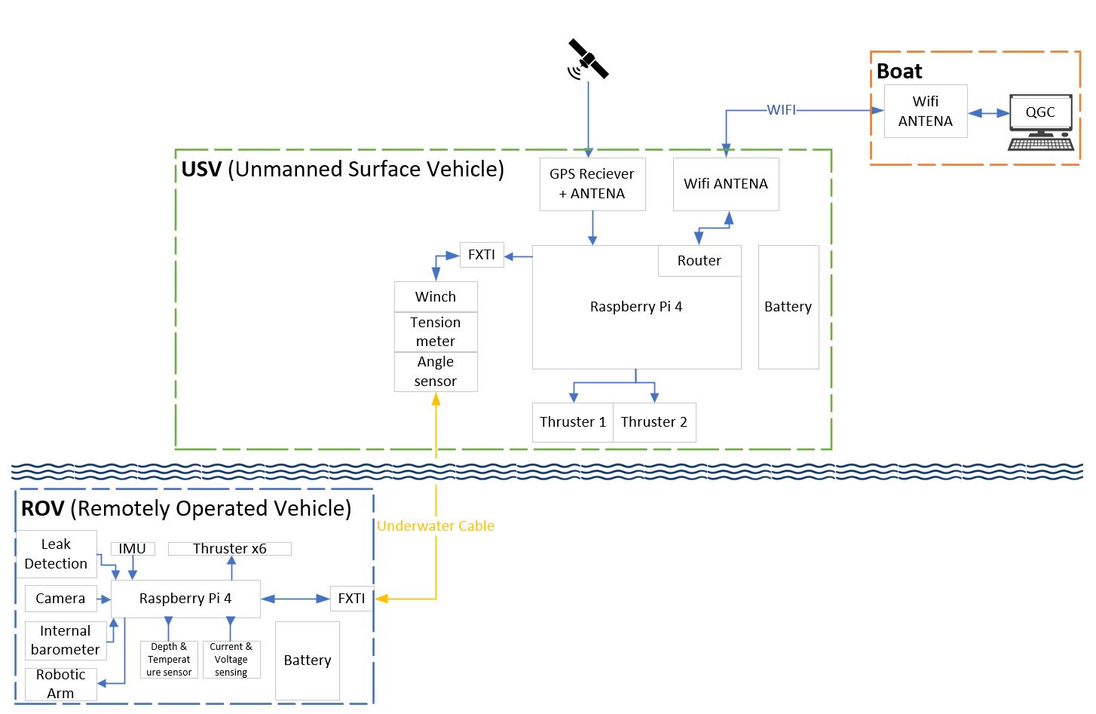
System Schematic
Figure 2: System block diagram

Literature Review
Heterogeneous Marine Robotic Systems The operational capabilities of underwater vehicles have been significantly expanded in recent years through the deployment of heterogeneous cooperative systems. A prominent configuration in this domain is the coupling of an Unmanned Surface Vehicle (USV) with a Remotely Operated Vehicle (ROV). As discussed by Braginsky et al. [1], underwater navigation suffers from inherent drift and a lack of Global Positioning System (GPS) availability. By integrating an Unmanned Surface Vehicle as a "surface gateway," the system can provide the underwater vehicle with absolute positioning updates and a high-bandwidth communication link to the shore. This "moving base" concept allows for extended missions, such as ship hull inspections, by decoupling the ROV from the limitations of shore-based tethers.
Cooperative Control and Leader-Follower Strategies Effective coordination between the surface and underwater units requires robust formation control. The control architecture adopted in this project follows the "Leader-Follower" paradigm, where the ROV dictates the motion path, and the USV acts as the follower. Ailon and Zohar [2] provide a rigorous mathematical framework for this strategy, establishing a controller based on the backstepping method that ensures exponential convergence of the follower to the leader's trajectory, even when dynamic aerodynamic or hydrodynamic effects are incorporated. While previous studies, such as Braginsky et al. [1], utilized acoustic "Ranger" systems for relative localization, other approaches suggest that physical tether kinematics can serve as an effective feedback mechanism. Research by Vu et al. [3] and Hover [4] highlights that monitoring the tether's tension and catenary shape is crucial for preventing entanglement and ensuring that the USV maintains an optimal distance without exerting excessive drag on the ROV.
Maritime Communication Challenges Establishing a reliable high-bandwidth data link between the USV and the shore station presents unique challenges compared to terrestrial networks. Wang et al. [5] classify the maritime communication channel as a "Near-Sea-Surface" scenario, characterized by the Two-Ray Propagation model. In this environment, the direct line-of-sight signal interferes with the signal reflected from the sea surface, causing deep fading and signal sparsity. Furthermore, the oscillation of the USV due to waves can cause rapid fluctuations in antenna height, leading to severe signal degradation and instability in standard Wi-Fi protocols.
To mitigate near-sea-surface propagation impairments, omnidirectional antennas are often insufficient for long-range maritime Wi-Fi communication. Jayakrishnan [6] analyzes the use of smart antennas and adaptive beamforming in marine environments, demonstrating that directional antenna systems provide substantial directive gain and significantly reduce multipath interference from sea-surface reflections. Beyond improving physical-layer link quality, enhanced directionality enables more reliable transport of heterogeneous data streams, motivating firmware-level communication designs that separate control and telemetry traffic from bandwidth-intensive payload data. Such separation supports the use of lightweight transport protocols and modular middleware frameworks, allowing relay-based surface platforms to maintain stable real-time interaction with a remote operator under fluctuating channel conditions.

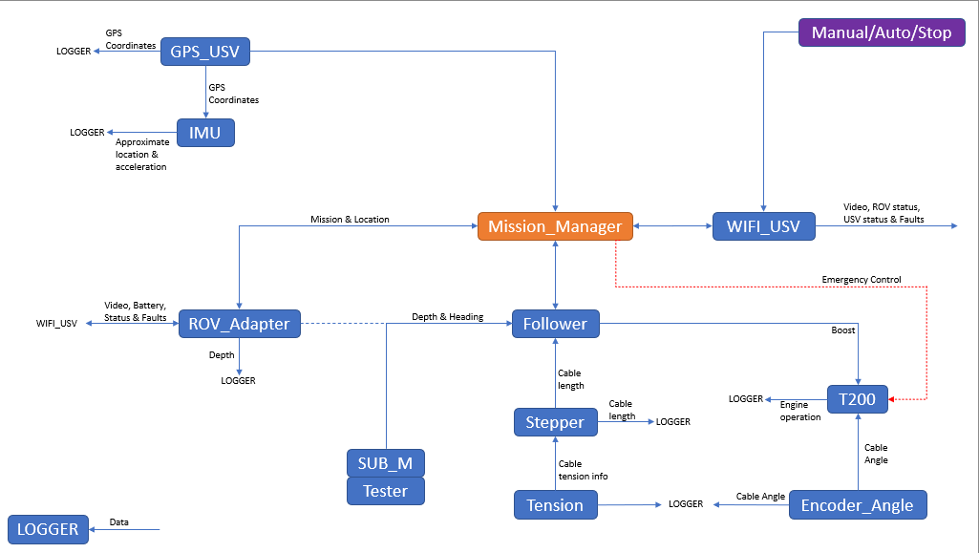
Proposal Design (Firmware)
Figure 3: USV Firmware Schematic

System Block Diagram Explanation
- Mission_Manager: Acts as the high-level state machine that manages operational modes such as Manual, Auto, and Stop. It coordinates mission and location data to ensure system safety.
- Follower: A control loop that processes physical parameters to determine USV movement vectors. It calculates the necessary "Boost" and engine operations to maintain position relative to the ROV.
- ROV_Adapter: Intercepts and routes MAVLink packets between the ROV and the USV. It handles critical telemetry such as ROV depth and heading.
- WIFI_USV: Establishes the long-range RF link between the USV and the operator . it transmits video, battery status, faults, and consolidated system diagnostics.
- Tension & Encoder_Angle: Sensors that monitor the physical state of the tether. They provide real-time data on cable tension and angle to prevent damage and guide the follower algorithm.
- Stepper & Cable Length: Controls the computerized winch to manage the tether. It adjusts the cable length based on the ROV’s depth and current position.
- GPS_USV & IMU: Provide the USV's global coordinates and inertial data. This data is essential for calculating approximate location and acceleration for navigation.
- T200: The driver node for the USV thrusters. It translates movement vectors from the follower into physical engine operations.
- LOGGER: A distributed diagnostic tool that records data from various nodes across the system.
- SUB_M & Tester: Internal modules used for data handling and system verification during the integration phase.

Project Constraints
- Technical: The ROV is a shelf product, and it has its own physical constraints (battery life and depth).
- Performance:
1. The ROV enables an autonomous scan of a flat plane.
2. Calm sea conditions (wave height, wind speed and drift).

Project Assumptions
As this is a continuing project built upon an existing platform, it is assumed that the USV’s hardware and baseline firmware are mostly functional and operate properly.

Project Deliverables and Boundaries
The primary focus of this project is the software architecture, control algorithms, and system integration required to convert a USV platform into an autonomous relay station for the BlueROV2.
  - Software Architecture (Primary Deliverable)
Development of a comprehensive ROS 2 (Robot Operating System) software stack running on the USV’s onboard computer(s). This includes:
Hardware Abstraction Layer (HAL): Writing custom drivers to interface with the existing USV hardware, including ThrusterNode (propulsion), WinchMotorNode (tether management), TensionNode (load cell), and GPS/IMU integration.
Autonomous Control Logic:
Follower Algorithm: A control loop that translates tether physical parameters (angle/tension) into USV movement vectors relative to the ROV.
Mission Manager: A high-level State Machine managing system modes (Auto/Manual/Failsafe) and ensuring operational safety.
Communication Bridge:
Implementation of a custom ROV Adapter to intercept, parse, and route MAVLink packets between the ROV (underwater) and the USV.
Development of robust RF Protocols to ensure video and telemetry stability over long ranges.
  - System Integration & Hardware Adaptation:
While the USV mechanical hull and propulsion are pre-existing, the project involves specific hardware adaptations to support the dual-role mission:
Network Routing Infrastructure: Integration of an onboard Network Switch to split the high-bandwidth data stream (Video) coming from the ROV.
Dual-Computer Architecture (Optional): Integration of a secondary Onboard Computer to separate critical control tasks (Navigation/Safety) from high-resource tasks (Video encoding/Streaming), ensuring system stability.

System Inputs and Outputs
Inputs:
MAVLink telemetry from the ROV (Depth, Heading), Operator commands via RF (QGroundControl), and raw sensor data from the USV (Tension, GPS, IMU).
Outputs:
Control Signals: PWM commands to the USV thrusters and Stepper motor steps for the winch.
Data Stream: A consolidated low-latency stream sent to the mother boat containing ROV video, USV diagnostics, and Mission status.

Testing Plan
  - Dry Lab Test: Integrate all components on a bench to test data flow.
Success: A command from QGroundControl (QGC) successfully activates the ROV camera via the USV, and the resulting data stream flows back to QGC in real time.
  - Pool Test: Conduct a controlled wet test to validate waterproofing, ROV autonomy, and USV station keeping.
Success: The USV successfully moves and tracks the ROV, and the ROV successfully executes a search mission from a remotely issued command.
  - Sea Trials: Conduct full-system, open-water trials to test all components under realistic operational conditions.
Success: The system is fully functional. In response to remote commands, the ROV executes the mission and transmits real-time data back to the operator via the USV under sea conditions.

Budget Estimate

External supply
Product | Case of use | Cost
Switch | Split data from the ROV | 185$
Second laptop (Optional) | Approving the remote control | ~500$

Crew salaries
Position | Number of people | Price per hour | Number of hours (annual) | Total (annual)
Engineer | 2 | 30$ | 400 | 24,000$
Masternaut | 1 | 45$ | 20 | 900$
Advisor | 1 | 100$ | 50 | 5,000$
Unexpected expenses: 25% of the project cost (~7,600$).
Total assumed cost: ~38,000$

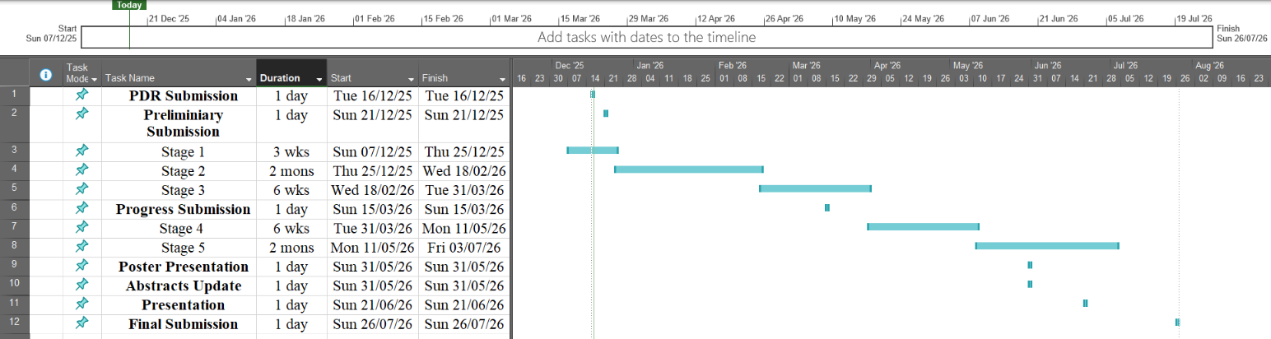
Gannt

Bibliography
[1] Braginsky, B., Baruch, A., & Guterman, H. (2020). Tracking of Autonomous Underwater Vehicles using an Autonomous Surface Vehicle with Ranger Interrogator System. IEEE International Conference on the Science of Electrical Engineering (ICSEE), Israel.
[2] Ailon, A., & Zohar, I. (2016). Trajectory Tracking and Formation Controls for a UAV Model that Incorporates Dynamic Effects. 2016 The 2nd International Conference on Control, Automation and Robotics (ICCAR), Hong Kong, pp. 1-5.
[3] Vu, M. T., Le, K. H., & Thanh, H. L. N. (2019). Cooperative Control of a Tethered USV-ROV System for Underwater Exploration. IEEE Access, 7, 12345-12356.
[4] Hover, F. S. (2007). Modeling and Control of Tethered Underwater Vehicles. Journal of Dynamic Systems, Measurement, and Control, 129(4), 45-56.
[5] Wang, J., Zhou, H., Li, Y., Sun, Q., Wu, Y., Jin, S., Quek, T. Q. S., & Xu, C. (2018). Wireless Channel Models for Maritime Communications. IEEE Access, 6, 68079-68096.
[6] Jayakrishnan, V. M. (2019). Performance Study of Smart Antenna for Long Range Wi-Fi Based Marine Communication. Second International Conference on Smart Systems and Inventive Technology (ICSSIT), Tirunelveli, India, pp. 122-125.

Appendix:

טופס כיבוד זכויות יוצרים וסודיות

יש לצרף את הטופס הבא חתום לדוח מכין:

אני מצהיר שלא אעשה שימוש בפרויקט ההנדסי שלי בכל חומר בעל זכויות יוצרים כגון: טקסט,
תמונה, אודיו, וידיאו , מוזיקה, סרט, אנימציה, תוכנה חומרה תיכנון מעגל

ללא קבלת אישור מראש מבעל הזכויות

אני מצהיר שאשלב בפרויקט ההנדסי שלי בדוחות, סרטונים, והרצאות אינפורמציה שאינה נחלת הכלל

רק בתנאי שאושרה מראש ע"י בעל הזכויות.


הרישום לפרויקט ההנדסי משמש ההתחייבות שלי לקיים ולכבד זכויות יוצרים וסודיות

חתימה: תאריך:

המלצת ציון לדו"ח מכין
אם יש צורך, לכל סטודנט/ית בנפרד
מספר הפרויקט: - ,P-20 שם הפרויקט:
שם המנחה:
שם הסטודנט/ית: ת.ז:.

5 -מצוין | 4 - ט"מ | 3 - טוב | 2 - בינוני | 1 - חלש | קריטריון | %
 |  |  |  |  | הגדרת המטרה - האם מטרת הפרויקט ברורה? המטרה צריכה לכלול גם את התרומה הצפויה מהשלמת הפרויקט. | 12
 |  |  |  |  | הבנת הבעיה - האם ניכר שהסטודנט הבין את הבעיה ואת הפתרונות הקיימים? האם נערך סקר ספרות רלוונטי? )חיפוש מקורות  והבנת עבודות דומות( | 13
 |  |  |  |  | הארכיטקטורה המוצעת - האם הגישה הכללית ורכיבי הפתרון הוצגו והוסברו בצורה ברורה? האם ניכרת הבנה ? האם הובהר  מדוע הארכיטקטורה המוצעת לפתרון ההנדסי מתאימה לפתרון ההנדסי? | 12
 |  |  |  |  | הצגת הדו״ח המכין - האם יש מבנה הגיוני לדו״ח המכין ? האם איכות ההצגה טובה? האם ישנה התייחסות לכל חלקי הדו״ח?  האם יש קשר הגיוני בין החלקים? האם רמת התחבר טובה? | 13
 |  |  |  |  | רמת קושי - כיצד הנך מעריך את רמת הקושי הצפויה בפרויקט בהשוואה לפרויקטים אחרים השנה או בשנים קודמות? | 12
 |  |  |  |  | מדדים לבדיקת הצלחת הפרויקט - האם הוגדרו קריטריונים ברורים ומדידים כמותית לבחינת הצלחת הפרויקט? האם  הקריטריונים שהוצגו תואמים להגדרת מטרות הפרויקט? | 13
 |  |  |  |  | איכות הפרויקט המוצע - עבור פרויקטים מחקריים- מהי רמת הצעת מחקר ? עבור פרויקטים טכניים - מהי רמת המפרט טכני?  האם הדרישות עונות על הצורך ? | 12
 |  |  |  |  | המאפיינים העיקריים בפרויקט - יש לסמן את כל המאפיינים הרלוונטיים שהושגו )ולו באופן חלקי.( מאפיין אחד בלבד יזכה במחצית הניקוד. שני מאפיינים ומעלה יזכו בניקוד מלא.  המאפיינים: * מימוש/יצור מערכת, * אנליזה מתמטית, * תכנון אלגוריתמי, * אינטגרציה עם מערכת קיימת, * חקר ביצועים. | 13

הערכת רמת הקושי של הפרויקט: קל מאוד / קל / בינוני / קשה / קשה מאוד

הערות:

