**Blood-flow based Biometric Authentication –**

**A Brief Summary**

* **Project Goal**

Collecting signals reflecting blood-flow at the fingertip using a cellular phone camera and flash. The blood-flow signals will be used to establish a unique personal blood-flow signature, that would then be used just a like a fingerprint for biometric authentication.

* **Chosen Solution**

We used 2 types of databases: the first one is a database of 42 PPG signals, and the second is from 7 videos of fingertips which we took using our phones. We will refer to them as PPG database and video database.

The difference in the classification algorithm between the 2 types is only in the pre-processing stage.

**Pre Processing:**

For the PPG database, we extracted from each 8 minutes long signal 2 different 20 seconds long segments. Each segment went through a 3rd order Butterworth band pass filter with cutoff frequencies of 0.5Hz-5Hz.

For the video database, we extracted from each video the red channel, and calculated the mean for each frame. Those means represent the PPG signals. Each signal went through a smoothing process.

From this point on, both databases went through the same process.

The derivatives of the PPG signals were calculated. The derivatives were divided into segments of 1 cycle each, with the peak at the center.

**Acquire DCT:**

From those 1 cycle long segments the auto-correlation of length $M$ was calculated. We used half of the auto-correlation coefficients. Then the DCT was Calculated, and we used $C$ DCT coefficients.

**Acquire PCA:**

First we calculated the eigen vectors of the database, then we selected $numOfVectors$ amount of those vectors and multiplied them with the database. That result was the PCA matrix.

**Classification Using SVM:**

We chose 4 cycles for a training set, and 2 for a test set. Once we had a train set, we could build an SVM model and train it. The SVM model is actually multiple SVM models: for each subject, a model was trained against all other subjects.

We tested the models with the test set: for each subject we found the likelihood it matches a certain label, and the maximum was selected.

The way to test our results was success rate in percentages.

We performed the SVM classification on 3 options: DCT coefficients, PCA coefficients and a combination of DCT and PCA coefficients.

For our final run, we went through multiple hyper-parameters, and saved the results in a table. The parameters are: the number of DCT coefficients selected, the number of PCA coefficients selected, and for the PPG database the number of subjects selected.

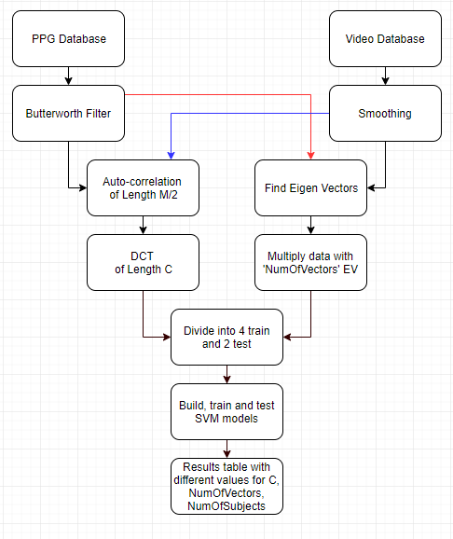

The Best results for the 3 options were for the combination of PCA and DCT coefficients. The results varied between different selections of segments in the stage where we chose cycles.

Here are the results for the video database, for specific segments (the best row in the table):

|  |  |  |  |  |  |
| --- | --- | --- | --- | --- | --- |
| numOfSubjects | numOfVectors | C | Test 1(%) | Test 2(%) | Average(%) |
| 7 | 6 | 1 | 100 | 85.7 | 92.85 |

Here are the results for the PPG database, for specific segments (the best row in the table):

|  |  |  |  |  |  |
| --- | --- | --- | --- | --- | --- |
| numOfSubjects | numOfVectors | C | Test 1(%) | Test 2(%) | Average(%) |
| 10 | 5 | 13 | 90 | 100 | 95 |