**The Harmonizome Mobile Application**

Michael G. McDermott, BS1,2, Gregory W. Gundersen, MA1,2, Maxim V. Kuleshov, MS1,2, Avi Ma’ayan, PhD1,2

1Department of Pharmacology and Systems Therapeutics, Icahn School of Medicine at Mount Sinai, One Gustave L. Levy Place, Box 1215, New York, NY 10029 USA

2BD2K-LINCS Data Coordination and Integration Center (DCIC)

Most online databases that enlist properties of human genes and proteins only include information from a hand full of resources. Genomics, transcriptomics and proteomics resources can provide additional information about single genes or proteins, but these are not readily organized and abstracted for such purpose. To create the Harmonizome mobile app, we assembled, extracted, and organized knowledge from over 60 online resources, including novel databases that we created such as: ChEA, KEA, SILAC phosphoproteomics, ESCAPE, PPI Hubs, and collections of signatures extracted from GEO. The Harmonizome mobile app serves this accumulated knowledge in an easy to access interface where users can enter their gene/protein of interest to discover its properties and functions. The knowledge spans many bioinformatics omics resources from expression in cells, tissues and diseases; regulation by transcription factors, chromatin marks and microRNAs; functional membership in protein complexes, pathways and ontologies; genomic associations with disease, and differential expression upon treatment of human cells with drugs; as well as structural and other genomic features. The Harmonizome app serves the collected knowledge in defined categories for navigation ease, and with links out for further exploration of associated functions of genes and proteins. The Harmonizome mobile application is available at the Google Play Store: <http://goo.gl/JWlI8H> for Android devices, and the App Store <http://appstore.com/harmonizome> for iOS devices.

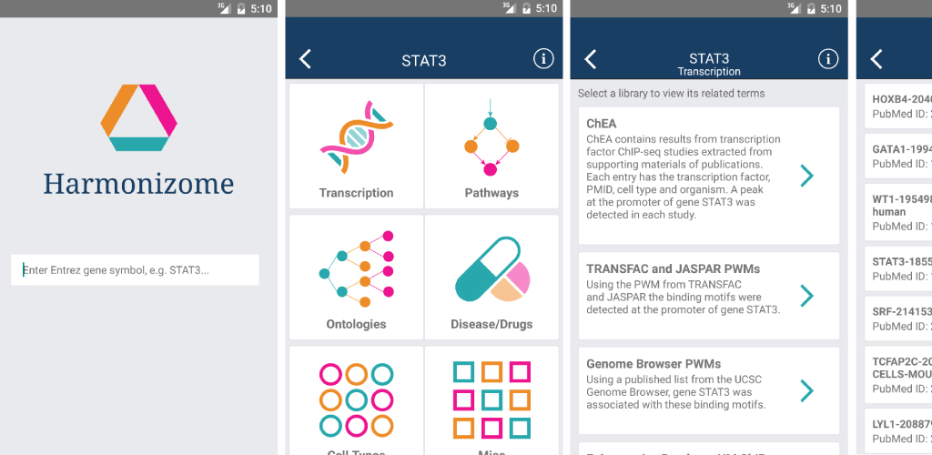

*Screenshots from the Harmonizome mobile app*

Submitting author’s career stage: Research Programmer/Analyst