
COMSATS UNIVERSITY ISLAMABAD, ABBOTABAD CAMPUS
SOFTWARE ENGINEERING

ASSIGNMENT SUBMITTED BY:
AHMED NAWAZ (SP23 BSE 059)

ASSIGNMENT 1:
SDA(DESIGN)

SUBMITTED TO:
SIR MUKHTIAR ZAMIN

CLASS DIAGRAM:

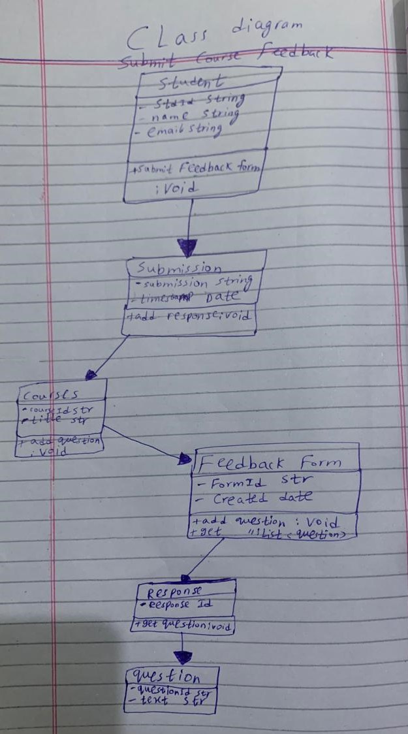

COMMUNICATION DIAGRAM:
