Developers Guide

Thirft Fashion



# Contents

**HomeController……………………………………………………………………………2**

**ProductController………………………………………………………………………….3**

**UserController…………………….………………………………………………………...8**

# **Home controller**

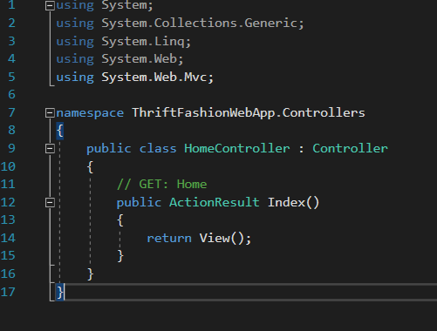

## **Product controller**

# 

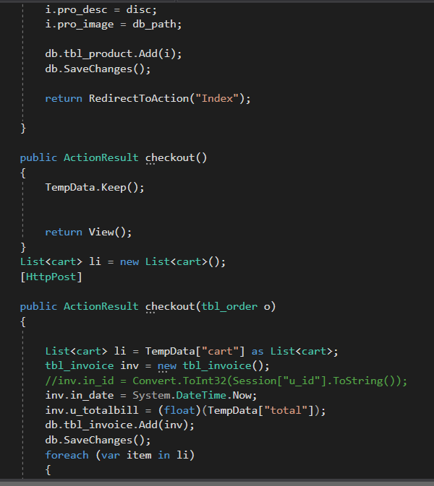

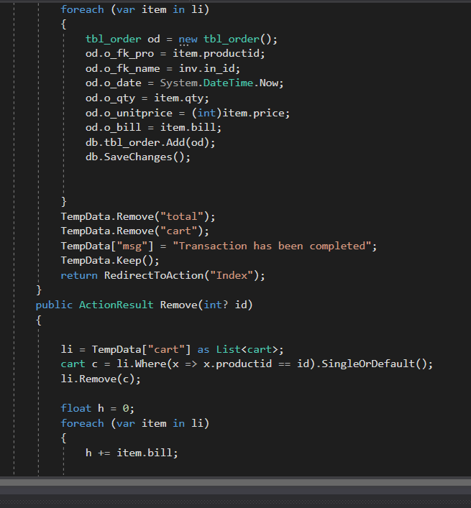

# 

## **User Controller**

