

**THRIFT**

**FASHION**

# **Table of Content**

## Particulars Page Nos.

**CERTIFICATE 3**

**Table of Content 4**

**Problem Statement 5**

**Customer Requirement 7**

**Project Plan 14**

**ER Diagrams 15**

**Context Diagram 16**

**Algorithms 21**

**GUI Standards 22**

**Interface Standard 30**

**Task Sheet 30**

**Project Review and Monitoring Report 31**

**Unit Testing Check List 32**

**Final Check List 33**

**PROJECT GROUP MEMBERS**

|  |  |
| --- | --- |
| **Students’ ID** | **Students’ Name** |
| **Student12** | **ZEHRA KHAN AFRIDI** |
| **Student1280883** | **MAAZ TAJAMMUL** |
| **Student1283827** | **MUHAMMAD HUZAIFA ALI** |
| **Student12** | **KAMAL** |

**BATCH CODE**

**2010C1**

**FACULTY**

**SIR MOHSIN HUSSAIN**

**CO-ORDINATOR**

**Miss Faiza**

# **CERTIFICATE**

This is to certify that the dissertation entitled **“THRIFT FASHION”** is submitted by **Ms. ZEHRA KHAN AFRIDI, Mr. MAAZ TAJAMMUL, Mr. MUHAMMAD HUZAIFA ALI & Mr. KAMAL**

in their partial fulfilment of the requirement of the award of the TechWiz 3.

# 

# **Problem Statement**

**INTRODUCTION:**

This website is designed to meet the e-commerce requirements of Fashion Industry to engaged in imparting by the name “Thrift Fashion”. The idea is to help individuals with online shopping for pre-used fashionable clothing and provide better access to such products. Users can browse for products, search, filter, and so on. Users can also submit their feedback regarding the application using a feedback form. e.g. Counselling for various courses, Follow ups for various queries of the past, Advertisement of the company to get new candidates for training, complete management of student data, batch details, faculty information, subject, material information etc. Besides all these it will also take the day to day operations of the organization e.g. No. of hours worked by the, each candidate, Comments and Suggestions of the candidates taking training there, maintenance of systems for the employees and candidates of the company. The system will be under the command of In- charge of the company. He will have the authority to modify the criteria for students according to the latest rules of Board of Management of the organization. In this way this system will greatly help the owner in getting latest happenings.

**OBJECTIVES:**

# To design a cost, effective Inventory Management System.

# To use the latest IT tools and Internet/Intranet technology to make a, Employee Management Evaluation System.

1. To save the precious time of Official Staff of Training Dept.

# To automate the records of all the queries and follow ups etc. about the

candidate.

# To keep the candidates updated about Organization activities, its courses divisions, groups etc.

# To help in getting information about a student i.e. about his batch, date of birth, date of joining, outstanding fee, material issued etc.

# Automate the Students records maintenance system of Organization.

# Strong RDBMS, capable of handling ‘sensitive’ data with utmost discretion. Support multi-location and distributed environment.

# Utilization of the latest Client –Server architecture, Enhanced query timings.

# **MODULES:**

# 1)    Login Module

# 2) Candidate Module

# 3)    Faculty Module

# 4)    Batch Module

# 5)    Course Module

# 6)    Exam Module

# 7)    Enquiry Module

# 8)    Reports Modules.

# **Login Module**

# Login module provides the security to the software. It asks for the user id and password

# to the user and confirms it with database whether the id and password combination is

# correct or not. It the combination is correct only then this module will allow the user to

# access the software else it will close the application.

# **Candidate Module**

# Candidate module deals with all the transactions of the candidate with the institute. It

# creates the accounts of the user and maintains them. All the activities regarding student

# like break of student, fine details, payment mode, timing of their batches etc.

# **Faculty Module**

# Faculty module handles all the transactions related to the faculties of the institute. It

# maintains their batch timings, batch code, provides them faculty codes and stores their

# personal information in the database.

# **Batch Module**

# Batch module is an important module, which is used by mostly all the modules of this

# software. It is used by the student module as well as faculty module. The course module

# and exam module also use it.

# **Course Module**

# Course module is an important module of this software. It contains the course details

# like course code, name of course, course fees, etc.

# **Exam Module**

# Exam Module is the last but not least module. It keeps details pertaining to exams like

# when to arrange exam, date, time, course, student id etc. Also keeps track of marks

# obtained by a particular student to later view his performance.

# **Enquiry Module:**

# Enquiries related to various courses offered by the institution.

# **Reports Module:**

# VARIOUS PROPOSED REPORTS IN THE SYSTEM

# The following reports can be generated through this module:

# *Student Detail Reports*

# Report showing details of Candidates month wise/year wise.

# Report showing details of Candidates completed training programs and still on roll.

# Report showing details of Candidates batch wise.

# Report showing details of Candidates applied for certificates.

# Report showing details of Installments paid or remaining by the Candidates.

# Report showing details of Discount given to Candidates.

# *Examination Report*

# Report showing details of Examination.

# *Financial Reports*

# Report showing details of Fee collected.

# Report showing details of Fine collected.

# Report showing details of Outstanding payment.

# Report showing details of Payment reminder.

# *Batch Details Reports*

# Report showing details of Ending Batches.

# Report showing details of Starting Batches.

# Report showing details of students in a particular batch.

# Report showing details of test report batch wise.

# **Project Plan**

|  |  |  |  |
| --- | --- | --- | --- |
| NO | Project Plan | Team Mates Name | Status |
|  |  |  |  |
| 1 | Material Searching | MAAZ TAJAMMU, MUHAMMAD HUZAIFA ALI, NABEEL SHAHID KHAN | Yes |
| 2 | Graphical Designing | MAAZ TAJAMMU, MUHAMMAD HUZAIFA ALI, NABEEL SHAHID KHAN | Yes |
| 3 | Interface Designing | MAAZ TAJAMMU, MUHAMMAD HUZAIFA ALI, NABEEL SHAHID KHAN | Yes |
| 4 | Data Base | MAAZ TAJAMMU, MUHAMMAD HUZAIFA ALI, NABEEL SHAHID KHAN | Yes |
|  |  |  |

# **ER Diagrams**

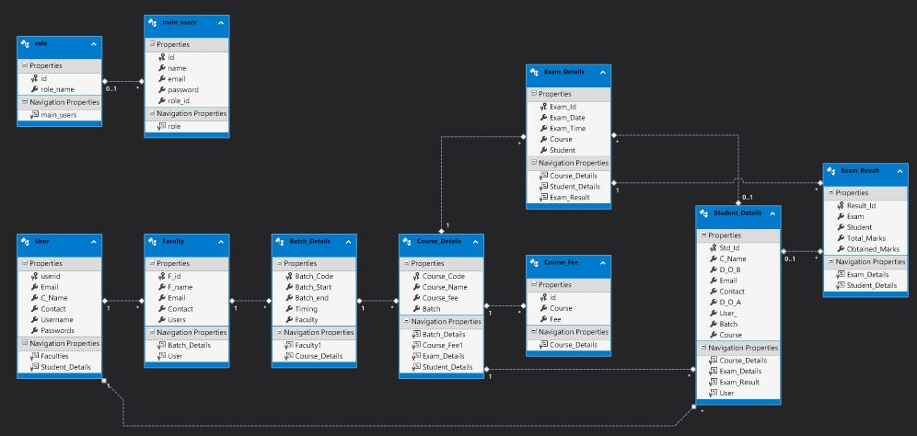

# **Algorithms**

**Home**

Home pages is the view of tickets purchase in the price of list and show of the location. Home pages are many buttons and linking of the buttons and others pages go to the easily provides and customer helping.

**About us**

About us pages are flight information and flight processing and other many details.

**Contact us**

There are customers guide to give the message and contact us to team they message are provide system.

**Register**

Register form are upload to the system and customer are register to them self and register form are so many fields. The register user login in any id and password.

**Login**

The register user is login and purchase the admission and many facilities are login user.

**Guest Login**

The guest login are, cannot purchase the ticket only view the website.

**Dash Board**

Dash board login id “[Admin@gmail.com](mailto:Admin@gmail.com)” is open to the dash board.

password: Admin1@

**Task Sheet**

|  |  |  |  |
| --- | --- | --- | --- |
| NO | Task Sheet | Team Mates Name | Status |
|  |  |  |  |
| 1 | Case Study | MAAZ TAJAMMU, MUHAMMAD HUZAIFA ALI, NABEEL SHAHID KHAN | Done |
| 2 | Graphical Designing | MAAZ TAJAMMU, MUHAMMAD HUZAIFA ALI, NABEEL SHAHID KHAN | Done |
| 3 | Interface Designing | MAAZ TAJAMMU, MUHAMMAD HUZAIFA ALI, NABEEL SHAHID KHAN | Done |
| 4  5 | Site Testing  Publishing | MAAZ TAJAMMU, MUHAMMAD HUZAIFA ALI, NABEEL SHAHID KHAN | Done  Done |
|  |  |  |

# 

+

# **Project Review and Monitoring Report**

**Purpose**

To provide increased project visibility through efficient and effective project monitoring and reporting.

**Overview**

Project monitoring and reporting involves:

The monitoring of actual project progress as compared to the planned project progress and the collection of key progress metrics such as risks, issues, changes and dependencies; and?? The reporting of project status, costs and outputs and other relevant information, at a summary level, to the project sponsor, project steering committee and other project stakeholders. Project monitoring typically involves tracking five variables: Schedule - the estimated effort and duration versus the actual effort and duration; Costs - the estimated cost versus the actual costs; Deliverables - what products or components have been delivered and plan to be delivered;

Quality how well are the deliverables being completed and Benefits - are the processes in place to achieve and to measure the lead indicators for benefits. The format and timing of project monitoring and reporting will vary in each other. And will also depend upon such items as the size, duration, risk and complexity of the project.

# **Unit Testing Check List**

|  |  |  |
| --- | --- | --- |
| NO | Unit Testing  Check List | Status |
|  |  |  |
| 1 | Search Bar | Done |
| 2 | Header | Done |
| 3 | Footer | Done |
| 4  5  6  7  8  9  10 | Site Testing  Data Base  Navigation  Images  Linking  Data Base Connect  Contact | Done  Done  Done  Done  Done  Done  Done |
|  |  |  | |

# **Final Check List**

|  |  |  |
| --- | --- | --- |
| NO | Unit Testing  Check List | Status |
|  |  |  |
| 1 | Search Bar | Done |
| 2 | Header | Done |
| 3 | Footer | Done |
| 4  5  6  7  8  9  10 | Site Testing  Data Base  Navigation  Images  Linking  Data Base Connect  Contact | Done  Done  Done  Done  Done  Done  Done |
|  |  |  | |