

**Web Programing Language:**

**Assignments**

NAME: Maaz Ahmed:

ID: (13378):

Program Bs(cs):

Assignments 1-25:

**Assignment No 1:**

**Screenshot:**

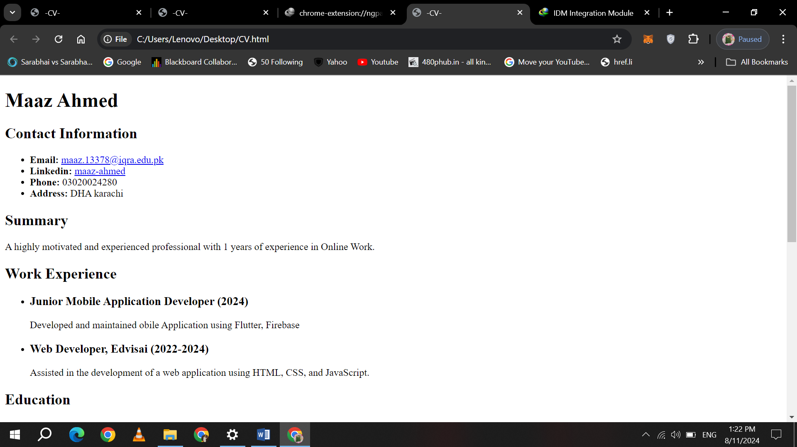

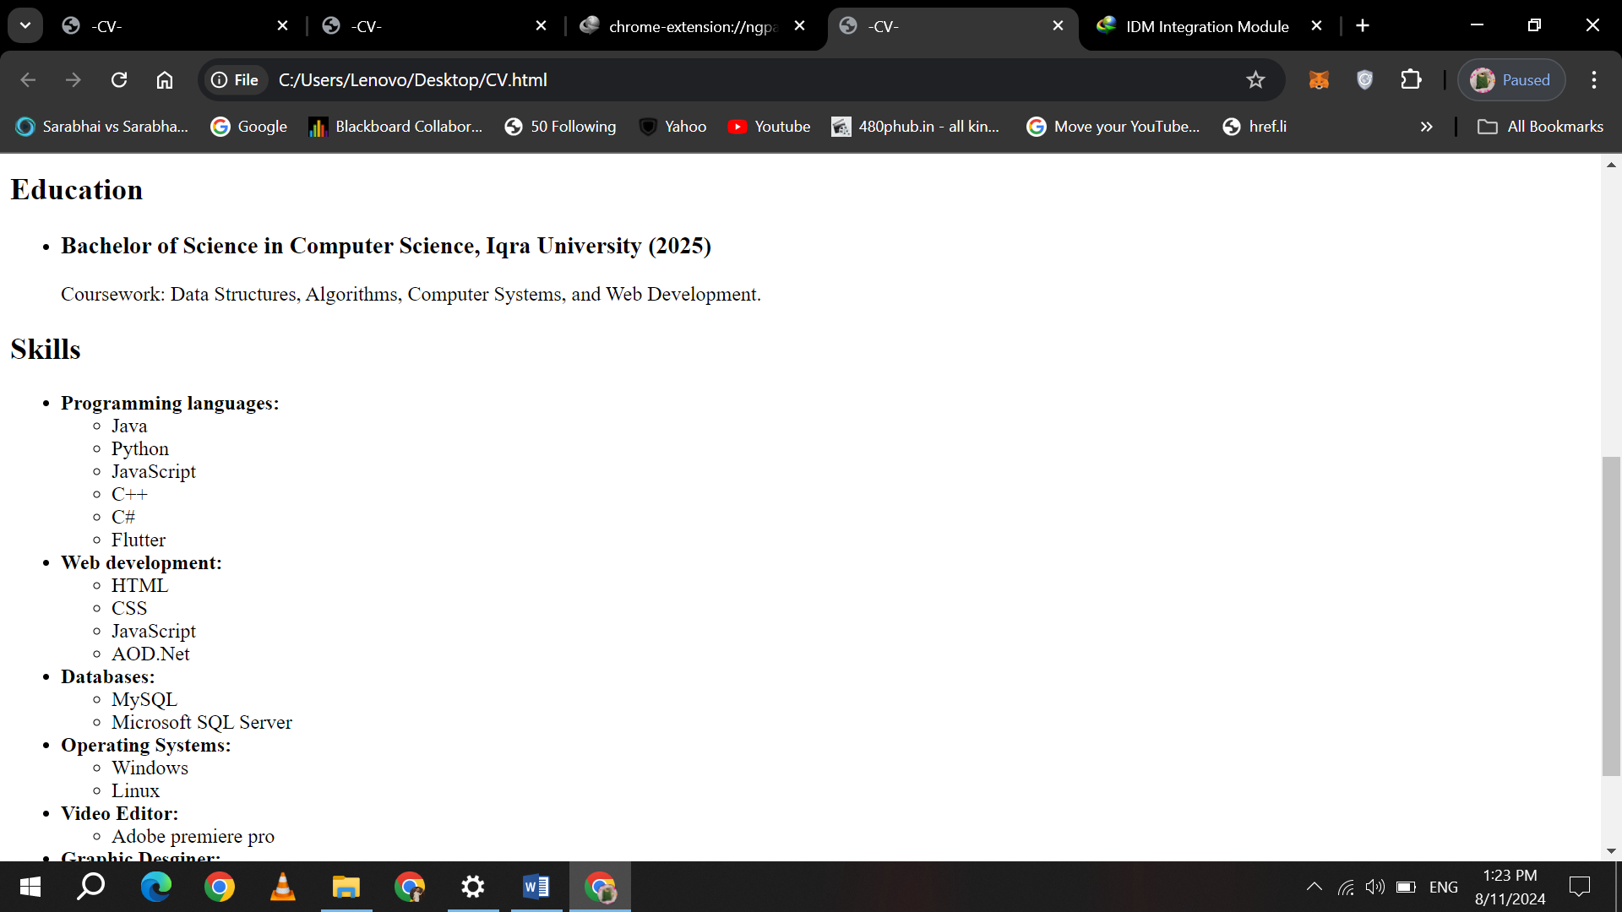

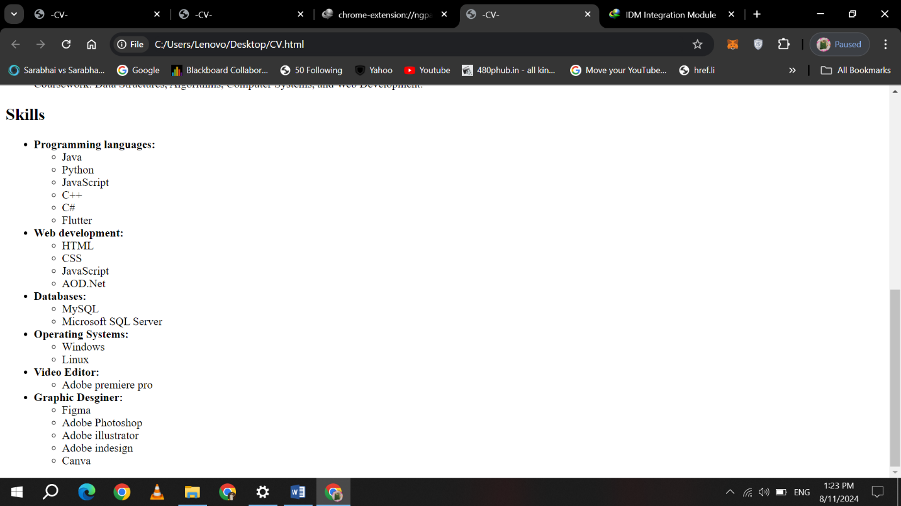

**Assignments No 2:**

**Screenshot:**

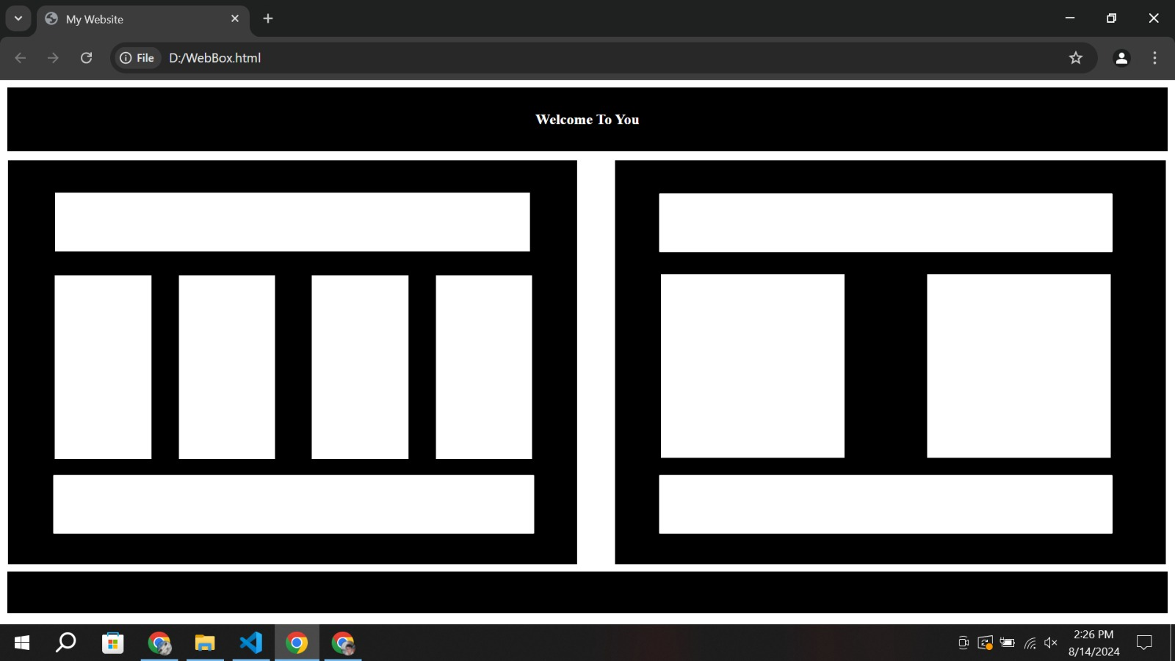

**Assignment No 3(a):**

**Screenshot:**

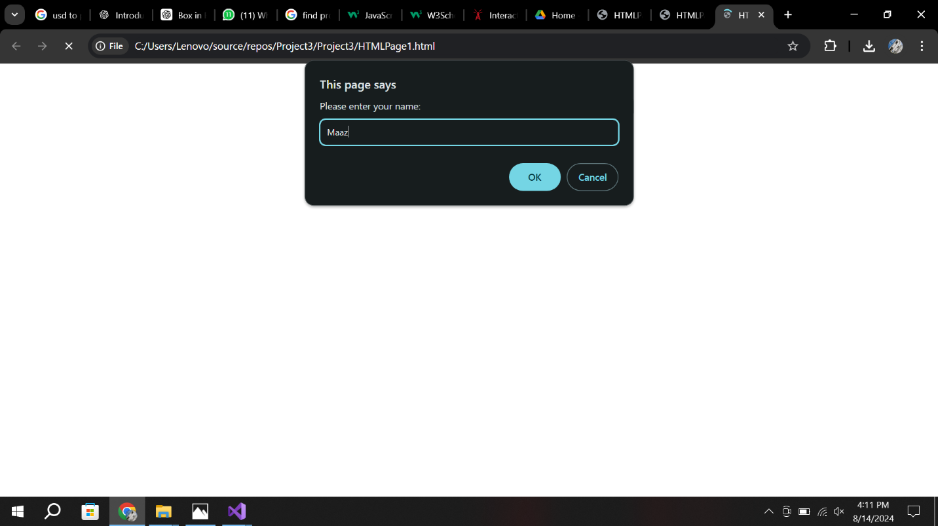

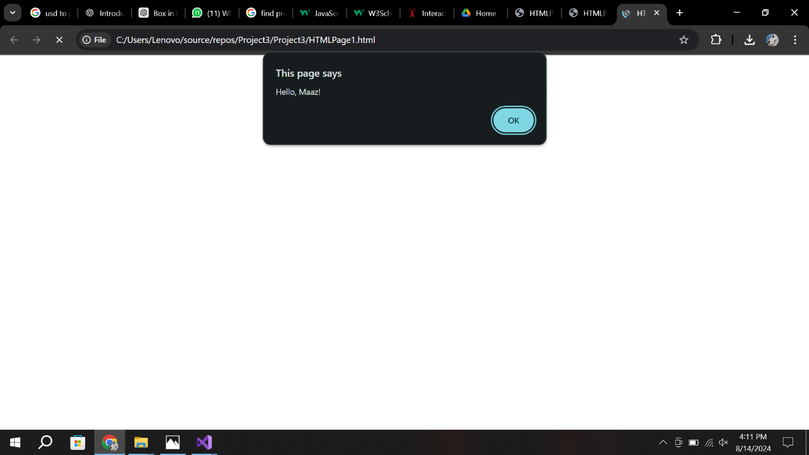

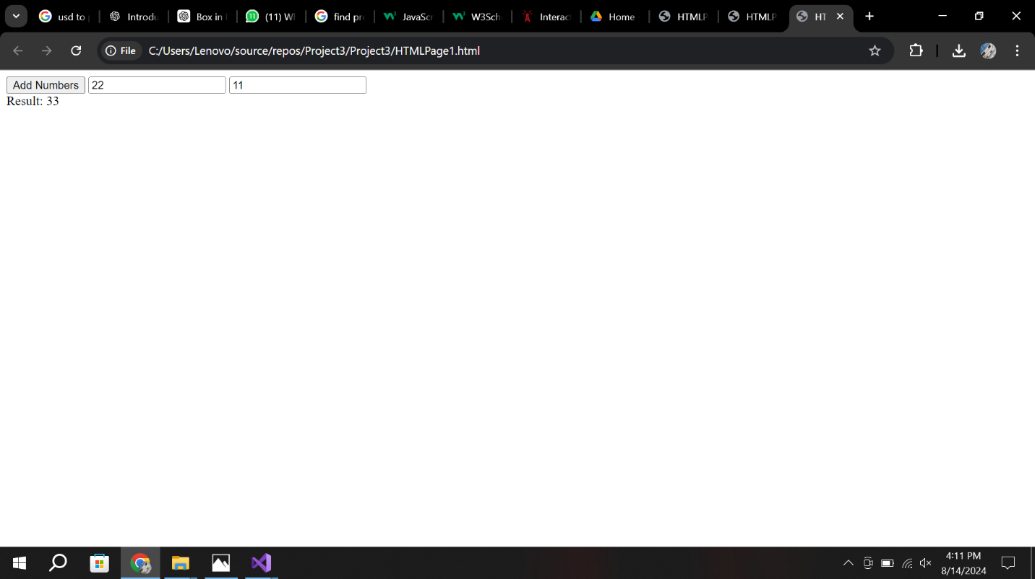

**Assignment No 3(b):**

**Screenshot**

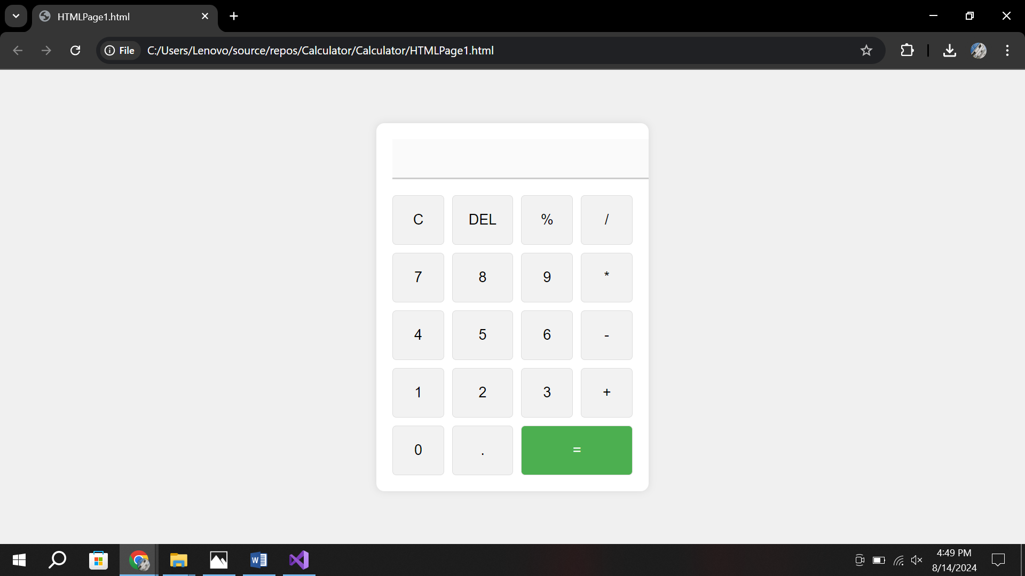

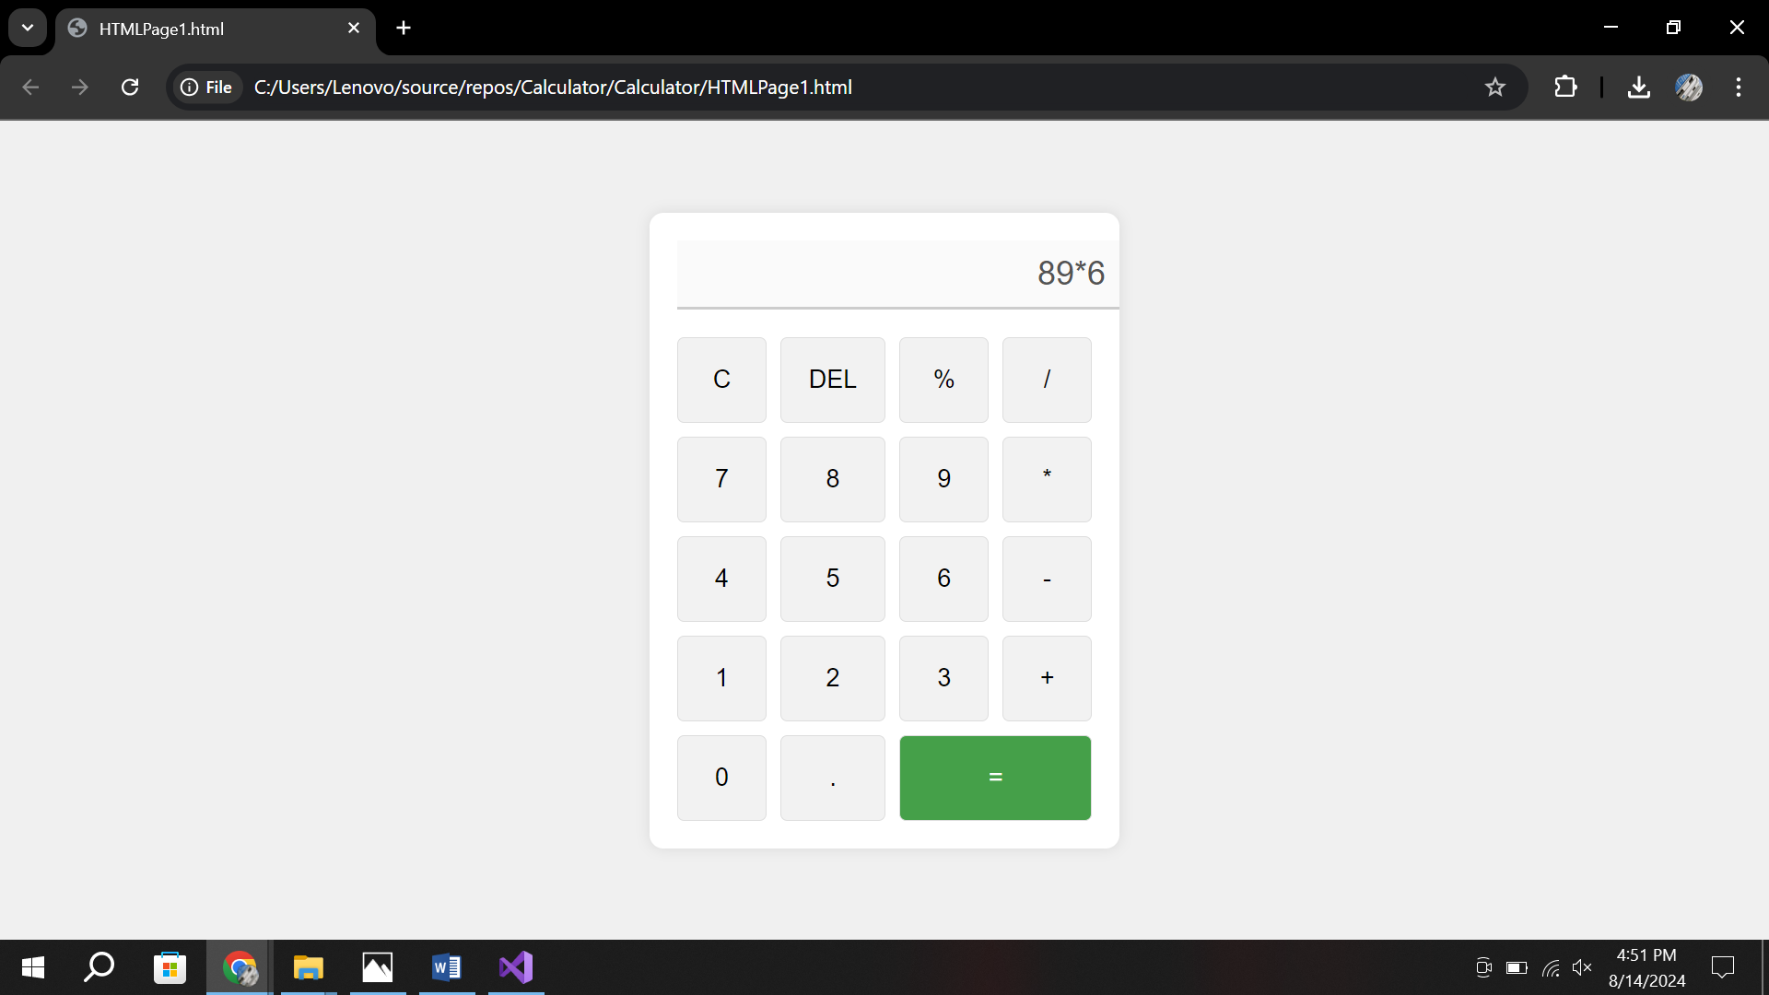

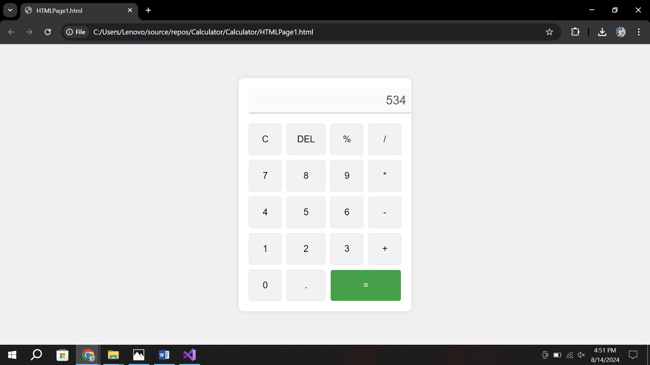

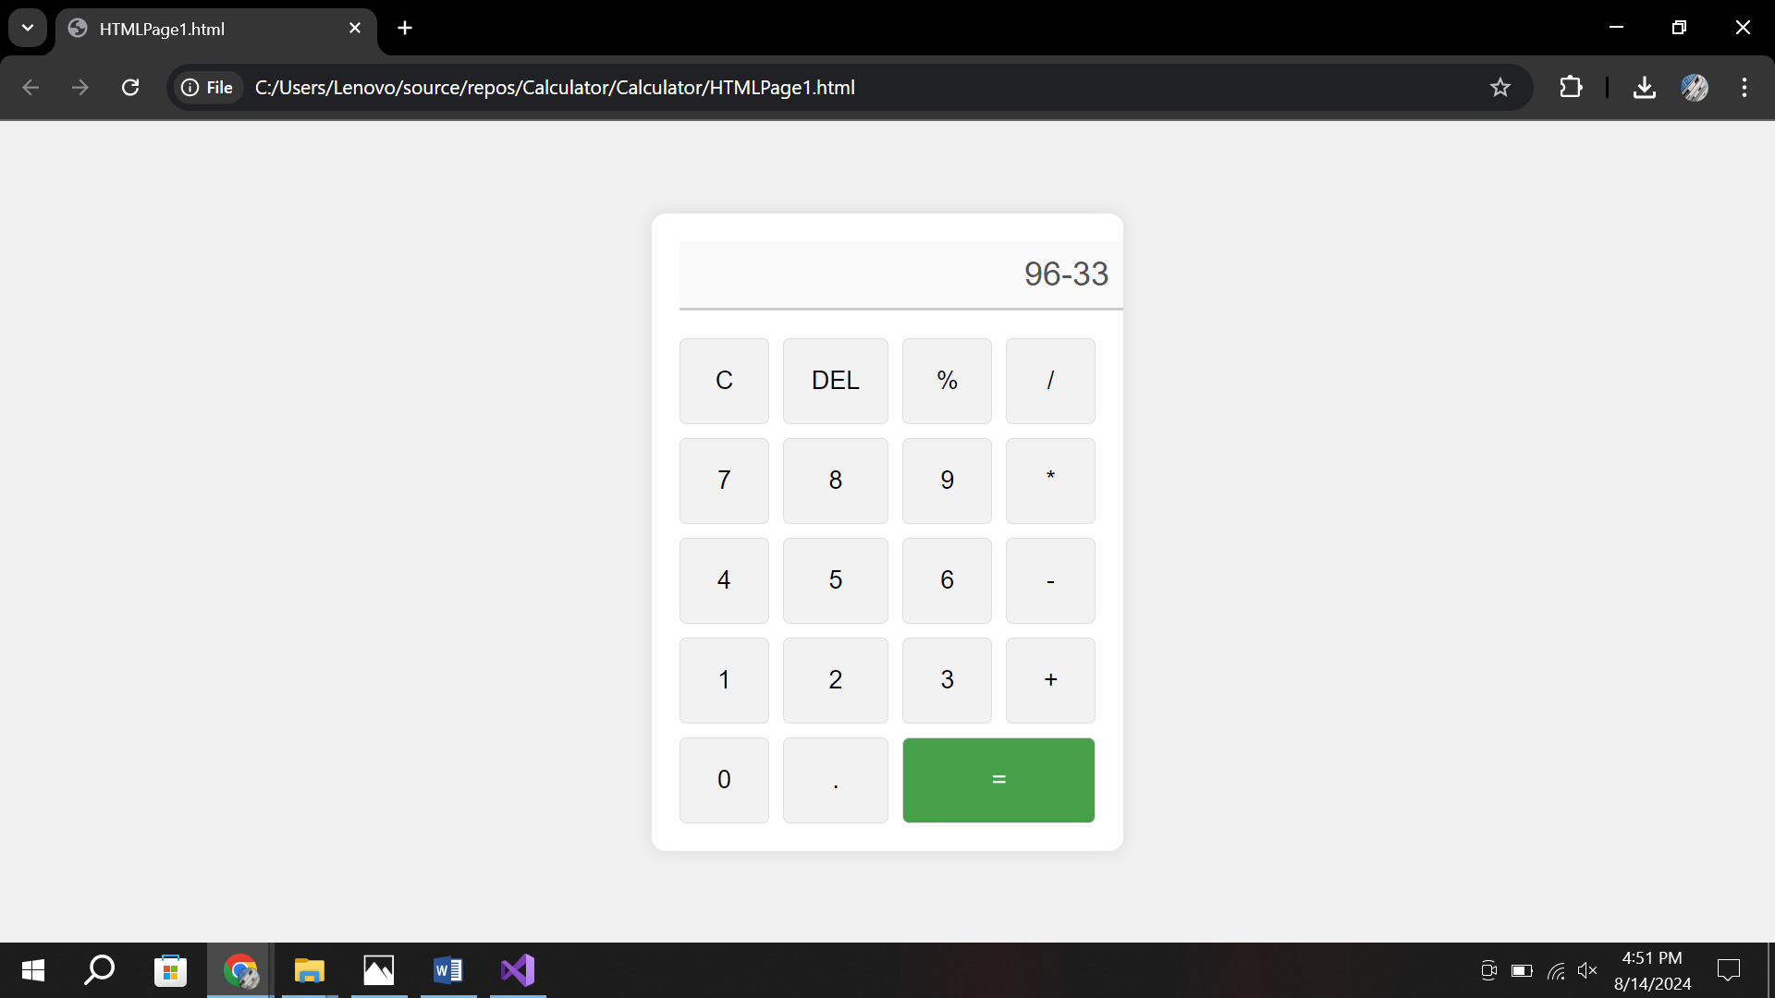

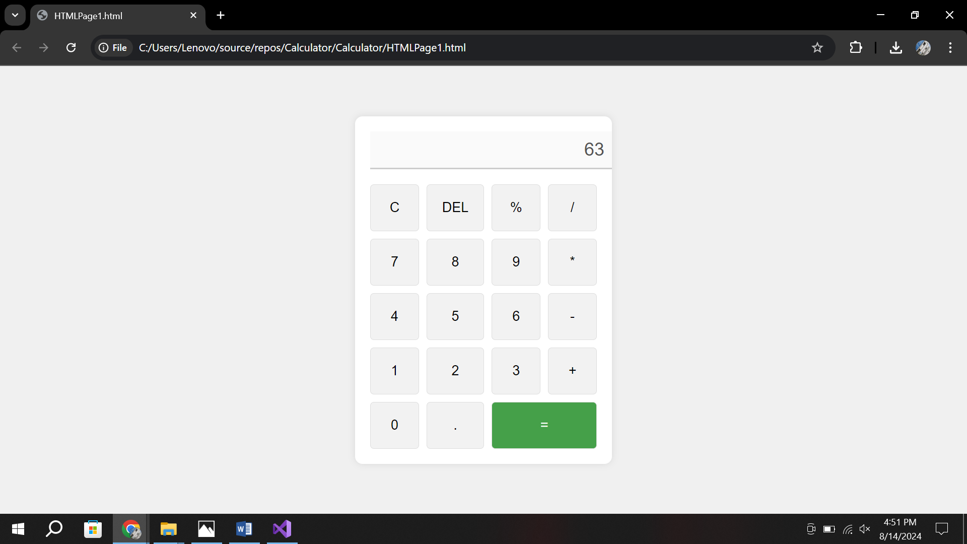

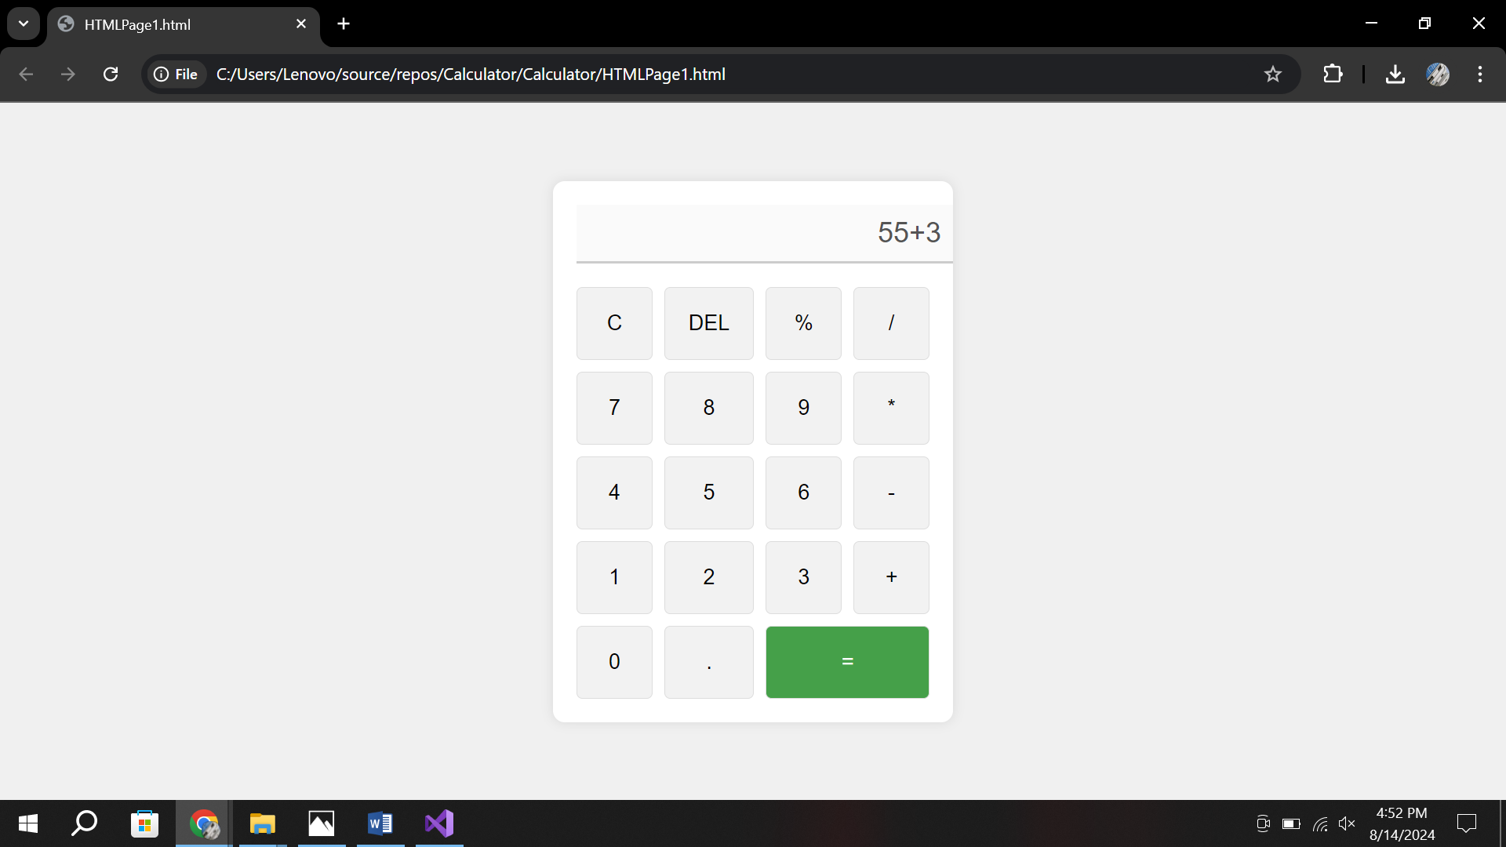

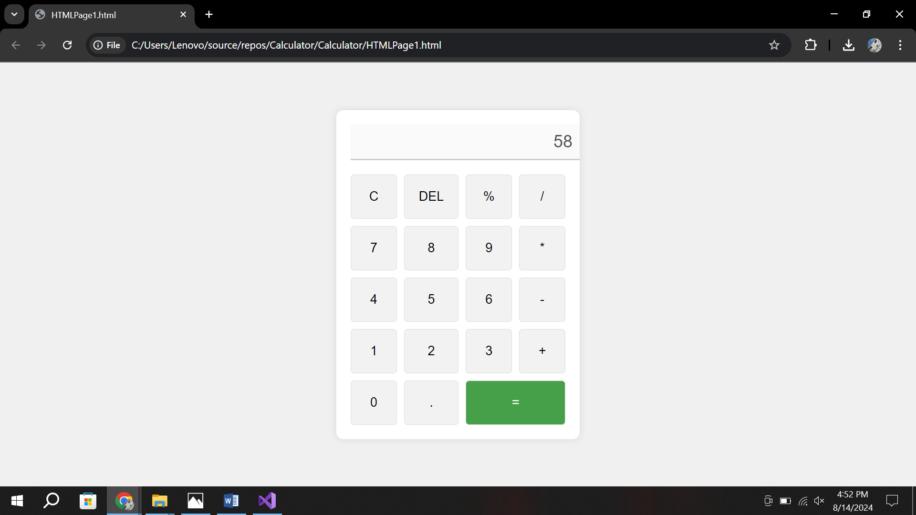

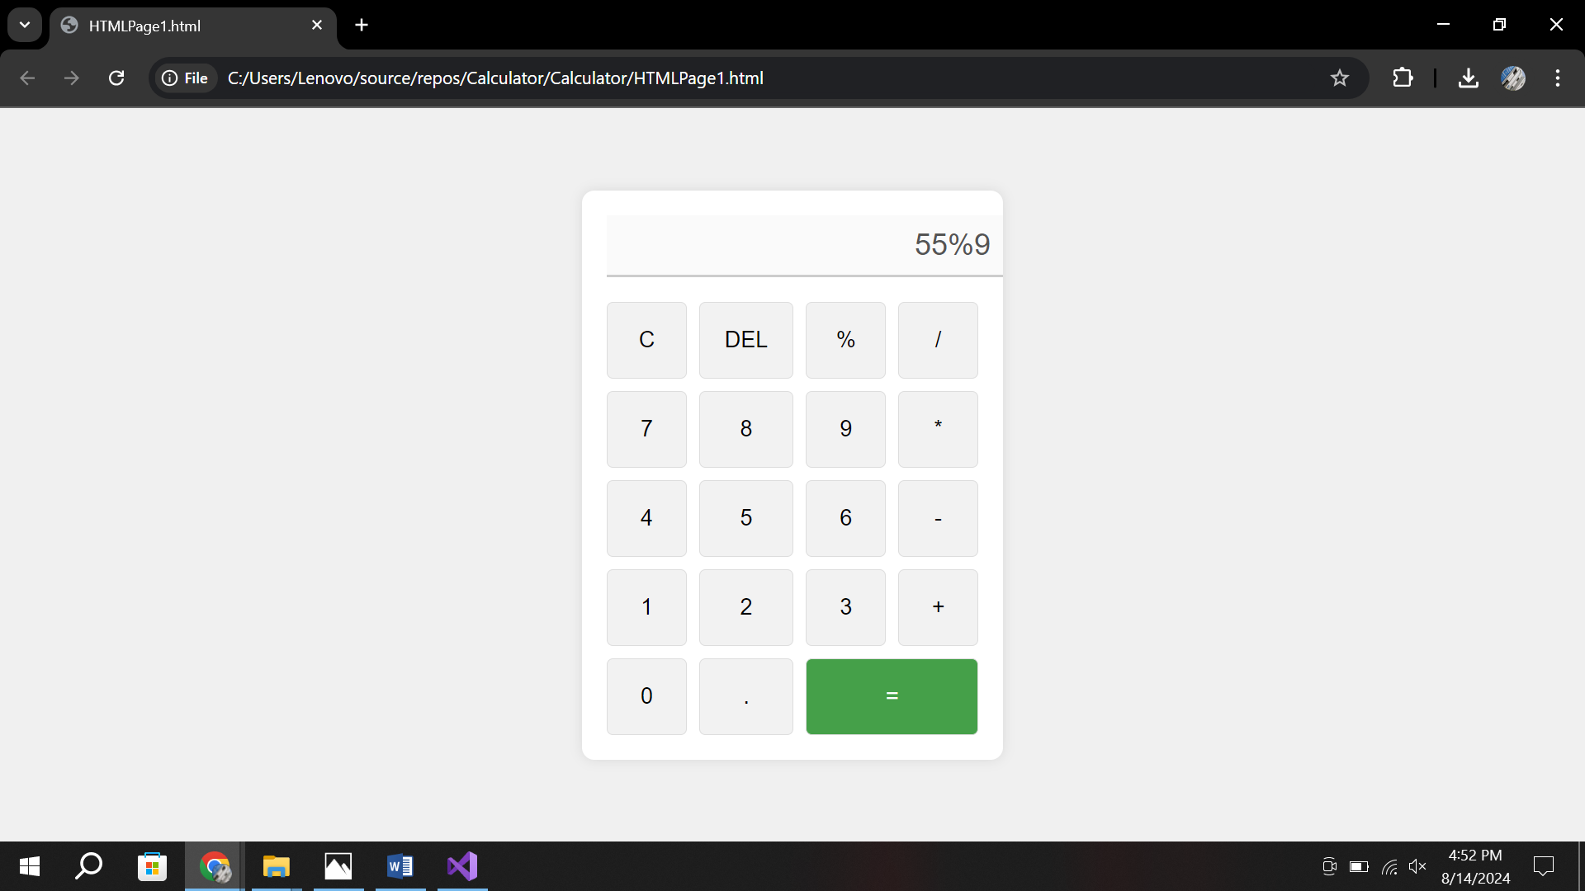

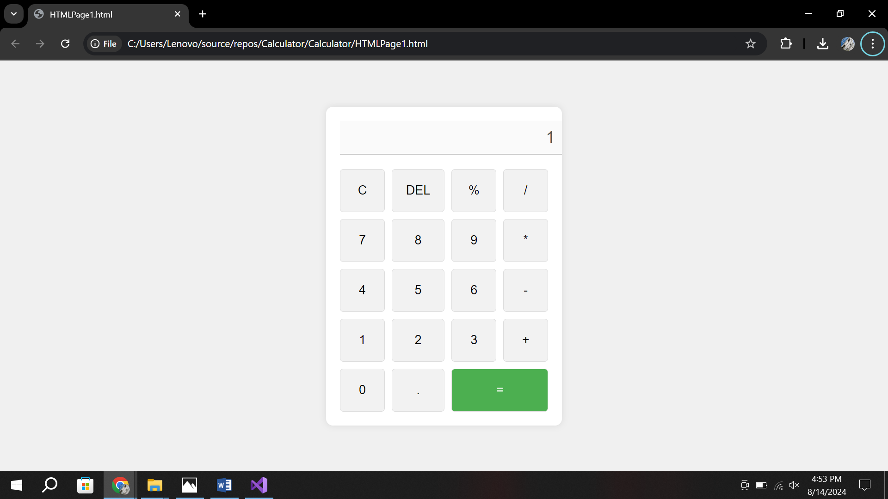

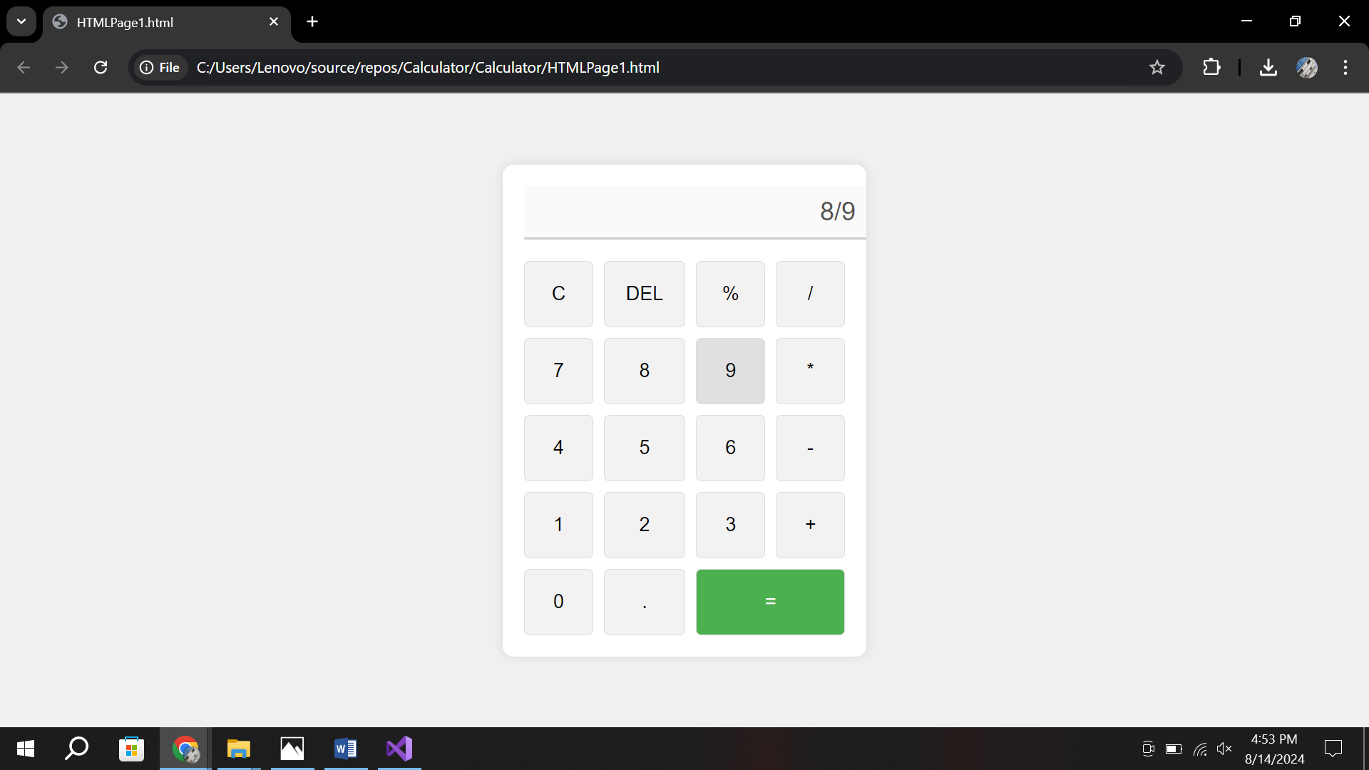

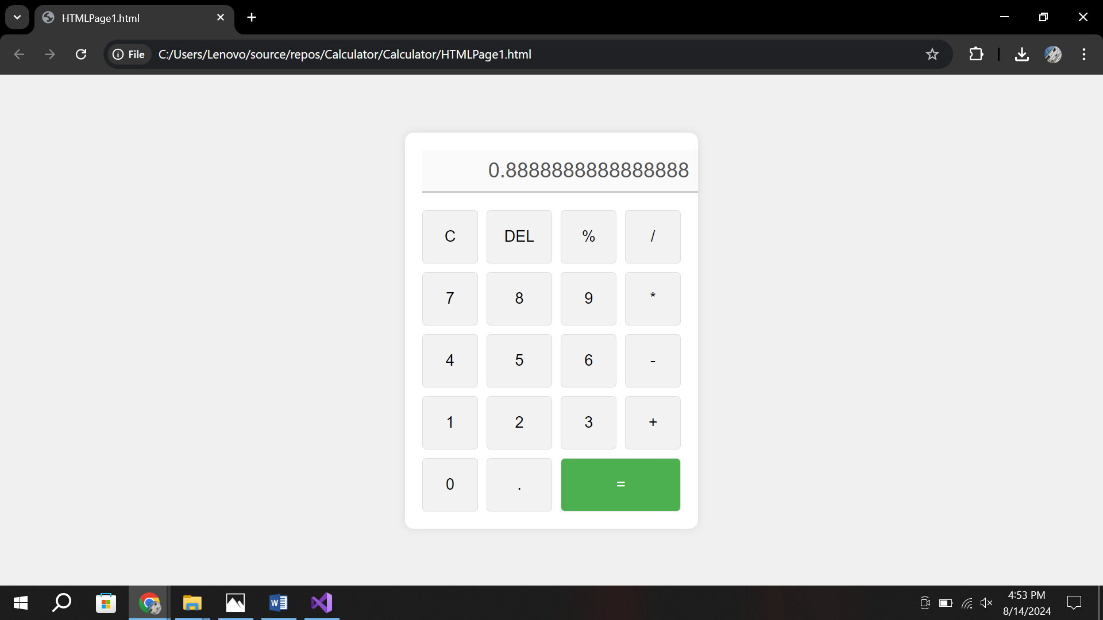

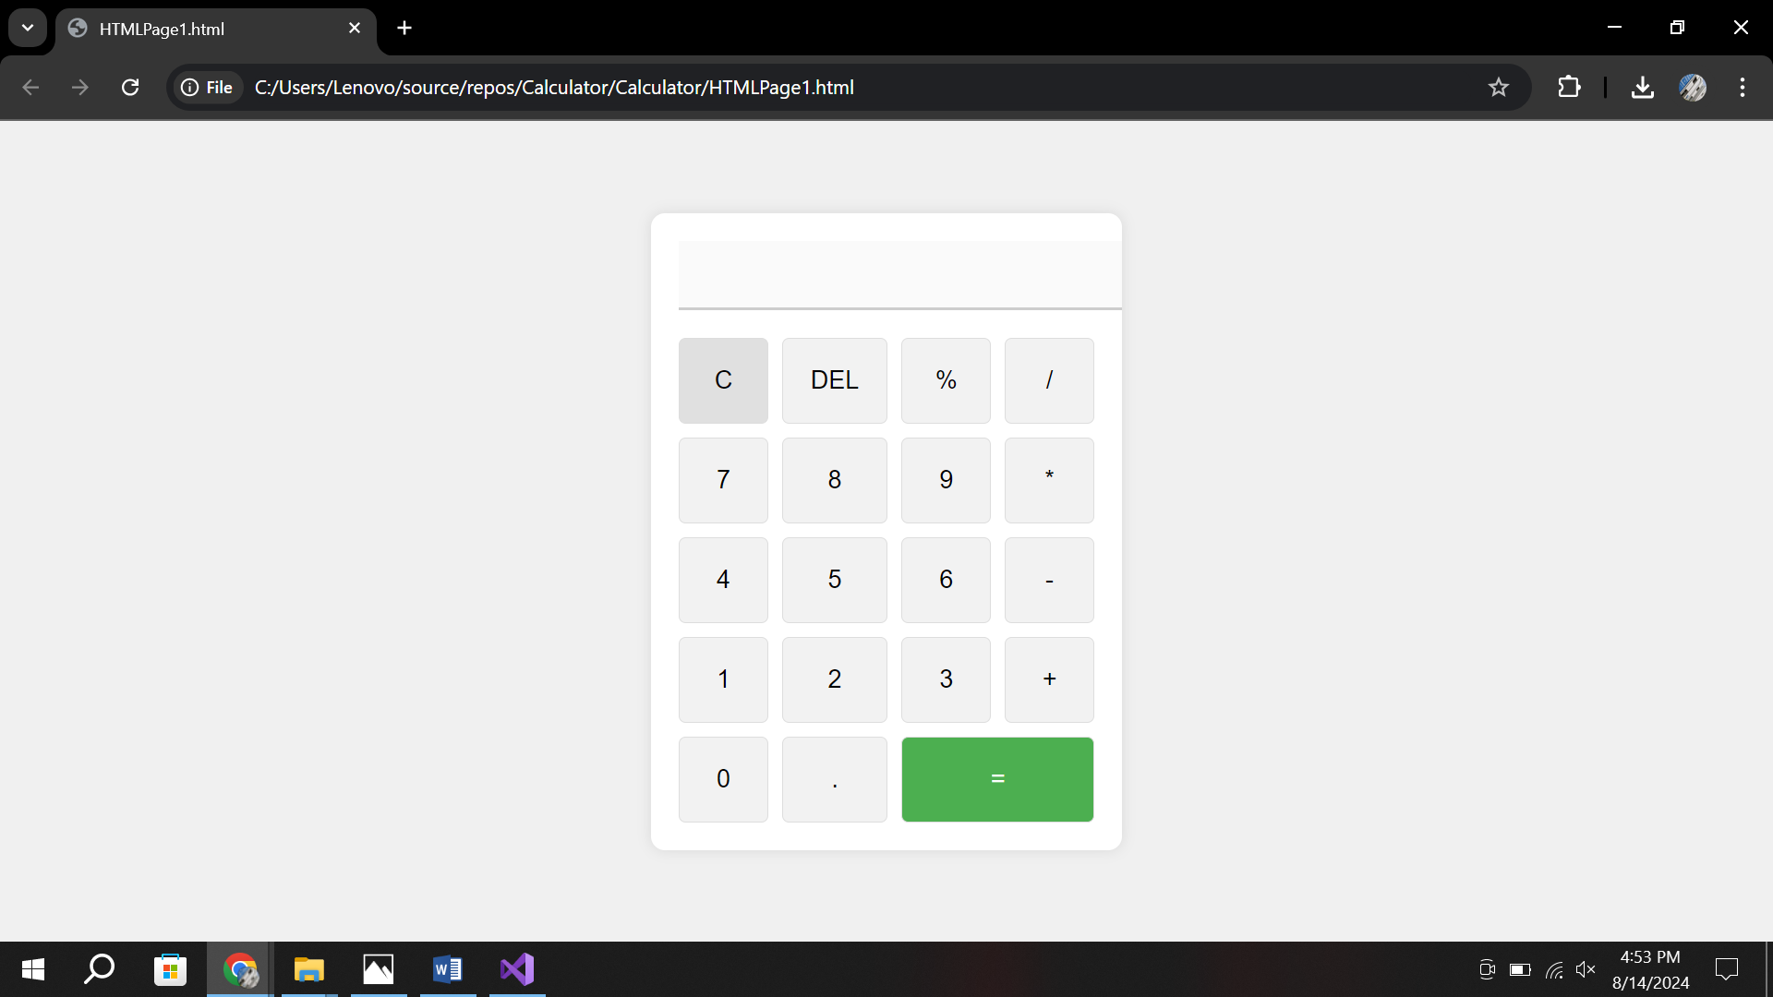

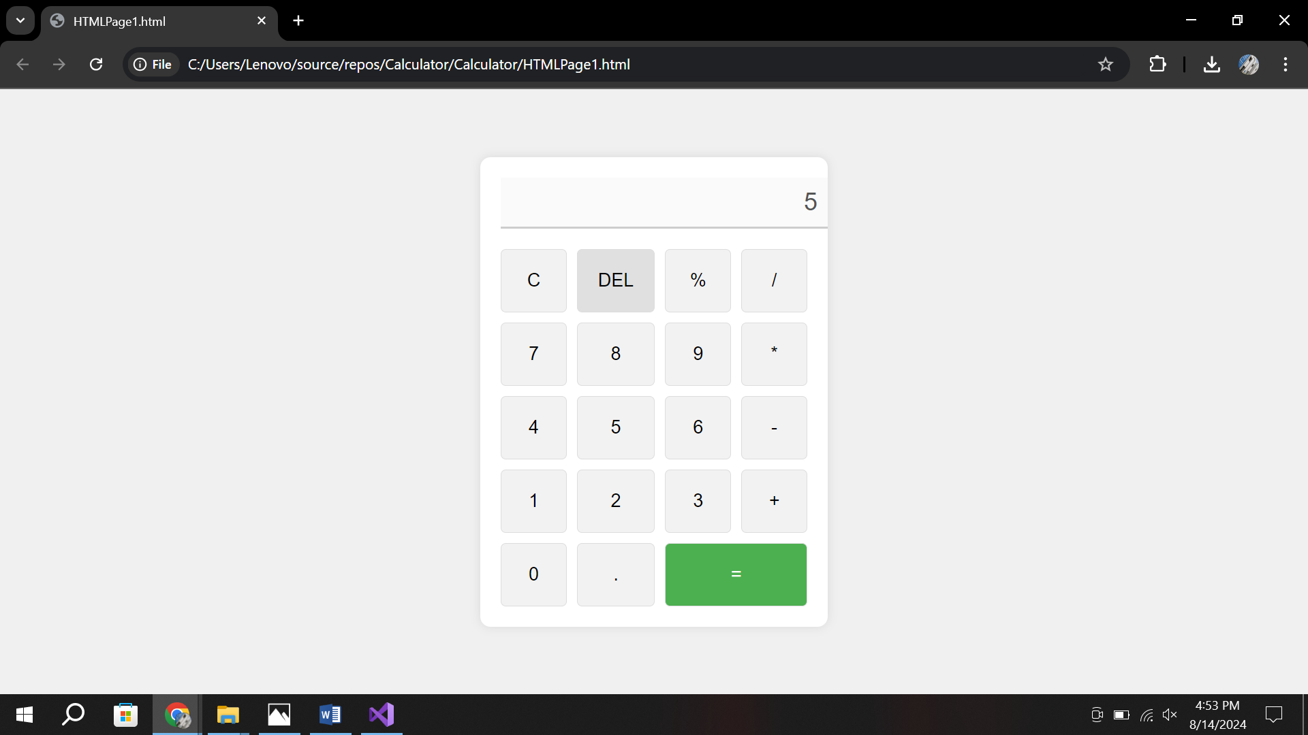

**Assignment NO 3(c):**

**Screenshot:**

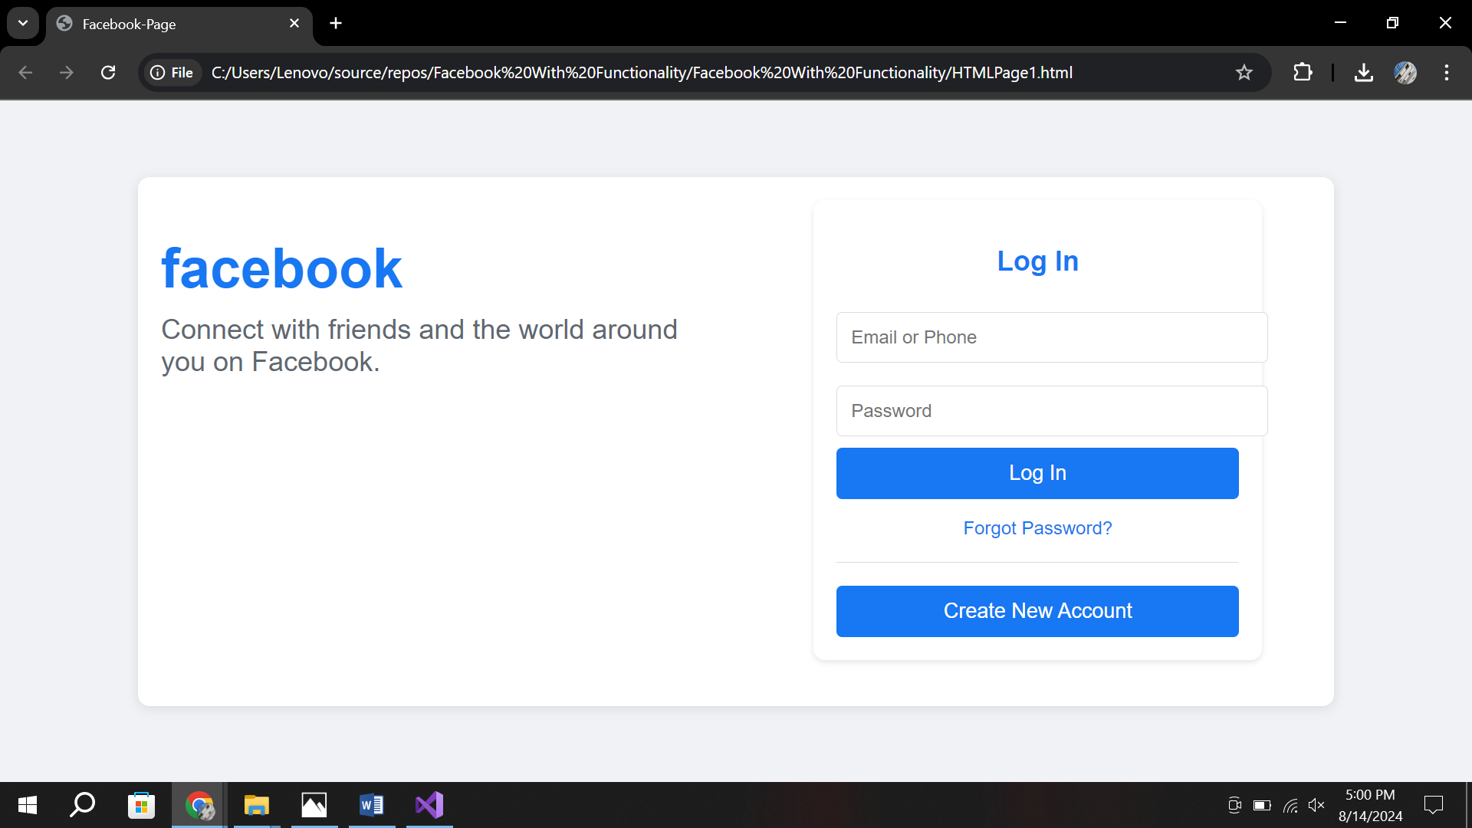

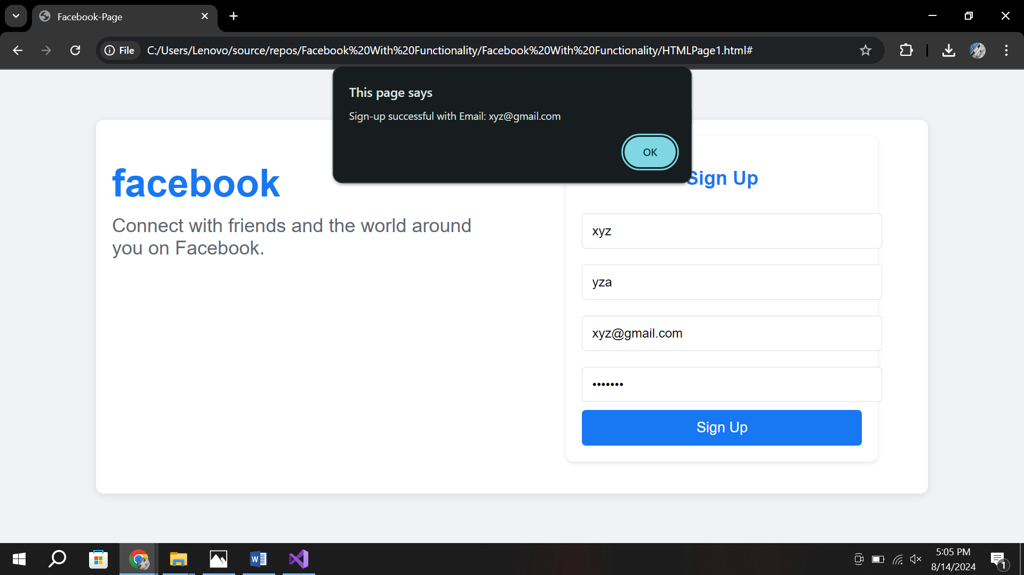

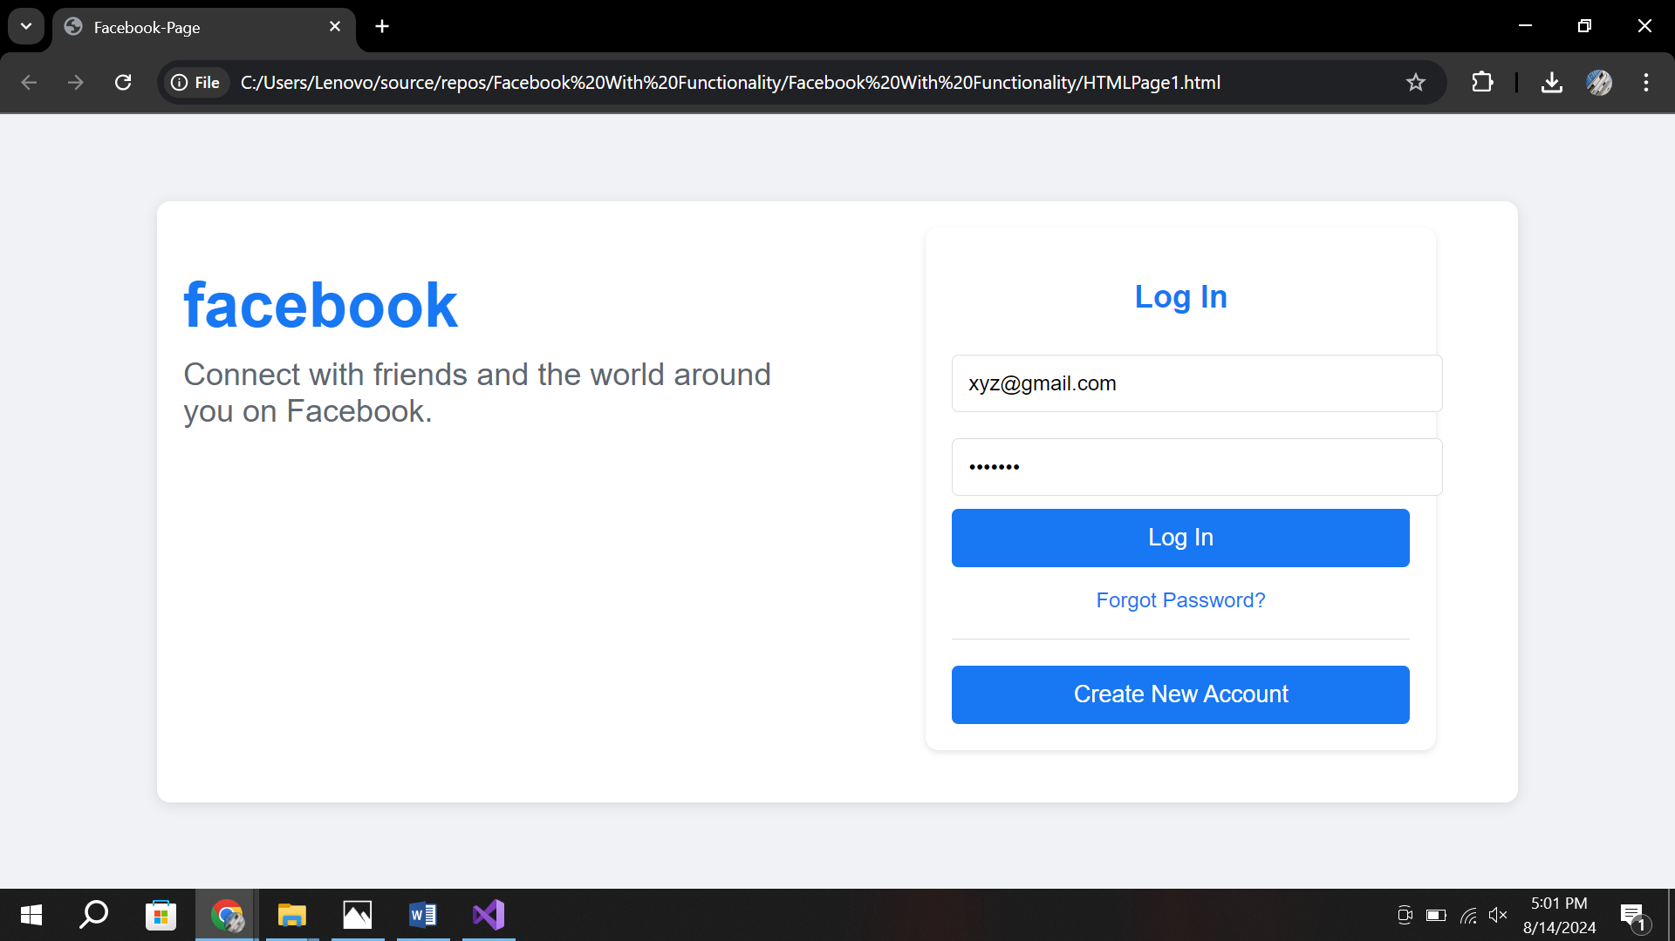

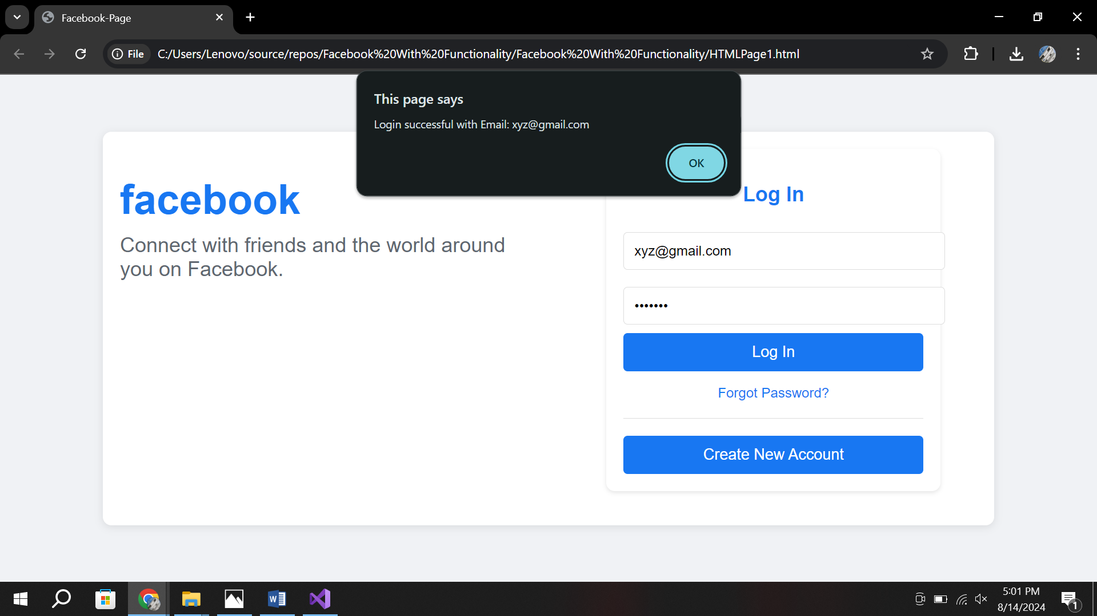

**Assignment No 4:**

**CODE:**

**Html:**

<!DOCTYPE html>

<html lang="en">

<head>

    <title>API Get</title>

    <link rel="stylesheet" href="styles.css">

    <script src="https://code.jquery.com/jquery-3.6.0.min.js"></script>

    <script src="script.js"></script>

</head>

<body>

    <div class="container">

        <table id="dataTable">

            <thead>

                <tr>

                    <th>Name</th>

                    <th>ID</th>

                </tr>

            </thead>

            <tbody>

                <tr>

                    <td id="nameField">N/A</td>

                    <td id="idField">N/A</td>

                </tr>

            </tbody>

        </table>

        <br><br>

        <button id="fetchData">Get Data</button>

    </div>

</body>

</html>

**Css:**

body {

    font-family: 'Segoe UI', Tahoma, Geneva, Verdana, sans-serif;

    background: linear-gradient(135deg, #e0eafc, #cfdef3);

    margin: 0;

    padding: 20px;

    display: flex;

    justify-content: center;

    align-items: center;

    height: 100vh;

}

.container {

    background-color: #ffffff;

    padding: 30px;

    border-radius: 12px;

    box-shadow: 0 4px 12px rgba(0, 0, 0, 0.2);

    text-align: center;

    max-width: 600px;

    width: 100%;

}

button {

    background: linear-gradient(45deg, #007bff, #0056b3);

    color: #ffffff;

    border: none;

    padding: 12px 24px;

    border-radius: 6px;

    cursor: pointer;

    font-size: 18px;

    transition: transform 0.3s ease, background-color 0.3s ease;

    box-shadow: 0 4px 6px rgba(0, 0, 0, 0.1);

}

button:hover {

    background-color: #004494;

    transform: scale(1.05);

}

table {

    width: 100%;

    border-collapse: collapse;

    margin-top: 20px;

}

table, th, td {

    border: 1px solid #ddd;

}

th, td {

    padding: 12px;

    text-align: left;

}

thead {

    background-color: #007bff;

    color: white;

}

tbody tr:nth-child(even) {

    background-color: #f9f9f9;

}

tbody tr:hover {

    background-color: #f1f1f1;

}

td {

    font-size: 16px;

}

**JavaScript:**

$(document).ready(function () {

    $("#fetchData").click(function () {

        // Replace this URL with your actual API endpoint

        const apiUrl = "https://your-endpoint1.free.beeceptor.com";

        $.get(apiUrl, function (data, status) {

            if (status === "success") {

                const name = data.name || "";

                const id = data.id || "";

                $("#nameField").text(name);

                $("#idField").text(id);

            } else {

                $("#nameField").text("Failed to retrieve data.");

                $("#idField").text("Failed to retrieve data.");

            }

        }, "json");

    });

});

**Screenshot:**

