Q1:

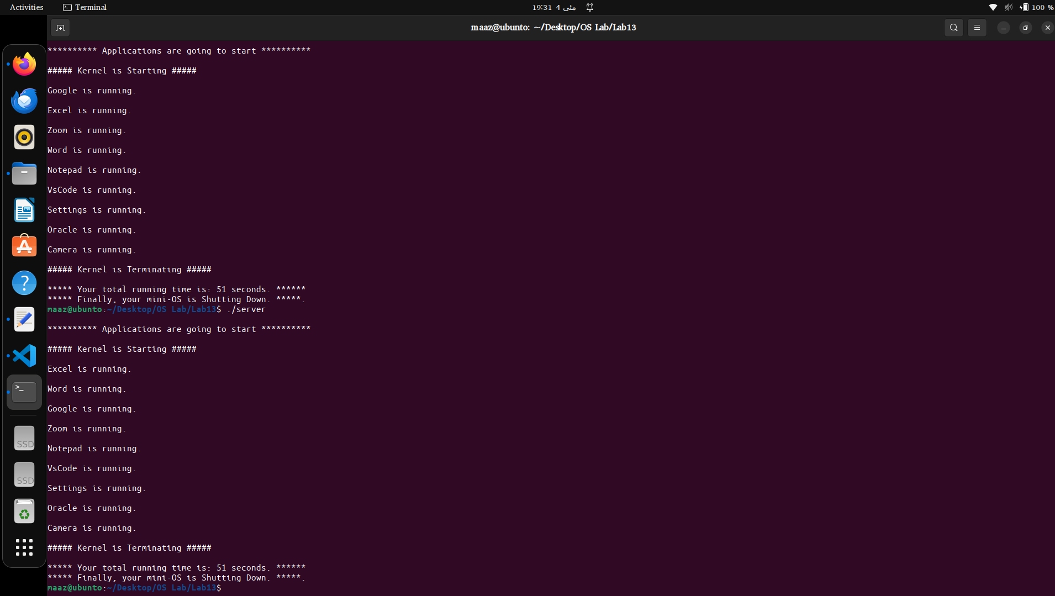

Q2:

in question 2 I have made the threads as multiple users trying to access same file.
All have read permissions(concurrency) but when one thread is writing to file others cannot write.

