
COMSATS University Islamabad (CUI)

Project Proposal
for
MalTwin
An AI-Based Framework for Malware Variant Detection in Industrial IoT Using Digital Twins and Visual Analysis

Version 1.0
By
Iman Fatima CIIT/SP23-BCT-021/ISB
Maaz Malik CIIT/SP23-BCT-025/ISB

Supervisor
Miss Najla Raza

An Industrial Collaboration with NECOP

Bachelor of Science in Cyber Security (2023-2027)

Table of Contents
Abstract 1
1. Introduction 2
2. Problem Statement 2
3. Problem Solution/Objectives of the Proposed System 2
3.1 Objectives 3
4. Related System Analysis/Literature Review 3
5. Vision Statement 4
6. Scope 4
7. Modules 4
7.1 Module 1: Digital Twin Simulation Module 4
7.2 Module 2: Binary-to-Image Conversion Module 4
7.3 Module 3: Dataset Collection & Preprocessing Module 5
7.4 Module 4: Data Enhancement & Balancing Module 5
7.5 Module 5: Intelligent Malware Detection Module 5
7.6 Module 6: Dashboard & Visualization Module 5
7.7 Module 7: Explainable AI (XAI) & Interpretability Module 5
7.8 Module 8: Automated Threat Reporting & Intelligence Module 5
8. System Limitations/Constraints 6
9. Data Gathering Approach 6
10. Tools and Technologies 7
11. Project Stakeholders and Roles 8
12. Module based Work Division 8
13. WBS and Gantt Chart 9
14. Flowchart 12
15. Mockups 13
16. References 16
17. Plagiarism Report 17

Project Category:
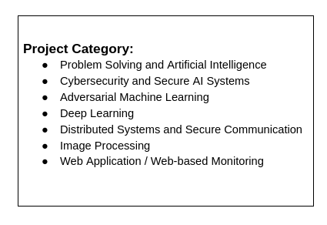

Abstract
The rapid integration of Industrial Internet of Things (IIoT) devices in critical infrastructure has improved automation and efficiency but has also exposed systems to advanced and evolving malware threats that traditional signature-based defenses cannot effectively counter. Attacks such as Stuxnet and WannaCry demonstrate how malware variants can disrupt operational technology environments, causing physical damage, safety risks, and economic losses. Key challenges include the inability of static signatures to detect obfuscated or polymorphic malware, the risks of analysing malware on real IIoT hardware, and the scarcity and imbalance of IIoT-specific malware datasets.
This project proposes MalTwin, a Digital Twin, based framework that enables safe malware analysis through simulated IIoT environments and visual binary representation. Executable files are transformed into grayscale images to expose structural patterns for analysis, while data enhancement techniques are applied to mitigate dataset imbalance. Instead of relying on predefined signatures, the framework supports intelligent learning-based classification methods to identify malware variants, including previously unseen samples. An interactive dashboard provides visualization, prediction results, and system monitoring. MalTwin delivers a scalable, research-oriented prototype for IIoT malware variant detection, emphasizing safety, adaptability, and robustness in resource-constrained industrial environments.

Introduction
This project proposal outlines MalTwin, an innovative AI-driven framework designed to detect malware variants in Industrial Internet of Things (IIoT) environments. With the convergence of IT and Operational Technology (OT), IIoT systems in critical sectors like manufacturing, energy, and transportation are increasingly vulnerable to advanced malware that evades traditional defenses. Signature-based methods fail against minor code modifications, polymorphism, or packing techniques, enabling zero-day and variant attacks to bypass antivirus tools. Real-world examples include Stuxnet targeting SCADA systems and ransomware like LockerGoga disrupting industrial operations. Recent advancements in cybersecurity leverage malware visualization by converting binaries to grayscale images, revealing structural textures analyzable via computer vision. Digital Twin technology further enables safe emulation of physical systems, allowing controlled malware observation without risking real infrastructure. MalTwin integrates Digital Twin–based simulation with visual binary analysis and intelligent learning-based detection techniques, providing a modular platform that supports experimentation with multiple analytical and classification methodologies. This design allows the framework to adapt to evolving research directions while maintaining safe and effective malware variant detection for IIoT environments.

Problem Statement
Industrial IoT (IIoT) systems are vulnerable to rapidly evolving malware, as minor changes like obfuscation or polymorphism can bypass traditional signature-based defenses, seen in attacks such as WannaCry and Stuxnet. Analyzing malware on real IIoT hardware is unsafe and impractical, while datasets are scarce and imbalanced, limiting detection accuracy. Existing tools relying on static signatures or limited behavioral analysis fail against unseen variants. A secure, scalable framework is therefore needed to simulate IIoT environments, enhance data diversity, visualize threats, and accurately detect malware in resource-constrained industrial systems.

Problem Solution/Objectives of the Proposed System
MalTwin addresses the identified challenges by proposing an integrated AI-based framework that combines Digital Twin simulation with visual malware analysis and adaptive learning techniques. The system creates a virtual IIoT testbed where malware can be safely executed and observed without risking physical infrastructure. Executable files are transformed into grayscale images to capture intrinsic structural patterns that remain resilient against obfuscation and packing techniques.
To overcome dataset scarcity and imbalance, the framework supports flexible data enhancement strategies, enabling improved generalization across malware families. Classification and variant detection are performed using intelligent analytical models selected based on experimental evaluation rather than fixed architectural assumptions. This methodology shifts detection away from signature dependence toward pattern-based analysis, improving resilience against zero-day and polymorphic threats. System performance is evaluated using standard metrics such as accuracy, precision, recall, F1-score, and confusion matrices. A user-friendly dashboard enables visualization, file analysis, and system monitoring, making MalTwin suitable as a research and educational platform for IIoT malware detection.

Objectives
BO-1: Develop a software-based Digital Twin to emulate IIoT devices and protocols for safe malware analysis.
BO-2: Implement binary-to-image conversion to enable visual and structural analysis of executable files.
BO-3: Apply data enhancement and balancing techniques to address scarcity and class imbalance in IIoT malware datasets.
BO-4: Design and evaluate intelligent learning-based detection models for malware variant classification.
BO-5: Rigorously evaluate detection performance using standard metrics on unseen and variant samples.
BO-6: Build an interactive dashboard for real-time analysis, visualization, and reporting.

Related System Analysis/Literature Review
Table 1: Related System Analysis with proposed project solution
Application Name | Weakness | Proposed Project Solution
Traditional Signature-Based AV (e.g., commercial tools) | Ineffective against variants, polymorphism, zero-days; relies on known signatures. | Shifts detection from static signatures to visual and pattern-based analysis using binary-to-image representation within a simulated IIoT environment..
Malimg-Based Malware Visualization (Nataraj et al., 2011; subsequent extensions) | Limited to static visualization; struggles with data scarcity and IIoT-specific samples; no simulation for safe analysis. | Integrates Digital Twin emulation for safe IIoT execution and applies dataset enhancement techniques to improve robustness against malware variants.
Learning-Based Malware Detection Frameworks | Primarily general malware; lacks IIoT context and safe execution environment. | Provides an IIoT-focused framework that integrates visual analysis, dataset balancing, and adaptable learning-based detection methods within a safe simulation environment.
IIoT Malware Detection Systems (behavioral or hybrid approaches) | Often dynamic/behavioral focus requiring risky execution; limited visualization and augmentation. | Provides safe static image analysis in simulated IIoT twin, enhanced by generative data.
Digital Twin Cybersecurity Tools (general DT in ICS) | Focus on monitoring/simulation; minimal AI integration for malware variant detection. | Integrates Digital Twin simulation with visual malware analysis, dataset enhancement, and intelligent detection to support comprehensive IIoT malware variant research.

Vision Statement
For IIoT security researchers and practitioners who need robust detection of rapidly evolving malware variants beyond signature-based limitations, MalTwin is an AI-based malware detection framework that provides safe simulation via Digital Twins, visual binary analysis, generative augmentation, and deep learning classification. Unlike conventional tools relying on static signatures or risky dynamic analysis, our system delivers a modular, scalable research platform for identifying unseen threats in IIoT through intelligent pattern recognition and synthetic data robustness.

Scope
The scope of MalTwin encompasses the design, implementation, and evaluation of a software-based framework for malware variant detection in Industrial Internet of Things (IIoT) environments. The project includes the construction of a virtual Digital Twin using containerization to emulate IIoT nodes and communication protocols (e.g., Modbus, MQTT) for safe baseline and infected-state logging. Executable files are transformed into fixed-size grayscale images through binary-to-image conversion, enabling static visual analysis of PE and ELF files.
To address dataset scarcity and class imbalance, the framework incorporates data enhancement and balancing techniques that improve dataset diversity and generalization. Malware detection is performed using intelligent learning-based classification models, selected and evaluated experimentally for multi-class tasks (e.g., benign vs. specific malware families). An interactive Streamlit-based dashboard supports file upload, visual inspection, prediction display, and system monitoring.
The project emphasizes reproducibility, utilizing public datasets, a modular Python-based implementation, and standard performance metrics for evaluation. Exclusions include physical IIoT hardware integration, full dynamic behavioral analysis (e.g., API hooking), automated remediation, or executable malware generation. The framework operates entirely in a simulated environment and is intended for research and academic demonstration, not production deployment.

Modules
The system comprises six interconnected modules for end-to-end malware analysis.

Module 1: Digital Twin Simulation Module
FE-1: Emulate IIoT network topology with virtual nodes (sensors, gateways).
FE-2: Generate normal/infected traffic using protocols like Modbus/MQTT.
FE-3: Collect logs safely without physical risks.

Module 2: Binary-to-Image Conversion Module
FE-1: Read binaries as byte streams.
FE-2: Reshape into 2D matrices based on size.
FE-3: Render grayscale images (0-255 pixel values).
FE-4: Resize to standard dimensions (e.g., 128x128) via interpolation.

Module 3: Dataset Collection & Preprocessing Module
FE-1: Source data from Malimg, EMBER, VirusShare, and IIoT-relevant samples.
FE-2: Normalize pixels, encode labels.
FE-3: Split into train/validation/test sets.

Module 4: Data Enhancement & Balancing Module
FE-1: Implement data enhancement techniques to increase diversity in malware image representations.
FE-2: Apply dataset balancing strategies to reduce class imbalance between benign and malicious samples.
FE-3: Validate enhanced datasets to ensure quality, consistency, and suitability for training detection models.

Module 5: Intelligent Malware Detection Module
FE-1: Implement learning-based classification techniques for malware variant detection.
FE-2: Train and evaluate models using enhanced datasets.
FE-3: Output prediction probabilities and confidence scores

Module 6: Dashboard & Visualization Module
FE-1: Streamlit-based web interface.
FE-2: File upload and grayscale image display.
FE-3: Real-time prediction with confidence bars.
FE-4: Enhanced data sample gallery and Digital Twin status monitoring.

Module 7: Explainable AI (XAI) & Interpretability Module
FE-1: Implement model-agnostic explainability techniques to generate visual or feature-based explanations for malware detection decisions.
FE-2: Map explanation outputs onto the binary grayscale images to highlight structural regions or patterns that influenced the detection outcome.
FE-3: Provide clear visual and textual interpretability to security analysts, explaining why a file was classified as malicious or benign by the detection model.

Module 8: Automated Threat Reporting & Intelligence Module
FE-1: Automatic generation of forensic reports (PDF/JSON) post-detection, including file hash (SHA-256), predicted family, and confidence score.
FE-2: Map detected threats to the MITRE ATT&CK framework for Industrial Control Systems (ICS) to provide context on potential adversary tactics.
FE-3: Log all detection events into a local database for historical trend analysis.

System Limitations/Constraints
LC-1: Computational Overhead of XAI: The integration of Explainable AI (Module 7) and Grad-CAM visualizations adds significant processing time per file. In a high-traffic IIoT environment, the system may prioritize classification speed over interpretability to maintain real-time performance.
LC-2: Susceptibility to Adversarial Image Attacks: Since the detection model relies on visual patterns (grayscale images), it is theoretically susceptible to adversarial perturbations, minor code modifications that do not change functionality but significantly alter the visual texture of the binary to deceive the AI.
LC-3: Execution Environment Isolation: To maintain the safety of the host system, the Digital Twin is strictly containerized. This prevents the analysis of malware that requires kernel-level interactions or specific hardware-bound drivers that are difficult to emulate in a software-only environment.

Data Gathering Approach
Data will be gathered from established public datasets, including the Malimg dataset (9,339 images from 25 families) as the primary source, supplemented by EMBER features and VirusShare/IIoT-relevant binaries (e.g., Mirai). Dataset enhancement and balancing techniques will be applied to increase diversity and improve class representation. Requirements and dataset selection will be refined through supervisor consultations and a literature review of similar frameworks.

Tools and Technologies
Table 2: Tools and Technologies for Proposed Project
Tools | Version | Rationale
Docker | 29.1.3 | Containerization for Digital Twin and IIoT simulation environments.
Mininet | 2.3.0 | Emulation of IIoT network topologies and protocols (Modbus, MQTT).
Streamlit | 1.52.0 | Interactive dashboard for visualization and malware prediction.
OpenCV | 4.12.0 | Image processing for binary-to-grayscale conversion.
Pillow (PIL) | 12.0.0 | Lightweight image handling and preprocessing support
MS Visual Studio Code | Latest | Development environment for Python-based modules
Git | Latest | Version control and collaborative development
Technology | Version | Rationale
Python | 3.14.2 | Core language for simulation, data processing, and AI models
PyTorch | 2.9.1 | Experimental framework for implementing and evaluating learning-based detection models.
NumPy | 2.4.0 | Numerical computation and array processing
Pandas | 2.3.3 | Dataset handling and preprocessing
Matplotlib | 3.10.8 | Visualization of images, metrics, and results
Scikit-learn | 1.8.0 | Preprocessing utilities and performance evaluation metrics
CUDA | 13.1 | GPU acceleration for deep learning training
Linux (Ubuntu) | 22.04 LTS | Stable environment for malware analysis and simulation
TensorFlow/Keras | 2.20.0 | Alternative deep learning framework for experimentation
FPDF | Latest | Library to programmatically generate PDF incident reports and alerts.
Captum | 0.7.0 | PyTorch’s model interpretability library to implement Grad-CAM and visualize model decisions.

Project Stakeholders and Roles
Table 3: Project Stakeholders for Proposed Project
Project Sponsor | COMSATS University Islamabad, Islamabad Campus
Stakeholder | Students: Iman Fatima, Maaz Malik for development, implementation, testing, and documentation.  Supervisor: Miss Najla Raza for Guidance, review, and evaluation.  Final Year Project Committee for Final assessment and defense evaluation.

Module based Work Division
Table 4: Team Member Work Division for Proposed Project
Student Name | Student Registration Number | Responsibility/ Module / Feature
Iman Fatima | SP23-BCT-021 | - Digital Twin Simulation Module (Module 1)  - Dataset Collection & Preprocessing Module (Module 3)  - Data Enhancement & Balancing Module (Module 4)  - Automated Threat Reporting & Alerting Module (Module 8)
Maaz Malik | SP23-BCT-025 | - Binary-to-Image Conversion Module (Module 2)  - Intelligent Malware Detection Module (Module 5)  - Dashboard & Visualization Module (Module 6)  - Explainable AI (XAI) Module (Module 7)

WBS and Gantt Chart
Project Duration Assumption: 16 Weeks
Project Start Date: 03 February 2025
Project End Date: 23 May 2025

Table 5: Work Breakdown Structure for Proposed Project
ID |  | Task | Duration | Resources
1 | Project Analysis & Planning |  | 10 d | Iman Fatima; Maaz Malik
2 |  | Requirement Analysis & Literature Review | 6 d | Iman Fatima; Maaz Malik
3 |  | Problem Definition & Objectives Finalization | 3 d | Iman Fatima; Maaz Malik
4 |  | Project Planning & Tool Finalization | 1 d | Iman Fatima
5 | Design |  | 12 d | Iman Fatima; Maaz Malik
6 |  | System Architecture Design | 4 d | Maaz Malik
7 |  | Digital Twin & Data Flow Design | 4 d | Iman Fatima
8 |  | Dataset & AI Pipeline Design | 4 d | Iman Fatima
9 | Module 1: Digital Twin Simulation |  | 14 d | Iman Fatima
10 |  | IioT Network Emulation | 8 d | Iman Fatima
11 |  | Traffic & Log Collection Setup | 6 d | Iman Fatima
12 | Module 2: Binary-to-Image Conversion |  | 10 d | Maaz Malik
13 |  | Binary Parsing & Byte Stream Handling | 4 d | Maaz Malik
14 |  | Grayscale Image Generation & Handling | 6 d | Maaz Malik
15 | Module 3: Dataset Collection & Preprocessing |  | 12 d | Iman Fatima
16 |  | Dataset Collection | 5 d | Iman Fatima
17 |  | Image Normalization & Dataset Splitting | 7 d | Iman Fatima
18 | Module 4: Data Enhancement & Balancing |  | 15 d | Iman Fatima
19 |  | Dataset Augmentation & Transformation Techniques | 6 d | Iman Fatima
20 |  | Dataset Validation & Quality Assessment | 9 d | Iman Fatima
21 | Module 5: Intelligent Malware Detection |  | 18 d | Maaz Malik
22 |  | Detection Model Design & Selection | 8 d | Maaz Malik
23 |  | Model Training, Tuning & Evaluation | 10 d | Maaz Malik
24 | Module 6: Dashboard & Visualization |  | 12 d | Maaz Malik
25 |  | Streamlit UI Development | 6 d | Maaz Malik
26 |  | Prediction & Visualization Integration | 6 d | Maaz Malik
27 | Module 7: Explainable AI (XAI) |  | 10 d | Maaz Malik
28 |  | Explain ability Method Implementation | 5 d | Maaz Malik
29 |  | XAI Visualization & Interpretation | 5 d | Maaz Malik
30 | Module 8: Automated Threat Reporting |  | 10 d | Iman Fatima
31 |  | PDF/JSON Report Generation (FPDF) | 6 d | Iman Fatima
32 |  | MITRE ATT&CK Mapping & Event Logging | 4 d | Iman Fatima
33 | Testing & Validation |  | 10 d | Iman Fatima; Maaz Malik
34 |  | Module-wise Integration Testing | 6 d | Iman Fatima; Maaz Malik
35 |  | Performance Evaluation & Metrics | 4 d | Maaz Malik
36 | Documentation & Finalization |  | 12 d | Iman Fatima; Maaz Malik
37 |  | Final Report Writing | 7 d | Iman Fatima
38 |  | Plagiarism Check & Formatting | 3 d | Iman Fatima
39 |  | Final Review & Submission | 2 d | Maaz Malik

Table 6: Task Dependencies
Task | Dependency
Design Phase | After Project Analysis
Module 1–4 | After Design Phase
Module 5 | After Modules 2, 3, 4
Module 6 | After Module 5
Module 7 | After Module 5
Module 8 | After Modules 5 & 6
Testing | After All Modules
Documentation | Parallel with Testing
Final Submission | After Documentation

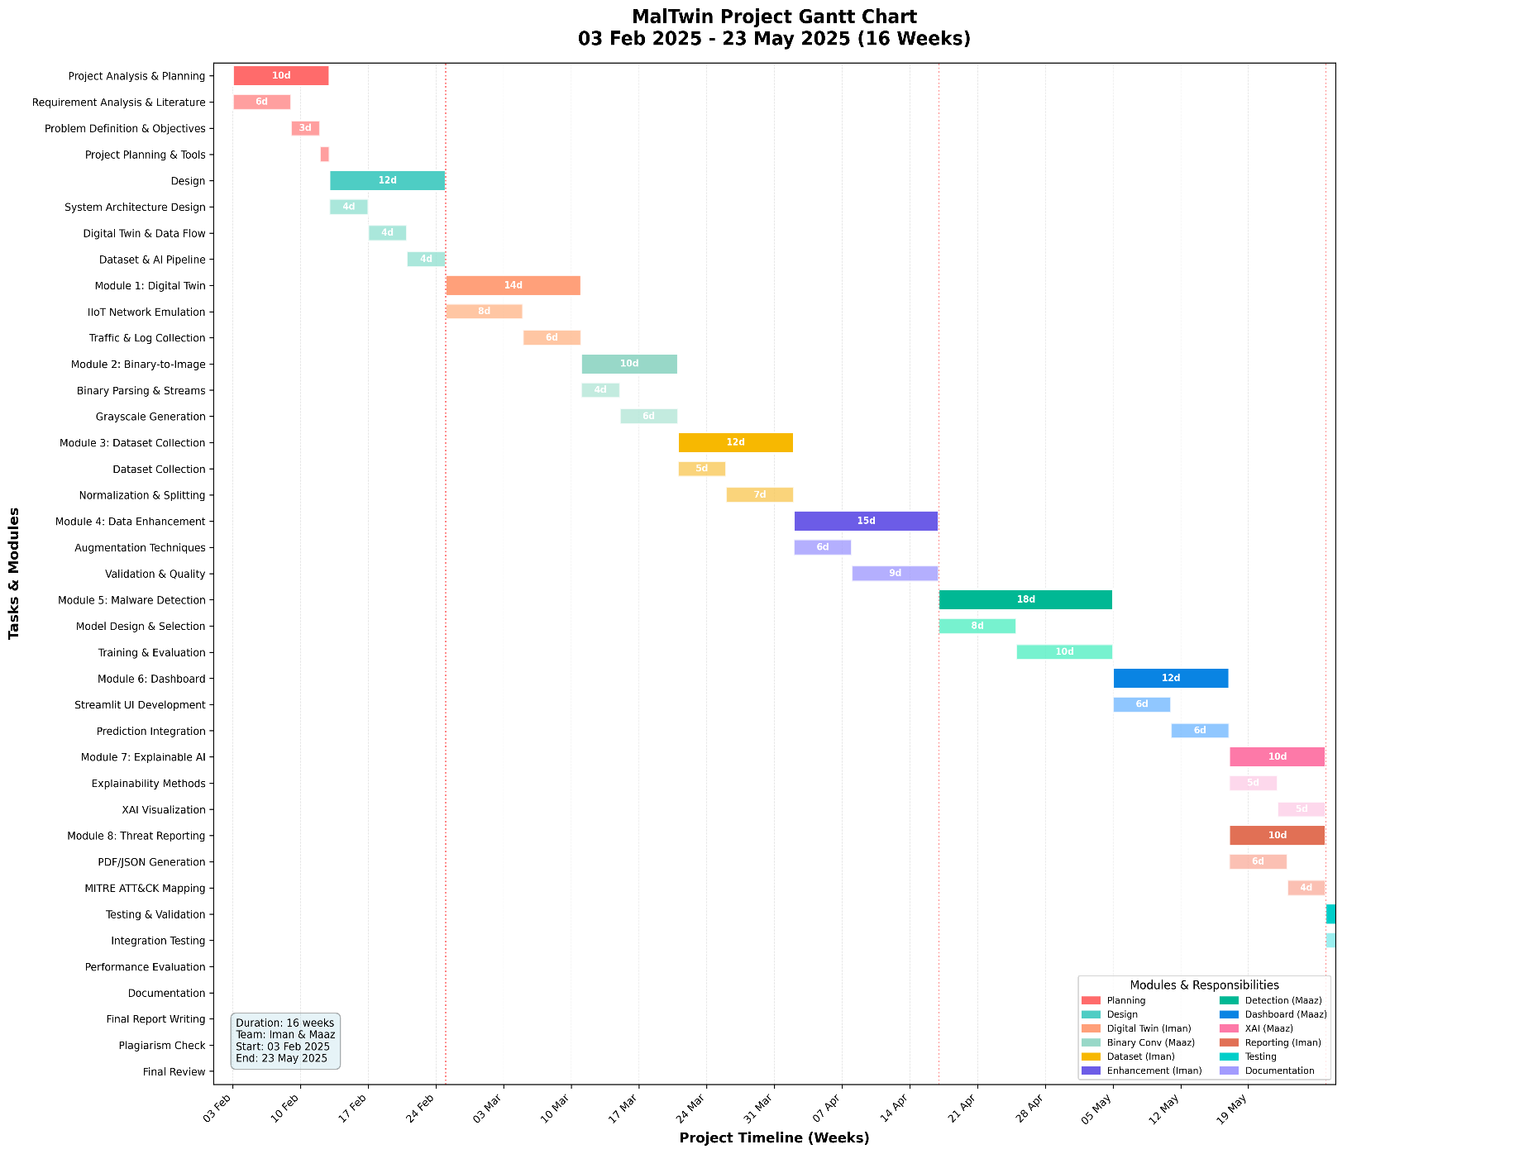

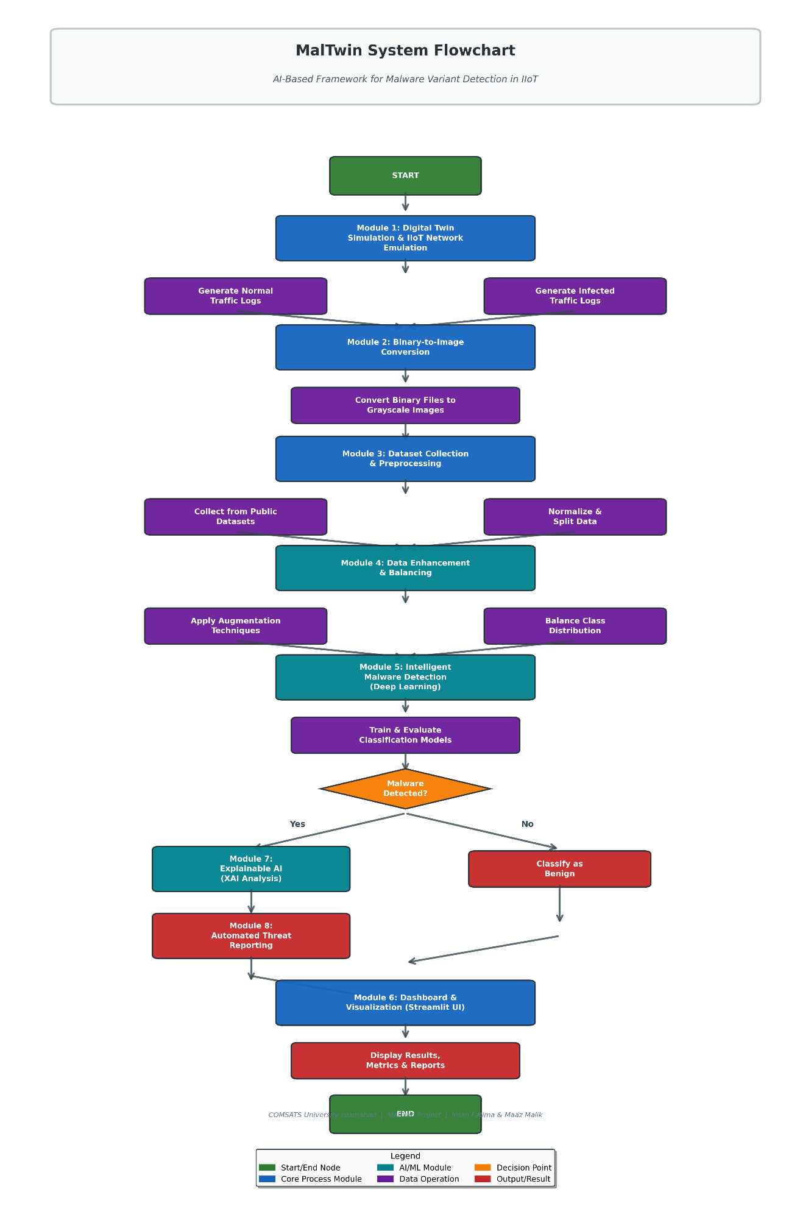
Flowchart

Mockups
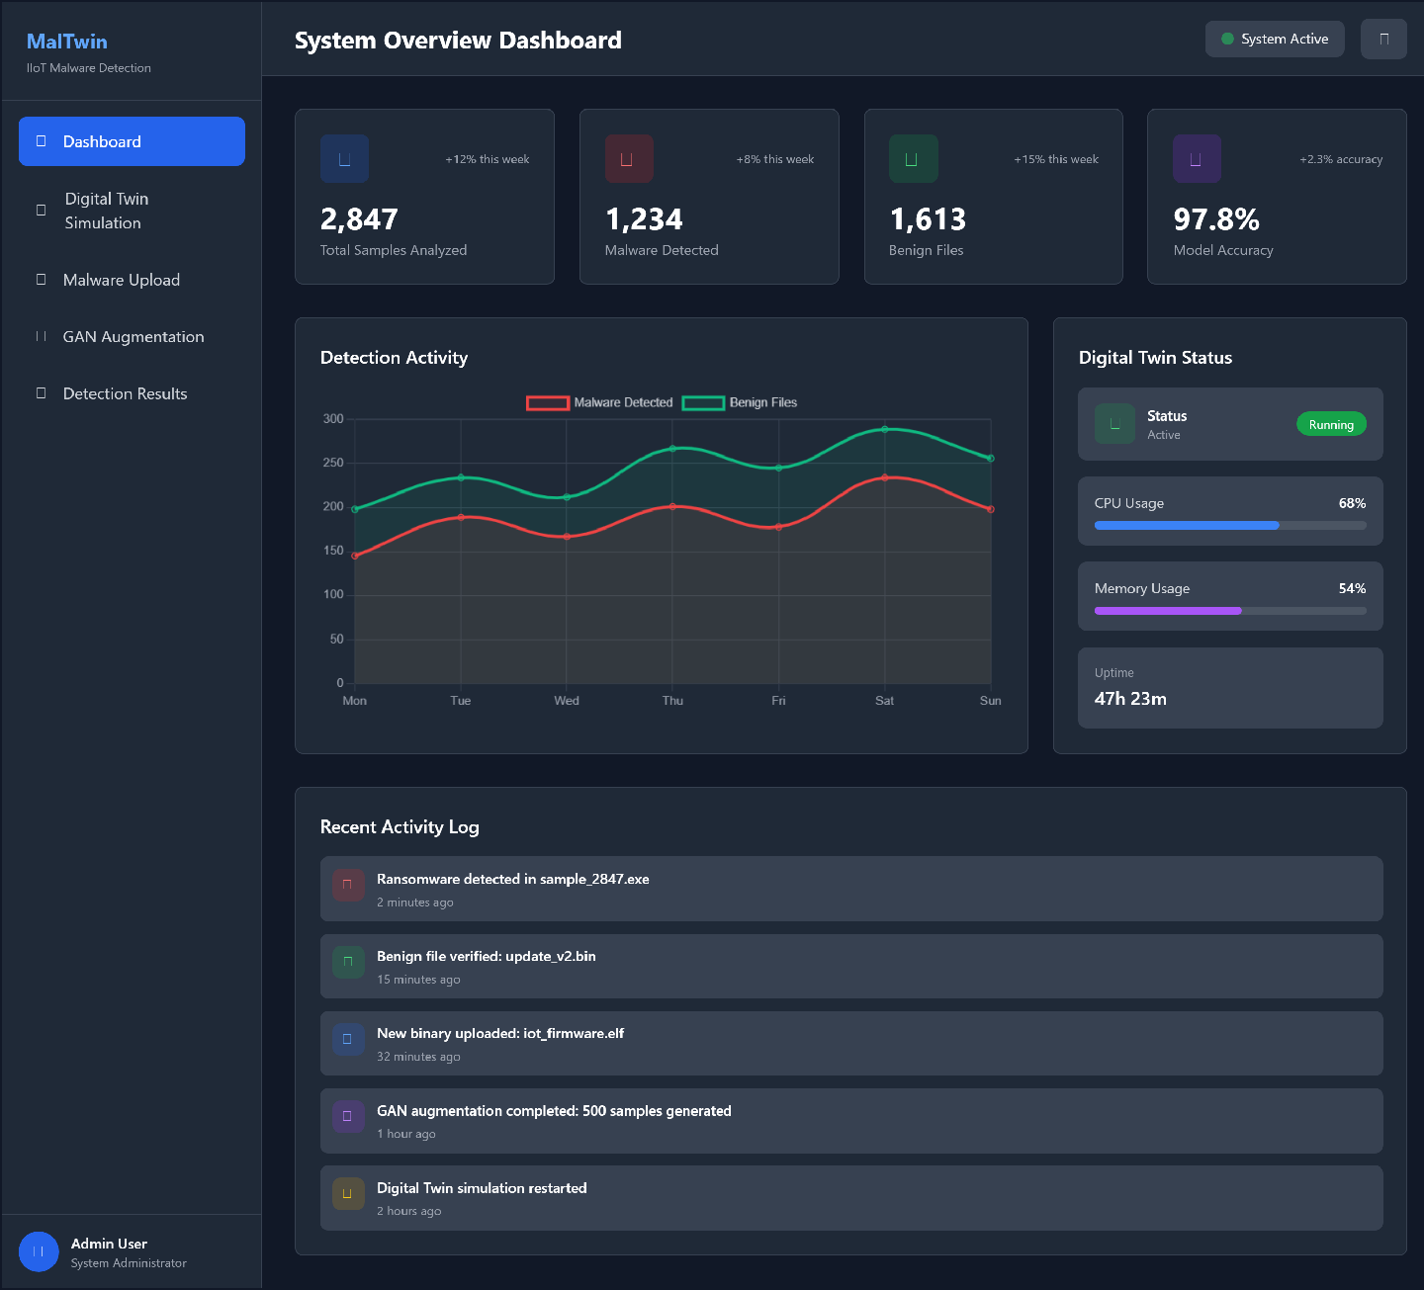
Description: This screen serves as the central control panel of the MalTwin framework. It provides a high-level overview of the system status, Digital Twin activity, and detection statistics.
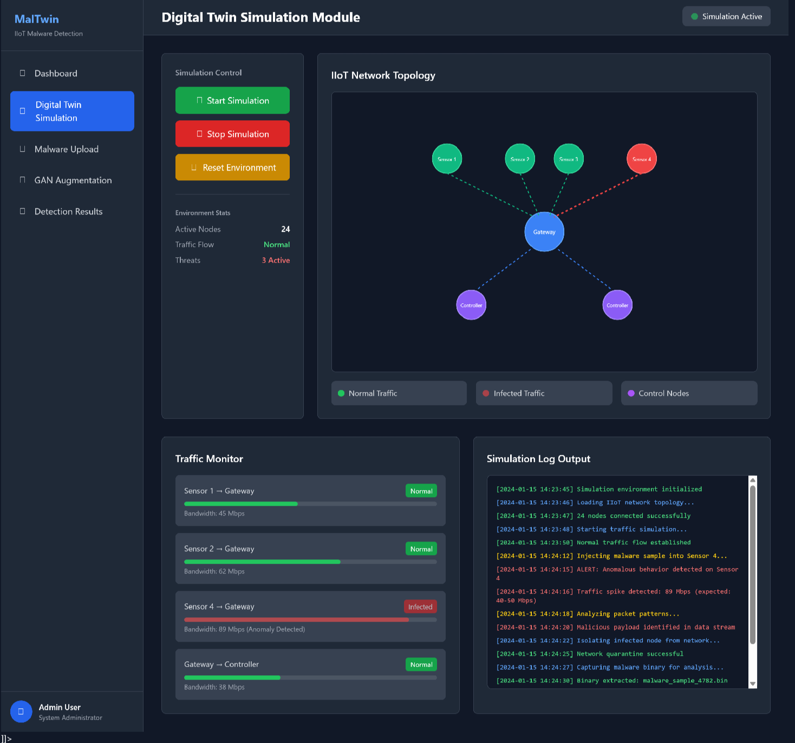
Description: This screen allows users to monitor and control the Digital Twin environment used for safe IIoT malware simulation.
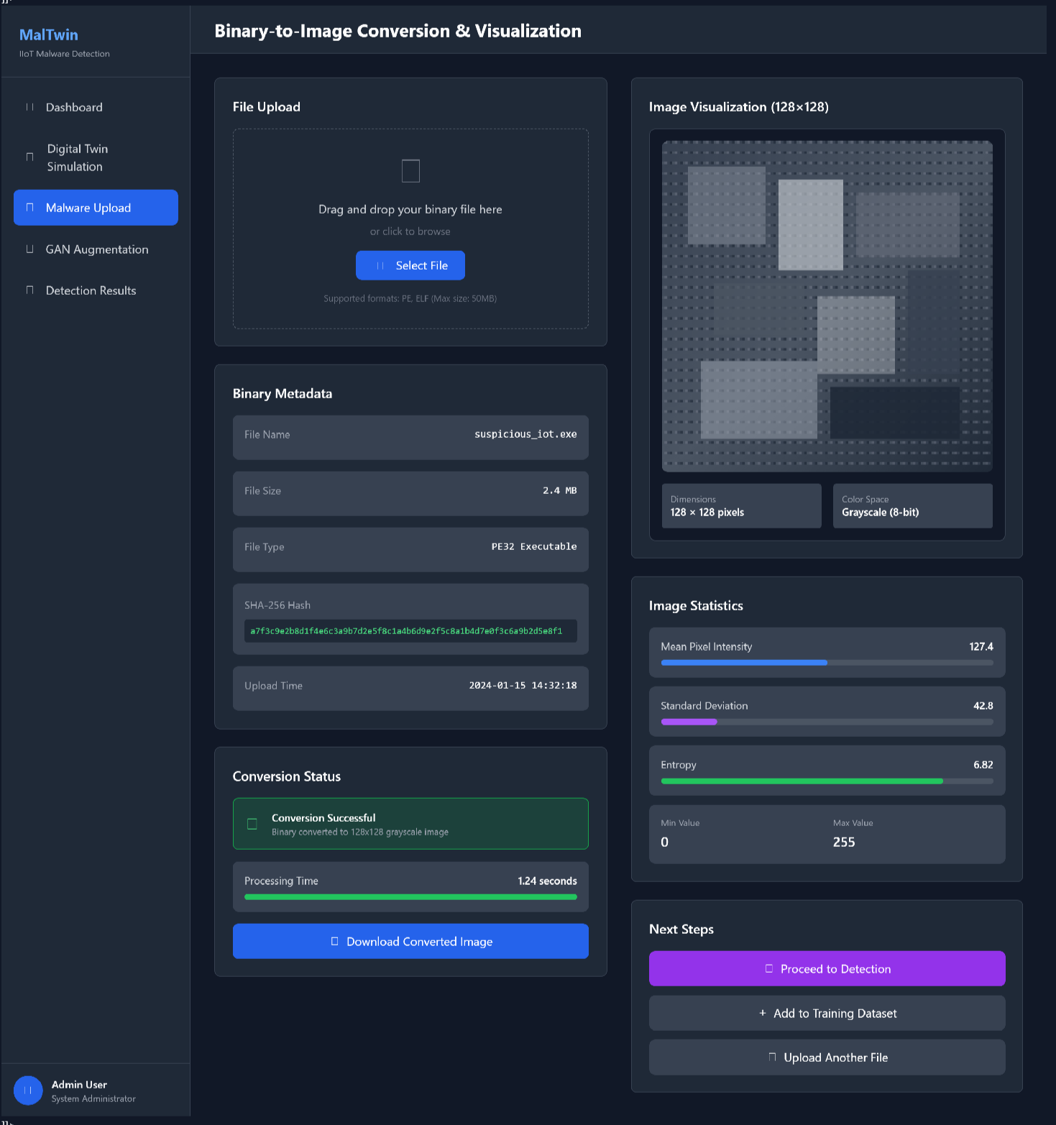
Description: This screen enables users to upload malware or benign binaries and visualize them as grayscale images for static analysis.
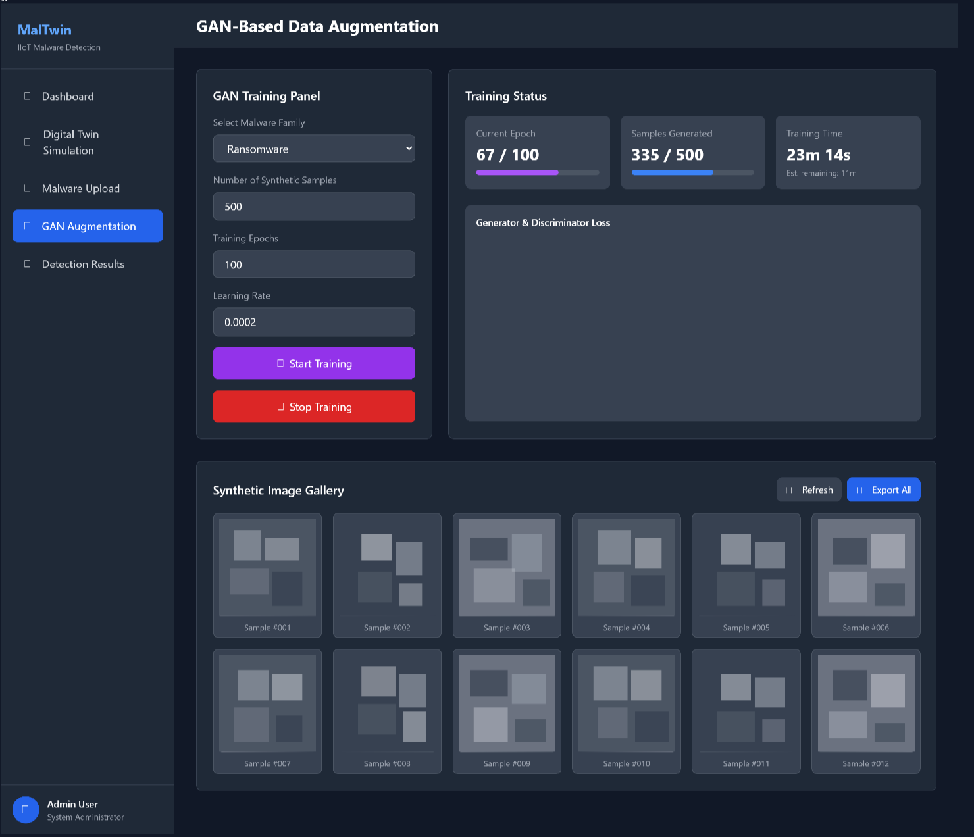
Description: This screen visualizes enhanced or balanced malware samples to address dataset imbalance and supports inspection of different malware families.

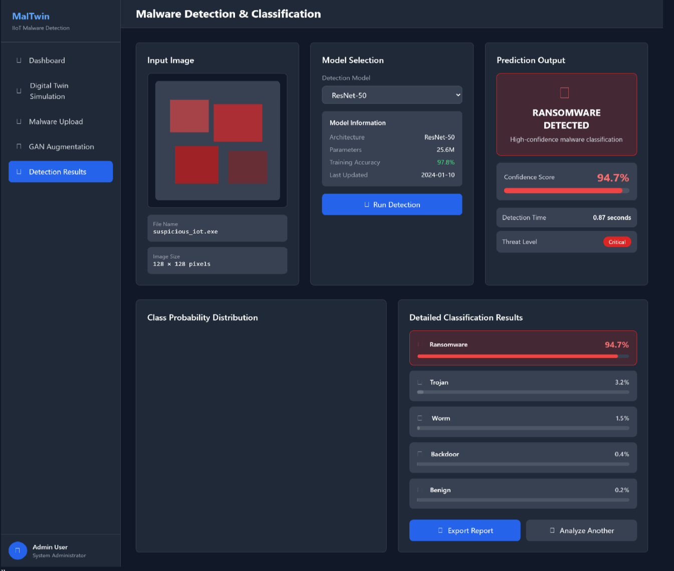

Description: This screen performs intelligent learning-based malware detection using trained classification models and displays prediction results with confidence scores.
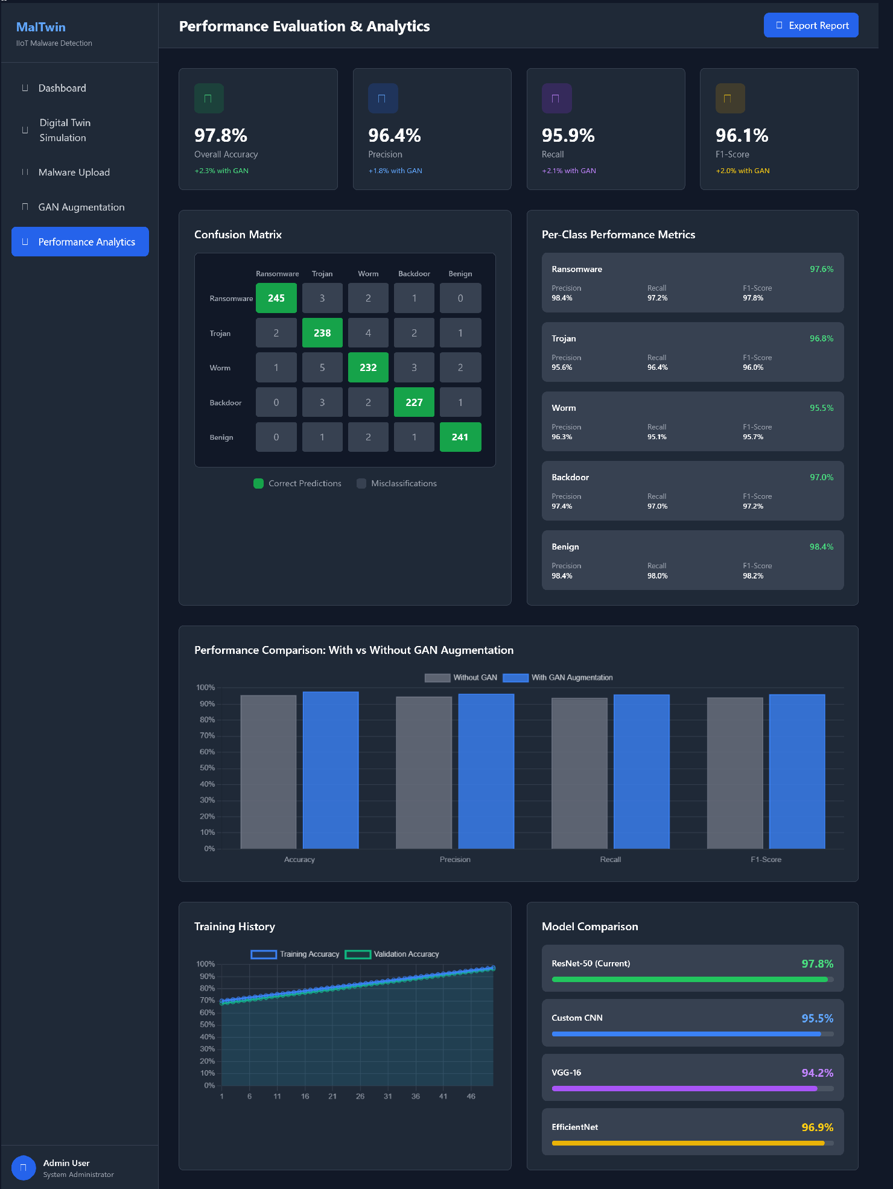
Description: This screen displays model evaluation metrics for performance validation.

References
Journal Articles
Cha, H.-J., Yang, H.-K., et al. “Intelligent Anomaly Detection System through Malware Image Augmentation in IIoT Environment Based on Digital Twin.” Applied Security Journal, vol. –, pp. –, 2024. Internet: https://www.mdpi.com/2076-3417/13/18/10196, [Dec. 19, 2025].
Saridou, B., Moulas, I., Shiaeles, S., & Papadopoulos, B. “Image-Based Malware Detection Using α-Cuts and Binary Visualisation.” Applied Sciences, vol. 13, 4624, 2023. Internet: https://pdfs.semanticscholar.org/874a/bc4b20193e419a18c951588083e203486285.pdf, [Dec. 19, 2025].
Transfer Learning for Image-Based Malware Detection for IoT. PMC, 2024. Internet: https://pmc.ncbi.nlm.nih.gov/articles/PMC10051059/, [Dec. 19, 2025].
Conference Proceedings
Author(s). “Malware Detection in Industrial Internet of Things Based on Hybrid Image Visualization and Deep Learning Models.” Ad Hoc Networks, 2020. Internet: https://www.researchgate.net/publication/341251842_Malware_Detection_in_Industrial_Internet_of_Things_based_on_Hybrid_Image_Visualization_and_Deep_Learning_Model, [Dec. 19, 2025].
World Wide Web
Author(s)*. “Malware Detection Frameworks for IoT.” PeerJ Computer Science. Internet: https://peerj.com/articles/cs-1366/, 2023 [Dec. 19, 2025].
Author(s)*. “SoK: Visualization-based Malware Detection Techniques.” ACM Digital Library. Internet: https://dl.acm.org/doi/fullHtml/10.1145/3664476.3664514, 2024 [Dec. 19, 2025].
Author(s)*. “Mirai (malware).” Wikipedia. Internet: https://en.wikipedia.org/wiki/Mirai_(malware), 2025 [Dec. 19, 2025].
Book (Optional Background Reference)
Gupta, B., et al. Internet of Things Security: Principles, Applications, Attacks, and Countermeasures. Boca Raton, FL: CRC Press, 2020, pp. 45–112.

Plagiarism Report
