# System Implementation

# Main Dashboard

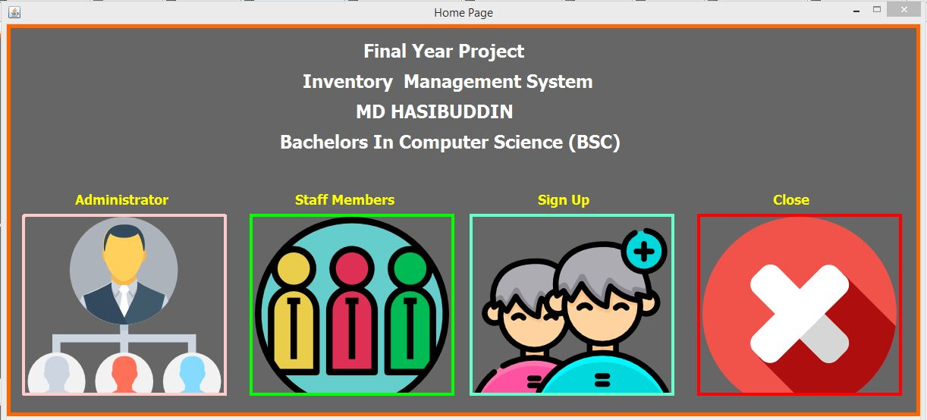

* This is the first form that appears on the screen, here the user has to select one of the four choices available.
* The first option from the left is for the admin, the second for registered staff members, the third for the un-registered employees and the fourth and the last option terminates the program.
* If the user behind the screen is the admin then it would be the first option on the left that the admin would click on. The following form would than appear on the screen.

# Administrator’s log in page

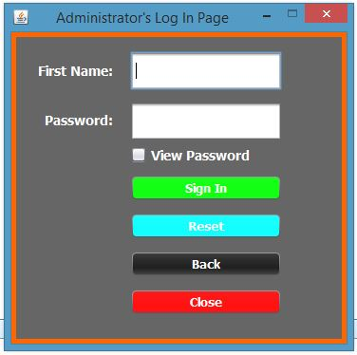

* Here the admin is required to fill in the text boxes by providing his/her first name and password.
* The reason for using admin’s first name as his/her login name is because there can only be one administrator of this system therefore chances of a clash because of a common name is next to null.
* The checkbox’s purpose is to allow the admin to view the typed password which is set to decrypt and is displayed in the asterisk characters.
* Sign in button colored in green is the log in button.
* Reset button under that sets the values typed in the text boxes to null (clears text fields).
* The back button closes this form and re-opens the main dashboard form again.
* Close button terminates the system.

# Administrator’s Dashboard

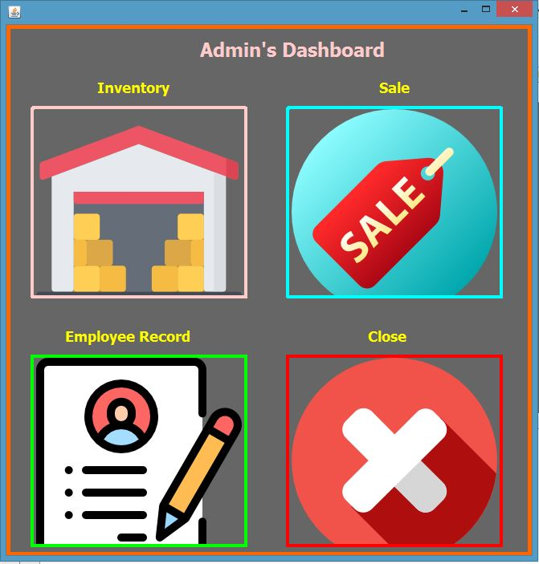

* The module on the top left is the inventory module only the admin has access to this module.
* The module on the top right is the sale’s module. Employees are only granted access to this module from the main dashboard.
* The module on the bottom left is the employee record module only the admin has access to this module.
* The module on the bottom right is program termination option.

# Inventory Module

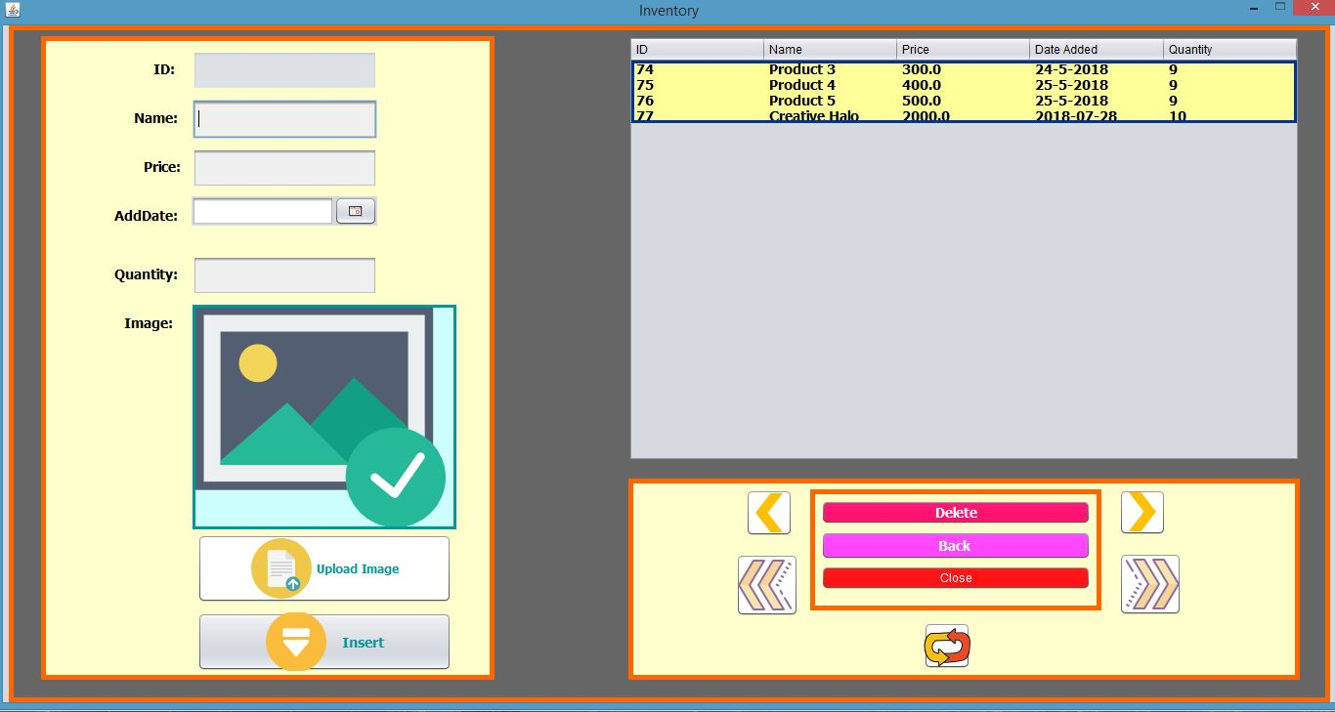

* The first text box displays the id number of the product. This text box cannot be edited the id is auto generated.
* The second text box displays the name of the product and it can be edited by the admin.
* The third text box displays the price of the product and it can be edited by the admin.
* The fourth text box displays the date of the product and it can be edited by the admin.
* The fifth text box displays the quantity of the product and it can be edited by the admin.
* The green square containing the portrait image is what displays the image of the product.
* The button below that lets the user select an image of the product.
* The insert button stores the values provided above in to the database and displays it in the table to the right.
* The table containing four rows show the stored products.
* The first left arrow lets the admin select the previous product in the table.
* The first right arrow button lets the admin select the next product in the table.
* The second left arrow button lets the admin select the first product in the table.
* The second right button lets the admin select the last product in the table.
* The delete button deletes the selected product.
* The back button closes this form and re-opens the admin’s dashboard form again.
* The close button terminates the system.
* The button below the close button deselects any selected product in the table and clears all the textboxes and the image of the product resetting it to the image displayed above.

# Product Selected

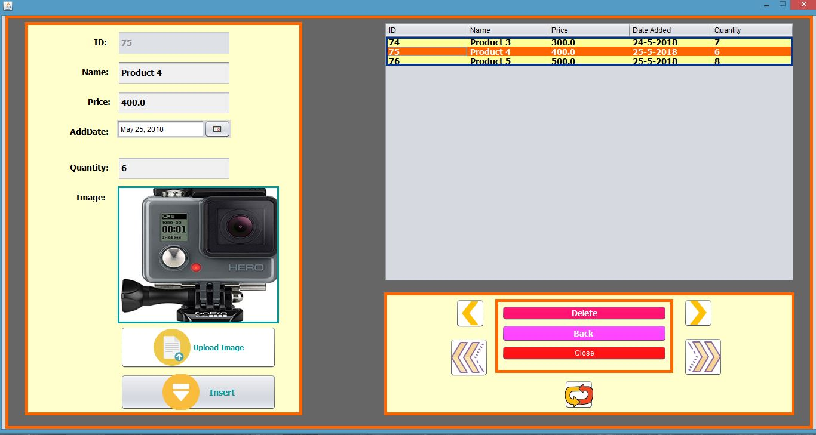

* The highlighted orange light shows that a product is selected from the inventory table and the its details are shown in relevant text boxes along with its image.

# New Product and its Image

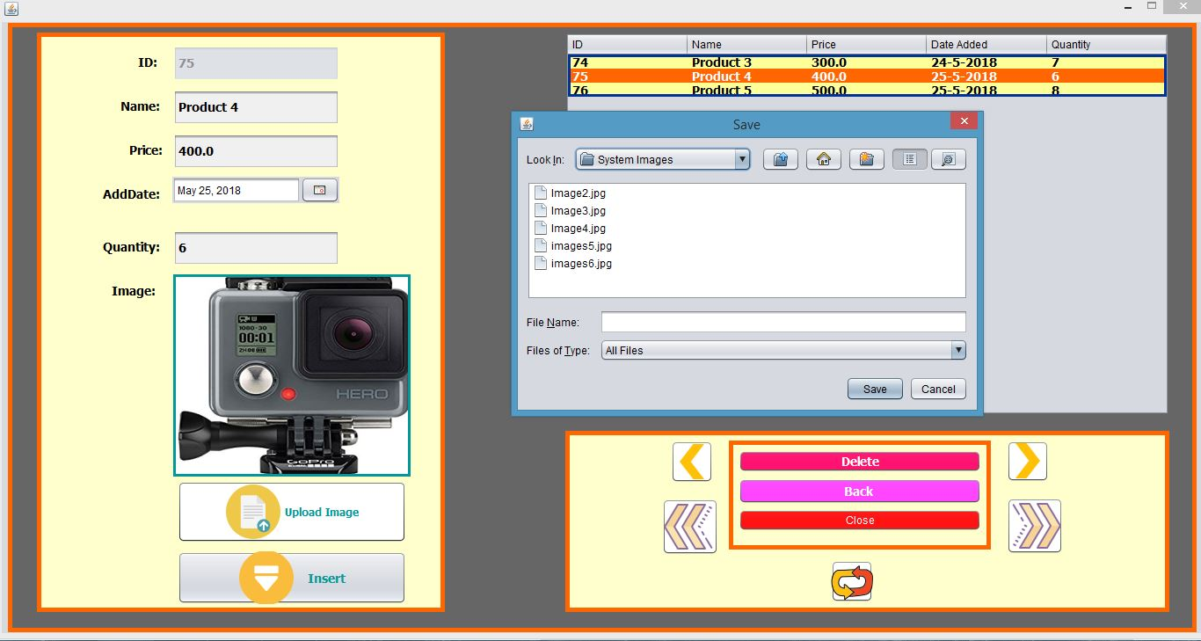

* The admin is first required to do clear any selected product by clicking on the refresh button.
* The admin than has to fill in the information in their relevant text boxes except for the “ID” text box(since its un-editable).
* The admin is then required to click on the click upload image button which would than prompt the “Save” window. The admin than has to navigate to the image’s location (given that the image is of on of the two type jpg or png) and select it followed by pressing the save button.
* The admin than has to click on the insert button which would write/store all the information provided in to the database which would than be display as a row in the inventory table.

# Delete Product

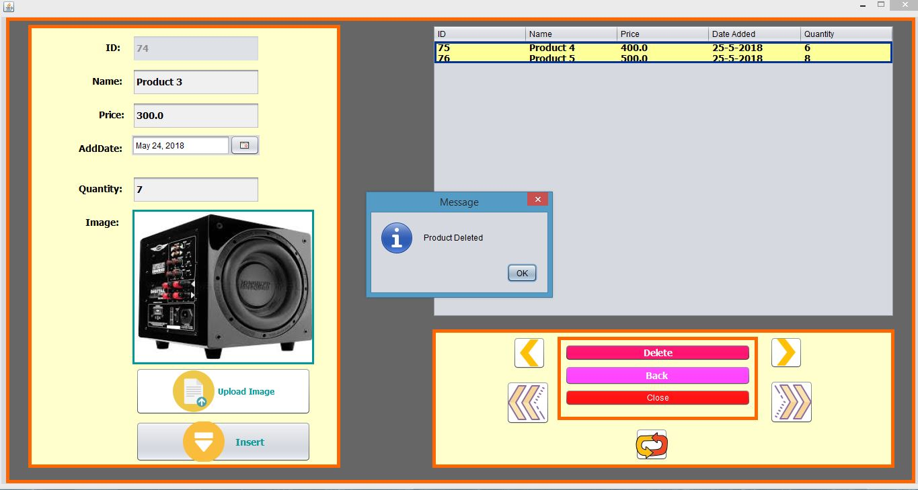

* In order to delete a product, the admin first has to select the product (row) in the inventory table.
* The admin than has to click on the delete button.
* The window display in the image “Message” would than appear notifying the admin that the product has been delete.
* As shown the product displayed is no longer displayed in the inventory table since it has already been deleted.
* The “Message” window is only further notifying the admin. Once the admin clicks the ok button the deleted product’s details would than be cleared from the text boxes and its image displayer.

# Sale’s Module

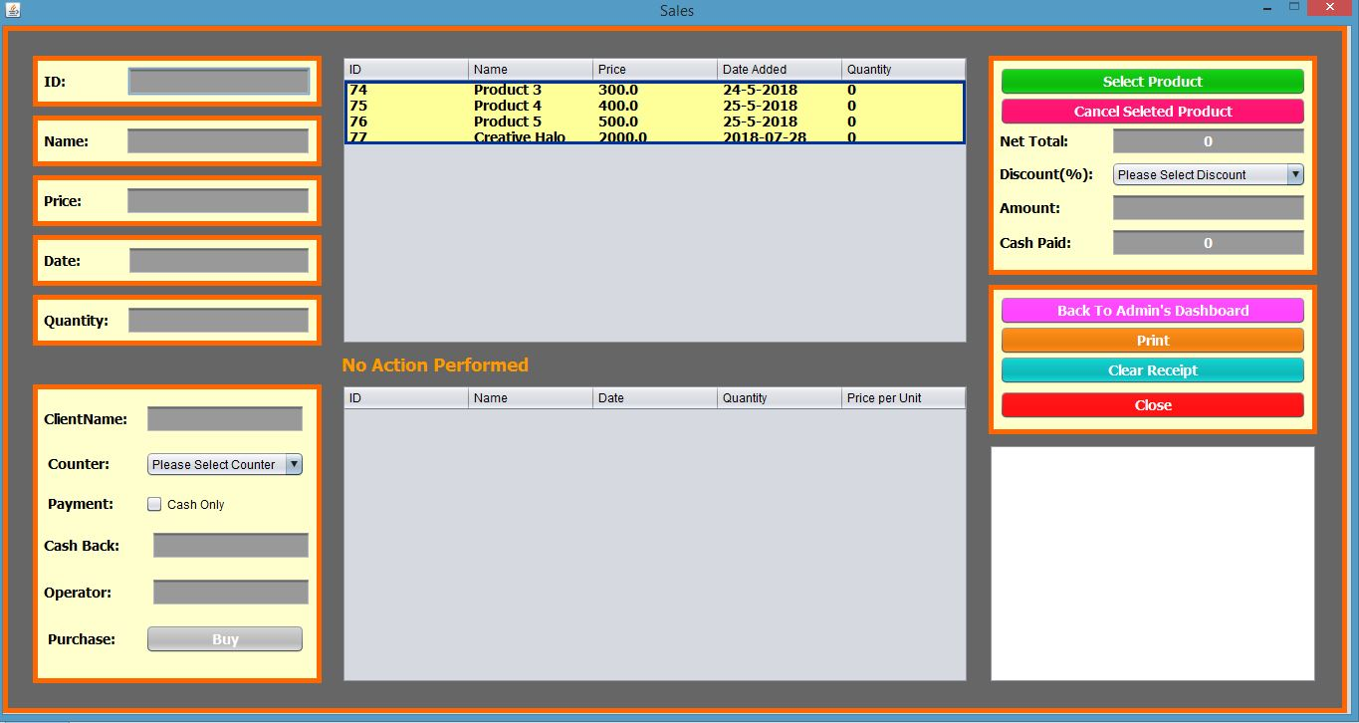

* The first text box displays the id number of the product which is auto generated. This text box cannot be edited by the admin and by any staff member.
* The second text box displays the name of the product and it cannot be edited by the admin and by any staff member.
* The third text box displays the price of the product and it cannot be edited by the admin and by any staff member.
* The fourth text box displays the date of the product and it cannot be edited by the admin and by any staff member.
* The fifth text box displays the quantity of the product and it cannot be edited by the admin and by any staff member.
* The first table containing four rows show the stored products.
* The message displayed in orange below it that reads” No Action Performed” displays errors if the user (admin/staffer) makes a mistake.
* The orange container next to the first table holds the green button called “Select Product”. This is the button the user clicks on once a product is selected from the first table.
* The pink button below that called “Cancel Selected Product” is to cancel any selected product or products (one at a time).
* The text box below it labelled “Net Total” displays the sum of selected product’s price(un-editable).
* The list below that labelled “Discount (%)” lets the user select a range of discount from 0-100 in increments of 5.
* The text box below it labelled “Amount” displays the amount after the discount has been deducted from the net total(un-editable).
* The text box below it labelled “Cash Paid” is where the user enters the amount that the client has paid. The amount can only be entered in whole numbers.
* The first button in the second orange container colored in purple and is labelled “Back To Admin’s Dashboard” lets the admin navigate back to the admin’s dashboard however it is only enabled for the administrator. If a staff member clicks that button it will prompt a window stating “Access Denied”.
* The button below that colored in orange labelled “Print” lets the user print out the receipt however if the user clicks on it while the receipt is empty an error would be displayed below the first table stating “The Receipt Is Empty” in orange.
* The button below it in blue labelled “Clear Receipt” clears out any pre-existing receipt. Once pressed it also displays a message in orange below the first table.
* The red button below it labelled “Close” terminates the system.
* The white box at the bottom displays the receipt.
* The orange container to the left of the table contains a text box labelled “Client Name” is where the user(admin/staffer) is required to enter the name of the client if it is left empty then the transaction would be unsuccessful and the system would display an error in a window.
* The list below it is labelled “Counter” the user(admin/staffer) is required to select one of the counters in the list otherwise the transaction would be unsuccessful and the system would display in error in a window.
* The check below that labelled “Payment” is where the user(admin/staffer) is required to check the box otherwise the transaction would be unsuccessful and the system would display in error in a window.
* The text box below that labelled “Cash Back” is where the excess amount is displayed to the user(admin/staffer). This is the amount that is to be returned to the customer.
* The text box below that labelled “Operator” is where the name of the logged in user (to the user(admin/staffer)) appears.
* The button next to the label “Purchase” is what write the receipt and completes the transaction. The value of all the text boxes is written on to the receipt.

# Product Selection

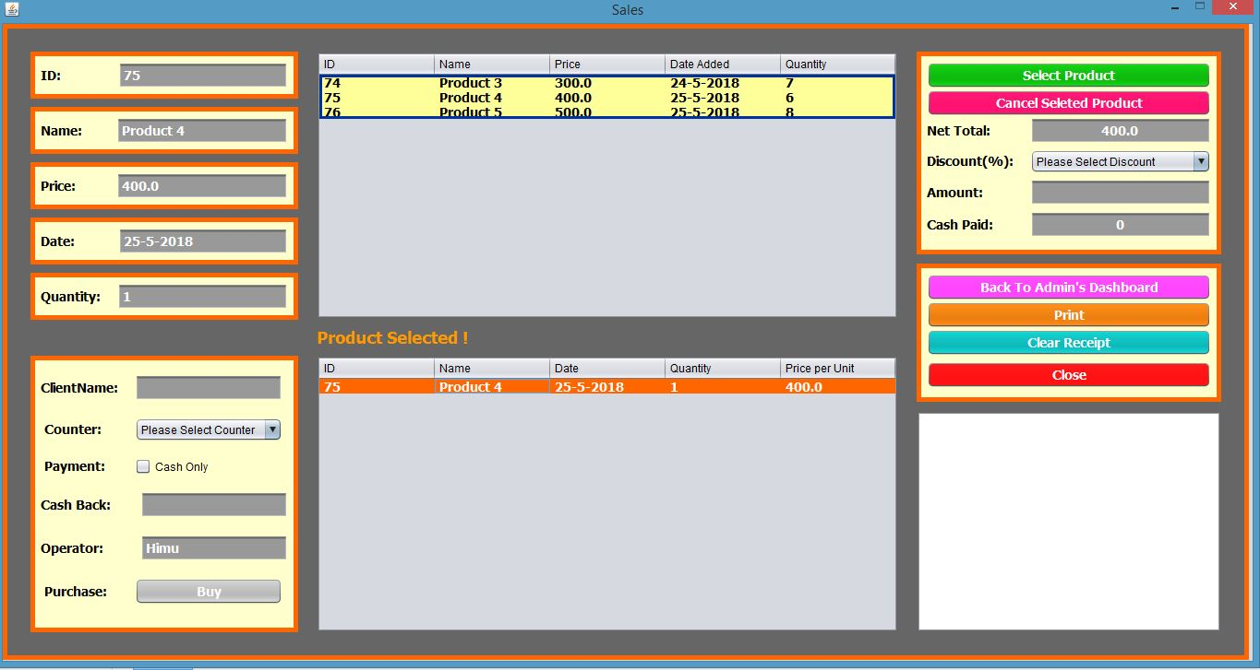

* In the image above the user has selected a product.
* In-order to select a product the user is first required to click on of the rows in the first table and click on the button “Select Product”.
* Once the button is clicked on the selected product is transferred over to the purchasing table below. The quantity of the product is then deducted from the first table.
* The label between the two labels indicates that a product has been selected by displaying the message “Product Selected !”.

# Writing a Receipt

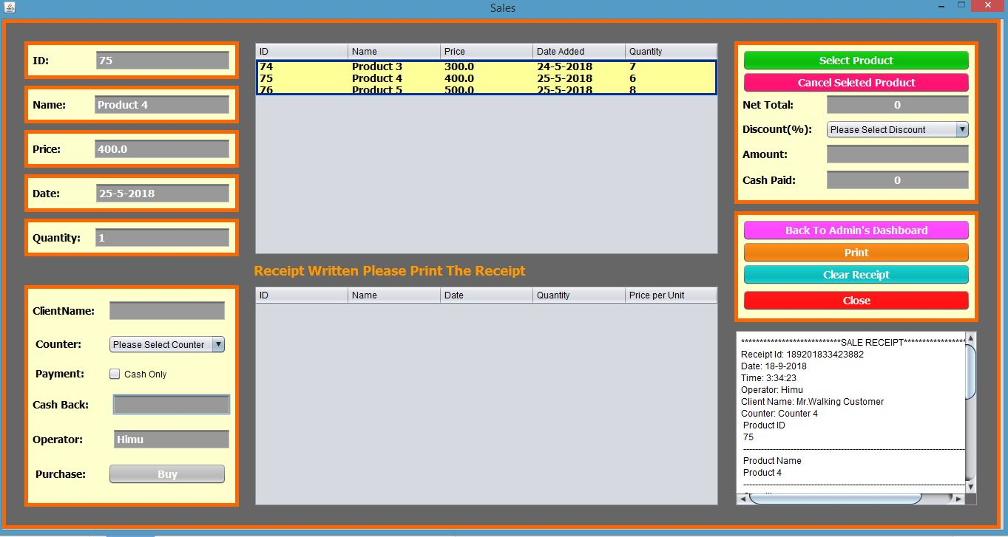

* To write a receipt all a user is required to do is to fill out the information the system requires and press on the button “Buy”. The receipt would than be written as shown in the image above.

# Precaution

# 

* If the user tries to terminate the system without printing the receipt an error would appear on the screen. It will let the user know that the receipt has not been printed or a product is selected. If either of those condition is true the system would not terminate.

# Receipt

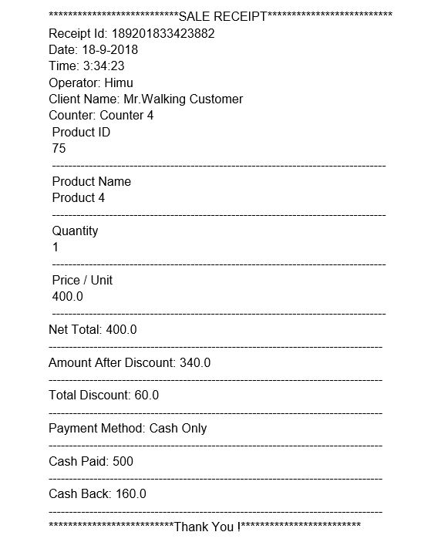

* The image above shows the print preview of the receipt.
* Receipt id shown in the receipt is a unique id number that is assigned to every receipt that is written.
* Date and time of the day the receipt is written is shown.
* The name of the Operator who made the transaction is written.
* The name of the Client who ordered the goods is written.
* The counter number is written as well.
* Product’s name, quantity, price/unit is written on the receipt in rows.
* Net total is written at the end of it.
* “Amount After Discount” is the final amount once the discount is deducted from the net total.
* “Total Discount” is the amount of discount the customer has received.
* “Payment Method” is the method by which the transaction has taken place therefore in this system it would say “Cash Only”.
* “Cash Back” is the surplus amount that is to be paid back to the customer.

# Employee Record Module

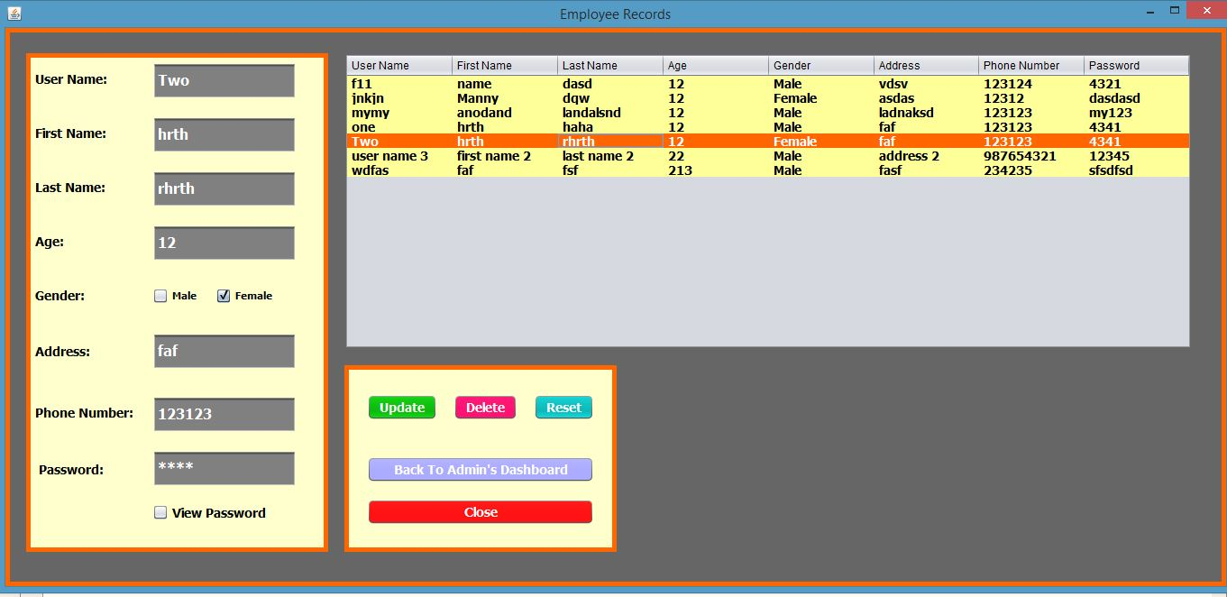

* This module is only accessible from the administrator’s dashboard therefore no staff member has access to it.
* The table on the right shows the list of registered staff members and all their credentials.
* Once the admin clicks on one of the rows the data is then transferred over to the textboxes on the left. The highlighted row in the image is selected therefore all its data is shown in the textboxes.
* The first text box labeled “User Name” shows the user name of the employee.
* The second text box labeled “First Name” shows the first name of the employee.
* The third text box labeled “Last Name” shows the last name of the employee.
* The fourth text box labeled “Age” shows the age of the employee in numeric. This text box only accepts integer values.
* The fifth on our list are two check boxes labeled “Gender” shows the gender of the employee. However only one check box can be selected at a time.
* This is the sixth item but the fifth text box labeled “Address” shows the address of the employee. This text field accepts both numbers and characters.
* The seventh item and the sixth text box labeled “Phone Number” shows the contact number of the employee and just like the age field it only accepts integer values.
* The eighth item and the seventh text box labeled “Password” shows the encrypted password of the employee.
* The ninth item is a checkbox labeled “View Password” once checked it will then decrypt the password shown in the password field above.
* Almost all the text boxes above including the two check boxes are editable. The text box labeled “User Name” cannot be edited because that serves as a primary key in the database.
* Update button in green updates the records.
* Delete button in pink deletes an employee record.
* Reset button in light blue clears up all the text boxes, deselects any selected row and un checks all the text boxes.
* The button labeled “Back To Admin’s Dashboard” opens the admin’s dashboard and closes the current module.
* The close button in red closes the current module and terminates the entire system.

# Update Employee Record

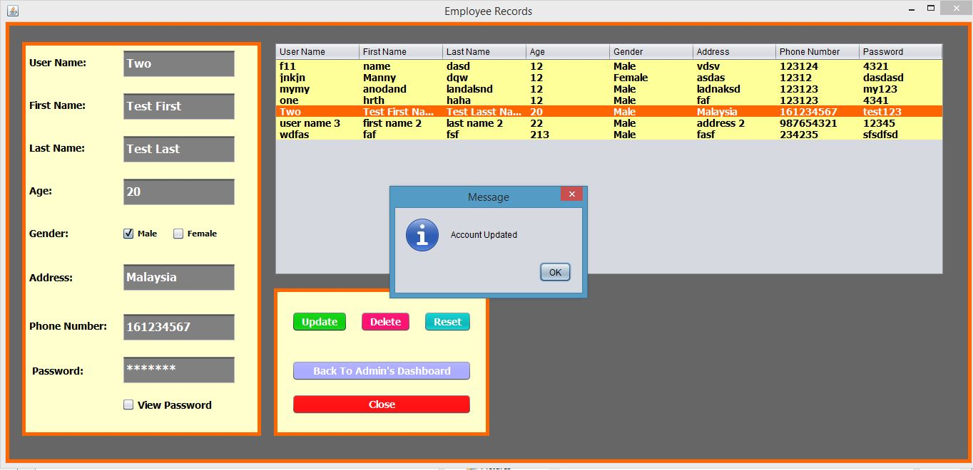

* Once the admin has made the desired changes he/she would then click on the update button in green and the employee record would be updated. The system would than prompt a message notifying the admin of the changes. Once the admin clicks on the “Ok” button the windows would then disappear.
* If the admin exits without clicking on the update button the changes would then be discarded.

# Delete Employee Record

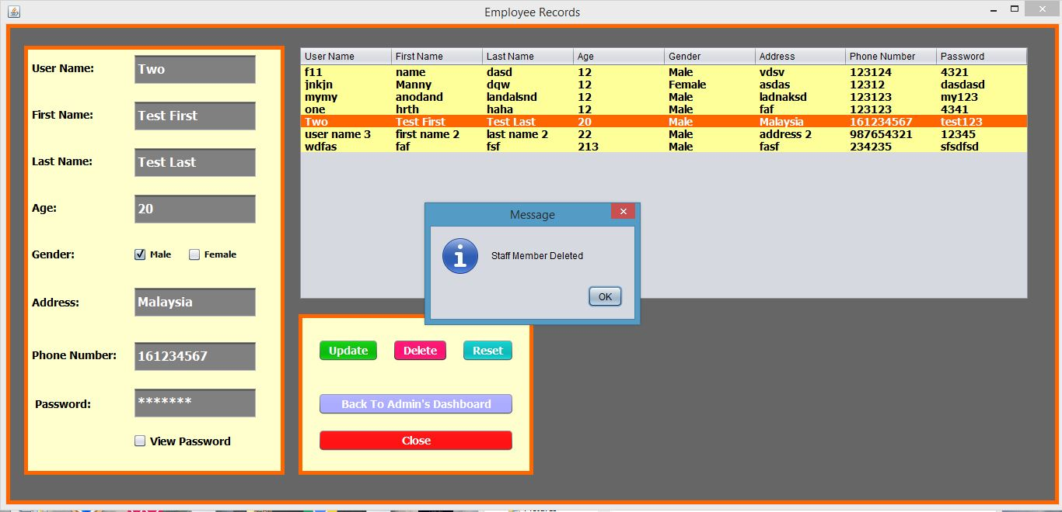

* In order to delete an employee from the system the administrator first has to click on one of the rows in the table and click on the delete button colored in pink. A window will then appear confirming and notifying the admin of the changes that has taken place.

# Employee Sign Up Module

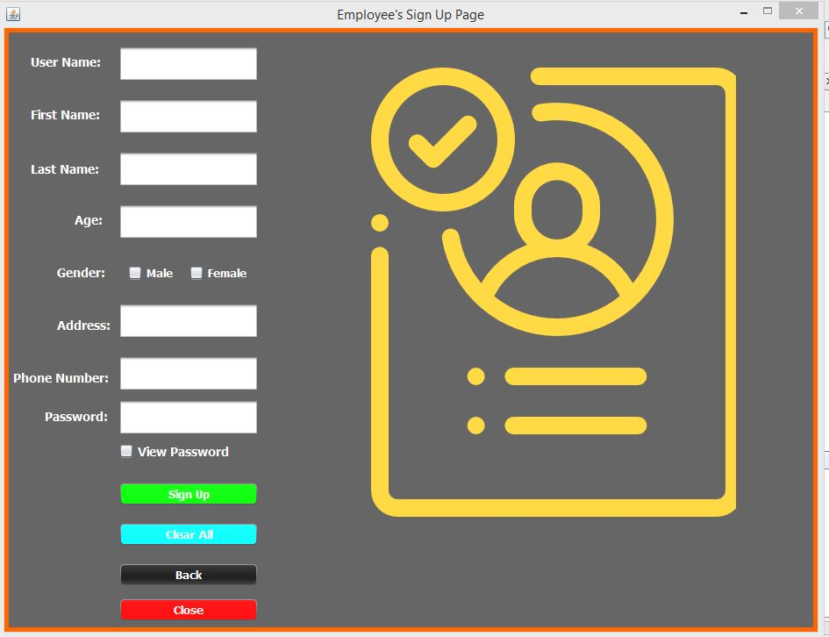

* This module is accessed from the main dashboard therefore ever one and one can have access to this module by clicking on the “Sign Up” image.
* The text box labeled “User Name” is the primary key that means each user name in the system is unique. This is how the record of the employees is identified in the system. This text only accepts alphabets and numbers.
* The text box labeled “First name” is where the user types in the first name.
* The text box labeled “Last Name” is where the user types in the last name.
* The text box labeled “Age” is where the user types in the age in numeric. This text box only accepts integer values.
* The two check boxes labeled “Gender” lets the user select a gender by clicking however only one check box can be selected at a time.
* The text box labeled “Address” is the where the user types in the address. This text box accepts both text and numbers.
* The text box labeled “Phone Numbers” is the where the user enters phone numbers but this text box only accepts numeric values.
* The text box labeled “Password” is where the user enters the password of one’s choosing. This text box accepts both alphabets and numbers.
* The check box labeled “View Password” decrypts the password user has typed in the text box above.
* The button in green labeled “Sing Up” is what writes the record in to the database. However, if the user has left any of the text boxes empty or has not checked one the check boxes the system would then prompt a small window showcasing the error. It would notify and guide the user on how to eliminate the error.
* The button in blue labeled “Clear All” clears all the text boxes and un checks all the text boxes.
* The button in black labeled “Back” opens and displays the main dashboard and closes the current module.
* The button in red labeled “Close” terminated the entire system.

# Primary Key

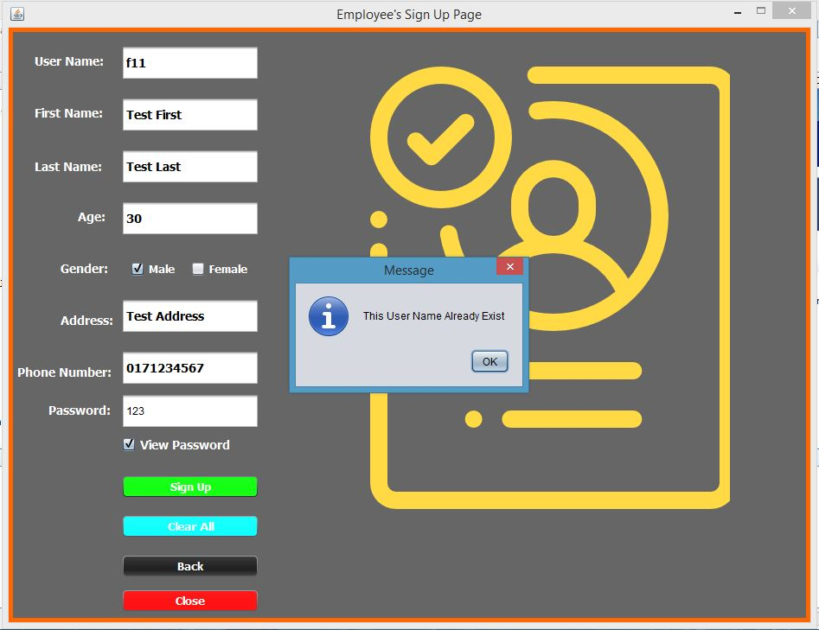

* If the user name entered by the user already exist the system would then display an error and notify the user to change the user name since the user serves as a primary key in the system.

# Password’s Length

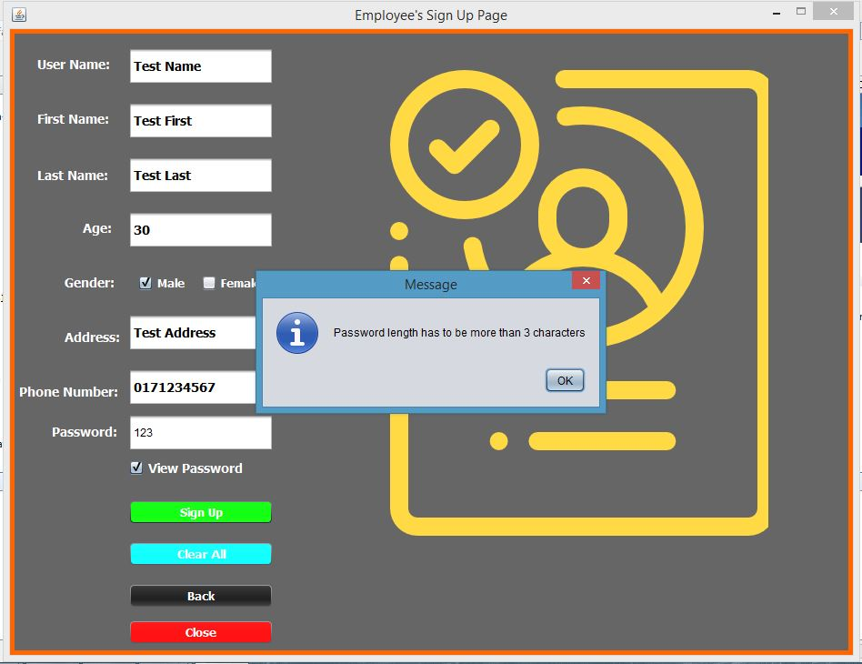

* If the password entered by the user is less than 4 characters the system would then display a message informing the user of the fault and guiding the user on how to eliminate the error.

# Account Created

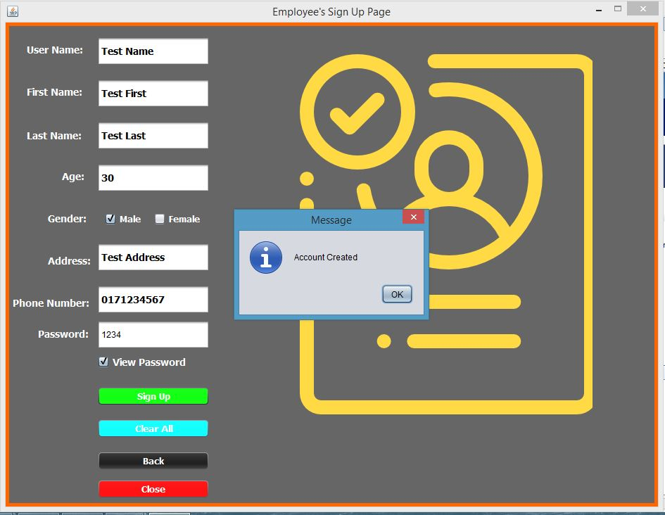

* Once the user has filled out all the details and clicked on the green sign up button the account of the user is now created. The details provided by the user is written in to the database.

# Confirmation

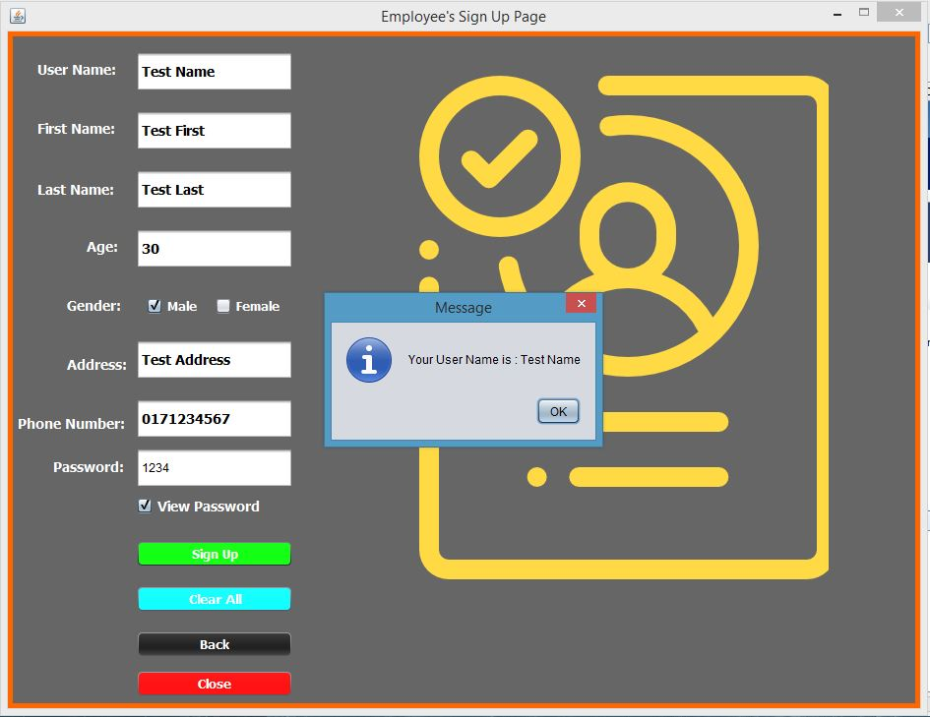

* Here the system is displaying the user name that the employee will use from now on and it is also one the of the log in details the user is required to provide to the system.
* This is a further confirmation message displayed by the system.