West Adelaide Legal
Website Content, Structure and Approved Requirements
Source-of-truth specification for Codex implementation
Critical content rule: Do not invent facts, credentials, practice areas, addresses, testimonials, statistics, awards, social-media profiles, lawyer photographs, slogans, case results, or other content not contained in this specification or explicitly supplied later by the client.

1. Authority and precedence
- Use this document as the primary implementation/content reference.
- The Markdown version contains the same written information and is the easiest machine-readable reference.
- Generated visual mockups may contain decorative wording that is not source-approved. Such wording is design-only and must not be published unless explicitly approved.
- Use akrishnan@westadelaidelegal.com.au as the primary website email. Do not use akrishnan@westadelaide.com.au.
- Do not add social-media links unless supplied later.
- Do not add a professional photograph of Ashwina Krishnan at this stage.
- Do not use placeholder business content. Omit unavailable information.

2. Business identity and contact information
- Business name: West Adelaide Legal Pty Ltd
- Website referenced in privacy policy: www.westadelaidelegal.com.au
- Primary email: akrishnan@westadelaidelegal.com.au
- Phone: 0410 106 136
- International phone format: +61 410 106 136
- Primary exact address: Spaces @ The Heroic, 1-3 Metro Parade, Mawson Lakes SA 5095
- Location context: Adelaide, South Australia
- WhatsApp: provide a WhatsApp contact option using the supplied phone number.

Map rule
The website must include a Google Map/location component. Use the exact address “Spaces @ The Heroic, 1-3 Metro Parade, Mawson Lakes SA 5095” for the map pin. Do not invent street addresses for other appointment locations.

3. Approved website architecture
- Home /
- About /about
- Practice Areas /practice-areas
- Fees & Appointments /fees-appointments
- Contact /contact
- Privacy Policy /privacy-policy

Main navigation
- Home
- About
- Practice Areas
- Fees & Appointments
- Contact
- Primary CTA: Free Initial Appointment
Privacy Policy should be linked from the footer and the contact-form privacy acknowledgement, not necessarily the primary navigation.

Future expansion
The architecture should remain extensible for individual practice-area pages, Insights/legal articles, appointment booking, social profiles and a real professional lawyer photograph. Do not add those now without supplied content/approval.

4. Approved brand and visual direction

Logo
- Approved direction: Option A.
- Elegant overlapping W/A monogram.
- Deep navy dominant colour with restrained warm gold/brass accent.
- Refined serif wordmark treatment for West Adelaide Legal.
- Prestigious, modern boutique-law-firm character.
- Avoid cliché legal imagery in the logo.
- Do not include unapproved taglines from concept artwork.

Visual system
- Overall mood: prestigious, modern, calm, credible, compassionate and accessible.
- Palette: deep navy/dark blue, white/warm ivory/light neutral, restrained gold/brass accent.
- Typography: elegant serif headings and clean sans-serif body/UI text.
- Spacing: generous, editorial and uncluttered.
- Animation: subtle/purposeful only - gentle reveal/fade, navigation transitions, restrained button hover and scroll motion.
- No fake/stock person should be presented as Ashwina Krishnan.
- Avoid overusing gavels, scales and courthouse clichés.

Responsive rule explicitly approved
At medium screen sizes and below, the lower contact-area components must stack vertically and each take the full available width. Do not compress the contact/enquiry form and map/location content into narrow side-by-side columns on tablet/mobile. Contact details, form and map should be comfortably readable and full-width/stacked as needed. Mobile navigation should use a clean hamburger/menu-drawer pattern.

5. Technology, performance and deployment requirements
- Next.js
- Chakra UI
- Tailwind CSS
- Production-ready code suitable for Netlify deployment
- Fully responsive, fast and SEO-friendly implementation
- Semantic HTML and accessible UI patterns
- Optimised assets and restrained client-side JavaScript
- Use Next.js metadata/SEO capabilities appropriately
- Run normal production checks such as linting and a successful production build
- Use Chakra UI and Tailwind intentionally rather than randomly mixing styling responsibilities
- Do not hard-code secrets or API keys
- Form delivery/backend provider is not yet specified; do not invent an external service without approval
- Google Maps implementation/API configuration is not yet specified; use the supplied exact address when finalised

6. Approved source copy - About Us

About Us
West Adelaide Legal are here to offer legal support that is trusted, compassionate and tailored to your needs.
West Adelaide Legal was founded with the objective of enhancing access to justice for our community’s most vulnerable by providing legal services that are affordable and accessible.
At West Adelaide Legal, we ensure that our clients feel supported, informed and empowered throughout their legal journey.

Content positioning
- trusted legal support
- compassionate legal support
- support tailored to client needs
- affordable and accessible legal services
- enhancing access to justice for vulnerable members of the community
- helping clients feel supported, informed and empowered
Do not invent claims such as award-winning, best law firm, case-win rates, years of firm operation, client counts or testimonials.

7. Areas of Practice
- Criminal & Traffic Law
- Family Law & Family Violence (incl. intervention order matters)
- Migration & Refugee Law
- Spent Conviction Order Applications
- Human Rights Law
No detailed practice-area descriptions have been supplied yet. Do not manufacture long service descriptions.

8. Pricing / Fees content

Pricing
We offer fixed fee agreements for when the cost of your matter can be estimated in advance. The cost of each matter is assessed on a case-by-case basis, depending on duration and complexity. You will be advised of the cost upfront prior to entering into any agreement.
West Adelaide Legal are committed to offering accessible and cost-effective legal assistance. A payment plan can also be arranged according to your specific circumstances. We also assist with obtaining Legal Aid funding for those eligible.

Key points that may be surfaced visually
- Fixed fee agreements where the cost can be estimated in advance
- Case-by-case assessment based on duration and complexity
- Cost advised upfront before entering an agreement
- Payment plans may be arranged according to individual circumstances
- Assistance with obtaining Legal Aid funding for eligible clients
Do not publish specific dollar amounts because none have been supplied.

9. Our People - Ashwina Krishnan

Role
Ashwina Krishnan is the principal solicitor of West Adelaide Legal.

Education
Ashwina graduated from the University of Adelaide with a Bachelor of Laws and Bachelor of International Studies in 2018. In 2026, Ashwina also completed a Masters of Law specialising in Human Rights Law and Policy.

Career and admissions
She was admitted to the Supreme Court of New South Wales in 2019 and commenced her legal career in private practice, primarily working in the areas of immigration, family and criminal defence.
Since then, Ashwina has gained a wealth of diverse and valuable professional experience working as a summary prosecutor for the Office of the Director of Public Prosecution in the Northern Territory and as a legal and policy officer for the Commonwealth Attorney-General’s Department. These experiences have furnished Ashwina with a unique insight into the inner workings of the justice system and the challenges associated with navigating it.
Ashwina is admitted to Supreme Court of South Australia and the High Court of Australia. She is also a current member of the Legal Services Commission of South Australia’s General Panel.

Client approach
Ashwina recognises that legal proceedings can be extremely stressful and is committed to providing accessible legal support tailored to individual client needs.

Image rule
Do not show a professional portrait/stock substitute at this stage. The page layout must remain visually complete without a portrait. A real photograph may be introduced later.

10. Appointments
Please contact us for a free, no obligation, initial appointment to discuss your matter. Free first appointments are currently available via telephone.
In-person appointments are offered, between 9:30 am and 5:00 pm, at the following locations:
- Spaces Currie St, Adelaide CBD
- Regus Victoria Park
- The Heroic, Mawson Lakes
West Adelaide is committed to accessibility and are here to accommodate your needs. We are happy to consider home visits or after hour appointments should the above locations or timings be unsuitable.
Please contact us at 0410 106 136 to discuss further.
Only The Heroic has a full street address supplied. List the other appointment locations by name only; do not invent their street addresses.

11. Contact experience

Contact information
- Phone: 0410 106 136
- Email: akrishnan@westadelaidelegal.com.au
- Address: Spaces @ The Heroic, 1-3 Metro Parade, Mawson Lakes SA 5095

Contact form
- Full Name - required
- Email - required
- Phone - required
- Message - required
- Privacy acknowledgement checkbox - required
- Submit CTA: Send Enquiry
Privacy acknowledgement should link to the Privacy Policy page. Do not add sensitive intake questions or request unnecessary personal/legal details without approval.

WhatsApp
- Include a floating WhatsApp contact control
- Use 0410 106 136 / +61 410 106 136 unless updated
- WhatsApp is a secondary quick-contact option and must not replace the contact form
- Keep the WhatsApp button visually restrained

Google Map
- Include an interactive location/map section
- Pin: Spaces @ The Heroic, 1-3 Metro Parade, Mawson Lakes SA 5095
- A Get Directions action is appropriate

12. Home page - approved content structure

Header / navigation
- Approved WA logo direction
- Home, About, Practice Areas, Fees & Appointments, Contact
- CTA: Free Initial Appointment

Hero
- Primary source-supported headline direction: “Trusted, compassionate legal support tailored to your needs.”
- Use source-supported About copy for supporting text
- Location context may be Adelaide, South Australia
- CTAs: Free Initial Appointment and Call 0410 106 136

About West Adelaide Legal
- Use the approved About Us copy

Areas of Practice
- Show the five supplied practice areas only

Our People / Ashwina Krishnan
- Introduce Ashwina as Principal Solicitor
- Use supplied education, career, admission and client-approach information
- No portrait for now

Fees & Appointments
- Fixed fee / case-by-case / upfront costs / payment plans / Legal Aid assistance
- Free no-obligation initial appointment via telephone
- In-person appointment locations and accessibility options

Contact
- Contact details
- Enquiry form
- Map for The Heroic
- WhatsApp floating contact option

Footer
- Business name/logo
- Primary site links
- Phone, email and exact supplied address
- Privacy Policy
- No unprovided social-media links
Important mockup-copy warning: visual mockups contain some decorative/generated taglines not supplied by the client. Those lines are not approved production copy. Use only source-supported content in this specification unless explicitly approved later.

13. About page - content structure
- About West Adelaide Legal - full About Us copy
- Firm purpose/client approach - access to justice, affordability, accessibility, supported/informed/empowered experience
- Ashwina Krishnan - Principal Solicitor - full supplied profile
- No fabricated history, staff, statistics, awards, testimonials or photographs

14. Practice Areas page - content structure
- Criminal & Traffic Law
- Family Law & Family Violence (incl. intervention order matters)
- Migration & Refugee Law
- Spent Conviction Order Applications
- Human Rights Law
No unsupported service descriptions should be added.

15. Fees & Appointments page - content structure
- Pricing / cost approach
- Fixed fee availability
- Upfront cost advice
- Payment plans
- Legal Aid funding assistance for eligible clients
- Free no-obligation initial telephone appointment
- In-person appointment locations and 9:30 am-5:00 pm availability
- Possible home visits / after-hours appointments
- Call 0410 106 136 CTA

16. Contact page - content structure
- Phone
- Primary email
- Exact Mawson Lakes address
- Contact/enquiry form
- Free initial telephone appointment information
- Appointment locations by supplied name
- Map pinned to The Heroic exact address
- WhatsApp quick-contact option
- Privacy Policy acknowledgement/link

17. Privacy Policy - approved website copy
The original source document included two email addresses in its final contact block. The client explicitly instructed that the website should use akrishnan@westadelaidelegal.com.au. The obsolete/secondary akrishnan@westadelaide.com.au address must not appear on the website.

Privacy Policy
West Adelaide Legal Pty Ltd is committed to providing quality services to you and this policy outlines our ongoing obligations to you in respect of how we manage your Personal Information.
We have adopted the Australian Privacy Principles (APPs) contained in the Privacy Act 1988 (Cth) (the Privacy Act). The NPPs govern the way in which we collect, use, disclose, store, secure and dispose of your Personal Information.
A copy of the Australian Privacy Principles may be obtained from the website of The Office of the Australian Information Commissioner at https://www.oaic.gov.au/.

What is Personal Information and why do we collect it?
Personal Information is information or an opinion that identifies an individual. Examples of Personal Information we collect includes names, addresses, email addresses, phone and facsimile numbers.
This Personal Information is obtained in many ways including interviews, correspondence, by telephone, by email, via our website www.westadelaidelegal.com.au, from other publicly available sources, from cookies and from third parties. We don’t guarantee website links or policy of authorised third parties.
We collect your Personal Information for the primary purpose of providing our services to you, providing information to our clients and marketing. We may also use your Personal Information for secondary purposes closely related to the primary purpose, in circumstances where you would reasonably expect such use or disclosure.
When we collect Personal Information we will, where appropriate and where possible, explain to you why we are collecting the information and how we plan to use it.

Sensitive Information
Sensitive information is defined in the Privacy Act to include information or opinion about such things as an individual's racial or ethnic origin, political opinions, membership of a political association, religious or philosophical beliefs, membership of a trade union or other professional body, criminal record or health information.
Sensitive information will be used by us only:
- For the primary purpose for which it was obtained
- For a secondary purpose that is directly related to the primary purpose
- With your consent; or where required or authorised by law.

Third Parties
Where reasonable and practicable to do so, we will collect your Personal Information only from you. However, in some circumstances we may be provided with information by third parties. In such a case we will take reasonable steps to ensure that you are made aware of the information provided to us by the third party.

Disclosure of Personal Information
Your Personal Information may be disclosed in a number of circumstances including the following:
- Third parties where you consent to the use or disclosure; and
- Where required or authorised by law.

Security of Personal Information
Your Personal Information is stored in a manner that reasonably protects it from misuse and loss and from unauthorized access, modification or disclosure.
When your Personal Information is no longer needed for the purpose for which it was obtained, we will take reasonable steps to destroy or permanently de-identify your Personal Information. However, most of the Personal Information is or will be stored in client files which will be kept by us for a minimum of 7 years.

Access to your Personal Information
You may access the Personal Information we hold about you and to update and/or correct it, subject to certain exceptions. If you wish to access your Personal Information, please contact us in writing.
West Adelaide Legal Pty Ltd will not charge any fee for your access request, but may charge an administrative fee for providing a physical copy of your Personal Information.
In order to protect your Personal Information we may require identification from you before releasing the requested information.

Maintaining the Quality of your Personal Information
It is an important to us that your Personal Information is up to date. We will take reasonable steps to make sure that your Personal Information is accurate, complete and up to date. If you find that the information we have is not up to date or is inaccurate, please advise us as soon as practicable so we can update our records and ensure we can continue to provide quality services to you.

Policy Updates
This Policy may change from time to time and is available on our website.

Privacy Policy Complaints and Enquiries
If you have any queries or complaints about our Privacy Policy please contact us at:
- akrishnan@westadelaidelegal.com.au
- Spaces @ The Heroic, 1-3 Metro Parade, Mawson Lakes SA 5095
- +61 410 106 136
Legal-text preservation rule: the privacy-policy wording above is reproduced from the supplied source document, except for applying the client’s explicit instruction to use only akrishnan@westadelaidelegal.com.au as the website email. Do not silently rewrite or “correct” legal-policy wording during implementation. Any legal-language edits should be client/lawyer-approved before publication.

18. Content explicitly not approved / not available
- Social-media URLs or icons that link to unprovided profiles
- Professional lawyer photograph
- Testimonials
- Case results
- Client counts
- Awards
- Success rates
- Years-in-business claims for the firm
- Additional lawyers/staff
- Detailed practice-area descriptions beyond supplied wording
- Exact street addresses for Spaces Currie St or Regus Victoria Park
- Legal articles / Insights content
- Appointment-booking functionality (future possibility only)
- Specific pricing amounts
- Unapproved slogans/taglines from mockups

19. Current design approval status

Approved so far
- Logo direction: Option A (WA monogram, navy/gold, elegant serif wordmark)
- Homepage desktop visual direction
- Homepage mobile visual direction
- Mobile/tablet correction: bottom/contact components stack and take full width at medium sizes and below

Not yet finalised visually
- About page design
- Practice Areas page design
- Fees & Appointments page design
- Contact page design
- Privacy Policy page design
The final Codex build command should only be issued after the remaining page designs/requirements are approved, unless the client explicitly decides to proceed sooner.

Appendix A - Approved visual references
These images are visual/composition references only. Any wording visible in the generated mockups that is not supported by the approved source content elsewhere in this document must not be treated as production copy.

Approved branding exploration - Option A selected
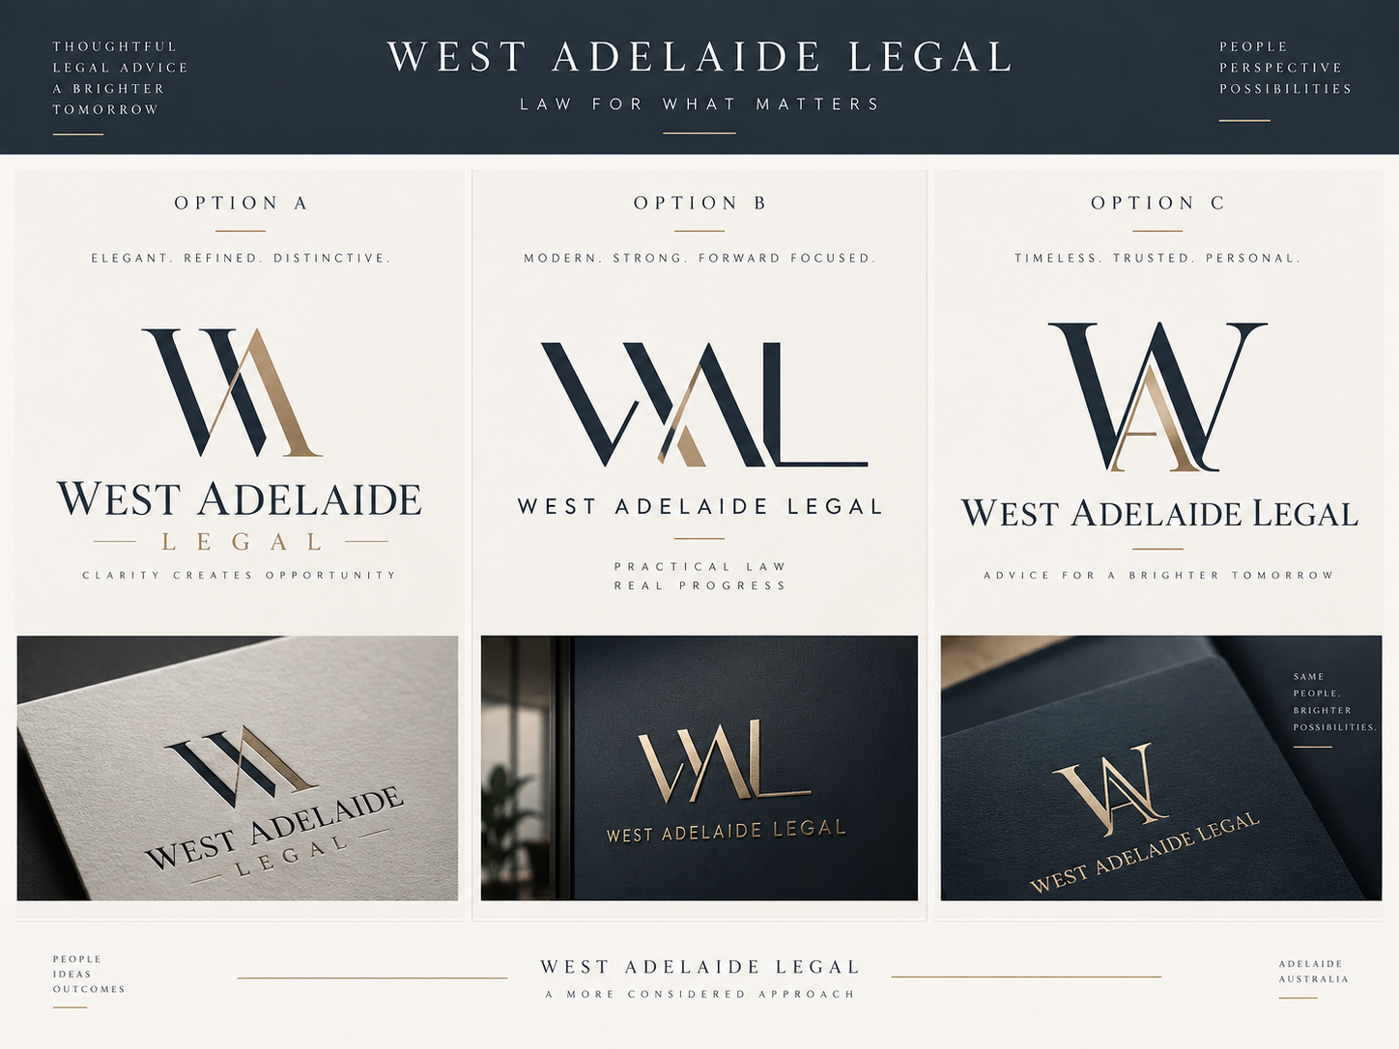

Approved homepage desktop design direction
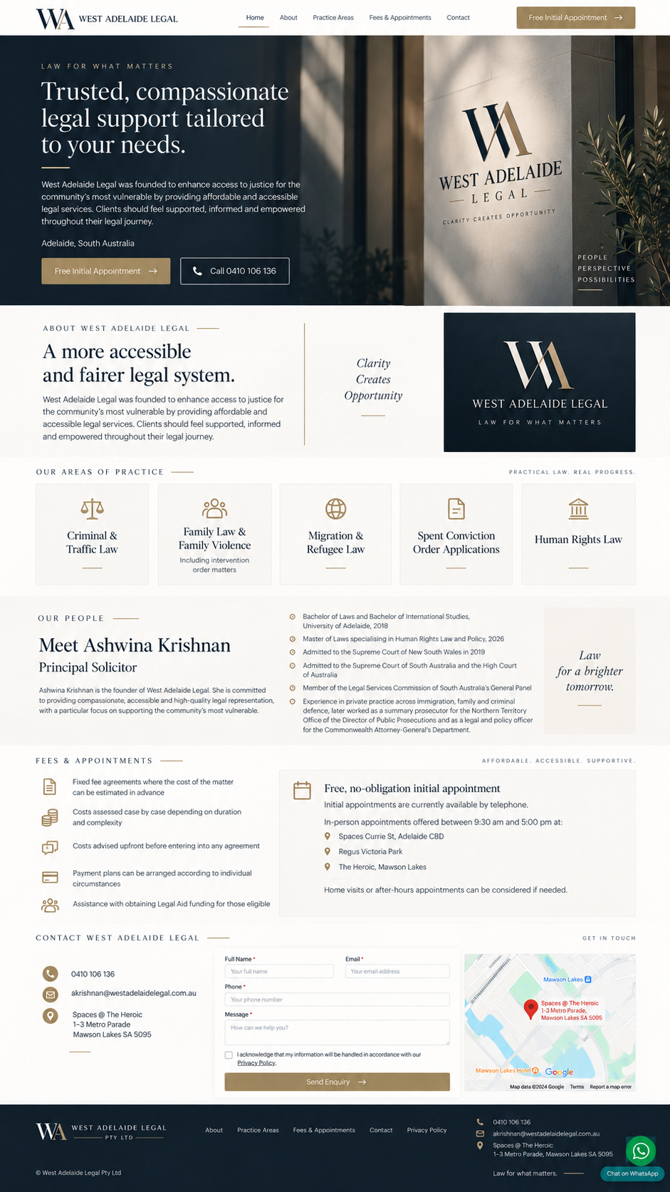

Approved/revised homepage mobile design direction
