|  |
| --- |
| **PROJECT PLANNING & MANAGEMENT FORM**  **CMSE 322**  **Computer Engineering Department**  **Eastern Mediterranean University**  **PROJECT NAME: University Second-Hand Book Sales and Exchange Platform**  **PROJECT START DATE: 05/03/2025**  **PROJECT END DATE: 21/05/2025**  **SUPERVISOR:** Prof. Dr. Duygu Çelik Ertuğrul  **SEMESTER TERM:** Spring 2024/2025  **COURSE GR NO: 11** |

A.1. Preliminary Project Information

# A.1.1

|  |  |
| --- | --- |
| **Project No** | 11 |
| **Project Name** | **University Second-Hand Book Sales and Exchange Platform** |
| **Start Date** | 05/03/2025 |
| **End Date** | 21/05/2025 |
| **Time** | 3 month |

# A.1.2

|  |  |  |  |
| --- | --- | --- | --- |
| **Project Manager** | | | |
| **Name Surname** | Maaz Qureshi | **ID No** | 21904531 |
| **Title/Role** | Project Manager, Lead Programmer | | |
| **Address** | Famagusta | | |
| **Phone** | 05391190583 | | |
| **Email** | maazqureshi161@gamil.com | | |

A.2 Group Information

# A.2.1

|  |  |  |  |
| --- | --- | --- | --- |
| **Student 1** | | | |
| **Name Surname** | Saad Ahmed | **ID No** | 22701636 |
| **Title/Role** | Analyst/Programmer | | |
| **Address** | Famagusta | | |
| **Phone** | 05488669012 | | |
| **Email** | saadtaqi2004@gmail.com | | |

|  |  |  |  |
| --- | --- | --- | --- |
| **Student 2** | | | |
| **Name Surname** | Syed Fazal Ul Hasan Mohani | **ID No** | 23700460 |
| **Title/Role** | QA Tester | | |
| **Address** | Famagusta | | |
| **Phone** | 05338482611 | | |
| **Email** | fazalmohani1@gmail.com | | |

|  |  |  |  |
| --- | --- | --- | --- |
| **Student 4** | | | |
| **Name Surname** | Samer Qaddoumi | **ID No** | 20910791 |
| **Title/Role** | Backend Developer/Database-Admin | | |
| **Address** | Famagusta | | |
| **Phone** | +13128418827 | | |
| **Email** | Samer_qaddoumi@hotmail.com | | |

# A.2.2

|  |
| --- |
| **List of Completed / Ongoing Projects of Team** |
| CMSE326 – Software Testing and Quality Assurance Term Project  CMSE201- Fundamentals of Software Engineering |

B.1 Introduction to Project

# B.1.1

|  |
| --- |
| **Summary of Project** |
| A second-hand Book sales and exchange Platform for university students where users can perform operations like buying, selling, and exchanging books. The system will be built after completing extensive market and domain research and consulting with specialists in the sector, such as university librarians, bookstore managers, and students who already use comparable platforms. Comments will be collected to understand their experiences and challenges better. The outcome will be an accurate, secure, and full platform that tackles students' daily difficulties, such as high textbook fees, limited access to affordable books, and the lack of a centralized system for book exchanges. The platform will encourage sustainability, affordability, and convenience for students. |

# B.1.2

|  |
| --- |
| **Key Words** |
| JavaScript, React Native, ASP.NET Core, Firebase, PostgreSQL, AWS S3, Visual Studio Code, VS Code, book listing, search filters, exchange system, user authentication, real-time messaging, secure transactions, admin panel, database management, cloud storage, location-based search, book rating, reviews, fraud prevention, user verification, mobile app, web dashboard, affordable textbooks |

# B.1.3

|  |
| --- |
| **Aim of Project** |
| This project is based on designing and implementing an online platform for second-hand book sales and exchanges tailored for university students. The main objective of the platform is to make textbooks and educational resources more affordable and accessible, eliminating constraints like high costs of new books, limited availability of specific editions, and the lack of a centralized system for buying, selling, or exchanging books. Our goal is to promote sustainability by reusing books, enhance convenience for students through an easy-to-use interface, and provide a secure, efficient, and maintainable system that addresses the daily challenges faced by students in acquiring educational materials. |

# B.1.4

|  |
| --- |
| **Innovative Aspects/Contributions of Project** |
| Integrated Book Exchange System: This platform stands out from conventional second-hand book services by implementing an exchange feature that allows users to fairly propose and accept book swaps.  Location-Based Search: Users can discover local book listings on the platform, which enhances accessibility and lowers shipping expenses.  Real-Time Messaging System: A built-in chat feature powered by Firebase Cloud Messaging or Signal facilitates effortless communication between buyers and sellers, eliminating the need for external apps.  Smart Book Recommendations: The system will recommend books tailored to each user based on their reading history.  User Engagement Features: Features such as Wishlist's, favorites, and rating/review options promote user interaction and foster trust within the community. |

# B.1.5

|  |
| --- |
| **Methods to be Applied** |
| During the planning and analysis stage, we will perform several meetings to discuss the  requirements of the system. Furthermore, we will do research and analyze book exchange to determine system. Some tools and methods that we will be used to develop our system are:  • MS Project for scheduling  • MS Visio and Modelio for Designing UML Diagram  • React Native Framework and React  • Expo for Device Simulation  • Node and Express for Server-Side implementation  • HTML, CSS, and JavaScript for Front-End implementation  • PostgreSQL to design the database system  • Extreme Programming  • Unit Testing, Integration Testing, Manual Testing |

# B.1.6

|  |
| --- |
| **Economic and National Outcomes** |
| This project can deliver economic and national benefits by making the educational resources cheap and providing students with an affordable way to access textbooks through secondhand book sales and exchanges. The platform promotes sustainability by reusing books, reducing waste, and minimizing the environmental impact of producing new textbooks |

B.2 Reason of Starting the Project, Methods and R&D Stages

# B.2.1

|  |
| --- |
| **1- Explain the reason of starting this project. (Max 500 character)** |
| We have decided to implement this project because there are very few mobile apps for book exchange. Some that are on the market have very complex user interfaces, so we want to build an app for book exchange that is more modern with some good features also to help students who find it difficult to buy expensive books. So, this mobile app will really help them find the books they need. Also, it will be an income source for students who wish to sell used books. |

|  |
| --- |
| **2- Explain the purpose of this project.** |
| The purpose of the University Second-Hand Book Sales and Exchange Platform is to create an efficient and secure online marketplace where students can buy, sell, and exchange used books. Reducing the cost of expensive books also encourages student book reuse & sustainability. The platform allows users to search for books by category, price, and location, making it easier to find the right book. also, it will help the students to find books near them. |
| **3- Explain**   * **output of project** * **national / international standards if exist** * **the specific objectives of the project** * **success criterias** * **realistic constraints** |
| 1: The output of this project is a mobile application where students can **buy, sell, and exchange** books and a location-based search feature to find books nearby. And real-time message systems for buyers and sellers.  2: National / International Standards (If exist)  This project aligns with various industry and security standards, including:  IEEE 830-1998 – Software Requirements Specification Standard  ISO/IEC 27001 – Security and Data Protection Standard  GDPR Compliance— Ensures protection of personal user data (for potential international use)  3: Specific Objectives of the Project  Reduce the waste of books.  Provide cheaper books for the user.  Improve accessibility with prove accessibility with  4: Success Criteria  The mobile app and admin should be user-friendly.  User authentication should work.  The search system response should be less than 2 seconds.  The mobile app should be capable of holding 5000 users concurrently.  The first month, the app should have 10,000 users.  5: Realistic Constraints  Limit time; we don’t have much time.  Cost for cloud hosting  User adoption and engagement may take time to grow. |
| **4- Explain**   * **the methods to be applied during R&D activities** * **applications** * **technics and tools to be used** * **standards to be followed under the workflow** |
| **Which SOFTWARE PROCESS MODEL will you apply? Why? How? Explain.**  We will use the increment model for our project because it provides early prototypes for user feedback, which is important for improving the system based on real user needs. It will help us to manage the risk effectively. Also, it supports parallel development, so different modules (mobile app, admin panel) can be developed simultaneously.  The project will develop many incremental models where each increment will add new features to the system.  We will have multiple phases during development of the system:  Phase 1: Main System Development  · User authentication  · Basic book listing  · Database setup  Phase 2: Book Search & Filters  · Implement search functionality with category, price, and location filters  · Optimize database queries for fast search results  Phase 3: Book Exchange System & Messaging  · Develop real-time chat for buyer-seller communication  Phase 4: Admin and Security features  Phase 5: Testing, Optimization & Deployment  · Beta testing with real users  · Improve UI/UX based on feedback  · Deploy the final version  **Explain, Project Workflow:**   1. **Feasibility and Pre-research:**   Conduct market research on existing book exchange platforms and We intend to gather data from multiple sources and techniques all through the initial stage of the project to better understand the issue and gather more detailed information about the system. So, we'll do some research. We will use the COCOMO cost estimation technique to figure out project parameters, including size, effort, duration, and cost. Using this strategy increases our understanding of our system's potential success, and we will identify our risk cases.   1. **System Design:** In this stage, we will define the core system architecture, decide which modules will be implemented, and select the most suitable techniques, algorithms, and methods for development we will design different diagrams such as use-case, class, activity, and E-R diagrams by using different software designing tools like modelio , MS Visio, also UI/UX Design Wireframes/mockups for the mobile app and admin panel.in here we will chose which tools we are going to use to make our mobile application. Choose a suitable framework like (React Native, ASP.NET Core), choose databases (Firebase, PostgreSQL), and APIs. 2. **Software development:** In this stage, we will start the coding phase, transforming the system design into a fully functional application. We will use CSS, HTML, and JavaScript to develop and implement our project's functionalities. The framework we will use is React Native and React for the Front End, ensuring a responsive and user-friendly interface. For the backend, we will use Node.js and Express.js to handle server-side logic, API requests, and database interactions efficiently. The database will be managed using Firebase for real-time updates and PostgreSQL for structured data storage. Additionally, we will integrate authentication mechanisms such as OAuth and email/password authentication to ensure secure user access. This phase will also involve implementing search algorithms, messaging systems, and cloud storage solutions like AWS S3 or Firebase Storage to handle media uploads. 3. **Prototype implementation and testing work:** In this phase, since we are using the increment model, small releases will be produced now and then until we get a prototype. The prototype is simply an early model of the expected system used to test the process. Each prototype will be tested, and if there are no errors, we will start testing the next ones. It will help us see how our system works. We are going to do function testing. Ensure features like login, search, and book exchange work correctly. Once the performance testing is finally done, we are going to get user feedback about our system. 4. **Maintenance:** For the maintenance stage, we will perform regular performance analysis and keep in touch with the end-users to get feedback from them. In case of any problem or bugs, it will be fixed immediately. We will have regular update and add new functionalities based on user needs to improve speed, scalability, and database efficiency. |
| **5- Explain**   * **the contribution of national/international technological development if exist** * **starting a new research and development projects within or outside the team** * **launch new applications or research studies in different technology areas**   **With whom we can cooperate?**  **Expectations:**  **Published work:**  **Can your output be an input for other similar national/international projects?** |
| This project supports affordable education, drives digital transformation, and promotes sustainability through a smart book marketplace. It also paves the way for future advancements like book recommendations. In the future, by collaborating with major universities, tech companies, other e-commerce platforms, NGOs, and education departments, we can expand the platform’s impact and reach even more people. |

B.3 Innovative and Unique Aspects

# B.3.1

|  |
| --- |
| **1- Describe**   * **differences** * **advantages** * **superiority**   **compared to other similar projects.** |
| Differences:   * Our app will have e-commerce, book exchange, enhanced search, in-app messaging, and admin monitoring to make it easier to get their book for the user. * User-Friendly & Optimized Performance: Unlike some cluttered or slow marketplaces, we prioritize optimized search performance, intuitive UI/UX, and smooth user interactions using React Native and Firebase for speed and efficiency. * The user can list their books for sale. Also, if user wants to distribute book as PDF file the app will also offer PDF file download. The user can also distribute free copies of their book given they are the author. Our app will have the latest UI/UX design and user-friendly system where it will be easier for users to interact and browse the app.   Advantages:   * Students can save money by either purchasing used books at lower prices or swapping books instead of buying new ones. * second-hand book reuse reduces paper waste and printing demand * We will implement authentication to prevent fraud   Superiority Compared to Other Similar Projects:  Most second-hand book exchange platforms today have significant limitations, lacking advanced features that could improve user experience and efficiency. Many existing apps do not offer enhanced search with filters or personalized book recommendations, making it difficult for users to find relevant books quickly. Additionally, most platforms only allow users to buy and sell books but do not support book exchanges, limiting affordability and flexibility. Our system supports these features that enable users to swap books based on mutual interests, making it a more cost-effective solution for students. Our system will have real-time messaging, where they can use our device to message each other. We will have a location-based search function to make it easier for the user to find books available nearby. |

# B.4.1

|  |
| --- |
| **2- Who can contribute to this project in your team?** |
| * Project manager * System analyst * Programmers * System Designer * User interface designer * Database developer * Tester |

C.1 Gantt Chart and Work Packages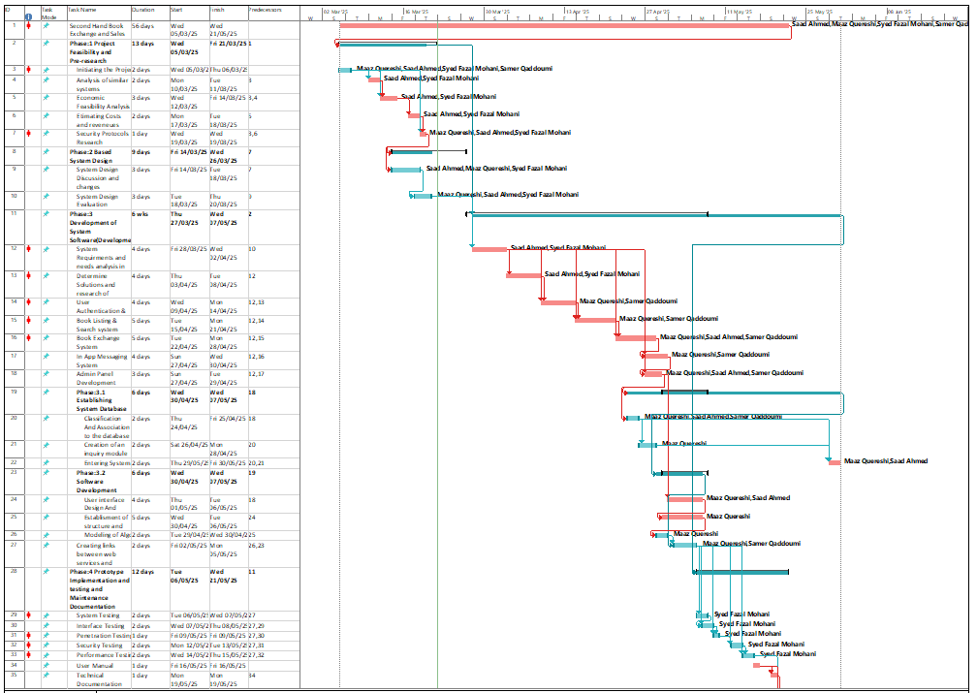

# C.1.2 List of Work Packages

|  |  |
| --- | --- |
| **Work Package No** | 1 |
| **Work Package Name** | **Project Feasibility and Pre-Research (Feasibility Analysis)** |
| **Start-End Date and Time** | 05/03/2025 to 21/03/2025 |
| **Related Organizations** | None |

|  |
| --- |
| **1- List the activities of work packages.** |
| **1.1 Project Process and Economic Feasibility:**   * Market research for demand of second-hand academic books * Consider the intended audience of project (students, teachers etc.) * Identify project key stakeholders * Assign project tasks to team members, identify key project targets and delivery timeline. * Assess budget and potential income use cases like fees from sales and advertisements.   **1.2 Technological Feasibility:**   * Evaluate technology used in existing book exchange platforms. * Determine technical requirements for the platform. * Consider suitable database software for book listings and user management. * Review the latest security and data protection measures. * Evaluate scope of the project, what features are needed. * Preliminary software requirements assessment for users (mobile app, web app) |
| **2- Describe the methods and parameters that will be used for work package.** |
| Competitor Analysis, Cost Estimation, Gantt Chart |
| **3- List the experiments, tests and analysis in the work package.** |
| Economic Feasibility study, Technical Feasibility study, Risk Assessment, PERT Analysis, User Surveys |
| **4- List the output of work package and its success criterias.** |
| **Outputs:**  Project timeline, feasibility analysis, resource and risk assessment  **Success Criteria's:**  Completion of feasibility analysis in the timeline.  Project is economically and technically feasible to implement and necessary approvals are given.  Project initiation and planning is completed. |
| **5- Explain the relation of output with other work packages** |
| Work Package 1 is a prerequisite to subsequent work packages. It is the basic input of future work packages and is necessary as the initial planning and research stage of the project must be completed before proceeding to the next work package. |

|  |  |
| --- | --- |
| **Work Package No** | 2 |
| **Work Package Name** | **Based System Design Technology** |
| **Start-End Date and Time** | 14/03/2025 to 26/03/2025 |
| **Related Organizations** | None |

|  |
| --- |
| **1- List the activities of work packages.** |
| * System Architecture:Design database, server, API and client-side architecture UML diagrams. * Develop initial functional and non-functional requirements for the SRS documents. * Entity-relationship (ER), Use Case and Data Flow Diagrams (DFD) for SRS * Develop draft of User Interface (UI) & User Experience (UX) documentation for the SDS document. |
| **2- Describe the methods and parameters that will be used for work package.** |
| Increment model, Figma for UI and UX Design, Use Case Analysis, ER Diagrams & Data Flow Diagrams with Modelio, standardized documentation for SRS and SDS Documents. |
| **3- List the experiments, tests and analysis in the work package.** |
| Validate use cases in software, System Architecture Evaluation, Data Flow and Process Validation |
| **4- List the output of work package and its success criterias.** |
| **Outputs:**  System architecture design blueprint, initial documentation.  Use case diagrams and descriptions.  ER diagrams representing database schema.  Data flow diagrams (DFDs) clearly show system processes.  **Success Criteria's:**  Considering all core functionalities within the timeline.  Successfully list all feasible test cases  Project cost forecast remains feasible and within budget |
| **5- Explain the relation of output with other work packages** |
| This work package depends on initial system design and requirements gathered in Work Package 1. It helps build upon the preliminary requirements of the software and helps evaluate the feasibility of the project. After completion of this work package the Software development stage will begin. |

|  |  |
| --- | --- |
| **Work Package No** | 3 |
| **Work Package Name** | **Development of System Software** |
| **Start-End Date and Time** | 27/03/2025 to 07/05/2025 |
| **Related Organizations** | None |

|  |
| --- |
| **1- List the activities of work packages.** |
| * Refine functional and non-functional requirements for SRS. * Refine documentation of SDS. * Security Implementation * Database Implementation * Phase 1– Backend Development:   + User Authentication & Profile Management   + Book Listing & Search system   + Book Exchange System   + In App Messaging System   + Admin Panel Development * Phase 2 – Frontend Development   + User Interface Design and Programming   + Establishment of structure and servers * Deployment Preparation |
| **2- Describe the methods and parameters that will be used for work package.** |
| Git Version Control, JavaScript / React, React Native.js, PostgreSQL, SSL encryption, Node.js, Express.js, Visual Studio, HTML, CSS, Android Studio |
| **3- List the experiments, tests and analysis in the work package.** |
| Prototype Testing. Integration Testing, Unit Testing, User Interface Testing, Functional Testing |
| **4- List the output of work package and its success criterias.** |
| **Outputs:**  UI/UX prototypes, Deployed and functioning software, Source code repository with relevant documentation, Various initial test data for thorough testing in work package 4  **Success Criteria's:**  Working prototype with all use cases implemented.  Software integration is successful without any issues.  Project running cost is within the forecasted budget. |
| **5- Explain the relation of output with other work packages** |
| This work package helps implement the software requirements realized in Work Package 2. The project feasibility is reviewed.  After completion of this work package, the documentation for the project can be finalized in Work Package 4. It is possible there might be some bugs or issues at this time so the next work package will also find and fix the bugs by thoroughly testing the software. |

|  |  |
| --- | --- |
| **Work Package No** | 4 |
| **Work Package Name** | **Prototype Implementation, Testing, and Documentation** |
| **Start-End Date and Time** | 06/05/2025 to 21/05/2025 |
| **Related Organizations** | None |

|  |
| --- |
| **1- List the activities of work packages.** |
| * Documenting testing methodology and test results. * Documenting debugging process. * Standardization of Project according to established standards |
| **2- Describe the methods and parameters that will be used for work package.** |
| IEEE Documentation standard, technical documentation review, Security Assessment, Software Alpha Testing |
| **3- List the experiments, tests and analysis in the work package.** |
| Prototype Testing. Integration Testing, Unit Testing, User Acceptance Testing, System Testing  Interface Testing, Penetration Testing, Security Testing, Performance Testing |
| **4- List the output of work package and its success criterias.** |
| **Outputs:**  Error Reports and Testing insights  Validated project source code  Bug-free application  **Success Criteria's:**  Accuracy and completeness of all project documentation.  Stakeholder approval of overall project suite.  Fixing any errors and bugs encountered during the testing process.  Functioning project suite with no faults.  Application ready for real-world deployment. |
| **5- Explain the relation of output with other work packages** |
| This is the final work package. Its success depends on successful and thorough testing of the project frontend and backend from Work Package 3 as well as the complete and accurate documentation of all project data. |

# C.1.3 List of Milestones (should be matched in the Gantt chart)

|  |  |  |
| --- | --- | --- |
| No. | **Description of Output** | **Expected Time Interval** |
| 1 | Project Feasibility Study, Pre-Research | 05/03/2025 to 21/03/2025 |
| 2 | Based System Design Technology and Evaluation | 14/03/2025 to 26/03/2025 |
| 3 | UI/UX, Software Development | 27/03/2025 to 07/05/2025 |
| 4 | Prototype implementation, Software testing, and maintenance | 06/05/2025 to 21/05/2025 |

# C.1.4 List of Risks (see following example, find other risks of your Project!)

|  |  |  |  |
| --- | --- | --- | --- |
| Risk | Probability | Effects | Your Strategy |
| Project timeline delays | Medium | Serious | Use increment model, set milestones, and track progress with Gantt charts. Keep in touch with team members for project updates. |
| Software Integration Issues | High | Tolerable | Review the codebase and find alternative solutions |
| Stakeholder disagreement | Medium | Tolerable | Conduct regular meetings to ensure satisfaction of all stakeholders in the project. |
| User Adoption is Low | High | Serious | Run advertisements on social media, place physical banners on university campus encouraging students to use the service. |
| Budget Overrun | Medium | Serious | Scale down low priority features in the software and focus on higher priority features to reduce development costs. |
| Inadequate Software performance | Moderate | Insignificant | Refine system architecture while keeping a low cost of development time. |
| Team member is ill/unavailable | Low | Serious | Outsource low-level functions to freelancer or use code-generating tools |
| Insufficient Documentation | Medium | Tolerable | Ensure that all team members create documentation for the parts they are responsible for. |

C.2 Project Management and Organization

# C.2.1 Project Team

|  |  |  |  |  |  |  |
| --- | --- | --- | --- | --- | --- | --- |
| **Personnel Name** | **Title** | **ID** | **Education Status** | **Graduation Date** | **Date of Starting Work** | **Idea Owner** |
| Samer Qaddoumi | Database/  Backend Dev | 20910791 | Bachelors | June-2026 | 05/03/25 | Yes |
| Syed Fazal Ul Hasan | QA Tester | 23700460 | Bachelors | Jan-2026 | 05/03/25 | Yes |
| Saad Ahmed | Programmer/  Analyst/  Frontend Dev | 22701636 | Bachelors | June-2026 | 05/03/25 | Yes |
| Maaz | Project Manager, Lead Programmer | 21904531 | Bachelors | June-2026 | 05/03/25 | Yes |

# C.2.2 Organization Scheme

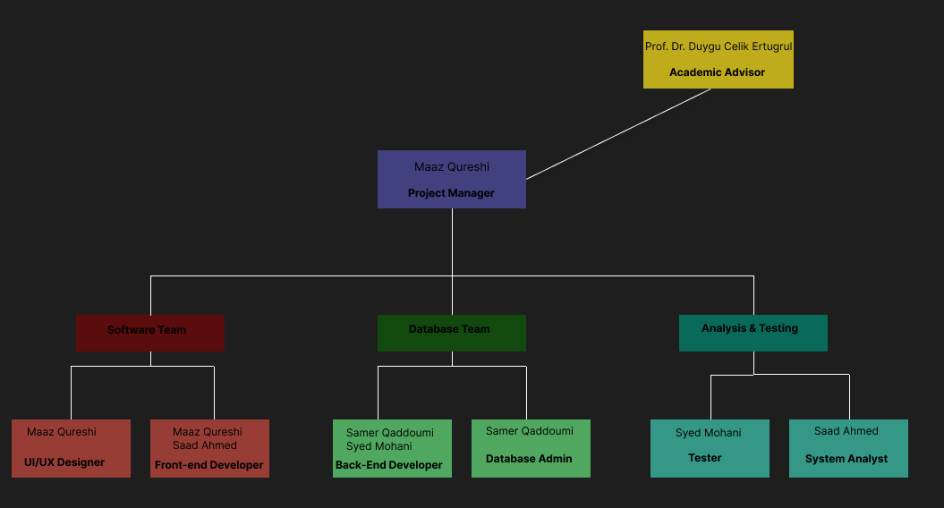

D.1 Economic Forecasts

|  |
| --- |
| **1- Evaluate the commercialization potential of project outcomes. List possible risks here?** |
| There is a good opportunity for commercializing the university second-hand book sales and exchange application, especially among students who are looking for affordable and ecofriendly ways to access textbooks and academic books. This app can generate revenue through multiple ways like premium subscriptions, transaction fees for making sales and exchanges, and advertisements from publishers, bookstores, and the university partners. Scalability is also a big plus as the platform can be expanded to different universities, even facilitating international book exchanges, given the right logistics. However, various risks need to be assessed when considering app commercialization. Market saturation is a worrying factor as other buy and sell, exchange platforms already exist like Amazon and Facebook Marketplace. Another risk is low user adoption, as a critical mass of users is needed for such a platform to work. Without enough people using the app, book exchanges may fall or even become impossible. If there are no users, who to exchange book with? |

|  |  |
| --- | --- |
| **2- List your expectations to your team which are come by your project** | |
| Time-to-market (month): | July 2025 |
| The expected increase in sales revenue (%): | 7 % |
| The expected increase in market share (%): | 9 % |
| Time to start to gain: | July 2025 |

D.2 National Outcomes

|  |
| --- |
| **1- Specify the output that may be subject to patent, utility model and industrial design registration in the project.** |
| In the university second-hand book sales and exchange application project some outputs may be patentable. A patent will apply if the app has a novel technological feature like a book matching system or an automated book verification process. If the innovation is practical but not patentable it can be protected as a utility model. The app’s industrial design including the user interface, custom icons or visual layout may be eligible for industrial design registration and protect the look and feel. These will give us a competitive advantage and enhance commercialization. It may even become a brand if the application becomes very popular then the brand can be patented. |
| **2- Explain the potential of project and its outputs that may have an effect on social life, education, health and etc.** |
| The university second-hand book sales and exchange app will go a long way in changing social life, education, and environmental sustainability. Users can set up accounts free of cost hence it is easily accessible and cost effective for students and readers to get books and access to education and lifelong learning. It can also become a contact point for readers with similar interests. It will also result in less waste of paper and deforestation. It may not be health specific, but reading reduces stress. Therefore, the app may directly result in better health and mental wellbeing for its users. |
| **3- Explain the positive and negative effects of project outputs for environment and human being.** |
| The app basically helps the environment in multiple ways, firstly it would help lower paper consumptions, secondly it can greatly help in deforestation, with those being mentioned it will also lower the cost of books, with cheap and accessible books this can help enhance education, literacy, and development of reading communities. On the negative side, it probably adds a little to the already long list of digital energy consumption. Additionally, there might be some challenges in maintaining user engagement, as the success of the platform depends on the amount of active user base. Even with these issues, the app's overall impact is positive more than its negative. |

(M013) Instrument / Equipment / Software / RELEASE PURCHASES

|  |  |  |  |  |  |  |  |  |  |  |  |
| --- | --- | --- | --- | --- | --- | --- | --- | --- | --- | --- | --- |
| **Project Name** | | **University Second-Hand Book Sales and Exchange Platform** | | | | | | | | | |
| **No.** | **Instrument / Equipment / Software / Publication Name** | | **No. of Item** | **Capacity** | **Technical specification** | **Purpose of Project Activities** | **Post-Project Place of Use / Purpose** | | **Unit Price (USD)** | **Unit Price (TL)** | **Total Amount (TL)** |
| **R & D** | **Production** |
| **1** | **Laptop** | | 4 |  |  | Development | Yes |  | $1,200 | 43,963 | 175,852 |
| **2** | **Internet Connection** | | 4 |  | High-Speed Internet | Connection | Yes |  | $40 | 1,465 / Per Month | 70,320 / Yearly |
| **3** | **Visual Studio Code** | | 4 |  |  | Coding, Debugging, and Testing |  | Yes | Free | Free | Free |
| **4** | **Github** | | 1 |  |  | Development | Yes |  | Free | Free | Free |
| **5** | **MS Visio** | | 1 |  | Chart Design | Diagram & Planning | Yes |  | $10 / Per User | 366 / Per User Monthly | 17,568 / Yearly |
| **6** | **Server Hosting** | | 1 |  |  | Deployment | Yes |  | $10 / Per Month | 366 / Per Month | 17,568 / Yearly |
| **7** | **Figma** | | 1 |  | Design Software | UI/UX Design | Yes | Yes | Free | Free | Free |
| **8** | **SQL** | | 1 |  | Database Management System | Database | Yes |  | Free | Free | Free |
| **9** | **MS Project Tools** | | 1 |  |  | Planning |  | Yes | Free / By University | Free | Free |
|  |  | |  |  |  |  |  |  |  | **TOTAL** | **281,308 TL** |

(M030) Quarterly Estimated Cost Form (TL)

|  |  |  |  |  |
| --- | --- | --- | --- | --- |
| **Project Name : University Second-Hand Book Sales and Exchange Platform** | | | | |
| **Cost Item** | **2025-2026** | | **TOTAL**  **(TL)** | **TOTAL COST RATE OF CONTENTS (%)** |
| **I** | **II** |
| **Personnel** | 70,000 | 70,000 | 140,000 | 56% |
| **Travel** | 10,000 | 10,000 | 20,000 | 8% |
| **Instrument / Equipment / Software / Publications** | 15,000 | 10,000 | 25,000 | 10% |
| **Domestic Works Made By R & D and Testing Institutions** | 10,000 | 10,000 | 20,000 | 8% |
| **International Works Made By R & D and Testing Institutions** | 0 | 0 | 0 | 0 |
| **Domestic Services Procurement** | 15,000 | 15,000 | 30,000 | 12% |
| **Overseas Service Procurement** | 0 | 0 | 0 | 0 |
| **Materials** | 10,000 | 5,000 | 15,000 | 6% |
| **TOTAL COST** | 130,000 | 120,000 | 250,000 | 100% |
| **CUMULATIVE COST** | 130,000 | 120,000 | 250,000 | 100% |
| **IN THE PROJECT TOTAL MAN-MONTH** | | | **48** | |

APPENDIX

1. Gantt Chart



1. Critical Path Method:

|  |  |  |  |  |
| --- | --- | --- | --- | --- |
| **Task** | **Name** | **Predecessor** | **Probability of Successful Completion Rate of Each Path ( % )** | **Duration(Days)** |
| **A** | Initiating the Project |  | 99 | 2 |
| **B** | Analysis of Similar Systems | A | 98 | 2 |
| **C** | Economic Feasibility Analysis | A | 98 | 3 |
| **D** | Estimating Costs and Revenues | C | 85 | 2 |
| **E** | System Design Evaluation | B C D | 85 | 3 |
| **F** | System Requirements and Needs Analysis in Developing Software | E | 95 | 4 |
| **G** | Determine Solutions and Research of Technological Models | F | 90 | 4 |
| **H** | User Authentication & Profile Management | F | 95 | 4 |
| **I** | Book Listing & Search system | F | 90 | 5 |
| **J** | Book Exchange System | F | 90 | 5 |
| **K** | In App Messaging System | F | 90 | 4 |
| **L** | Admin Panel Development | F | 90 | 3 |
| **M** | Classification And Association to the database | L | 95 | 2 |
| **N** | Creation of an inquiry module | M | 90 | 2 |
| **O** | Entering System Data | M | 99 | 2 |
| **P** | User interface Design And Programming | O | 90 | 4 |
| **Q** | Establisment of structure and servers | P | 88 | 5 |
| **R** | Modeling of Algorithm | Q | 85 | 2 |
| **S** | Creating links between web services and database module | M N O | 90 | 2 |
| **T** | System Testing | S | 95 | 2 |
| **U** | Interface Testing | T | 95 | 2 |
| **V** | Penetration Testing | U | 95 | 1 |
| **W** | Security Testing | V | 95 | 2 |
| **X** | Performance Testing | W | 95 | 2 |
| **Y** | Closure of project (Final Presentation & Demo) | W X V | 95 | 2 |

1. Variation & Deviation.

|  |  |  |  |  |  |  |
| --- | --- | --- | --- | --- | --- | --- |
| **Task** | **Dependency** | **o (min.)** | **Most Likely** | **p (max)** | **Expected Duration** | **Variance ((P-O)/6)^2** |
| **A** | **-** | 1 | 2 | 3 | 2 | 0.111111111 |
| **B** | A | 1 | 2 | 3 | 2 | 0.111111111 |
| **C** | A | 1 | 3 | 5 | 3 | 0.444444444 |
| **D** | C | 1 | 2 | 3 | 2 | 0.111111111 |
| **E** | D | 2 | 3 | 4 | 3 | 0.111111111 |
| **F** | E | 2 | 4 | 6 | 4 | 0.444444444 |
| **G** | F | 2 | 4 | 6 | 4 | 0.444444444 |
| **H** | F | 3 | 4 | 5 | 4 | 0.111111111 |
| **I** | F | 3 | 5 | 6 | 4.8333333 | 0.25 |
| **J** | F | 3 | 5 | 6 | 4.8333333 | 0.25 |
| **K** | F | 3 | 4 | 6 | 4.1666667 | 0.25 |
| **L** | F | 2 | 3 | 4 | 3 | 0.111111111 |
| **M** | L | 1 | 2 | 3 | 2 | 0.111111111 |
| **N** | M | 1 | 2 | 3 | 2 | 0.111111111 |
| **O** | M | 1 | 2 | 3 | 2 | 0.111111111 |
| **P** | O | 2 | 4 | 6 | 4 | 0.444444444 |
| **Q** | P | 4 | 5 | 7 | 5.1666667 | 0.25 |
| **R** | Q | 1 | 2 | 4 | 2.1666667 | 0.25 |
| **S** | M N O | 1 | 2 | 4 | 2.1666667 | 0.25 |
| **T** | S | 1 | 2 | 3 | 2 | 0.111111111 |
| **U** | T | 1 | 2 | 3 | 2 | 0.111111111 |
| **V** | U | 1 | 1 | 3 | 1.3333333 | 0.111111111 |
| **W** | V | 1 | 2 | 3 | 2 | 0.111111111 |
| **X** | W | 1 | 2 | 3 | 2 | 0.111111111 |
| **Y** | W X V | 1 | 2 | 3 | 2 | 0.111111111 |

1. **CPM (Critical Path Management) Analysis** using **PERT** (Defining Paths)

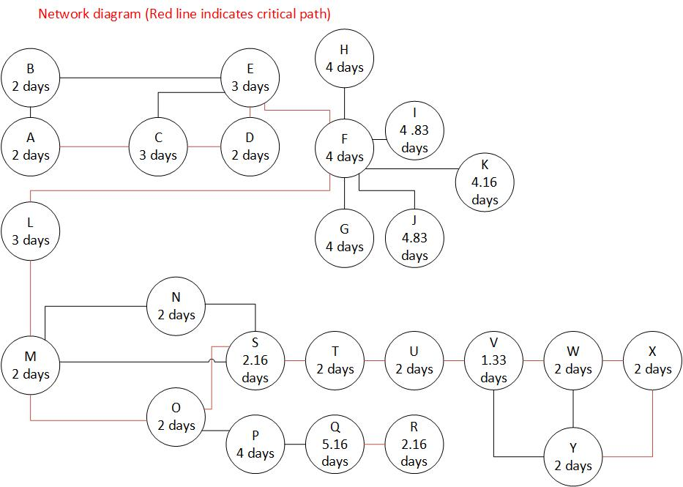

**PERT CALCULATION:**

Expected time calculated using expected duration values.

Variance calculated by variance values of each process.

Standard deviation is calculated by taking the square root of variance.

The longest path, “A C D E F L M O S T U V W X Y,” have 34.5 days is our critical path

**Formulas:**

**Expected Time: (min. duration + 4 * avg. duration + max. duration) / 6**

**Variance: ((max. duration−min. duration)/6) ^2**

**Derivation: √Variance**

|  |  |  |  |  |
| --- | --- | --- | --- | --- |
| **No** | **Paths** | **Total Expected Time For Each Path** | **Variance Of Each Path** | **Standard Deviation Of Each Path** |
| **1** | A B E F L M S T U V Y | 25.5 | 1.69444 | 1.3017 |
| **2** | A B E F L M S T U V W Y | 27.5 | 1.8055551 | 1.3437 |
| **3** | A B E F L M S T U V W X Y | 29.5 | 1.9166621 | 1.38443 |
| **4** | A B E F L M N S T U V Y | 27.5 | 1.8055551 | 1.3437 |
| **5** | A B E F L M N S T U V W Y | 29.5 | 1.9166621 | 1.38443 |
| **6** | A B E F L M N S T U V W X Y | 31.5 | 2.02777721 | 1.42399 |
| **7** | A C D E F L M S T U V W X Y | 32.5 | 2.361111 | 1.53659 |
| **8** | A C D E F L M N S T U V W X Y | 34.5 | 2.4722221 | 1.5723298 |
| **9** | **A C D E F L M O S T U V W X Y** | **34.5** | **2.4722221** | **1.5723298** |

The path in BOLD is the path with the highest expected time hence it is the critical path.

**Function Point Calculation**

|  |  |  |  |  |  |  |  |
| --- | --- | --- | --- | --- | --- | --- | --- |
| **Functions** | **Simple No** | **Simple Weight** | **Average No** | **Average Weight** | **Complex No** | **Complex Weight** | **Total** |
| **User Input** | 20 | 2 | 5 | 4 | 2 | 5 | 70 |
| **User Output** | 10 | 3 | 5 | 5 | 2 | 7 | 69 |
| **User Query** | 20 | 4 | 10 | 5 | 1 | 6 | 136 |
| **Internal Files** | 30 | 7 | 5 | 10 | 5 | 15 | 335 |
| **External Interfaces** | 30 | 5 | 10 | 8 | 5 | 10 | 280 |

**Total: 70 + 69 + 136 + 335 + 280 = 890 Unadjusted Function Points**

**Technical Complexity Factor (DI)**

|  |  |  |
| --- | --- | --- |
| **Factors** | **Complexity** | **Complexity Value** |
| **Data Communication** | **Essential** | **5** |
| **Performance Criteria** | **Essential** | **5** |
| **Online Data Entry** | **Significant** | **4** |
| **Reusability** | **Significant** | **4** |
| **Ease of Installation** | **Essential** | **5** |
| **Maintainability** | **Essential** | **5** |
| **Online Updating** | **Significant** | **4** |
| **Complex Calculations** | **Moderate** | **2** |
|  |  | **DI=34** |

**Function Points (FP) =** UFP*(0.65+0.01*DI) =890*(0.65+0.01*34)=881.1

**COCOMO Estimation**

KLOC from FP = 881.1*53=46698.3 LOC = 46.6983 KLOC

The team is new with the methods and languages used, so we will follow a semi-detached type of development:

Effort = person-month = a*(KLOC)^b = 3.0* = 222.197

Total time Duration in month = c*(Effort)^d = 2.5* = 16.56 months

Number of Team Members = Effort/Duration = 222.197/16.56 = 13.41 persons required.