We want to sort:
[5, 3, 8, 4, 2]
Our rule will be:
Always choose the first element as the pivot.

Step 1: Choose the pivot
The first element is 5.
[5, 3, 8, 4, 2]
↑
pivot
Now compare every other number with 5.
3 < 5 → left
8 > 5 → right
4 < 5 → left
2 < 5 → left
So:
left pivot right
[3, 4, 2] 5 [8]
Notice: [3, 4, 2] is not sorted yet.
We only separated the numbers into:
smaller than 5 | 5 | bigger than 5

Step 2: Quick Sort the left side
Now work on:
[3, 4, 2]
Again, choose the first element as pivot.
Pivot = 3.
[3, 4, 2]
↑
pivot
Compare the other numbers with 3:
4 > 3 → right
2 < 3 → left
So:
left pivot right
[2] 3 [4]
Now [2] has only one element.
[4] also has only one element.
A list with one element is already sorted.
So:
[2] + [3] + [4]
becomes:
[2, 3, 4]

Step 3: What about the right side of 5?
Remember our first step:
[3, 4, 2] 5 [8]
We sorted [3, 4, 2] and got:
[2, 3, 4]
The right side is:
[8]
There is only one number, so it is already sorted.
Now combine everything:
[2, 3, 4] + [5] + [8]
Final result:
[2, 3, 4, 5, 8]

The whole process visually
Start:

[5, 3, 8, 4, 2]

pivot = 5
↓

[3, 4, 2] 5 [8]

↓
Sort this part

[3, 4, 2]

pivot = 3
↓

[2] 3 [4]

Now combine:

[2, 3, 4] 5 [8]

Final:
[2, 3, 4, 5, 8]

The code (with line numbers)
python
1: def quicksort(arr, low, high):
2: if low < high:
3: pivot_index = partition(arr, low, high)
4: quicksort(arr, low, pivot_index - 1)
5: quicksort(arr, pivot_index + 1, high)
6:
7: def partition(arr, low, high):
8: pivot = arr[low]
9: i = low
10:
11: for j in range(low + 1, high + 1):
12: if arr[j] < pivot:
13: i += 1
14: arr[i], arr[j] = arr[j], arr[i]
15:
16: arr[low], arr[i] = arr[i], arr[low]
17: return i
Array: arr = [7, 2, 9, 4, 1]

quicksort(arr, 0, 4)
Line 2: low=0, high=4 → 0 < 4 is True, enter if
Line 3: call partition(arr, 0, 4)

→ partition(arr, 0, 4)
Line 8: pivot = arr[0] = 7
Line 9: i = 0
Line 11: loop j from 1 to 4
j = 1:
Line 12: arr[1]=2, is 2 < 7? Yes
Line 13: i += 1 → i = 1
Line 14: swap arr[1] and arr[1] → no visible change
Array is now: [7, 2, 9, 4, 1]
j = 2:
Line 12: arr[2]=9, is 9 < 7? No → skip lines 13-14
Array is still: [7, 2, 9, 4, 1]
j = 3:
Line 12: arr[3]=4, is 4 < 7? Yes
Line 13: i += 1 → i = 2
Line 14: swap arr[2] and arr[3] → swap 9 and 4
Array is now: [7, 2, 4, 9, 1]
j = 4:
Line 12: arr[4]=1, is 1 < 7? Yes
Line 13: i += 1 → i = 3
Line 14: swap arr[3] and arr[4] → swap 9 and 1
Array is now: [7, 2, 4, 1, 9]
Loop ends (j goes past 4).
Line 16: swap arr[0] and arr[3] → swap 7 and 1
Array is now: [1, 2, 4, 7, 9]
Line 17: return i → return 3

Back in quicksort(arr, 0, 4)
Line 3: pivot_index = 3
Line 4: call quicksort(arr, 0, 2) ← sort left part [1, 2, 4]

quicksort(arr, 0, 2)
Line 2: low=0, high=2 → 0 < 2 is True, enter if
Line 3: call partition(arr, 0, 2)

→ partition(arr, 0, 2)
Line 8: pivot = arr[0] = 1
Line 9: i = 0
Line 11: loop j from 1 to 2
j = 1:
Line 12: arr[1]=2, is 2 < 1? No → skip
j = 2:
Line 12: arr[2]=4, is 4 < 1? No → skip
Loop ends.
Line 16: swap arr[0] and arr[0] → no change
Array is still: [1, 2, 4, 7, 9]
Line 17: return i → return 0

Back in quicksort(arr, 0, 2)
Line 3: pivot_index = 0
Line 4: call quicksort(arr, 0, -1) ← low=0, high=-1

quicksort(arr, 0, -1)
Line 2: low=0, high=-1 → 0 < -1 is False → do nothing, return

Back in quicksort(arr, 0, 2)
Line 5: call quicksort(arr, 1, 2) ← sort right part [2, 4]

quicksort(arr, 1, 2)
Line 2: low=1, high=2 → 1 < 2 is True, enter if
Line 3: call partition(arr, 1, 2)

→ partition(arr, 1, 2)
Line 8: pivot = arr[1] = 2
Line 9: i = 1
Line 11: loop j from 2 to 2
j = 2:
Line 12: arr[2]=4, is 4 < 2? No → skip
Loop ends.
Line 16: swap arr[1] and arr[1] → no change
Line 17: return i → return 1

Back in quicksort(arr, 1, 2)
Line 3: pivot_index = 1
Line 4: call quicksort(arr, 1, 0) ← low=1, high=0 → 1 < 0 False → returns immediately
Line 5: call quicksort(arr, 2, 2) ← low=2, high=2 → 2 < 2 False → returns immediately

Everything unwinds back up — no more calls left
Final array: [1, 2, 4, 7, 9]
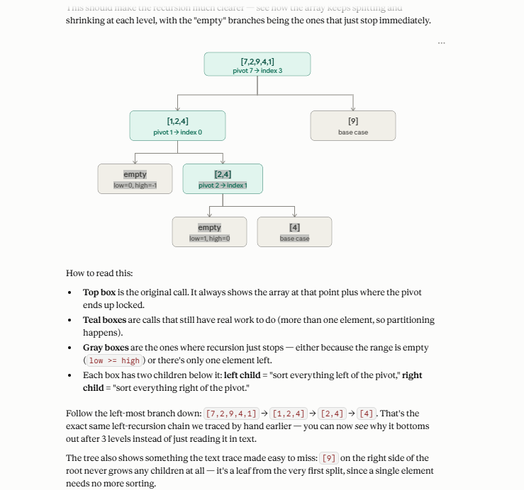

Great question — this is the part where quicksort feels different from something like merge sort, because there's no actual "combining" step. Let me explain why.

The key insight: nothing needs to be merged
In merge sort, the pieces get sorted separately and then you have to weave them back together. Quicksort doesn't work that way — the array is sorted in place, and the pivot never moves again once it's locked. So "coming back together" isn't really combining data — it's just the function calls finishing and control returning to whoever called them.

What actually happens step by step
Using our tree, let's trace the order these calls finish in (this is called the "return order"):
- empty (low=1,high=0) → does nothing, returns immediately
- [4] base case → single element, returns immediately
- Now both children of [2,4] are done → [2,4]'s call finishes and returns
- empty (low=0,high=-1) → does nothing, returns immediately
- Now both children of [1,2,4] are done → [1,2,4]'s call finishes and returns
- [9] base case → single element, returns immediately
- Now both children of the root are done → the root call finishes

Why no "merging" is needed
At every step, when a call finishes, the array segment it was responsible for is already fully sorted in place — because:
- The pivot got locked into its correct final index during partitioning
- The left recursive call already sorted everything to the pivot's left
- The right recursive call already sorted everything to the pivot's right
So by the time [2,4]'s call returns, indices 1–2 in the real array already hold 2, 4 in sorted order. By the time [1,2,4]'s call returns, indices 0–2 already hold 1, 2, 4. There's no data to hand back and stitch together — the array itself is the answer, built up in place.

The "coming back together" is just unwinding
Think of it like a stack of dominoes falling in one direction then the pile getting cleared in reverse:
- Going down: root calls left child, which calls its left child, which calls its left child... (all the way to the deepest empty call)
- Going back up: each function just returns to whoever called it, in reverse order — no work happens on the way back up, because the work (partitioning) already happened on the way down
That's really the whole trick: quicksort does its work before recursing, not after (unlike merge sort, which does its work — the merge — after recursing).

