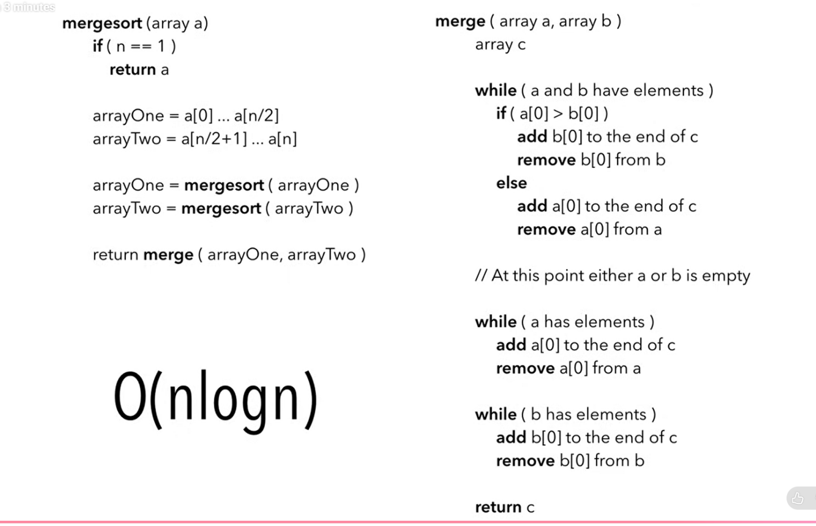
Merge sort sorts a list using divide and conquer:
- Split the list into two halves.
- Recursively sort each half.
- Merge the sorted halves.
Example:
[5, 2, 4, 1]
split
[5, 2] [4, 1]
split split
[5] [2] [4] [1]
merge merge
[2, 5] [1, 4]
merge
[1, 2, 4, 5]
Python implementation:
def merge_sort(values):
if len(values) <= 1:
return values

middle = len(values) // 2

left = merge_sort(values[:middle])
right = merge_sort(values[middle:])

return merge(left, right)

def merge(left, right):
result = []
i = j = 0

while i < len(left) and j < len(right):
if left[i] <= right[j]:
result.append(left[i])
i += 1
else:
result.append(right[j])
j += 1

result.extend(left[i:])
result.extend(right[j:])

return result
The base case is a list with zero or one element—it is already sorted.
Complexity:
- Time: O(n log n) in the best, average, and worst cases
- Extra space: O(n)
- Stable: yes, when equal left-side elements are selected first (<=)
The splitting creates about log n levels, and merging processes all n elements at each level. Therefore, the total time is O(n log n).

First: what do the two functions do?
merge_sort(values):
- Splits a list into smaller lists.
- Calls itself to sort those smaller lists.
- Sends the sorted smaller lists to merge().
merge(left, right):
- Receives two lists that are already sorted.
- Combines them into one sorted list.
Now we call:
merge_sort([8, 3, 5, 1])

Call 1: merge_sort([8, 3, 5, 1])
The parameter values is:
[8, 3, 5, 1]

Check the base case
if len(values) <= 1:
The length is 4.
4 <= 1 → False
So we do not return yet.

Find the middle
middle = len(values) // 2
That means:
middle = 4 // 2
middle = 2
// is integer division.

Start sorting the left half
left = merge_sort(values[:middle])
values[:2] means everything before index 2:
[8, 3]
Therefore, the computer calls:
merge_sort([8, 3])
Important: Call 1 is now paused. It cannot assign anything to left until merge_sort([8, 3]) finishes and returns an answer.

Call 2: merge_sort([8, 3])
Now this call has its own values:
[8, 3]
The earlier call still has [8, 3, 5, 1]. Every recursive call has its own variables.

Check the base case
len([8, 3]) = 2
2 <= 1 → False

Find the middle
middle = 2 // 2
middle = 1

Sort its left half
left = merge_sort(values[:1])
values[:1] is:
[8]
So the computer calls:
merge_sort([8])
Call 2 is paused while this new call runs.

Call 3: merge_sort([8])
Its values is:
[8]
Check the base case:
len([8]) = 1
1 <= 1 → True
So this line runs:
return values
It returns:
[8]
A one-element list is already sorted. This is the base case that stops the recursion.
We now return to the paused Call 2:
left = merge_sort([8])
The returned value is [8], so Call 2 now has:
left = [8]

Call 2 now sorts its right half
The next line is:
right = merge_sort(values[middle:])
In Call 2:
values = [8, 3]
middle = 1
values[1:] means everything from index 1 onward:
[3]
So it calls:
merge_sort([3])

Call 4: merge_sort([3])
Check the base case:
len([3]) = 1
1 <= 1 → True
It returns:
[3]
We return to Call 2. It now has:
left = [8]
right = [3]
Call 2 reaches:
return merge(left, right)
That becomes:
return merge([8], [3])

First merge: merge([8], [3])
The merge function starts with:
result = []
i = 0
j = 0
The variables mean:
- result: the new sorted list we are building.
- i: the current position in left.
- j: the current position in right.
Current state:
left = [8]
↑
i

right = [3]
↑
j

result = []
The loop condition is:
while i < len(left) and j < len(right):
Currently:
i = 0, len(left) = 1 → 0 < 1 is True
j = 0, len(right) = 1 → 0 < 1 is True
Both sides still have an available number, so enter the loop.
Compare:
if left[i] <= right[j]:
That is:
8 <= 3 → False
Therefore, the else block runs:
result.append(right[j])
j += 1
We append 3:
result = [3]
j = 1
Check the loop condition again:
i < len(left) → 0 < 1 → True
j < len(right) → 1 < 1 → False
The loop stops because the right list has no numbers left.
But 8 is still unused in the left list.
result.extend(left[i:])
left[i:] is left[0:], which is:
[8]
Add it to result:
result = [3, 8]
Then:
result.extend(right[j:])
right[1:] is empty, so nothing changes.
Finally:
return result
This merge returns:
[3, 8]
Therefore:
merge_sort([8, 3])
has finished and returns:
[3, 8]

Return to Call 1
Remember that Call 1 was waiting here:
left = merge_sort(values[:middle])
The answer has now returned, so Call 1 has:
values = [8, 3, 5, 1]
left = [3, 8]
Now Call 1 executes:
right = merge_sort(values[middle:])
In Call 1, middle is 2.
values[2:] = [5, 1]
So it calls:
merge_sort([5, 1])
Call 1 pauses again.

Call 5: merge_sort([5, 1])
Check the base case:
len([5, 1]) = 2
2 <= 1 → False
Find the middle:
middle = 2 // 2 = 1
Sort the left half:
left = merge_sort(values[:1])
values[:1] is [5], so it calls:
merge_sort([5])

Call 6: merge_sort([5])
The length is 1, so the base case returns:
[5]
Return to Call 5:
left = [5]
Now sort the right half:
right = merge_sort(values[1:])
values[1:] is [1], so it calls:
merge_sort([1])

Call 7: merge_sort([1])
The length is 1, so it returns:
[1]
Return to Call 5:
left = [5]
right = [1]
Call 5 now executes:
return merge([5], [1])

Second merge: merge([5], [1])
Start:
result = []
i = 0
j = 0
Compare:
left[i] = 5
right[j] = 1

5 <= 1 → False
Take 1 from the right:
result = [1]
j = 1
The right list is now finished, so the loop stops.
Add all unused left-side values:
result.extend(left[i:])
left[0:] is [5]:
result = [1, 5]
Nothing remains on the right.
Return:
[1, 5]
Therefore:
merge_sort([5, 1])
returns:
[1, 5]

Return to the original call
Call 1 now has both sorted halves:
left = [3, 8]
right = [1, 5]
It reaches:
return merge(left, right)
That becomes:
return merge([3, 8], [1, 5])

Final merge: merge([3, 8], [1, 5])
Start:
left = [3, 8]
right = [1, 5]
result = []
i = 0
j = 0

Comparison 1
left[i] = left[0] = 3
right[j] = right[0] = 1

3 <= 1 → False
Take 1 from the right:
result = [1]
i = 0
j = 1
Notice that i remains 0 because we did not take anything from left.

Comparison 2
left[i] = left[0] = 3
right[j] = right[1] = 5

3 <= 5 → True
Take 3 from the left:
result = [1, 3]
i = 1
j = 1

Comparison 3
left[i] = left[1] = 8
right[j] = right[1] = 5

8 <= 5 → False
Take 5 from the right:
result = [1, 3, 5]
i = 1
j = 2
The right list is now finished because its length is 2 and j is 2.
The loop stops.
The left list still has 8 at index 1:
result.extend(left[i:])
left[1:] is [8], so:
result = [1, 3, 5, 8]
There is nothing remaining on the right:
result.extend(right[j:])
Finally:
return result
The final answer is:
[1, 3, 5, 8]

The complete recursion order
This is the exact order in which the calls happen:
merge_sort([8, 3, 5, 1])
│
├── merge_sort([8, 3])
│ ├── merge_sort([8]) → returns [8]
│ ├── merge_sort([3]) → returns [3]
│ └── merge([8], [3]) → returns [3, 8]
│
├── merge_sort([5, 1])
│ ├── merge_sort([5]) → returns [5]
│ ├── merge_sort([1]) → returns [1]
│ └── merge([5], [1]) → returns [1, 5]
│
└── merge([3, 8], [1, 5]) → returns [1, 3, 5, 8]
The most important recursion idea is this:
left = merge_sort(values[:middle])
The assignment to left does not finish immediately. The current function pauses and waits while another merge_sort call runs. That new call might also pause and call another merge_sort. Once a one-element list is reached, the calls start returning in reverse order.
So the movement is:
Downward: split, split, split
Upward: return, merge, return, merge
For 8351, the essential journey is:
[8, 3, 5, 1]
→ [8, 3] and [5, 1]
→ [8], [3], [5], [1]
→ [3, 8] and [1, 5]
→ [1, 3, 5, 8]

