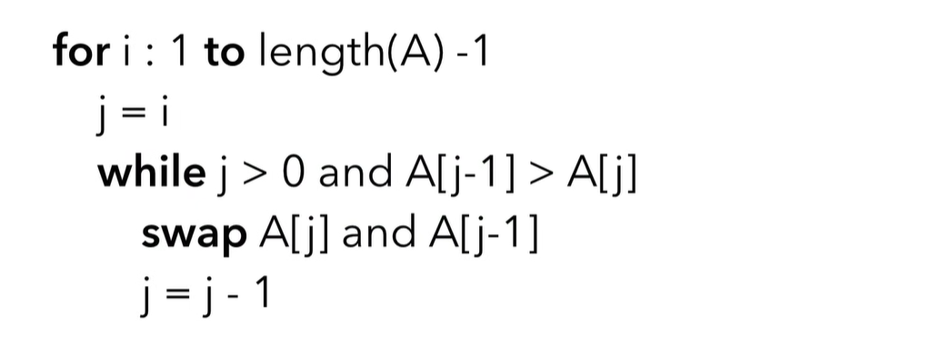

What is Insertion Sort?
Insertion Sort is a sorting algorithm that builds the sorted array one element at a time.
It works the same way many people sort playing cards in their hands:
- Pick one card.
- Compare it with the cards already sorted.
- Insert it into the correct position.
- Repeat until all cards are sorted.

Example
Unsorted array:
[5, 2, 4, 6, 1, 3]

Step 1
Assume the first element is already sorted.
[5] | [2, 4, 6, 1, 3]
Take 2.
Compare with 5.
Since 2 < 5, move 5 to the right.
[2, 5] | [4, 6, 1, 3]

Step 2
Take 4.
Compare with 5.
Move 5.
Compare with 2.
Insert after 2.
[2, 4, 5] | [6, 1, 3]

Step 3
Take 6.
6 is already larger than 5.
[2, 4, 5, 6] | [1, 3]
No shifting needed.

Step 4
Take 1.
Compare with 6 → shift
Compare with 5 → shift
Compare with 4 → shift
Compare with 2 → shift
Insert at beginning.
[1, 2, 4, 5, 6] | [3]

Step 5
Take 3.
Compare with 6 → shift
Compare with 5 → shift
Compare with 4 → shift
Compare with 2 → stop
Insert after 2.
[1, 2, 3, 4, 5, 6]
Array is sorted.

Algorithm
For every element:
- Store the current value (called the key).
- Compare it with elements before it.
- Shift larger elements one position to the right.
- Insert the key into the empty position.

Python Code
def insertion_sort(arr):
for i in range(1, len(arr)):
key = arr[i]
j = i - 1

while j >= 0 and arr[j] > key:
arr[j + 1] = arr[j]
j -= 1

arr[j + 1] = key

return arr

numbers = [5, 2, 4, 6, 1, 3]
print(insertion_sort(numbers))
Output:
[1, 2, 3, 4, 5, 6]

JavaScript Code
function insertionSort(arr) {
for (let i = 1; i < arr.length; i++) {
let key = arr[i];
let j = i - 1;

while (j >= 0 && arr[j] > key) {
arr[j + 1] = arr[j];
j--;
}

arr[j + 1] = key;
}

return arr;
}

console.log(insertionSort([5, 2, 4, 6, 1, 3]));

Time Complexity
Case | Time
Best (already sorted) | O(n)
Average | O(n²)
Worst (reverse sorted) | O(n²)

Space Complexity
O(1)
It sorts the array in place, using only a small amount of extra memory.

Advantages
- Very simple to implement.
- Fast for small datasets.
- Efficient if the array is already nearly sorted.
- Stable (equal elements keep their relative order).
- Uses constant extra space.

Disadvantages
- Slow for large datasets.
- Much slower than algorithms like Merge Sort or Quick Sort on large inputs.

When should you use Insertion Sort?
Use it when:
- The array is small (around 10–50 elements).
- The data is almost sorted.
- You need a simple, in-place sorting algorithm.
Avoid it for very large, randomly ordered arrays because its average and worst-case time complexity is O(n²).
Good question! The loop starts at index 1 because the first element (index 0) is already considered sorted.
Let's look at an example.
arr = [5, 2, 4, 6, 1, 3]
Indexes:
Index | Value
0 | 5
1 | 2
2 | 4
3 | 6
4 | 1
5 | 3
The code is:
for i in range(1, len(arr)):
So i will be:
1, 2, 3, 4, 5
It never starts at 0.

Why?
At the beginning, there is only one element:
[5]
A single element is already sorted. There is nothing to compare it with.
So we treat it as our first sorted part.
Sorted | Unsorted

[5] | [2, 4, 6, 1, 3]
Now we start with index 1 (the value 2) and insert it into the sorted part.

First iteration (i = 1)
key = arr[1] # 2
j = i - 1 # 0
Compare:
5 > 2 ?
Yes.
Move 5 one step right.
[5, 5, 4, 6, 1, 3]
Insert 2.
[2, 5, 4, 6, 1, 3]
Now the sorted part becomes
[2, 5]

Second iteration (i = 2)
key = 4
Compare
5 > 4 ? Yes → move 5

2 > 4 ? No → stop
Insert 4.
[2, 4, 5, 6, 1, 3]

What if we started from index 0?
Suppose we wrote
for i in range(len(arr)):
The first iteration would be
i = 0
key = arr[0] # 5
j = -1
The while condition is
while j >= 0 and arr[j] > key:
Since
j = -1
the condition
j >= 0
is already False, so nothing happens.
The first iteration does no useful work—it just wastes one loop iteration.

Visual idea
Initially

Sorted Unsorted
[5] [2, 4, 6, 1, 3]

↓

Take 2

Sorted Unsorted
[2, 5] [4, 6, 1, 3]

↓

Take 4

Sorted Unsorted
[2, 4, 5] [6, 1, 3]

↓

Take 6

Sorted Unsorted
[2, 4, 5, 6] [1, 3]
The sorted section grows from left to right, one element at a time.
Rule to remember:
- Index 0 is already sorted because it contains only one element.
- Therefore, Insertion Sort always starts with index 1, inserting each remaining element into the already sorted left side.
- erfect. Let's trace it exactly as Python executes it.
- We'll use this array:
- arr = [5, 2, 4, 6, 1, 3]
- Our algorithm:
- def insertion_sort(arr):
- for i in range(1, len(arr)):
- key = arr[i]
- j = i - 1

- while j >= 0 and arr[j] > key:
- arr[j + 1] = arr[j]
- j -= 1

- arr[j + 1] = key

- return arr

Initial State
- Index: 0 1 2 3 4 5
- Array: [5, 2, 4, 6, 1, 3]
- The first element is already sorted.
- Sorted | Unsorted

- [5] | [2,4,6,1,3]

Iteration 1
- i = 1
- key = arr[1]
- key = 2
- j = 0
- Current array
- [5,2,4,6,1,3]

while
- Check
- j >= 0
- 0 >= 0
- ✅ True
- Check
- arr[j] > key
- 5 > 2
- ✅ True
- Move 5 to the right
- arr[j+1] = arr[j]
- arr[1] = arr[0]
- Array becomes
- [5,5,4,6,1,3]
- Decrease j
- j -= 1
- j = -1
- Loop again
- j >= 0
- -1 >= 0
- ❌ False
- Exit while.
- Insert key
- arr[j+1] = key
- arr[0] = 2
- Array becomes
- [2,5,4,6,1,3]
- Sorted part
- [2,5]

Iteration 2
- i = 2
- key = 4
- j = 1
- Array
- [2,5,4,6,1,3]

while
- 5 > 4
- True
- Move 5
- [2,5,5,6,1,3]
- Decrease
- j = 0
- Again
- 2 > 4
- False
- Stop
- Insert key
- arr[1] = 4
- Array
- [2,4,5,6,1,3]
- Sorted
- [2,4,5]

Iteration 3
- i = 3
- key = 6
- j = 2
- Array
- [2,4,5,6,1,3]
- Check
- 5 > 6
- False
- Nothing moves.
- Array stays
- [2,4,5,6,1,3]

Iteration 4
- i = 4
- key = 1
- j = 3
- Array
- [2,4,5,6,1,3]
- Compare
- 6 > 1
- Move
- [2,4,5,6,6,3]
- j = 2
- Compare
- 5 > 1
- Move
- [2,4,5,5,6,3]
- j = 1
- Compare
- 4 > 1
- Move
- [2,4,4,5,6,3]
- j = 0
- Compare
- 2 > 1
- Move
- [2,2,4,5,6,3]
- j = -1
- Stop
- Insert key
- arr[0] = 1
- Array
- [1,2,4,5,6,3]

Iteration 5
- i = 5
- key = 3
- j = 4
- Array
- [1,2,4,5,6,3]
- Compare
- 6 > 3
- Move
- [1,2,4,5,6,6]
- j = 3
- Compare
- 5 > 3
- Move
- [1,2,4,5,5,6]
- j = 2
- Compare
- 4 > 3
- Move
- [1,2,4,4,5,6]
- j = 1
- Compare
- 2 > 3
- False
- Insert
- arr[2] = 3
- Final array
- [1,2,3,4,5,6]

Here's the key idea to remember
- When we store the current element in key, we temporarily "take it out" of the array.
- For example, when key = 1:
- Before:
- [2,4,5,6,1,3]

- Take out 1:

- key = 1

- [2,4,5,6,_,3]
- Now we shift larger numbers right:
- [2,4,5,6,6,3]
- [2,4,5,5,6,3]
- [2,4,4,5,6,3]
- [2,2,4,5,6,3]
- Finally, we place key into the empty spot:
- [1,2,4,5,6,3]
- This "take one element out, shift larger elements, insert it into the gap" is the entire idea behind Insertion Sort. Once this clicks, the algorithm becomes much easier to understand.

