Welcome to the course

Welcome to the course!
In this course, you’ll learn how to use Git to keep a history of your code changes.

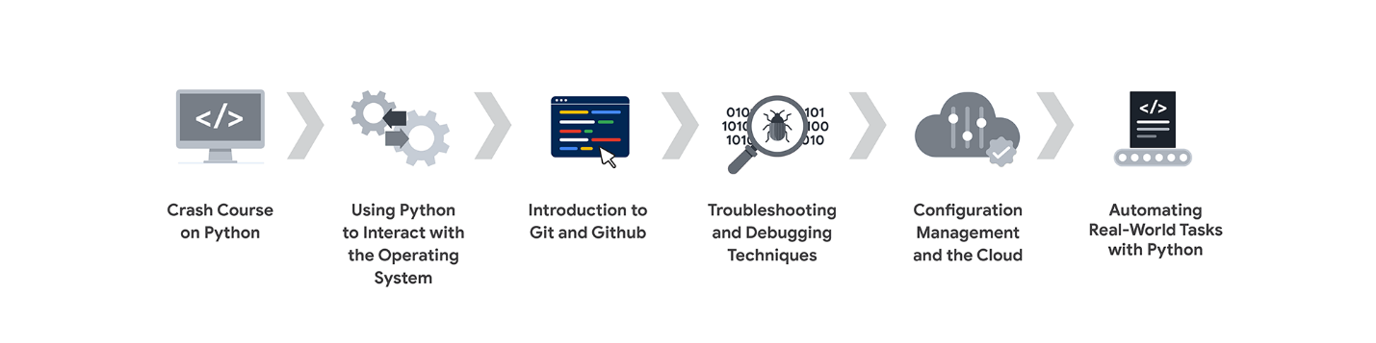
This is the third course in the program.
- Crash Course on Python
- Using Python to Interact with the Operating System
- Introduction to Git and GitHub (this course)
- Troubleshooting and Debugging Techniques
- Configuration Management and the Cloud
- Automating Real-World Tasks with Python
- Accelerate Your Job Search with AI

Course prerequisites
This course requires some familiarity with a few basic operating system concepts like files, directories, and file systems. You'll be using the command line for interacting with Git, so you'll need some familiarity with that as well.
All the examples in this course use Python 3. You'll need a basic grasp of the Python syntax, and the most common data structures and objects. To get the most out of this course, we also strongly recommend that you install software in your machine, or have your system administrator install it. You'll need to install Git to follow our examples, and Python 3 to test out the examples.
We'll use Linux for our examples, but you can follow along with Windows or MacOS computers.

Obtain the Google IT Automation with Python Certificate
To receive your official Google IT Automation with Python Certificate, you must:
- Pass all graded assignments in all 7 courses of the certificate program. Each graded assignment is part of a cumulative graded score for the course, and the passing grade for each course is 80%.
AND one of the following:
- Pay the course certificate fee,
- Be approved for Coursera Financial Aid, or
- Complete the certificate through an educational institution, employer, or agency that's sponsoring your participation.

Healthy habits for course completion
Here is a list of best practices that will help you complete the courses in the program in a timely manner:
- Plan your time: Setting regular study times and following them each week can help you make learning a part of your routine. Use a calendar or timetable to create a schedule, and list what you plan to do each day in order to set achievable goals. Find a space that allows you to focus when you watch the videos, review the readings, and complete the activities.
- Work at your own pace: Everyone learns differently, so this program has been designed to let you work at your own pace. Although your personalized deadlines start when you enroll, feel free to progress through the program at the speed that works best for you. There is no penalty for late assignments; to earn your certificate, all you have to do is complete all of the work. You can extend your deadlines at any time by going to Overview in the navigation panel and selecting Switch Sessions. If you have already missed previous deadlines, select Reset my deadlines instead.
- Be curious: If you find an idea that gets you excited, act on it! Enrich your learning experience with Gemini's Guided Learning feature. It acts as your personal learning assistant, helping you ask insightful questions, find more details online, and explore interesting topics. The steps you take to support your learning along the way will advance your knowledge, create more opportunities in this high-growth field, and help you qualify for jobs.
- Take notes: Notes will help you remember important information in the future, especially as you’re preparing to enter a new job field. In addition, taking notes is an effective way to make connections between topics and gain a better understanding of those topics.
- Review exemplars: Exemplars are completed assignments that fully meet an activity's criteria. Many activities in this program have exemplars for you to compare to your own work. Although there are often many ways to complete an assignment, exemplars offer you guidance and inspiration about how to complete the activity.
- Build your Career Identity: Your career identity is the unique value you bring to the workforce. Watch this video to learn about the key components of career identity and write your own career identity statement. Discovering and defining your own career identity makes you better equipped to choose a career path that aligns with your strengths, values, and goals and is more effective in your chosen profession.
- Connect with other learners: If you have a question, chances are, you’re not alone. You can visit Coursera’s private Google IT 201 Automation with Python Community to expand your network, discuss career journeys, and share experiences. You can also check out the quick start guide.
- Coursera learner support: Use the Learner Help Center to find information on specific technical issues. These include error messages, difficulty submitting assignments, or problems with video playback. If you can’t find an answer in the documentation, you can also report your problem to the Coursera support team by clicking on the Contact Us! link available at the bottom of help center articles.
- Update your profile: Consider updating your profile on Coursera to include your photo, career goals, and more. When other learners find you in the Community, they can click on your name to access your profile and get to know you better.

Finding out more information
Throughout this course, we’ll teach you how to do a range of things with Git and GitHub. While we’ll provide a lot of information through videos and supplemental readings, sometimes you may need to look things up on your own, both now and throughout your career. Things change fast in IT, so it’s critical to do your own research to stay up-to-date on what’s new. We recommend you use your favorite search engine to find more information about the concepts we cover in this course — it’s great practice for the real world!
On top of search results, here are some great Git resources available online:
- Pro Git: This book (available online and in print) covers all the fundamentals of how Git works and how to use it. Refer to it if you want to learn more about the subjects that we cover throughout the course.
- Git tutorial: This tutorial includes a very brief reference of all Git commands available. You can use it to quickly review the commands that you need to use.
Note: As you progress this course you may see updated or repeated content due to Google’s regular review of the certificate program to provide the most up-to-date skills and tools in the industry. These changes include the addition of new practice material and supportive content. In addition, Google’s certificate updates sometimes include changes to graded items like quizzes and labs. If you have previously completed a graded item in this course, you may need to take a new assessment to complete this course. We hope the new content will support you on your learning journey!

