Resources for Setting up the Sensors and Their Wirings

# Logistics

The combined sketch is the final sketch that will be used for the project where it integrated multiple sensors into a single sketch. The other ones are used for testing the sensors individually.

# HX711 + Load Cell Sensor

## Tutorial

<https://randomnerdtutorials.com/esp8266-load-cell-hx711/>

## Wiring

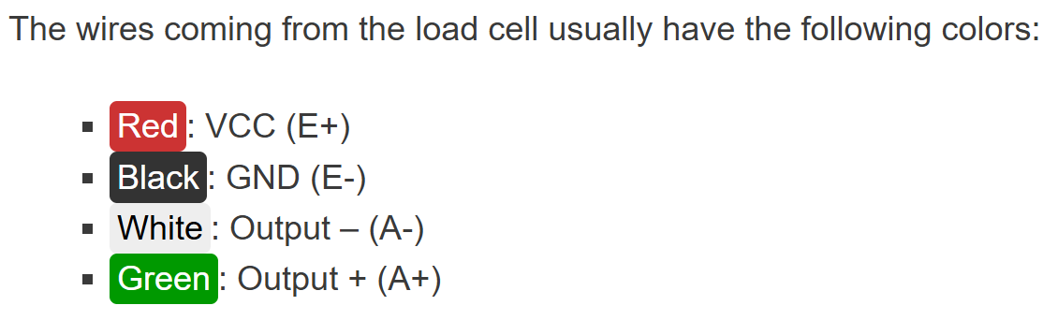

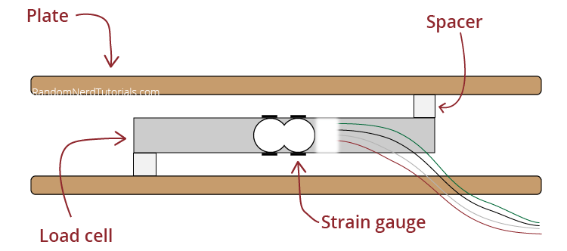

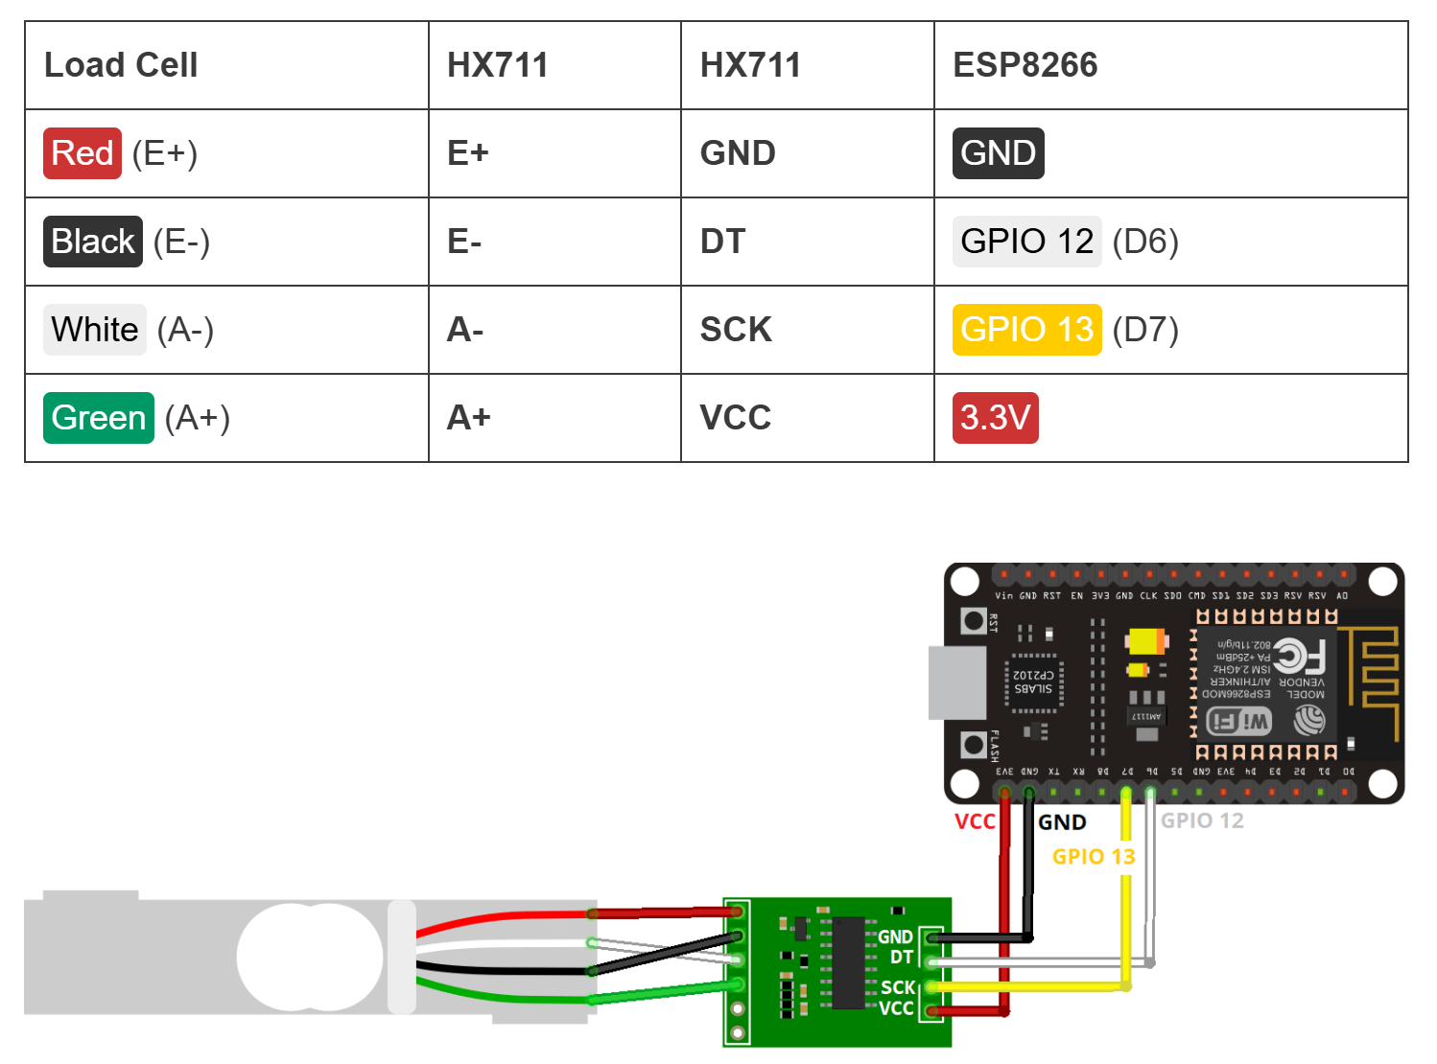

## Library Used

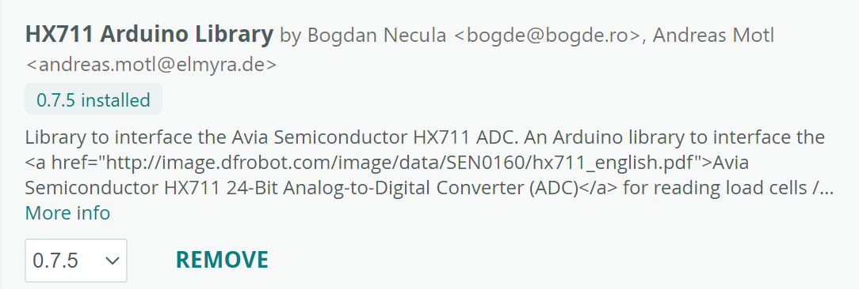

# MPU6050 - Accelerometer + Gyroscope

## Tutorial

For getting the sensor setup and understanding what it does: <https://randomnerdtutorials.com/esp8266-nodemcu-mpu-6050-accelerometer-gyroscope-arduino/>

For getting the yaw, pitch, and roll: <https://www.youtube.com/watch?v=ythjrfQViRQ>

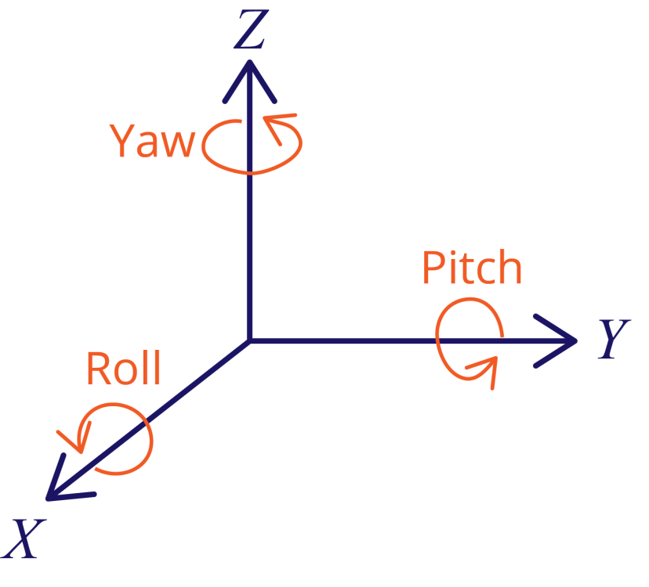

## Wiring

**Important**: you should use the 3.3 V option! Using the 5 V option is ***un***safe!

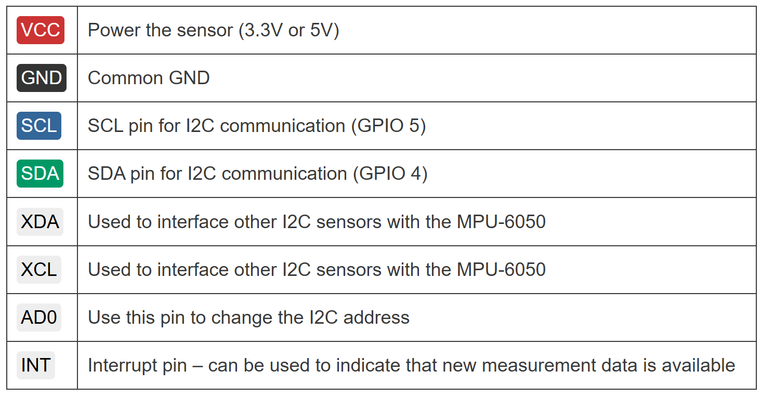

## Libraries Used

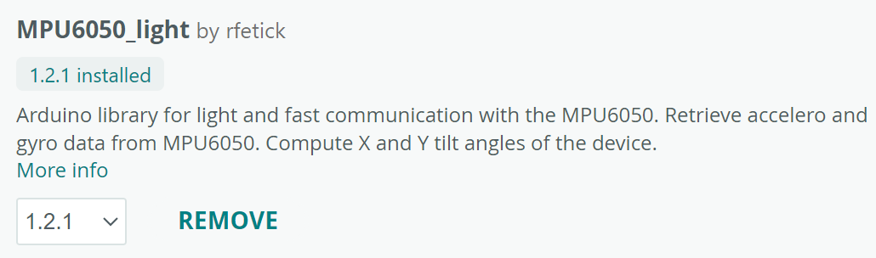

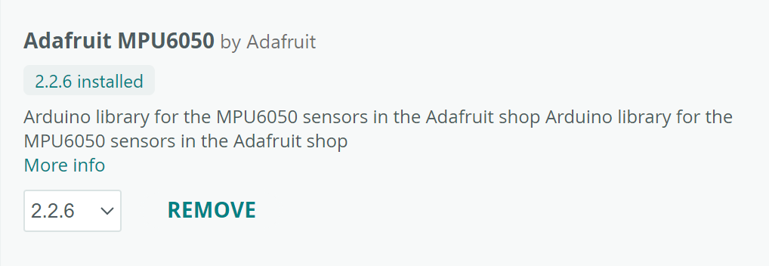

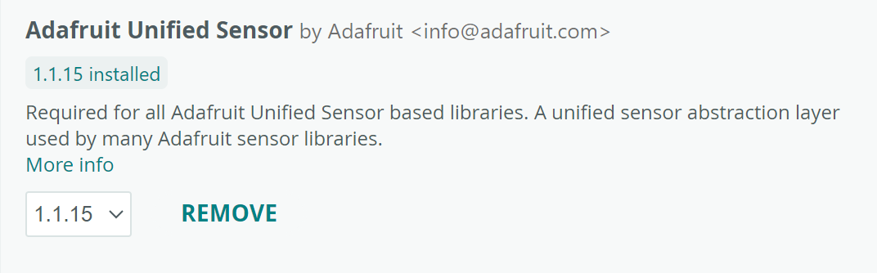

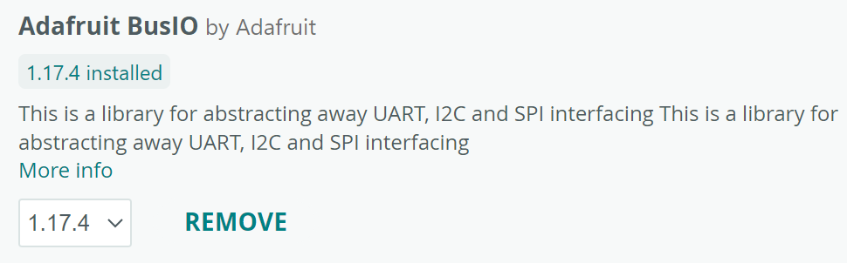

# DS18B20 Waterproof Temperature Sensor

## Tutorial

<https://randomnerdtutorials.com/esp8266-ds18b20-temperature-sensor-web-server-with-arduino-ide/>

## Wiring

Need a 4.7K resistor. Although, I am just using the resistor that was sent with the sensor from the Amazon order.

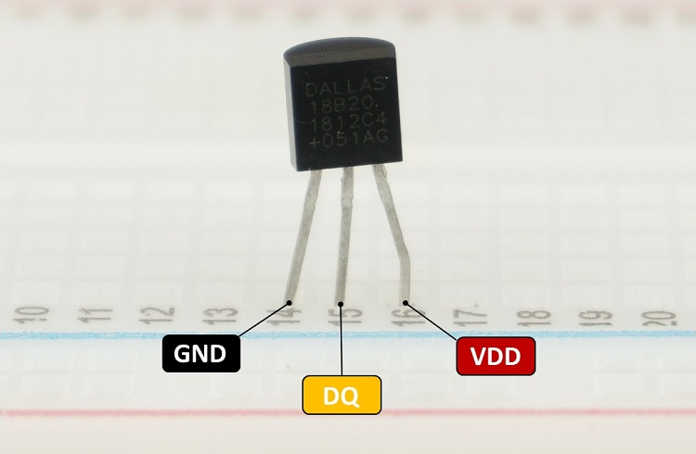

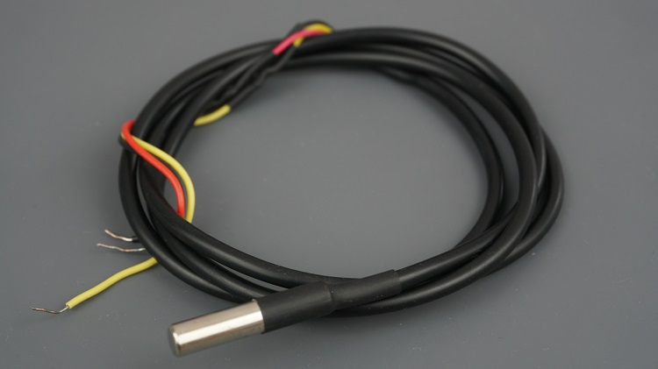

**Important Note**: when connecting the DS18B20 do **NOT** use consecutive pins on the breadboard because as soon as the metal from red wire the one on the black or yellow wire, the system will freak out and MCU will power off.

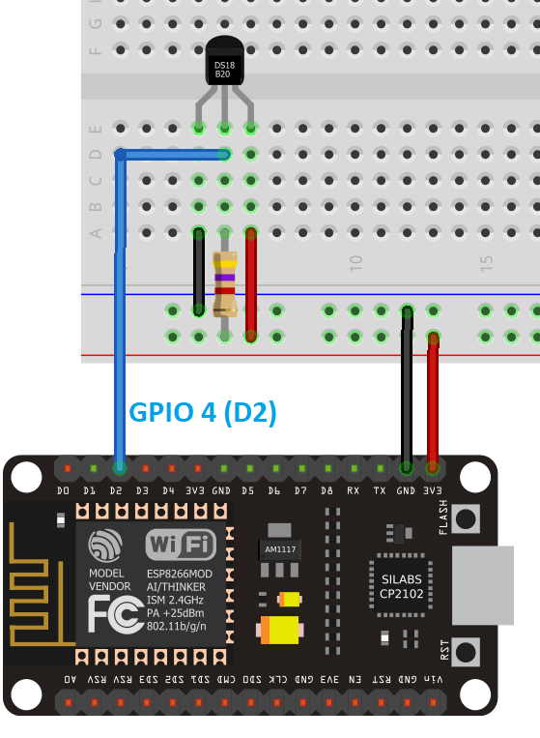

## Libraries Used

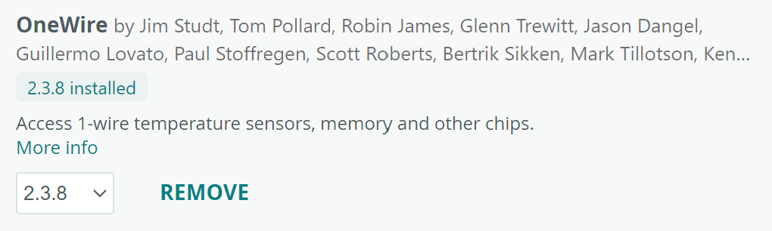

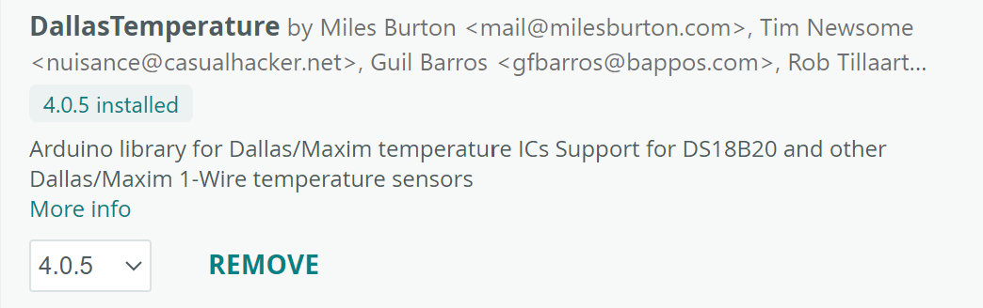

## MQTT Communication

## Command to run the broker

docker run -it -p 1883:1883 eclipse-mosquitto:1.6.15

## Command to subscribe to “topic”

mosquitto_sub -h localhost -t "topic"

# Board in our Lab Kit

## Board Name

WEMOS D1R1 2 ESP8266 WiFi Board

## Arduino IDE Board Name



## Pinout

