Manuscript Title : Letter to editor: Outcomes with venetoclax 50mg, Hypomethylating agents , and voriconazole & posoconazole in acute myeloid leukemia

Running Title :Outcomes of Venetoclax , HMA and Azoles in AML

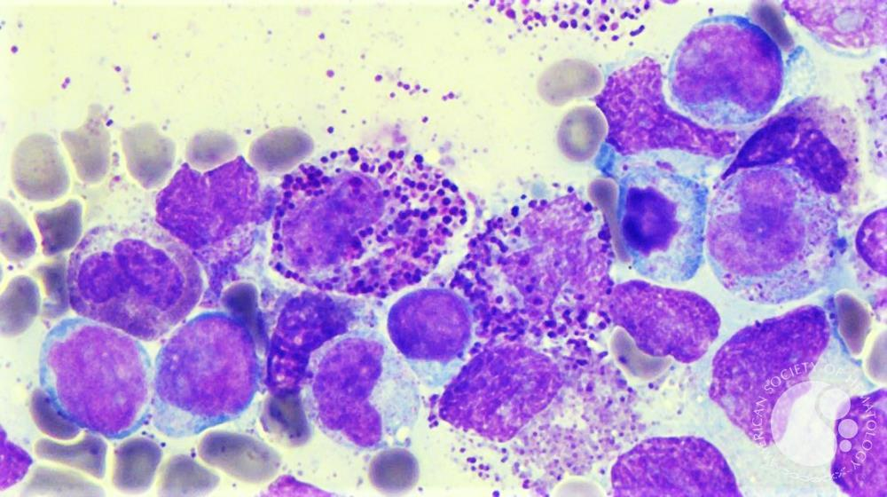INSHAL HUSSAIN1  , SAIM RAFIQUE2

1. Bachelor of Medicine and Bachelor of Surgery(MBBS)

Federal Medical College

2. Bachelor of Medicine and Bachelor of Surgery (MBBS)

Federal Medical College

Corresponding Author : Inshal Hussain Bachelor of Medicine and Bachelor of Surgery (MBBS) Federal Medical College (FMC) Pakistan Institute of Medical Science (PIMS)

Email : inshalhussain12345@gmail.com

Dear Dr-Andrew M.Evens

*We read the article with great interest and appreciate the contribution it makes to the growing body of evidence regarding the use of venetoclax 50mg in combination with Hypomethylating agents and azole antifungals in acute myeloid leukemia (AML) . While the findings are clinically relevant , we would like to highlight several limitations that may affect the interpretation of the trial results and their applicability in broader clinical settings*

*Firstly, the omission of the p-value, a cornerstone of statistical inference, significantly limits the ability of access the significance of reported outcomes. The p-value determines the probability that observed results occurred by chance . A widely accepted threshold for statistical significance is p<0.05. Its absence in the study raises concerns regarding the robustness of the results . Inferential statistical significance tests, including those processed through software such as Jamovi or SPSS, rely on the p-value to validate outcomes. Without it, readers are left without a key metric for interpreting the findings. All inferential statistical test end with a test statistic and the associated P value. 1This P value has been accorded such an elevated status that everybody who performs or reads research is familiar with the expression Ps 0.05 as a cutoff that indicates statistical significance1*

*Secondly , the study did not appear to include multivariate analysis, which is essential in adjusting for confounding variables such as age, disease severity, performance status and comorbidities. Treatment effects often vary among patients with different clinical profiles. Ignoring this heterogeneity may oversimplify the results and compromise the external validity of the findings . Addressing such variables through appropriate statistical modeling could enhance the reliability of conclusions drawn regarding treatment efficacy. 2Addressing such treatment heterogeneity is crucial to investigate whether patients with specific characteristics are likely to gets benefits2*

*Another important aspect not addressed is inter individual variability in drug response , particularly in patients with altered physiology such as those with chronic kidney disease (CKD). CKD significantly influences drug pharmacokinetics, affecting both metabolism and clearance. Prescribing without considering these physiological changes may lead to suboptimal or even harmful outcomes Future studies should explicitly address how such comorbidities are managed during treatment and analysis . 3Prescribing to patients with kidney diseases requires knowledge about the drugs,the extent of the patients altered physiology,and pharmacokinetic principles that influence the design of dosing regimens. There are multiple physiologic effects of impaired kidney functions,and the extent to which they occur in an individual at any given time can be difficult to define3.*

*Additionally, in the systematic review by Ucceiro et al, the authors noted a lower median overall survival rate than that observed in VIAL-A trial4. Although the deviation in real world setting, several other contributing factors must be considered . For instance , a recent retrospective study by Diebold et al. Evaluated outcomes of venetoclax 50 mg with concurrent antifungal use and observed similarly reduced median overall survival. The study identified dosing inconsistencies, differences in early mortality rates, and inclusion of patients who did not meet the VIAL-A eligibility criteria as significant factors that could explain this divergence.*

1. [**Greenland S, Senn SJ, Rothman KJ, Carlin JB, Poole C, Goodman SN, Altman DG. Statistical tests, *P* values, confidence intervals, and power: a guide to misinterpretations. *Eur J Epidemiol.* 2016 Apr;31(4):337–350. doi:10.1007/s10654‑016‑0149‑3**](https://link.springer.com/article/10.1007/s10654-016-0149-3)
2. [***Kavelaars X, Mulder J, Kaptein M. Bayesian multivariate logistic regression for superiority and inferiority decision-making under observable treatment heterogeneity. Multivariate Behav Res. 2024;59(4):859–882. doi:10.1080/00273171.2024.2337340***](https://www.tandfonline.com/doi/full/10.1080/00273171.2024.2337340)
3. [***Roberts DM, Sevastos J, Ierino FL, et al. Clinical pharmacokinetics in kidney disease: Fundamental principles. Clin J Am Soc Nephrol. 2018 Oct 8;13(11):1774–83. doi:10.2215/CJN.00340118. PMID: 29934432.***](https://europepmc.org/article/MED/29934432?utm)
4. [***Ucciero A, Di Carlo D, Benedetti R, Cristiano L, Di Vito Nolfi M, Sorà F, et al. Venetoclax with hypomethylating agents in newly diagnosed acute myeloid leukemia: a systematic review and meta-analysis of survival data from real-world studies. Cancers (Bas***](https://research.uniupo.it/en/publications/venetoclax-with-hypomethylating-agents-in-newly-diagnosed-acute-m?utm)