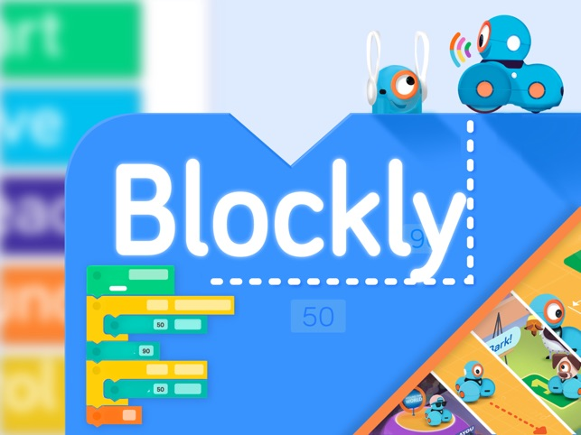

[**Blockly**](http://docs.google.com/blockly.html)

[Learn coding with blockly through various challenges! Featuring Javascript.](http://docs.google.com/blockly.html)

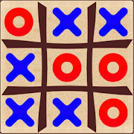

VDG Design: TicTacToe

Design a TictacToe game using JavaScript in this activity using if and else conditions.



[**COG 5 - Debugging**](http://docs.google.com/apps/debug/index.html)

[Learn different types of debugging techniques through fun activities. **(Curriculum Special)**](http://docs.google.com/apps/debug/index.html)



[**COG 6 - Sequencing**](http://docs.google.com/apps/sequencing/sequencing.html)

[Quizzes based on sequencing,selection and iteration **(Curriculum Required)**](http://docs.google.com/apps/sequencing/sequencing.html)