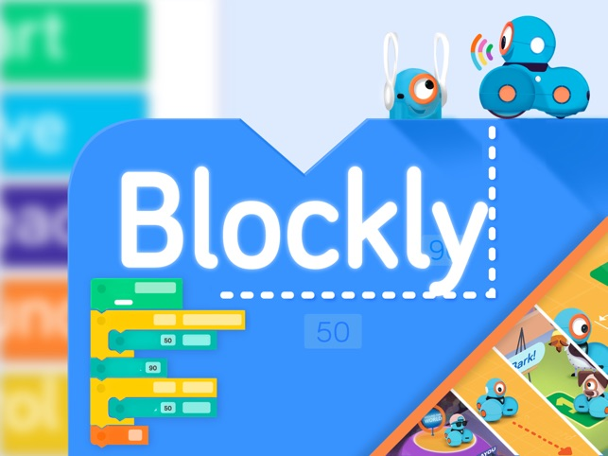

##### Blockly

Coding

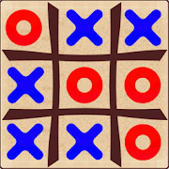

##### VDG Design : TicTacToe

Coding



##### COG 5 - Debugging

Coding



##### COG 6 - Sequencing

Coding