Khadim Mbow



Home

Categories

Brain Box

Learn



Highlights

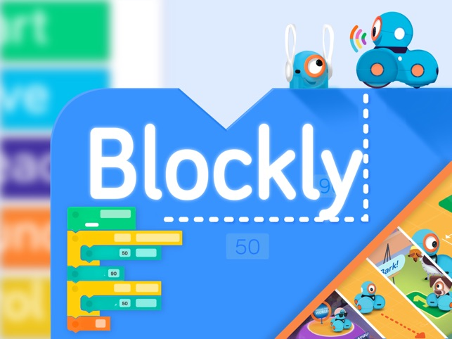

Blockly

Coding



A Slimey Situation

Learn

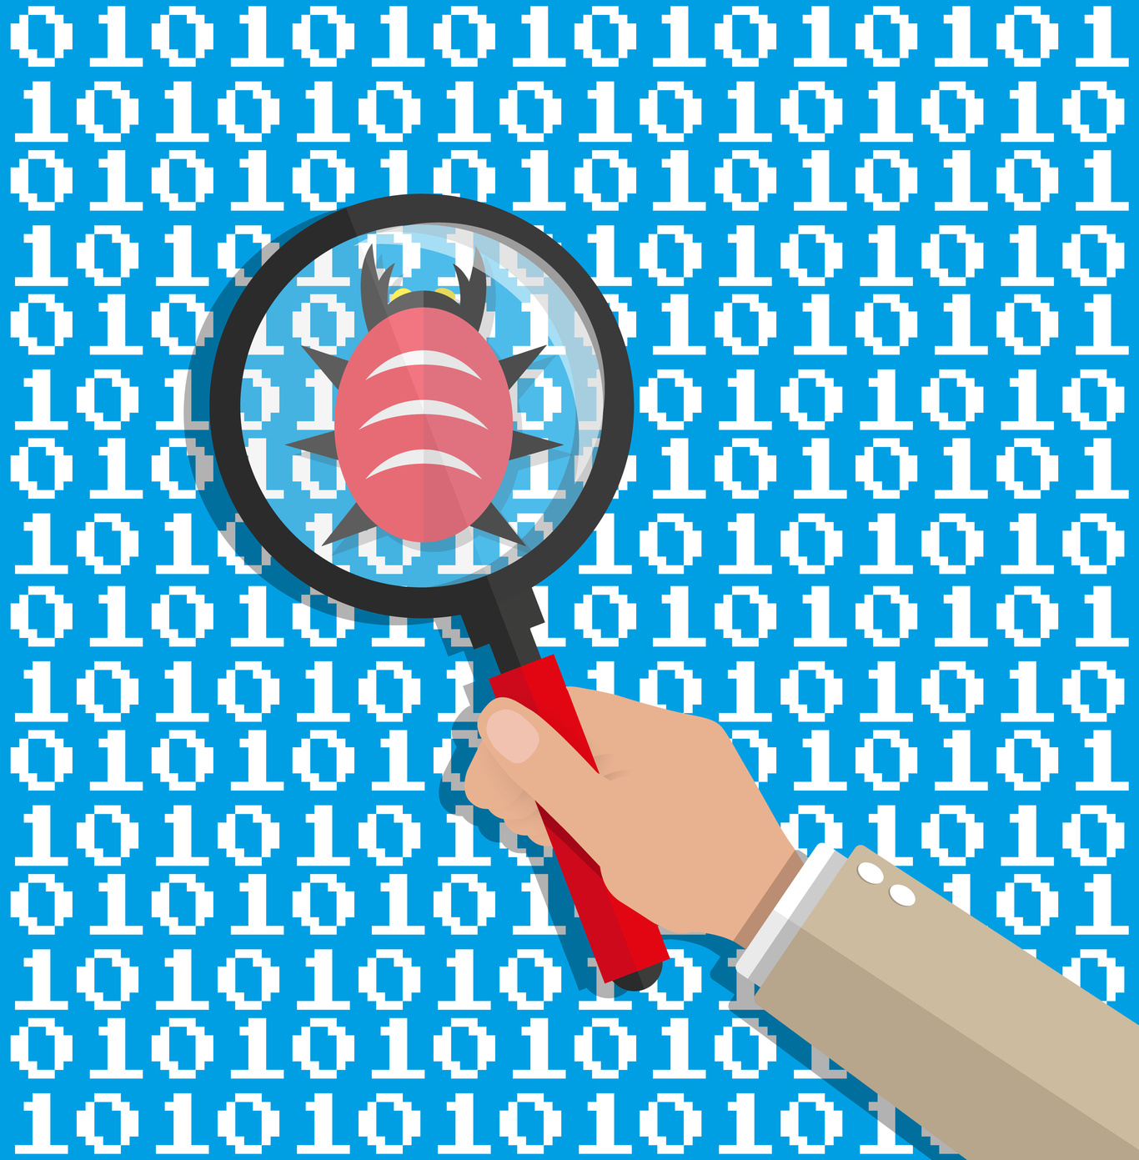

Debugging

Coding



Capacitive Piano

BrainBox

By Our Creators

Every month we highlight the best creations from our students. Dive into their creative minds!

Using the skills learned on Scratch, a student created this platformer game.

[Try it for yourself!](https://scratch.mit.edu/projects/262245679/)

Another Scratch highlight as this student uses variables and physics to create a turret defense game.

[Try it for yourself!](https://scratch.mit.edu/projects/262245679/)

Follow us!

Coding

Web

Robotics

Engineering



Capacitive Piano

BrainBox

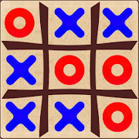

VDG Design: TicTacToe

Coding



Debugging (Ft COG 5)

Coding



Sequencing (Ft COG 6)

Coding



Blog Builder

Web

Play With Hub



Piano

BrainBox



Motion Jeff

BrainBox

Learn How To

Purchased a BrainBox? Great! But that's just the first step to awesome adventures. You can watch tutorials on how to put them together right here. Simply select your product 👉

#### *music_note*

Touch Piano

(Click to watch)

#### *track_changes*

Room Defender

(Click to watch)

#### *format_paint*

Monster Artbot

(Click to watch)









Profile

Edit

Title :

Level :

Exp :

Other

Dark Mode

On

Off

Classes



3D Printing

Coding & Programming

Culinary Art

Design Based Engineering

Drone Engineering

Entreprenurship

Investigative Science Lab

Maker Studio

Mental Math

Minecraft

Movie Studio

Robotics

Visual Art Studio

Classes



Kinder

First

Second

Third

Fourth

Fifth

Learn

×

A Message From Us

Please use a laptop, chromebook or tablet to better enjoy the experience on the Ideacodinghub. Thanks!

Change Picture