
Nile University
School of Information Technology and Computer Science
Program of Computer Science
Student Training Report
Fullstack Web Development with Scrimba and Coursera
Submitted in Partial Fulfilment of the Requirements
For the Bachelor's Degree in Information Technology and Computer Science
Computer Science
Submitted by
Mohamed Abdelhafiz Mohamed - 221001317
Training Provider
Scrimba (Online) - Coursera Platform
Giza - Egypt Spring 2026

1. Executive Summary
I did an online training course. The name of the course is the Fullstack Development Specialization. The company Scrimba made this course. The course is on the Coursera website. The training was about web development.
In this training I learned many new skills. I learned HTML, CSS, and JavaScript. I also learned React, Node.js, Express, SQL, TypeScript, and Next.js. I used these tools to build many small projects. I put all my projects in one GitHub repository.
This report explains three things. First, it explains the company. Second, it explains the training and the projects I built. Third, it explains the skills I learned and the problems I faced. These skills are close to my study in Computer Science at Nile University. The pictures of my projects are in the Appendix at the end of the report.
2. The Company
Scrimba is an online school for coding. It started in Norway. Scrimba is not like other online schools. It uses special videos called 'scrims'. A scrim is a video and code together. The student can stop the video and change the code inside it. This way of learning is active and easy to follow.
Coursera is a big website for online learning. Many universities and companies put their courses on Coursera. Scrimba put its Fullstack Development Specialization on Coursera. So I could study it there.
The course is big. It has about 22 small courses inside it. It teaches front-end and back-end web development. The full course needs about three months of study. I studied at my own speed. At the end, the student builds many projects for a portfolio.
3. The Project
My main work in the training was to build projects. Every project uses one part of the course. I put all the projects in one GitHub repository. The name of the repository is 'scrimba-fullstack-development-projects'. Below is the list of the projects I built.
3.1 The Projects I Built
- Business Card: a simple personal card page. Tools: HTML and CSS.
- Space Exploration Page: a landing page about space. Tools: HTML and CSS.
- Birthday Website: a fun birthday page with animation. Tools: HTML and CSS.
- Basketball Scoreboard: an app to count points for two teams. Tools: JavaScript.
- Blackjack Game: a small card game. Tools: JavaScript.
- Leads Tracker: a Chrome extension to save links. Tools: JavaScript and localStorage.
- API Dashboard: a page that gets live data (time, weather, and a quote). Tools: Fetch and async JavaScript.
- Tenzies Game: a dice game. Tools: React.
- Assembly Endgame: a word game like Hangman. Tools: React.
- Express REST API: a small server for tasks. Tools: Node.js and Express.
- SQL Practice: database tables and queries. Tools: SQL.
- Next.js Mini Blog: a small blog with many pages. Tools: Next.js and TypeScript.
- Full-Stack Blog: a complete blog. The user can add, edit, and delete posts. Tools: Express, SQLite, and React.
3.2 Skills I Gained
I learned how to build web pages that work on a phone and on a computer. I learned how to write JavaScript to make a page interactive. I learned React to build a page from small components. I learned how to make a server with Node.js and Express. I learned how to save data in a SQL database. I learned how to get data from an API on the internet. I also learned TypeScript and Next.js, which are modern tools for big web apps.
3.3 Challenges I Faced
Some parts of the training were hard for me. React state was difficult at the start. Async JavaScript and Promises were also new, so I needed more practice. In the full-stack blog I had a problem with a port. Port 4000 was already used by another program on my computer. I found the problem and I fixed it. I moved the backend to port 5050. This problem taught me how to solve real errors, not only errors in a lesson.
3.4 Connection to My Study
This training is close to my Computer Science study at Nile University. The programming ideas, like variables, functions, loops, and conditions, are the same as in my programming courses. The SQL part is close to my database course. The idea of a client and a server is close to my web and networks courses. The training gave me hands-on practice for this theory. So the training and my study help each other.
4. Conclusion
This training was very useful for me. I learned modern web development, from the front-end to the back-end. I built many real projects. Now I can build a full website with a database.
I liked the active way of learning on Scrimba. The 'scrim' videos helped me a lot. The hardest parts were React and async JavaScript, but practice made them clear for me.
My advice for other students is simple. Build a small project after every lesson. Do not only watch the videos. Also save your work on GitHub from the first day.
In the future, I want to learn more about testing, security, and cloud deployment. I also want to add a user login to my full-stack blog. This training is a strong base for my career as a software developer.

Appendix: Screenshots of the Projects
This appendix shows pictures of the projects. Projects 10 (Express REST API) and 11 (SQL Practice) do not have a screen, because they are a server and a database. The other projects are shown below.
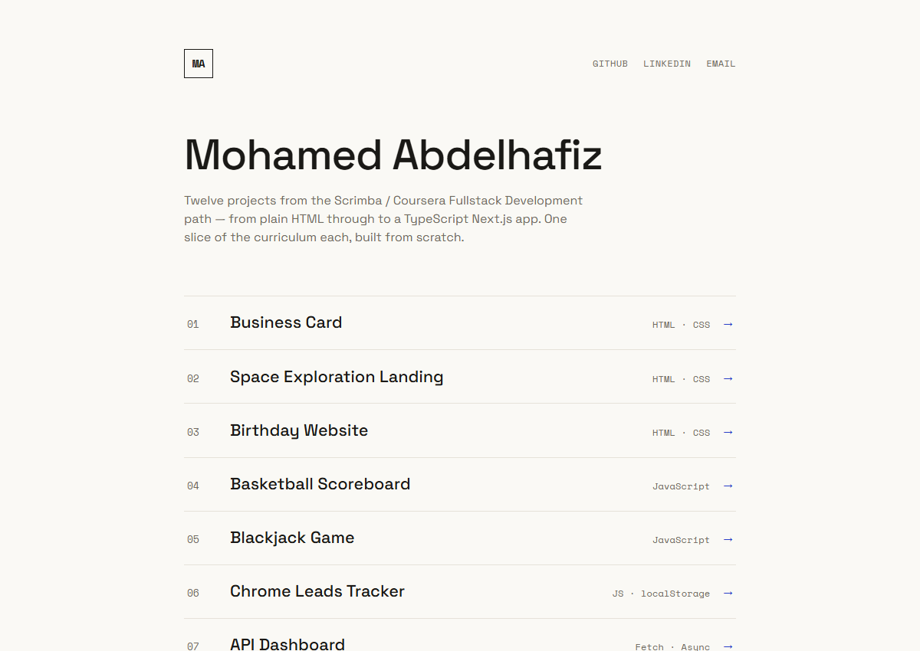
Figure 1: The portfolio home page. It lists all the projects.
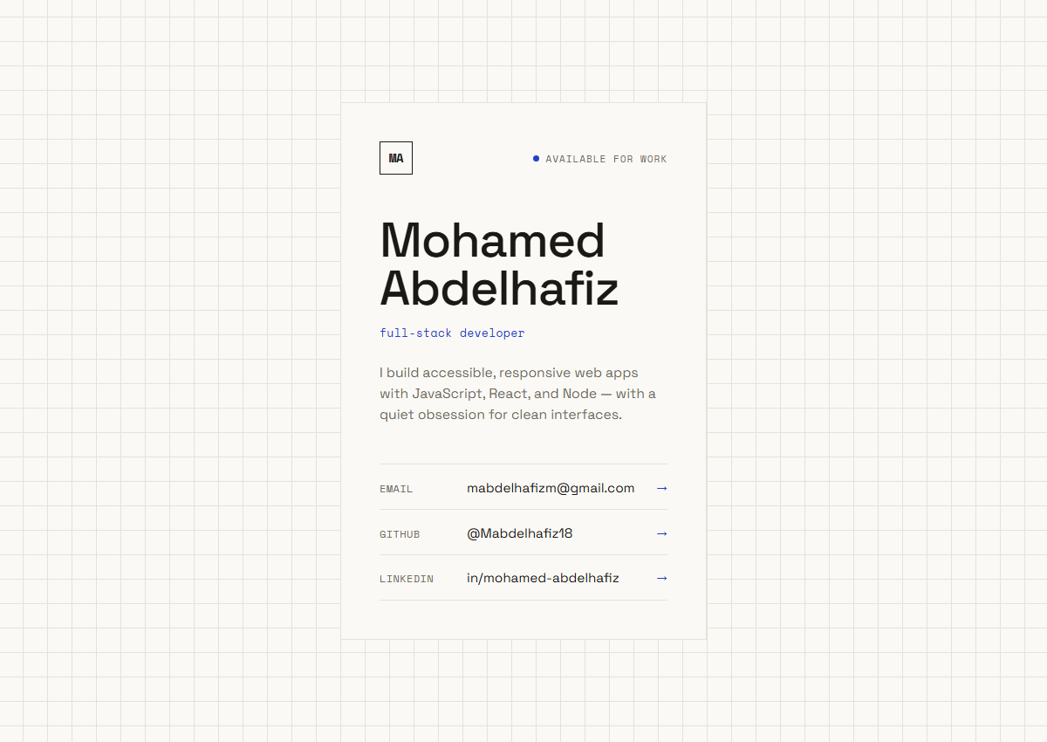
Figure 2: Project 1 - Business Card (HTML, CSS).
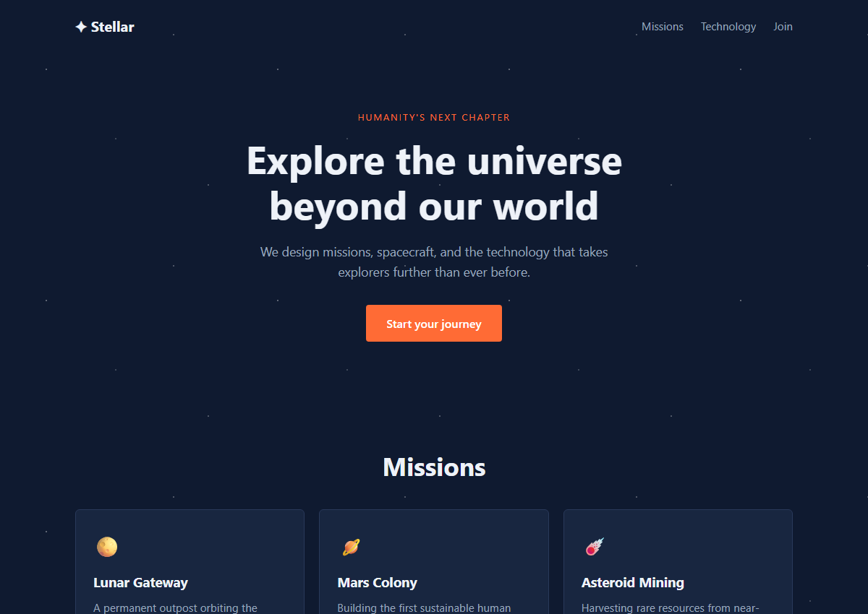
Figure 3: Project 2 - Space Exploration landing page (HTML, CSS).
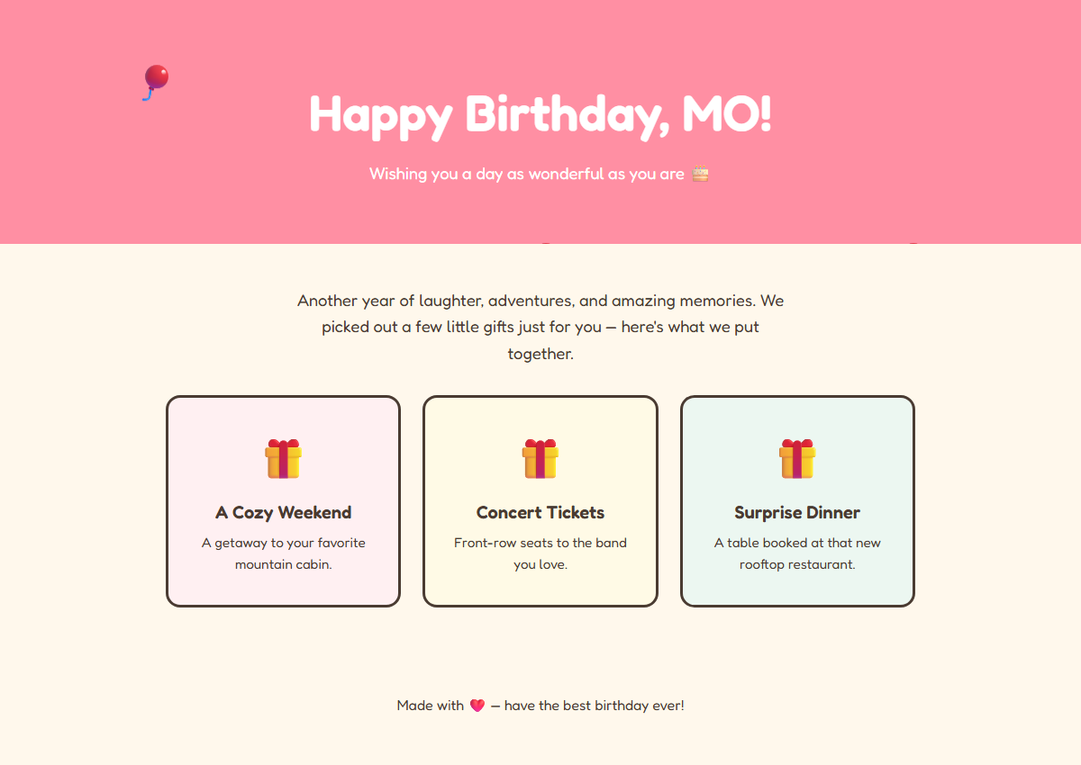
Figure 4: Project 3 - Birthday Website (HTML, CSS).
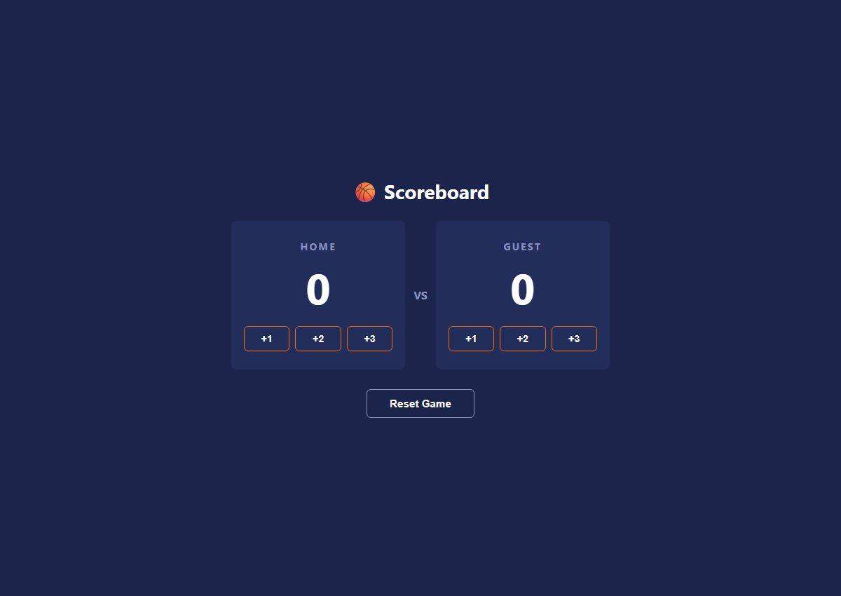
Figure 5: Project 4 - Basketball Scoreboard (JavaScript).
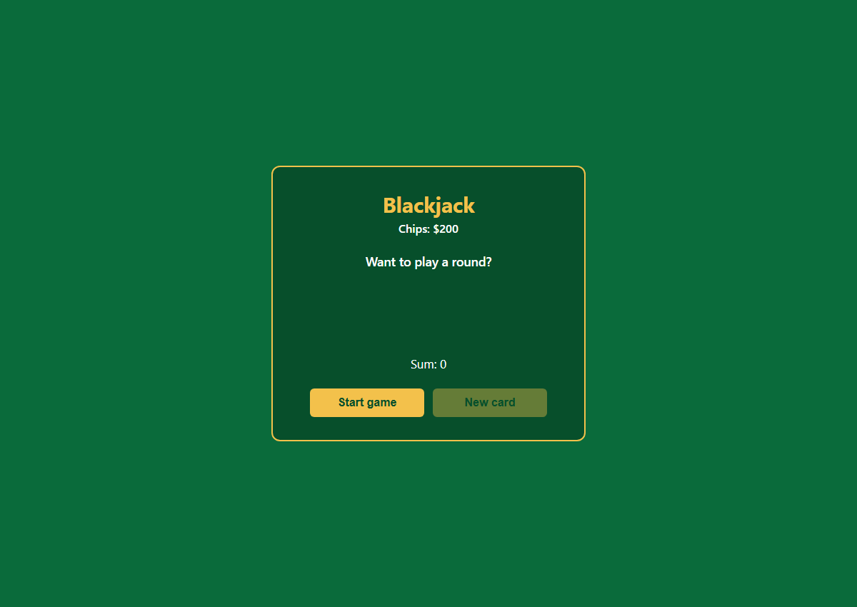
Figure 6: Project 5 - Blackjack Game (JavaScript).
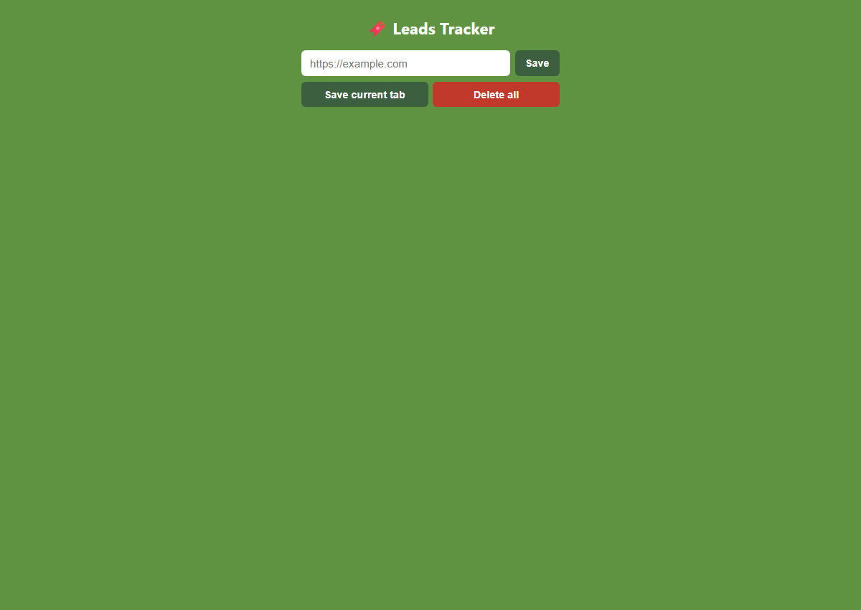
Figure 7: Project 6 - Leads Tracker (JavaScript, localStorage).
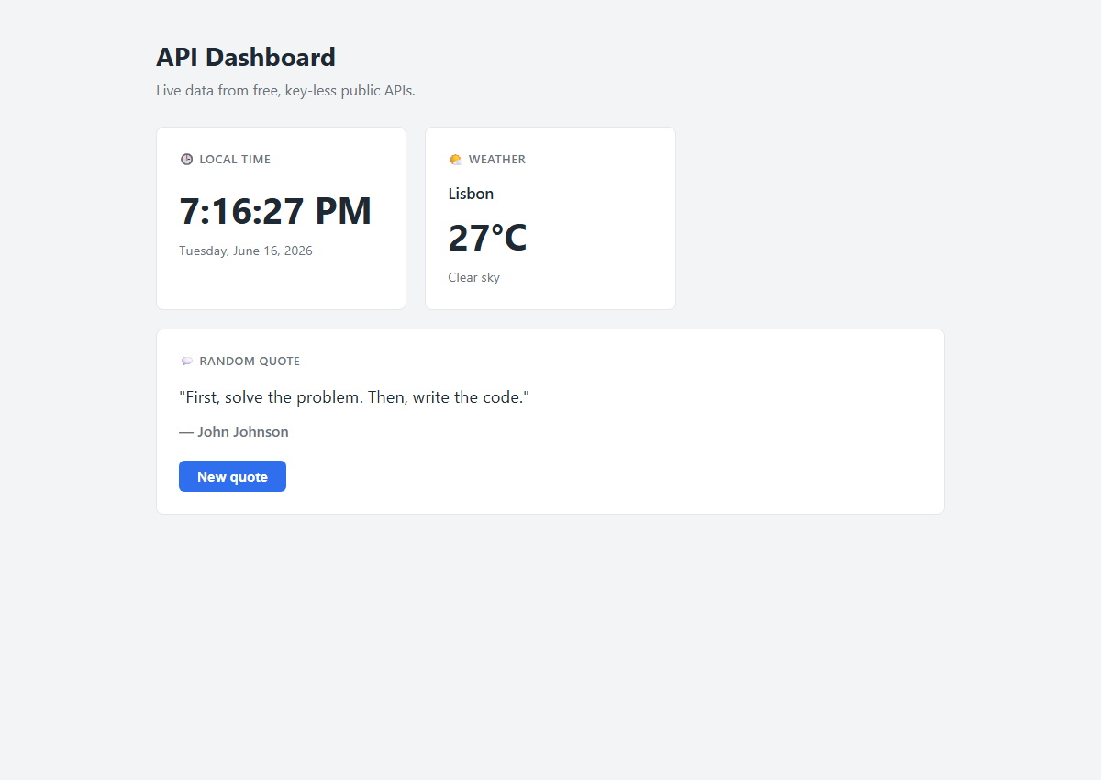
Figure 8: Project 7 - API Dashboard with live data (Fetch, async).
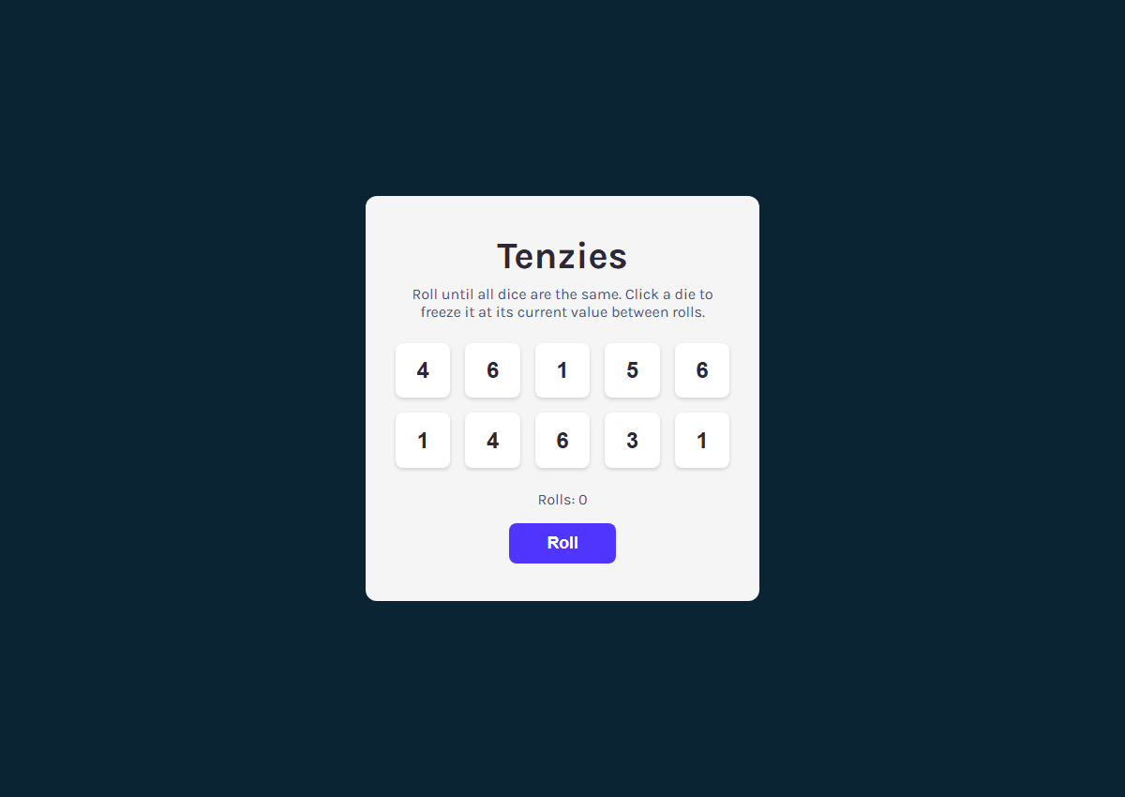
Figure 9: Project 8 - Tenzies dice game (React).
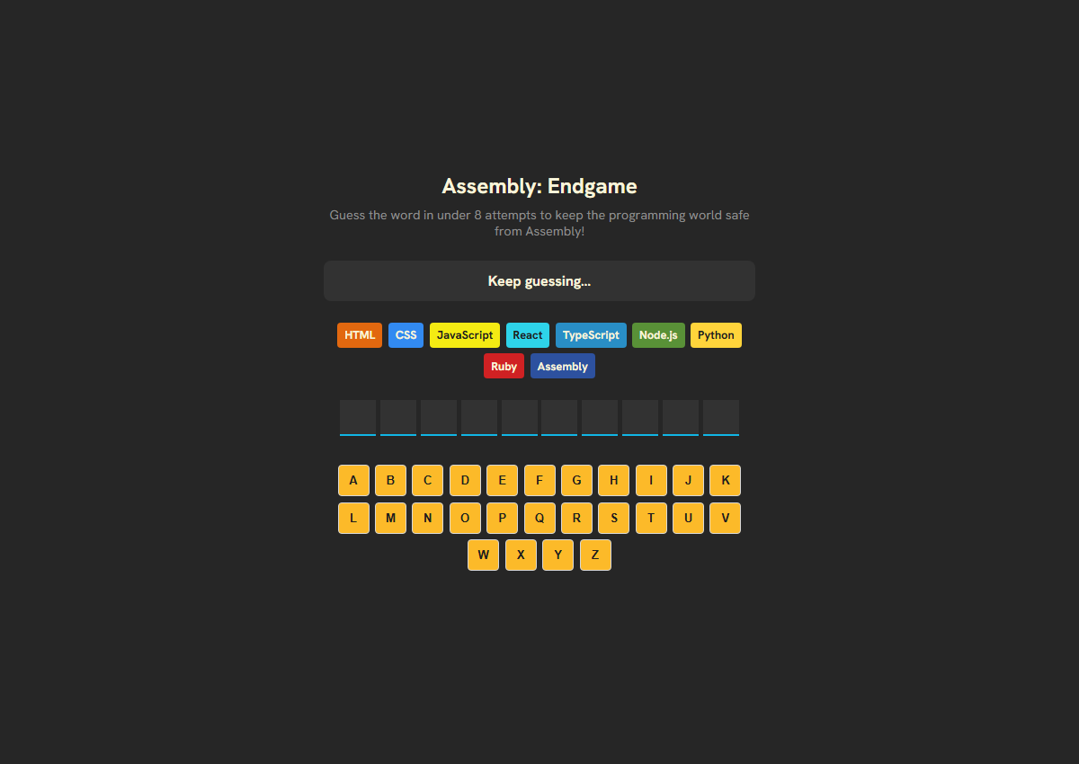
Figure 10: Project 9 - Assembly Endgame word game (React).
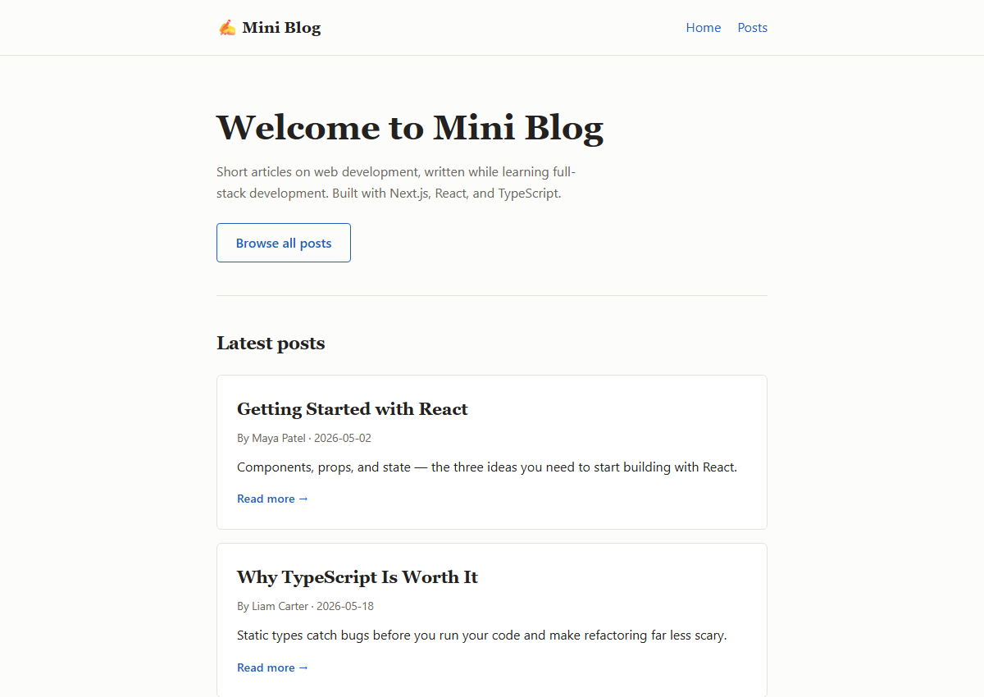
Figure 11: Project 12 - Next.js Mini Blog, home page (Next.js, TypeScript).
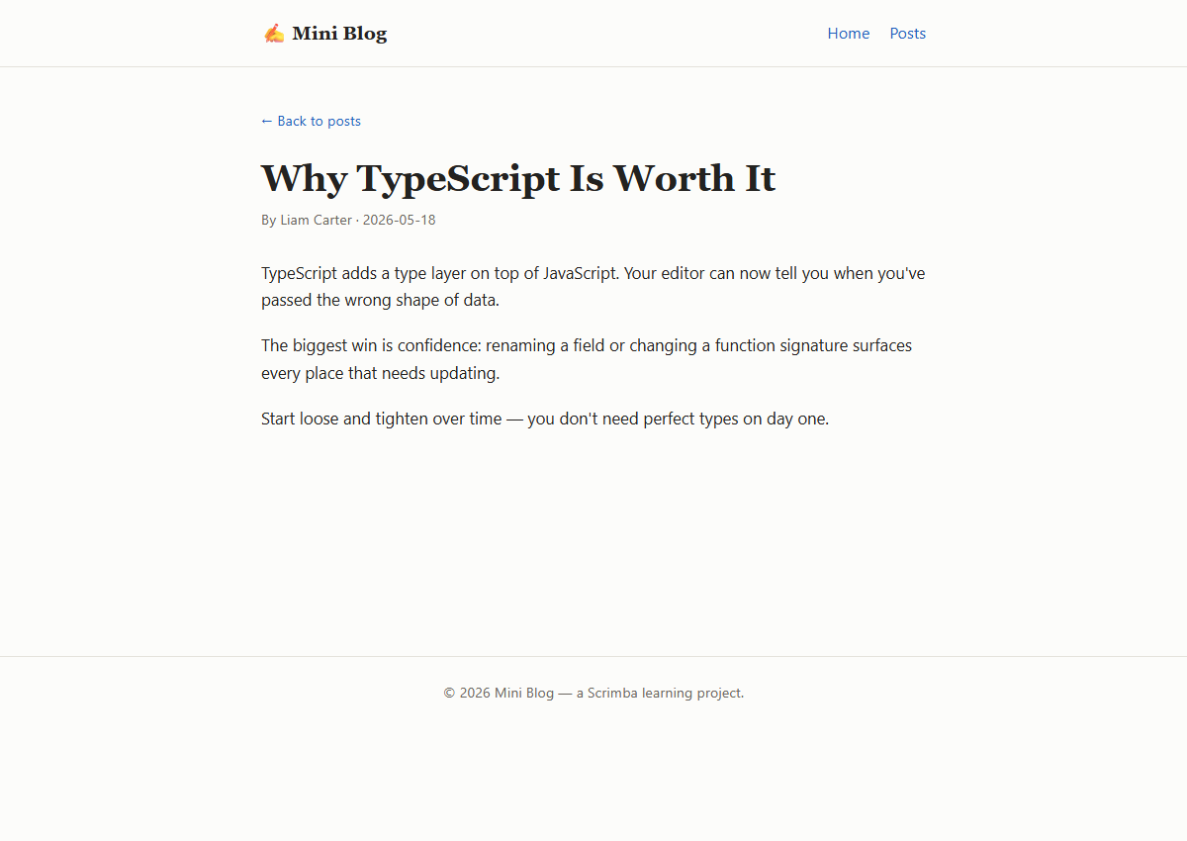
Figure 12: Project 12 - Next.js Mini Blog, a post page.
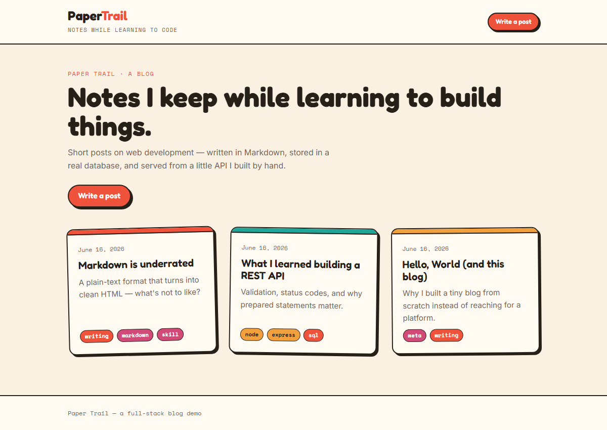
Figure 13: Project 14 - Full-Stack Blog, home page (Express, SQLite, React).
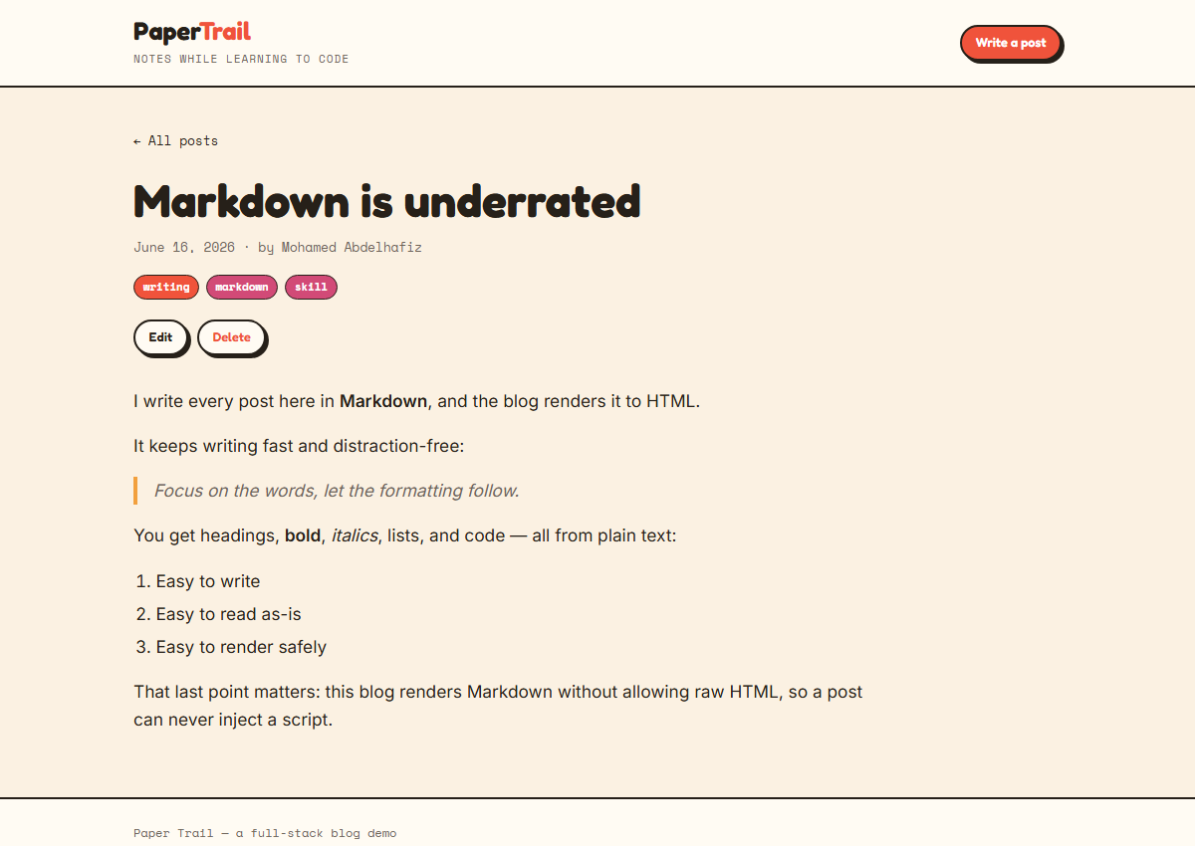
Figure 14: Project 14 - Full-Stack Blog, a post with Markdown.
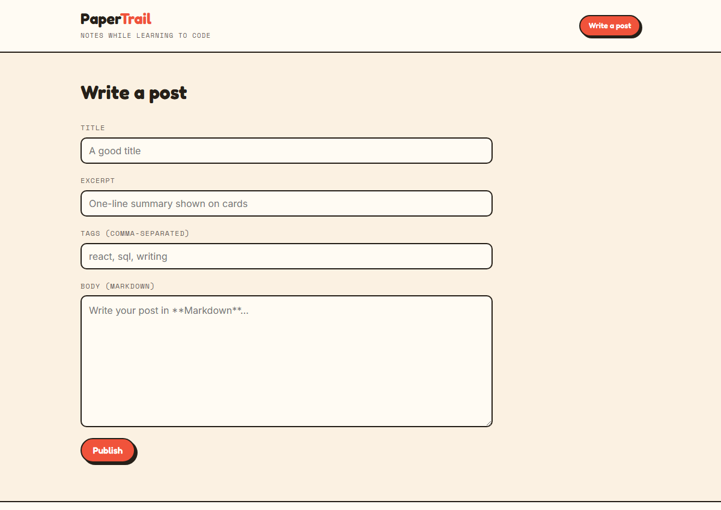
Figure 15: Project 14 - Full-Stack Blog, write a new post.

