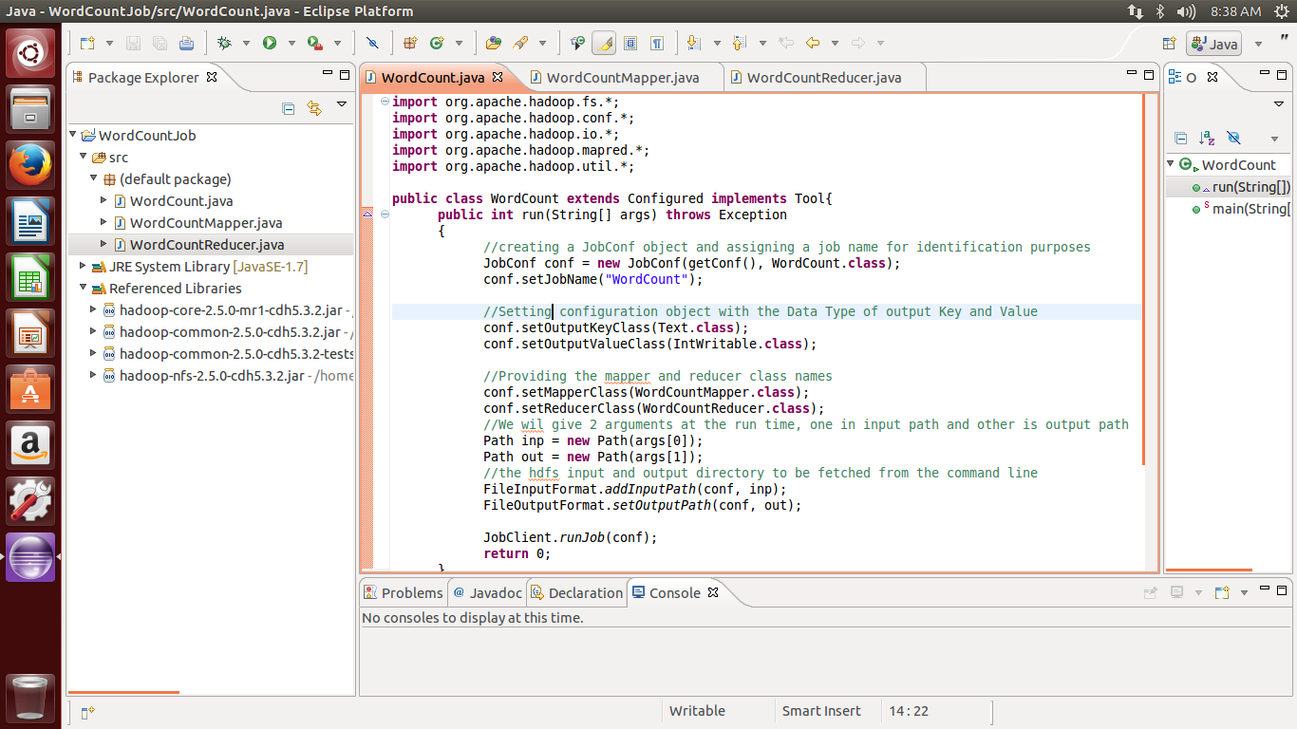

192.168.83.145

$HADOOP_HOME/sbin/start-dfs.sh

$HADOOP_HOME/sbin/start-yarn.sh

jps

$HADOOP_HOME/sbin/stop-dfs.sh

$HADOOP_HOME/sbin/stop-yarn.sh

$cd /home/hdadmin/MapReduceExamples/Wordcount

~MapReduceExamples/Wordcount$

hdfs dfs -mkdir /wordcountdata

hdfs dfs -put /home/hdadmin/MapReduceExamples/Wordcount/sample.txt /wordcountdata

$HADOOP_HOME/bin/hadoop jar wordcount.jar /wordcountdata /wordcount_output

$hdfs dfs -ls /wordcount_output

$hdfs dfs -cat /wordcount_output/part-00000

Open main machine's browser and type url

http://192.168.83.145:50070/dfshealth.html#tab-overview