AQRESS SENSEGRID

System Design Architecture
AQRESS SenseGrid — IoT Sensor & Device Management Platform

Logical, integration, data and deployment architecture for the MVP and its extensible sensor model.

Document version | 0.1.1
Date | 22 August 2026
Primary frontend | React + TypeScript
Primary backend | Python + FastAPI + PostgreSQL

MVP objective: allow a user to register a device, add and configure supported sensors, receive sensor readings, and view live and historical data.

Architecture decision
Build a generic sensor platform where devices host sensor instances. Sensor types define supported capabilities and configuration schemas; users create sensor instances and configure them without changing application code.

1. Architecture Goals
- Allow users to register IoT devices and add multiple supported sensors to each device.
- Allow sensor configuration through the web application without editing firmware for every instance.
- Receive and persist sensor readings reliably in PostgreSQL.
- Display latest readings and historical readings in a React web application.
- Keep the MVP simple while preserving a clean path to alerts, LoRaWAN, gateways, automation and analytics later.
- Separate normal API traffic from high-volume telemetry ingestion.

2. High-Level System Architecture
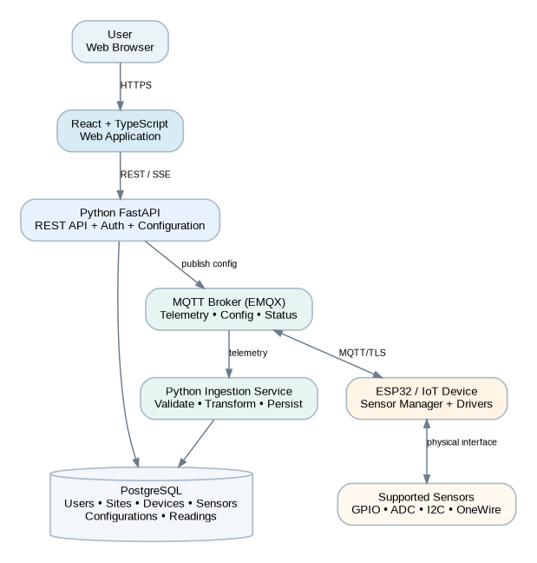
The React application handles user-facing configuration and monitoring. FastAPI owns business rules and metadata. EMQX handles device messaging. A dedicated Python ingestion service validates telemetry and writes readings to PostgreSQL.

3. Core Domain Model
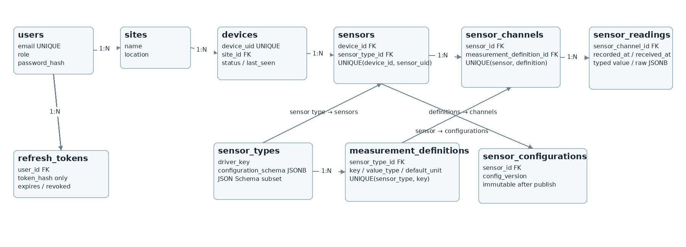
Concept | Purpose | Key design rule
Device | Physical IoT controller or gateway such as an ESP32. | A device can host zero or many sensors.
Sensor Type | Definition of a supported sensor model or generic interface. | Contains driver key, JSON Schema configuration contract and reusable measurement definitions.
Measurement Definition | Reusable output definition belonging to a sensor type, such as temperature or humidity. | Defines key, value type and default unit; unique within a sensor type.
Sensor | Physical sensor instance attached to one device. | References one sensor type; sensor_uid is unique within its device.
Sensor Channel | Per-sensor measurement channel created from a measurement definition. | Carries the instance unit/enabled state; one sensor can expose multiple channels.
Sensor Configuration | Immutable versioned parameters applied to a sensor instance. | Stored as JSONB; edits create a new version and device acknowledgement determines APPLIED state.
Sensor Reading | Time-stamped typed value for one sensor channel. | Optimised for time-range queries and high write volume; preserves raw payload trace data.

4. Sensor Configuration Architecture
Sensor types drive the configuration UI through a standard JSON Schema subset and define reusable measurement definitions. When a sensor instance is added to a device, the platform creates sensor channels from those definitions. For example, a DS18B20 creates one temperature channel, while a BME280 creates temperature, humidity and pressure channels.
Sensor Type: DS18B20
Interface: OneWire
Value Type: NUMBER
Default Unit: °C
Driver: ds18b20
Measurements: temperature (NUMBER, °C)
Configuration schema:
gpio_pin: integer, required
sample_interval_seconds: integer, default 10
decimal_places: integer, default 2

5. End-to-End Data Flow
- A user selects a device and adds a supported sensor.
- React submits the sensor definition and configuration to FastAPI.
- FastAPI validates the configuration against the sensor type schema and stores a new configuration version.
- FastAPI publishes the configuration to the device-specific MQTT topic.
- The device validates and applies the configuration, then publishes an acknowledgement.
- The device samples each enabled sensor according to its configured interval.
- Telemetry is published to MQTT in batches where practical.
- The Python ingestion service validates device identity, sensor identity, value type and timestamp.
- Valid readings are persisted to PostgreSQL; invalid messages are logged and rejected or quarantined.
- React retrieves latest/history data through FastAPI and may use SSE/WebSocket for live updates.

6. MQTT Topic Contract
Topic | Direction | Purpose
sensegrid/{device_uid}/telemetry | Device → Platform | Sensor readings, ideally batched.
sensegrid/{device_uid}/status | Device → Platform | Heartbeat, firmware, uptime and signal information.
sensegrid/{device_uid}/config | Platform → Device | Complete or incremental sensor configuration.
sensegrid/{device_uid}/config/ack | Device → Platform | Confirms whether a configuration version was applied.
sensegrid/{device_uid}/command | Platform → Device | Reserved for later device commands.
sensegrid/{device_uid}/command/ack | Device → Platform | Reserved for later command acknowledgements.

7. Telemetry Payload
{
"device_id": "ESP32-A8C339",
"timestamp": "2026-08-22T00:10:05+02:00",
"sensors": [
{"sensor_id": "CLIMATE-001", "measurements": {
"temperature": 28.7, "humidity": 63.2, "pressure": 1012.4}},
{"sensor_id": "DOOR-001", "measurements": {"state": true}}
]
}
The ingestion service normalises each measurement channel into numeric, text or boolean columns and also stores the original message in raw_payload JSONB for audit and troubleshooting.

8. PostgreSQL Logical Design
Table | Minimum fields | Notes
users | id, email, password_hash, role, is_active, created_at, updated_at | email UNIQUE; role ∈ ADMIN/USER/VIEWER; timestamps are TIMESTAMPTZ.
refresh_tokens | id, user_id, token_hash, expires_at, revoked_at, created_at | Store token hash only; supports logout/session revocation.
sites | id, name, description, latitude, longitude, created_at, updated_at | Logical location for devices.
devices | id, site_id, device_uid, name, status, firmware_version, last_seen_at | device_uid globally UNIQUE; last_seen_at TIMESTAMPTZ.
sensor_types | id, code, name, interface_type, driver_key, configuration_schema | configuration_schema is JSONB using a documented JSON Schema subset.
measurement_definitions | id, sensor_type_id, key, name, value_type, default_unit | UNIQUE(sensor_type_id, key); reusable outputs defined by sensor type.
sensors | id, device_id, sensor_type_id, sensor_uid, name, enabled, status | UNIQUE(device_id, sensor_uid); physical sensor instance.
sensor_channels | id, sensor_id, measurement_definition_id, name, unit, enabled | UNIQUE(sensor_id, measurement_definition_id); per-sensor measurement channel.
sensor_configurations | id, sensor_id, config_version, configuration, status, is_active, applied_at | UNIQUE(sensor_id, config_version); immutable after publication; changes create a new version.
sensor_readings | id, sensor_channel_id, sensor_id, device_id, recorded_at, received_at, typed value, quality, raw_payload | High-volume telemetry; recorded_at/received_at TIMESTAMPTZ; raw_payload JSONB.
Recommended indexes and constraints: users.email UNIQUE; devices.device_uid UNIQUE; sensors(device_id, sensor_uid) UNIQUE; measurement_definitions(sensor_type_id, key) UNIQUE; sensor_channels(sensor_id, measurement_definition_id) UNIQUE; sensor_configurations(sensor_id, config_version) UNIQUE. Index sensor_readings on (sensor_channel_id, recorded_at DESC), (sensor_id, recorded_at DESC), (device_id, recorded_at DESC) and recorded_at. Use PostgreSQL TIMESTAMPTZ and store all server timestamps in UTC. Partition sensor_readings by time when volume requires it.

9. Deployment Architecture
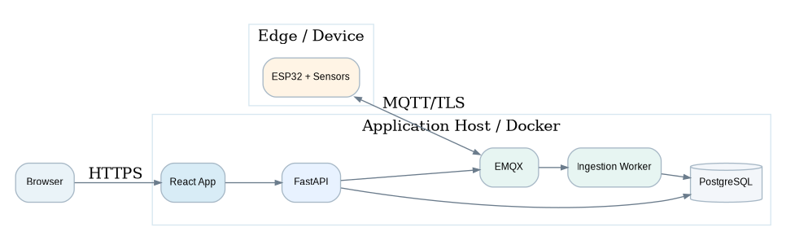
For development and the first production deployment, use Docker containers for React, FastAPI, the ingestion service, EMQX and PostgreSQL. Keep services independently deployable without introducing a large microservice estate.

10. Security Architecture
- All browser traffic uses HTTPS; all device MQTT traffic uses MQTT over TLS.
- Users authenticate separately from devices. Users have an explicit role (ADMIN, USER or VIEWER). Use short-lived access tokens and server-revocable refresh tokens stored only as hashes.
- Each device has its own identity and credentials. Broker ACLs restrict the device to its own namespace: publish telemetry/status/config acknowledgements and subscribe only to its own config/command topics. A device must never access another device's topic namespace.
- Sensor configuration changes are validated server-side and versioned before publication.
- Secrets are stored outside source control and injected through environment or secret management.
- Administrative actions and configuration changes are audit logged.

11. MVP Boundary and Future Extensions
MVP V0.1 | Future
Wi-Fi connected ESP32 devices | LoRaWAN, 4G, BLE gateways, industrial gateways
GPIO, ADC, I2C and OneWire drivers | RS485, Modbus RTU/TCP, CAN, SPI and vendor-specific drivers
Add/configure/enable/disable sensors | Alert rules, remote commands, OTA firmware, automation
Latest and historical readings | Predictive maintenance, anomaly detection, advanced analytics
Single platform tenant or simple site ownership | Full multi-tenant organisations, roles, billing and subscriptions

12. Architecture Decision Summary
Recommended baseline
React + TypeScript frontend; Python FastAPI API; separate Python MQTT ingestion worker; PostgreSQL as the system database; EMQX as MQTT broker; ESP32 as initial device class; versioned JSONB sensor configuration; device acknowledgement before configuration is considered applied.

13. V0.1.1 Specification Refinements
- Role model: users.role is required for ADMIN, USER and VIEWER access decisions.
- Authentication: refresh tokens are server-revocable and stored as hashes, never plaintext.
- Time standard: all persisted timestamps use PostgreSQL TIMESTAMPTZ and UTC; clients convert for display.
- Configuration schema: sensor_types.configuration_schema uses a documented subset of JSON Schema so React and Python validate the same contract.
- Pagination: inventory APIs use page/page_size; high-volume readings use bounded, cursor-oriented retrieval by time range.
- Configuration history: published sensor configurations are immutable; edits create a new incrementing version and acknowledgement determines APPLIED status.
- MQTT authorization: each device is restricted to its own sensegrid/{device_uid}/ topic namespace.
- Scoped uniqueness: device_uid is global; sensor_uid is unique only within a device; measurement/channel/configuration version constraints are enforced at parent scope.

