AQRESS SENSEGRID

UI/UX Design Specification
AQRESS SenseGrid — IoT Sensor & Device Management Platform

Information architecture, user flows, screen behaviours and MVP wireframes for the React application.

Document version | 0.1.1
Date | 22 August 2026
Primary frontend | React + TypeScript
Primary backend | Python + FastAPI + PostgreSQL

MVP objective: allow a user to register a device, add and configure supported sensors, receive sensor readings, and view live and historical data.

Experience principle
A user should not need to understand MQTT, JSON or firmware to add a supported sensor. The UI translates sensor-type metadata into a guided configuration workflow and makes connectivity/configuration state obvious.

1. UX Objectives
- Make device and sensor status understandable at a glance.
- Make adding a supported sensor a guided, low-risk task.
- Show whether configuration has merely been saved or has actually been applied by the device.
- Keep live readings prominent while preserving access to technical detail when needed.
- Use consistent status language: Online/Offline for devices; Active/Disabled/Configuring/Configuration Failed for sensors.
- Design desktop-first for the MVP while remaining responsive for tablet and mobile.

2. Information Architecture
Navigation | Purpose | Primary actions
Dashboard | Overall operational summary. | See device health, active sensors, recent readings and issues.
Sites | Logical locations. | Create site; open site; view devices.
Devices | Device inventory and state. | Add device; filter; open device; inspect last seen.
Sensors | Cross-device sensor inventory. | Search/filter sensors; open sensor; enable/disable.
Readings | Data exploration. | Choose sensor/time range; chart/table; inspect timestamps.
Settings | Account and administrative configuration. | Manage sensor types and platform settings where authorised.

3. Primary Flow — Add and Configure Sensor
- Open Devices and select the target device.
- Select Add Sensor.
- Choose a supported sensor type.
- Enter sensor name and connection/configuration fields generated from the sensor type schema.
- Review configuration and select Save & Apply.
- The UI shows Configuring while the platform waits for the device acknowledgement.
- On acknowledgement, status changes to Active. If the device rejects the configuration, show Configuration Failed with the reported reason.
- When the first reading arrives, show the latest value and make View Readings available.

4. Dashboard Wireframe
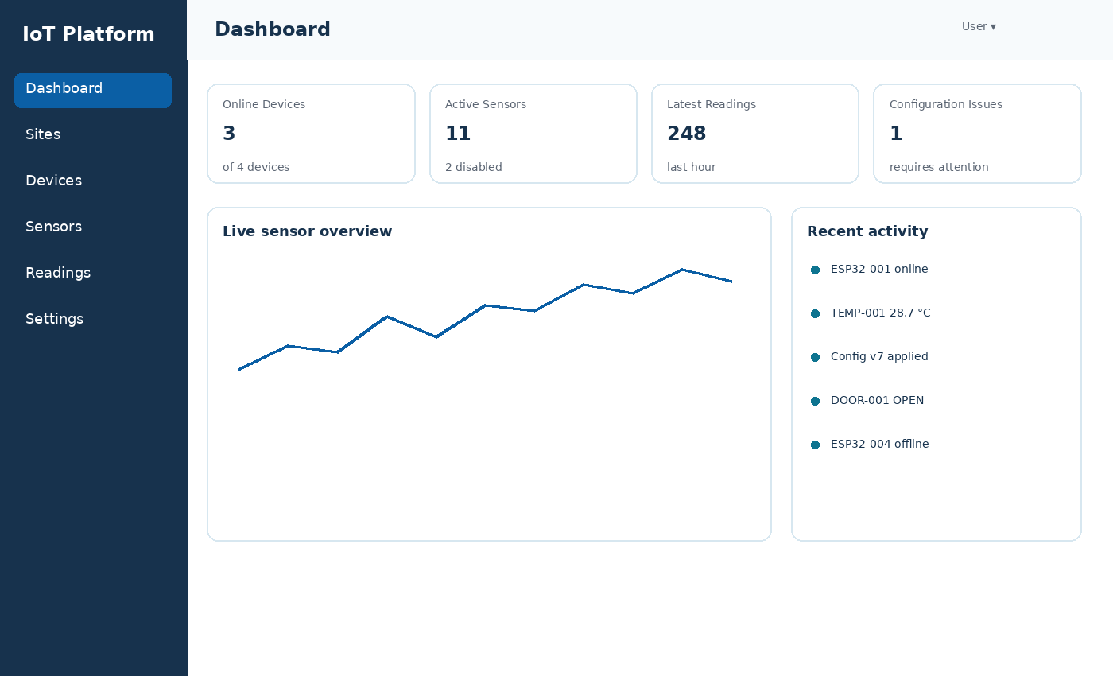
The dashboard focuses on health and recency. It avoids presenting every sensor at once; users can drill into Devices or Sensors for detail.

5. Devices Screen
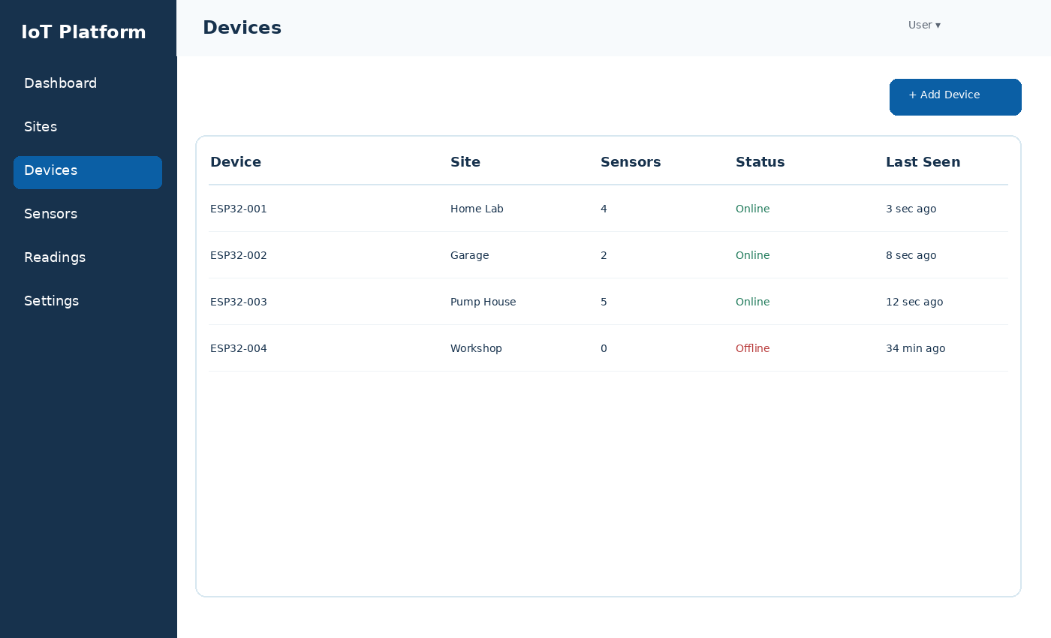
Element | Behaviour
Search/filter | Filter by device name/UID, site and online status.
Status | Online when heartbeats are recent; Offline when heartbeat timeout is exceeded.
Last seen | Use relative time with exact timestamp on hover/detail.
Add Device | Opens device registration flow and credential provisioning.
View | Navigates to device detail without requiring separate edit mode.
Pagination | Default to 25 items per page with page-size control; preserve filters when moving between pages.

6. Device Detail Screen
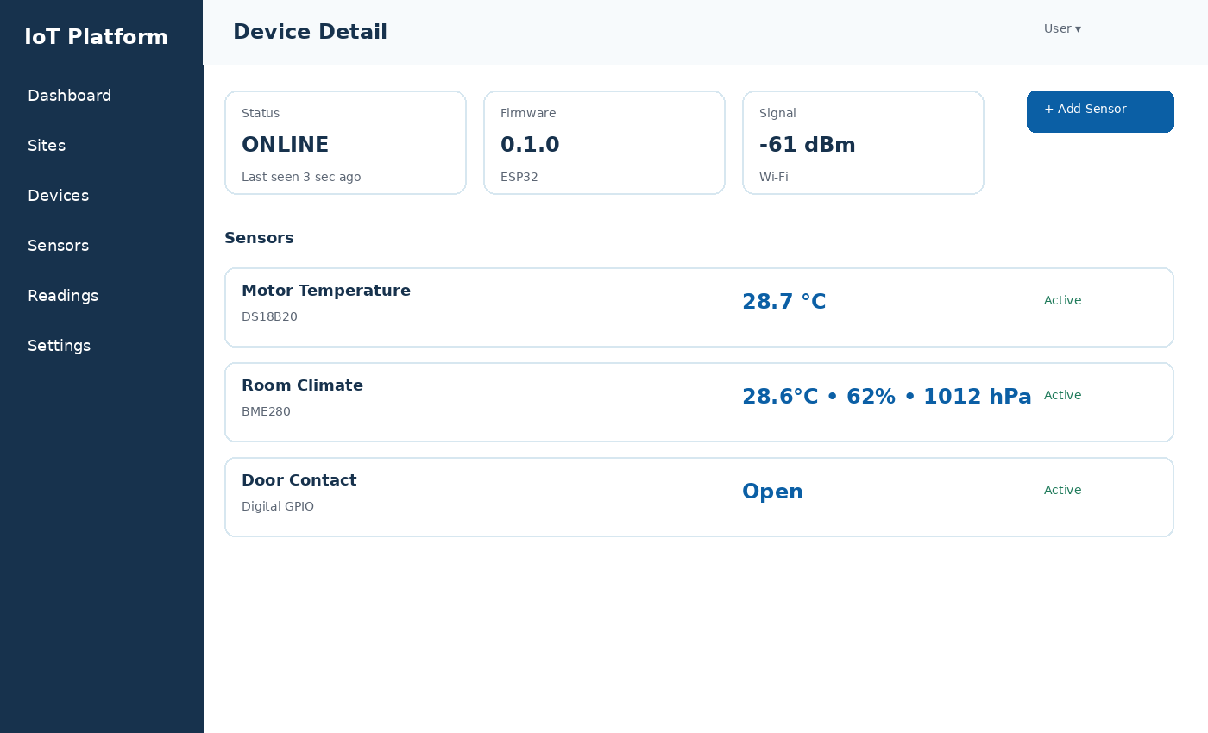
Device detail is the operational home for attached sensors. It should show connection state, device metadata and a sensor list with current values. Add Sensor is the primary action.

7. Add Sensor Wizard
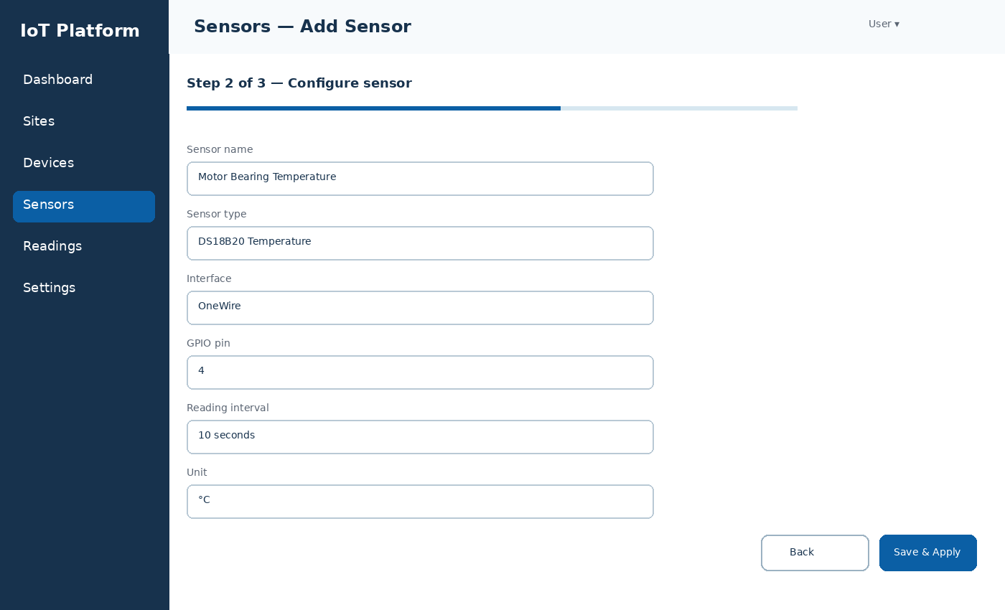
Step | Content | Validation
1 — Select Type | Sensor type, short description, interface and measurement type. | Only active supported types may be selected.
2 — Configure | Name and dynamic connection/configuration fields generated from the selected sensor type JSON Schema (for example GPIO pin, I2C address or sample interval). | Client-side guidance mirrors the JSON Schema; backend validation remains authoritative.
3 — Review & Apply | Summary of device, sensor type and configuration. | User confirms; platform creates configuration version and publishes it.

8. Sensor Detail & Readings
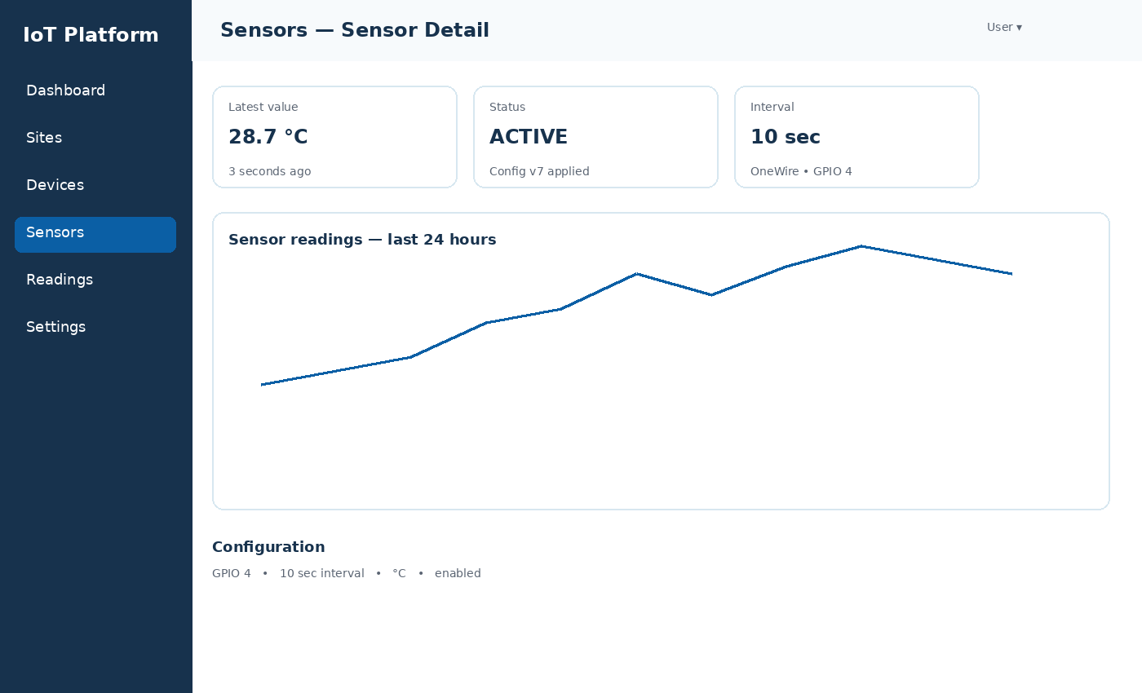
- Latest value cards include measurement name, value, unit and freshness timestamp; multi-measurement sensors can show several current values.
- Status card distinguishes Active, Disabled, Configuring and Configuration Failed.
- Readings chart defaults to a practical recent period, supports explicit date/time selection, and allows measurement-channel selection for multi-measurement sensors. Historical requests are bounded and use cursor continuation when more rows are available.
- Configuration summary shows the active configuration version and key fields.
- Edit Configuration creates a new version rather than overwriting audit history.

9. Key States and Feedback
State | Visual treatment | User guidance
Online | Green status indicator; last seen recent. | Normal operation.
Offline | Red indicator with last seen time. | Check power/network; configuration cannot be confirmed until device reconnects.
Configuring | Blue progress/state indicator. | Saved on server; waiting for device acknowledgement.
Configuration Failed | Red warning with reason. | Correct invalid pin/address/driver setting and re-apply.
No readings yet | Neutral empty state. | Explain that configuration is active but the platform has not received a reading.
Disabled | Muted status. | Historical data remains visible; no current readings expected.

10. Form Design Rules
- Use labels above fields; do not rely on placeholders as labels.
- Show units next to numeric inputs and provide sensor-type defaults.
- Only show interface-specific fields relevant to the chosen sensor type.
- Display validation errors next to the field and preserve entered values.
- Clearly separate Save configuration from Apply configuration only if those become distinct product actions later; for MVP use Save & Apply.
- Warn before disabling or archiving a sensor, but do not overuse confirmation dialogs.

11. Responsive Behaviour
Viewport | Behaviour
Desktop ≥ 1200 px | Persistent sidebar; multi-column KPI cards; full device/sensor tables.
Tablet 768–1199 px | Collapsible sidebar; KPI cards wrap; tables may horizontally scroll or reduce columns.
Mobile < 768 px | Drawer navigation; cards stacked; device and sensor list presented as responsive cards; configuration wizard uses single-column forms.

12. MVP Component Inventory
Component | Reusable purpose
AppShell | Sidebar, header, content area and responsive navigation.
StatusBadge | Consistent device/sensor state styling.
MetricCard | Dashboard and detail KPIs.
DataTable | Devices, sensors and reading tables with pagination/filtering.
SensorTypeCard | Sensor type selection.
DynamicConfigForm | Renders fields from sensor configuration schema.
ReadingChart | Time-series chart with measurement selector, unit and range controls.
EmptyState | No devices, no sensors or no readings guidance.
ConfirmDialog | Disable/archive actions.
Toast/Alert | Success/error feedback after configuration actions.

13. Accessibility & Usability Requirements
- Do not rely on colour alone for status; include labels/icons.
- Keyboard access for navigation, forms and dialogs.
- Visible focus states and meaningful form error messages.
- Charts must also expose values through an accessible table or data view.
- Use readable contrast and minimum touch targets for mobile use.

14. V0.1.1 Interaction Standards
- Role-aware UI: ADMIN sees administrative actions; USER sees permitted create/edit actions; VIEWER sees read-only controls and cannot mutate records.
- Time display: API timestamps remain UTC; the React client renders them in the user/device context using localised date/time formatting and can expose the exact UTC value where useful.
- Pagination: site/device/sensor tables use page-based pagination; telemetry tables/charts use bounded time-range requests with cursor continuation.
- Dynamic configuration forms are generated from the platform-approved JSON Schema subset rather than a custom ad-hoc schema format.
- Sensor configuration history is presented as versions; editing creates a new version rather than overwriting an applied configuration.

