JobScheduler System Design Architecture
Question 2: Local C#/.NET 10 implementation
1. Overview
The implemented JobScheduler application uses a local C#/.NET 10 architecture with an ASP.NET Core API, a console client, background workers, in-memory persistence, task handlers, generated time-series data, generated PDF reports, and console-based email delivery. The design keeps the implementation self-contained for the practical test while preserving production-style interfaces that can later be connected to a real time-series database, durable job store, SMTP provider, and recurring schedule engine.
2. Architecture Diagram

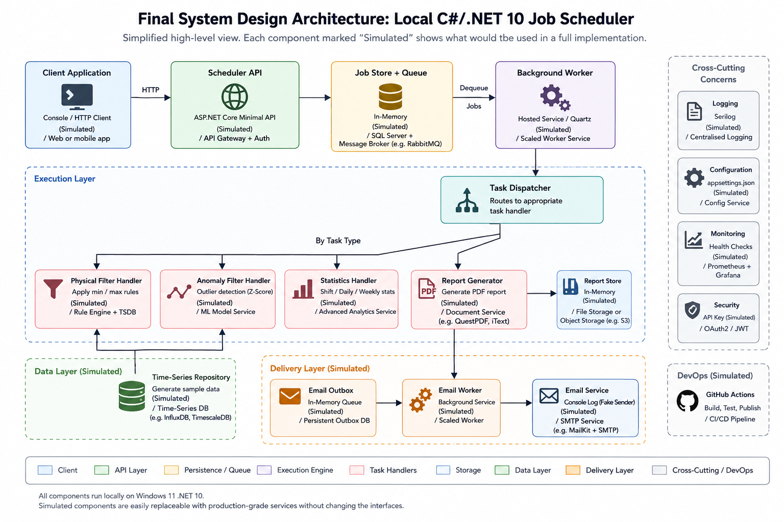
Figure 1: Implemented local .NET 10 JobScheduler architecture.
3. Component Responsibilities
Component | What It Does | How It Works | Reason
Console Client | Submits jobs and polls status. | Scheduler.Client sends HTTP requests to the API and displays job results. | Demonstrates network-based job arrival from a client application.
Scheduler API | Receives, validates, accepts, lists, and queries jobs. | Scheduler.Api exposes the job, health, and report download endpoints. | Keeps the network boundary separate from scheduling and processing.
Job Orchestrator | Coordinates job creation and retrieval. | Creates job records, updates status, and queues work. | Centralizes application workflow without placing business logic in controllers.
Store + Queue | Stores jobs, statuses, and queued work. | Uses in-memory repositories and queue implementations. | Keeps the test self-contained while preserving replaceable interfaces.
Background Worker | Processes queued jobs asynchronously. | Dequeues jobs, resolves handlers, runs tasks, and records results. | Prevents API calls from blocking while jobs execute.
Task Dispatcher | Routes each task to the correct handler. | TaskHandlerRegistry maps TaskType values to ITaskHandler implementations. | New task types can be added without changing the scheduler core.
Mock Data + Static Rules | Provides generated historical data and filtering rules. | MockTimeSeriesRepository and StaticFilteringRuleProvider stand in for external services. | Avoids external database setup while keeping realistic abstractions.
Physical Filter | Removes physically impossible values. | Applies static min/max limits to time-series points. | Demonstrates variable-specific physical filtering.
Anomaly Filter | Removes outliers. | Uses a z-score based anomaly filter. | Provides a simple, explainable anomaly strategy.
Statistics | Calculates shift, daily, and weekly metrics. | Calculates count, min, max, average, uptime, and target-range percentage. | Demonstrates the required statistics task without real plant data.
PDF Report | Generates report output. | FakeReportGenerator creates a minimal valid PDF document. | Avoids PDF library setup while still producing downloadable PDF output.
Report Store | Stores generated reports. | InMemoryReportStore stores PDF bytes by job ID. | Supports GET /api/jobs/{id}/report/download.
Email Outbox + Worker | Queues and processes report emails. | InMemoryEmailOutbox and EmailOutboxWorker handle asynchronous delivery requests. | Separates report generation from email delivery.
Email Service | Simulates email delivery. | ConsoleEmailService logs send attempts and attachment presence. | Avoids SMTP credentials while preserving IEmailService.
Tests + CI/CD | Verifies behavior automatically. | xUnit tests and GitHub Actions restore, build, test, and publish. | Shows development process discipline.

4. Job Lifecycle and Processing Flow
1. A client submits a job to POST /api/jobs.
2. The API validates the request using JobRequestValidator.
3. JobOrchestrator creates a job record with status Queued.
4. The job and current status are stored in the in-memory repositories.
5. The job is placed on InMemoryJobQueue.
6. The API returns 202 Accepted with the job identifier and status URL.
7. BackgroundJobWorker dequeues the job and marks it Running.
8. For each task, the worker creates a JobContextDto.
9. TaskHandlerRegistry resolves the handler for the task type.
10. Handlers read generated historical data and execute filtering, anomaly detection, statistics, or reporting logic.
11. Report jobs create a PDF, save it to InMemoryReportStore, and queue an email request.
12. EmailOutboxWorker dequeues email requests and ConsoleEmailService logs the send attempt.
13. The worker records task summaries and marks the job Completed or Failed.
14. The client polls GET /api/jobs/{id}; report jobs can download the PDF from GET /api/jobs/{id}/report/download.
5. Implemented API Contract
Endpoint | Purpose
POST /api/jobs | Submits a new job and returns 202 Accepted with jobId, status, and statusUrl.
GET /api/jobs | Lists current jobs and their statuses.
GET /api/jobs/{id} | Returns status and result details for a job.
POST /api/jobs/{id}/cancel | Returns a cancellation acknowledgement.
GET /api/jobs/{id}/report/download | Downloads the generated PDF report for a report job.
GET /health | Confirms API health.
6. Key Interfaces and Extension Points
- IJobOrchestrator coordinates job submission and status retrieval.
- IJobRepository and IJobStatusRepository isolate persistence from application logic.
- IJobQueue decouples API submission from background execution.
- ITaskHandler and TaskHandlerRegistry route each TaskType to its implementation.
- ITimeSeriesRepository abstracts the time-series database.
- IFilteringRuleProvider abstracts physical limits and anomaly rule lookup.
- IReportGenerator and IReportStore separate report creation from report retrieval.
- IEmailOutbox and IEmailService separate report generation from email delivery.

7. Interface Folder Map
Concern | Interface Location | Current Implementation
Job submission and status | Scheduler.Application/Orchestration/IJobOrchestrator.cs | Scheduler.Application/Orchestration/JobOrchestrator.cs
Job persistence | Scheduler.Application/Interfaces/Repositories/IJobRepository.cs | Scheduler.Infrastructure/Repositories/InMemoryJobRepository.cs
Job status persistence | Scheduler.Application/Interfaces/Repositories/IJobStatusRepository.cs | Scheduler.Infrastructure/Repositories/InMemoryJobStatusRepository.cs
Background queue | Scheduler.Application/Interfaces/Queue/IJobQueue.cs | Scheduler.Application/Queue/InMemoryJobQueue.cs
Task dispatch | Scheduler.Application/Interfaces/Handlers/ITaskHandlerRegistry.cs | Scheduler.Application/Handlers/TaskHandlerRegistry.cs
Task execution contract | Scheduler.Application/Interfaces/Handlers/ITaskHandler.cs | Scheduler.Application/Handlers/*Handler.cs
Time-series data access | Scheduler.Application/Interfaces/Repositories/ITimeSeriesRepository.cs | Scheduler.Infrastructure/Repositories/MockTimeSeriesRepository.cs
Physical filtering rules | Scheduler.Application/Interfaces/Services/IFilteringRuleProvider.cs | Scheduler.Infrastructure/Services/StaticFilteringRuleProvider.cs
Physical filtering service | Scheduler.Application/Interfaces/Services/IPhysicalFilterService.cs | Scheduler.Infrastructure/Services/FakePhysicalFilterService.cs
Anomaly filtering service | Scheduler.Application/Interfaces/Services/IAnomalyFilterService.cs | Scheduler.Infrastructure/Services/FakeAnomalyFilterService.cs
Statistics calculation | Scheduler.Application/Interfaces/Services/IStatisticsService.cs | Scheduler.Infrastructure/Services/FakeStatisticsService.cs
PDF generation | Scheduler.Application/Interfaces/Services/IReportGenerator.cs | Scheduler.Infrastructure/Services/FakeReportGenerator.cs
Report storage/download | Scheduler.Application/Interfaces/Services/IReportStore.cs | Scheduler.Infrastructure/Services/InMemoryReportStore.cs
Email outbox | Scheduler.Application/Interfaces/Services/IEmailOutbox.cs | Scheduler.Infrastructure/Services/InMemoryEmailOutbox.cs
Email delivery | Scheduler.Application/Interfaces/Services/IEmailService.cs | Scheduler.Infrastructure/Services/ConsoleEmailService.cs
Processing mode configuration | Scheduler.Application/Interfaces/Configuration/ISchedulerProcessingModeProvider.cs | Scheduler.Infrastructure/Configuration/SchedulerProcessingModeProvider.cs

8. Assumptions for This Implementation
Assumption | Reason
Jobs are submitted over HTTP to a local ASP.NET Core API. | This satisfies the requirement that jobs arrive over the network from a client application.
Persistence is in-memory. | The solution is self-contained for assessment; repository interfaces allow durable storage later.
The time-series database is simulated. | No external TSDB setup is required; MockTimeSeriesRepository acts as a future adapter seam.
Physical filtering rules are static. | This demonstrates per-variable limits without requiring a rules database.
Anomaly detection uses z-score filtering. | It is simple, explainable, and suitable for a prototype.
PDF generation uses an internal minimal PDF generator. | This avoids extra package setup while producing a real downloadable PDF file.
Email delivery is simulated through logging. | No SMTP credentials are required, but the IEmailService contract can be replaced with SMTP later.
Recurring report schedules are represented architecturally, not fully implemented. | The current implementation supports queued report jobs and email outbox processing; cron/calendar scheduling is a future extension.
CI/CD uses GitHub Actions. | This matches the repository submission process and demonstrates automated restore/build/test.
9. Summary
The implemented system supports network job submission, background execution, task dispatching, generated historical time-series data, physical filtering, anomaly filtering, statistics, PDF report generation, report download, email outbox processing, status polling, unit tests, integration tests, and CI/CD. External infrastructure such as a real time-series database, SMTP server, durable job store, and recurring schedule engine is intentionally abstracted behind interfaces so the solution remains easy to build and run for assessment.
10. AI Declaration
AI coding assistance was used during development of this submission. The generated output was reviewed, adapted, tested, and accepted by the author.

