From Working Sets to AI Inference:
Virtual Memory, Filesystems, and Data Movement in Modern Systems
  - Green Sheet Final Report
This report synthesizes six paper analyses and one measurement study to examine how operating systems manage memory, storage, and data movement under modern AI-like workloads.

1. Introduction
This project studies a classic operating systems problem that has become newly important in the age of artificial intelligence: how a system moves data efficiently when the active workload is large, long-lived, and only partly local. Traditional virtual memory was designed around paging, locality, and the assumption that the operating system can keep the currently useful pages in physical memory while pushing the rest away. That model still matters, but modern workloads such as large language model inference stress it in unusual ways. Model weights are large and persistent, key-value caches grow during generation, and background file access can compete with inference for bandwidth, cache space, and kernel attention.
The six papers supplied for this project trace an intellectual path from foundational memory theory to current AI systems practice. Peter Denning’s working set model provides the central lens: performance depends not on virtual memory in the abstract, but on whether the actively used footprint fits the available resources. VAX/VMS shows how a real operating system translated that principle into policy. Later work questions whether paging is still the right abstraction for all workloads, while recent AI systems papers show that the main bottleneck often shifts from address translation to data movement, shared bandwidth, and scheduling across heterogeneous hardware.

Project sources and their contribution
Paper | Core idea | Why it matters for this measurement
The Working Set Model for Program Behavior | Working set as quantitative memory demand | Provides the main theory for interpreting locality, overcommitment, and thrashing.
Virtual Memory Management in the VAX/VMS Operating System | Pager, swapper, clustering, resident-set control | Shows how VM policy is shaped by hardware limits and mixed workloads.
Efficient Virtual Memory for Big Memory Servers | Direct segments bypass unnecessary paging overhead | Questions whether page-based translation matches large stable regions.
Tidying Up the Address Space | Hotness fragmentation and object-level layout repair | Shows that memory inefficiency can come from layout, not only replacement policy.
FlexGen | LLM inference is limited by tiered data movement | Reframes the problem from translation overhead to bandwidth and placement.
μAgent | SoC inference needs flow-aware heterogeneous scheduling | Connects memory behavior to scheduling and shared-memory contention in AI systems.

2. Literature Synthesis

2.1 Working sets, system demand, and the limits of virtualization
Denning’s working set model is the most important foundation for this project. Its key claim is that memory management and scheduling should not be treated as separate problems. A running process creates processor demand, but it also creates memory demand, and the working set is the best approximation of that demand. Instead of trying to guess the next page reference exactly, the operating system tracks the pages referenced in the recent past and estimates how many pages the process currently needs. The major lesson is simple but powerful: if the active working sets of the system do not fit in memory, no clever page replacement policy can save performance. In that case, the failure is not a poor eviction choice but a resource-allocation problem.
This argument remains relevant because it restores physical limits to the center of the discussion. Virtual memory can create the illusion of abundance, but it cannot remove the cost of moving data. That insight is especially useful for AI workloads. During local inference, model weights, caches, and file-backed activity can coexist in the same machine. The question is not merely whether the address space is valid, but whether the hot footprint and the streaming footprint can coexist without forcing expensive interference.

2.2 VM policy in practice: VAX/VMS
The VAX/VMS paper shows what it looks like when these principles are turned into operating system policy under tight hardware constraints. The system had to run on small memories, weak processors, and slow moving-head disks while still supporting mixed workloads such as timesharing, batch jobs, and more interactive activity. Its design therefore separated responsibilities between a pager, which handled per-process page faults, and a swapper, which managed coarser control of global memory pressure. The paper emphasizes several concerns that still matter today: fairness, startup cost, disk pressure, and CPU overhead inside the memory-management subsystem itself.
What stands out is the system’s disciplined use of locality. VAX/VMS limited each process to its own resident-set policy rather than allowing a globally faulting process to evict everyone else’s pages. It also used free and modified page lists as a cache of recently removed pages, and it relied on clustered I/O to amortize disk seeks. The larger lesson is not that these exact policies should be copied today, but that VM design is always shaped by the real bottlenecks of the machine. Memory management is part of a hierarchy that connects processor cost, I/O latency, and workload behavior.

2.3 When paging no longer matches the workload
Two later papers push the critique further. Efficient Virtual Memory for Big Memory Servers argues that page-based translation is not always the right abstraction for modern large-memory workloads. If a workload uses large contiguous regions that are stable over time and do not need fine-grained page protection or frequent remapping, then the flexibility of paging becomes overhead. The proposed direct segment idea bypasses TLB lookups for a large contiguous region while preserving paging elsewhere. In the student analysis attached to this project, the most interesting extension is to LLM inference: model weights and KV caches look like large, persistent regions that may not benefit from the full generality of page-based virtual memory.
Tidying Up the Address Space reaches a similar conclusion from a different angle. It argues that the problem is often not only replacement policy but memory layout. The operating system manages pages, while applications use objects, and hot and cold objects can end up mixed together in the same page. This 'hotness fragmentation' makes it difficult for the OS to reclaim memory cleanly. HADES addresses the issue by reorganizing object layout so that hot and cold data are separated into different regions. The striking result is that the system needs no OS changes; it changes the input to the OS so that existing page-based mechanisms work better. This is an important reminder that working-set behavior is partly a property of program layout, not just page-fault policy.

2.4 AI systems as a new memory-and-scheduling problem
The final two papers show why these ideas matter for AI systems. FlexGen examines LLM inference on a single GPU and makes a crucial distinction: the central bottleneck is often not address translation but data movement between GPU memory, CPU memory, and disk. When a model and its KV cache cannot fit entirely in VRAM, the system becomes an exercise in careful placement and transfer scheduling. FlexGen therefore focuses on throughput, tensor placement, and I/O-efficient scheduling rather than on classical VM overhead alone.
μAgent extends the discussion to heterogeneous system-on-chip machines. In those systems, CPUs, integrated GPUs, and NPUs share physical memory, so performance depends heavily on contention in shared bandwidth and on the scheduling of different inference stages. The paper distinguishes between compute-heavy prefill and memory-bound decode, then assigns work to different accelerators and uses flow-aware scheduling to prioritize latency-sensitive tasks. This is an OS problem in modern form: deciding how memory-intensive and compute-intensive work should share a constrained machine. Together, FlexGen and μAgent show that AI systems have not made OS ideas obsolete. They have made them broader, because the bottleneck now spans virtual memory, page cache behavior, data movement across tiers, and scheduler policy.

3. Measurement Study

3.1 Experimental design
Experiments were conducted on a Windows 11 Pro system using a Lenovo Legion R9000P ARX8 equipped with an AMD Ryzen 9 7945HX, 95.69 GiB RAM (DDR5-5200), and an NVIDIA GeForce RTX 4060 Laptop GPU (8 GB VRAM). The inference stack used Ollama v0.19.0 serving the local Qwen3 4B model (qwen3:4b, GGUF, Q4_K_M). Inference was executed with fixed settings (num_predict=64, temperature=0.0, stream=false; other parameters at defaults), using a constant prompt (“Explain in 3 short paragraphs why locality matters in operating systems,” 24 tokens), which consistently produced 64 output tokens per request. Each condition consisted of 60 measured requests (3 trials × 20 requests), following a single warm-up request and a 2 s stabilization period. Page-fault counts were collected via the Windows GetProcessMemoryInfo API (PROCESS_MEMORY_COUNTERS.PageFaultCount). Background pressure was generated by a sequential file-scanning workload over a 143.53 GiB preallocated file, read in 4 MiB chunks in a continuous loop, applying file-backed pressure from 0.10× to 1.50× of system memory during inference.
Rather than instrumenting the kernel directly, I observed externally visible indicators: end-to-end inference latency, total page-fault counts, and disk I/O. The workload held the inference request constant while introducing controlled filesystem pressure through a sequential file-scanning background task. This created two broad conditions: a baseline with no pressure, and file_seq runs with increasing file-backed pressure from 0.10x to 1.50x RAM. Each condition was repeated for 60 requests, and the reported metrics focused on median latency and p95 latency.
This setup was designed to test a narrow but important question: when a local inference service shares the machine with file-backed streaming work, does performance degrade because the system enters a Denning-style working-set collapse, or because it enters a more stable regime of cache and I/O contention? Windows limited the analysis because it exposes only total page-fault counts rather than a clean breakdown into minor and major faults. Even so, the combination of latency, fault counts, and read volume was sufficient to distinguish between a collapse model and a steady streaming model.

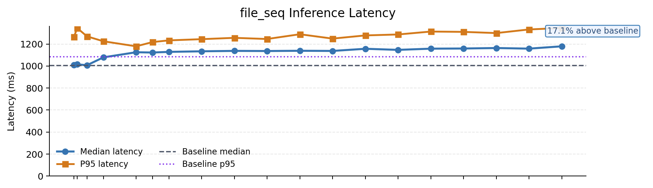
Figure 1. Inference latency rises as file_seq pressure increases. The slope is monotonic but gradual, not catastrophic.

3.2 Results
The baseline median latency was 1002.25 ms. Under file-backed sequential pressure, latency increased immediately: 1078.87 ms at 0.10x RAM, 1146.93 ms at 1.00x RAM, and 1173.99 ms at 1.50x RAM. This means the overall median slowdown reached about 17.1 percent at the highest reported pressure level. Importantly, most of the slowdown appeared early. The results summary notes that degradation was front-loaded, with the largest relative jump occurring at low pressure and then tapering into a flatter curve.
Tail latency followed the same pattern. The p95 latency rose from 1058.09 ms at baseline into the 1300 ms range under higher pressure. The page-fault results revealed a very different shape from the latency curve. Baseline runs showed only about six faults, while file_seq runs jumped into a narrow band around 29,444 to 29,572 faults and then remained there. Disk reads also increased under pressure, reaching up to about 85.93 GiB in the larger file_seq runs. Together, these measurements show an immediate transition into file-backed streaming activity, but not a continually worsening explosion in faults.
Representative measurements
Condition | Median latency | Delta vs baseline | Fault / I/O note
Baseline | 1002.25 ms | - | ~6 page faults
file_seq, 0.10x RAM | 1078.87 ms | +7.6% | Immediate entry into high-fault streaming regime
file_seq, 1.00x RAM | 1146.93 ms | +14.4% | Fault count stays near 29.5K; p95 in 1300 ms range
file_seq, 1.50x RAM | 1173.99 ms | +17.1% | Read volume can reach ~85.93 GiB

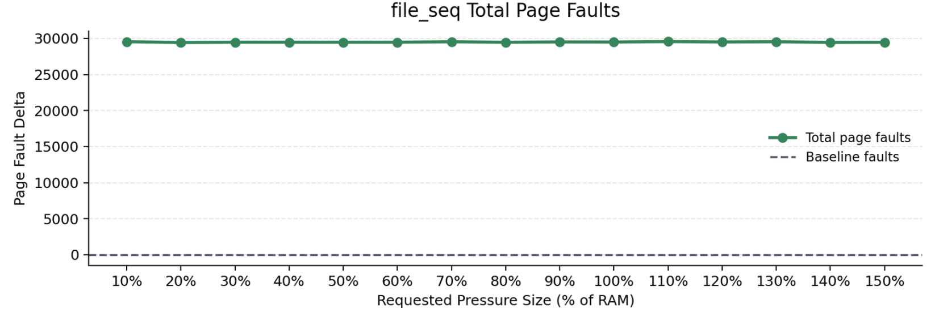
Figure 2. Page faults show a step change after introducing file-backed streaming, then remain roughly stable rather than scaling with pressure size.

3.3 Interpretation
These results support a cache-and-I/O contention explanation more strongly than a classic thrashing explanation. In Denning’s framework, a true working-set collapse should produce a sharper performance breakdown: repeated reloading of needed pages, escalating fault costs, and a more dramatic increase in latency as pressure grows. That is not the pattern observed here. Instead, the system entered a high-fault regime quickly and then remained in that regime while latency increased only gradually.
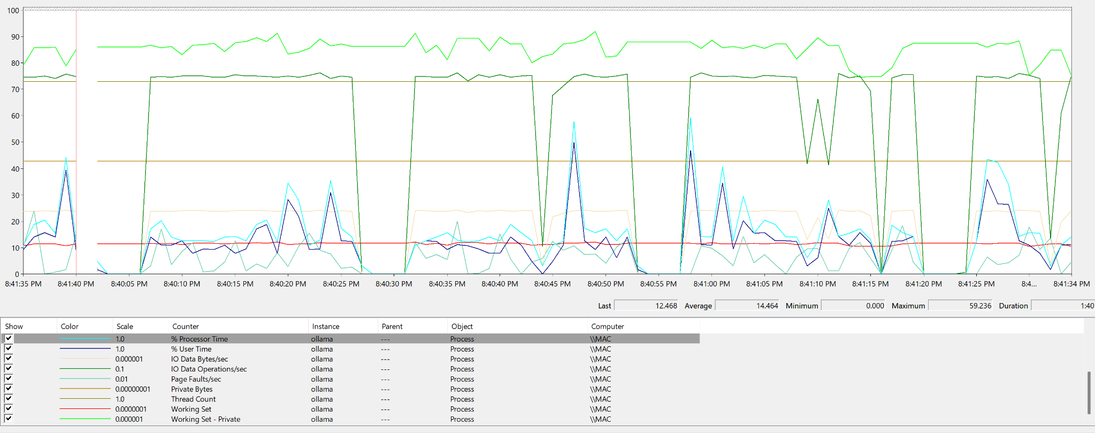
Figure 3. Process-level PerfMon trace for ollama across repeated experiment conditions. CPU and process I/O activity appear in short bursts aligned with each condition, while Private Bytes and Working Set remain stable. The pattern suggests gradual latency growth from shared-resource contention rather than repeated eviction and reloading of the model working set.
At the process level, PerfMon traces for ollama showed a repeated burst pattern aligned with the execution of individual experimental conditions. CPU activity (% Processor Time and % User Time) rose in short spikes during inference, but remained well below sustained saturation, indicating that the service was intermittently active rather than continuously compute-bound. Process I/O counters also oscillated with each condition, showing repeated bursts of data movement during inference under pressure. In contrast, Private Bytes and Working Set remained broadly stable across the run, indicating that the model’s allocated and resident footprint did not collapse or require repeated reloading. Page Faults/sec was bursty but bounded rather than continuously increasing. Taken together, these process-level measurements suggest that the latency increase was not caused by catastrophic working-set thrashing inside Ollama itself.
System-level PerfMon counters point to a different mechanism. Under increasing file-backed background pressure, Page Reads/sec, Pages/sec, and disk activity rose together, while Available MBytes remained broadly stable and Processor Queue Length stayed low. This pattern indicates that the machine was servicing substantial file-backed page-ins and storage-path traffic without entering a full CPU or memory collapse. In other words, the operating system continued to keep the model’s hot footprint resident, but inference still incurred additional waiting on shared cache, memory, kernel I/O, and disk services.
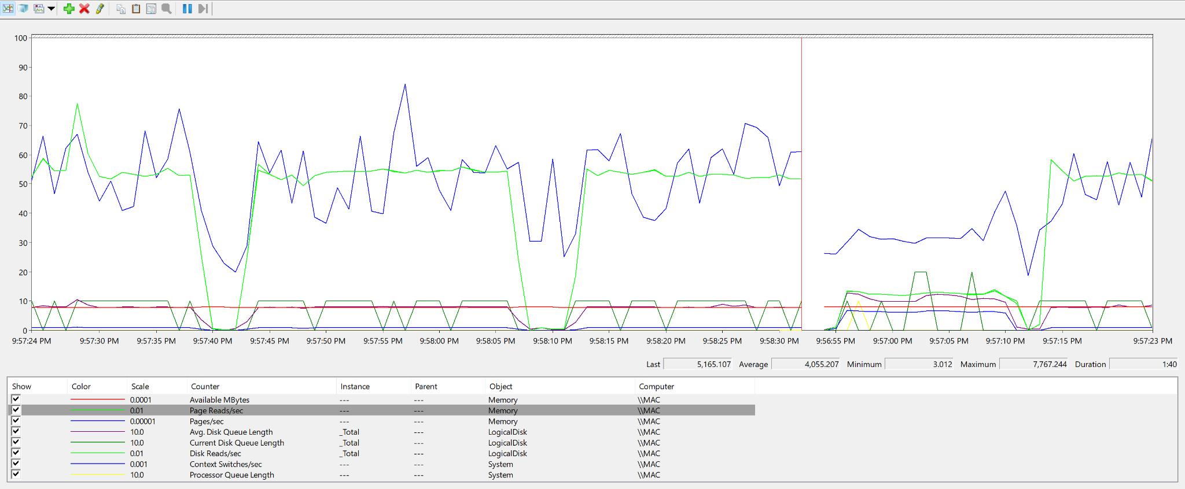
Figure 4. System-level PerfMon trace under file-backed pressure. Page Reads/sec, Pages/sec, and disk activity rise together while Available MBytes remains broadly stable, indicating file-backed page-in and storage-path contention rather than a catastrophic memory collapse.
The simplest interpretation is therefore that sequential file streaming created sustained competition for shared resources without fully destabilizing the inference service’s active footprint. The slowdown arose from page-cache churn, file-backed page-in activity, and contention along the memory–storage path, rather than from repeated eviction and reloading of the model itself. This explains why latency rose immediately once pressure was introduced, yet continued to increase only gradually as pressure grew: the system had entered a stable but more expensive operating regime, not a catastrophic thrashing collapse.
This result refines the working-set story rather than rejecting it. The experiment suggests that modern local AI inference can suffer meaningful slowdown before the system reaches an obvious thrashing event. The active inference set may still fit well enough to avoid collapse, while cold or streaming file-backed activity consumes bandwidth, page-cache attention, and storage service time in the background. That pattern matches the distinction suggested by the literature: some overheads come from replacement policy or translation, but a growing share comes from how the system moves data through the hierarchy.

4. Discussion
Taken together, the papers and the measurement study point to a broader conclusion. Operating systems are still solving the same fundamental problem they faced in earlier decades: limited physical resources must be shared across workloads with different locality and timing behavior. What has changed is the shape of the workloads. In classic VM studies, the main fear was that active pages would not fit, causing thrashing. In modern AI systems, the danger is often more layered. A machine may avoid full thrashing yet still lose a noticeable fraction of performance to bandwidth pressure, page-cache churn, long-lived hot regions, and scheduler interference between reactive and background work.
This synthesis also helps separate two kinds of system misfit. The first is abstraction misfit: paging may be too flexible and too expensive for large contiguous regions, as argued by direct segments. The second is layout misfit: even with the same abstraction, hot and cold data may be packed together in ways that make the working set look larger than it really is, as HADES demonstrates. AI systems then add a third layer: tier and accelerator misfit, where the main challenge becomes moving data across GPU memory, CPU memory, disks, or shared SoC memory at the right time and in the right order.
My measurement study fits best into this third perspective. The results do not show an OS that completely fails once memory pressure crosses a threshold. Instead, they show an OS that keeps working, but at the cost of shared-resource contention that is visible in latency. This is an important practical lesson for ML systems work. A local inference service can remain functional while suffering meaningful quality-of-service degradation from background streaming access. That means system evaluation should look beyond binary success or failure and measure how bandwidth, cache behavior, and scheduler decisions shift latency under realistic mixed workloads.

4.1 Computation Affinity Across Accelerators
Besides memory behavior, AI systems also depend on computation affinity across accelerators. The figures below show that inference is not one uniform workload. Different stages expose different operator mixes and different arithmetic-intensity regimes, so the best backend depends on which phase of inference is running rather than on the model as a whole.
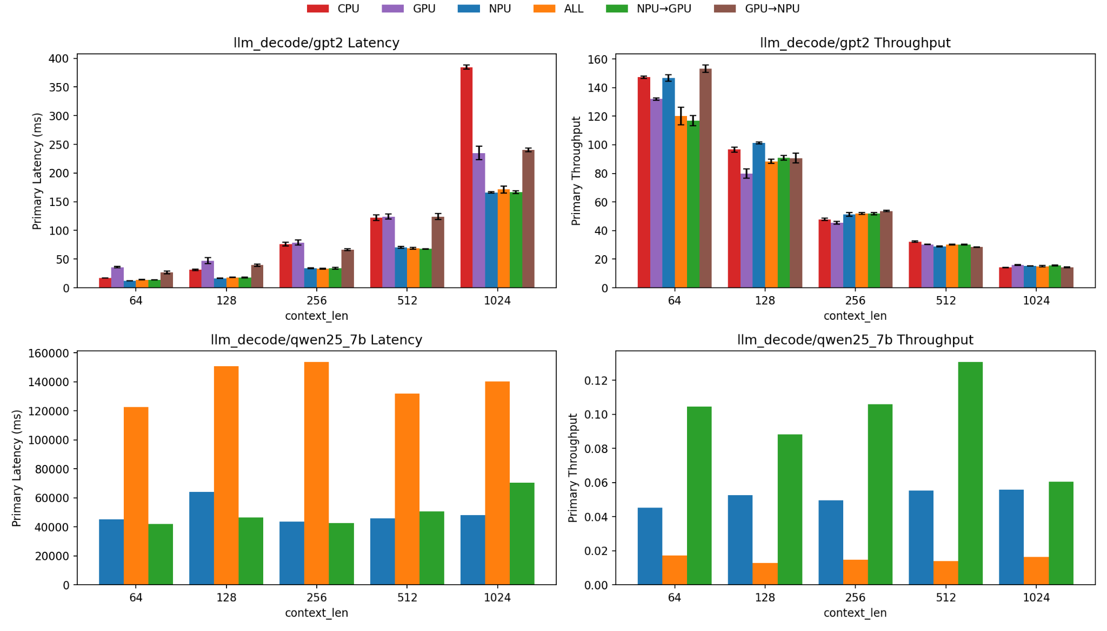
Figure 5. Decode latency and throughput across accelerators. GPT-2 decode shows that CPU latency rises fastest as context length grows, while hybrid mappings keep latency lower and throughput more stable. For Qwen2.5-7B, the difference is sharper: the NPU→GPU path clearly outperforms single-backend and ALL placements, showing that decode efficiency depends strongly on stage placement.
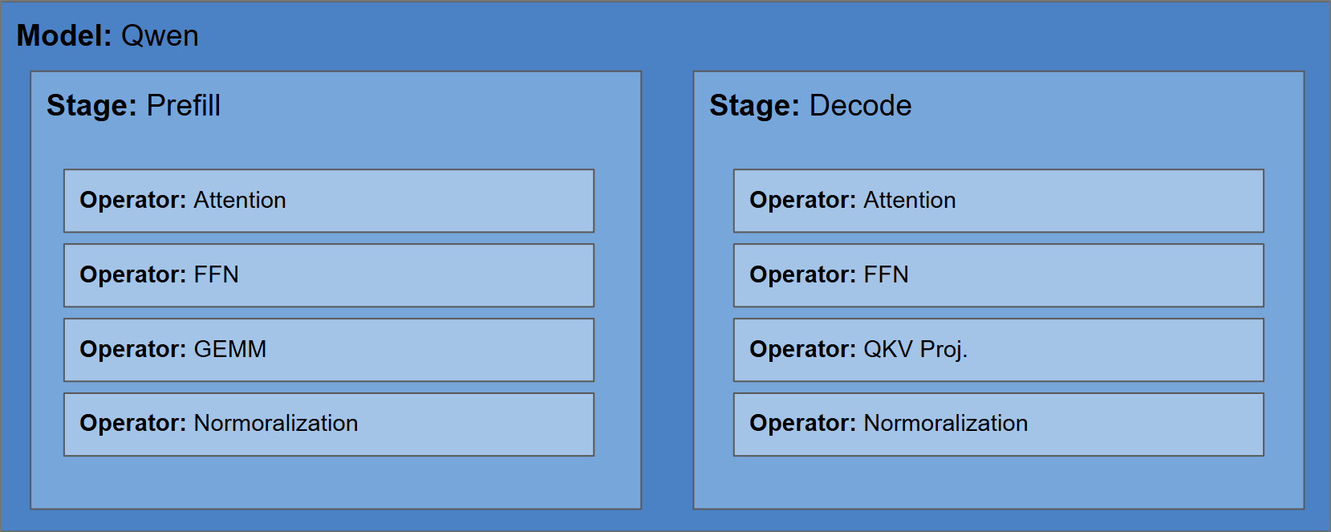
Figure 6. Stage decomposition of Qwen inference. Prefill contains attention, FFN, GEMM, and normalization, while decode contains attention, FFN, QKV projection, and normalization. The split shows that inference is a sequence of stages with different computational structure rather than a single homogeneous workload.
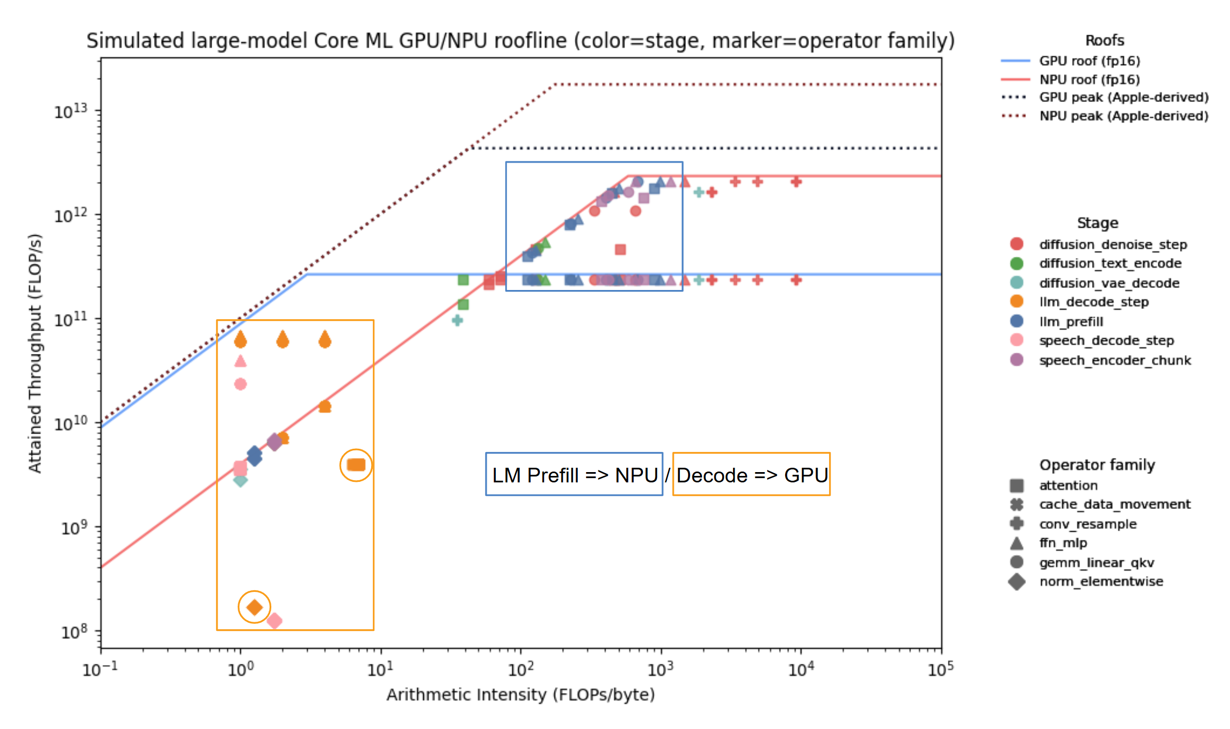
Figure 7. GPU/NPU roofline with stage and operator-family placement. Higher-intensity prefill operators cluster in a regime that matches the NPU better, while lower-intensity decode operators sit in a more memory-sensitive regime that aligns better with the GPU. The pattern supports stage-aware placement rather than sending the entire model to one accelerator.
Together, these figures suggest that efficient AI systems need both memory-aware data management and stage-aware accelerator mapping. In other words, data movement and computation affinity should be analyzed together, because performance depends on matching each phase of inference to the hardware that fits it best.

5. Conclusion
This project began as a study of virtual memory and filesystems, but it ended as a study of how operating systems evolve when the cost of moving data becomes the defining performance constraint. Denning’s working set model remains the clearest conceptual anchor because it explains why locality and resource demand cannot be ignored. VAX/VMS shows how those ideas became concrete policy in a real system. Later papers reveal that paging alone is no longer the whole story: some workloads are too stable and too contiguous for page-based translation to be ideal, some programs hide their true hotness behind poor object layout, and AI systems often run into bandwidth and scheduling limits before they hit classical VM collapse.
The measurement study supports that conclusion. Under file-backed sequential pressure, local LLM inference slowed down noticeably, but the system did not exhibit a catastrophic thrashing point. Instead, it entered a stable streaming regime in which page faults stayed high but bounded and latency grew gradually. For modern AI-like workloads, then, the relevant question is not only whether the operating system can virtualize memory, but how well it can coordinate hot footprints, cold streams, cache space, and shared bandwidth. That is the connective thread across all of the papers in this project, and it is the main lesson I will carry forward from the course.

References
Basu, A., Gandhi, J., Chang, J., Hill, M. D., & Swift, M. M. (2013).
Efficient virtual memory for big memory servers. In Proceedings of the 40th Annual International Symposium on Computer Architecture (ISCA) (pp. 237–248). Association for Computing Machinery.
Sheng, Y., Zheng, L., et al. (2023).
FlexGen: High-throughput generative inference of large language models with a single GPU. In Proceedings of the 40th International Conference on Machine Learning (ICML).
Denning, P. J. (1968).
The working set model for program behavior. Communications of the ACM, 11(5), 323–333.
Banakar, V., Yang, S., Wu, K., Arpaci-Dusseau, A. C., Arpaci-Dusseau, R. H., & Keeton, K. (2025).
Tidying up the address space. arXiv preprint arXiv:2510.19765.
Levy, H. M., & Lipman, P. H. (1982).
Virtual memory management in the VAX/VMS operating system. IEEE Computer, 15(3), 35–41.
Zhang, Q., et al. (2024).
μAgent: System-level orchestration of LLM inference on heterogeneous SoCs. arXiv preprint.

