RECYM: An Automated Multi-Feeder Workflow for Demand Allocation and Load-Flow Studies in CYMDIST Distribution Networks
Mac Tapia Ccosyo
Electro Dunas S.A.A. (distribution concessionaire) · mtapia@electrodunas.com
Abstract
Distribution utilities need repeatable procedures to clean network models, allocate measured substation demand, inject important-customer and prospective spot loads, and compare situational versus projected operating cases. This paper presents RECYM, a multi-feeder software suite that couples CYMDIST/CymPy with a seven-step SPA and a batch pipeline. The workflow integrates network diagnostics, large-customer energy/power mapping to SED nodes, kWh-based load allocation via the CYMDIST COM API, locked three-phase spot loads, dual load-flow scenarios, and automated delivery reports. On feeder PA217 (22.9 kV, Electro Dunas), the campaign closed with zero diagnostic problems, customers verified within tolerances, headroom-balanced allocation (9537.9 kW vs. 9537.88 kW), a 1420 kW prospective spot load, and successful dual load flows. The architecture scales to ~96 feeders sharing one Access database.
Index Terms—CYMDIST, demand studies, distribution networks, load allocation, load flow analysis, power system modeling, software tools.
I. INTRODUCTION
Modern distribution planning relies on detailed feeder models [1], [2]. CYMDIST provides load allocation and unbalanced load flow [3], yet campaigns often remain manual. OpenDSS [5] and pandapower [6] support research automation, while many Latin American utilities standardize on .zxst/.mdb assets. RECYM bridges that gap [7], [8] with a layered architecture, a §§1–7 campaign, and validation on PA217 (22.9 kV).
II. RELATED WORK
Kersting [1] formalizes three-phase modeling. Allocation uses energy/demand/kVA weights [3], [9]. COM automation of commercial tools is critical when the system of record is proprietary [7], [8]. Capacity and interconnection studies motivate situational vs. projected narratives [12]–[14].
III. SYSTEM ARCHITECTURE
Five layers: presentation (React SPA), API (FastAPI jobs/SSE + Flask bridge), domain (pipeline/analysis/optimization), CymPy/COM core, and external data (.zxst/.mdb/Excel). Multi-feeder config via settings.json + feeders/<ID>.json (~96 feeders + ELD study).
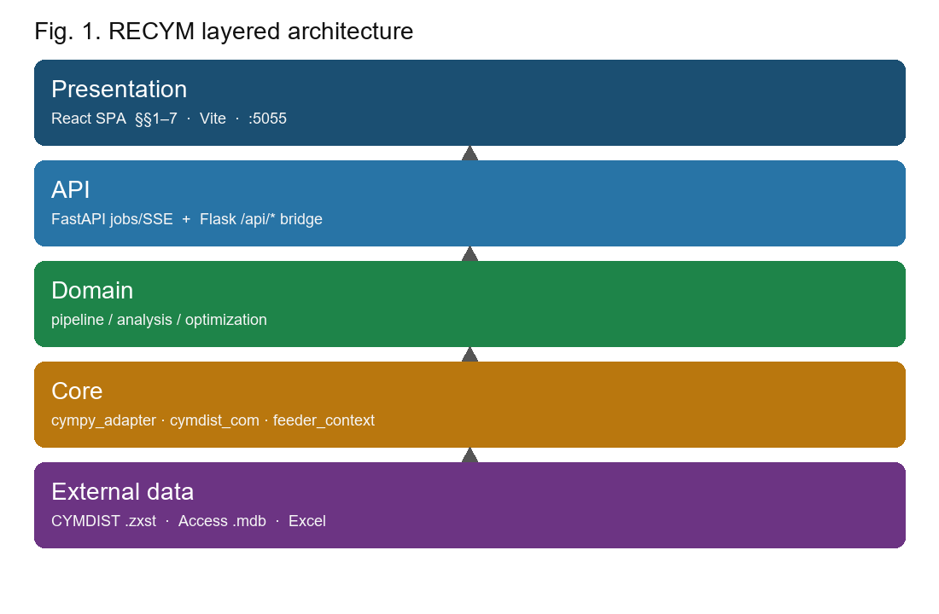
Fig. 1. RECYM layered architecture (UI → API → domain → CYMDIST core → data).
IV. MATHEMATICAL MODELS AND ALGORITHMS
Model 1 (kWh allocation): Pcab_res = Pcab - sum Pfix; Pi = Pcab_res * Ei / sum Eu; balance error eps_P = |sum Pi - Pcab|/Pcab * 100%. Precision MAE/RMSE of DeltaP, DeltaE (tol. 0.01 kW / 0.5 kWh).
Model 2 (SpotLoad + dual LF): Pphase = P3ph/3, Qphase = Q3ph/3; y_sit = F(x; c=0), y_prj = F(x; c=1); Delta y = y_prj - y_sit; delta_P = 100*DeltaP/Psit. Pseudocode Algorithms 1-3. Sample PA217 validation: eps_P ~ 7.6e-5%, MAE=0, delta_P=+17.17%, closure 21/21.
IV-bis. OPERATIONAL WORKFLOW
IV. PROPOSED WORKFLOW
§1 context/headroom; §2 quality gate; §3 customers EA→KWH / Pot→kW Locked + allocation; §4 SpotLoad P/3 Q/3 Locked (no re-allocation afterward); §5 situational (disconnect §4) / projected (connect §4) LF; §§6–7 reports and suite.
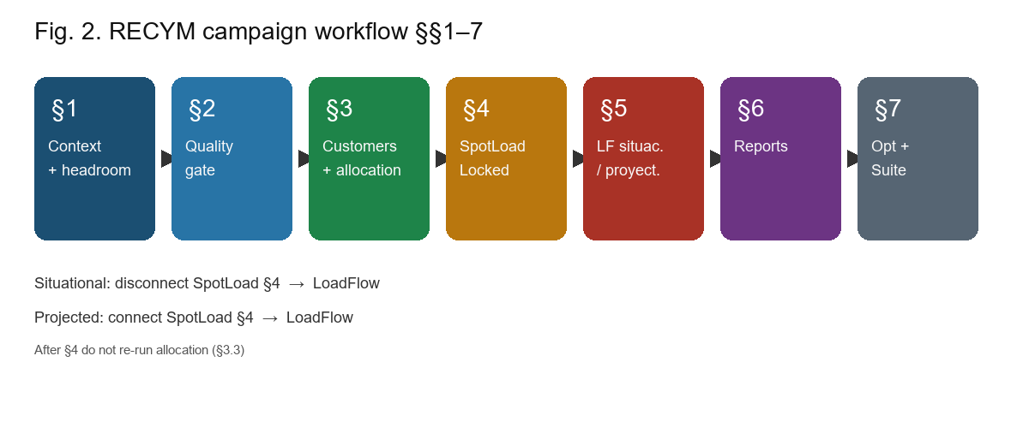
Fig. 2. RECYM operational campaign §§1–7.
V. CASE STUDY
RECYM is already wired to the Electro Dunas Access database with 97 feeder configurations and multiple .zxst studies; PA217 (22.9 kV) is reported as a representative experimental sample. On PA217: zero diagnostic problems, verified customers, headroom-balanced allocation (9537.9 vs 9537.88 kW), 1420 kW SpotLoad, and dual LF with quantified P/Q/S deltas.
Corpus: 97 feeders + ELD; shared DB; multiple .zxst. PA217 is a sample to validate RECYM (not the delivery report in doc/).
VI. RESULTS AND DISCUSSION
Diagnostics: 0 messages / 0 problems. Customer precision: 11 OK, 0 fails (Table I). COM allocation: ΣP=9537.9 kW vs headroom 9537.88 kW (Δ≈0%), 257 loads. Locked SpotLoad 1420 kW at NODE_1080_320357_MI-17145_2 (Fig. 3). Situational and projected LF OK (Figs. 4–5). Automated closure 21/21 steps.
TABLE I. IMPORTANT-CUSTOMER PRECISION ON PA217 (SAMPLE)
Customer | SED | EA (kWh) | Pot (kW) | ΔkWh | ΔkW | Status
Caliza cementos inca | SE30940 | 1,747,551.27 | 3800.57 | 0.0 | 0.0 | OK
Minerales Paracas | SE30480 | 678,852.12 | 1273.76 | 0.0 | 0.0 | OK
LJMetales | SE30642 | 527,079.81 | 956.49 | 0.0 | 0.0 | OK
Emsalsa | SE30353 | 157,621.44 | 458.00 | 0.0 | 0.0 | OK
Uvica | SE30424 | 167,101.44 | 366.30 | 0.0 | 0.0 | OK
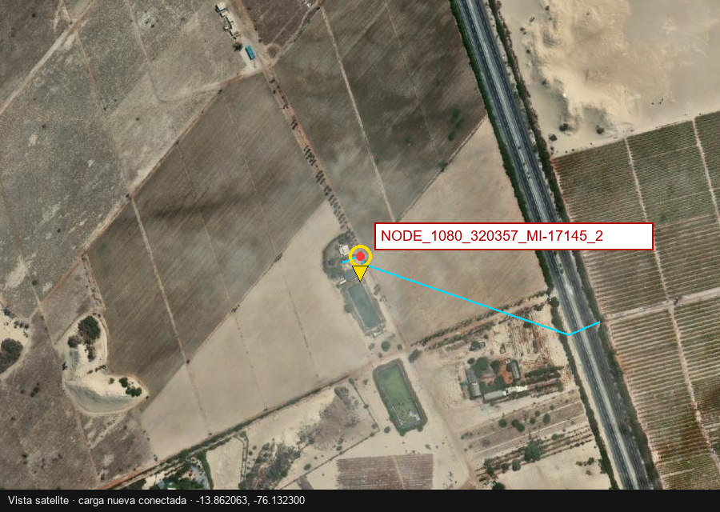
Fig. 3. Location of the prospective SpotLoad (1420 kW) on PA217.
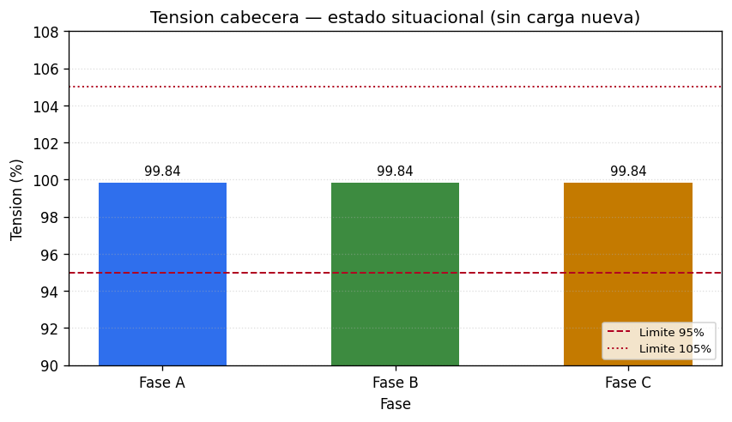
Fig. 4a. Voltage map — situational scenario (SpotLoad §4 disconnected).
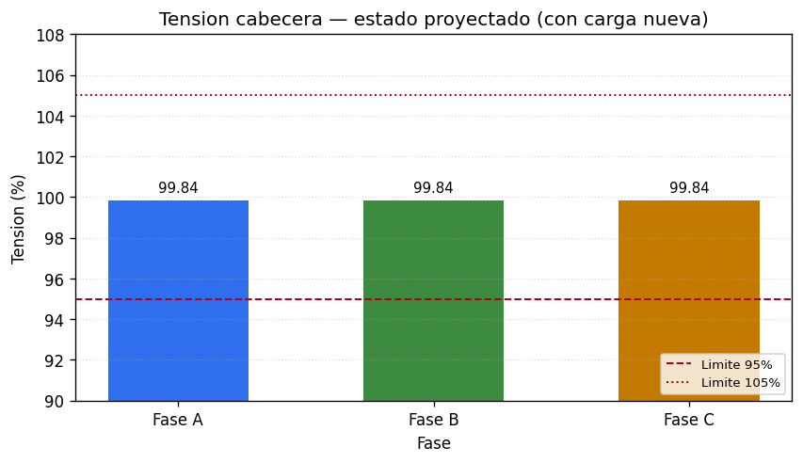
Fig. 4b. Voltage map — projected scenario (SpotLoad §4 connected).
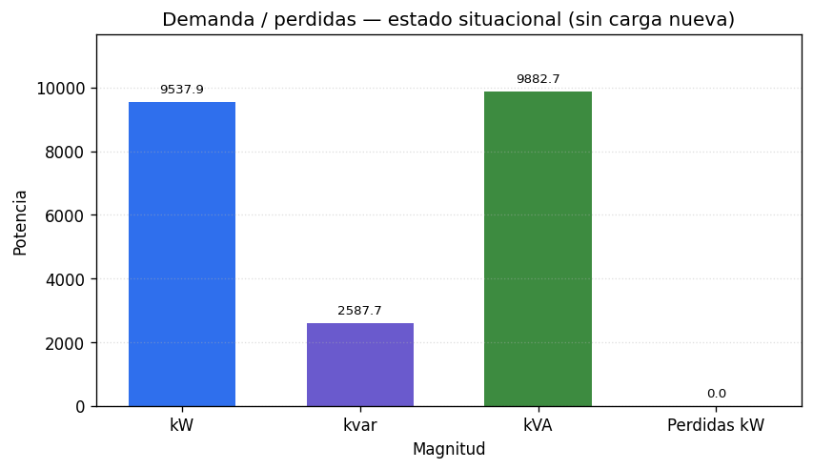
Fig. 5a. Loading — situational scenario.
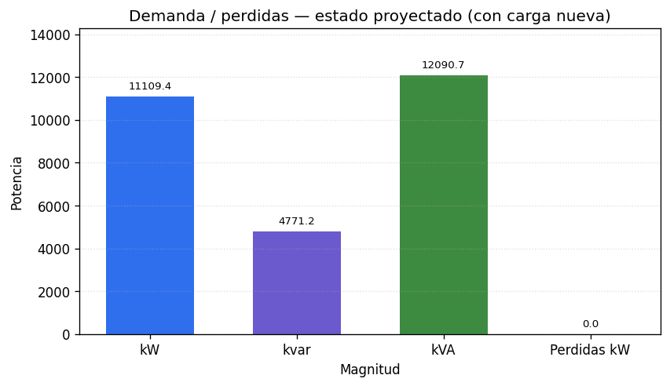
Fig. 5b. Loading — projected scenario (sample PA217).
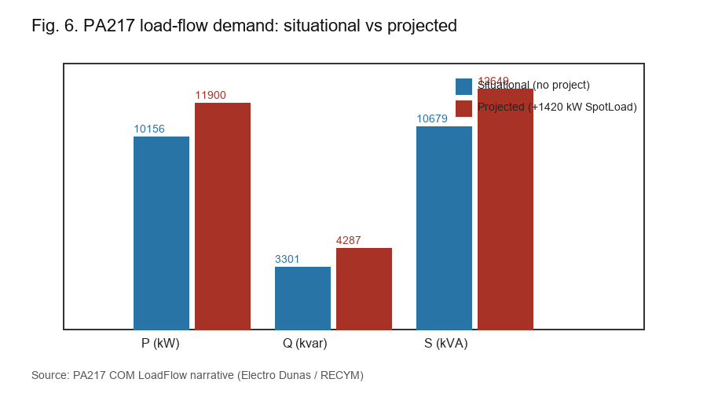
Fig. 6. Headroom demand situational vs projected (real COM LF data, PA217).
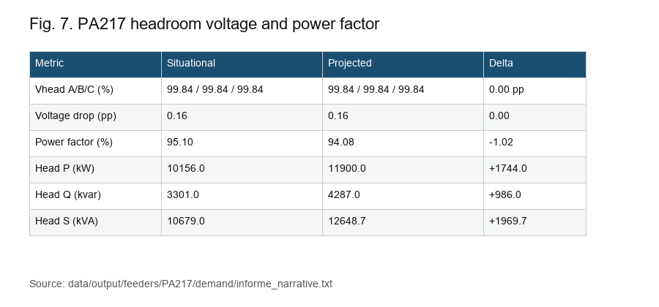
Fig. 7. Visual Table III: voltage, PF and P/Q/S (sample PA217).
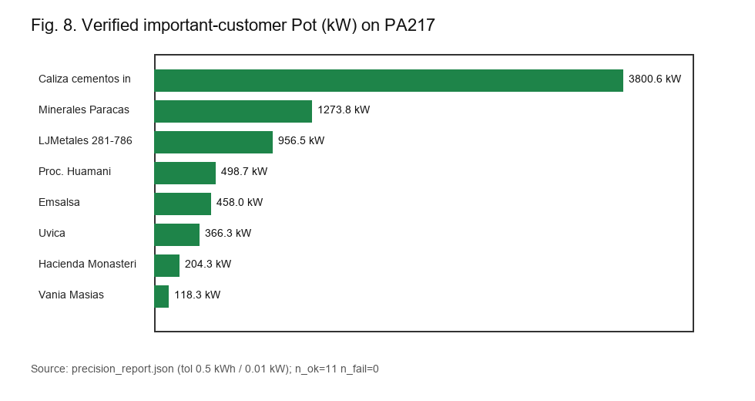
Fig. 8. Verified important-customer Pot (kW) on sample PA217.
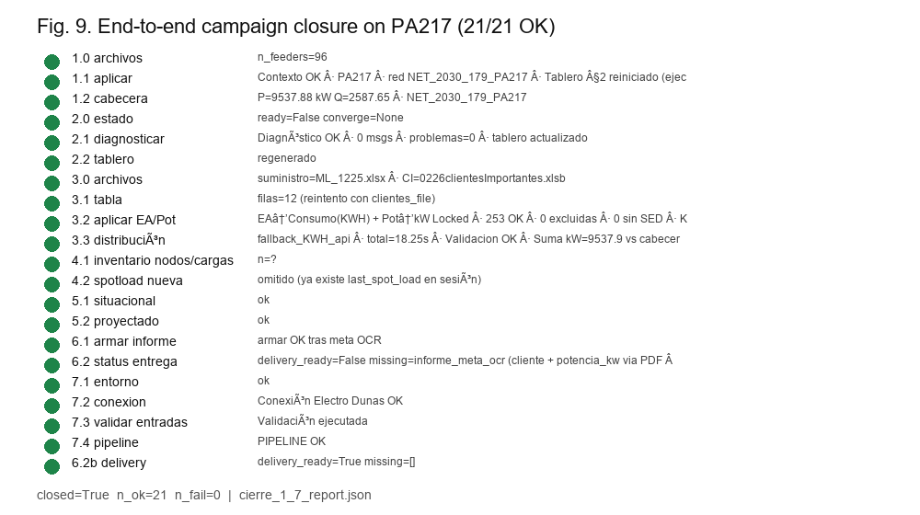
Fig. 9. Automated §§1–7 closure on PA217 (21/21 OK).
Limitations: Windows/COM; study integrity; COM fallback. Detailed tables are for sample PA217; the catalog already has 97 feeders and multiple studies—fleet KPIs remain future work.
VII. CONCLUSION
RECYM automates multi-feeder CYMDIST campaigns across 97 Electro Dunas feeders and multiple .zxst studies. With PA217 as representative sample: zero diagnostic issues, verified precision, balanced allocation, dual LF for 1420 kW, and 21/21 closure. Future work: fleet KPIs over the full catalog and §7 hardening.
REFERENCES
[1] W. H. Kersting, Distribution System Modeling and Analysis, 4th ed. Boca Raton, FL, USA: CRC Press, 2017.
[2] T. Gönen, Electric Power Distribution Engineering, 3rd ed. Boca Raton, FL, USA: CRC Press, 2014.
[3] Eaton CYME, CYMDIST Reference Manual / How-to Tutorials (Load Allocation, Load Flow), version 9.2. Saint-Bruno, QC, Canada: Eaton, 2022.
[4] R. C. Dugan, M. F. McGranaghan, S. Santoso, and H. W. Beaty, Electrical Power Systems Quality, 3rd ed. New York, NY, USA: McGraw-Hill, 2012.
[5] R. C. Dugan and T. E. McDermott, “An open source platform for collaborating on smart grid research,” in Proc. IEEE Power Energy Soc. Gen. Meeting, Detroit, MI, USA, 2011, pp. 1–7.
[6] L. Thurner et al., “pandapower—An open-source Python tool for convenient modeling, analysis, and optimization of electric power systems,” IEEE Trans. Power Syst., vol. 33, no. 6, pp. 6510–6521, Nov. 2018.
[7] J. Peppanen, M. J. Reno, M. Thakkar, S. Grijalva, and R. G. Harley, “Leveraging AMI data for distribution system model calibration and situational awareness,” IEEE Trans. Smart Grid, vol. 6, no. 4, pp. 2000–2009, Jul. 2015.
[8] Y. Wang, Q. Chen, T. Hong, and C. Kang, “Review of smart meter data analytics: Applications, methodologies, and challenges,” IEEE Trans. Smart Grid, vol. 10, no. 3, pp. 3125–3148, May 2019.
[9] A. K. Ghosh, D. L. Lubkeman, and R. H. Jones, “Load modeling for distribution circuit state estimation,” IEEE Trans. Power Del., vol. 12, no. 2, pp. 999–1005, Apr. 1997.
[10] M. E. Baran and A. W. Kelley, “State estimation for real-time monitoring of distribution systems,” IEEE Trans. Power Syst., vol. 9, no. 3, pp. 1601–1609, Aug. 1994.
[11] T. Brown, J. Hörsch, and D. Schlachtberger, “PyPSA: Python for power system analysis,” J. Open Res. Softw., vol. 6, no. 1, Art. no. 4, 2018.
[12] M. Rylander, J. Smith, and W. Sunderman, “Streamlined method for determining distribution system hosting capacity,” in Proc. IEEE Rural Electric Power Conf., Asheville, NC, USA, 2015, pp. 3–9.
[13] F. Ding and B. Mather, “On distributed PV hosting capacity estimation, sensitivity study, and improvement,” IEEE Trans. Sustain. Energy, vol. 8, no. 3, pp. 1010–1020, Jul. 2017.
[14] IEEE Standard for Interconnection and Interoperability of Distributed Energy Resources with Associated Electric Power Systems Interfaces, IEEE Std 1547-2018, Apr. 2018.
[15] H. L. Willis, Power Distribution Planning Reference Book, 2nd ed. New York, NY, USA: Marcel Dekker, 2004.
[16] J. A. Momoh, Electric Power Distribution, Automation, Protection, and Control. Boca Raton, FL, USA: CRC Press, 2008.
[17] A. Abur and A. G. Expósito, Power System State Estimation: Theory and Implementation. New York, NY, USA: Marcel Dekker, 2004.
[18] OSINERGMIN, Normativa técnica de calidad de servicio eléctrico / distribución (Perú). Lima, Peru. [Online]. Available: https://www.osinergmin.gob.pe
[19] IEEE Guide for Electric Power Distribution Reliability Indices, IEEE Std 1366-2022, 2022.
[20] S. Conti, S. Raiti, G. Tina, and U. Vagliasindi, “Study of the impact of PV generation on voltage profile in LV distribution networks,” in Proc. IEEE Power Tech, St. Petersburg, Russia, 2005, pp. 1–6.
Note: paste into the official IEEE template before submission. Text: MANUSCRIPT.md. BibTeX: references.bib. Author: Mac Tapia Ccosyo (Electro Dunas S.A.A.).

