RECYM: An Automated Multi-Feeder Workflow for Demand Allocation and Load-Flow Studies in CYMDIST Distribution Networks
Mac Tapia Ccosyo
Electro Dunas S.A.A., Peru
e-mail: mtapia@electrodunas.com
Abstract—Distribution utilities need repeatable procedures to clean network models, allocate measured headroom demand, inject important-customer and prospective spot loads, and compare situational versus projected operating cases. This paper presents RECYM, a multi-feeder software suite that couples CYMDIST/CymPy with a seven-step SPA and a batch pipeline. The workflow integrates network diagnostics, large-customer energy/power mapping to SED nodes, kWh-based load allocation via the CYMDIST COM API, locked three-phase spot loads, dual load-flow scenarios, and campaign artifacts. RECYM is wired to the Electro Dunas Access database with 97 feeder configurations and multiple .zxst studies; PA217 (22.9 kV) is the representative experimental sample. On PA217 the campaign achieved zero diagnostic problems, verified customer precision, allocation balance error eps_P ~ 7.6e-5%, a 1420 kW spot load, and dual load flows with delta_P = +17.17%.
Index Terms—CYMDIST, demand studies, distribution networks, load allocation, load flow analysis, power system modeling, software tools.

I. INTRODUCTION
Distribution planning relies on detailed three-phase feeder models [1], [2]. CYMDIST provides allocation and unbalanced load flow [3], [4], yet campaigns often remain manual. OpenDSS and pandapower automate research [11], [12]; theses often migrate CYMDIST models [13]-[15]. RECYM instead orchestrates COM/CymPy on native .zxst/.mdb assets, with a multi-feeder architecture (97 configs), a §§1-7 campaign, and validation on sample feeder PA217.
Contributions: (i) layered architecture L1-L5; (ii) mathematical models for kWh allocation and dual LF with pseudocode; (iii) experimental statistical validation on PA217 as a sample from the Electro Dunas catalog.
II. THEORETICAL FRAMEWORK AND RELATED WORK
A. Three-Phase Flow and Allocation
Kersting [1] and Cheng-Shirmohammadi [9], [10] underpin radial/weakly meshed flow. Energy-based allocation often outperforms connected-kVA when measurements exist [7], [8]. CYMDIST implements Connected+Total templates [4].
B. Positioning
Unlike CYMDIST→OpenDSS conversions [13]-[15], RECYM keeps the system of record. Versus utility integrations [16], [17], it adds SPA/job orchestration, Locked SpotLoad, and situational/projected scenarios [23]-[25].
III. SYSTEM ARCHITECTURE
RECYM is a five-layer stack L1..L5 (Fig. 1): React SPA; FastAPI/SSE API + Flask bridge; domain pipeline/analysis/optimization; CymPy/COM core; .zxst/.mdb/Excel data. Configuration (S, F) with |F|=97 feeders plus ELD study.
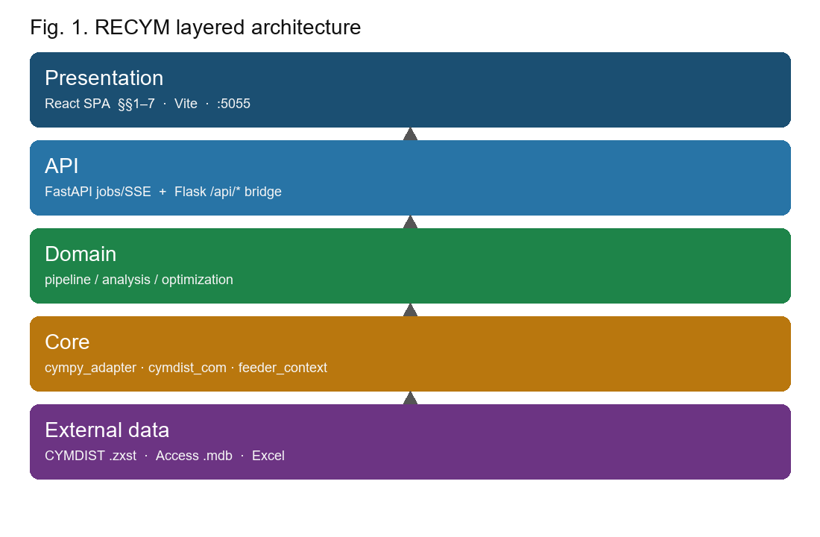
Fig. 1. RECYM layered architecture.
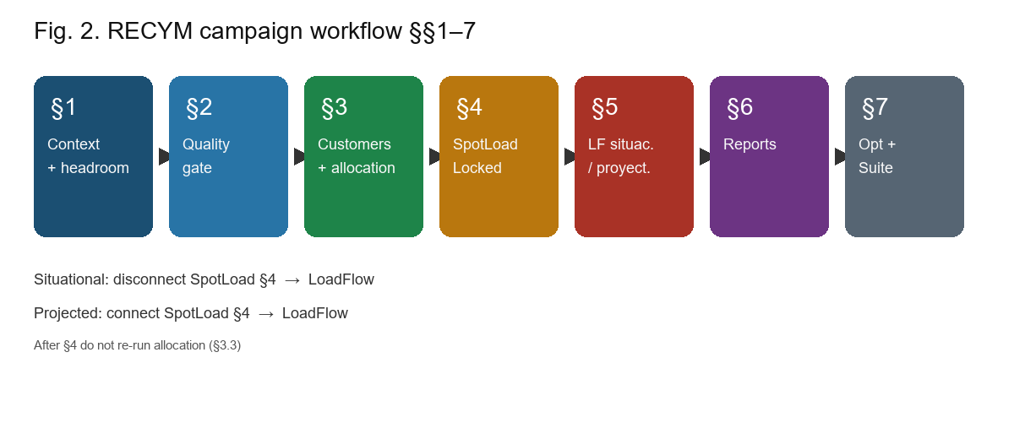
Fig. 2. Operational campaign §§1-7.
IV. MATHEMATICAL MODELS AND ALGORITHMS
A. kWh Allocation Model
Let Pcab be headroom active power and L = F ∪ U the Locked/unlocked partition. Residual and allocation are Pcab_res = Pcab − Σ_j∈F Pj_fix and Pi = Pcab_res · Ei / Σ_u∈U Eu for i∈U. Balance error is eps_P = |Σ_i Pi − Pcab| / Pcab · 100%. Precision uses MAE_P and RMSE_P of |ΔPi| with tolerance 0.01 kW (0.5 kWh for energy). This paragraph states the first closed-form mathematical model [7], [8], [4].
B. Spot-Load and Dual LF Model
For SpotLoad (P3φ, Q3φ): Pφ = P3φ/3, Qφ = Q3φ/3, φ∈{A,B,C}, Locked. With flag c∈{0,1}, y_sit = F(x; c=0) and y_prj = F(x; c=1); Δy = y_prj − y_sit; δP = 100·ΔP/Psit. This paragraph states the second mathematical model [9], [10], [23]-[25].
C. Pseudocode
Algorithm 1 (allocation): compute Pcab_res; distribute Pi by Ei; COM write; return eps_P. Algorithm 2 (dual LF): disconnect SpotLoad → situational LF; connect → projected LF; Δy. Algorithm 3 (campaign): headroom → diagnose Nmsg=0 → Alg.1 → SpotLoad → Alg.2 → artifacts/closure.
V. EXPERIMENTATION
Corpus: 97 configs + ELD, shared Access DB, multiple .zxst. Sample: PA217 (22.9 kV), 1324 nodes, 253 loads. Headroom L-PA235: P=9537.88 kW, Q=2587.65 kvar. Protocol dry_run=false §§1-7. The utility delivery report (doc/informe.*) is a different product; here we validate software and method.
VI. RESULTS AND VALIDATION
Diagnostics: Nmsg=0. Precision: 11/11 OK, p-hat=1.00 (Clopper-Pearson 95% CI [0.72, 1.00]), MAE=RMSE=0. Allocation: eps_P ≈ 7.6×10^−5%. SpotLoad 1420 kW; phase imbalance 0. Dual LF: ΔP=+1744 kW (δP=+17.17%), ΔQ=+986 kvar, ΔS=+1969.7 kVA; Vhead=99.84% both cases. Closure 21/21.
TABLE I. CUSTOMER PRECISION (SAMPLE)
Customer | SED | Pot kW | Status
Caliza cementos | SE30940 | 3800.57 | OK
Minerales Paracas | SE30480 | 1273.76 | OK
LJMetales | SE30642 | 956.49 | OK
Emsalsa | SE30353 | 458.00 | OK
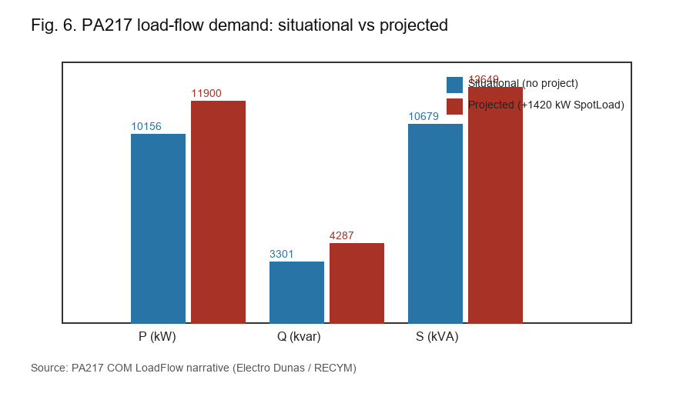
Fig. 3. Situational vs projected demand (PA217).
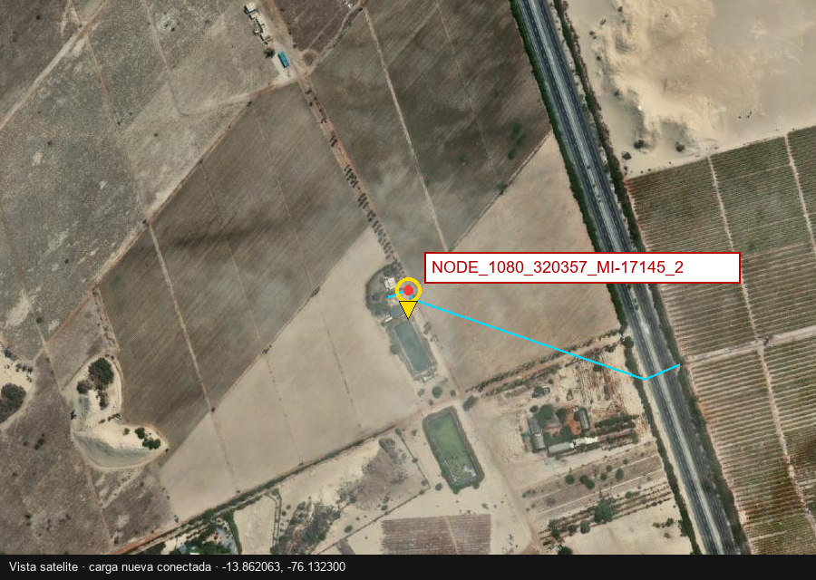
Fig. 4. SpotLoad 1420 kW location (campaign).
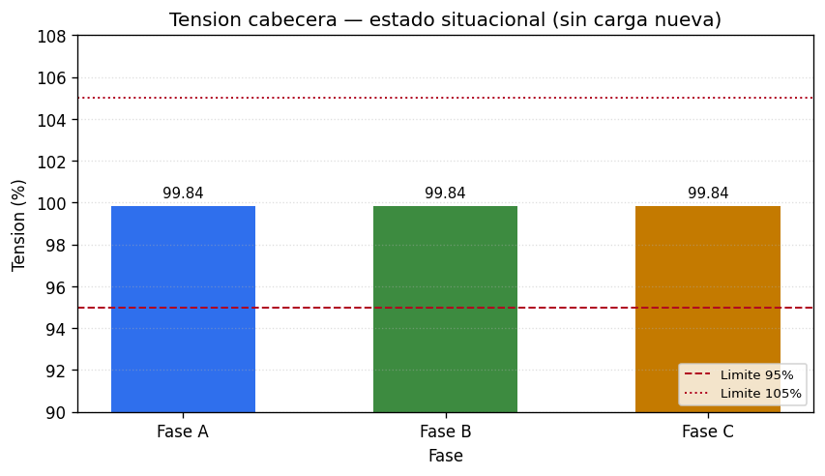
Fig. 5. Situational voltage map.
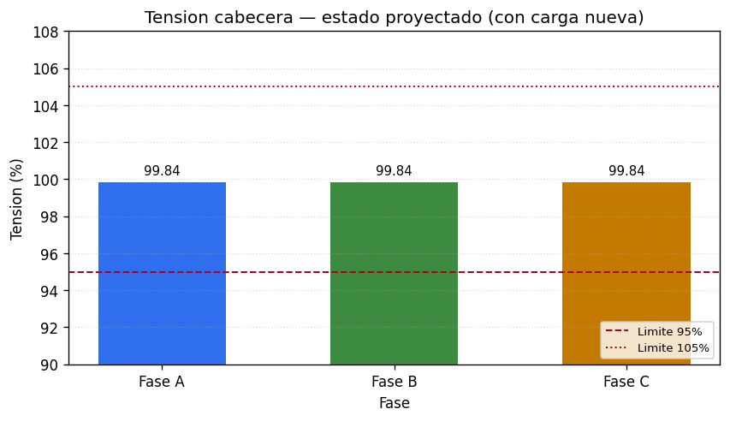
Fig. 6. Projected voltage map.
VII. CONCLUSION
RECYM formalizes architecture, allocation/dual-LF models, pseudocode, and validation on a 97-feeder catalog, with PA217 as sample. Future work: fleet KPIs, official IEEEtran camera-ready, and AMI.
REFERENCES
[1] W. H. Kersting, Distribution System Modeling and Analysis, 4th ed. CRC Press, 2017.
[2] T. Gonen, Electric Power Distribution Engineering, 3rd ed. CRC Press, 2014.
[3] H. L. Willis, Power Distribution Planning Reference Book, 2nd ed. Marcel Dekker, 2004.
[4] Eaton CYME, CYMDIST Reference Manual, v9.2, 2022.
[5] A. K. Ghosh et al., IEEE Trans. Power Del., vol. 12, no. 2, pp. 999-1005, 1997.
[6] M. E. Baran and A. W. Kelley, IEEE Trans. Power Syst., vol. 9, no. 3, pp. 1601-1609, 1994.
[7] R. F. Arritt et al., in Proc. IEEE REPC, 2012.
[8] J. Peppanen et al., in Proc. IEEE PSC, 2018.
[9] D. Shirmohammadi et al., IEEE Trans. Power Syst., vol. 3, no. 2, pp. 753-762, 1988.
[10] C. S. Cheng and D. Shirmohammadi, IEEE Trans. Power Syst., vol. 10, no. 2, pp. 671-679, 1995.
[11] R. C. Dugan and T. E. McDermott, in Proc. IEEE PES GM, 2011.
[12] L. Thurner et al., IEEE Trans. Power Syst., vol. 33, no. 6, pp. 6510-6521, 2018.
[13] V. Ramachandran, M.S. thesis, West Virginia Univ., 2011.
[16] R. H. Chumbi and T. I. Verdugo, Tesis, Univ. de Cuenca, 2013.
[17] N. A. Ramos and W. E. Espinoza, Tesis de maestria, UNAC, 2023.
[18] D. W. Puma Ttito, Tesis doctoral, UNI, 2024.
[23] M. Rylander et al., in Proc. IEEE REPC, 2015.
[26] IEEE Std 1547-2018.

